Hero
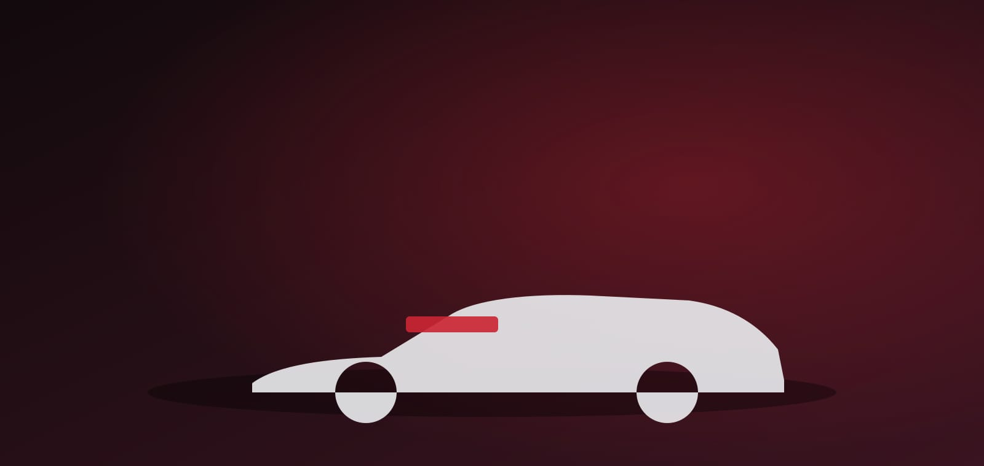 | Electric Roadster  MG Cyberster  Price: Coming soon · Dual-Motor AWD · 0–100 km/h in ~3.2s  Register InterestBook a Test Drive

Section Metadata
style | full-width

Breadcrumb
Home

A roadster reborn, electric
Cards (highlights)

~3.2s 0–100
Dual-motor all-wheel drive delivers supercar-quick acceleration.

Scissor Doors
Electric scissor doors make every arrival an occasion.

2-Seat Convertible
A soft-top roadster that drops in seconds at the touch of a button.

Long Range
77 kWh battery delivers up to 580 km on a single charge (WLTP).

Variant Selector
Choose your colour
Flare Red | #c0202b | 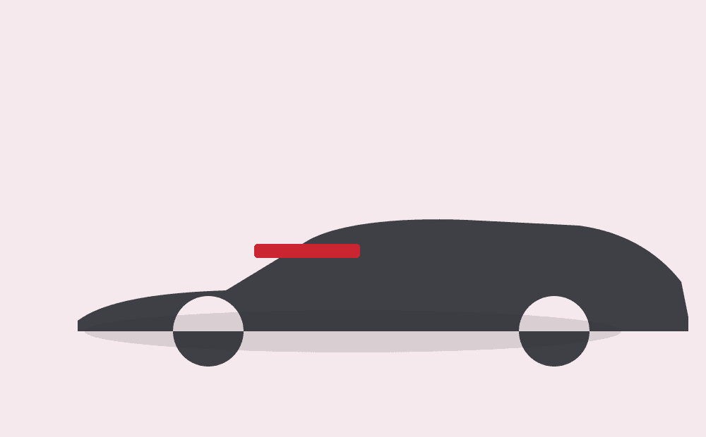 | Coming soon
Andes Grey | #5b6066 |  | Coming soon
Modena Yellow | #f2c018 |  | Coming soon

Section Metadata
style | light

Gallery
Carousel (gallery)





Born to thrill
Columns (feature)

Dual-motor AWD
Two electric motors produce a combined 375 kW (510 PS) and 725 Nm, launching the Cyberster from 0–100 km/h in roughly 3.2 seconds — pure electric adrenaline.

Columns (feature, reverse)
Drama in every detail  Electric scissor doors, a driver-focused triple-screen cockpit and a fully electric soft-top define a roadster built for the senses — top down, silence up front, torque on tap. | 

Specifications
Accordion (specifications, single)
Battery & Range | Battery: 77 kWh  Range (WLTP): Up to 580 km  Charging (DC): 10–80% in ~38 min
Performance | Drivetrain: Dual-motor AWD  Max power: 375 kW (510 PS)  Max torque: 725 Nm  0–100 km/h: ~3.2 s
Body & Features | Body: 2-seat convertible roadster  Doors: Electric scissor  Roof: Electric soft-top  Cockpit: Triple-screen digital
Dimensions | Length: 4535 mm  Width: 1913 mm  Height: 1329 mm  Wheelbase: 2690 mm

Banner
 | Be first to drive the future  Register your interest in the MG Cyberster and be among the first to experience the electric roadster.  Register InterestBook a Test Drive

Section Metadata
style | full-width

Explore other MG cars
Cards (model-range)
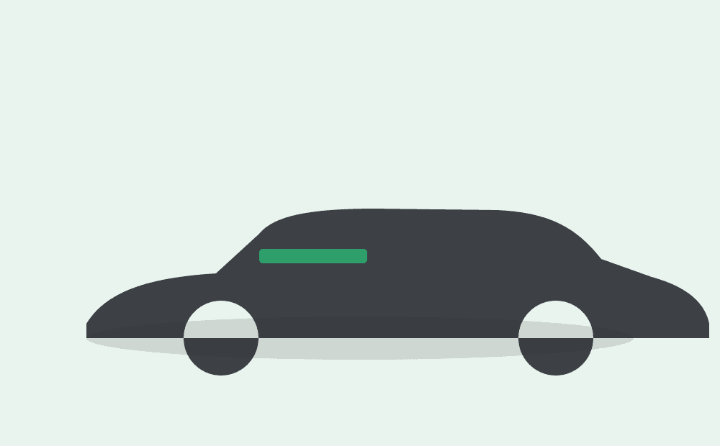 | MG ZS EV  Electric SUV · ₹18.98 Lakh*  Explore
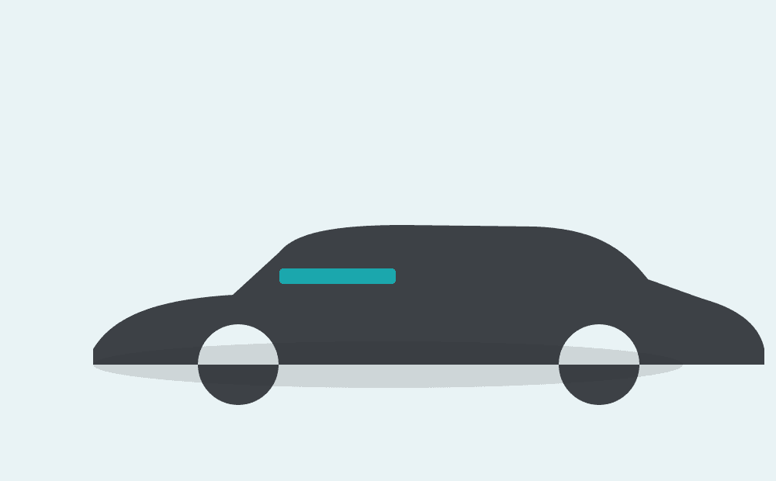 | MG Windsor EV  Intelligent CUV · ₹14.00 Lakh*  Explore
 | MG Comet EV  Smart city EV · ₹7.00 Lakh*  Explore

Sticky Cta
Register Interest  Book a Test Drive | 350

Metadata
Title | MG Cyberster — Electric Roadster | MG Motor India
Description | MG Cyberster — an all-electric two-seat convertible roadster with dual-motor AWD, 0–100 km/h in ~3.2s and dramatic scissor doors. Register your interest.

