PhonePe Pulse: Transaction Insights

A Comprehensive Project Report on Digital Payment Insights in India
Github Link - https://github.com/mansi0406/PhonePe-Transaction-Insights
BY- Mansi Soni
Date: March 2026

Table of Contents

1. Introduction
2. Project Objectives
3. Technology Stack
4. Data Architecture (ETL Process)
5. Database Schema
6. Data Analysis & SQL Queries
7. Streamlit Dashboard Overview
8. Visualization & Insights
9. Key Findings
10. Business Recommendations
11. Conclusion

1. Introduction
The Indian digital payments landscape has witnessed a revolutionary transformation over the last decade. PhonePe, as one of the pioneers in the UPI (Unified Payments Interface) ecosystem, has played a pivotal role in this change. This project aims to demystify the vast amount of data generated by digital payments in India using the 'PhonePe Pulse' open-source dataset. By extracting, cleaning, and visualizing this data, we uncover trends that define the what, why, and how of digital transactions across the country.

2. Project Objectives
- Extract data from the PhonePe Pulse GitHub repository.
- Transform raw, nested JSON data into a structured relational format.
- Load the structured data into a high-performance PostgreSQL database.
- Perform deep-dive data analysis using SQL and Python.
- Develop an interactive, user-friendly dashboard using Streamlit.
- Generate actionable business insights for strategic decision-making.

3. Technology Stack
Python: The core programming language for scripting and data handling.
PostgreSQL: The relational database management system (RDBMS) used for data storage.
Pandas: Used for data cleaning, manipulation, and transformation.
SQLAlchemy: The database toolkit and Object-Relational Mapper (ORM) for Python.
Streamlit: The web framework used to build the interactive dashboard.
Plotly: The library used for creating high-quality, interactive visualizations.

4. Data Architecture (ETL Process)
The project follows a robust ETL (Extract, Transform, Load) architecture to ensure data integrity and query performance.

4.1 Extraction
Data is extracted from a nested directory structure in the pulse-master repository. The extraction process involves navigating through folders categorized by 'Aggregated', 'Map', and 'Top', and further subdivided by 'Transactions', 'Users', and 'Insurance'.

4.2 Transformation
Raw JSON files are parsed using Python. Key metadata like State, Year, and Quarter are extracted from the file paths and combined with the internal JSON data. Data is flattened into rows and columns using Pandas DataFrames.

4.3 Loading
Using SQLAlchemy, the flattened DataFrames are pushed into nine distinct tables in a PostgreSQL database. This allows for fast, multi-dimensional querying using SQL.

5. Database Schema
The database 'phonepe_pulse' consists of nine tables designed for optimized analytical queries:
- aggregated_transaction: State-level yearly and quarterly transaction totals.
- aggregated_user: State-level device brand distribution and user metrics.
- aggregated_insurance: State-level insurance transaction data.
- map_transaction: District-level transaction data.
- map_user: District-level user registration and app usage data.
- map_insurance: District-level insurance metrics.
- top_transaction: Rankings of top districts and pincodes by transaction value.
- top_user: Rankings of top districts and pincodes by registered users.
- top_insurance: Rankings of top districts and pincodes by insurance value.

6. Data Analysis & SQL Queries
Before building the dashboard, several complex SQL queries were executed to validate the data and extract initial insights. For example:

Example: Top 10 States by Transaction Amount
SELECT state, SUM(transaction_amount) as total_amount
FROM aggregated_transaction
GROUP BY state
ORDER BY total_amount DESC
LIMIT 10;
This query identified Telangana and Karnataka as major contributors to the digital economy.

7. Streamlit Dashboard Overview
The dashboard is an interactive web application built with Streamlit. It features a sidebar for filtering data by Year, Quarter, and State, and five main tabs for exploring different analytical perspectives.
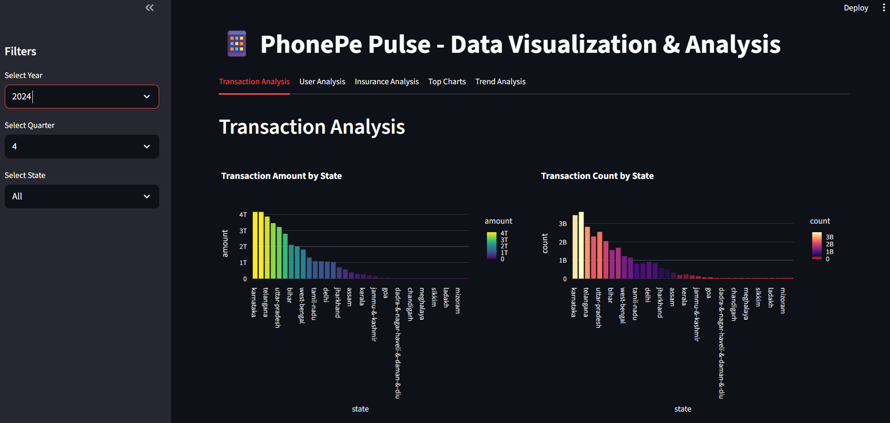

8. Visualization & Insights

1. Transaction Amount by State
A bar chart identifying the revenue engines of the country.
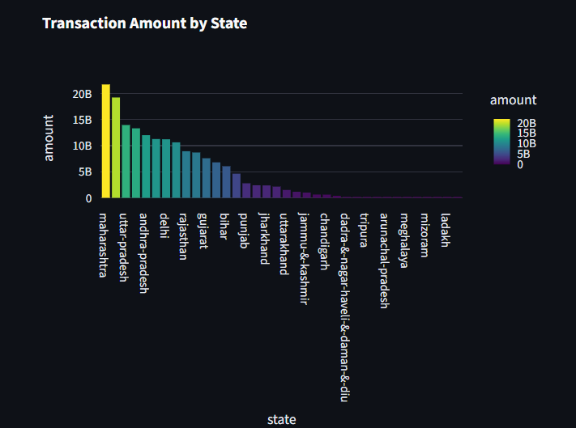
Insight: This chart demonstrates which states are contributing the most to the digital economy.

2. Transaction Count by State
A bar chart showing where the highest digital activity occurs.
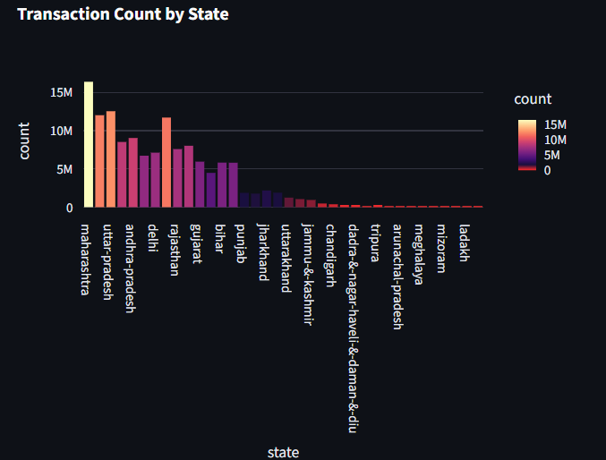
Insight: This chart Identifies high-frequency transaction states.

3. Transaction Type Distribution
A pie chart breaking down P2P, Merchant, and Bill payments.
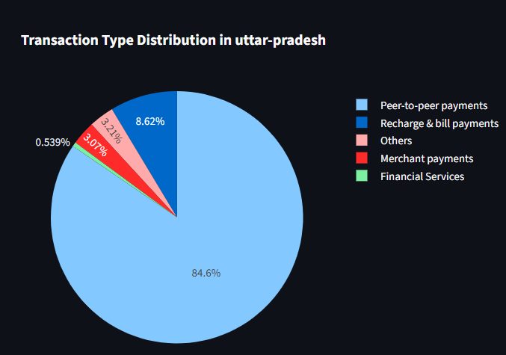
Insight: This chart demonstrates breakdown of Peer-to-Peer, Merchant, Recharge, etc., at the state level

4. Transaction Count by Type
A volume-based view of payment categories.
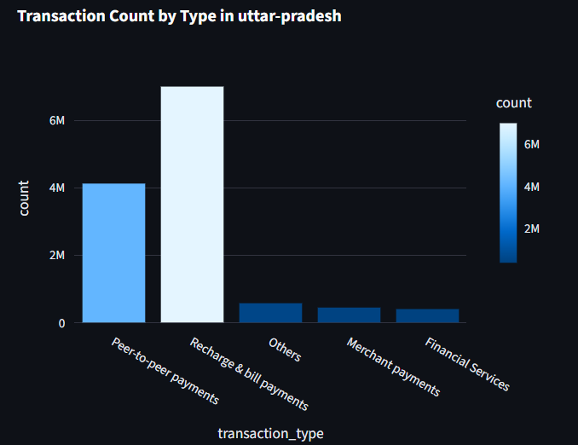
Insight: This chart Visualizes the volume of each payment category.

5. Registered Users by State
Visualizing market penetration across Indian states.
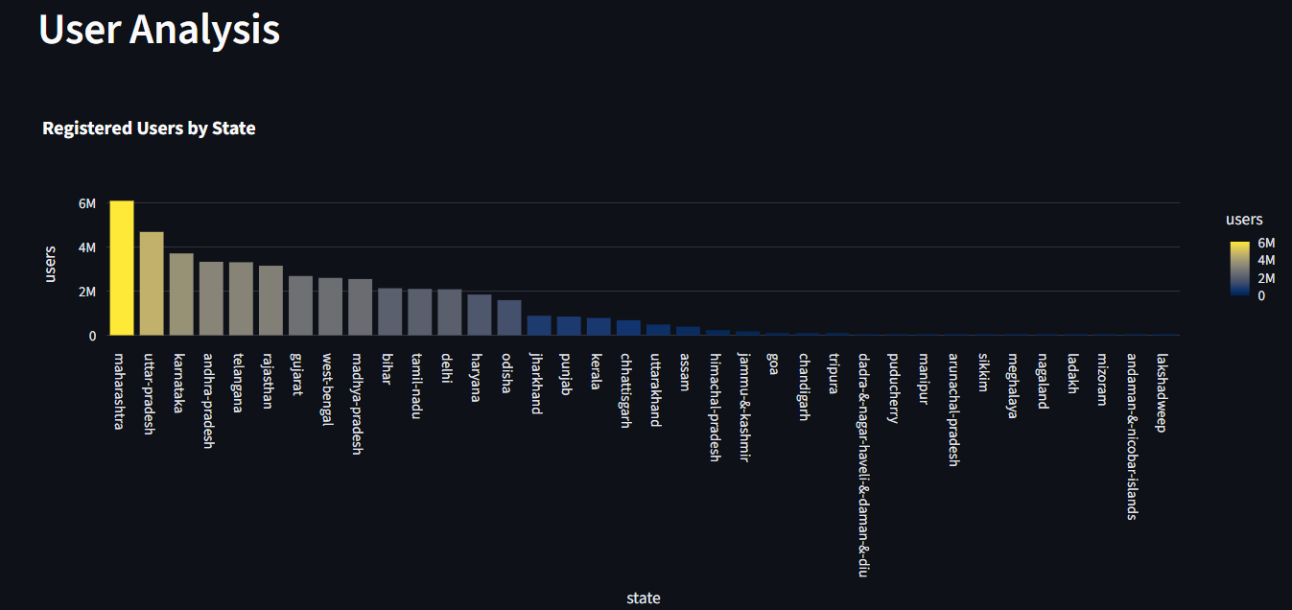
Insight: This chart Compares the user base across India.

6. Device Brand Market Share
A pie chart showing dominance of Xiaomi and Samsung.
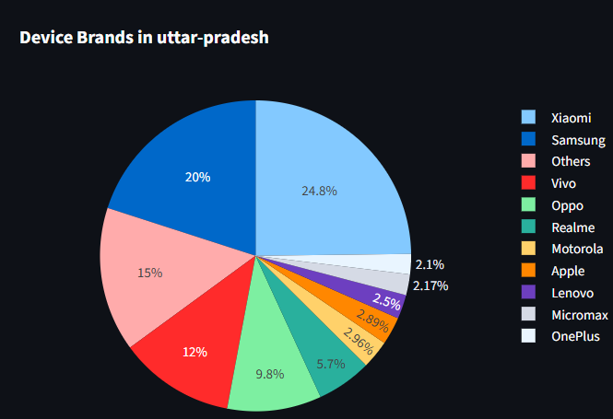
Insight: This chart Shows the market share of Xiaomi, Samsung, Vivo, etc., among PhonePe users.

7. Total Registered Users (KPI)
A metric showing real-time user counts.
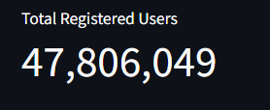
Insight: This chart demonstrates A high-level KPI showing the total user count for a selected state (Uttar Pradesh, 2023).

8. Total App Opens (KPI)
A metric measuring user engagement.
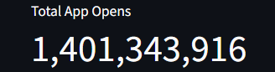
Insight: This chart Measures user engagement/stickiness in a specific region.

9. Insurance Amount by State
Tracking the penetration of insurance products.
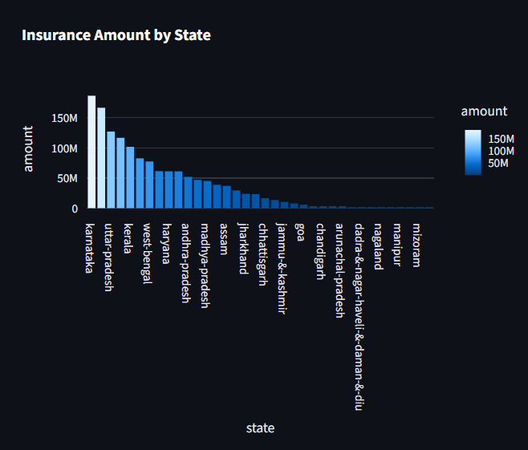
Insight: This chart Tracks the penetration of insurance products via digital payments.

10. Insurance Count by State
Visualizing insurance volume.
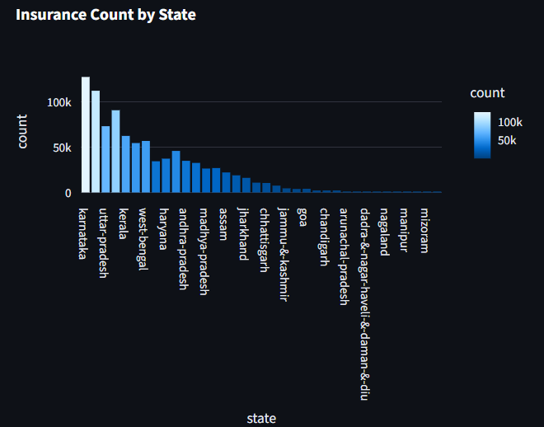
Insight: This chart shows the number of insurance policies bought/renewed.

11. Insurance Type Distribution
Categorizing insurance products sold.
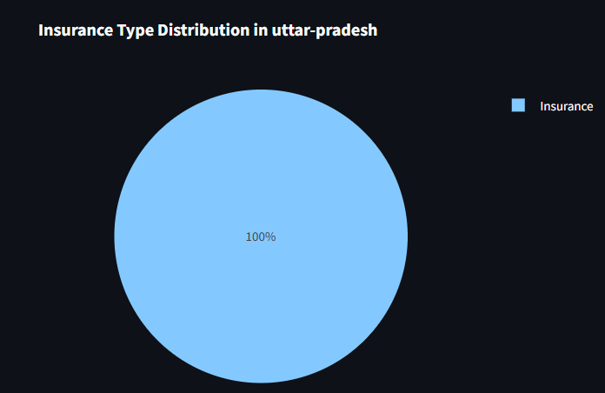
Insight: This chart Categorizes insurance types

12. Top 10 Districts by Amount
Identifying urban hubs like Bengaluru or Pune.
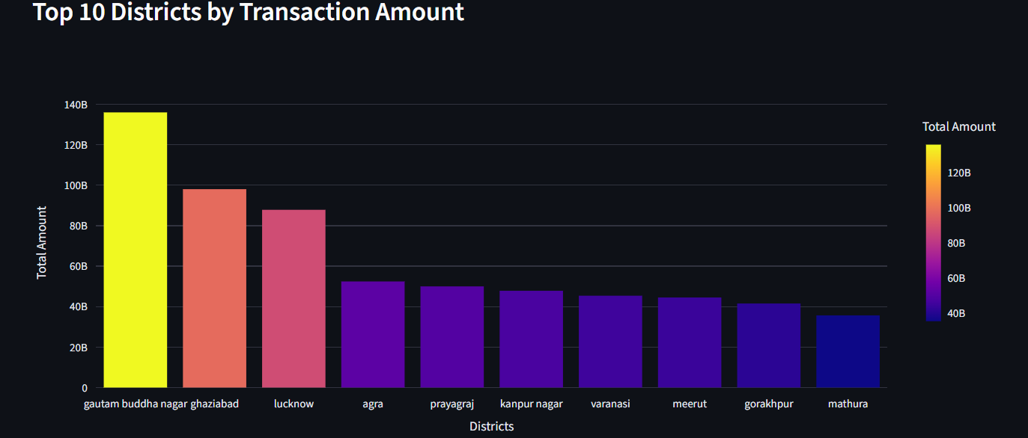
Insight: This chart Identifies urban centers with high digital spending of Uttar Pradesh.

13. Top 10 Pincodes by Amount
Hyper-local analysis of spending patterns.
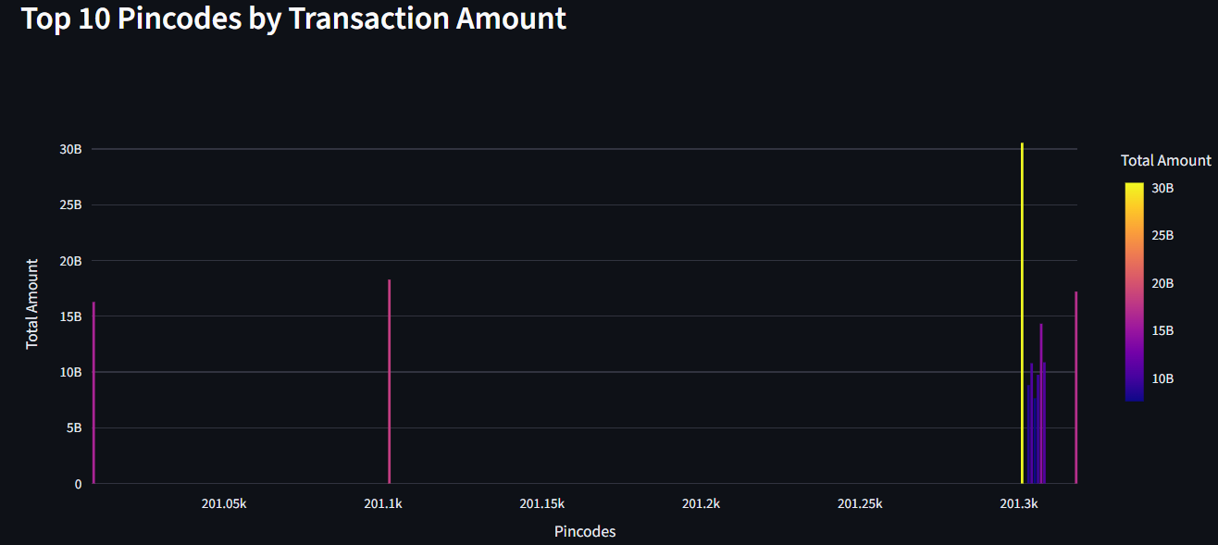
Insight: This chart demonstrates Hyper-local analysis of spending patterns of Uttar Pradesh 2023 data.

14. Transaction Amount Trend
Line chart showing growth from 2018 to 2024.
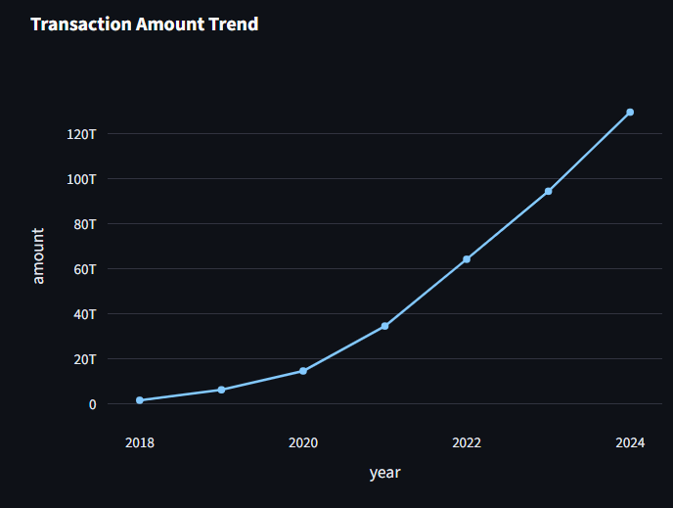

15. User Acquisition Trend
Tracking yearly growth in new users.
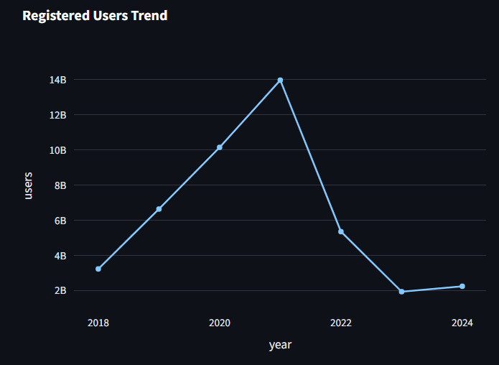
Insight: This chart Visualizes the adoption rate of the PhonePe platform.

16. App Opens Trend
Correlating growth with app engagement.
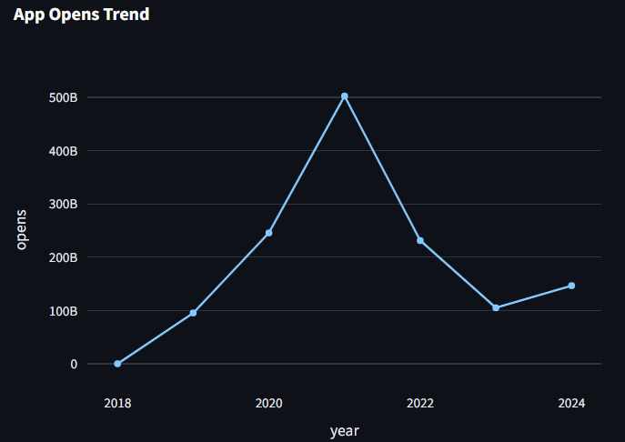
Insight: This chart Tracks how user engagement has evolved over time.

9. Key Findings
- Hyper-Growth: UPI transactions have seen exponential growth post-2020.
- Regional Leaders: Southern and Western India are the primary drivers of digital adoption.
- Merchant Shift: Digital spending is shifting from P2P to Merchant transactions for daily needs.
- Mobile Preference: Android devices (Xiaomi/Samsung) remain the primary gateway for digital payments.

10. Business Recommendations
- Hyper-Local Marketing: Use pincode data to partner with local merchants in high-spending areas.
- Product Diversification: Launch micro-insurance products in states with high transactions but low insurance penetration.
- Device Optimization: Ensure peak app performance for mid-range Android devices.
- Merchant Incentives: Incentivize Tier-2 city merchants to increase adoption.

11. Conclusion
The PhonePe Pulse analysis project successfully demonstrates the power of data engineering and analytics in the FinTech sector. By transforming raw, unstructured data into actionable insights, we can better understand the pulse of digital India and make informed strategic decisions. This project serves as a foundational tool for any business looking to navigate the rapidly evolving digital payments landscape in India.

