Abstract
This report documents the acquisition, inspection, cleaning and exploratory analysis of a telecommunications customer churn dataset covering 7,043 customers of a California-based provider for the second quarter of 2022. Each record describes one customer’s demographics, location, subscribed services, contract and billing details, revenue, and quarterly status (Stayed, Churned or Joined). The work was carried out in Python using pandas, NumPy, Matplotlib and Seaborn.
Inspection showed no duplicate rows, but 13 columns contained missing values, mostly because a customer does not hold the related service (no internet, no phone) or has not churned. Each cleaning step is documented below with the issue, the action and the reason. Exploratory analysis found that 26.5% of customers churned, that churn is overwhelmingly concentrated among month-to-month contract holders (45.8% churned, against 2.6% on two-year contracts), that churned customers pay higher monthly charges and leave early in their tenure, and that competitor-related reasons account for 45% of churn. The report also records data-quality issues that remain open, including 120 negative monthly charges and an imputation that mislabels non-internet customers as Fiber Optic users.

Introduction and Objectives
Customer churn, the loss of subscribers to competitors or to cancellation, is one of the most costly problems in the telecommunications industry, because acquiring a new customer is generally more expensive than retaining an existing one. Understanding who leaves, when, and why is the first step toward any retention strategy or predictive model.
The objectives of this Week 01 project were to:
- Load the telecom customer churn dataset and understand its structure, variables and target column.
- Inspect data types, summary statistics, unique values and missing values.
- Clean and preprocess the data, documenting the issue, action and reason for every step.
- Explore the data visually to identify patterns associated with churn.
- Record limitations and define the next steps toward predictive modelling.

Dataset Acquisition and Description

Source and scope
The raw file, telecom_customer_churn.csv, was loaded from a local folder into a pandas DataFrame, and a working copy (df) was made so that the original (df1) stayed untouched. According to the notebook, the table holds information on 7,043 customers of a California telecommunications company in Q2 2022, with one record per customer. The structure matches the publicly available IBM Telco customer churn sample dataset distributed through Kaggle; the original source and licence should be confirmed before formal publication. After cleaning, the file was saved as telecom_churn_cleaned.csv, which has 7,043 rows and 31 columns.

Variable groups
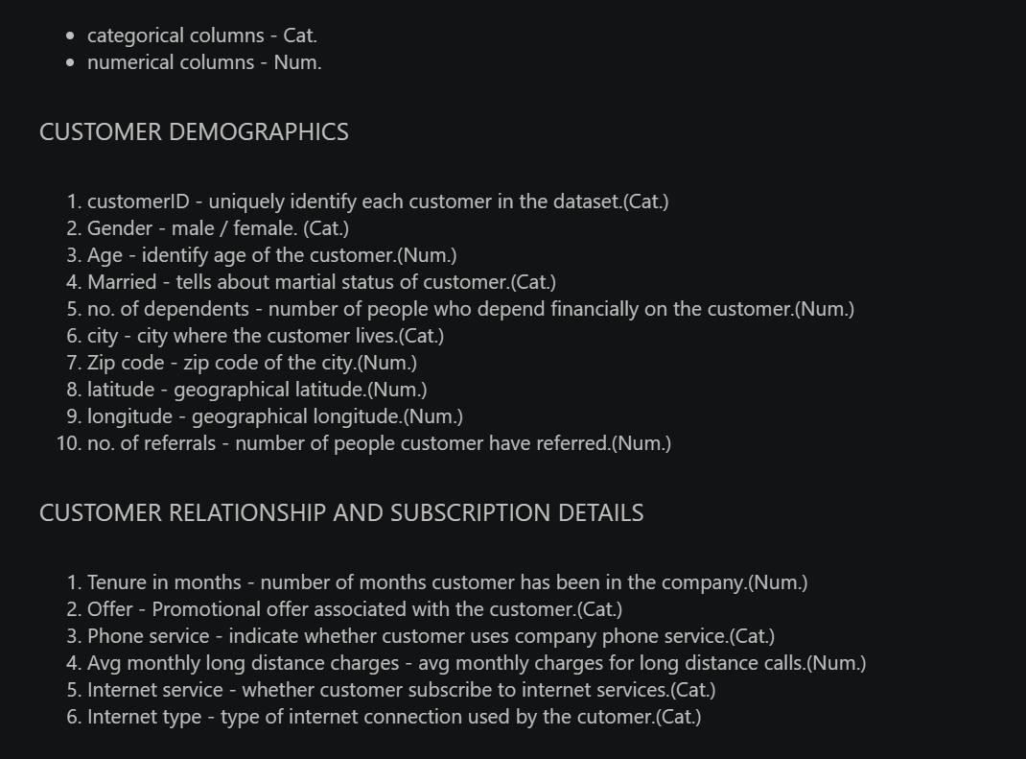
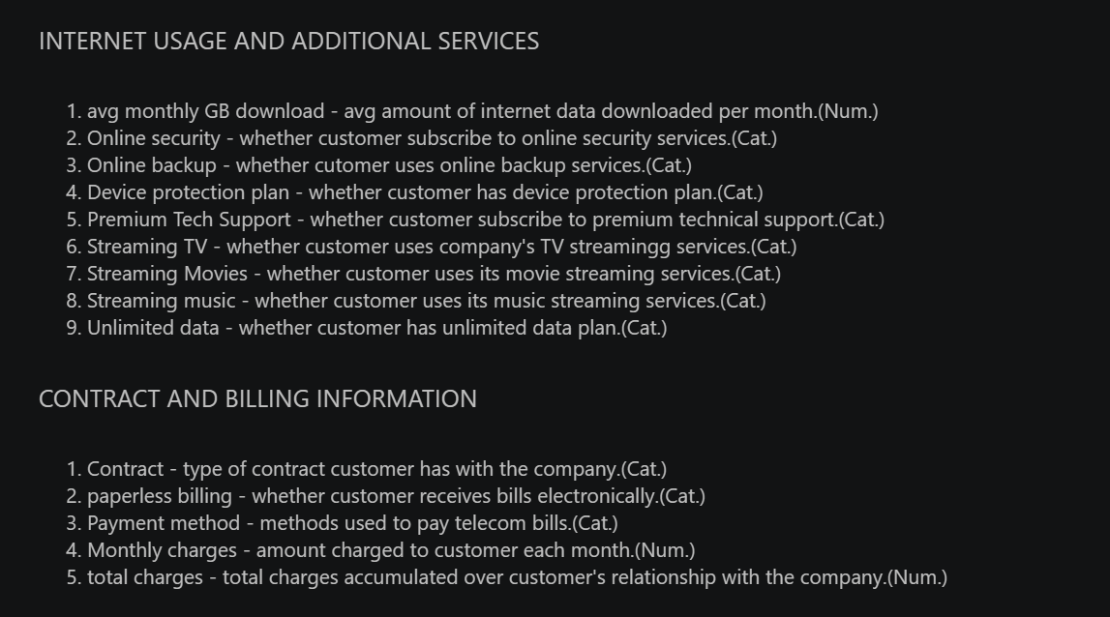
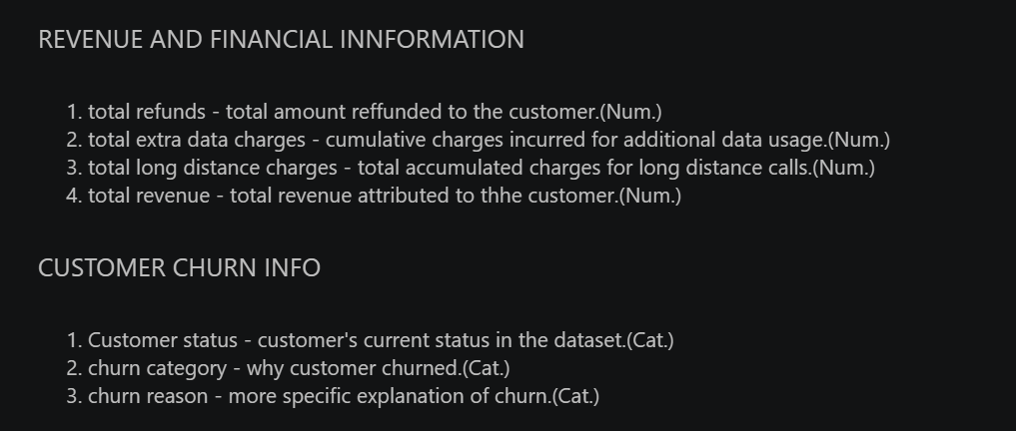
The target variable is Customer Status, renamed Churn during preprocessing. It has three classes: Stayed (4,720 customers), Churned (1,869) and Joined (454, customers who joined during the quarter).

Tools and Libraries Used
Tool | Purpose in this project
Python / Jupyter Notebook | Interactive environment used to run and document the analysis (Week01.ipynb).
pandas | Loading the CSV, inspection (info, describe, nunique), missing value handling, grouping and cross-tabulation.
NumPy | Numerical support for pandas operations.
Matplotlib | Base plotting: bar charts, figure formatting and saving images.
Seaborn | Statistical charts: count plot, histogram with density curve, box plot and correlation heatmap.

Initial Data Inspection

Shape and data types
At the time of inspection the working DataFrame had 7,043 rows and 37 columns: 15 numeric columns (6 integer and 9 float) and 22 text columns, including the customer identifier. Customer ID is unique for all 7,043 rows, so each row represents one customer. The numeric columns were correctly stored as numbers, so no type conversion was required.

Summary statistics
Variable | Count | Mean | Min | Median | Max
Age | 7,043 | 46.5 | 19 | 46 | 80
Number of Dependents | 7,043 | 0.47 | 0 | 0 | 9
Number of Referrals | 7,043 | 1.95 | 0 | 0 | 11
Tenure in Months | 7,043 | 32.4 | 1 | 29 | 72
Avg Monthly Long Distance Charges | 6,361 | 25.42 | 1.01 | 25.69 | 49.99
Avg Monthly GB Download | 5,517 | 26.19 | 2 | 21 | 85
Monthly Charge | 7,043 | 63.60 | -10.00 | 70.05 | 118.75
Total Charges | 7,043 | 2,280.38 | 18.80 | 1,394.55 | 8,684.80
Total Revenue | 7,043 | 3,034.38 | 21.36 | 2,108.64 | 11,979.34

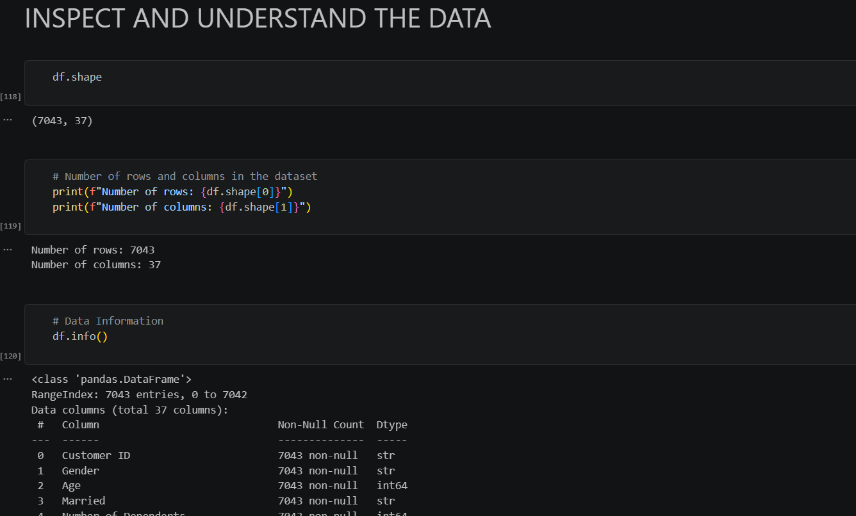
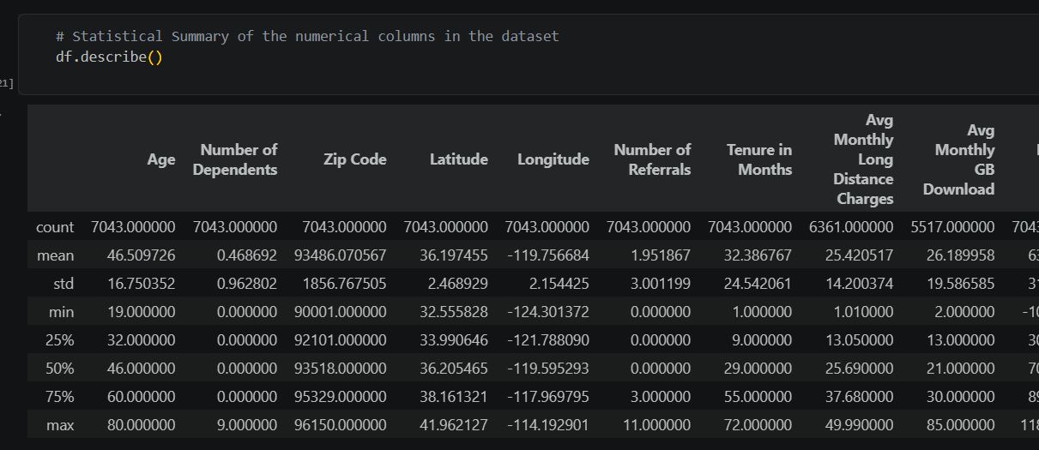
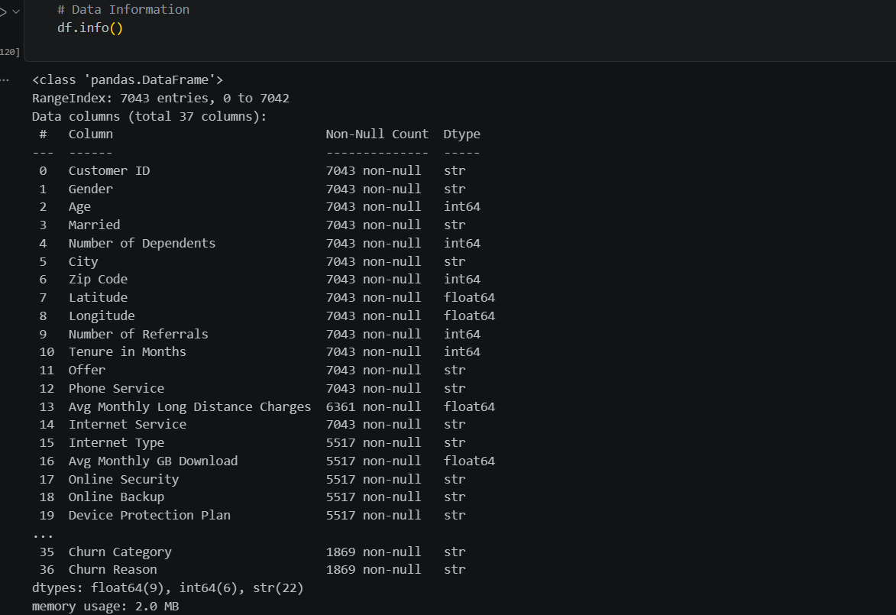
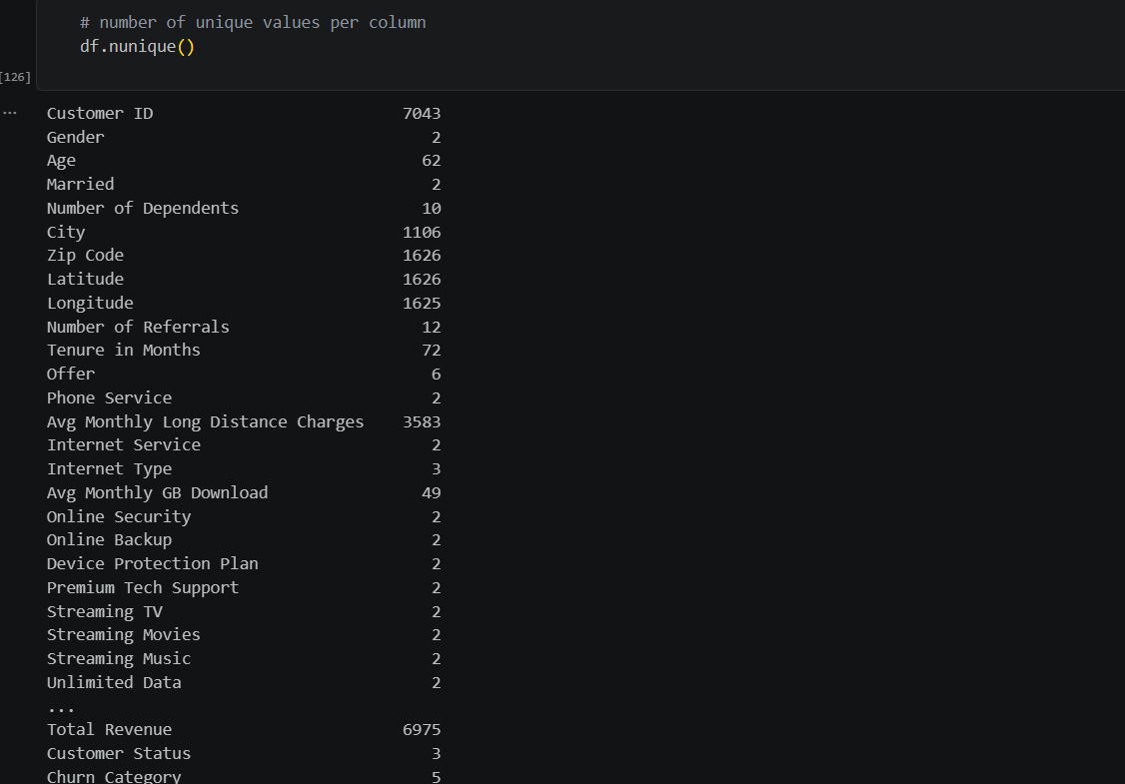
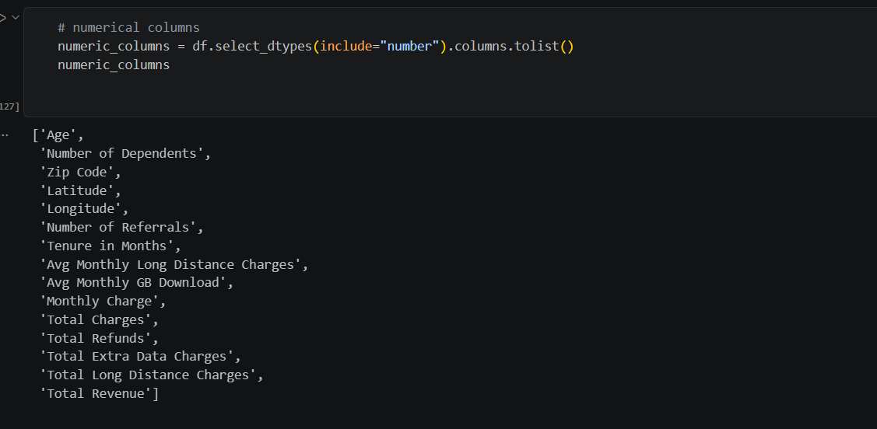
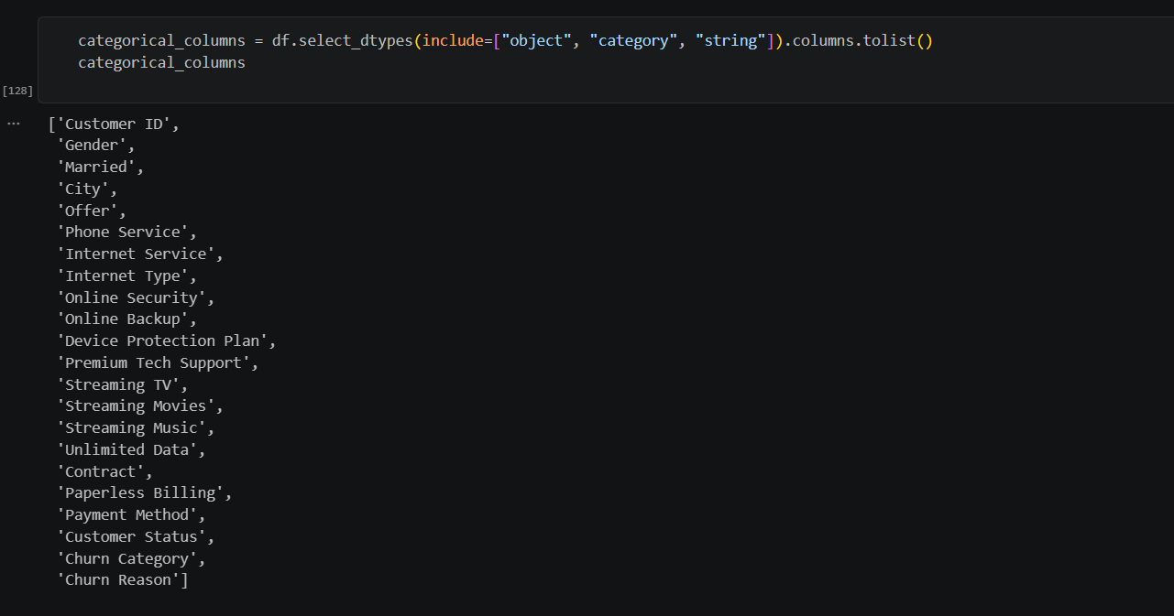

Two observations stand out. First, the count column shows that Avg Monthly Long Distance Charges and Avg Monthly GB Download are incomplete. Second, Monthly Charge has a minimum of -10.00, which is not a plausible price for a monthly service and is examined in Section 7.

Missing values
Column(s) | Missing | Share of rows | Likely cause
Churn Category, Churn Reason | 5,174 | 73.46% | Customer did not churn
Offer | 3,877 | 55.05% | Customer has no promotional offer
Internet Type, Avg Monthly GB Download, Online Security, Online Backup, Device Protection Plan, Premium Tech Support, Streaming TV, Streaming Movies, Streaming Music, Unlimited Data | 1,526 each | 21.67% | No internet service
Avg Monthly Long Distance Charges, Multiple Lines | 682 each | 9.68% | No phone service

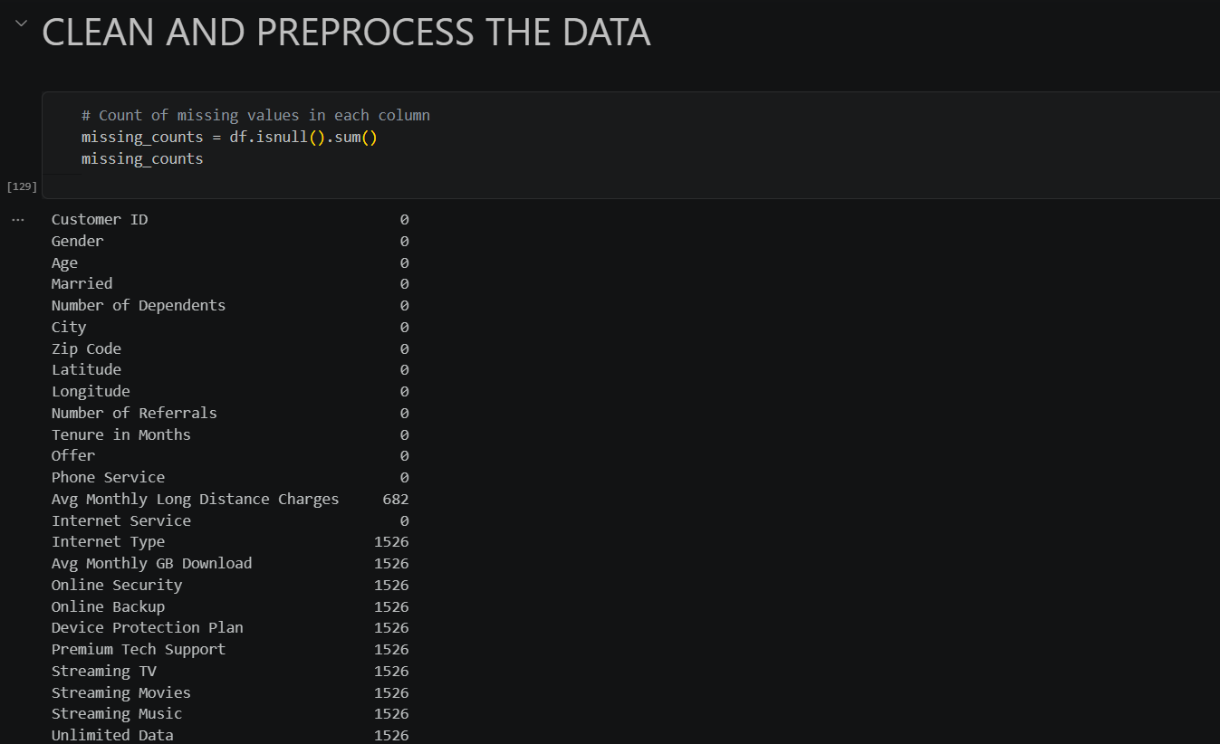
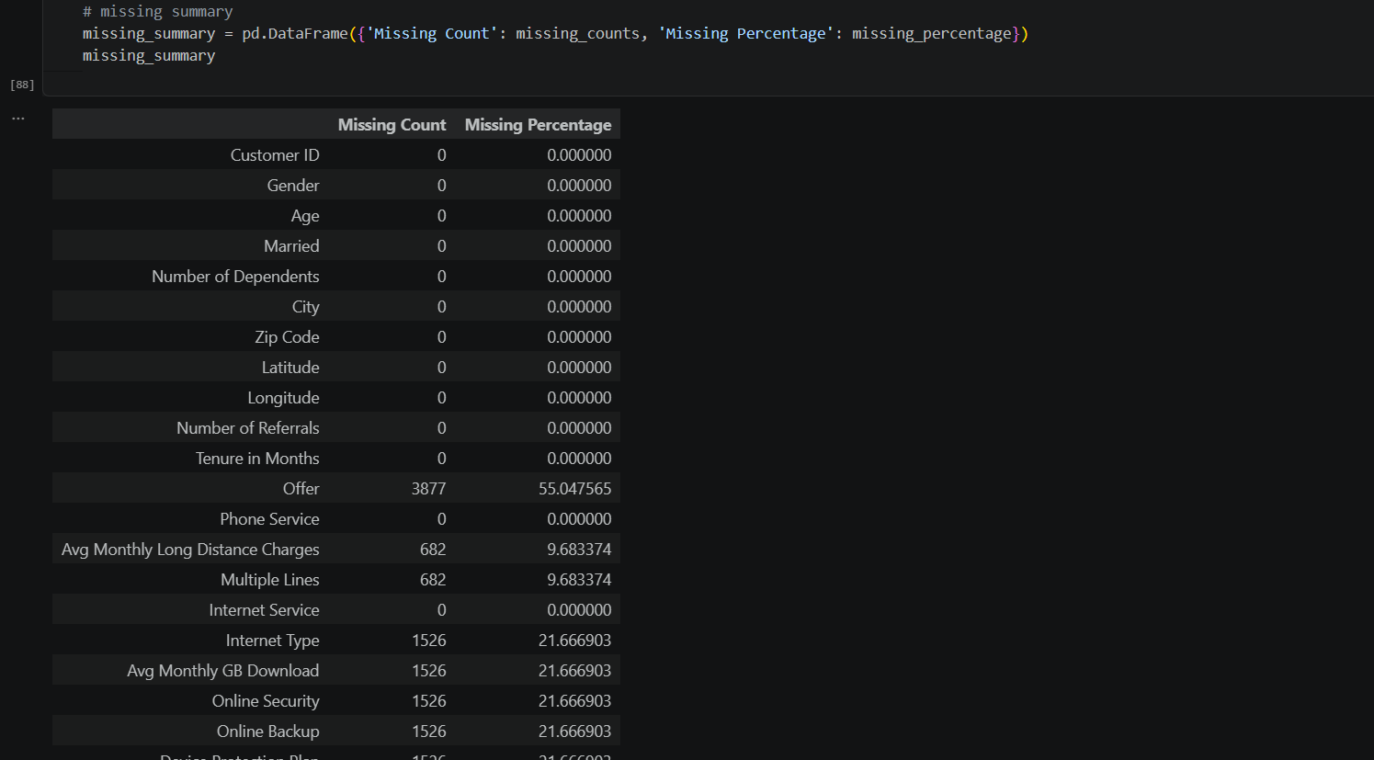
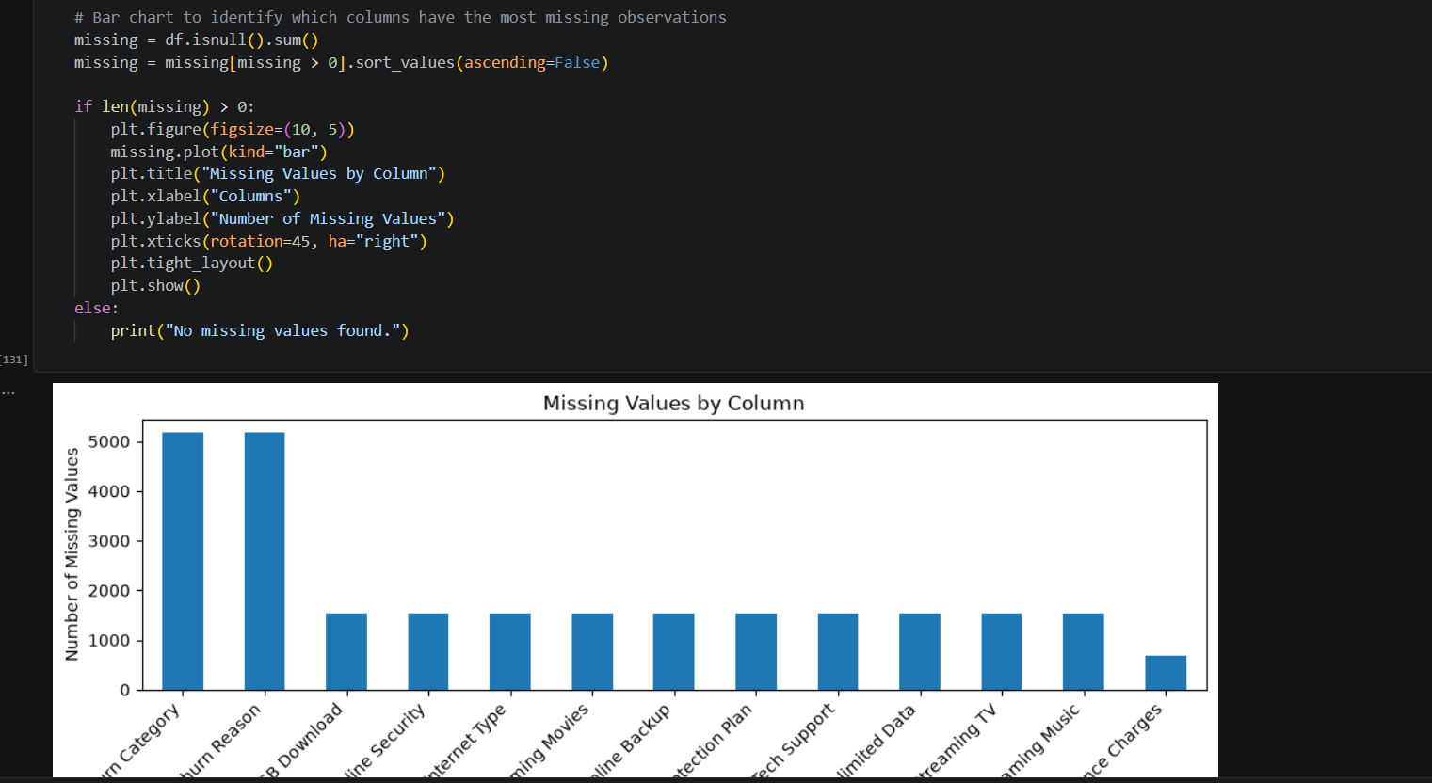
The causes were confirmed against the cleaned file: all 1,526 customers with Internet Service = No have blank internet-related fields, and all 682 customers with Phone Service = No have no long distance average. The missing values are therefore structural rather than random data-entry gaps.
Churn Category and Churn Reason have the most gaps, about 5,174 each (73.5%), followed by ten internet-related columns with 1,526 each (21.7%). Avg Monthly Long Distance Charges has the fewest at 682 (9.7%). The identical counts across the internet columns show that these gaps appear together, which points to one shared cause rather than random omissions.

Duplicates and target distribution
No duplicate rows were found (0 of 7,043). The target column holds Stayed 67.02%, Churned 26.54% and Joined 6.45%.
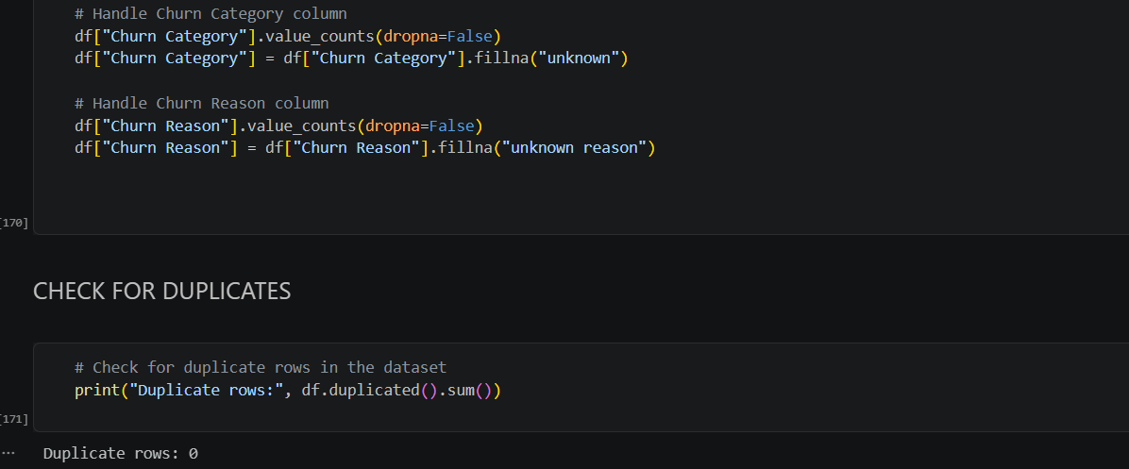

Data Cleaning and Preprocessing
Every step performed in the notebook is listed below with the issue found, the action taken and the reason. Steps 9 and 10 describe issues that were identified but intentionally or unintentionally left untreated, so that the record is complete.
Step 1: Rename the target column
Issue found | The target column was named Customer Status, which does not state its purpose and is inconsistent with the project goal of studying churn.
Action taken | Renamed Customer Status to Churn using df.rename().
Reason | A clear target name makes later analysis, charts and modelling code easier to read.
Step 2: Fill missing Offer values
Issue found | 3,877 records (55.05%) had a blank Offer.
Action taken | Replaced the blanks with the label “No Offer”.
Reason | A blank here means the customer holds no promotion, so it is information rather than missing data. Labelling it keeps all 3,877 customers and creates a usable category. After filling, Offer has six values: No Offer, and Offers A to E.
Step 3: Remove the Multiple Lines column
Issue found | Multiple Lines had 682 missing values (9.68%). The same 682 customers have Phone Service = No.
Action taken | The column is not present in the final working DataFrame or in the cleaned CSV, although it appears in the earlier missing-value summary (the 38-column source versus 37 columns at inspection).
Reason | The value is undefined for customers without a phone line, and it is not needed for the churn analysis. Removing it avoids creating false values.
Step 4: Fill missing Internet Type with the most frequent value
Issue found | 1,526 records (21.67%) had a blank Internet Type. All of them are customers with Internet Service = No.
Action taken | Filled the blanks with the mode of the column, which is Fiber Optic.
Reason | Imputing with the mode keeps every row and gives a complete categorical column for modelling. Caveat: because these customers have no internet at all, this step mislabels them. Fiber Optic rises from 3,035 true users to 4,561 in the cleaned file, and a more accurate label such as “None” is recommended (see Section 11).
Step 5: Fill missing Online Security with the most frequent value
Issue found | 1,526 records (21.67%) had a blank Online Security, again customers with no internet service.
Action taken | Filled the blanks with the mode of the column, which is “No”.
Reason | A customer without internet cannot hold online security, so “No” is also the logically correct value. Online Security then has 5,024 “No” and 2,019 “Yes” entries.
Step 6: Remove six internet add-on service columns
Issue found | Device Protection Plan, Premium Tech Support, Streaming TV, Streaming Movies, Streaming Music and Unlimited Data each had 1,526 missing values (21.67%).
Action taken | Dropped the six columns. They are absent from the final DataFrame and from the cleaned CSV, reducing the file to 31 columns.
Reason | Their missingness is tied to the absence of internet service, and filling over one fifth of each column would invent values. The notebook keeps Online Security and Online Backup as representative service indicators.
Step 7: Restore and fill Churn Category and Churn Reason
Issue found | 5,174 records (73.46%) had blank Churn Category and Churn Reason. These are the customers who did not churn (Stayed or Joined).
Action taken | Re-copied both columns from the untouched original DataFrame (df1), then filled blanks with “unknown” in Churn Category and “unknown reason” in Churn Reason.
Reason | A reason cannot exist for a customer who did not leave. Explicit labels remove nulls without discarding rows, and they allow the 1,869 genuine churn reasons to be isolated (Churn = Churned) in analysis.
Step 8: Check for duplicate records
Issue found | Duplicate customer rows would inflate counts and bias churn rates.
Action taken | Ran df.duplicated().sum(), which returned 0. No rows were removed.
Reason | Confirming uniqueness validates the one-row-per-customer assumption. Customer ID is also unique across all 7,043 rows.
Step 9: Leave three columns with structural missing values
Issue found | After the steps above, Avg Monthly Long Distance Charges (682 missing), Avg Monthly GB Download (1,526) and Online Backup (1,526) still contain blanks.
Action taken | No imputation or deletion was applied.
Reason | Long distance and download figures are undefined for customers with no phone or internet service, and imputing them would create fabricated usage. Online Backup is the same case as Online Security, so leaving it blank is inconsistent with Step 5 and should be harmonised in the next iteration.
Step 10: Flag negative Monthly Charge values
Issue found | Monthly Charge contains 120 negative values between -10 and -1, in 61 month-to-month, 30 one-year and 29 two-year contracts. Of these customers, 84 Stayed, 30 Churned and 6 Joined.
Action taken | No correction was applied in the notebook. The issue is documented here and the values are retained in the cleaned file.
Reason | Negative amounts could be billing credits or data-entry errors, and the data alone cannot decide which. Silently changing them would hide a real quality issue, so they are flagged for confirmation with the data owner (see Section 11).

Summary of the outcome: the cleaned dataset keeps all 7,043 customers, has 31 columns, contains no duplicates, and has missing values only in the three structurally empty columns listed in Step 9.
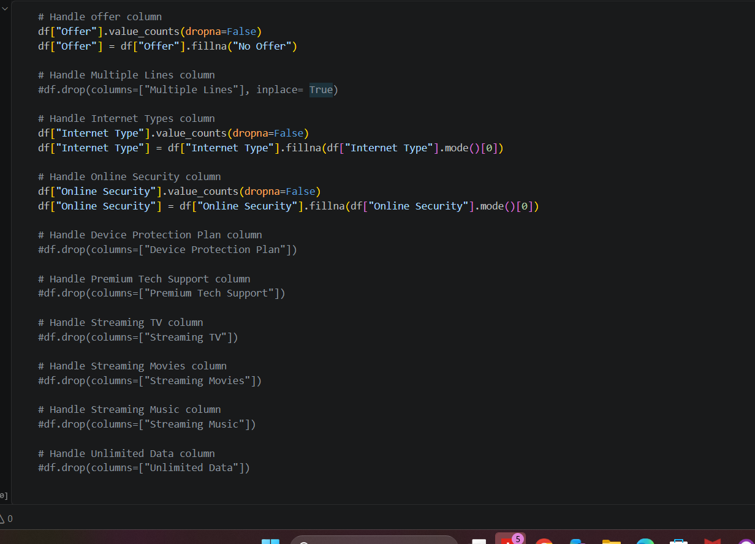
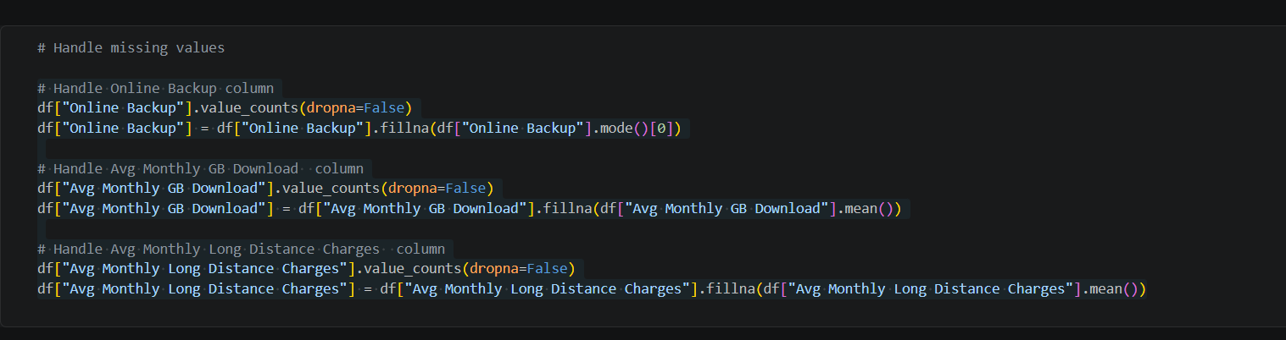

Exploratory Data Analysis

Churn distribution
Customer status | Customers | Share | Notes
Stayed | 4,720 | 67.02% | Existing customers retained
Churned | 1,869 | 26.54% | Left during the quarter
Joined | 454 | 6.45% | New customers this quarter

Because the Joined group could not have churned before the quarter began, the churn rate among customers who were present at the start (Stayed plus Churned) is 28.4% (1,869 of 6,589).

Customer profile by status
Measure (mean) | Stayed | Churned | Joined
Tenure in months | 41.0 | 18.0 | 1.7
Monthly Charge | 61.74 | 73.35 | 42.78
Number of Referrals | 2.61 | 0.52 | 0.95
Age | 45.6 | 49.7 | 42.9
Total Revenue | 3,735.68 | 1,971.35 | 119.56

Churned customers have roughly half the tenure of those who stayed, pay about 11.6 more per month on average, and have referred far fewer people. They are also slightly older on average.

Churn by contract type
Contract | Churned | Joined | Stayed
Month-to-Month | 45.84% | 11.30% | 42.85%
One Year | 10.71% | 1.55% | 87.74%
Two Year | 2.55% | 1.17% | 96.28%

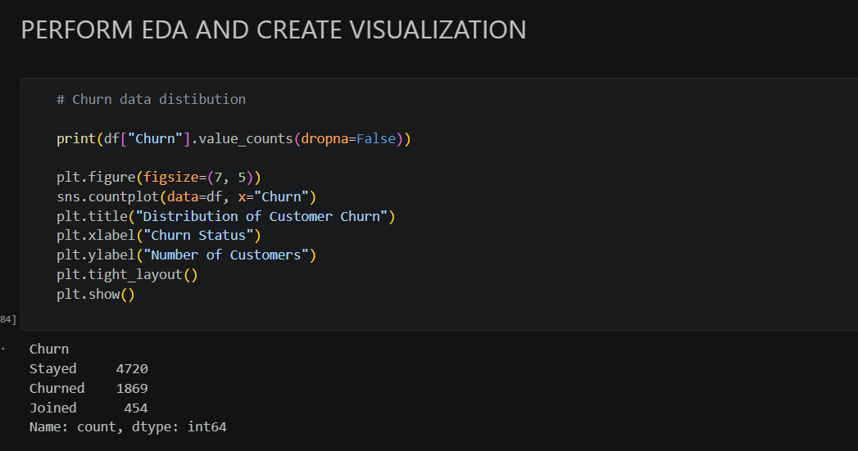

Additional checks computed for this report
The following churn rates were calculated from the cleaned file, excluding the Joined group, and were not part of the original notebook:
- Internet service: 33.5% of customers with internet churned, against 8.4% of those without.
- Payment method: mailed check 41.4%, bank withdrawal 35.6% and credit card 15.8%.
- Paperless billing: 35.2% for paperless customers against 17.9% for others.
- Offer: Offer E shows 67.6% churn, against 6.7% for Offer A, 12.3% for Offer B, 22.9% for Offer C, 26.7% for Offer D and 29.2% for customers with no offer.

Why customers churn
Among the 1,869 churned customers, the Churn Category field attributes 841 (45.0%) to competitors, 321 (17.2%) to dissatisfaction, 314 (16.8%) to attitude of staff or provider, 211 (11.3%) to price and 182 (9.7%) to other reasons. The most frequent specific reasons are “Competitor had better devices” (313) and “Competitor made better offer” (311), followed by “Attitude of support person” (220).

Visualizations and Interpretation
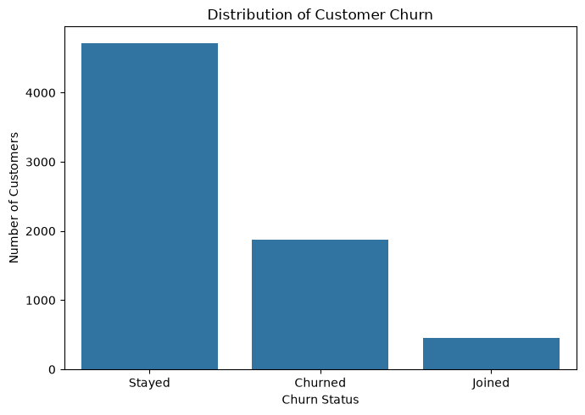
Figure 2: Distribution of customer churn status
Of the 7,043 customers, 4,720 stayed (67.0%), 1,869 churned (26.5%) and 454 joined (6.5%). Roughly one in four customers left during the quarter, so the target is imbalanced but still has a substantial churn class for analysis.
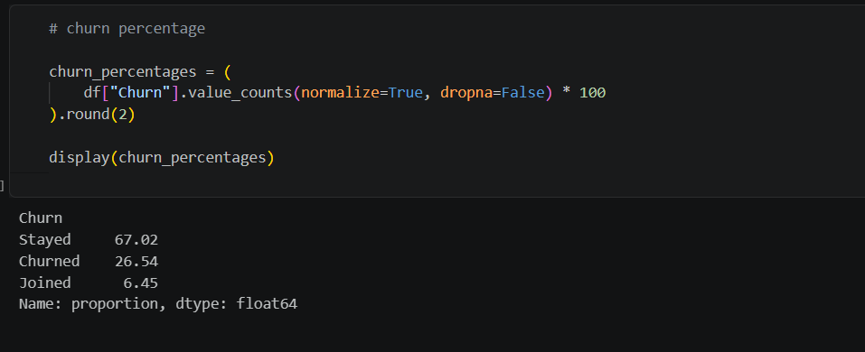

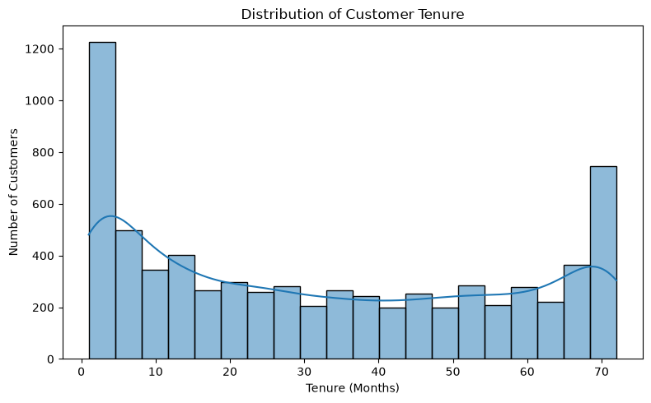
Figure 3: Distribution of customer tenure (months)
Tenure has a U-shape: about 1,200 customers fall in the first bin (under roughly 4 months) and about 750 in the last bin (around 70 months), while the middle bins hold about 200 to 300 each. This shows a large group of very new customers and a loyal long-term base, with the mean tenure of 32.4 months sitting between them.

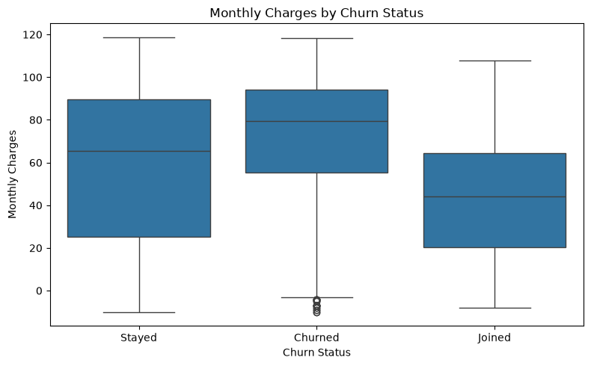
Figure 4: Monthly charges by churn status
Churned customers have the highest median monthly charge, about 79.5, compared with about 65.6 for those who stayed and about 44 for those who joined. The churned box is also tighter at the top, with half of those customers paying between roughly 55 and 94. A cluster of negative outliers near -10 to -4 appears in the churned group, which reflects the data-quality issue in Step 10.

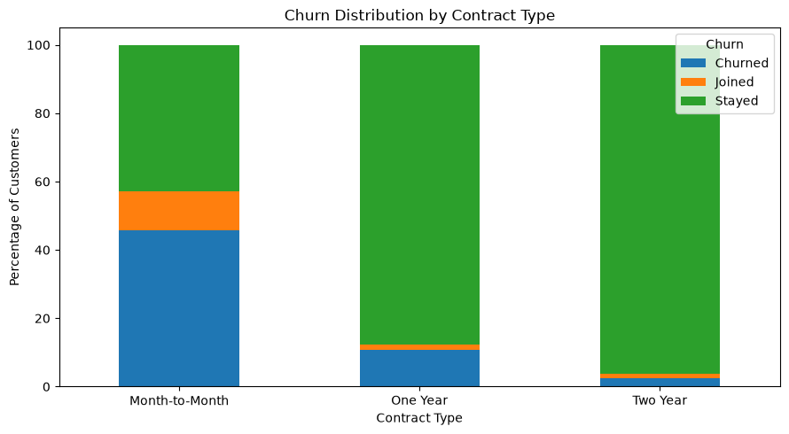
Figure 5: Churn distribution by contract type (percentage of customers)
Month-to-month customers churn at 45.8%, against 10.7% on one-year and 2.6% on two-year contracts. Month-to-month also has the highest share of new joiners (11.3%). Longer contracts are strongly associated with retention.

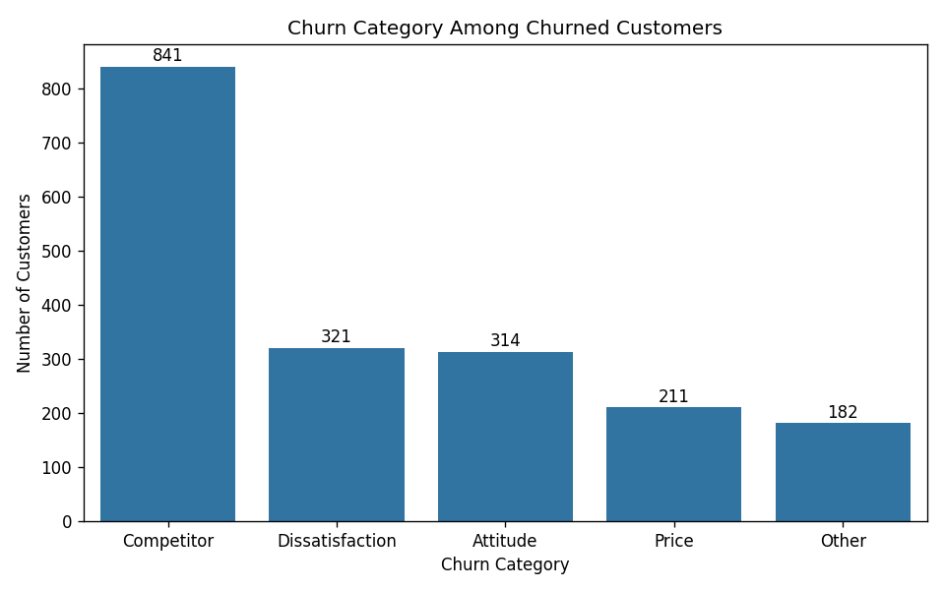
Figure 6: Churn category among churned customers
Competitor-related reasons dominate with 841 of 1,869 churned customers (45.0%), followed by dissatisfaction (321), attitude (314), price (211) and other (182). Reasons tied to service quality and support (dissatisfaction and attitude) together account for about 34% of churn, so they are a second major lever beyond competitive pricing.

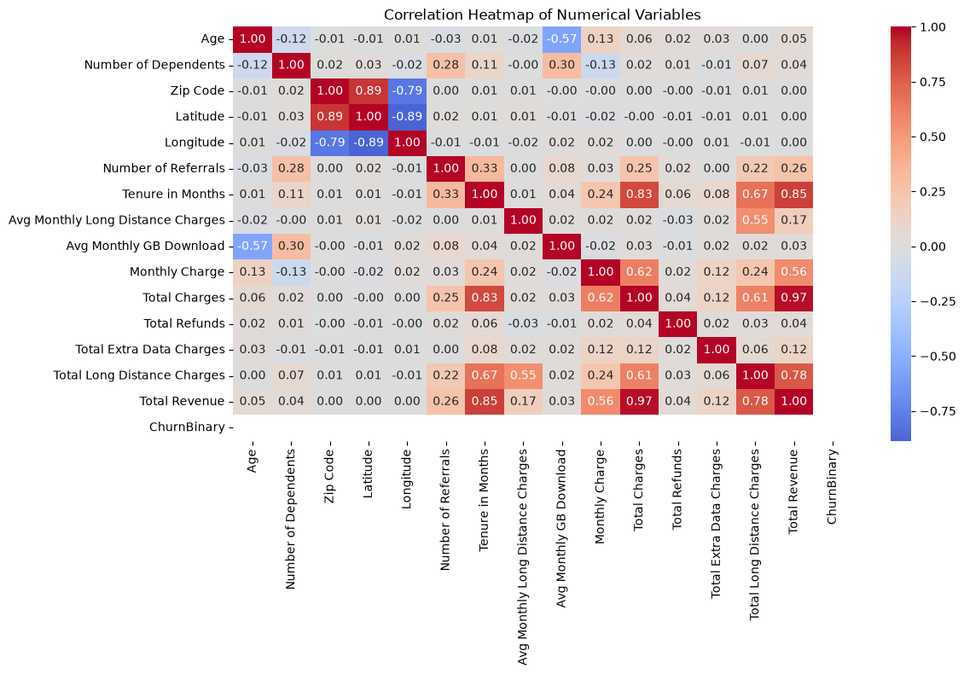
Figure 7: Correlation heatmap of numerical variables
The strongest relationships are between Total Charges and Total Revenue (0.97), Tenure and Total Revenue (0.85), and Tenure and Total Charges (0.83), which is expected because revenue accumulates over time. Zip Code, Latitude and Longitude are strongly related (0.89 and -0.89) because they describe location, and Age is negatively related to Avg Monthly GB Download (-0.57). The ChurnBinary row is empty because the mapping used the keys “No” and “Yes”, which do not exist in the Churn column, so no churn correlation is shown.

Key Insights
- Contract type is the strongest churn signal. Month-to-month customers churn at 45.8%, about 18 times the rate of two-year customers (2.6%).
- Churn happens early. The median tenure of churned customers is 10 months and 25% of them leave within 2 months, while customers who stayed have a median tenure of 42 months.
- Higher bills accompany churn. Churned customers pay about 73 per month on average against about 62 for retained customers.
- Competition is the main stated reason. Competitors account for 45% of churn, mainly through better devices and better offers, while price itself is only 11%.
- Referrals appear linked to loyalty. Retained customers average 2.61 referrals, against 0.52 for churned customers.
- Some segments need attention. Customers on Offer E (67.6% churn), customers paying by mailed check (41.4%) and customers with internet service (33.5%) churn at well above the 28.4% average.
- Revenue at stake. Churned customers generated about 3.68 million of the 21.37 million total revenue in the file (17.2%).
These findings describe associations in a single quarter and should not be read as proof of cause.

Conclusion
This project took a 7,043-customer telecom dataset from raw file to a cleaned, analysed table. Missing values were found to be mostly structural, linked to absent phone or internet service and to customers who did not churn, and they were handled by labelling, imputing or removing columns, with each step documented. The cleaned file has no duplicates and keeps all customers.
The exploratory analysis shows that 26.5% of customers churned and that contract type, tenure and monthly charge are strongly associated with leaving: month-to-month, short-tenure and higher-paying customers are the most likely to go, and competitors are the most common stated reason. Several data-quality issues, especially the negative charges and the Fiber Optic imputation, should be resolved before predictive modelling begins.

