Understanding Customer Churn in a Telecom Company
Advanced Data Visualization and Storytelling: Week 02 Report

Introduction and Problem Statement
Customer churn, the loss of customers who stop using a service, is one of the most expensive problems a telecom provider faces. Winning a new subscriber usually costs more than keeping an existing one, so understanding who leaves, when they leave and why is a direct route to protecting revenue.
This report analyses a telecom customer dataset to answer one central question: which customers are most likely to churn, and what do the data suggest the company should do about it? The analysis is built around five visualizations that move from the shape of the customer base, to the contract and pricing patterns tied to churn, to the revenue at stake and the reasons customers give for leaving.
The specific sub-questions addressed are:
- How long do customers typically stay with the company?
- How strongly does contract type relate to churn?
- Do churned customers pay more or less than customers who stayed?
- How much recorded revenue is associated with churned customers, and in which contract segment?
- What reasons do churned customers give for leaving?

Dataset Description
The data come from a cleaned telecom customer file (telecom_churn_cleaned.csv) with one row per customer. It contains 7,043 customers and 31 columns, with no duplicated customer identifiers (all 7,043 Customer ID values are unique). The columns fall into five groups:
Group | Example columns
Demographics | Gender, Age, Married, Number of Dependents
Location | City, Zip Code, Latitude, Longitude
Account and services | Tenure in Months, Offer, Contract, Phone Service, Internet Service, Internet Type, Online Security, Online Backup, Number of Referrals
Billing and revenue | Monthly Charge, Total Charges, Total Refunds, Total Extra Data Charges, Total Long Distance Charges, Total Revenue, Payment Method, Paperless Billing
Outcome | Churn, Churn Category, Churn Reason

The target variable, Churn, has three values: 4,720 customers Stayed, 1,869 Churned and the remaining 454 Joined during the period. Churned customers therefore make up about 26.5% of the whole base. Churn Category and Churn Reason are only meaningful for churned customers; for everyone else they hold the placeholder values “unknown” (5,174 rows).
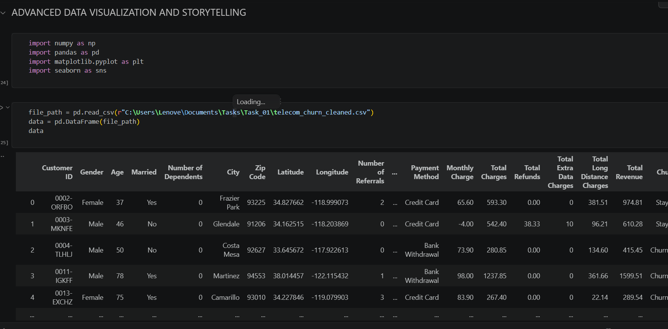
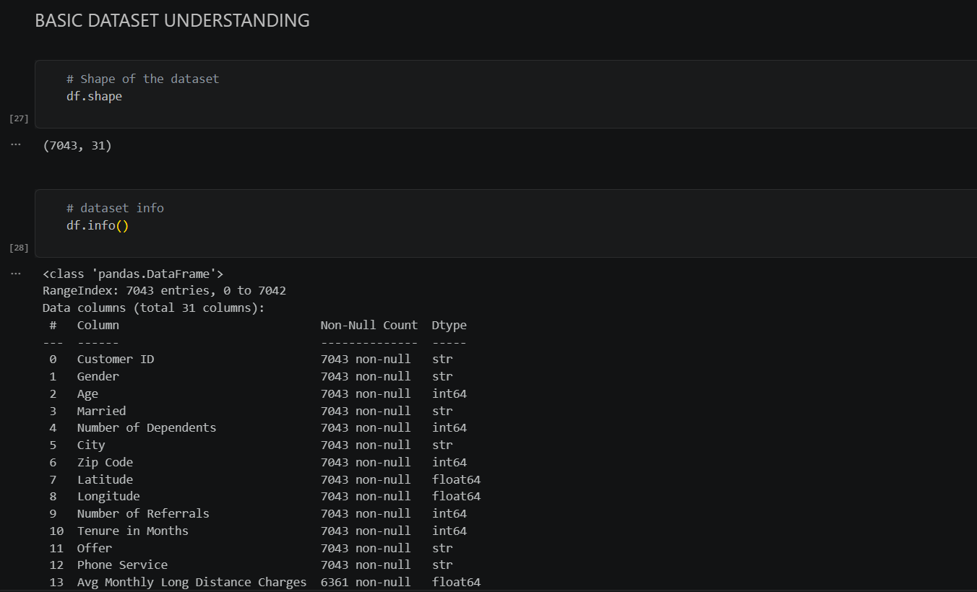
Selected summary statistics for the numerical fields are shown below.
Variable | Mean | Median | Min | Max
Age (years) | 46.5 | 46 | 19 | 80
Tenure in Months | 32.4 | 29 | 1 | 72
Monthly Charge | 63.60 | 70.05 | -10.00 | 118.75
Avg Monthly GB Download | 26.2 | 21 | 2 | 85
Avg Monthly Long Distance Charges | 25.42 | 25.69 | 1.01 | 49.99

Methodology and Preprocessing
The analysis was carried out in Python using pandas for data handling and matplotlib and seaborn for visualization. The workflow had three stages.

Initial data understanding
The dataset’s shape, data types, descriptive statistics (for numerical and categorical columns), first and last rows and missing-value counts were inspected before any plotting. This surfaced the missing values and the unusual negative Monthly Charge values discussed below.

Handling missing values
Three columns contained missing values:
Column | Missing | Treatment
Avg Monthly GB Download | 1,526 | Filled with the column mean
Online Backup | 1,526 | Filled with the most frequent value (mode)
Avg Monthly Long Distance Charges | 682 | Filled with the column mean

All other columns were complete. Imputation kept all 7,043 customers in the analysis rather than discarding about 22% of rows. The limitations section returns to why these particular gaps may carry meaning.
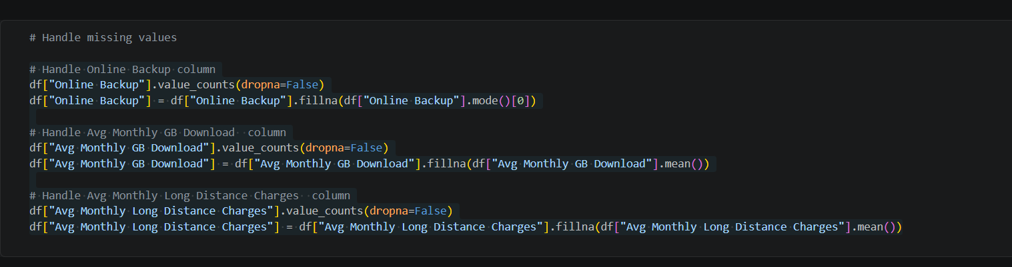

Visualization choices
Each chart type was chosen to suit the question it answers: a histogram with a density curve for the distribution of tenure, a 100% stacked bar for comparing churn proportions across contract types, a box plot for comparing price distributions across customer groups, a horizontal bar chart for revenue by segment, and a ranked count plot for churn reasons. Charts were exported at 300 dpi. The analysis also included a correlation heatmap of the numerical features; because it mainly confirmed expected relationships (for example, Total Charges and Total Revenue at 0.97, and tenure with accumulated revenue) and did not directly address churn, it was left out of the five figures below to keep the story focused.

Visualizations

Customer Tenure Distribution

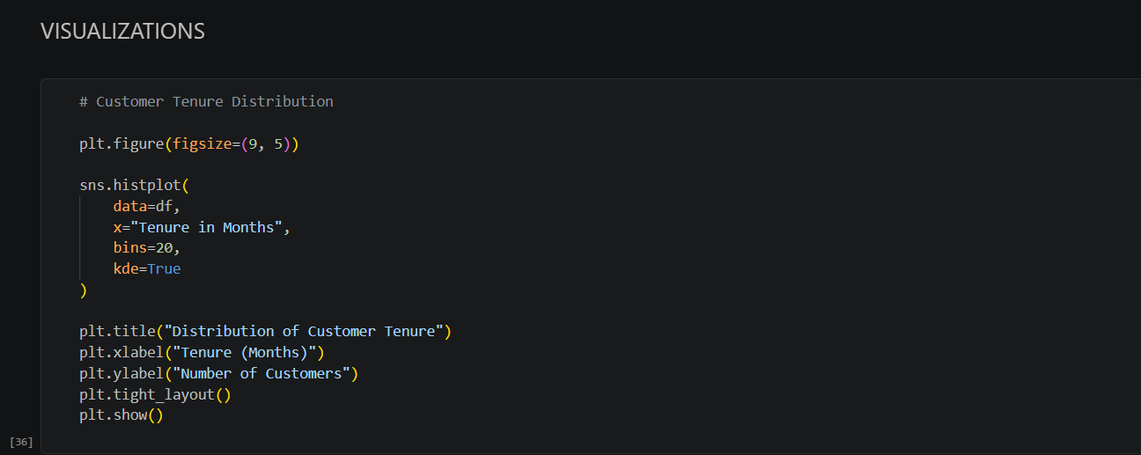
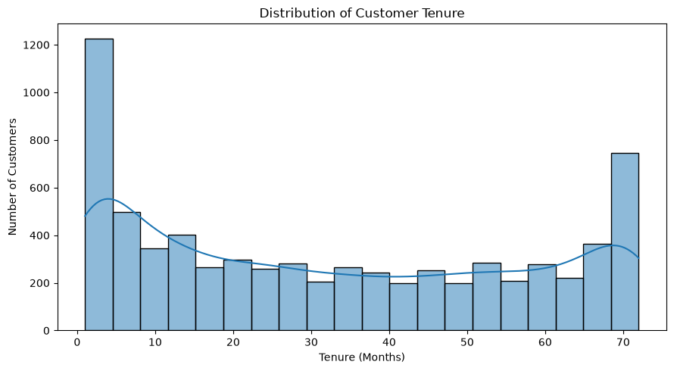
Figure 1. Distribution of customer tenure in months, shown as a histogram with a density (KDE) curve.
Explanation. The histogram shows how long customers have been with the company. Tenure is U-shaped rather than bell-shaped: roughly 1,200 customers sit in the first bin (under about 4 months) and roughly 750 in the last bin (around 70 months), while the middle bins hold only about 200 to 300 each. The mean tenure of 32.4 months falls in the sparse middle, so it describes very few actual customers.
Implication. The customer base is made of two distinct groups: a large wave of very new customers and a loyal long-term core. New customers are the group still deciding whether to stay, so the first months of the relationship are the critical window for retention efforts. Averages alone would hide this structure.

Churn Rate by Contract Type

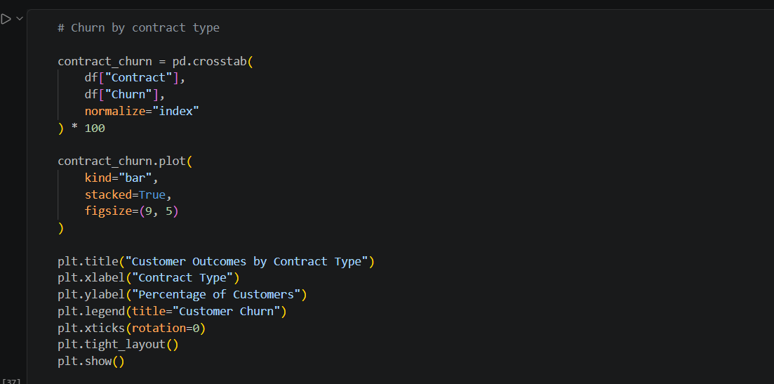
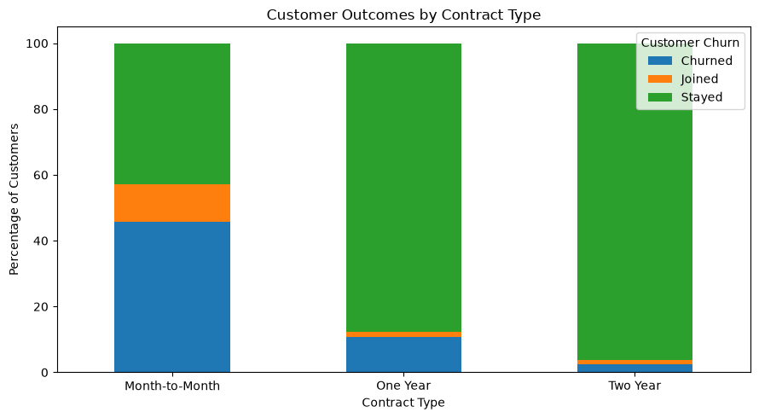
Figure 2. Share of customers in each outcome (Stayed, Churned, Joined) by contract type, shown as a 100% stacked bar.
Explanation. Month-to-month customers churned at 45.8%, compared with 10.7% for one-year contracts and 2.6% for two-year contracts. Month-to-month also has the highest share of new joiners (11.3%), so this contract type is both where customers arrive and where they leave. Churn falls sharply as the commitment period lengthens.
Implication. Contract type is the strongest single lever visible in the data. Moving month-to-month customers onto longer contracts, for example through discounts or bundled benefits, is likely to reduce churn. Because this is an association, it does not prove that contracts cause retention: customers who already intend to stay may simply choose longer terms.

Monthly Charges by Customer Status

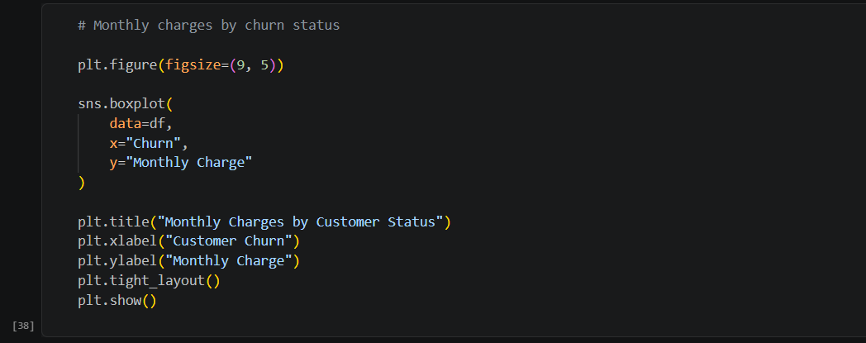
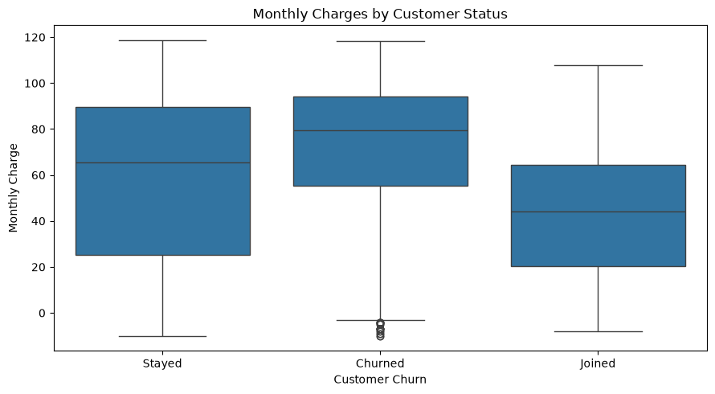
Figure 3. Box plot of Monthly Charge for customers who Churned, Joined and Stayed.
Explanation. Churned customers have the highest median monthly charge, about 79.5, compared with about 65.6 for those who stayed and about 44 for those who joined. Half of the churned customers pay between roughly 55 and 94. A cluster of negative values near -10 to -4 also appears in the churned group, which points to a data-quality problem in the Monthly Charge field (the minimum recorded value is -10.00).
Implication. Customers who leave tend to be paying more than those who remain, which suggests price sensitivity or a perception of poor value at higher price points. Pricing and plan design deserve attention, particularly for high-paying customers. The negative charges should be investigated and corrected before this field is used in any model or financial reporting.

Recorded Revenue of Churned Customers by Contract

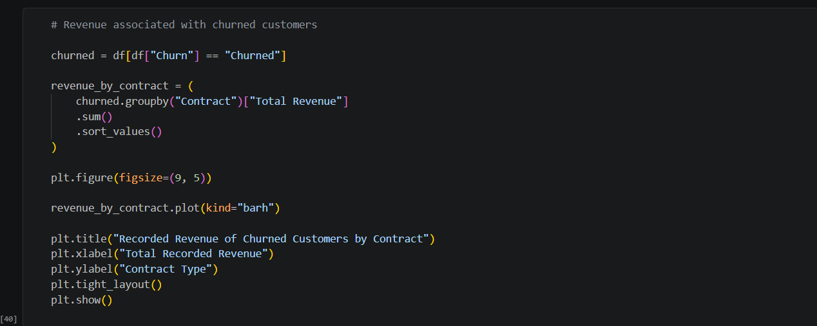
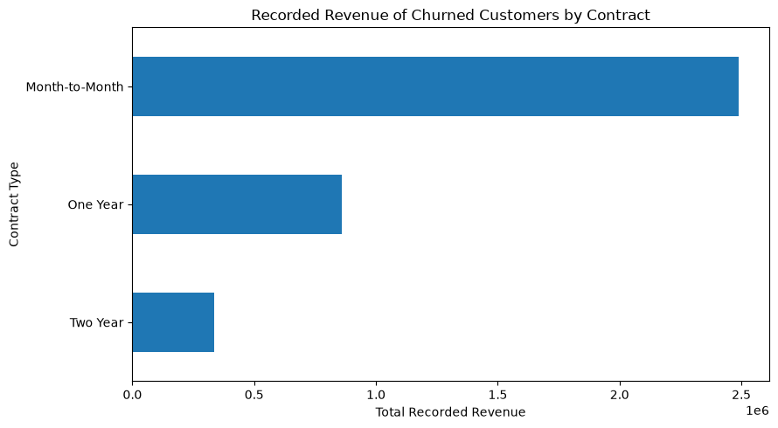
Figure 4. Total recorded revenue from churned customers, by contract type.
Explanation. Among churned customers, month-to-month accounts represent by far the largest pool of recorded revenue, at roughly 2.5 million, compared with roughly 0.9 million for one-year and 0.3 million for two-year contracts (values read from the chart). Month-to-month is therefore the largest segment in both the number of churned customers and the revenue they had generated.
Implication. The financial cost of churn is concentrated in the month-to-month segment, which strengthens the case for focusing retention budgets there. Note that this chart shows revenue already collected from customers who left; it does not measure the future revenue lost, which would require a lifetime-value estimate.

Churn Categories among Churned Customers

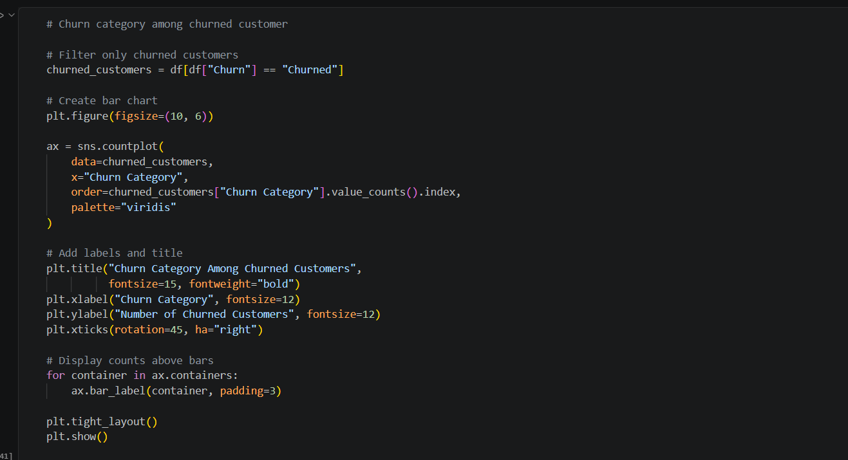
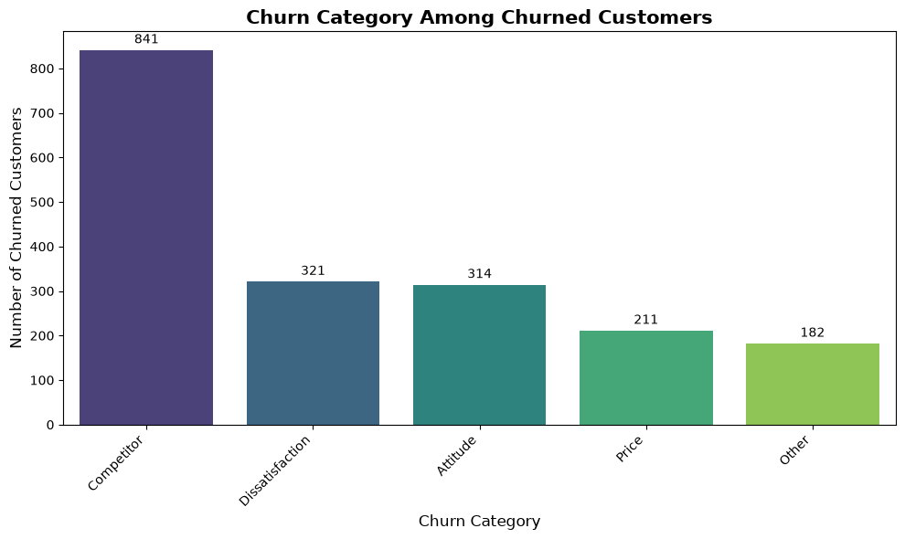
Figure 5. Number of churned customers by stated churn category, ranked from most to least common.
Explanation. Competitor-related reasons dominate, accounting for 841 of the 1,869 churned customers (45.0%). They are followed by dissatisfaction (321), attitude (314), price (211) and other reasons (182). Dissatisfaction and attitude together, which relate to service quality and support, explain about 34% of churn.
Implication. Nearly half of churn is a response to competing offers, so competitive benchmarking of devices, data and prices is essential. A further third is tied to service experience, which the company can control directly through support quality, staff conduct and product reliability. The two levers call for different teams and different fixes.

5. Overall Data Story and Key Findings
Taken together, the five figures tell a connected story. The customer base is split between a large group of newcomers and a loyal long-term core (Figure 1). Those newcomers are disproportionately on month-to-month contracts, which is where churn is highest, at 45.8% (Figure 2). Customers who leave tend to pay more than those who stay (Figure 3), and the month-to-month segment accounts for most of the revenue attached to departing customers (Figure 4). When asked why they left, close to half cite a competitor and a third cite service quality (Figure 5).
In short: churn is concentrated among newer, higher-paying, uncommitted customers who are drawn away by competitors or let down by service.
No. | Finding | Evidence
1 | Tenure is bimodal: many new customers and a loyal long-term base | Figure 1
2 | Month-to-month churn is 45.8% vs 10.7% (one year) and 2.6% (two year) | Figure 2
3 | Churned customers have the highest median monthly charge (about 79.5) | Figure 3
4 | Month-to-month churners hold the largest share of recorded revenue lost | Figure 4
5 | Competitors drive 45.0% of churn; service quality and support about 34% | Figure 5

6. Business Implications
The findings translate into practical actions for a telecom business:
- Convert month-to-month customers to longer contracts. Offer loyalty discounts, device upgrades or bundled services in exchange for a one- or two-year commitment, prioritising customers in their first months.
- Strengthen early-tenure engagement. Because new customers form a large and vulnerable group, onboarding calls, early-life check-ins and proactive support can reduce early exits.
- Review pricing for higher-paying customers. Ensure that plans above roughly the 80 mark deliver clear value, since this is where churn is most visible.
- Respond to competitors. Track competitor devices and offers and build targeted counter-offers for customers at risk of leaving.
- Fix service and support issues. Invest in support training and network reliability, because roughly a third of churn stems from service experience the company controls.
- Target retention budgets by revenue at risk. Focus first on the month-to-month segment, where both churn rate and revenue exposure are greatest.

7. Limitations and Conclusion

7.1 Limitations
- Associations, not causes. The charts show relationships between variables. They do not show that contract type, price or any other factor causes churn.
- Data quality in Monthly Charge. Negative monthly charges (minimum -10.00) are not plausible and affect the box plot and any statistics built on this field. They need to be investigated at the source.
- Imputation may distort the data. The missing counts line up with customers who lack a service: 6,361 customers have phone service (682 missing long-distance values) and 5,517 have internet service (1,526 missing download and backup values). These gaps are most likely “not applicable” rather than random, so filling them with a mean or mode can misrepresent those customers. A separate “no service” category would be more faithful.
- Churn reasons are partial. Reasons are recorded only for churned customers and are self-reported or categorised, so they may not capture the true underlying cause.
- Revenue is historical. Figure 4 reflects revenue already collected, not future revenue lost, and the currency is not stated in the data.
- Descriptive scope only. No predictive model or statistical significance testing was performed, and the analysis covers a single snapshot of customers.

7.2 Conclusion
The analysis shows that churn in this telecom customer base is not random. It clusters among customers on flexible month-to-month contracts, those paying higher monthly charges, and those who are relatively new, and it is driven mostly by competitor offers and service experience. The clearest opportunities are to secure longer commitments, improve the early customer experience, and close service gaps. Future work should correct the data-quality issues noted above, treat missing service values explicitly, and build a predictive churn model to identify at-risk customers before they leave.

