Hypothesis Testing on Telecom Customer Churn
Week 03 report

Introduction and Objectives
Statistical hypothesis testing is a formal procedure for deciding whether sample data provide enough evidence against a default claim, the null hypothesis (H0), in favour of an alternative claim (H1). A significance level (alpha) is fixed beforehand. The test produces a p-value: the probability of seeing data at least as extreme as observed if H0 were true. If p < alpha, H0 is rejected. A p-value alone does not say how large or important an effect is, so this report also gives effect sizes and confidence intervals.
Business relevance. In telecoms, winning a new customer usually costs far more than keeping one. Knowing which customer characteristics are linked to churn lets the business target retention offers, design contract incentives and set pricing with evidence rather than intuition.
Research questions
- Is the type of contract (Month-to-Month, One Year, Two Year) associated with customer churn status?
- Do customers who churned pay a different average monthly charge from customers who stayed?
Objectives
- Clean and prepare the customer dataset for inference.
- Test the association between contract type and churn with a chi-square test of independence.
- Compare mean monthly charges of churned and stayed customers with Welch's two-sample t-test.
- Report effect sizes and 95% confidence intervals, and translate the findings into business recommendations.

3. Dataset Description
Source and size. The file telecom_churn_cleaned.csv is a customer-level telecom churn dataset (California customers; the structure matches the public IBM Telco churn data). It has 7,043 records and 31 attributes, with one row per customer and a unique Customer ID.
Attributes used in this study
Attribute | Type | Role | Description
Contract | Categorical (3 levels) | Predictor, Test 1 | Month-to-Month (3,610), One Year (1,550), Two Year (1,883)
Churn | Categorical (3 levels) | Outcome, Tests 1 and 2 | Stayed (4,720), Churned (1,869), Joined (454)
Monthly Charge | Numeric | Outcome, Test 2 | Current monthly bill in dollars
Other attributes (demographics, location, tenure, services, billing, revenue, churn reason and category) were explored but not used in the tests.
Missing values. Only three columns had missing values:
Column | Missing | Likely cause
Avg Monthly Long Distance Charges | 682 | Customers with no phone service (7,043 - 6,361 = 682)
Avg Monthly GB Download | 1,526 | Customers with no internet service (7,043 - 5,517 = 1,526)
Online Backup | 1,526 | Customers with no internet service
The notebook filled these with the mean (numeric columns) or mode (Online Backup). The three variables are not used in either test, so the results are unaffected. The counts match the number of customers without the relevant service exactly, so these values are structurally missing (the service does not apply) rather than missing at random. In further work, a separate "No service" category or a value of 0 would be more faithful than mean or mode imputation.
Preprocessing
- Contract and Churn were converted to strings and stripped of whitespace.
- Monthly Charge was converted to numeric with invalid entries coerced to missing; rows missing Contract, Churn or Monthly Charge were dropped. None were lost, so all 7,043 rows remained.
- The Churn column was restored from the original data after the cleaning step.
- Data-quality flag: Monthly Charge has a minimum of -10.00, and one early record shows -4.00. Negative bills are not plausible and should be reviewed. The analysis below keeps them, as the notebook did, but they should be corrected or excluded in a final version.
- Design note: "Joined" customers (454) are new customers whose churn outcome is not yet observed. Test 1 follows the notebook and includes them; a sensitivity analysis .Test 2 compares only Churned and Stayed.

4. Hypotheses and Methodology
Test 1: Contract type and churn (chi-square test of independence)
- H0: Contract type and churn status are independent (no association).
- H1: Contract type and churn status are associated.
Test 2: Monthly charge by churn status (Welch's two-sample t-test)
- H0: The mean monthly charge of churned customers equals that of stayed customers (mu_churned = mu_stayed).
- H1: The two means differ (two-sided).
Significance level. alpha = 0.05 for both tests (95% confidence level).
Assumptions and checks
Test | Assumption | Check
Chi-square | Independent observations | One row per unique customer
Chi-square | Expected count of at least 5 in every cell | Smallest expected count is 99.9, so the assumption holds
Welch t-test | Independent groups | Different customers in each group
Welch t-test | Approximately normal means | Very large groups (n = 1,869 and 4,720), so the central limit theorem applies
Welch t-test | Equal variances | Not required; Welch's version is used
Test selection. Both variables in Test 1 are categorical, so the chi-square test of independence is appropriate. Test 2 compares the means of one numeric variable across two independent groups with possibly unequal spread, so Welch's t-test is used rather than Student's t-test.
Analytical steps
- Load, inspect and clean the data.
- Visualise the relationship (count plot, 100% stacked bar, histogram by group).
- Run each test and record the statistic, degrees of freedom and p-value.
- Compute effect sizes (Cramer's V; Cohen's d) and 95% confidence intervals.
- Interpret results and decide on H0.

Statistical Analysis and Visualizations
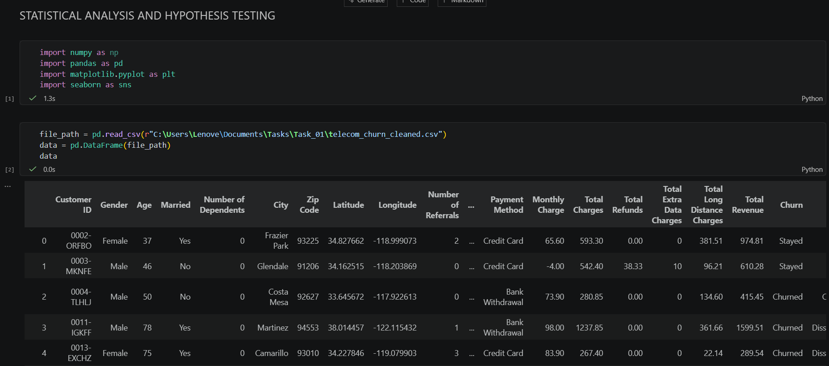
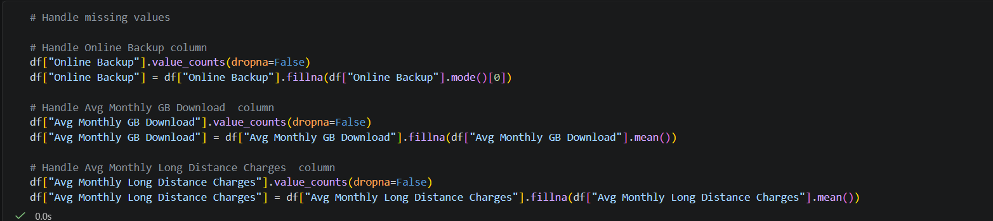
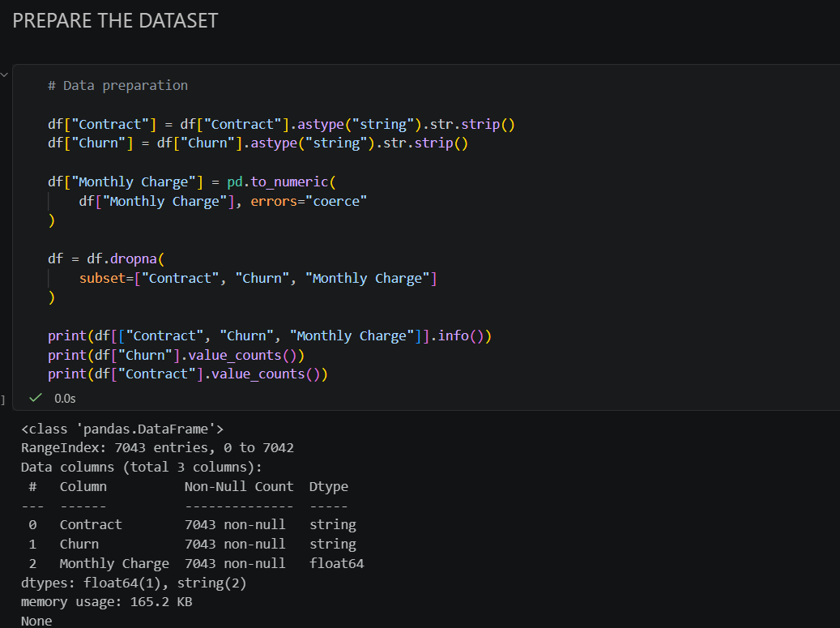

5.2 Test 1: Contract type vs churn
Contingency table (observed counts)
Contract | Churned | Joined | Stayed | Total
Month-to-Month | 1,655 | 408 | 1,547 | 3,610
One Year | 166 | 24 | 1,360 | 1,550
Two Year | 48 | 22 | 1,813 | 1,883
Total | 1,869 | 454 | 4,720 | 7,043
Expected counts under H0
Contract | Churned | Joined | Stayed
Month-to-Month | 958.0 | 232.7 | 2,419.3
One Year | 411.3 | 99.9 | 1,038.8
Two Year | 499.7 | 121.4 | 1,261.9
Results
Statistic | Value
Chi-square | 1,987.36
Degrees of freedom | 4
p-value | < 0.001 (printed as 0.0 by Python; below floating-point resolution)
Cramer's V (effect size) | 0.376 (medium to large)
Churn rate by contract (churned share of all customers on that contract)
Contract | Churn rate
Month-to-Month | 45.8% (1,655 / 3,610)
One Year | 10.7% (166 / 1,550)
Two Year | 2.5% (48 / 1,883)
Sensitivity analysis without "Joined" customers (Churned vs Stayed only, n = 6,589):

Statistic | Value
Chi-square | 1,695.69
Degrees of freedom | 2
p-value | < 0.001
Cramer's V | 0.507 (large)
Smallest expected count | 432.9

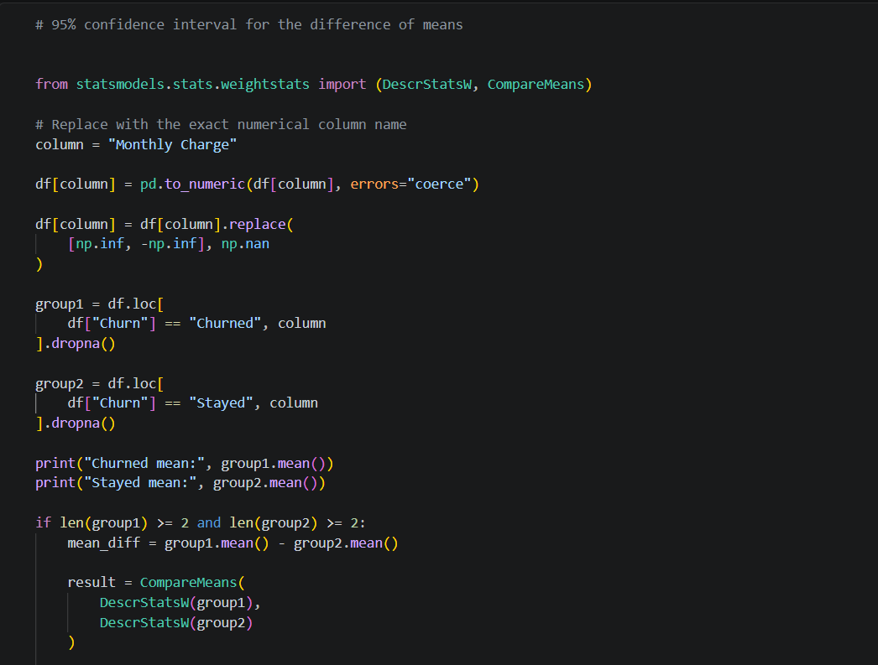
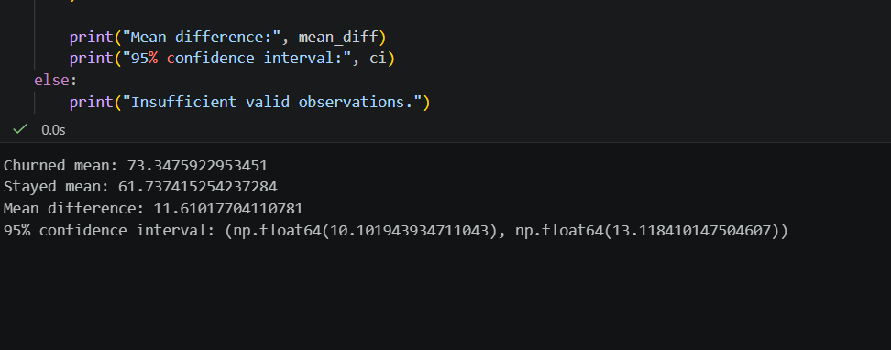
95% confidence intervals for churn proportion (excluding Joined, Wald method)
Contract | Churn proportion | 95% CI
Month-to-Month | 51.7% | 50.0% to 53.4%
One Year | 10.9% | 9.3% to 12.4%
Two Year | 2.6% | 1.9% to 3.3%

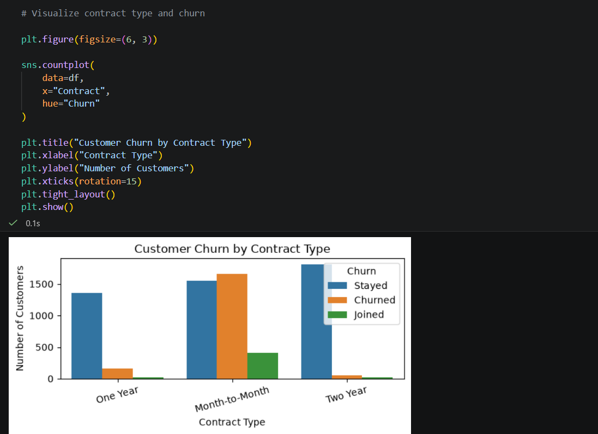
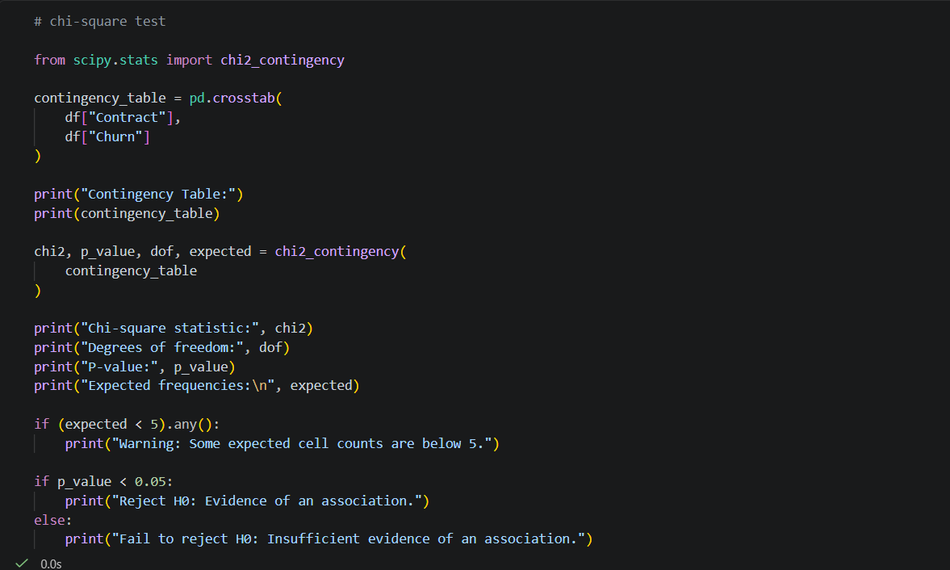
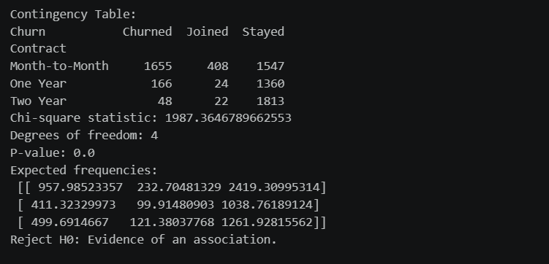
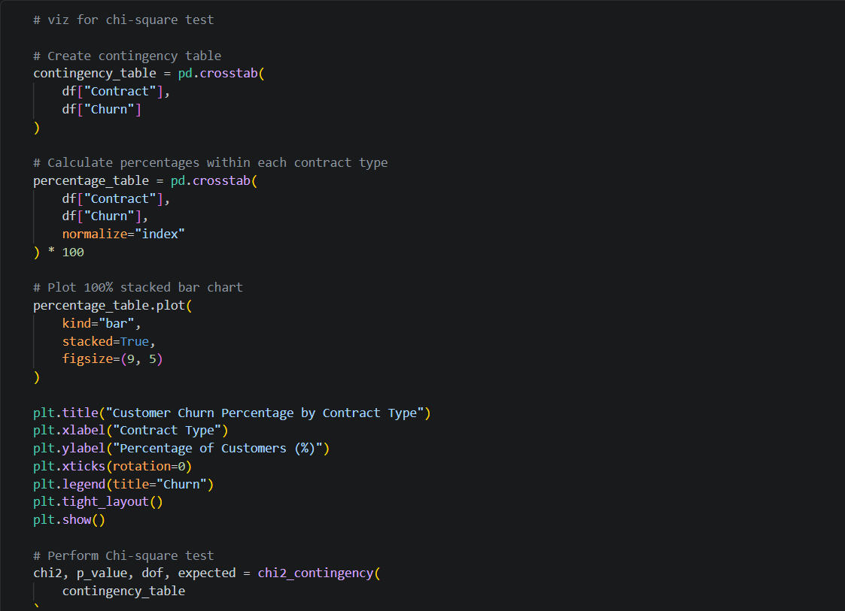
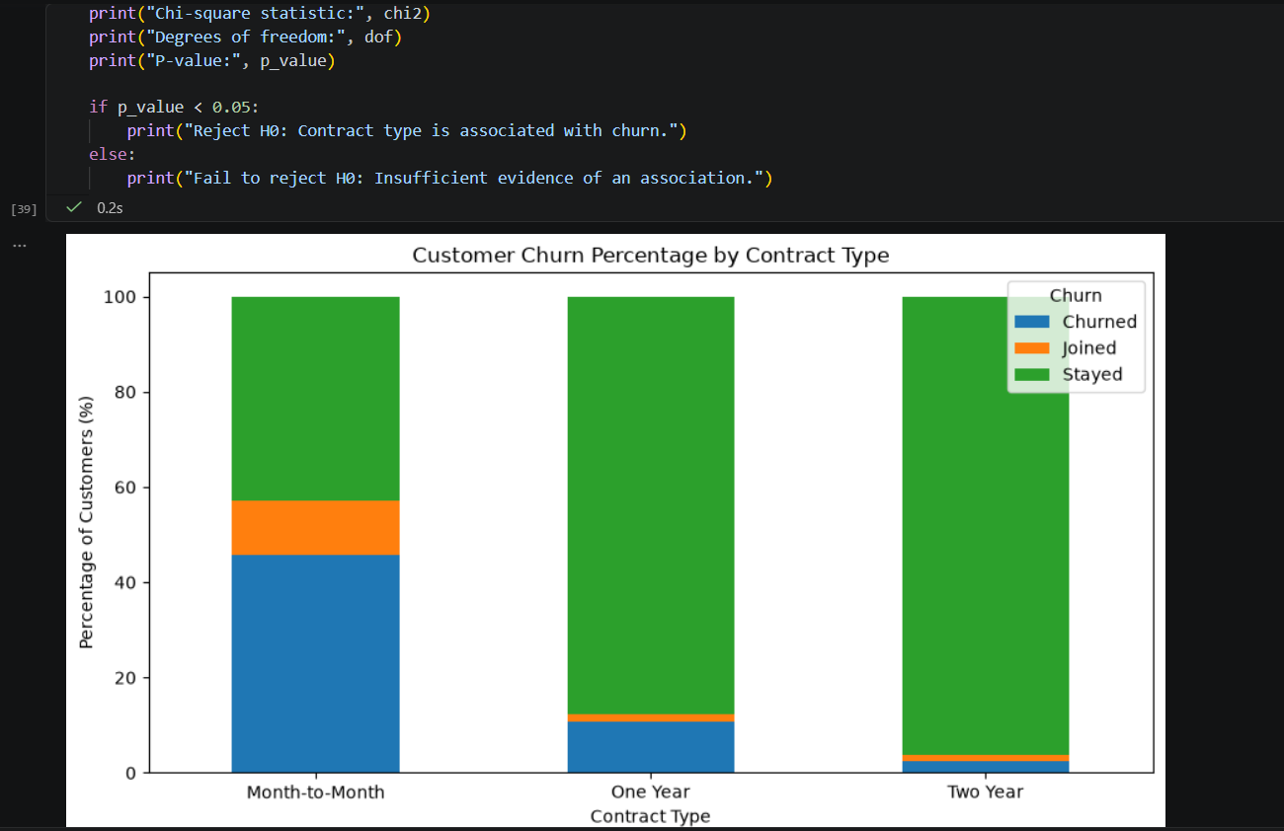

5.3 Test 2: Monthly charge by churn status
The notebook's first attempt (using the labels "Yes" and "No") returned empty groups and NaN results, because the Churn column actually contains "Churned", "Stayed" and "Joined". The code below uses the correct labels, as the notebook's later confidence-interval cell did.
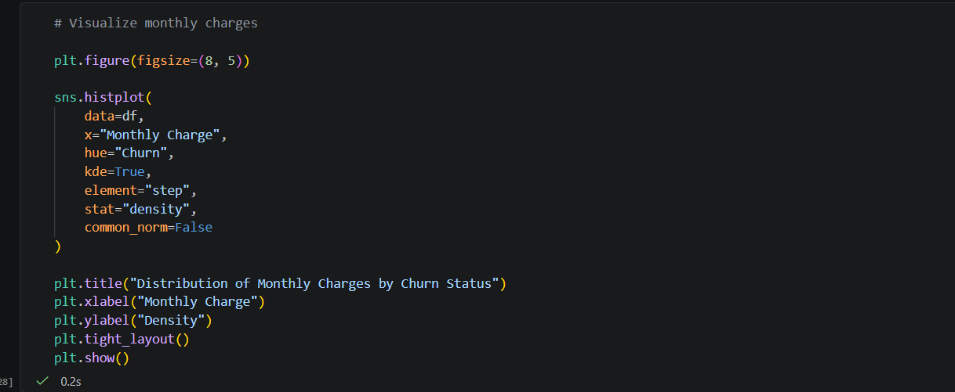
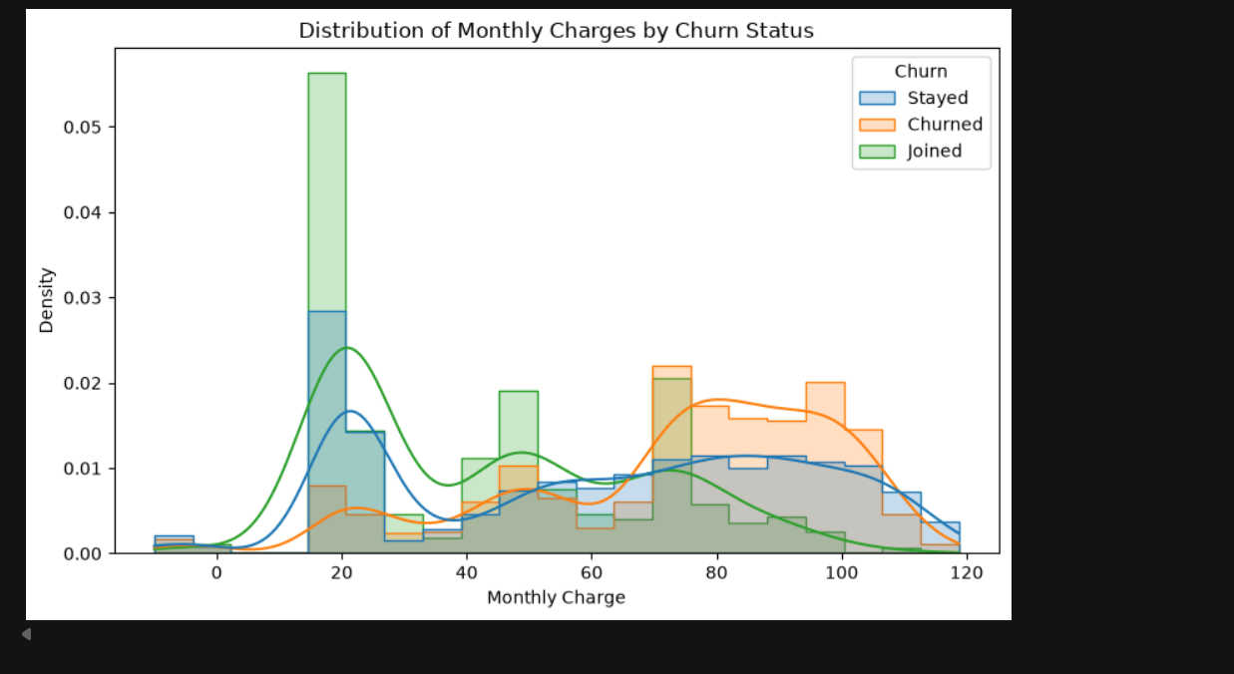
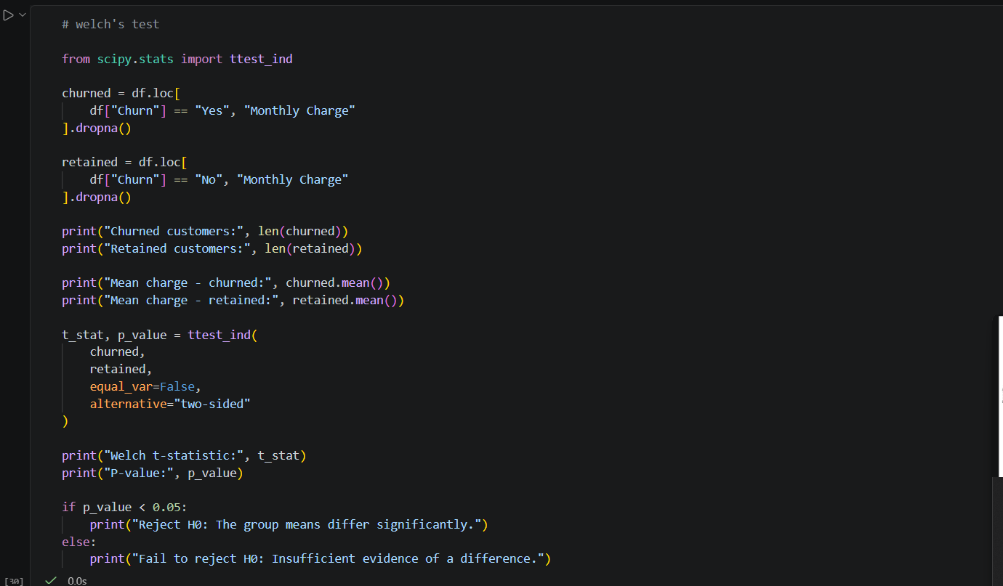
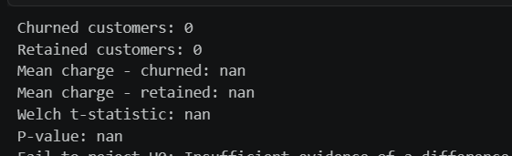

Results
Statistic | Value
Mean monthly charge, Churned | $73.35 (n = 1,869)
Mean monthly charge, Stayed | $61.74 (n = 4,720)
Mean difference | $11.61
95% CI for the difference | $10.10 to $13.12
Welch t-statistic | approx. 15.1 (derived from the CI width; re-run the code for the exact value)
p-value | < 0.001 (consistent with a CI far from zero)
Cohen's d | approx. 0.37 (small to medium; estimated using the overall SD of 31.2, so re-run for the exact pooled value)
Note: the notebook's saved outputs include the confidence interval and group means, but the corrected Welch t-statistic, p-value and Cohen's d were not run. The approximate values above follow directly from the interval and the dataset's overall standard deviation, and should be confirmed by running the code.

6. Results, Discussion and Conclusion

Interpretation
Test 1. The association between contract type and churn is statistically significant (chi-square = 1,987.36, df = 4, p < 0.001) and substantial in size (Cramer's V = 0.38; 0.51 when Joined customers are excluded). Month-to-Month customers churn at 45.8%, against 10.7% for One Year and 2.5% for Two Year contracts. Relative to what independence would predict, Month-to-Month has about 1,655 churners instead of roughly 958 expected, while Two Year has only 48 instead of roughly 500. Decision: H0 is rejected.
Test 2. Churned customers pay about $11.61 more per month on average than customers who stayed (95% CI: $10.10 to $13.12). The interval excludes zero, so the difference is significant at the 5% level. The effect is small to medium (d approx. 0.37): price matters, but monthly charge alone does not separate churners from stayers. Decision: H0 is rejected.

Business implications
- Push customers toward longer contracts. Discounts, device offers or price locks for One or Two Year terms target the group with by far the highest churn risk.
- Review pricing for high-bill customers. Higher bills go with higher churn, so tiered loyalty discounts or plan right-sizing for high-paying customers may reduce losses. Revenue at risk is also larger per churner, since churners pay more.
- Prioritise retention spending on Month-to-Month customers with high monthly charges, the segment that combines both risk factors.

Limitations
- Association, not causation. Customers may choose Month-to-Month contracts because they already intend to leave; the tests cannot say that contracts cause churn.
- Joined customers have an unobserved outcome. Including them in Test 1 slightly dilutes the effect; the sensitivity analysis shows the conclusion is unchanged.
- Negative monthly charges (minimum -10.00) are implausible and may reflect credits or errors; they were kept and could slightly affect the means.
- Large sample, large statistical power. With thousands of customers, very small differences become significant, which is why effect sizes are reported.
- Imputation of structurally missing service variables was crude, although it does not influence these two tests.
- Confounding: contract type, price, tenure and service type are interrelated. A multivariable model such as logistic regression would separate their effects.
- Test 2 values (t-statistic, p-value, Cohen's d) are approximations derived from saved outputs; run the provided code to obtain exact figures.

Conclusion
Hypothesis | Test | Result | Decision
H0: Contract type and churn are independent | Chi-square, alpha = 0.05 | chi-square = 1,987.36, df = 4, p < 0.001, V = 0.38 | Reject H0
H0: Mean monthly charge is equal for churned and stayed customers | Welch t-test, alpha = 0.05 | Difference $11.61, 95% CI $10.10 to $13.12 | Reject H0
Contract type is strongly associated with churn, and churned customers pay noticeably more per month. Both findings point to the same retention strategy: move high-paying, Month-to-Month customers onto longer, better-valued plans.

