MACHINE LEARNING MODEL DEVELOPMENT AND EVALUATION
Telecom Customer Churn Prediction using Logistic Regression
Project Report | Week 04
Dataset: telecom_churn_cleaned.csv
Tools: Python, pandas, scikit-learn, matplotlib, seaborn

Abstract
This project develops and evaluates a supervised machine learning model that predicts whether a telecom customer will churn (leave the service provider). The work uses a cleaned telecom customer dataset of 7,043 records and 31 columns. After retaining only customers with a known outcome (Stayed or Churned), 6,589 records were used for modelling, of which 28.4% are churners.
Missing values were imputed, the target was converted to a binary variable, numeric features were standardised, and categorical features were one-hot encoded inside a single scikit-learn pipeline. A Logistic Regression classifier with balanced class weights was trained on 80% of the data and tested on the remaining 20% using a stratified split. Performance was assessed using accuracy, precision, recall, F1-score, ROC-AUC, a confusion matrix and an ROC curve.
The model achieved a score of 1.00 on every metric, with no misclassified test customers. A perfect score on a real-world churn problem is not credible as a measure of true predictive ability. Review of the code shows that the churn-outcome columns Churn Category and Churn Reason were left in the feature set, which leaks the answer to the model. This report presents the results as obtained, explains the cause, and recommends the fix before the model is used in practice.

Introduction

Customer churn in telecommunications
Customer churn is the loss of customers who stop using a company's services. In the telecom industry, where competition is intense and switching is easy, churn directly reduces recurring revenue. Acquiring a new customer is generally more expensive than retaining an existing one, so telecom operators invest in identifying customers at risk of leaving so that retention offers can be targeted at them.
A churn prediction model estimates, for each customer, the probability of leaving based on attributes such as demographics, contract type, tenure, billing information and service usage. This report documents the development of such a model using logistic regression.

Objectives
The main goal is to build a reliable and interpretable classifier for telecom customer churn and to evaluate it properly. The specific objectives are:
- To load, inspect and clean the telecom churn dataset, including handling of missing values.
- To convert the Churn column into a binary target variable suitable for classification.
- To build a reproducible preprocessing pipeline that scales numeric features and encodes categorical features.
- To train a logistic regression model using a stratified training/testing split.
- To evaluate the model using accuracy, precision, recall, F1-score and ROC-AUC.
- To visualise performance using a confusion matrix, an ROC curve and a metrics chart.
- To critically interpret the results and identify limitations and improvements.

Dataset Description
The data is stored in the file telecom_churn_cleaned.csv and describes telecom customers in California, with one row per customer. It contains 7,043 records and 31 columns: 6 integer columns, 9 floating-point columns and 16 text columns.
Item | Details
Total records | 7,043 customers
Total columns | 31 (including the target)
Records used for modelling | 6,589 (customers whose Churn value is Stayed or Churned)
Target variable | Churn (converted to 0 = Stayed, 1 = Churned)
Class distribution | Stayed: 4,720 (71.63%); Churned: 1,869 (28.37%)
Identifier column | Customer ID (removed before training)

The columns can be grouped as follows:
Group | Columns
Demographics | Gender, Age, Married, Number of Dependents
Location | City, Zip Code, Latitude, Longitude
Relationship | Number of Referrals, Tenure in Months, Offer, Contract
Services | Phone Service, Internet Service, Internet Type, Online Security, Online Backup, Avg Monthly GB Download, Avg Monthly Long Distance Charges
Billing | Paperless Billing, Payment Method, Monthly Charge, Total Charges, Total Refunds, Total Extra Data Charges, Total Long Distance Charges, Total Revenue
Churn information | Churn (target), Churn Category, Churn Reason

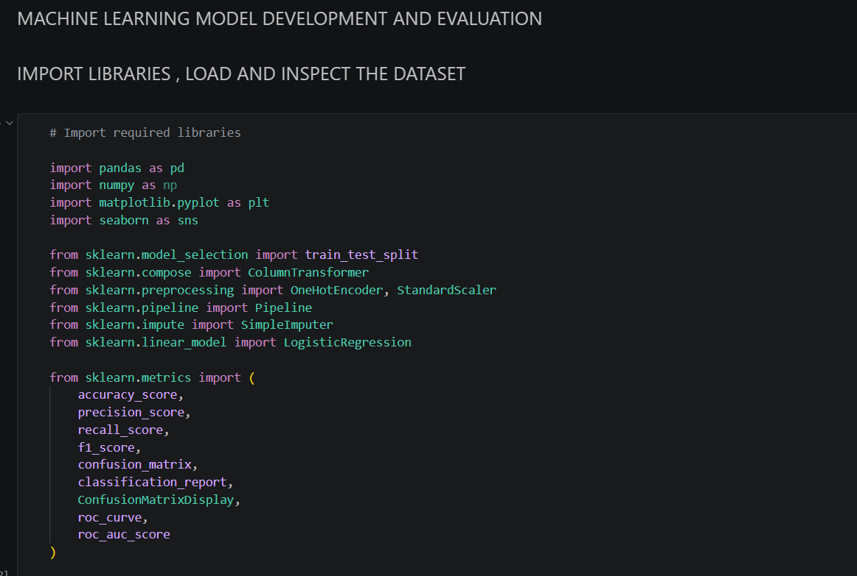
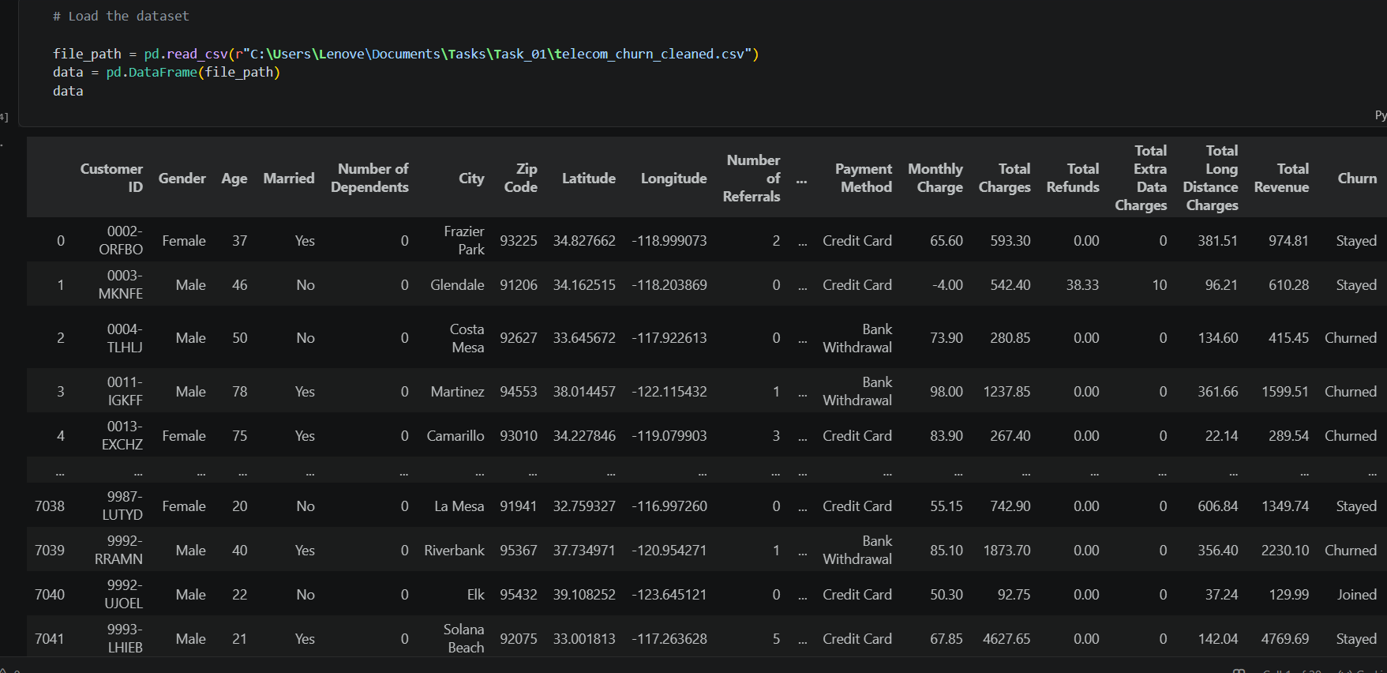
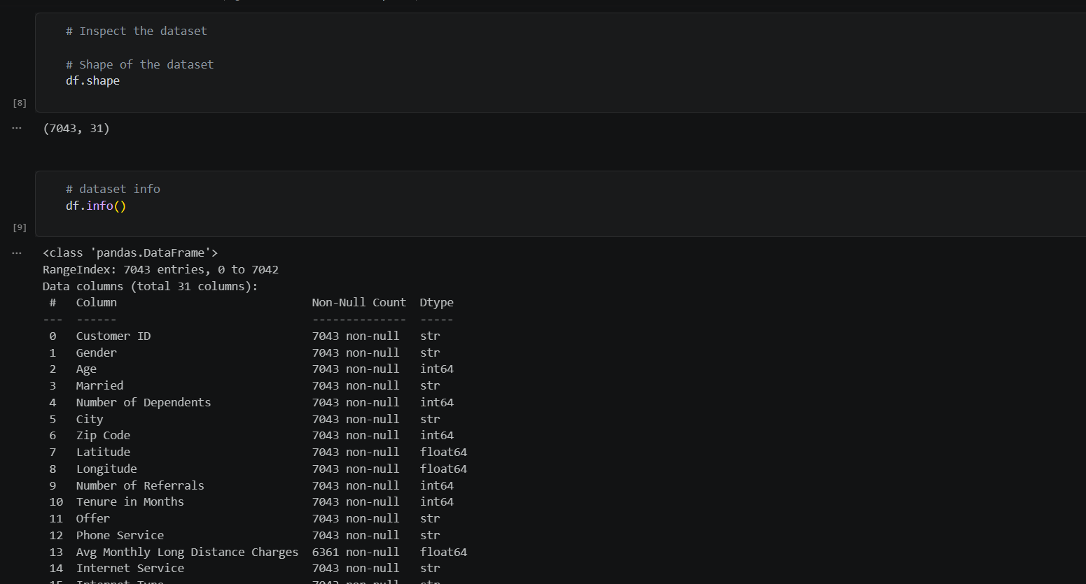
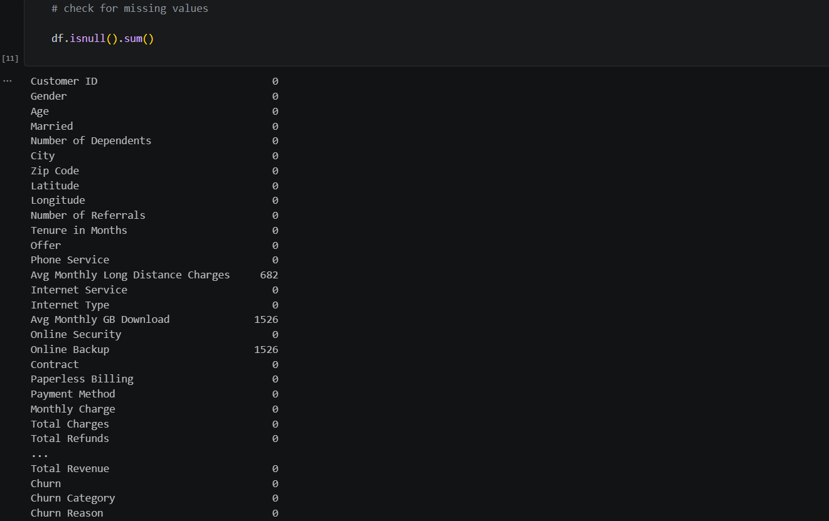
Three columns contained missing values: Avg Monthly Long Distance Charges (682 missing), Avg Monthly GB Download (1,526 missing) and Online Backup (1,526 missing). The remaining 28 columns were complete.

Data Preparation

Handling missing values
Missing values were filled before the train/test split using simple statistical imputation:
Column | Method | Reason
Online Backup (categorical) | Mode | Most frequent category is a neutral replacement for a categorical field
Avg Monthly GB Download (numeric) | Mean | Keeps the column average unchanged
Avg Monthly Long Distance Charges (numeric) | Mean | Keeps the column average unchanged

The same number of missing values (1,526) in Online Backup and Avg Monthly GB Download suggests that these are customers without internet service, for whom the fields do not apply. Mean/mode imputation is a practical choice, although a separate "Not applicable" category or a missing-indicator flag would preserve this information more faithfully. As an additional safeguard, the model pipeline also contains median and most-frequent imputers for any values missing in future data.

Target transformation
Only rows where Churn is either "Stayed" or "Churned" were kept. This removed 454 records (7,043 minus 6,589), which have a different status (for example, recently joined customers) and therefore no final outcome. The Churn column was then converted to numeric form: Churned = 1 and Stayed = 0.
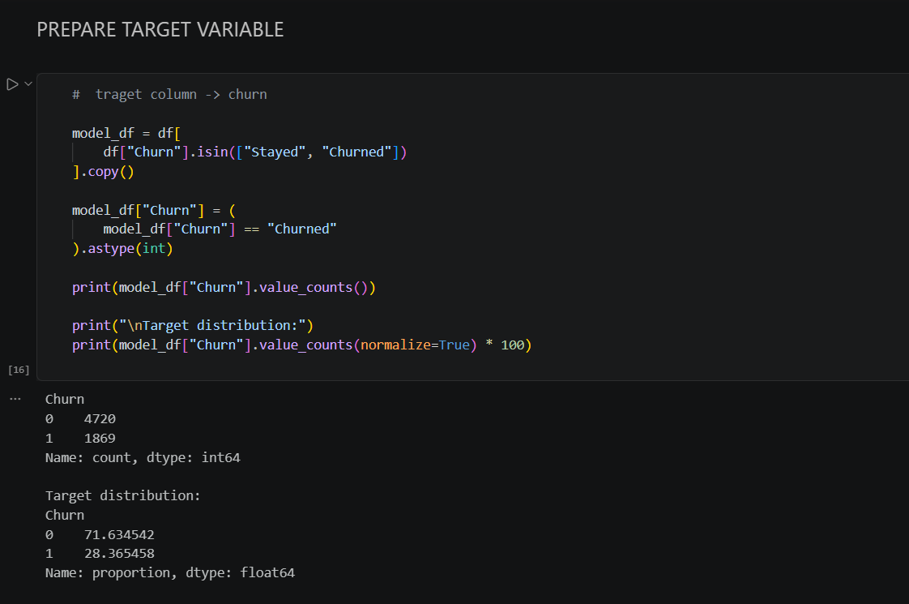

Feature and target separation
The target y is the Churn column. The feature matrix X contains all other columns except the identifier Customer ID, which is unique to each customer and carries no predictive meaning. This produced 29 input features.
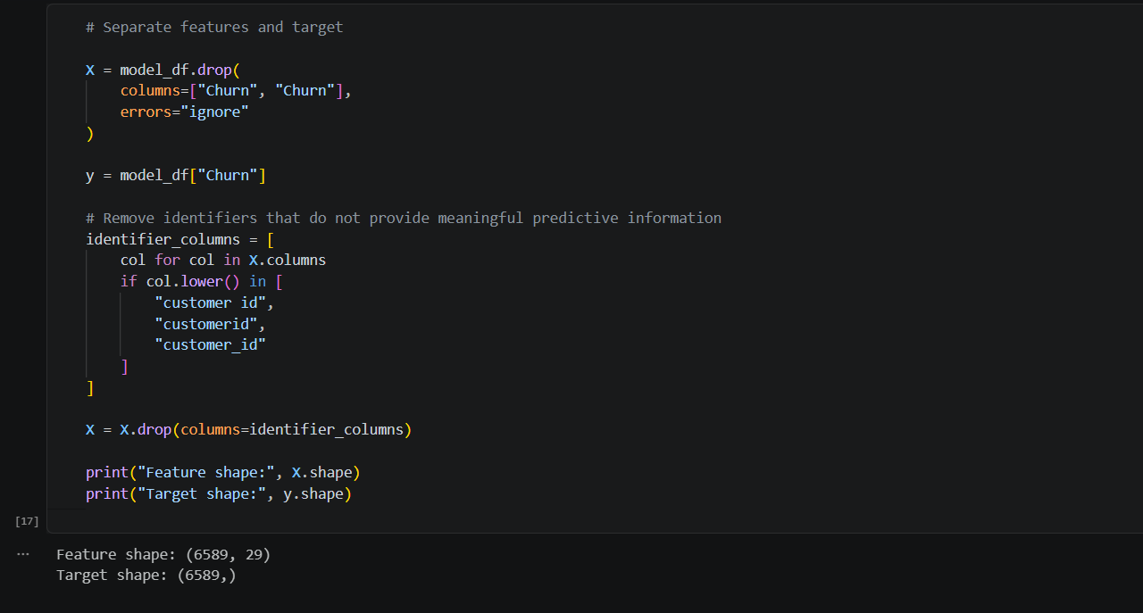
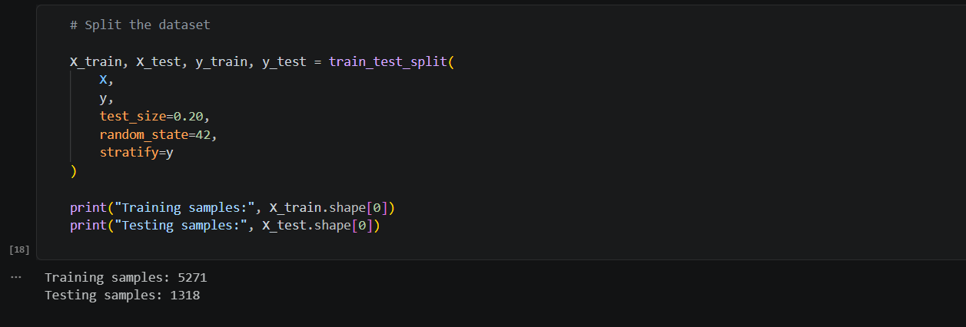

Encoding and scaling
- Numeric features: Columns of numeric type (for example Age, Tenure in Months, Monthly Charge) are median-imputed and standardised with StandardScaler, giving each a mean of 0 and a standard deviation of 1. Scaling matters for logistic regression because it helps the optimiser converge and makes coefficients comparable.
- Categorical features: Text columns (for example Gender, Contract, Payment Method) are imputed with the most frequent value and converted to binary indicator columns using OneHotEncoder with handle_unknown="ignore", so unseen categories at prediction time do not cause errors.
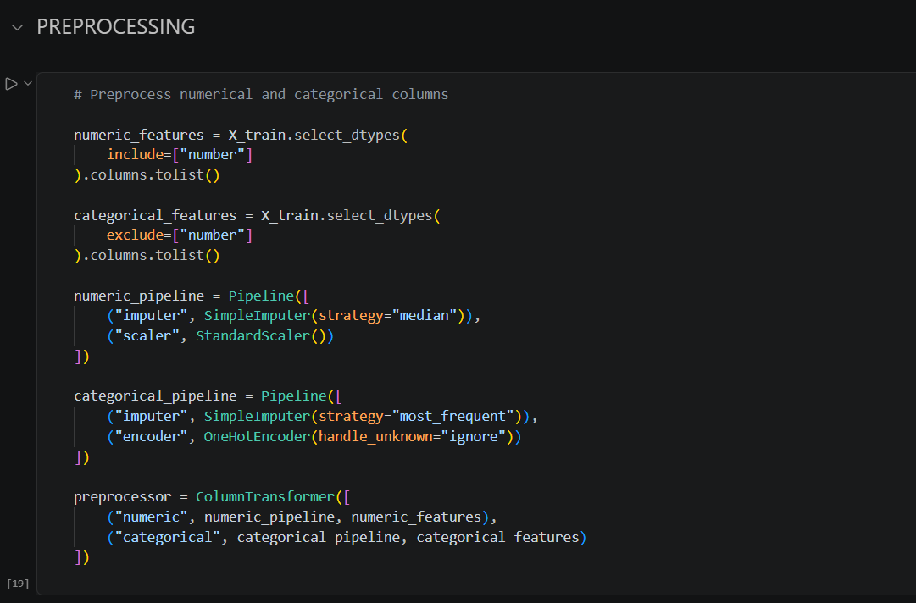

Algorithm Selection
Logistic Regression was chosen as the classification algorithm. It models the probability that an observation belongs to the positive class (here, Churned) by passing a weighted sum of the features through the sigmoid function:
P(Churn = 1 | x) = 1 / (1 + e^-(b0 + b1x1 + ... + bnxn))
The choice is justified by the following points:
- Suited to binary classification: It is designed for two-class problems such as stay versus churn.
- Probability estimates: It outputs a probability, which lets the business rank customers by risk and choose its own decision threshold.
- Interpretability: Each coefficient shows the direction and strength of a feature's effect on the log-odds of churn, which is valuable when explaining results to non-technical stakeholders.
- Efficiency and baseline value: It is fast to train and is a standard, strong baseline against which more complex models can be compared.
- Linear assumption: It performs well when the relationship between the features and the log-odds of churn is approximately linear.
The classifier was configured with max_iter=1000 to ensure convergence, class_weight="balanced" to compensate for the 72/28 class imbalance by giving the minority (churn) class more weight, and random_state=42 for reproducibility.

Model Development

Training/testing split
The 6,589 records were divided into 80% training and 20% testing data using train_test_split with random_state=42. The split was stratified on the target, so the churn proportion (about 28.4%) is preserved in both subsets.
Subset | Samples | Share
Training set | 5,271 | 80%
Testing set | 1,318 | 20%

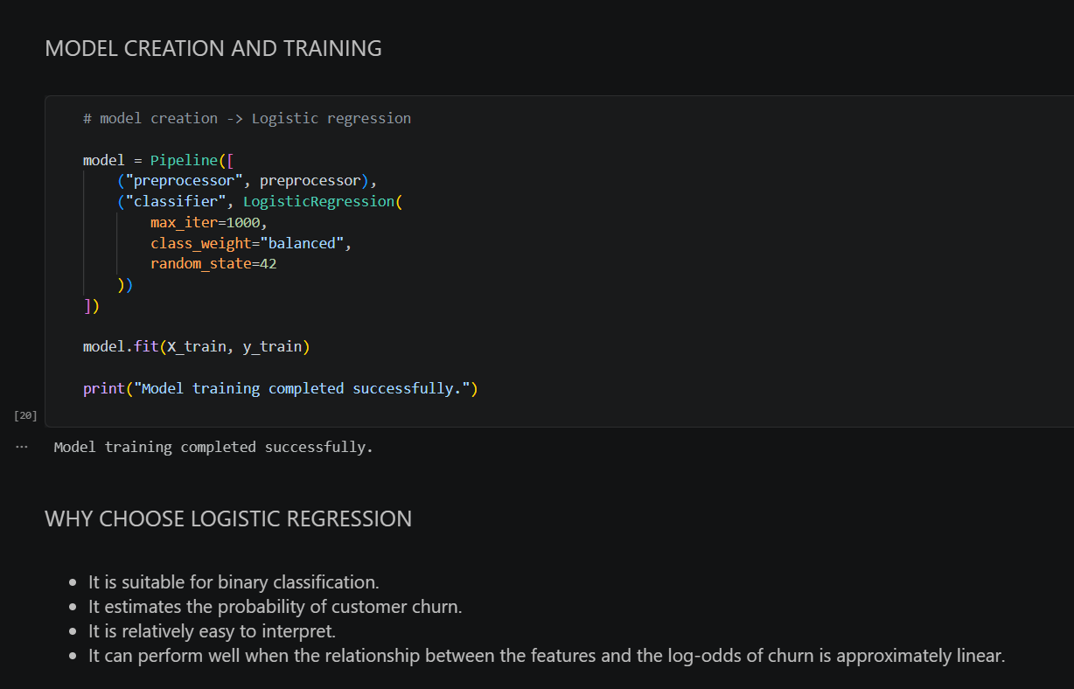

Preprocessing pipeline
A ColumnTransformer routes each column type to its own sub-pipeline: numeric columns pass through a median imputer and StandardScaler, and categorical columns pass through a most-frequent imputer and OneHotEncoder. The transformer is combined with the classifier in one Pipeline object.
Using a single pipeline ensures that scaling and encoding parameters are learned only from the training data and then applied unchanged to the test data. This is the correct way to avoid leakage from the preprocessing step.
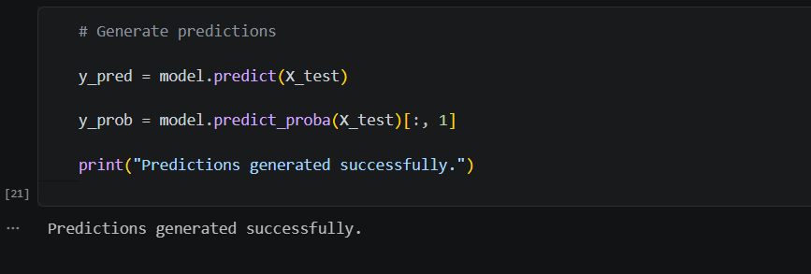

Training and prediction procedure
- The pipeline is fitted on X_train and y_train.
- Class predictions (0 or 1) are generated for X_test using model.predict().
- Churn probabilities are generated using model.predict_proba(), taking the column for the positive class. These probabilities are needed for the ROC curve and ROC-AUC.
- Predictions are compared with y_test to compute the evaluation metrics.

Evaluation Metrics
Because the classes are imbalanced, several complementary metrics are used instead of accuracy alone. In the definitions below, TP, TN, FP and FN denote true positives, true negatives, false positives and false negatives, with "Churned" as the positive class.
Metric | Formula | Interpretation
Accuracy | (TP + TN) / (TP + TN + FP + FN) | Share of all predictions that are correct. Can be misleading when classes are imbalanced.
Precision | TP / (TP + FP) | Of the customers predicted to churn, the share that actually churned. Important when retention offers are costly.
Recall | TP / (TP + FN) | Of the customers who actually churned, the share the model caught. Important when missing a churner is costly.
F1-score | 2 x (Precision x Recall) / (Precision + Recall) | Harmonic mean of precision and recall; balances the two.
ROC-AUC | Area under the ROC curve | Probability that a random churner is ranked above a random non-churner. 0.5 is random guessing and 1.0 is perfect separation; it is independent of the threshold.

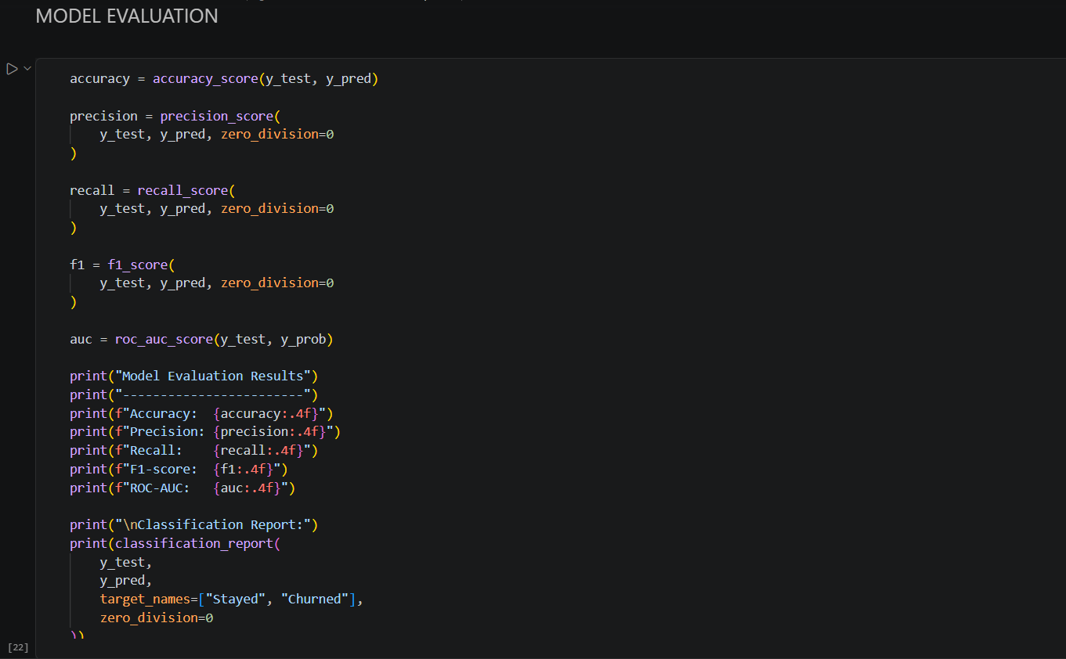

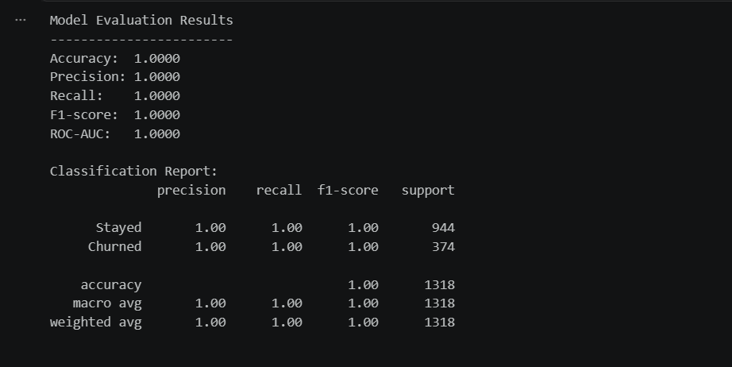

Visualizations

Confusion matrix
The confusion matrix compares actual and predicted classes for the 1,318 test customers. Rows show the true class and columns the predicted class.
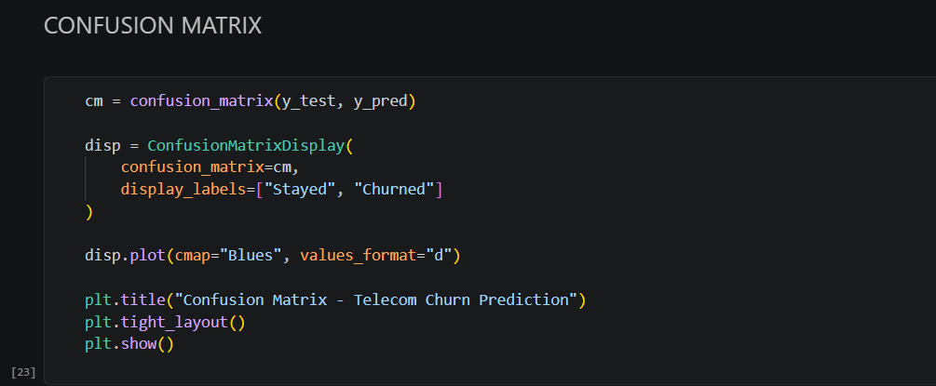
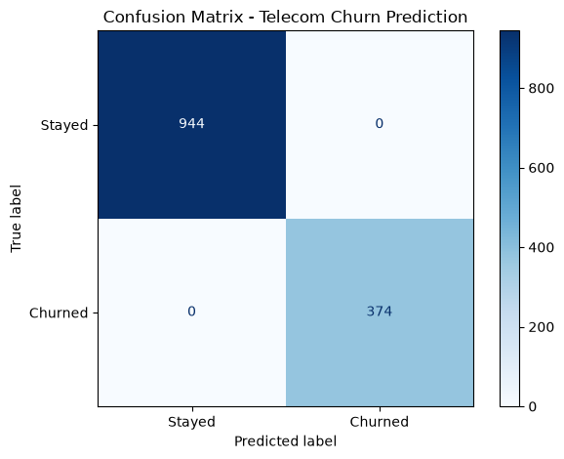
Figure 1: Confusion matrix for the test set
 | Predicted: Stayed | Predicted: Churned
Actual: Stayed | 944 (TN) | 0 (FP)
Actual: Churned | 0 (FN) | 374 (TP)

ROC curve
The ROC curve plots the true positive rate against the false positive rate across all classification thresholds. The dashed diagonal represents a random classifier. A curve that hugs the top-left corner indicates strong separation of the two classes.
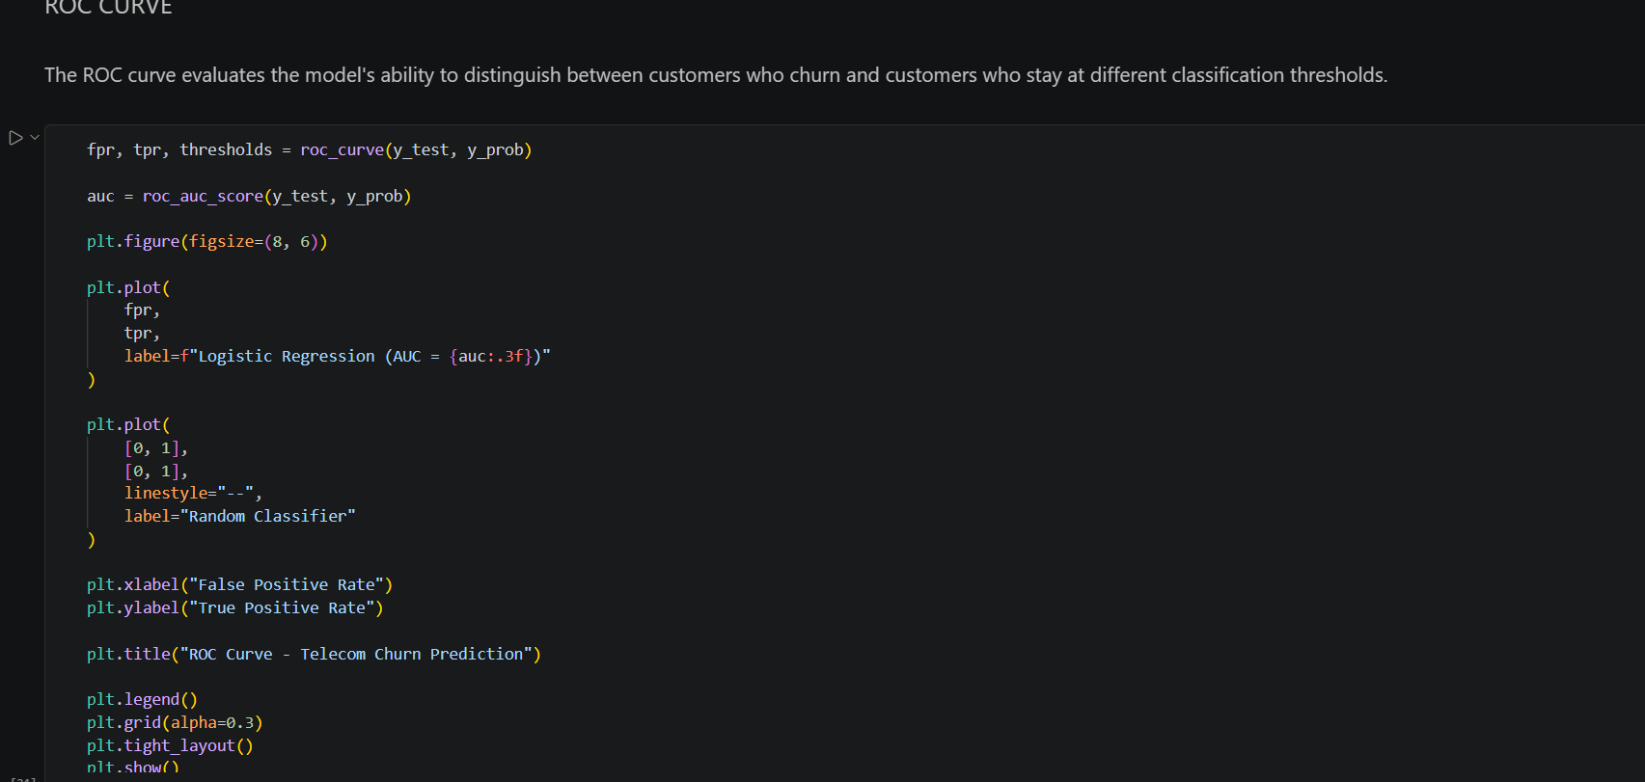
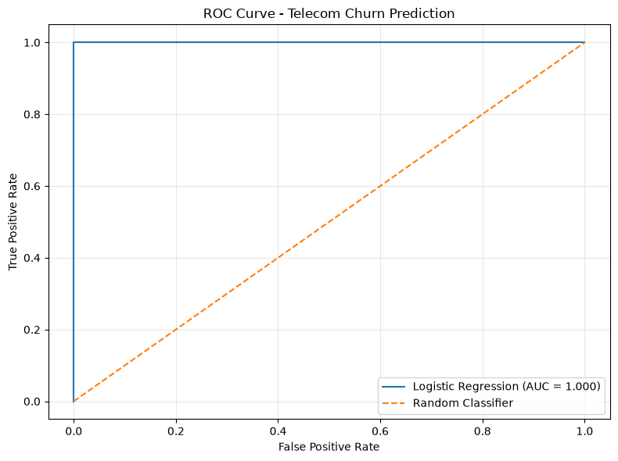
Figure 2: ROC curve for logistic regression (AUC = 1.000)

Performance metrics chart
The bar chart summarises the five evaluation metrics on a common 0 to 1 scale.
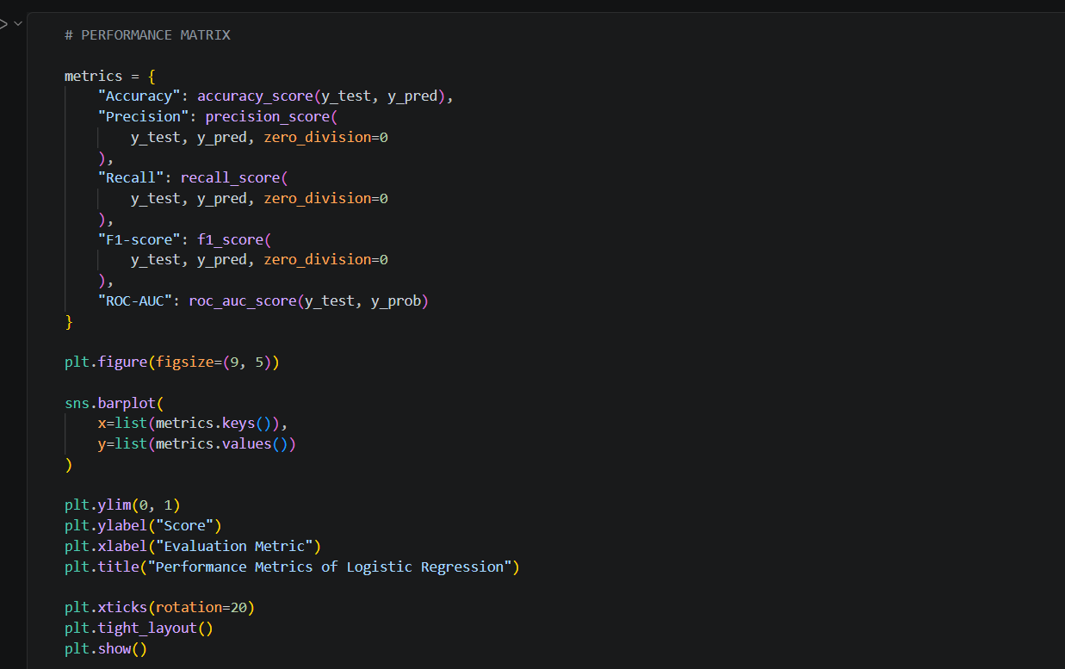
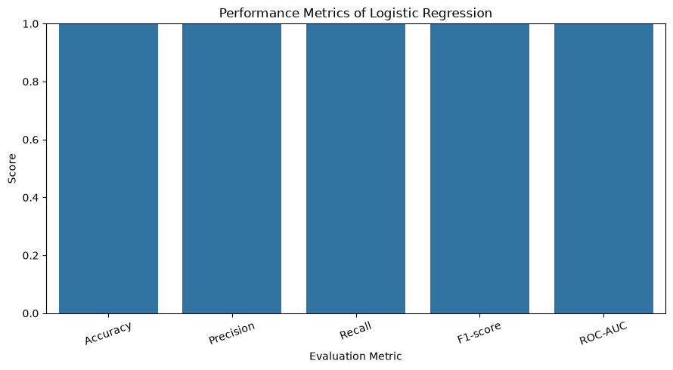
Figure 3: Performance metrics of the logistic regression model

Results and Discussion

Evaluation results
Metric | Score | Support / Note
Accuracy | 1.0000 | 1,318 test samples
Precision | 1.0000 | Churned class
Recall | 1.0000 | Churned class
F1-score | 1.0000 | Churned class
ROC-AUC | 1.0000 | Perfect separation

Class | Precision / Recall / F1 | Support | Misclassified
Stayed (0) | 1.00 / 1.00 / 1.00 | 944 | 0
Churned (1) | 1.00 / 1.00 / 1.00 | 374 | 0

Interpretation
On the face of it, the model classified all 1,318 test customers correctly: all 944 customers who stayed and all 374 who churned. The ROC curve rises straight to the top-left corner with an AUC of 1.0.
These results should not be accepted as evidence of an excellent model. Published churn models on comparable telecom data typically reach accuracy between roughly 75% and 85% and ROC-AUC between roughly 0.80 and 0.90, because customer behaviour is only partly predictable from account data. A flawless score on every metric almost always signals data leakage, where information that would not be available at prediction time is present in the features.

Likely cause: target leakage
Inspection of the notebook shows that the feature matrix contains the columns Churn Category and Churn Reason. The dataset sample shows these columns hold values such as "unknown" and "unknown reason" for customers who stayed, and specific values such as "Competitor", "Dissatisfaction", "Competitor had better devices" or "Network reliability" for customers who churned. These columns are recorded only after a customer leaves, so they reveal the target almost perfectly. The model has simply learned that "unknown" means Stayed and anything else means Churned.
The line intended to remove the target from the features, X = model_df.drop(columns=["Churn", "Churn"]), lists "Churn" twice and does not drop the two related columns. The identifier removal step only addresses Customer ID.
This conclusion is based on the column names and sample values visible in the notebook; it can be confirmed by checking the model coefficients or by re-running the model without these two columns, as recommended in Section 11.

Other observations
- Invalid values: The sample shows a Monthly Charge of -4.00, which is not a valid charge and suggests remaining data-quality issues despite the file being named "cleaned".
- Imputation before splitting: Missing values were imputed on the full dataset before splitting, which lets test-set statistics influence the training data. The pipeline already includes imputers, so the earlier manual imputation is redundant.
- Correlated features: Total Revenue, Total Charges, Total Refunds and Total Long Distance Charges are strongly related to each other and to tenure, which may produce multicollinearity and make individual coefficients less stable.
- High-cardinality fields: Zip Code and City are high-cardinality location fields. One-hot encoding City creates hundreds of sparse columns and adds noise.

Limitations and Improvements

Limitations and potential errors
- Data leakage: Churn Category and Churn Reason leak the outcome and invalidate the reported metrics.
- Overfitting to a shortcut: The perfect score cannot be taken as proof of generalisation; the true out-of-sample performance is unknown until leakage is removed.
- Underfitting risk: Logistic regression assumes a linear relationship between features and log-odds. If real churn behaviour contains interactions (for example contract type combined with tenure), a linear model may underfit.
- Single split evaluation: A single 80/20 split gives one estimate that may vary with the random seed.
- Class imbalance: Only 28.4% of customers churned. Balanced class weights help, but accuracy alone remains unreliable.
- Simplistic imputation: Mean and mode imputation ignores the fact that some values are structurally missing (no internet service).
- Static data: The dataset is a snapshot and does not capture how behaviour changes over time.

Conclusion
This project built a complete, well-structured churn prediction workflow: data loading and inspection, missing-value treatment, binary target creation, a leakage-safe preprocessing pipeline for the scaling and encoding steps, a stratified train/test split, a balanced logistic regression model, and evaluation through five metrics and three visualisations.
The model reported accuracy, precision, recall, F1-score and ROC-AUC of 1.00, with zero errors on the 1,318 test customers. However, this outcome is almost certainly the result of target leakage through the Churn Category and Churn Reason columns rather than genuine predictive skill.

