REPORT LAB07
Q1(2)
- Centralized system means that crude oil is not equally distributed in two refineries so we formed one constraint as
$$x_{1}+x_{2}+y_{1}+y_{2}≤120$$
- Where x1,x2 = amount of oil used in D and (Decision variables)
- Y1,y2 = amount of oil used in E. (non-neg decision variables)
- OBJECTIVE FUNCTION : max $10x_{1}+15x_{2}+10y_{1}+15y_{2}$
- Constraints :
- ${4x}_{1}+{2x}_{2}≤80$
- ${2x}_{1}+{5x}_{2}≤60$
- ${4y}_{1}+{3y}_{2}≤60$
- ${5y}_{1}+{6y}_{2}≤75$
- X1,x2,y1,y2>0
- SOLUTION :
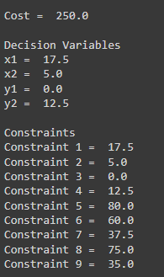
So maximum profit = 250, with given values of decision variables.

(3)
- Given that crude oil is allocated such that the
decentralized profit> centralized profit for which
- Constraints :
- ${4x}_{1}+{2x}_{2}≤80$
- ${2x}_{1}+{5x}_{2}≤60$
- ${4y}_{1}+{3y}_{2}≤60$
- ${5y}_{1}+{6y}_{2}≤75$
- $x_{1}+x_{2}+y_{1}+y_{2}≤120$r + 120(1-r)
- From the graph we observe a inverted parabola which implies for different values of r lying between 0 and 1 how the value of profit changes , As the value of r increases profit increase then becomes constant and then decreases for larger values of r.
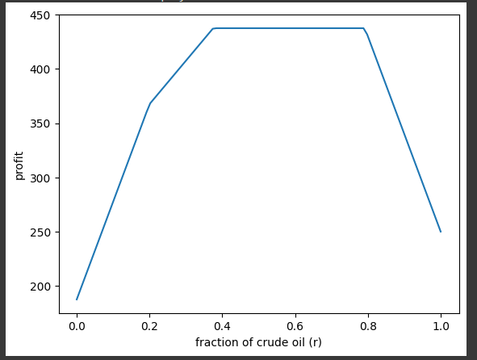

(4)
- For DUAL constraints are as follows:
- ${4y}_{1}+{2y}_{2}≤10$
- ${2y}_{1}+{5y}_{2}≥15$
- $y_{1}, y2≥0$
- OBJECTIVE FUNCTION :
$80y_{1}+60y_{2}$
- SOLUTION :
The solution is unbounded.
Q2(1)
- CONSTRAINTS:
- $x_{1}+{3x}_{2}+x3+7x4+x5-y≤100$
- $-0.8x_{1}+{4.8x}_{2}-0.8x3+3.8x4+2.2x5≤0$
- ${-x}_{1}+12x_{2}+x3+3x4-5x5≤0$
- $x_{2}+2x3+4x4≥60$
- 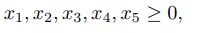
- OBJECTIVE FUNCTION:
- Assumptions
- When we cross multiply the given two fractional constraints it is important that
          - X1-x2+x3-x4+x5 not equal to zero
          - X1+x2+x3-x5 also not equal to zero
      - The model assumes linear relationship between constraints and variables.
(2),(3)
- On solving we get
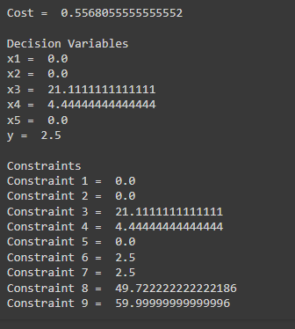
(4)
Without assumptions : there might be quadratic equations.
(5)

