WEEK 1 TASK — DATA ACQUISITION, CLEANING AND EXPLORATORY ANALYSIS

Titanic Passenger Dataset: Data Cleaning and EDA
Prepared as a practical demonstration of a reproducible data-analysis workflow using Python.
Dataset: Public Titanic training CSV | Tools: Python, Pandas, NumPy, Matplotlib

1. Introduction
Data analysis usually begins with collecting data from a trustworthy source and checking whether it is complete, consistent, and suitable for analysis. This project demonstrates the process using the widely used Titanic passenger dataset. The data contains passenger characteristics such as age, sex, ticket class, fare, family members aboard, port of embarkation, and survival status. The purpose is not to build a prediction model; it is to clean the dataset, summarize its structure, explore relationships, and communicate findings with clear visualizations.

2. Problem statement and objectives
Problem statement: The raw passenger table contains missing values and fields with different analytical usefulness. Without checking and documenting these issues, summaries can be misleading. The task is to create a transparent workflow that preserves the original data, handles quality problems with justified rules, and explores patterns associated with survival.
- Acquire the public CSV and preserve an untouched raw copy.
- Inspect dimensions, data types, missing values, duplicate rows, and numerical ranges.
- Clean missing values and inconsistent text in a documented way.
- Compare survival counts and rates by sex and passenger class.
- Export a cleaned CSV and reproducible Python code.

3. Dataset acquisition and description
Source URL: https://raw.githubusercontent.com/datasciencedojo/datasets/master/titanic.csv
The commonly used training file contains 891 passenger records and 12 columns. Key fields include Survived (0 = did not survive, 1 = survived), Pclass (ticket class), Sex, Age, SibSp, Parch, Fare, Cabin, and Embarked. The source is a public GitHub mirror of the commonly used Titanic training dataset. The script reads it directly with pandas.read_csv(URL), so an internet connection is required when running the analysis.
Item | Description
Records in standard training file | 891
Original columns | 12
Outcome field | Survived: 0 or 1
Format | CSV
Primary tools | Python, Pandas, NumPy, Matplotlib

4. Data quality assessment
The standard training CSV is known to contain incomplete values, especially in Age and Cabin. The quality checks in the included script calculate missing values from the downloaded file at runtime rather than hard-coding the counts. The following table describes the cleaning decisions and why they are appropriate.
Field / issue | Treatment | Reason
Age missing values | Fill with median age | Median is less sensitive to extreme values than the mean.
Fare missing values | Fill with median fare | Keeps the row while using a robust central value.
Embarked missing values | Fill with most frequent category (mode) | Appropriate for a categorical field with few missing entries.
Cabin | Drop from analysis copy; retain in raw file | The field is heavily incomplete and can reduce usability if used without further feature engineering.
Duplicate rows | Check exact duplicates and remove only exact duplicates | Prevents identical records from being counted twice.
Text formatting | Strip surrounding whitespace | Improves consistency in categorical values.
Numeric validity | Convert relevant fields to numeric; invalid negative age/fare set to missing | Avoids invalid values contaminating calculations.

5. Cleaning workflow and before/after documentation
- Step 1 — Load the public CSV and save an unchanged raw copy in data/titanic_raw.csv.
- Step 2 — Inspect shape, column names, data types, missing-value counts, and exact duplicate rows.
- Step 3 — Standardize column labels and trim whitespace in text fields.
- Step 4 — Remove exact duplicate rows only if they exist; do not remove records merely because names or tickets repeat.
- Step 5 — Convert analysis columns to numeric and treat impossible negative age/fare values as missing.
- Step 6 — Impute Age and Fare using their medians; impute Embarked with its mode.
- Step 7 — Exclude Cabin from the analysis copy because of extensive missingness, while preserving the original raw file.
- Step 8 — Create FamilySize and SurvivalLabel, export the cleaned dataset, and re-check missing values.
Check | Before cleaning | After cleaning (expected rule)
Raw source copy | Original source fields retained | Untouched raw CSV remains available
Age / Fare | Potential missing values | Median-imputed; no missing values in these fields
Embarked | A small number of missing categories | Mode-imputed where needed
Cabin | Large proportion missing | Removed from cleaned analysis copy
Exact duplicates | Count calculated by script | Exact duplicates removed if present
Output | Raw CSV from source | Cleaned CSV plus derived columns
The script prints actual before-and-after missing-value counts when run. This is preferable to guessing values and makes the process reproducible. The report’s figures below summarize standard aggregate patterns in the public training dataset; the included script regenerates charts and exact outputs directly from the downloaded CSV.

6. Exploratory data analysis and findings
The overall outcome is imbalanced: 342 of 891 passengers survived (about 38.4%), while 549 did not survive (about 61.6%). Survival rates vary by sex and passenger class. These are descriptive associations in this dataset and should not be interpreted as proof that a single variable caused the outcome.
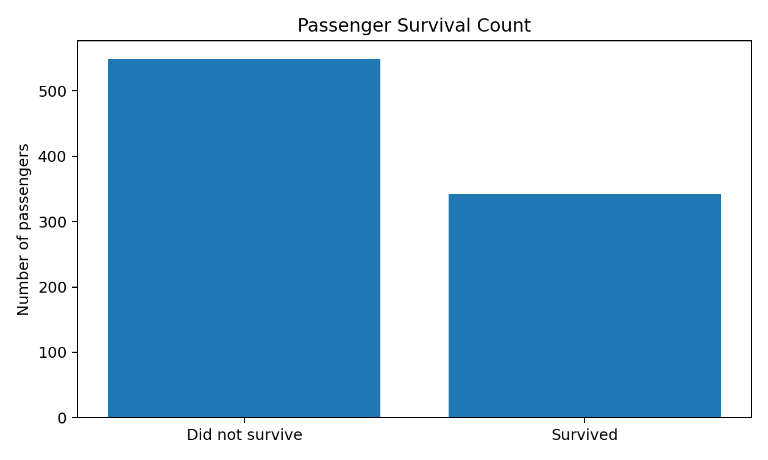
Figure 1. Overall survival counts in the standard Titanic training dataset.
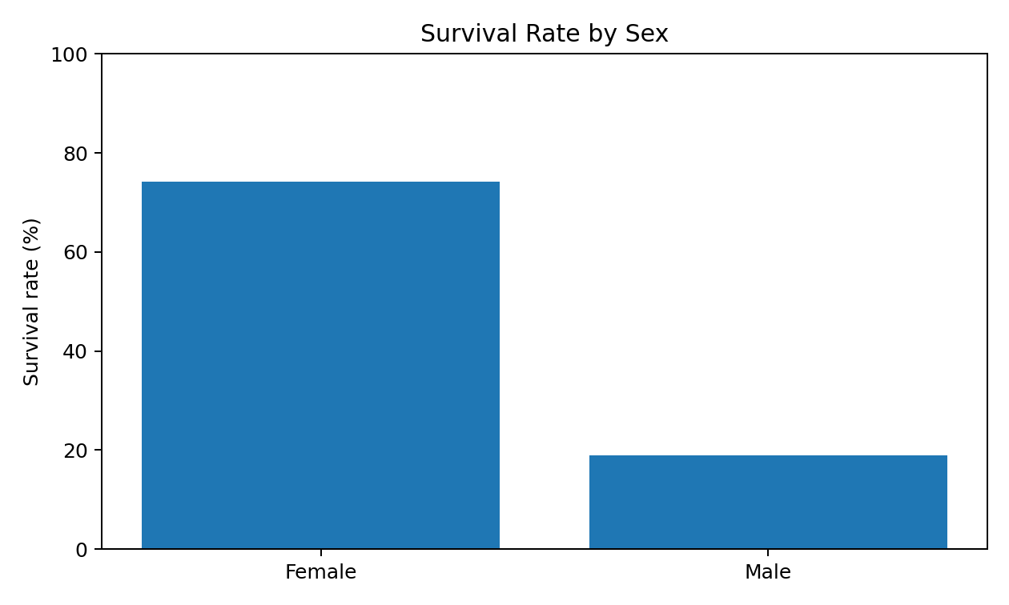
Figure 2. Approximate survival rate by sex: female 74.2%, male 18.9%.
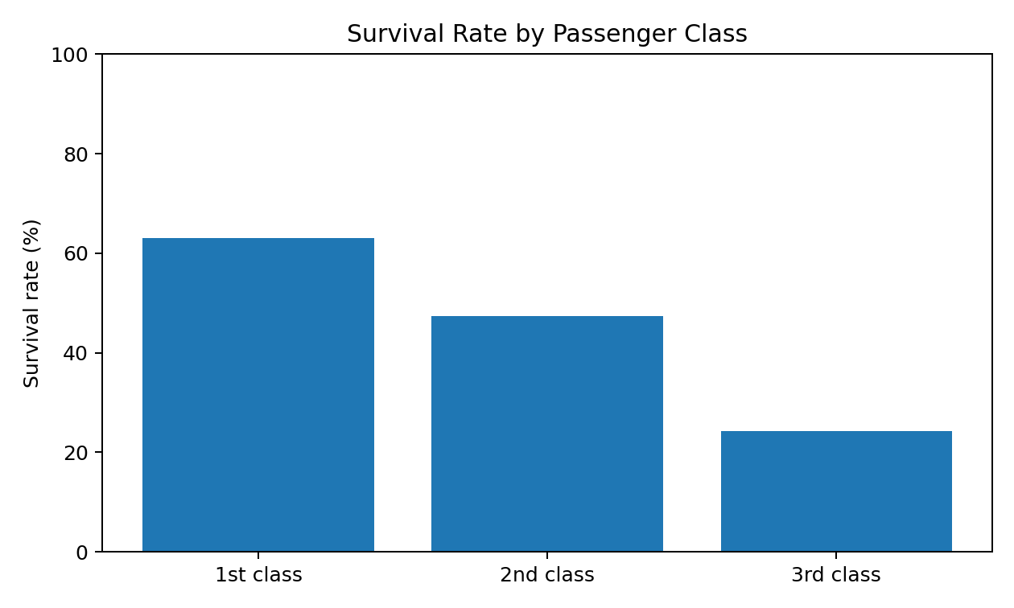
Figure 3. Approximate survival rate by passenger class: first class 63.0%, second class 47.3%, third class 24.2%.

7. Python tools and reproducibility
Library | Use in this project
Pandas | Read CSV, inspect missing values, clean data, group and aggregate results, export CSV.
NumPy | Handle numeric missing/invalid values and support data operations.
Matplotlib | Create readable charts with labels and titles.
Pathlib | Create consistent project output paths.
To reproduce the analysis, install dependencies with `pip install -r requirements.txt`, then run `python src/titanic_eda.py` from the project folder. The script downloads the source CSV, saves raw and cleaned data, prints quality checks and group-level survival rates, and creates the visualizations.

8. Challenges, limitations, and mitigation
- Missing values: use a documented median/mode strategy and retain the raw source so the choices can be reviewed.
- Cabin incompleteness: exclude it from the cleaned analysis copy rather than inventing values; preserve it in the raw copy.
- Outliers: inspect fare and age distributions before deciding whether an extreme value is an error. Do not automatically delete legitimate high fares or ages.
- Imputation bias: median/mode imputation makes the dataset easier to analyze but can reduce variation and introduce bias; report the decision clearly.
- Reproducibility: use a public source URL, script all steps, and record package requirements. The source must be reachable when running the script.
- Interpretation: results are descriptive and reflect this historical dataset; they should not be generalized to modern travel or treated as causal findings.

9. Conclusion
This project demonstrates a complete introductory workflow from data acquisition to cleaning, exploratory analysis, visualization, and documentation. The most important practice is to keep raw data unchanged, explain every cleaning decision, and generate outputs from code so that another person can reproduce them. The descriptive analysis shows that survival outcomes differed considerably across sex and passenger class, while also highlighting the need to interpret historical data carefully.

References
DataScienceDojo dataset mirror. Titanic passenger training dataset (CSV). https://raw.githubusercontent.com/datasciencedojo/datasets/master/titanic.csv
Pandas documentation. https://pandas.pydata.org/docs/
NumPy documentation. https://numpy.org/doc/
Matplotlib documentation. https://matplotlib.org/stable/

