- The "Divisible by 7" Sum: Loop from 1 to 200. Check if a number is divisible by 7; if it is, add it to a running total. Print the final sum at the end.
CODE:
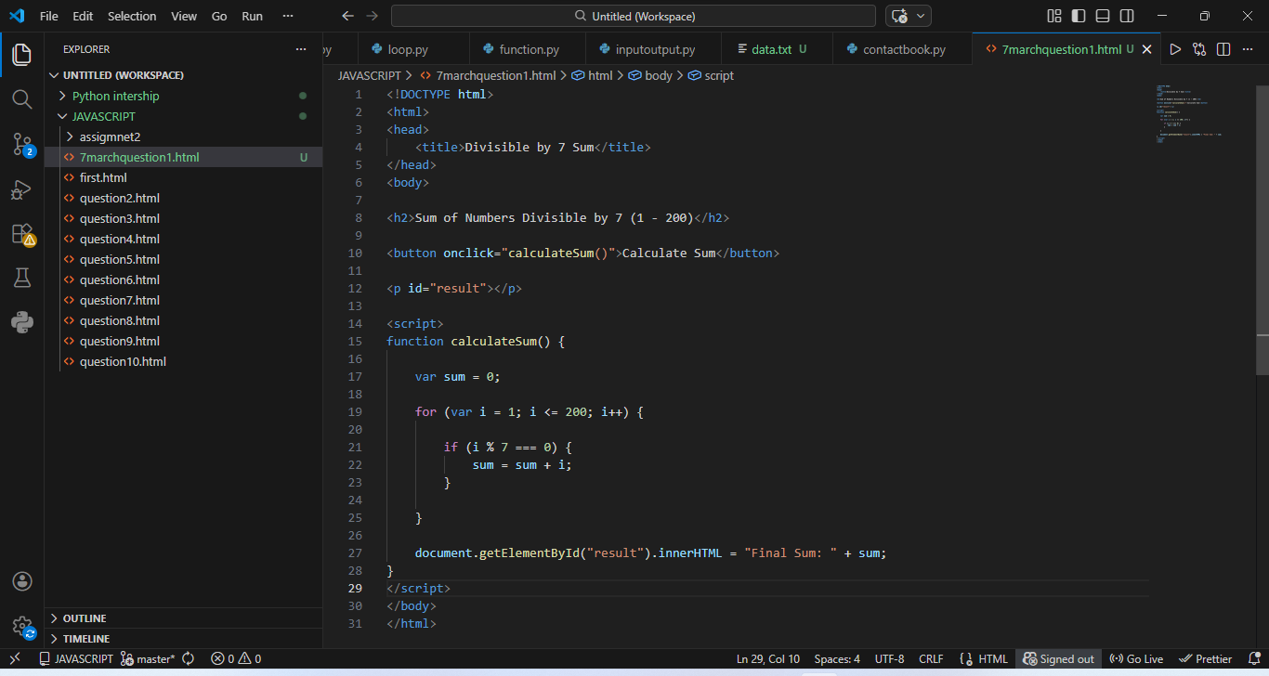

OUTPUT:
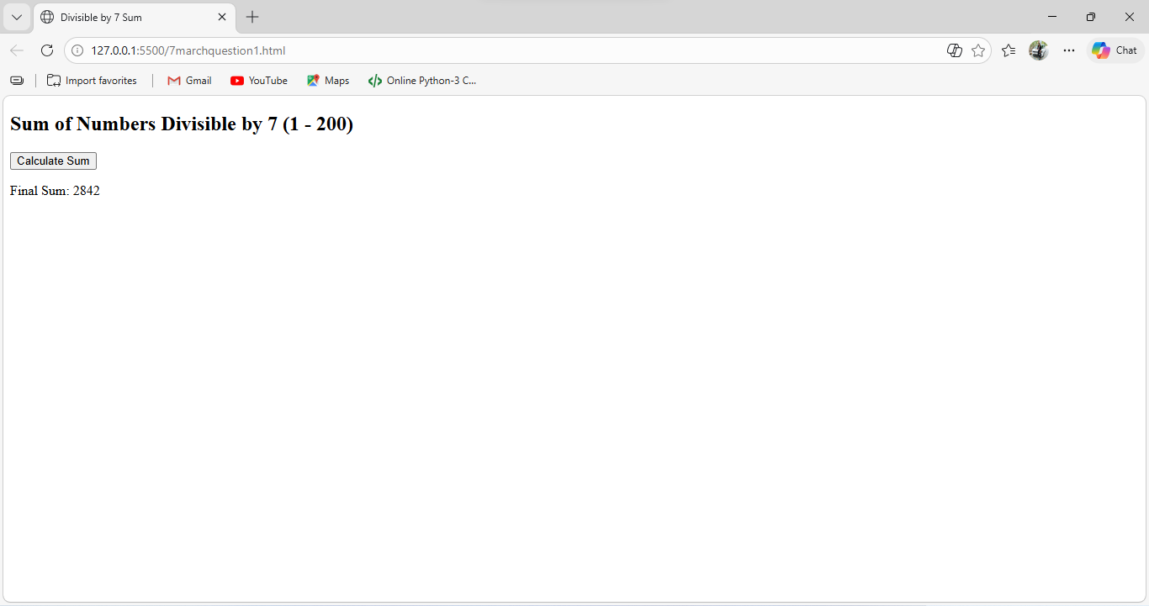

- Skipping Multiples: Loop from 1 to 50, but use the continue statement to skip any number that is a multiple of 10.
CODE:
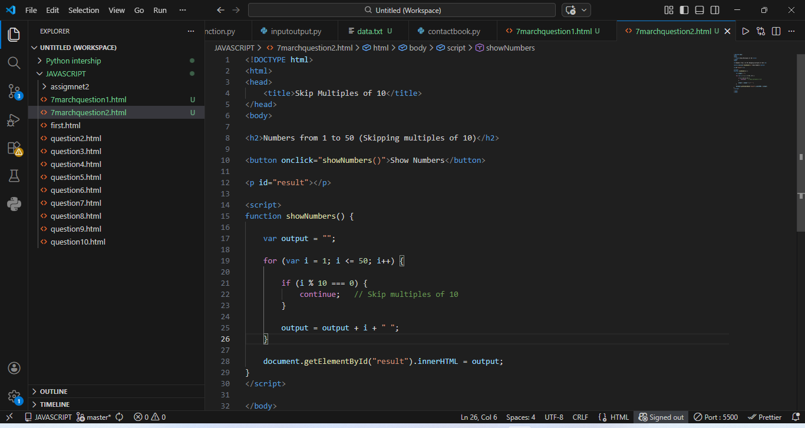
OUTPUT:
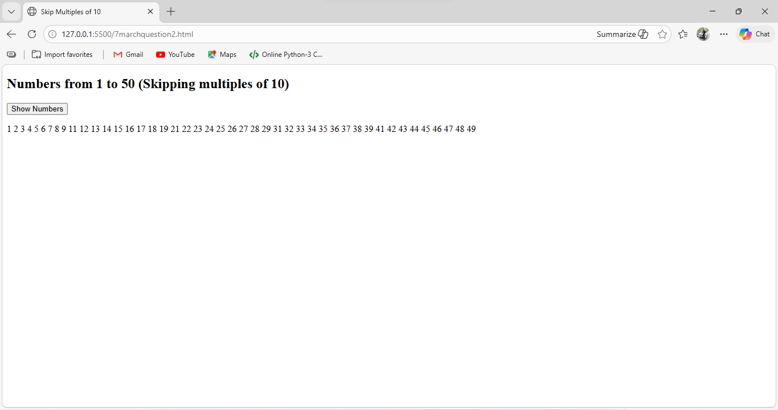
- String Reversal with Conditions: Loop through a string backwards. If the character is a space, replace it with a dash (-); otherwise, print the character.
CODE:
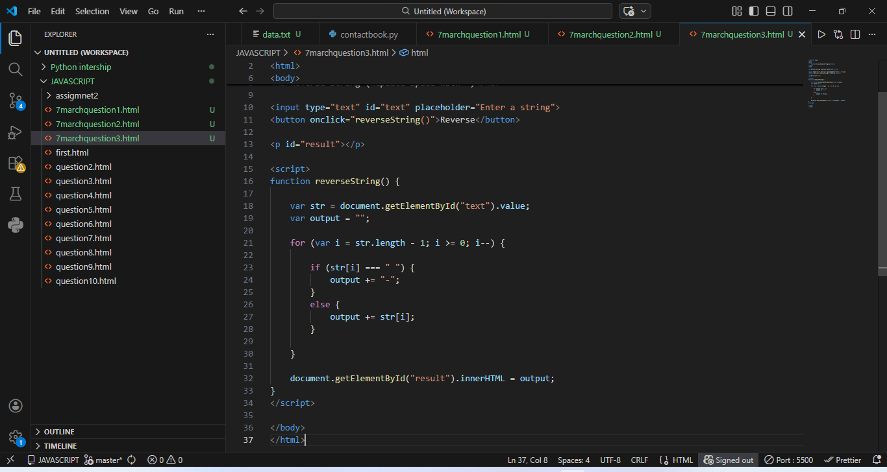
OUTPUT:
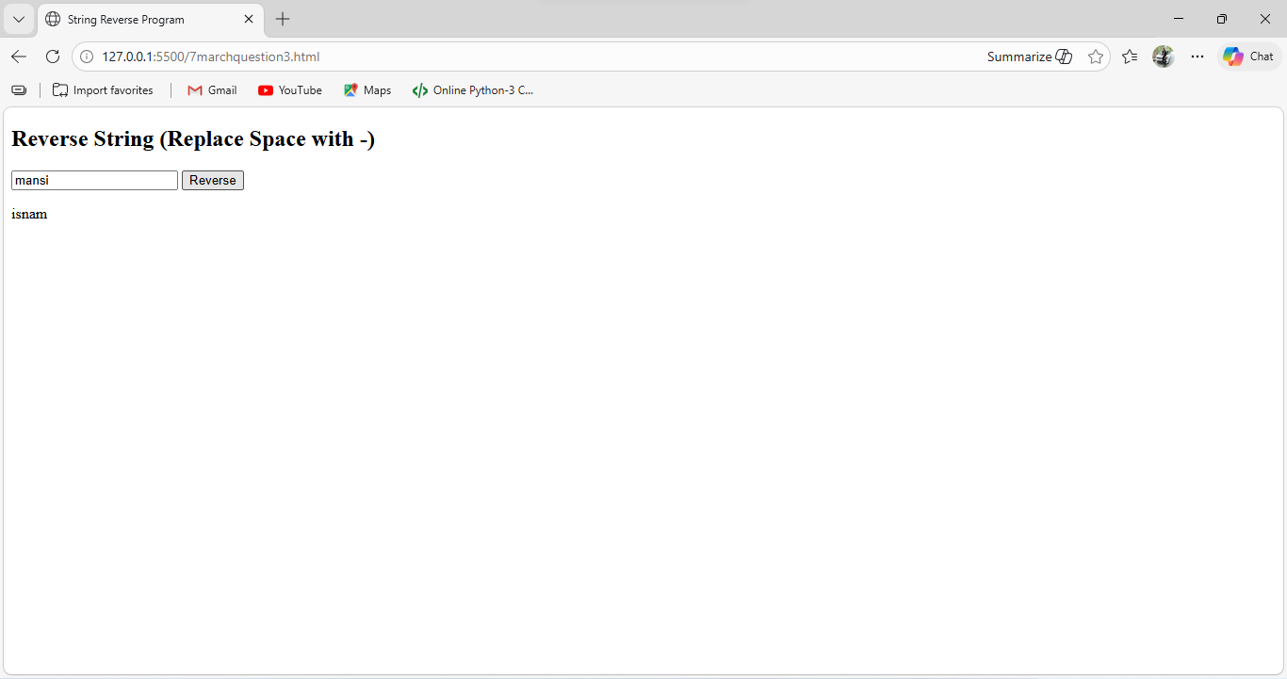
- Nested Multiplication Table: Use a nested for loop to print a 5x5 multiplication grid, but only print the result if it is an even number
CODE:
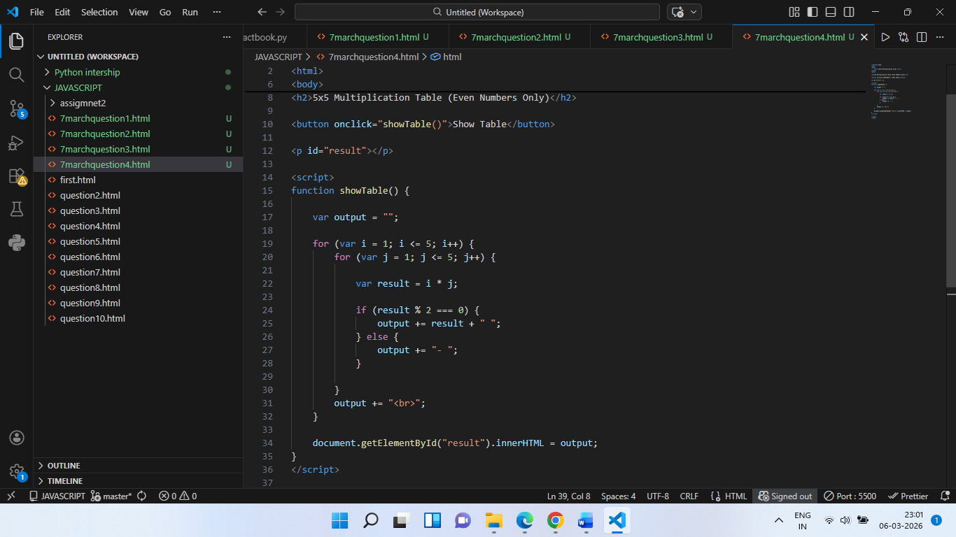
OUTPUT:
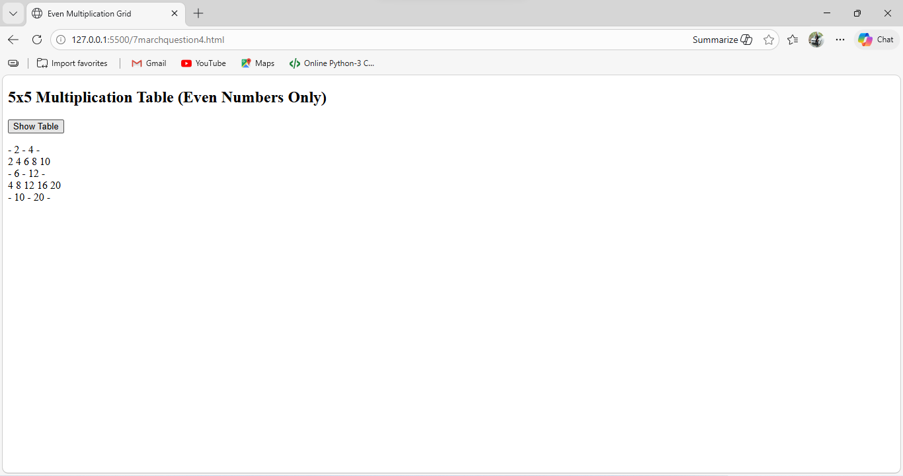

https://github.com/mansiKhule2331/fullstackMansikhule

