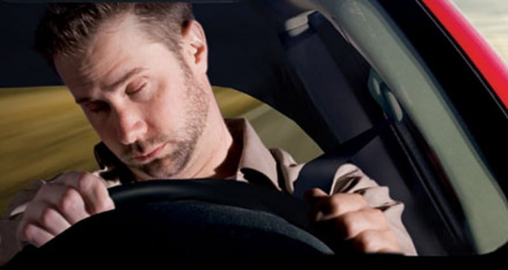

DRIVER AWARENESS DETECTION IN AUTONOMOUS CARS

**INFO 6105 Data Science Engineering Methods and Tools**

**Dhanashri Palodkar**

**Mansi Agrawal**

12/03/2020

# **I**NTRODUCTION

In recent years, driver awareness has been one of the major causes of road accidents and can lead to severe physical injuries, deaths and significant economic losses. Statistics indicate the need for a reliable driver awareness detection system which could alert the driver before a mishap happens.

## ABSTRACT

In this project, we collected different types of facial emotions images to create our own database by performing image-preprocessing. Using transfer learning, we trained our CNN models and tweaked the parameters which gave us better accuracy. Also, we created bottleneck features for training on our dataset. We created inferences for evaluating the model for testing video streams real time. The best model gave an accuracy of 89% and the checkpoint of this file will be used for simulation.

## PROJECT GOALS

* Compare and increase the accuracy and reliability of drowsiness detection and emotion detection using new dataset
* Using deep-learning and neural nets improving road safety in automatic vehicles
* Compare and state the difference between EARSVM Model and present models

# 

# METHODOLOGY

## PROBLEM ANALYSIS

A driver who falls asleep and when the wheel loses control of the vehicle, an action which often results in a crash with either another vehicle or stationary objects. In order to prevent these devastating accidents, the state of drowsiness of the driver should be monitored.

## PLAN

* Integration of multiple facial recognition datasets and CEW(closed eye in the wild)
* Data preprocessing and dataset formation (conversion of all images to a standard format and standard color scale
* Designing and training a convolutional neural network on our dataset.
* Creating bottleneck features and training the model on the newly formed dataset
* Selecting the model with best accuracy & using that model prediction for simulation
* Creating an inference model to test on real world image

## ALGORITHMS

### HAAR cascade for face detection

Haar Cascade is basically a classifier which is used to detect the object for which it has been trained for, from the source. The Haar Cascade is trained by superimposing the positive image over a set of negative images. The training is generally done on a server and on various stages. Better results are obtained by using high quality images and increasing the amount of stages for which the classifier is trained.

## 

## Architecture

Layer (type) Output Shape Param # =================================================================

image_array (Conv2D) (None, 48, 48, 16) 800 _________________________________________________________________

batch_normalization_61 (Batc (None, 48, 48, 16) 64 ________________________________________________________________

conv2d_69 (Conv2D) (None, 48, 48, 32) 25120 _________________________________________________________________

batch_normalization_62 (Batc (None, 48, 48, 32) 128 _________________________________________________________________

activation_27 (Activation) (None, 48, 48, 32) 0 _________________________________________________________________

average_pooling2d_29 (Averag (None, 24, 24, 32) 0 _________________________________________________________________

dropout_25 (Dropout) (None, 24, 24, 32) 0 _________________________________________________________________

conv2d_70 (Conv2D) (None, 24, 24, 64) 51264 ________________________________________________________________

batch_normalization_63 (Batc (None, 24, 24, 64) 256 _________________________________________________________________

conv2d_71 (Conv2D) (None, 24, 24, 64) 102464 _________________________________________________________________

batch_normalization_64 (Batc (None, 24, 24, 64) 256 _________________________________________________________________

activation_28 (Activation) (None, 24, 24, 64) 0 _________________________________________________________________

average_pooling2d_30 (Averag (None, 12, 12, 64) 0 _________________________________________________________________

dropout_26 (Dropout) (None, 12, 12, 64) 0 _________________________________________________________________

conv2d_72 (Conv2D) (None, 12, 12, 64) 36928 _________________________________________________________________

batch_normalization_65 (Batc (None, 12, 12, 64) 256 _________________________________________________________________

conv2d_73 (Conv2D) (None, 12, 12, 128) 73856 _________________________________________________________________

batch_normalization_66 (Batc (None, 12, 12, 128) 512 _________________________________________________________________

activation_29 (Activation) (None, 12, 12, 128) 0 _________________________________________________________________

average_pooling2d_31 (Averag (None, 6, 6, 128) 0 _________________________________________________________________

dropout_27 (Dropout) (None, 6, 6, 128) 0 _________________________________________________________________

conv2d_74 (Conv2D) (None, 6, 6, 128) 147584 _________________________________________________________________

batch_normalization_67 (Batc (None, 6, 6, 128) 512 _________________________________________________________________

conv2d_75 (Conv2D) (None, 6, 6, 256) 295168 _________________________________________________________________

batch_normalization_68 (Batc (None, 6, 6, 256) 1024 _________________________________________________________________

activation_30 (Activation) (None, 6, 6, 256) 0 _________________________________________________________________

average_pooling2d_32 (Averag (None, 3, 3, 256) 0 _________________________________________________________________

dropout_28 (Dropout) (None, 3, 3, 256) 0 _________________________________________________________________

conv2d_76 (Conv2D) (None, 3, 3, 256) 590080 ________________________________________________________________

batch_normalization_69 (Batc (None, 3, 3, 256) 1024 _________________________________________________________________

conv2d_77 (Conv2D) (None, 3, 3, 8) 18440 _________________________________________________________________

global_average_pooling2d_4 ( (None, 8) 0 _________________________________________________________________

predictions (Activation) (None, 8) 0 =================================================================

Total params: 1,345,736

Trainable params: 1,343,720

Non-trainable params: 2,016

Why do we need Layers?

Fully connected layers are an essential component of Convolutional Neural Networks (CNNs), which have been proven very successful in recognizing and classifying images for computer vision. The CNN process begins with convolution and pooling, breaking down the image into features, and analyzing them independently.

CNN :

Convolutional neural network (ConvNets or CNNs) is one of the main categories to do image recognition, images classifications. Objects detections, recognition faces etc., are some of the areas where CNNs are widely used. CNN image classifications take an input image, process it and classify it under certain categories. Technically, deep learning CNN models to train and test, each input image will pass it through a series of convolution layers with filters (Kernels), Pooling, fully connected layers (FC) and apply Softmax function to classify an object with probabilistic values between 0 and 1.

Batch Normalization :

Batch normalization is a technique for training very deep neural networks that standardizes the inputs to a layer for each mini-batch. This has the effect of stabilizing the learning process and dramatically reducing the number of training epochs required to train deep networks.

Average Pooling :

Average pooling involves calculating the average for each patch of the feature map. This means that each 2×2 square of the feature map is down sampled to the average value in the square. For example, the output of the line detector convolutional filter in the previous section was a 6×6 feature map.

Dropout :

Dropout is a technique used to prevent a model from overfitting. Dropout works by randomly setting the outgoing edges of hidden units (neurons that make up hidden layers) to 0 at each update of the training phase.

## PIPELINE DESIGN

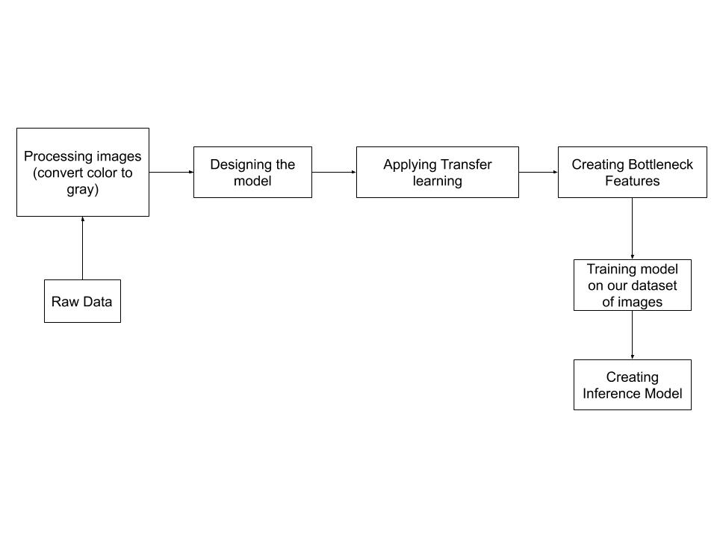

## FLOWCHART DESIGN

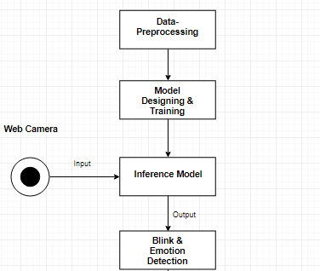

## 

## IMPLEMENTATION DETAILS

In this project, the techniques which we are implementing are data-resizing, transfer learning, bottleneck features, inference predictions, docker implementation, simulation on Django environment.

STEP 1:Data-Resizing

* Resizing an image helps to adjust the size of the image to the desired proportions ,whether it is in pixels,inches or in a specified percentage of change. We use the rescale operation that resizes an image by a given scaling factor. The scaling factor can either be a single floating point value, or multiple values - one along each axis.
* Resize serves the same purpose, but allows to specify an output image shape instead of a scaling factor.When down-sampling an image, resize and rescale should perform Gaussian smoothing to avoid aliasing artifacts. Downscale serves the purpose of down-sampling an n-dimensional image by integer factors using the local mean on the elements of each block of the size factors given as a parameter to the function.
* We have resized the all the original images to 48x48 dimensions
* The dataset created had nearby 32000 images which belonged to 8 classes

STEP 2:Transfer learning

* Transfer learning is a machine learning technique where a model trained on one task is re-purposed on a second related task.
* In transfer learning, we first train a base network on a base dataset and task, and then we repurpose the learned features, or transfer them, to a second target network to be trained on a target dataset and task. This process will tend to work if the features are general, meaning suitable to both base and target tasks, instead of specific to the base task.

STEP 3:Bottleneck Features

* Deep Learning supports an immensely useful feature called 'Transfer Learning'. Basically, we are able to take a pre-trained deep learning model - which is trained on a large-scale dataset and re-purpose it to handle an entirely different problem.
* The basic technique to get transfer learning working is to get a pre-trained model (with the weights loaded) and remove final fully-connected layers from that model. We then use the remaining portion of the model as a feature extractor for our smaller dataset.
* These extracted features are called "Bottleneck Features" (i.e. the last activation maps before the fully-connected layers in the original model). We then train a small fully-connected network on those extracted bottleneck features in order to get the classes we need as outputs for our problem.

## Libraries

**Libraries**: Tensorflow, Keras, OpenCV, Scipy

Tensorflow :

TensorFlow is an open source library for numerical computation and large-scale machine learning. TensorFlow bundles together a slew of machine learning and deep learning (aka neural networking) models and algorithms and makes them useful by way of a common metaphor.

Keras :

KERAS is an Open Source Neural Network library written in Python that runs on top of Theano or Tensorflow. It is designed to be modular, fast and easy to use. Keras High-Level API handles the way we make models, defining layers, or set up multiple input-output models. In this level, Keras also compiles our model with loss and optimizer functions, training process with fit function. Keras doesn't handle Low-Level API such as making the computational graph, making tensors or other variables because it has been handled by the "backend" engine.

OpenCV :

OpenCV is a cross-platform library using which we can develop real-time computer vision applications. It mainly focuses on image processing, video capture and analysis including features like face detection and object detection.

Scipy :

SciPy is an open-source Python library which is used to solve scientific and mathematical problems. It is built on the NumPy extension and allows the user to manipulate and visualize data with a wide range of high-level commands.

## DETAILS ON RUNNING THE MODELS:

The model for this project has various functions such as detection, sleep checker, and emotion detection. It is explained as follows

Load Detection model: This function deals with a cascaded classifier where it loads the pre-trained model which has trained modules of the face and eye detection with the listed expression. The pre-trained data for face is 32000 and for eye-detection is 2000.

Offsets - This function deals with the coordinate mapping on face and eyelids.

Blink Detect - This function works on blink detection where it captures the time for which eyes are closed or open. Blink detect works on the eye dataset.

Predict Emotions: We have given 6 flags to 6 different emotions which involve angry, neutral, happy, sad, surprised. ‘Predict emotions function’ uses face features from face data to predict the emotions of faces in real time. It helps to understand the driver's current mood. The data set used in this function is 32000.

To download pre-trained models please use the following link -[Click Here](https://drive.google.com/open?id=1PGAad7Qh5DZMc1_tEHMqZqQ9qIeod9I4)

# DATASET

We will be using the following resources for creating the database:

* [FacesDB](http://app.visgraf.impa.br/database/faces/)
* [Closed Eye Database](http://parnec.nuaa.edu.cn/xtan/data/ClosedEyeDatabases.html)
* [Japanese Female Facial Expression (JAFFE) Database](http://www.kasrl.org/jaffedb_info.html)
* [Facial Expression Recognition](https://www.kaggle.com/c/challenges-in-representation-learning-facial-expression-recognition-challenge/data)

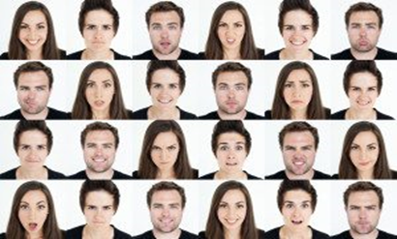

The database IMPA-FACE3D was created in 2008 to assist in the research of facial animation. In particular, for analysis and synthesis of faces and expressions. We take the six universal expressions between human races proposed:

● Happiness

● Sadness

● Surprise

● Anger

● Disgust

● Fear .

This dataset includes acquisitions of 38 individuals with a neutral face sample, samples corresponding to six universal facial expressions and other expressions referring to 5 samples containing mouth and eyes open and / or closed. Also two samples were considered corresponding to the lateral profiles of individuals. Altogether, the data set is composed of 22 men and 16 women, with the majority of individuals aged between 20 and 50 years. 14 samples were acquired for all individuals, summarizing 532 samples in total.

# RESULTS & ANALYSIS

## ANALYSIS OF MODELS

-Emotion Detection Models

|  |  |  |  |  |  |  |
| --- | --- | --- | --- | --- | --- | --- |
| Model No | No. of Epochs | Layers | Training Accuracy | Training Loss | Validation Accuracy | Validation Loss |
| CNN Model 1 | 5 | Convo2D :4  Dense : 2 | 0.3495 | 1.7063 | 0.3523 | 1.6901 |
| CNN Model 2 | 30 | Convo2D :4  Dense : 2  AvgPool: 3 | 0.4348 | 1.5039 | 0.4631 | 1.4335 |
| CNN Model 3 | 41 | Convo2D :4  Dense : 2  AvgPool: 4 | 0.8892 | 0.2858 | 0.8907 | 0.2800 |
| CNN Model 4 | 60 | Convo2D :5  Dense : 3  AvgPool: 1 | 0.5615 | 1.1753 | 0.5635 | 1.1649 |
| CNN Model 5 | 56 | Convo2D :4  Dense : 3  AvgPool: 3 | 0.5349 | 1.2426 | 0.5425 | 1.2060 |
| CNN Model 6 | 25 | Convo2D :2  Dense : 2  AvgPool: 2 | 0.8870 | 0.2933 | 0.8890 | 0.2859 |
| CNN Model 7 | 72 | Convo2D :4  Dense : 2 | 0.8965 | 0.2624 | 0.8987 | 0.2554 |
| CNN Model 8 | 75 | Convo2D :2  Dense : 2  AvgPool : 1 | 0.7850 | 0.2783 | 0.7981 | 0.2134 |
| CNN Model 9 | 85 | Convo2D :3  Dense : 3 | 0.6970 | 1,1369 | 0.5481 | 1.1428 |
| CNN Model 10 | 17 | Convo2D :4  Dense : 3  AvgPool: 3 | 0.8510 | 0.3633 | 0.8528 | 0.3509 |

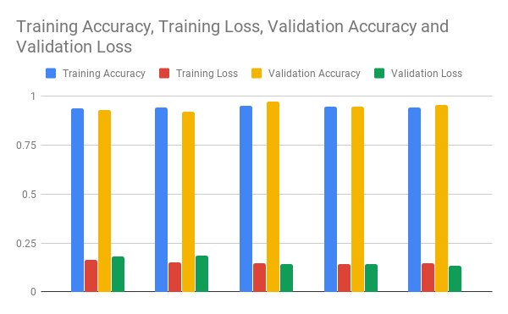

-Eye-classifier Recognition Models:

|  |  |  |  |  |  |  |
| --- | --- | --- | --- | --- | --- | --- |
| Model No | No. of Epochs | Layers | Training Accuracy | Training Loss | Validation  Accuracy | Validation Loss |
| 1 | 22 | Conv2D-4  Dense- 2 | 0.9384 | 0.1642 | 0.9317 | 0.1825 |
| 2 | 47 | Conv2D-4  Dense- 2 | 0.9421 | 0.1521 | 0.9202 | 0.1873 |
| 3 | 17 | Conv2D-4  Dense- 2 | 0.9517 | 0.1477 | 0.9746 | 0.1420 |
| 4 | 63 | Conv2D-4  Dense- 2 | 0.9454 | 0.1431 | 0.9462 | 0.1437 |
| 5 | 58 | Conv2D-4  Dense- 2 | 0.9417 | 0.1478 | 0.9561 | 0.1354 |



# 

# Conclusion

In the conclusion of this project, we can say that currently available technologies use EAR technology or coordinate mapping with accuracy till 90%. Our model uses CNN and transfer learning for blink detection which helps to increase the model accuracy to 96% with less validation and training loss.

We have compared this model with the currently available pretrained models and can arguably say that the model developed by aforementioned process is better and if more data is provided.

# 

# References

* [https://towardsdatascience.com/real-time-face-liveness-detection-with-python-keras-and-openc-c35dc70dafd3](https://towardsdatascience.com/real-time-face-liveness-detection-with-python-keras-and-opencv-c35dc70dafd3)
* <https://medium.com/datadriveninvestor/real-time-facial-expression-recognition-f860dacfeb6a>
* <https://blog.keras.io/building-powerful-image-classification-models-using-very-little-data.html>
* <https://www.pyimagesearch.com/2017/05/08/drowsiness-detection-opencv/>
* <https://machinelearningmastery.com/>
* <https://medium.com/>