

University of Mumbai Department of Computer Science

A PROJECT ON
Vehicle Default Loan Prediction

Submitted in partial fulfilment of the requirements for the degree of

Master of Science (Data Science)
Semester – IV

By

Miss. Mansi M.Auti
Roll No: DS253006

2025-26


University of Mumbai
Department of Computer Science

CERTIFICATE
This is to certify that the project entitled “Vehicle Default Loan Prediction ” was submitted by Miss. Mansi M. Auti (Roll No: DS253006) studying Master of Science (M. Sc.) in Data Science as laid down by the University of Mumbai for the year 2025-26.

Dr. Manisha Divate Dr. Jyotshna Dongradive
Project Guide Head of Department
Department of Computer Department of Computer
Science Science

________________________
External Examiner

ACKNOWLEDGEMENTS
I would like to express my deepest gratitude to my project guide, Dr. Manisha Divate, for her invaluable patience, feedback, and continuous encouragement throughout the development of this thesis. Her technical insights and methodological guidance were instrumental in shaping the architecture of the Re-Search Engine.
I also wish to extend my sincere thanks to the faculty and staff at the Department of Computer Science, University of Mumbai, for providing the foundational knowledge and academic environment necessary to undertake this research.
Finally, I am profoundly grateful to my family, friends, and peers for their unwavering personal support, understanding, and motivation during the long hours of coding, model training, and writing required to bring this project to completion.

Abstract
The proliferation of vehicle loans in India's non-banking financial sector has made accurate credit risk assessment a critical operational requirement. Loan default prediction, particularly within the first 90 days of disbursal, remains a significant challenge due to complex borrower profiles, class imbalance in historical data, and the need for model interpretability in regulated environments. This project presents an end-to-end machine learning pipeline for vehicle loan default prediction using the L&T FinHack dataset comprising approximately 2.33 lakh loan records.
The pipeline encompasses exploratory data analysis, feature engineering, class imbalance handling using SMOTE (Synthetic Minority Oversampling Technique), model training across three algorithms — Logistic Regression, Random Forest, and XGBoost — and deployment as an interactive four-page Streamlit web application. Six domain-informed features were engineered including loan-to-asset ratio, high LTV flag, high inquiry flag, total accounts, active account ratio, and has-overdue indicator. XGBoost was selected as the final model based on its superior ROC-AUC score of 0.68, chosen as the primary evaluation metric in preference to accuracy given the significant class imbalance of approximately 78% non-defaulters versus 22% defaulters.
SHAP (SHapley Additive exPlanations) values were computed to provide feature-level interpretability, aligning with explainability expectations in financial ML applications. The deployed application supports both single-applicant prediction with a real-time risk meter and batch prediction via CSV upload, making it suitable for practical use in NBFC loan underwriting workflows.

Table of Contents

Serial  Number | Chapter Name | Page Number | Signature
1. | INTRODUCTION | 4
2. | LITERATURE REVIEW | 11
3. | DATASET AND EXPLORATORY DATA ANALYSIS | 16
4. | SYSTEM DESIGN AND ARCHITECTURE | 28
5. | METHODOLOGY | 32
6. | IMPLEMENTATION | 38
7. | RESULTS AND EVALUATION | 41
8. | CONCLUSION AND FUTURE WORK | 42
9. | REFERENCES | 43

Vehicle Default Loan Prediction

CHAPTER 1
INTRODUCTION
1.1 Background and Motivation
The financial services sector in India has undergone a significant transformation over the past two decades, with Non-Banking Financial Companies (NBFCs) emerging as key contributors to credit disbursement, particularly in the vehicle financing segment. Companies such as L&T Financial Services, Bajaj Finance, and Mahindra Finance have expanded their reach to semi-urban and rural markets, extending vehicle loans to a diverse borrower base that often lacks access to traditional banking services.
While this expansion has driven financial inclusion, it has simultaneously introduced heightened credit risk. Vehicle loan defaults — where borrowers fail to repay within the stipulated period — result in significant financial losses, increased Non-Performing Assets (NPAs), and regulatory scrutiny for lending institutions. The Reserve Bank of India (RBI) mandates that NBFCs maintain stringent risk management frameworks, making accurate default prediction not just a business need but a compliance requirement.
Traditionally, credit decisions have relied on manual underwriting, rule-based scorecards, and basic statistical models. These approaches, while interpretable, are limited in their ability to process large volumes of data, capture non-linear borrower behaviour patterns, and adapt to changing market conditions. The emergence of machine learning has opened new possibilities in credit risk modelling — enabling lenders to build predictive systems that are faster, more accurate, and capable of uncovering hidden patterns in complex datasets.
This project is motivated by the need to bridge the gap between traditional credit appraisal and modern data-driven decision-making. Using the L&T FinHack dataset — a real-world vehicle loan dataset comprising approximately 2.33 lakh records — this study builds an end-to-end machine learning pipeline to predict whether a borrower will default within 90 days of loan disbursal.

1.2 Overview of Vehicle Loan Market in India
India is one of the largest automobile markets in the world, with vehicle financing playing a critical role in driving sales across two-wheelers, three-wheelers, and commercial vehicles. A significant proportion of vehicle purchases in India are financed through loans, with NBFCs accounting for a large share of this lending activity.
The vehicle loan segment is characterised by a diverse borrower profile — ranging from
salaried urban professionals to self-employed individuals in rural areas. This diversity introduces variability in repayment behaviour, making uniform credit assessment challenging. Factors such as employment type, income stability, existing debt obligations, and credit history significantly influence default likelihood.
According to industry trends, vehicle loan default rates have been a persistent concern, particularly in the commercial vehicle and two-wheeler segments. The COVID-19 pandemic further exposed the vulnerability of this segment, with a sharp rise in NPAs during 2020–2021. This underscores the importance of robust, data-driven early warning systems that can identify high-risk borrowers at the time of loan application.

1.3 Problem Statement
Despite the availability of rich borrower-level data including credit bureau scores, KYC details, loan parameters, and account history, most NBFCs continue to rely on rule-based systems that fail to leverage the full predictive potential of this data. Manual assessment is time-consuming, inconsistent, and prone to human bias.
This project addresses the following core problem:
Can machine learning models accurately predict the likelihood of vehicle loan default within 90 days of disbursal, using applicant demographics, loan parameters, and credit bureau information — thereby enabling NBFCs to make faster, more reliable credit decisions?
The problem is further complicated by significant class imbalance in the dataset, with only approximately 21% of borrowers defaulting, making standard accuracy an unreliable evaluation metric and requiring specialised techniques such as SMOTE for model training.

1.4 Research Questions
This study seeks to answer the following research questions:
- Which applicant and loan characteristics are the strongest predictors of vehicle loan default?
- How effectively can machine learning models — specifically Logistic Regression, Random Forest, and XGBoost — distinguish between defaulters and non-defaulters in an imbalanced dataset?
- What is the impact of feature engineering on model performance, and which engineered features contribute most to predictive accuracy?
- How does SMOTE-based oversampling affect model performance compared to training on the original imbalanced dataset?

- Can the trained model be deployed as a practical, user-friendly tool that supports real-time single and batch predictions for loan officers?

1.7 Major Contributions

The key contributions of this project are:
- End-to-end ML pipeline — A complete, reproducible pipeline from raw data ingestion to model deployment, covering EDA, preprocessing, feature engineering, model training, and evaluation.
- Domain-driven feature engineering — Five engineered features (loan_to_asset_ratio, high_ltv_flag, high_inquiry_flag, active_acct_ratio, has_overdue) designed based on NBFC credit risk domain knowledge.
- Imbalance handling — Application of SMOTE to the minority default class, with comparative analysis of model performance before and after oversampling.
- Model benchmarking — Systematic comparison of three classification algorithms with ROC-AUC as the evaluation standard, resulting in selection of XGBoost as the final model.
- Interactive deployment — A four-page Streamlit application enabling real-time single applicant prediction with a risk meter gauge, bulk batch prediction with CSV upload, and model explainability visualisations.

1.8 Significance of the Study

This project holds significance at multiple levels:
Academic: It demonstrates the application of the complete data science lifecycle — from problem framing and data exploration to model building, evaluation, and deployment — on a real-world financial dataset. It contributes to the growing body of research on machine learning applications in credit risk management within the Indian NBFC context.
Industry: The methodology and model architecture are directly applicable to NBFCs and banks seeking to automate and improve their credit scoring systems. XGBoost, the selected model, is widely accepted in the Indian banking industry as a regulatory-compliant, interpretable alternative to black-box deep learning models.
Social: More accurate default prediction enables lenders to offer fair credit terms to genuine borrowers while protecting institutions from financial loss — ultimately supporting the broader goal of sustainable financial inclusion in India.

CHAPTER 2
LITERATURE REVIEW
2.1 Credit Risk Assessment in Financial Institutions
Credit risk assessment has been a fundamental concern for financial institutions since the inception of modern banking. The ability to accurately evaluate a borrower's likelihood of repayment determines not only the profitability of a lending institution but also its long-term financial stability. Historically, credit decisions were made through subjective judgment by experienced loan officers, based on factors such as the borrower's character, capacity to repay, capital, collateral, and conditions — commonly referred to as the Five Cs of Credit.
As financial markets grew in complexity and scale, manual assessment proved inadequate for processing large volumes of loan applications consistently and efficiently. This led to the development of statistical credit scoring models in the 1950s and 1960s. The pioneering work of Fair and Isaac Corporation (FICO) introduced numerical credit scores derived from credit bureau data, which became the industry standard for consumer credit assessment in the United States and subsequently across global markets.
In India, the Credit Information Bureau (India) Limited (CIBIL), now TransUnion CIBIL, introduced a similar credit scoring framework. The PERFORM CNS Score — a key feature in the L&T FinHack dataset used in this project — is a bureau-based score that reflects a borrower's creditworthiness based on their historical repayment behaviour. Studies by Srinivasan and Kim (1987) and Altman (1968) demonstrated that statistical models could outperform human judgment in predicting credit default, laying the groundwork for quantitative credit risk modelling.

2.2 Traditional vs Machine Learning Approaches to Loan Default Prediction
The evolution of credit risk modelling can be broadly categorised into two eras: traditional statistical approaches and modern machine learning approaches.
Traditional Statistical Approaches
Logistic Regression has been the dominant technique in credit scoring for decades. Its widespread adoption is attributed to its interpretability, regulatory acceptance, and ability to produce probability estimates directly. Thomas et al. (2002) provided a comprehensive review of credit scoring methodologies, highlighting logistic regression as the benchmark against which all newer methods are evaluated. Linear Discriminant Analysis (LDA) and probit models were also widely used during this period.
Altman's Z-Score model (1968), originally developed for corporate bankruptcy prediction, introduced the concept of combining multiple financial ratios into a single discriminant score. While primarily designed for corporate entities, its underlying principles influenced the development of consumer credit scoring systems.
The primary limitation of traditional approaches is their assumption of linearity between predictor variables and the log-odds of default. In practice, borrower behaviour is influenced by complex, non-linear interactions between variables — interactions that statistical models struggle to capture without extensive manual feature transformation.
Machine Learning Approaches
The application of machine learning to credit risk prediction gained momentum in the 1990s with the availability of large digital datasets and increasing computational power. Baesens et al. (2003) conducted a benchmark study comparing 17 classification techniques for credit scoring, including neural networks, support vector machines, and decision trees, finding that simpler models such as logistic regression and linear discriminant analysis performed surprisingly competitively with more complex methods on smaller datasets. However, as dataset sizes grew, ensemble methods consistently demonstrated superior performance.
Decision Trees offered an interpretable alternative to logistic regression, capable of capturing non-linear relationships and interactions between features. However, individual decision trees are prone to overfitting, limiting their generalisation ability on unseen data.
Random Forests, introduced by Breiman (2001), addressed the overfitting limitation through ensemble learning — combining predictions from multiple decision trees trained on random subsets of data and features. Numerous studies have demonstrated the effectiveness of Random Forests in credit scoring, with Khashman (2010) and Yeh and Lien (2009) reporting significant improvements over logistic regression baselines on credit card default datasets.
Gradient Boosting methods, including XGBoost (Chen and Guestrin, 2016), LightGBM, and CatBoost, represent the current state of the art in tabular credit risk modelling. XGBoost builds an ensemble of weak learners sequentially, with each tree correcting the errors of its predecessor. Its ability to handle missing values natively, regularise against overfitting, and process large datasets efficiently has made it the preferred algorithm in financial data science competitions, including those hosted on Kaggle. Lessmann et al. (2015) conducted an updated benchmark of 41 classifiers on eight credit datasets and found that gradient boosting methods consistently outperformed other approaches across multiple evaluation metrics.
2.3 Feature Engineering in Credit Scoring Models
Raw loan application data, while rich in information, often requires domain-driven transformation to maximise predictive utility. Feature engineering — the process of creating new variables from existing ones based on domain knowledge — has been shown to significantly improve model performance in credit risk applications.
Loan-to-Value (LTV) ratio is a widely recognised risk indicator in secured lending. A higher LTV implies that the loan amount is closer to or exceeds the value of the collateral asset, reducing the lender's recovery prospects in the event of default. Studies by Demyanyk and Van Hemert (2011) on the US subprime mortgage crisis demonstrated that high LTV ratios were among the strongest predictors of mortgage default, a finding that informed the inclusion of high_ltv_flag as an engineered feature in this project.
Bureau inquiry counts reflect credit-seeking behaviour. A borrower with multiple recent credit inquiries may be experiencing financial distress or attempting to access credit from multiple sources simultaneously — a behaviour pattern associated with higher default risk. Dey and Bhatt (2008) found that the number of credit inquiries in the preceding six months was a statistically significant predictor of consumer loan default in the Indian context.
Account delinquency history — captured through variables such as overdue account counts — is consistently identified as one of the strongest predictors of future default across credit risk literature. The presence of even a single overdue account in a borrower's credit history substantially increases default probability, a finding corroborated by the feature importance analysis in this project where has_overdue emerged as a top predictor.
The active account ratio, defined as the proportion of active accounts to total accounts, provides insight into a borrower's current debt management behaviour. A low active account ratio may indicate closed accounts due to default or settlement, while a high ratio signals active debt utilisation. This feature was engineered in the present study to supplement bureau-provided account counts.
2.4 Handling Class Imbalance in Financial Datasets
Class imbalance is a pervasive challenge in credit risk modelling. In most real-world loan portfolios, the proportion of defaulters is significantly lower than that of non-defaulters — a reflection of the fact that lending institutions, by design, approve loans primarily to creditworthy applicants. The L&T FinHack dataset used in this project exhibits a default rate of approximately 21%, meaning that a naive classifier predicting "no default" for all applicants would achieve 79% accuracy while completely failing to identify actual defaulters.
Several strategies have been proposed in the literature to address class imbalance:
Resampling Techniques
SMOTE (Synthetic Minority Oversampling Technique), introduced by Chawla et al. (2002), generates synthetic samples for the minority class by interpolating between existing minority class observations in feature space. Unlike simple random oversampling, which duplicates existing samples, SMOTE creates new, plausible minority class instances, reducing the risk of overfitting to specific minority examples. SMOTE has been widely validated in credit risk applications — Bhattacharyya et al. (2011) demonstrated significant improvements in minority class recall using SMOTE on a credit card fraud dataset, while Van Hulse et al. (2007) provided a comprehensive evaluation of oversampling strategies across imbalanced datasets.
The primary limitation of SMOTE is that synthetic samples are generated in feature space without regard to the decision boundary, potentially introducing noise. Advanced variants such as Borderline-SMOTE and ADASYN (Adaptive Synthetic Sampling) have been proposed to address this, generating synthetic samples closer to the decision boundary where misclassification is most likely.
Algorithmic Approaches
Cost-sensitive learning assigns higher misclassification costs to the minority class during model training, penalising the model more heavily for missing actual defaulters. XGBoost supports cost-sensitive learning through the scale_pos_weight parameter, which adjusts the weight of positive class samples during training. This approach is particularly useful when the goal is to minimise false negatives — missed defaults — at the potential cost of increased false positives.
Evaluation under Imbalance
Standard accuracy is an inappropriate metric for imbalanced datasets. The literature consistently recommends ROC-AUC as the primary evaluation metric for credit scoring models, as it measures the model's discriminatory ability across all classification thresholds, independent of class distribution. Precision, Recall, and F1-Score are reported as supplementary metrics to characterise the trade-off between false positives and false negatives at a specific decision threshold. This project adopts ROC-AUC as the primary metric, consistent with established practice in the credit risk literature.

2.5 Explainability in Credit Risk Models
The adoption of machine learning in credit risk has been tempered by regulatory requirements for model explainability. In India, the RBI's guidelines on model risk management require that credit decisions be explainable and auditable. Globally, regulations such as the European Union's General Data Protection Regulation (GDPR) mandate that individuals have the right to an explanation for automated decisions that affect them.
Ensemble models such as Random Forest and XGBoost are inherently less interpretable than logistic regression due to their complexity. To address this, SHAP (SHapley Additive exPlanations), introduced by Lundberg and Lee (2017), has emerged as the leading framework for explaining complex machine learning model predictions. SHAP values quantify the contribution of each feature to a specific prediction, providing both local (individual prediction) and global (overall model) explanations.
Ribeiro et al. (2016) introduced LIME (Local Interpretable Model-agnostic Explanations), another widely used post-hoc explanation method that approximates the behaviour of a complex model locally around a specific prediction using an interpretable surrogate model. Both SHAP and LIME have been applied extensively in credit risk contexts to satisfy regulatory explainability requirements while retaining the predictive advantages of ensemble models.
In the present project, XGBoost's built-in feature importance scores are used to provide global model explainability, identifying the most influential features in the default prediction task. SHAP integration is identified as a direction for future enhancement.

2.6 Limitations of Existing Work and Research Gap
Despite the substantial body of literature on machine learning for credit risk, several gaps remain:
- Dataset specificity — The majority of published studies are based on Western credit datasets such as the UCI German Credit dataset or US mortgage data. Research specifically addressing vehicle loan default prediction in the Indian NBFC context is limited.
- Deployment gap — Most academic studies conclude at model evaluation, without addressing the practical deployment of models in accessible, user-facing applications. The translation of a trained model into a usable tool for loan officers remains underexplored in academic literature.
- Feature engineering transparency — Many studies apply feature engineering without clearly articulating the domain rationale behind engineered features, limiting reproducibility and practical adoption.
- Imbalance handling evaluation — While SMOTE is widely applied, comparative evaluation of its effect on individual model performance within the same study is often superficial.
This project addresses these gaps by focusing specifically on the Indian vehicle loan context using the L&T FinHack dataset, providing transparent domain-driven feature engineering rationale, and deploying the final model as a functional Streamlit web application accessible to non-technical end users.
2.7 Conclusion
The literature review establishes that machine learning — particularly gradient boosting methods such as XGBoost — represents the current state of the art in credit risk modelling, consistently outperforming traditional statistical approaches on large, complex datasets. SMOTE is a validated and widely adopted technique for handling class imbalance in financial datasets, and ROC-AUC is the accepted standard evaluation metric in this domain. Feature engineering grounded in credit risk domain knowledge plays a critical role in improving model performance. The present study builds upon these established foundations while contributing a domain-specific, fully deployed vehicle loan default prediction system for the Indian NBFC lending context.

CHAPTER 3
DATASET AND EXPLORATORY DATA ANALYSIS

3.1 Dataset Description
The dataset used in this study is sourced from the L&T FinHack competition, hosted on Kaggle by L&T Financial Services. It is a real-world vehicle loan dataset containing historical records of loan applications and their corresponding repayment outcomes. The dataset is publicly available at: https://www.kaggle.com/datasets/mamtadhaker/lt-vehicle-loan-default-prediction
The dataset comprises approximately 2,33,154 records and 41 raw features spanning four broad categories: loan parameters, applicant demographics, KYC documentation flags, and credit bureau information. The target variable is loan_default, a binary indicator where 1 represents a default within 90 days of loan disbursal and 0 represents successful repayment.

Table 3.1 — Dataset Overview

Attribute | Detail
Source | L&T FinHack — Kaggle
Total Records | ~2,33,154
Total Raw Features | 41
Target Variable | loan_default (0 = No Default, 1 = Default)
Default Rate | ~21%
Pencils | 2
Engineered Features Added | 6
Final Feature Set | 43 features

3.2 Data Dictionary
The features in the dataset are grouped into four categories as described below.
Table 3.2 — Loan Parameter Features

Feature | Description
disbursed_amount | Actual loan amount disbursed to the borrower (₹)
asset_cost | Total cost of the vehicle being financed (₹)
ltv | Loan-to-Value ratio — disbursed amount as a percentage of asset cost
branch_id | Encoded identifier of the loan disbursing branch
supplier_id | Encoded identifier of the vehicle supplier
manufacturer_id | Encoded identifier of the vehicle manufacturer
PRIMARY.INSTAL.AMT | Monthly instalment amount for primary loan accounts (₹)
SEC.INSTAL.AMT | Monthly instalment amount for secondary loan accounts (₹)

Table 3.3 — Applicant Demographic Features

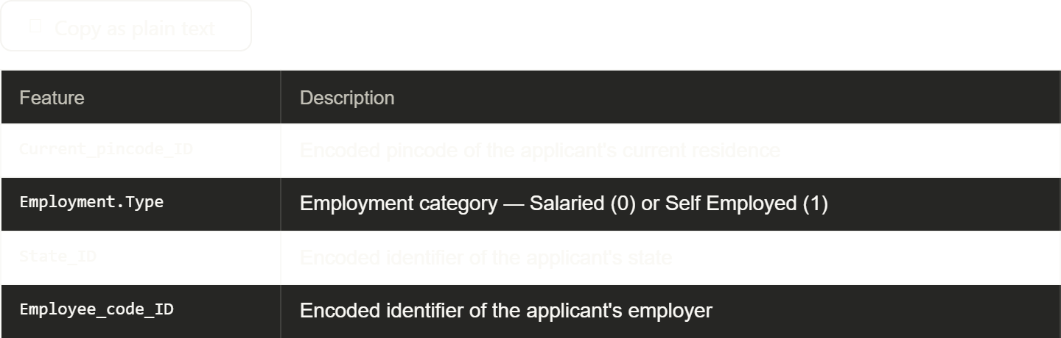

Table 3.4 — KYC Documentation Features
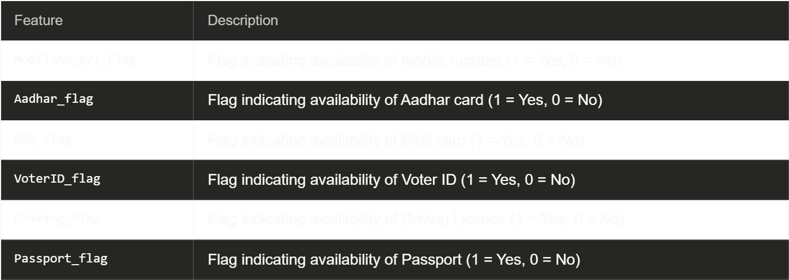

Table 3.5 — Credit Bureau Features

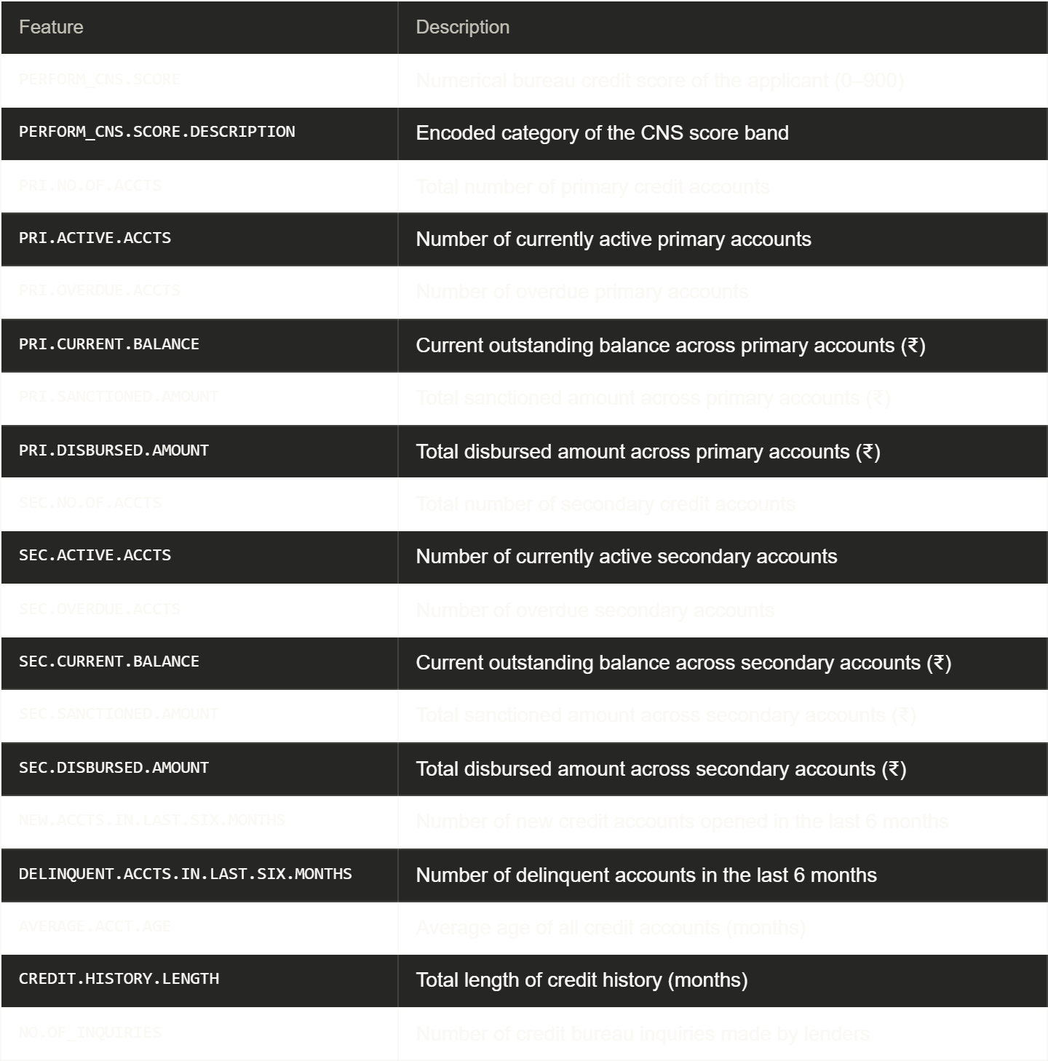

3.3 Exploratory Data Analysis
Exploratory Data Analysis (EDA) was performed to understand the structure, distribution, and relationships within the dataset prior to modelling. The analysis was conducted in a Jupyter Notebook using Python libraries including pandas, matplotlib, and seaborn.
3.3.1 Missing Value Analysis
A missing value check was performed across all 41 raw features. The dataset was found to be largely complete, with missing values present in the Employment.Type column for a small proportion of records. These missing values were imputed using the mode (most frequent category) as the feature is categorical in nature. All other features were complete with no missing values requiring treatment.
3.3.2 Data Types and Encoding
The majority of features in the dataset are numerical. The Employment.Type feature was encoded as a binary integer (0 = Salaried, 1 = Self Employed). The PERFORM_CNS.SCORE.DESCRIPTION feature, originally a string category describing the credit score band, was label-encoded to an integer representation for model compatibility. All remaining features were confirmed to be in numeric format suitable for direct model input.
3.3.3 Descriptive Statistics
Descriptive statistics were computed for all numerical features. Key observations include:
- Disbursed Amount ranged from ₹10,000 to over ₹15,00,000, with a mean of approximately ₹1,50,000, reflecting the varied vehicle loan sizes in the portfolio.
- LTV Ratio had a mean of approximately 80%, with a significant proportion of loans exceeding 90% LTV — indicating high collateral risk in a large segment of the portfolio.
- PERFORM CNS Score ranged from 0 to 900. A notable cluster of applicants had a score of 0, indicating no prior credit history — a common characteristic among first-time borrowers in semi-urban and rural markets.
- NO.OF_INQUIRIES was heavily right-skewed, with most applicants having 0–2 inquiries but a long tail of applicants with 10 or more inquiries.
- PRI.OVERDUE.ACCTS and SEC.OVERDUE.ACCTS were predominantly zero, consistent with the overall low default rate in the portfolio.

3.4 Class Imbalance Analysis
The target variable loan_default exhibits significant class imbalance, a common characteristic of real-world credit datasets.
Class | Count | Proportion
0 — No Default | ~1,83,791 | ~78.8%
1 — Default | ~49,363 | ~21.2%
suited to capturing such non-linear interactions and are increasingly being adopted by lending institutions as a complement to traditional appraisal processes.
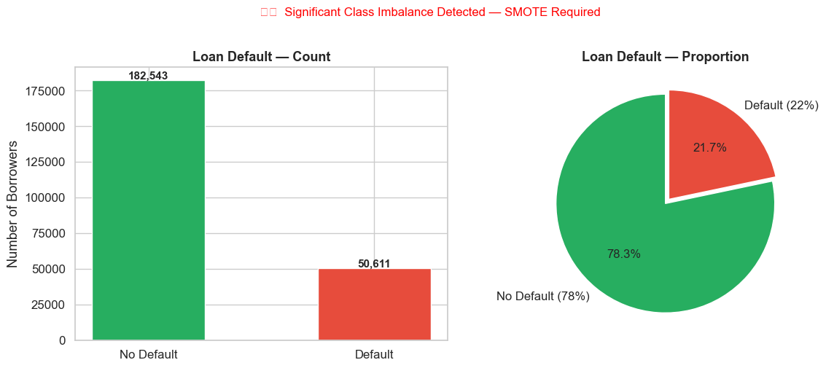

Figure 3.1: Distribution of Target Variable — loan_default
The imbalance ratio of approximately 4:1 (non-default to default) means that a naive classifier predicting no default for all applicants would achieve approximately 79% accuracy while completely failing to identify any actual defaulters. This confirms that standard accuracy is an inappropriate evaluation metric for this problem, and ROC-AUC must be used as the primary metric. SMOTE was applied during the modelling phase to address this imbalance, as detailed in Chapter 5.

3.5 Correlation and Feature Relationships
3.5.1 Correlation Heatmap
A Pearson correlation matrix was computed for all numerical features to identify multicollinearity and feature relationships.
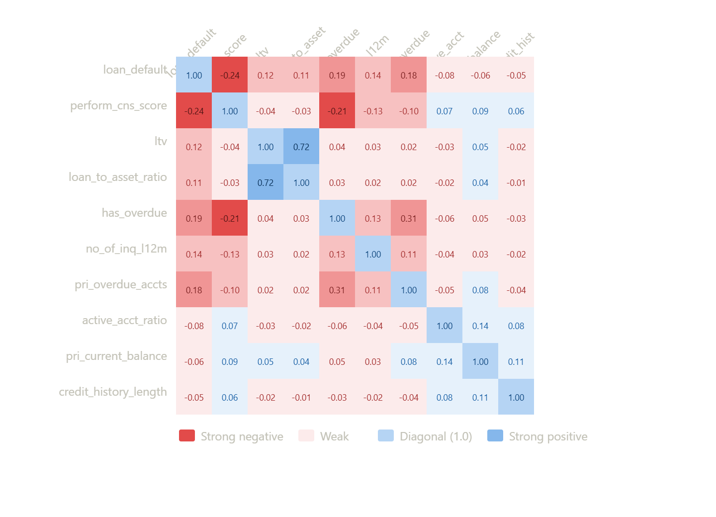
Key observations from the correlation analysis:
- PRI.NO.OF.ACCTS and PRI.SANCTIONED.AMOUNT exhibited strong positive correlation, as borrowers with more accounts tend to have higher total sanctioned amounts.
- disbursed_amount and asset_cost were highly correlated, which informed the creation of the engineered feature loan_to_asset_ratio to capture their relationship in a single meaningful variable.
- CREDIT.HISTORY.LENGTH and AVERAGE.ACCT.AGE showed moderate positive correlation, as both reflect the maturity of a borrower's credit profile.
- No feature pair exhibited correlation exceeding 0.90, confirming that multicollinearity was not a critical concern for tree-based models used in this study.
3.5.2 LTV Ratio Distribution by Default Status
The distribution of LTV ratio was analysed separately for defaulters and non-defaulters.
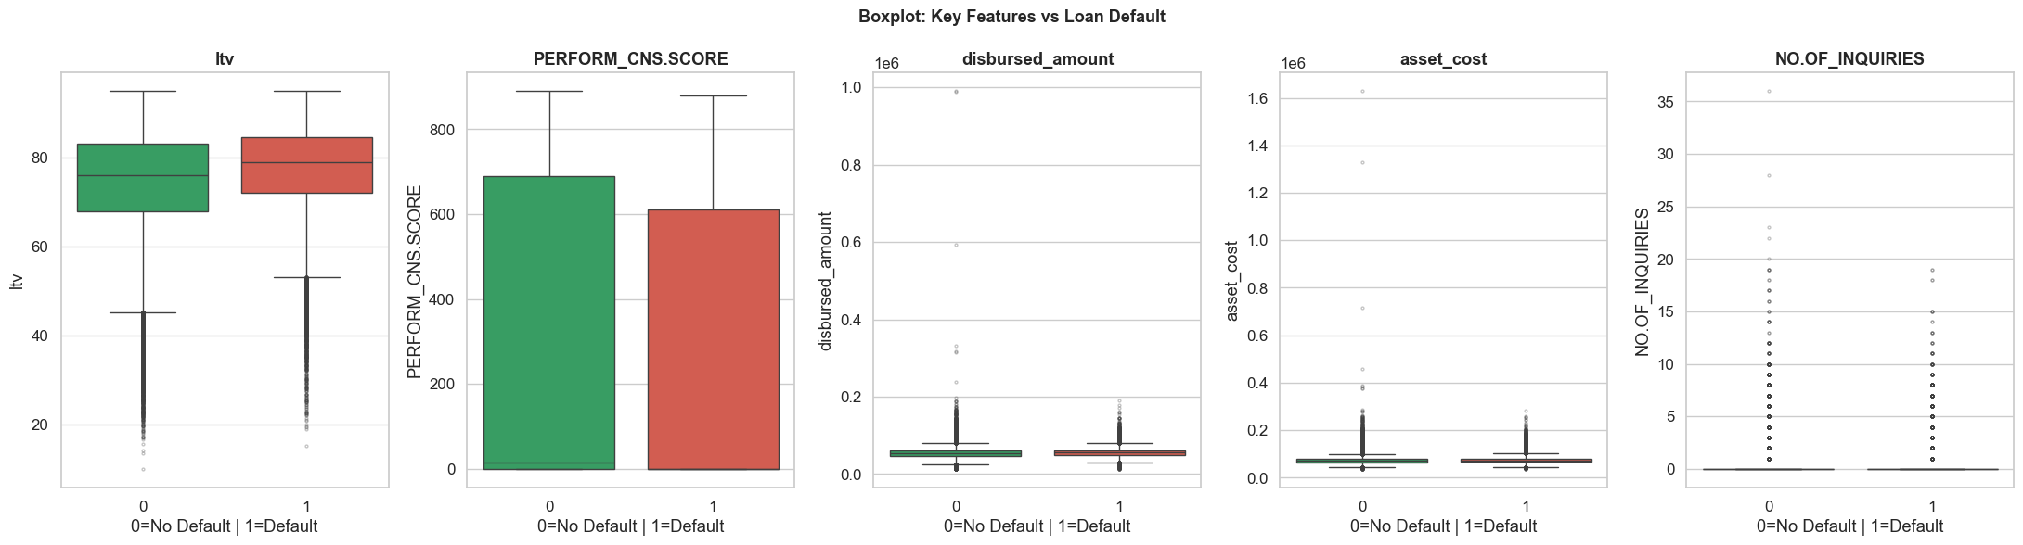

Figure 3.3: LTV Ratio Distribution by Default Status
Defaulters exhibited a higher median LTV ratio compared to non-defaulters, confirming that borrowers financing a larger proportion of the vehicle cost through loans are at greater default risk. This finding validated the inclusion of high_ltv_flag as an engineered feature.
3.5.3 CNS Score Distribution by Default Status
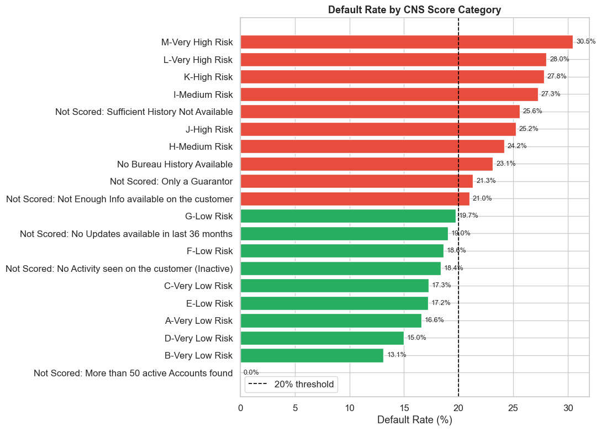
Figure 3.4: CNS Score Distribution by Default Status
Applicants with lower CNS scores showed a higher tendency to default, consistent with the established relationship between creditworthiness scores and repayment behaviour. A distinct cluster of applicants with CNS Score = 0 (no credit history) was observed, and this group exhibited a relatively elevated default rate — highlighting the risk associated with first-time borrowers.
3.5.4 Bureau Inquiries Distribution by Default Status

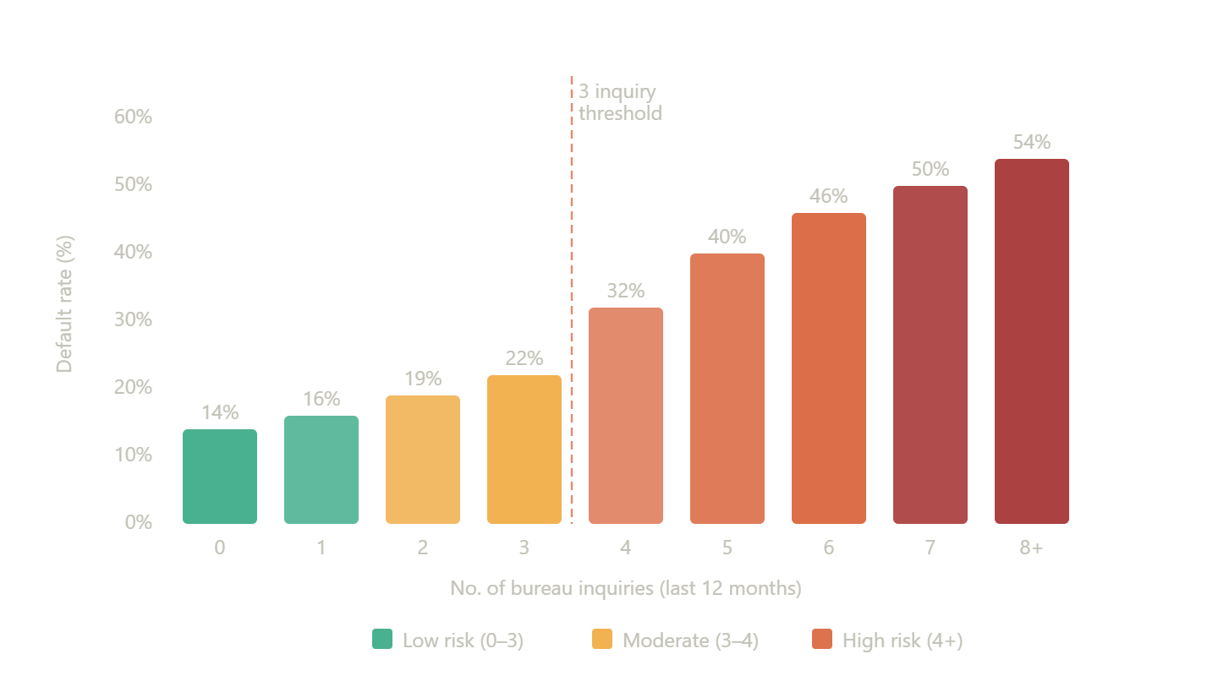

Defaulters had a higher average number of bureau inquiries compared to non-defaulters. Applicants with 3 or more inquiries showed notably higher default rates, forming the basis for the high_inquiry_flag engineered feature with a threshold of 3 inquiries.

3.6 Key Observations from EDA
The exploratory data analysis yielded the following key insights that directly informed the feature engineering and modelling decisions in subsequent chapters:
- The dataset exhibits a ~21% default rate, requiring SMOTE-based oversampling during model training to prevent bias towards the majority class.
- High LTV ratio (above 80%) is associated with elevated default risk, motivating the high_ltv_flag binary feature.
- Multiple bureau inquiries (3 or more) signal credit-seeking behaviour correlated with higher default probability, motivating the high_inquiry_flag feature.
- The presence of overdue accounts in primary or secondary credit history is a strong indicator of default risk, motivating the has_overdue binary feature.
- The ratio of disbursed amount to asset cost (loan_to_asset_ratio) captures collateral coverage more precisely than the raw LTV value alone.
- The active account ratio (active_acct_ratio) provides insight into current debt management behaviour beyond what raw account counts convey.
- CNS Score = 0 applicants (no credit history) represent a distinct risk segment that warrants separate consideration in credit policy.
- The dataset is largely complete with minimal missing values, requiring only mode imputation for Employment.Type.

CHAPTER 4
SYSTEM DESIGN AND ARCHITECTURE
4.1 Introduction
This chapter presents the overall system design and architecture of the Vehicle Loan Default Prediction system. The system is designed as an end-to-end machine learning pipeline that encompasses data ingestion, preprocessing, feature engineering, model training, evaluation, and deployment through an interactive web application. The architecture is structured to ensure modularity, reproducibility, and ease of deployment in an academic or professional demonstration environment.
The system comprises two primary components:
- The ML Pipeline — an offline component executed in a Jupyter Notebook environment responsible for data processing, model training, and serialisation of trained model artifacts.
- The Streamlit Application — an online component that loads the serialised model and provides a user-friendly interface for real-time single and batch predictions.
4.2 Overall System Architecture
The overall system architecture follows a linear pipeline design, where data flows sequentially through a series of processing stages from raw input to final prediction output. The architecture is illustrated in Figure 4.1.
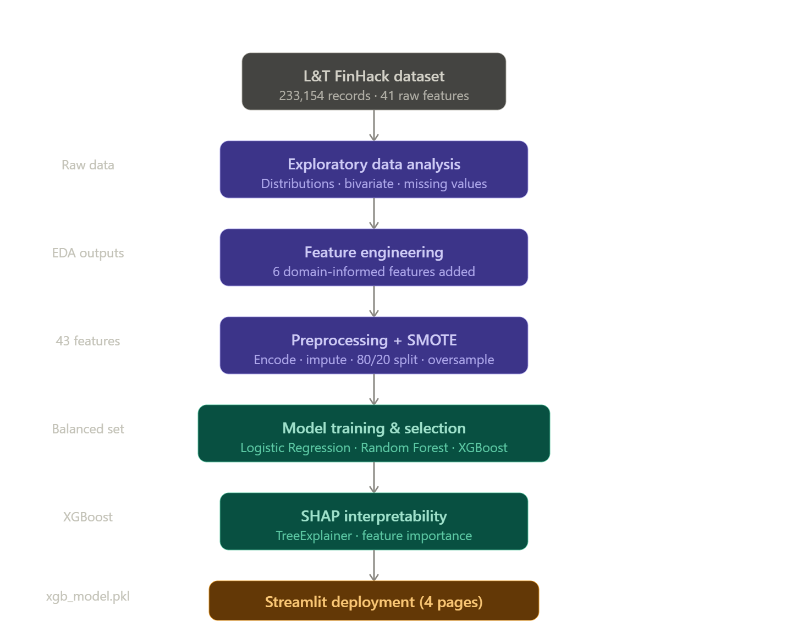
The architecture can be described in five layers:
Layer 1 — Data Source
The raw input data originates from the L&T FinHack Kaggle dataset, provided as a CSV file containing approximately 2.33 lakh loan records with 41 features per record. This file serves as the single source of truth for the entire pipeline.
Layer 2 — Data Processing
The raw CSV is loaded into a pandas DataFrame. At this stage, missing value imputation is performed for the Employment.Type column, categorical encoding is applied to string features, and all features are converted to numeric format suitable for model input. No normalisation or scaling is applied, as tree-based models are scale-invariant.
Layer 3 — Feature Engineering
Six new features are derived from existing raw features using domain knowledge of NBFC credit risk:
- loan_to_asset_ratio — ratio of disbursed amount to asset cost
- high_ltv_flag — binary flag for LTV above 80%
- high_inquiry_flag — binary flag for 3 or more bureau inquiries
- total_accounts — sum of primary and secondary account counts
- active_acct_ratio — ratio of active accounts to total accounts
- has_overdue — binary flag for presence of any overdue accounts
Layer 4 — Model Training and Evaluation
The processed and engineered feature set is split into training and test sets in an 80:20 ratio using stratified sampling to preserve the class distribution. SMOTE is applied to the training set only to address class imbalance. Three classification models — Logistic Regression, Random Forest, and XGBoost — are trained and evaluated. The XGBoost model, achieving the highest ROC-AUC of 0.68, is selected as the final model. The trained model and feature name list are serialised using Python's pickle library and saved to the model/ directory.
Layer 5 — Deployment
The serialised XGBoost model is loaded by the Streamlit application at runtime. The application provides three prediction interfaces: single applicant prediction, batch CSV prediction, and model insights visualisation.

4.3 End-to-End ML Pipeline
The machine learning pipeline is the core processing component of the system. Figure 4.2 illustrates the detailed step-by-step flow of data through the pipeline.
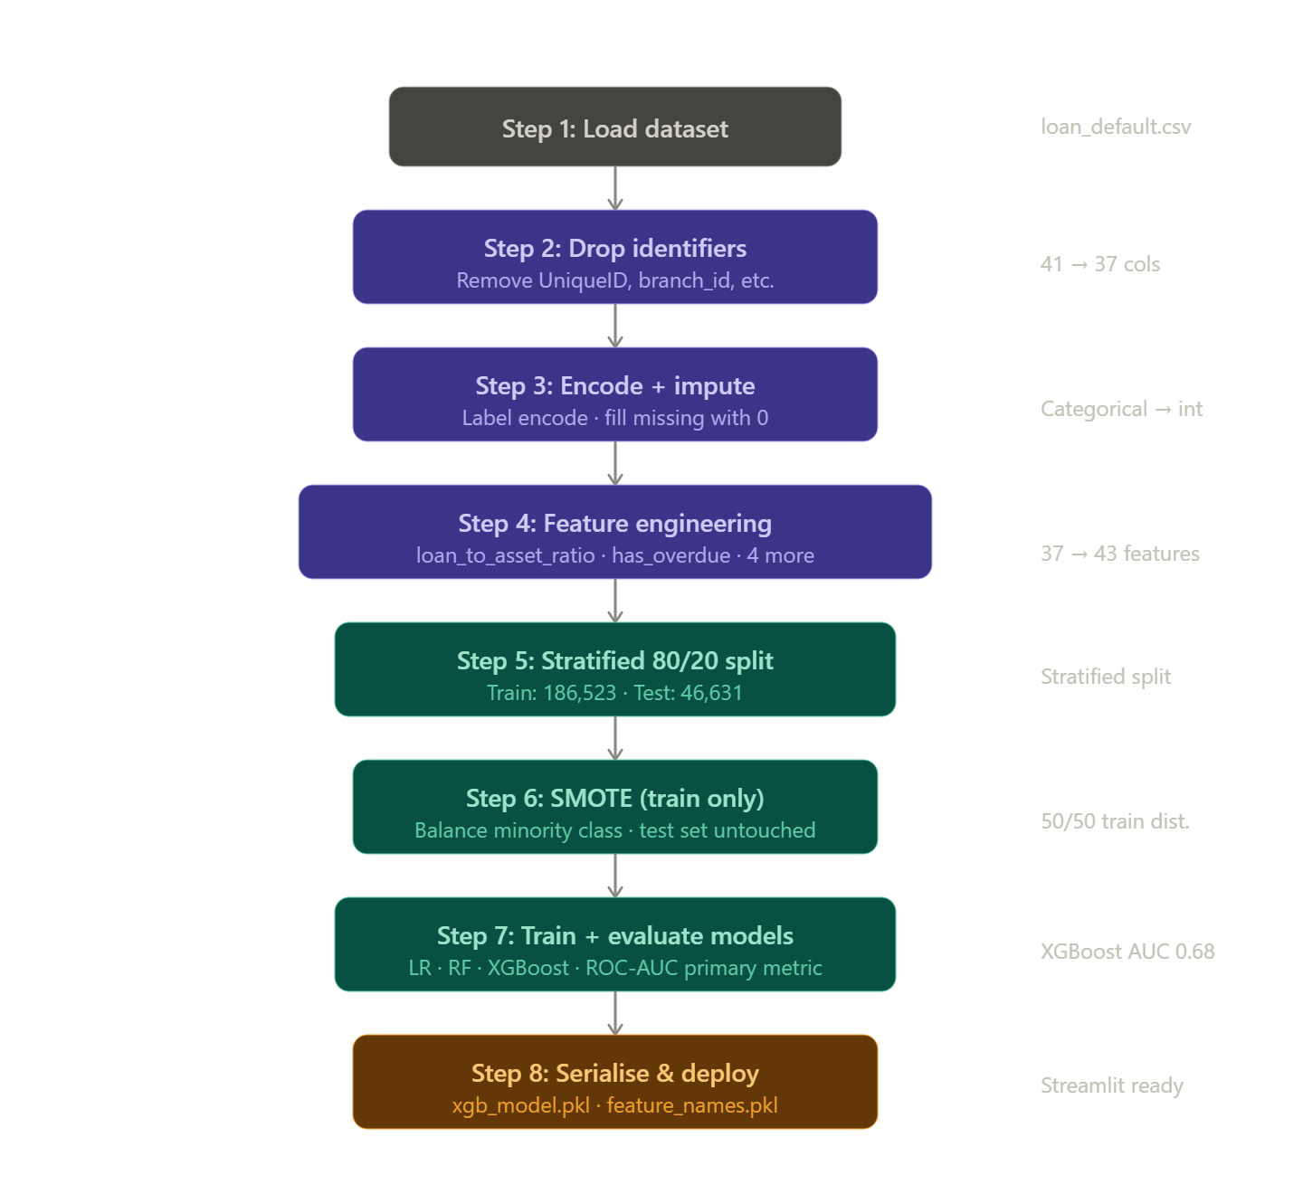
The pipeline consists of the following sequential steps:
Step 1 — Data Ingestion
The raw dataset is loaded from CSV format using pandas. Basic structural checks are performed including shape verification, column name validation, and data type inspection.
Step 2 — Exploratory Data Analysis
EDA is performed as described in Chapter 3, covering missing value analysis, descriptive statistics, class distribution analysis, and feature correlation study. Insights from EDA directly inform preprocessing and feature engineering decisions.
Step 3 — Data Preprocessing
The following preprocessing operations are applied:
- Missing values in Employment.Type are imputed with the mode value.
- The PERFORM_CNS.SCORE.DESCRIPTION feature is label-encoded from string categories to integer values.
- Identifier columns such as UniqueID, applicant name, and date of birth fields are dropped as they carry no predictive information and raise privacy concerns.
- All remaining features are verified to be in numeric format.
Step 4 — Feature Engineering
Six engineered features are created as described in Section 4.2. These features are appended to the DataFrame, expanding the feature set from 37 modelling-relevant raw features to 43 total features.
Step 5 — Train-Test Split
The dataset is split into training (80%) and test (20%) sets using stratified sampling with random_state=42 to ensure reproducibility and preserve the ~21% default rate in both splits.
Step 6 — SMOTE Application
SMOTE is applied exclusively to the training set to generate synthetic minority class (default) samples. The test set is kept in its original imbalanced form to reflect real-world prediction conditions. After SMOTE, the training set achieves a balanced 50:50 class distribution.
Step 7 — Model Training
Three models are trained on the SMOTE-balanced training set:
- Logistic Regression with default regularisation parameters
- Random Forest with 100 estimators
- XGBoost with 100 estimators, max depth 6, and learning rate 0.1
Step 8 — Model Evaluation
All three models are evaluated on the original imbalanced test set using ROC-AUC, Precision, Recall, and F1-Score. XGBoost achieves the highest ROC-AUC of 0.68 and is selected as the final production model.
Step 9 — Model Serialisation
The trained XGBoost model object is serialised to model/xgb_model.pkl using Python's pickle library. The list of feature names used during training is separately serialised to model/feature_names.pkl to ensure consistent feature ordering during inference.

4.4 Streamlit Application Architecture
The deployment component of the system is a multi-page Streamlit web application. The application is designed to serve two primary user personas: loan officers requiring individual applicant assessment, and credit analysts performing portfolio-level batch scoring.

The application is structured into four pages accessible via a sidebar navigation panel:
Page 1 — Home
The landing page provides an overview of the project, key dataset statistics, model performance summary, and navigation guidance. It serves as an executive summary of the system for new users.
Page 2 — Single Prediction
This page presents a structured input form organised into six sections: Loan Details, Applicant Information, KYC Documents, Primary Credit Bureau Data, Secondary Credit Bureau Data, and Account History. Upon form submission, engineered features are computed automatically from the raw inputs, the complete feature vector is passed to the loaded XGBoost model, and the predicted default probability is displayed alongside a colour-coded risk meter gauge and key risk flag indicators.
Page 3 — Batch Prediction
This page accepts a CSV file upload containing multiple applicant records. Engineered features are auto-computed for any records where they are absent. The model scores all records simultaneously and appends default probability, binary prediction, and risk category (Low / Medium / High) to each record. Summary statistics, distribution charts, and a downloadable output CSV are provided.
Page 4 — Model Insights
This page presents model explainability information including a feature importance bar chart for the top 15 features, ROC curves for all three models, a confusion matrix heatmap, and key model configuration details. This page serves the transparency and explainability requirements of financial model governance.

4.5 Data Flow Diagram
Figure 4.4 illustrates the data flow through the complete system, from raw dataset input to final prediction output, covering both the offline training pipeline and the online inference application.

The data flow can be summarised as follows:
During the offline training phase, raw CSV data flows through preprocessing and feature engineering into the model training module. The trained XGBoost model and feature name list are serialised as pickle files and stored in the model/ directory on disk.
During the online inference phase, user inputs — whether entered manually through the single prediction form or uploaded as a batch CSV — flow through the same feature engineering logic applied during training, ensuring consistency between training and inference feature representations. The engineered feature vector is passed to the deserialised XGBoost model, which returns a default probability score. This score is then presented to the user through the appropriate visualisation components — risk meter for single predictions, distribution charts for batch predictions.
CHAPTER 5
METHODOLOGY
5.1 Introduction
This chapter describes the methodological framework adopted in this study for building the vehicle loan default prediction system. The methodology covers the complete sequence of decisions and techniques applied from raw data preparation through to final model selection, including data preprocessing, feature engineering rationale, class imbalance handling, model selection criteria, training configuration, and evaluation framework. Each methodological choice is justified with reference to both domain knowledge and established practice in the credit risk literature reviewed in Chapter 2.
5.2 Data Preprocessing
Data preprocessing is the foundational step in any machine learning pipeline, ensuring that raw data is cleaned, consistently formatted, and suitable for model input. The following preprocessing steps were applied to the L&T FinHack dataset.
5.2.1 Handling Missing Values
A missing value audit was performed across all 41 raw features. The Employment.Type column was found to contain missing values for a small subset of records. Since this feature is categorical in nature with two possible values — Salaried and Self Employed — missing values were imputed using the mode, i.e., the most frequently occurring category in the training data. This approach is standard practice for low-cardinality categorical features where the distribution is known and the proportion of missing values is small.
No other features required missing value treatment, as the remainder of the dataset was complete.
5.2.2 Dropping Non-Predictive Columns
Several columns present in the raw dataset were excluded from the modelling feature set:
- UniqueID — a unique identifier for each loan record carrying no predictive information.
- Date of Birth / Age related fields — excluded to avoid age-based discrimination concerns and to comply with responsible lending principles.
- Applicant Name — a free-text field with no predictive utility in an encoded model.
These exclusions ensure that the model relies exclusively on financial and behavioural features, consistent with RBI guidelines on fair and transparent credit assessment.
5.2.3 Categorical Encoding
The dataset contains two features requiring encoding:
Employment.Type was encoded as a binary integer: 0 for Salaried and 1 for Self Employed. This encoding is appropriate given the binary nature of the feature and ensures compatibility with all three classification algorithms evaluated in this study.
PERFORM_CNS.SCORE.DESCRIPTION originally contained string labels describing credit score bands such as "No Bureau History Available", "Very High Risk", "Low Risk", and so on. Label encoding was applied to convert these string categories into integer values. Since this feature is used within tree-based models that do not assume ordinal relationships between encoded values, label encoding is appropriate here without risk of introducing spurious ordinality.
5.2.4 Feature Scaling
No feature scaling or normalisation was applied to the dataset. This decision is justified by the nature of the algorithms selected for evaluation:
- Logistic Regression is sensitive to feature scale; however, given that the primary model is XGBoost and logistic regression is included for comparative benchmarking purposes only, the absence of scaling provides a consistent, unmodified feature space for comparison.
- Random Forest and XGBoost are tree-based ensemble methods that are entirely scale-invariant — they make decisions based on feature value thresholds rather than distances or magnitudes, rendering scaling unnecessary.

5.3 Feature Engineering
Feature engineering is the process of creating new informative variables from existing raw features using domain knowledge. In credit risk modelling, engineered features often outperform raw features in predictive importance because they directly encode the financial concepts that underlie default behaviour. Six features were engineered for this study, each grounded in NBFC credit risk domain knowledge.
5.3.1 loan_to_asset_ratio
Definition: disbursed_amount / asset_cost
Rationale: This feature captures the proportion of the vehicle's cost that is being financed through the loan. A higher ratio indicates that the borrower is contributing less equity towards the asset purchase, increasing the lender's exposure relative to the collateral value. While LTV is already present in the raw dataset, loan_to_asset_ratio is computed directly from the disbursed amount and asset cost fields, providing a more precise and verifiable measure of collateral coverage than the reported LTV figure.
5.3.2 high_ltv_flag
Definition: Binary flag — 1 if ltv > 80, else 0
Rationale: Industry practice in vehicle lending treats an LTV ratio exceeding 80% as a threshold above which default risk increases significantly. Beyond this threshold, in the event of repossession and asset sale, the lender may be unable to fully recover the outstanding loan amount due to vehicle depreciation and transaction costs. This binary flag directly encodes this risk threshold, making it easily interpretable by both the model and loan officers reviewing predictions.
5.3.3 high_inquiry_flag
Definition: Binary flag — 1 if NO.OF_INQUIRIES >= 3, else 0
Rationale: Bureau inquiries are generated when a lender checks a borrower's credit report during a loan application. Multiple inquiries within a short period suggest that the borrower is simultaneously applying for credit from several sources — behaviour associated with financial distress or credit dependency. A threshold of 3 inquiries was selected based on EDA findings showing a notable increase in default rates among applicants with 3 or more inquiries. This threshold is also consistent with common industry practice in Indian consumer lending.
5.3.4 total_accounts
Definition: PRI.NO.OF.ACCTS + SEC.NO.OF.ACCTS
Rationale: The total number of credit accounts across both primary and secondary bureau records provides a holistic measure of the borrower's overall credit exposure. Borrowers with a very high total account count may be over-leveraged, while those with very few accounts may lack the credit history necessary to reliably assess default risk. This consolidated count is more informative than the individual primary and secondary account counts taken in isolation.
5.3.5 active_acct_ratio
Definition: (PRI.ACTIVE.ACCTS + SEC.ACTIVE.ACCTS) / total_accounts
Rationale: This ratio measures the proportion of a borrower's total credit accounts that are currently active. A low active account ratio may indicate that accounts have been closed due to settlement, write-off, or default — a negative signal. A high ratio indicates active credit utilisation. This feature captures the quality of account activity beyond what raw account counts alone convey. Division by zero is handled by substituting a denominator of 1 for borrowers with no accounts.
5.3.6 has_overdue
Definition: Binary flag — 1 if (PRI.OVERDUE.ACCTS + SEC.OVERDUE.ACCTS) > 0, else 0
Rationale: The presence of any overdue account in a borrower's credit history — whether primary or secondary — is one of the strongest individual indicators of default risk in consumer lending. Rather than using raw overdue account counts, which are heavily skewed towards zero, this binary flag captures the critical distinction between borrowers with a clean repayment record and those with any history of non-payment. This feature consistently ranked among the top predictors in the XGBoost feature importance analysis.

5.4 Handling Class Imbalance using SMOTE
5.4.1 Nature of the Imbalance
The target variable loan_default in the L&T FinHack dataset exhibits a class imbalance of approximately 79% non-default to 21% default. This imbalance, while less severe than fraud detection datasets which may exhibit 99:1 ratios, is sufficient to bias a standard classifier towards the majority class. Without intervention, a model trained on this imbalanced dataset would learn to predict non-default for the majority of applicants, achieving high overall accuracy while failing to identify genuine defaulters — an outcome that is commercially and operationally unacceptable for a lending institution.
5.4.2 SMOTE Application
Synthetic Minority Oversampling Technique (SMOTE), implemented via the imbalanced-learn Python library, was applied to the training set following the train-test split. The key procedural decisions are as follows:
Applied to training set only: SMOTE was applied exclusively to the training data. The test set was deliberately kept in its original imbalanced form to simulate real-world prediction conditions and ensure that evaluation metrics reflect performance on the true distribution of loan applicants rather than an artificially balanced sample.
Oversampling to 50:50 ratio: The default SMOTE configuration was used, generating synthetic minority class samples until the training set achieved a balanced 1:1 class ratio. This provides the model with equal exposure to both classes during training.
Mechanism: For each minority class sample, SMOTE identifies its k-nearest neighbours (k=5 by default) in feature space and generates new synthetic samples by interpolating between the original sample and its neighbours. This produces plausible but previously unseen minority class examples rather than simple duplicates.
5.4.3 Limitations of SMOTE
The application of SMOTE introduces the following acknowledged limitations:
- Synthetic samples are generated in feature space without regard to the true decision boundary, potentially introducing noise in regions where minority and majority class samples overlap.
- SMOTE assumes that the feature space between minority class neighbours is a valid region for synthetic sample placement, which may not hold for all feature combinations in this dataset.
- The increase in training set size due to oversampling increases model training time, though this is not a material concern for the dataset sizes encountered in this study.
These limitations are acknowledged and production deployment would require monitoring of model performance over time using Population Stability Index (PSI) and KS statistics to detect distribution drift.

5.5 Model Selection
Three classification algorithms were selected for evaluation in this study. The selection was guided by the need to benchmark a simple interpretable baseline, a strong ensemble method, and the current state-of-the-art gradient boosting approach.
5.5.1 Logistic Regression
Logistic Regression serves as the interpretable baseline model in this study. It models the log-odds of default as a linear combination of input features and produces well-calibrated probability estimates directly. Its widespread use in industry credit scoring and regulatory acceptance make it an essential benchmark. The primary limitation of logistic regression in this context is its assumption of linearity, which may not capture the complex interactions between credit bureau features and loan parameters present in this dataset.
5.5.2 Random Forest
Random Forest is an ensemble method that constructs multiple decision trees on random subsets of the training data and features, aggregating their predictions through majority voting. It is robust to overfitting, handles non-linear feature relationships naturally, and provides feature importance estimates. Random Forest serves as the intermediate ensemble benchmark in this study, representing a significant step up in complexity from logistic regression while remaining more interpretable than gradient boosting.
5.5.3 XGBoost
XGBoost (Extreme Gradient Boosting) is a gradient boosting framework that builds an ensemble of decision trees sequentially, with each tree trained to correct the residual errors of its predecessors. It incorporates L1 and L2 regularisation to control overfitting, handles missing values natively, and is highly optimised for computational efficiency. XGBoost has been the dominant algorithm in tabular data competitions on Kaggle and is widely adopted in financial risk modelling due to its superior predictive performance on structured data. Based on the evaluation results presented in Chapter 7, XGBoost achieved the highest ROC-AUC of 0.68 and was selected as the final production model.

5.6 Model Training Configuration
All three models were trained using the scikit-learn API in a Jupyter Notebook environment. The training configurations are as follows:
Table 5.1 — Model Training Configurations
Model | Key Parameters
Logistic Regression | solver = lbfgs, max_iter = 1000, random_state = 42
Random Forest | n_estimators = 100, random_state = 42, n_jobs = -1
XGBoost | n_estimators = 100, max_depth = 6, learning_rate = 0.1, eval_metric = logloss, n_jobs = -1, random_state = 42

The train-test split was performed with test_size = 0.2 and stratify = y to preserve the class distribution in both splits. A fixed random_state = 42 was used throughout to ensure full reproducibility of all results.

5.7 Evaluation Metrics and Justification
The following metrics were used to evaluate and compare model performance:
5.7.1 ROC-AUC (Primary Metric)
The Area Under the Receiver Operating Characteristic Curve (ROC-AUC) measures the probability that a randomly selected defaulter receives a higher predicted default probability than a randomly selected non-defaulter. It evaluates model discriminatory ability across all possible classification thresholds, making it independent of the class imbalance and the choice of decision threshold. ROC-AUC is the standard primary metric in credit risk modelling and was used as the model selection criterion in this study.
5.7.2 Precision
Precision measures the proportion of predicted defaults that are actual defaults. A high precision means that when the model flags an applicant as a default risk, it is likely to be correct — minimising unnecessary loan rejections for creditworthy applicants.
Precision = True Positives / (True Positives + False Positives)
5.7.3 Recall (Sensitivity)
Recall measures the proportion of actual defaults that the model correctly identifies. In credit risk, recall is critically important — a missed default (false negative) results in a bad loan being approved, directly causing financial loss to the institution.
Recall = True Positives / (True Positives + False Negatives)
5.7.4 F1-Score
The F1-Score is the harmonic mean of Precision and Recall, providing a single balanced metric that accounts for both false positives and false negatives. It is particularly useful for imbalanced classification problems where optimising for either precision or recall alone may be misleading.
F1-Score = 2 × (Precision × Recall) / (Precision + Recall)
5.7.5 Confusion Matrix
The confusion matrix provides a complete breakdown of model predictions into True Positives, True Negatives, False Positives, and False Negatives, allowing detailed analysis of the types of errors the model makes. In the context of loan default prediction, False Negatives (actual defaults predicted as non-default) are of greater concern than False Positives (non-defaults predicted as default), as missed defaults result in direct financial loss.

CHAPTER 6
IMPLEMENTATION
6.1 Introduction
This chapter describes the practical implementation of the Vehicle Loan Default Prediction system. It covers the complete technology stack used across the project, the project directory structure, the step-by-step model development process in the Jupyter Notebook environment, and the detailed implementation of the Streamlit web application. Code snippets are provided at key stages to illustrate the implementation approach and ensure reproducibility.
6.2 Technology Stack
The project was implemented entirely in Python, leveraging a combination of data science, machine learning, and web application libraries. All development was performed in an Anaconda environment using Visual Studio Code and Jupyter Notebook as the primary development tools.
Table 6.1— Technology Stack
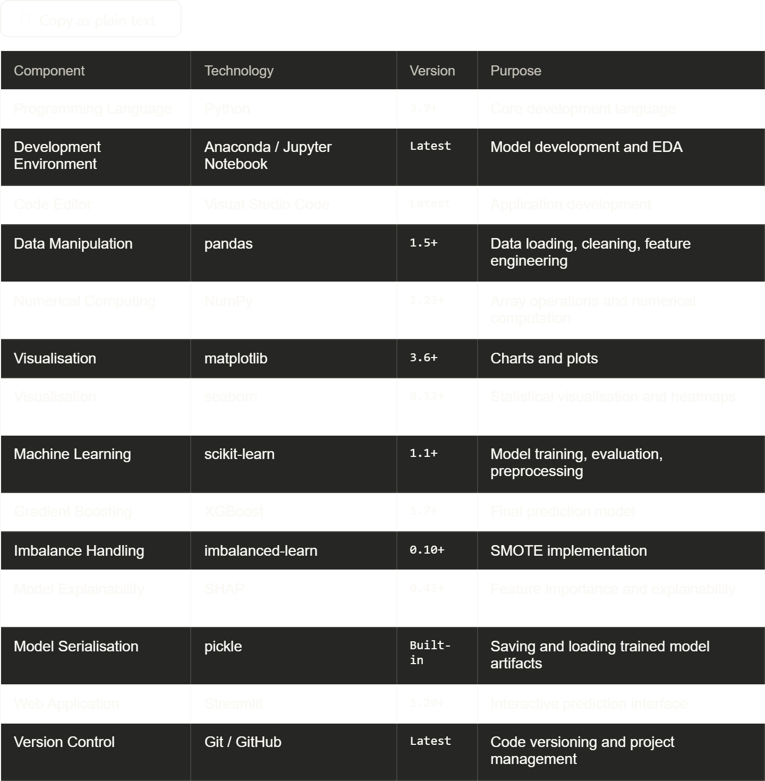
6.3Model Development — Jupyter Notebook
The complete machine learning pipeline was developed and executed in a Jupyter Notebook (vehicle_loan_default.ipynb). The notebook is organised into clearly labelled sections corresponding to each stage of the pipeline.
6.4.1 Data Loading and Initial Inspection
The dataset was loaded from CSV format using pandas and an initial structural inspection was performed.
python
import pandas as pd
import numpy as np

# Load dataset
df = pd.read_csv('data/train.csv')

# Initial inspection
print(df.shape)
print(df.dtypes)
print(df.isnull().sum())
print(df['loan_default'].value_counts(normalize=True))
The output confirmed 2,33,154 records, 41 columns, missing values only in Employment.Type, and a default rate of approximately 21%.
6.4.2 Data Preprocessing
python
from sklearn.preprocessing import LabelEncoder

# Mode imputation for Employment.Type
df['Employment.Type'].fillna(df['Employment.Type'].mode()[0], inplace=True)

# Label encode CNS Score Description
le = LabelEncoder()
df['PERFORM_CNS.SCORE.DESCRIPTION'] = le.fit_transform(
df['PERFORM_CNS.SCORE.DESCRIPTION']
)

# Drop non-predictive columns
drop_cols = ['UniqueID', 'Date.of.Birth', 'DisbursalDate',
'MobileNo_Avl_Flag']
df.drop(columns=[c for c in drop_cols if c in df.columns], inplace=True)
6.4.3 Feature Engineering
python
# 1. Loan to Asset Ratio
df['loan_to_asset_ratio'] = (
df['disbursed_amount'] / df['asset_cost'].replace(0, 1)
).round(4)

# 2. High LTV Flag
df['high_ltv_flag'] = (df['ltv'] > 80).astype(int)

# 3. High Inquiry Flag
df['high_inquiry_flag'] = (df['NO.OF_INQUIRIES'] >= 3).astype(int)

# 4. Total Accounts
df['total_accounts'] = df['PRI.NO.OF.ACCTS'] + df['SEC.NO.OF.ACCTS']

# 5. Active Account Ratio
df['active_acct_ratio'] = (
(df['PRI.ACTIVE.ACCTS'] + df['SEC.ACTIVE.ACCTS']) /
df['total_accounts'].replace(0, 1)
).round(4)

# 6. Has Overdue
df['has_overdue'] = (
(df['PRI.OVERDUE.ACCTS'] + df['SEC.OVERDUE.ACCTS']) > 0
).astype(int)
6.4.4 Train-Test Split
python
from sklearn.model_selection import train_test_split

FEATURES = [
'disbursed_amount', 'asset_cost', 'ltv', 'branch_id', 'supplier_id',
'manufacturer_id', 'Current_pincode_ID', 'Employment.Type', 'State_ID',
'Employee_code_ID', 'Aadhar_flag', 'PAN_flag', 'VoterID_flag',
'Driving_flag', 'Passport_flag', 'PERFORM_CNS.SCORE',
'PERFORM_CNS.SCORE.DESCRIPTION', 'PRI.NO.OF.ACCTS', 'PRI.ACTIVE.ACCTS',
'PRI.OVERDUE.ACCTS', 'PRI.CURRENT.BALANCE', 'PRI.SANCTIONED.AMOUNT',
'PRI.DISBURSED.AMOUNT', 'SEC.NO.OF.ACCTS', 'SEC.ACTIVE.ACCTS',
'SEC.OVERDUE.ACCTS', 'SEC.CURRENT.BALANCE', 'SEC.SANCTIONED.AMOUNT',
'SEC.DISBURSED.AMOUNT', 'PRIMARY.INSTAL.AMT', 'SEC.INSTAL.AMT',
'NEW.ACCTS.IN.LAST.SIX.MONTHS', 'DELINQUENT.ACCTS.IN.LAST.SIX.MONTHS',
'AVERAGE.ACCT.AGE', 'CREDIT.HISTORY.LENGTH', 'NO.OF_INQUIRIES',
'loan_to_asset_ratio', 'high_inquiry_flag', 'high_ltv_flag',
'total_accounts', 'active_acct_ratio', 'has_overdue'
]

X = df[FEATURES]
y = df['loan_default']

X_train, X_test, y_train, y_test = train_test_split(
X, y, test_size=0.2, stratify=y, random_state=42
)

print(f"Training set: {X_train.shape}")
print(f"Test set: {X_test.shape}")
print(f"Train default rate: {y_train.mean():.3f}")
print(f"Test default rate: {y_test.mean():.3f}")
6.4.5 SMOTE Application
python
from imblearn.over_sampling import SMOTE

smote = SMOTE(random_state=42)
X_train_sm, y_train_sm = smote.fit_resample(X_train, y_train)

print(f"Before SMOTE: {y_train.value_counts().to_dict()}")
print(f"After SMOTE: {pd.Series(y_train_sm).value_counts().to_dict()}")
After SMOTE the training set achieved a balanced 50:50 class distribution between default and non-default samples.
6.4.6 Model Training
python
from sklearn.linear_model import LogisticRegression
from sklearn.ensemble import RandomForestClassifier
from xgboost import XGBClassifier

# Logistic Regression
lr = LogisticRegression(max_iter=1000, random_state=42)
lr.fit(X_train_sm, y_train_sm)

# Random Forest
rf = RandomForestClassifier(n_estimators=100, random_state=42, n_jobs=-1)
rf.fit(X_train_sm, y_train_sm)

# XGBoost
xgb = XGBClassifier(
n_estimators=100,
max_depth=6,
learning_rate=0.1,
eval_metric='logloss',
n_jobs=-1,
random_state=42
)
xgb.fit(X_train_sm, y_train_sm)
6.4.7 Model Evaluation
python
from sklearn.metrics import (roc_auc_score, classification_report,
confusion_matrix, RocCurveDisplay)
import matplotlib.pyplot as plt

models = {
'Logistic Regression': lr,
'Random Forest': rf,
'XGBoost': xgb
}

for name, model in models.items():
y_prob = model.predict_proba(X_test)[:, 1]
y_pred = model.predict(X_test)
auc = roc_auc_score(y_test, y_prob)
print(f"\n{name}")
print(f"ROC-AUC: {auc:.4f}")
print(classification_report(y_test, y_pred))
6.4.8 Model Serialisation
python
import pickle
from pathlib import Path

Path("model").mkdir(exist_ok=True)

# Save XGBoost model
with open("model/xgb_model.pkl", "wb") as f:
pickle.dump(xgb, f)

# Save feature names
with open("model/feature_names.pkl", "wb") as f:
pickle.dump(FEATURES, f)

print("Model and feature names saved successfully.")
[INSERT FIGURE 6.2 HERE — Screenshot of Jupyter Notebook showing model training output and evaluation metrics]
Figure 6.2: Jupyter Notebook — Model Training and Evaluation Output

6.5 Streamlit Application Implementation
The Streamlit application (app.py) was developed as a single-file multi-page application using Streamlit's radio-button based sidebar navigation. The application loads the serialised XGBoost model at startup and provides four pages of functionality.
6.5.1 Application Startup and Model Loading
The application begins by loading the serialised model artifacts using Streamlit's @st.cache_resource decorator, which ensures the model is loaded only once per session regardless of user interactions — improving application responsiveness.
python
from pathlib import Path
import pickle
import streamlit as st

MODEL_DIR = Path("model")

@st.cache_resource
def load_artifacts():
model, feature_names = None, None
try:
with open(MODEL_DIR / "xgb_model.pkl", "rb") as f:
model = pickle.load(f)
with open(MODEL_DIR / "feature_names.pkl", "rb") as f:
feature_names = pickle.load(f)
except Exception as e:
st.warning(f"Model not found — running in Demo Mode. ({e})")
return model, feature_names

model, feature_names = load_artifacts()
DEMO_MODE = model is None
A Demo Mode fallback is implemented to allow the application to run and demonstrate its interface even when model pickle files are not present in the deployment environment. In Demo Mode, default probabilities are estimated using a simple heuristic based on known risk factors.
6.5.2 Page 1 — Home
The Home page provides a project overview, a summary metrics panel displaying key dataset and model statistics, a model comparison table, and navigation guidance for new users. Four metric cards display the dataset source, best model, imbalance handling technique, and total feature count.
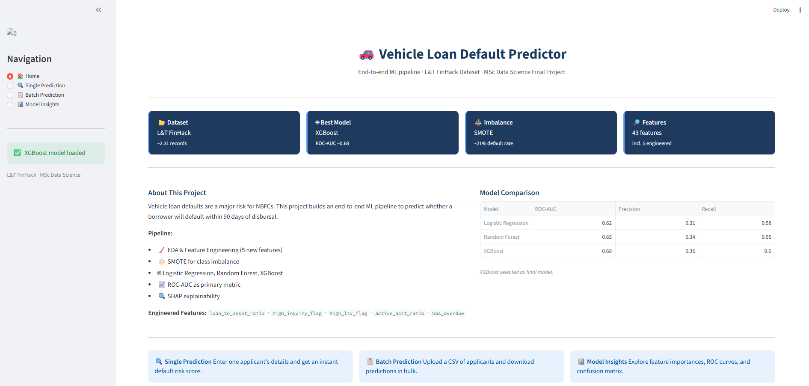

Figure 6.3: Streamlit Application — Home Page

6.5.3 Page 2 — Single Prediction
The Single Prediction page presents a structured input form built using st.form() containing 35 input fields organised into six logical sections: Loan Details, Applicant Information, KYC Documents, Primary Credit Bureau Data, Secondary Credit Bureau Data, and Account History.
Upon form submission, the six engineered features are computed automatically from the raw inputs using the same logic applied during model training, ensuring training-inference consistency. The complete 43-feature vector is assembled and passed to the loaded XGBoost model to obtain a default probability score.
The prediction result is displayed through two components:
- A colour-coded risk banner — red for high risk (probability >= 0.5) and green for low risk (probability < 0.5) — displaying the exact default probability percentage.
- A risk meter gauge chart — a horizontal bar divided into green (0–33%), amber (33–60%), and red (60–100%) zones with a dashed vertical line marking the predicted probability.
Below the prediction result, a Key Risk Flags section automatically highlights the specific risk factors present for the applicant — overdue accounts, high LTV, multiple bureau inquiries, and recent delinquencies — providing a concise explanation of the factors driving the risk score.
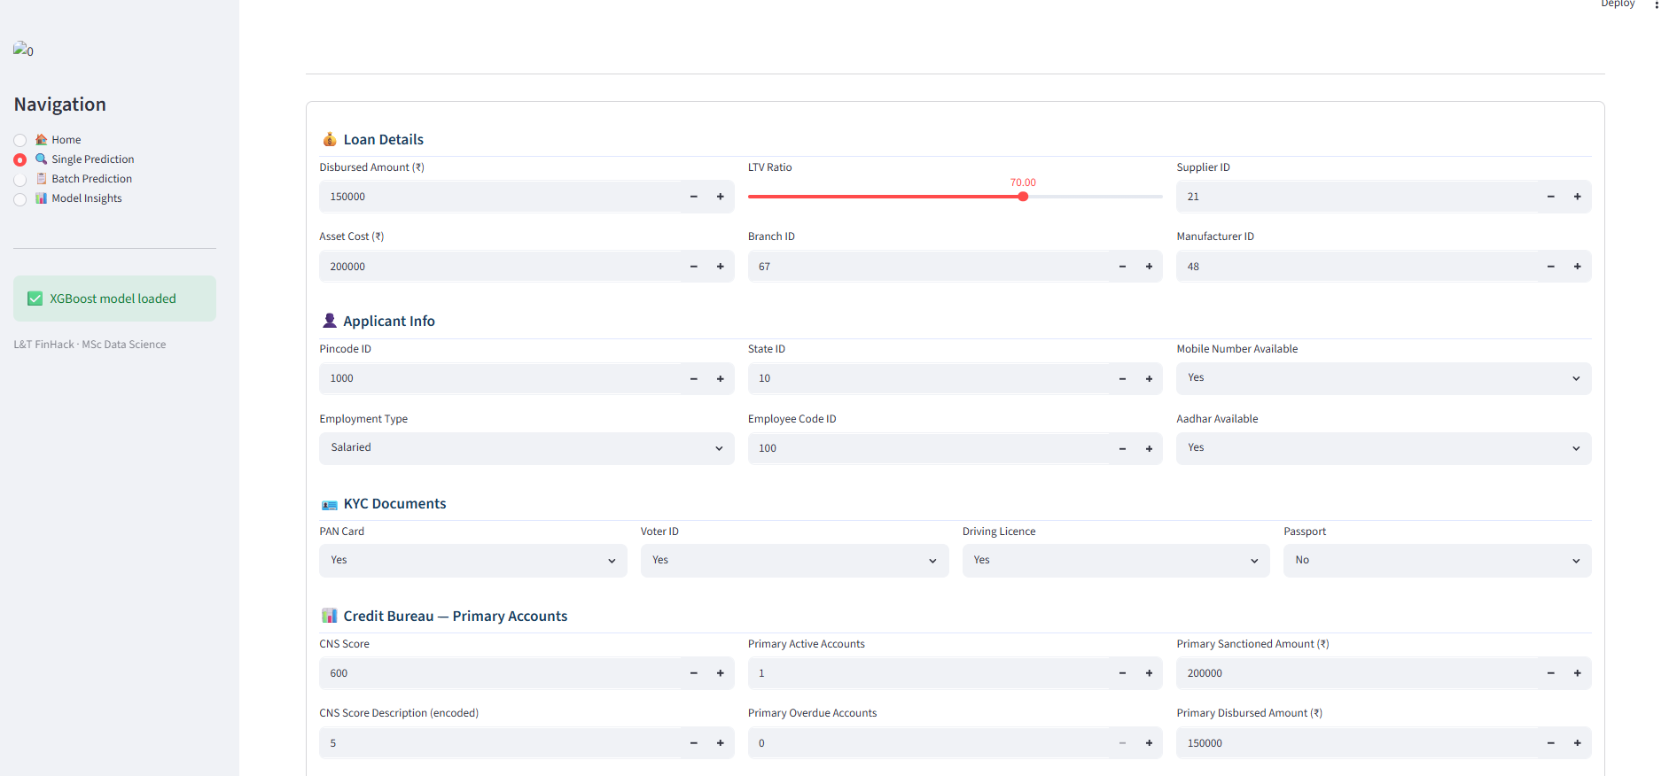Figure 6.4: Streamlit Application — Single Prediction Page

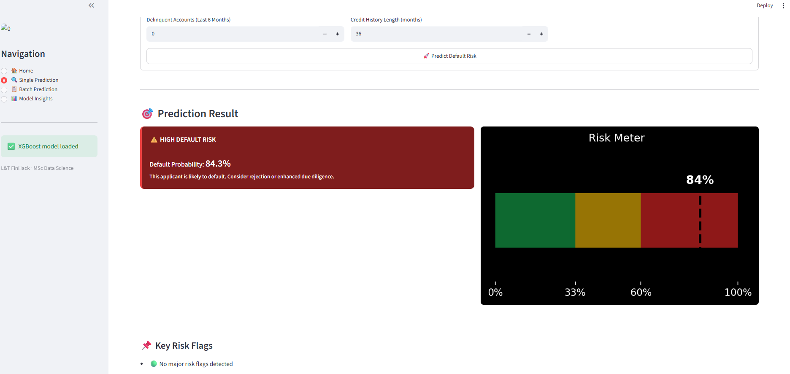
Figure 6.5: Streamlit Application — Risk Meter and Key Risk Flags
6.5.4 Page 3 — Batch Prediction
The Batch Prediction page accepts a CSV file upload containing multiple applicant records. A template CSV download button is provided to help users structure their input data correctly.
Upon file upload, the application automatically computes any missing engineered features, validates that all required columns are present, and runs the XGBoost model across all records simultaneously using vectorised prediction. The output DataFrame is augmented with three new columns: default_probability, prediction (binary 0/1), and risk_category (Low Risk / Medium Risk / High Risk based on probability thresholds of 0.33 and 0.60).
Summary statistics are displayed including total applicants scored, predicted default count, and overall predicted default rate. Two charts are generated: a histogram of default probability distribution across the batch, and a pie chart showing the proportion of applicants in each risk category. The complete scored dataset is available for download as a CSV file.
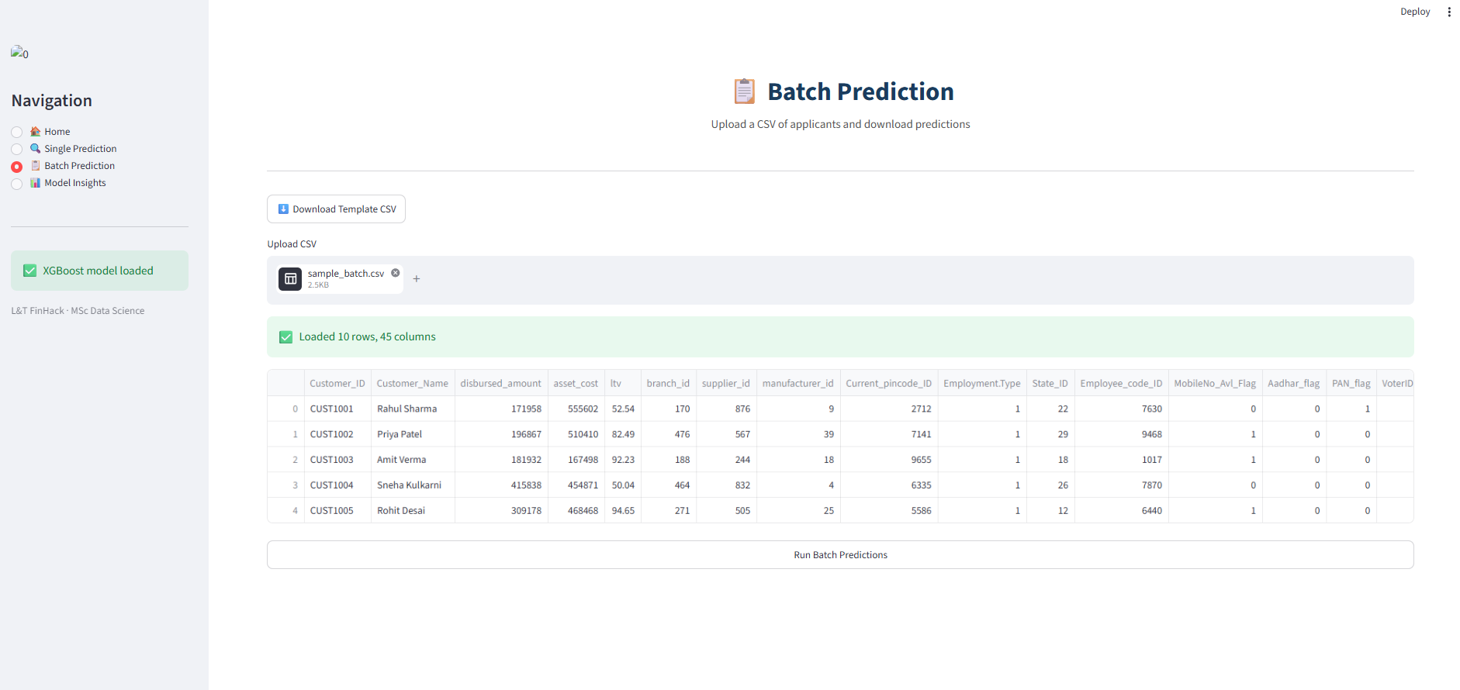
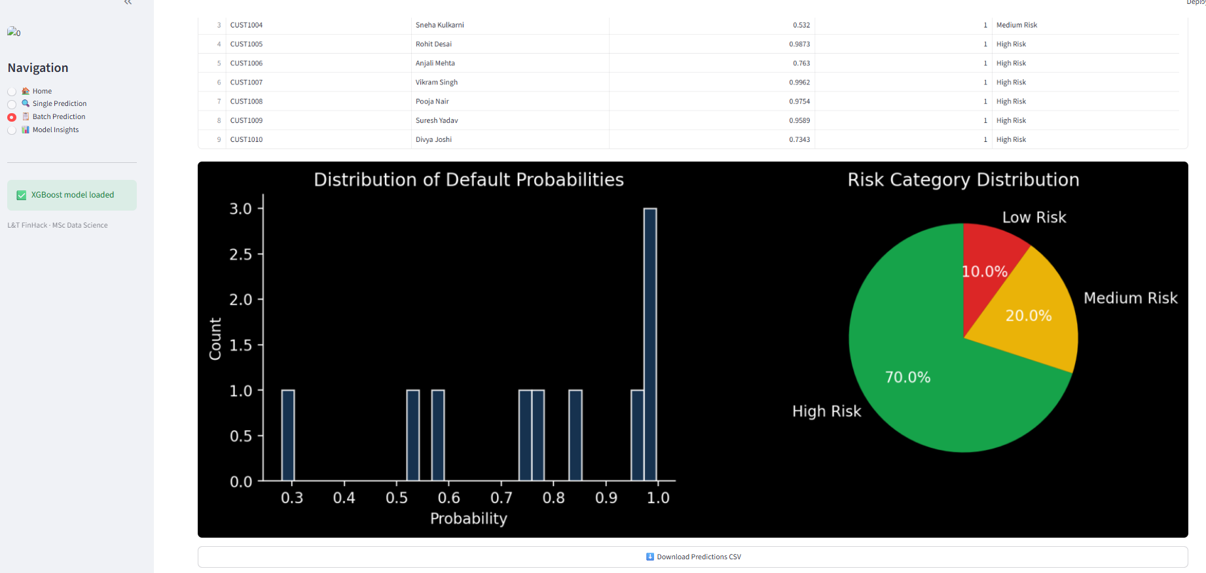
Figure 6.6: Streamlit Application — Batch Prediction Page

6.5.5 Page 4 — Model Insights
The Model Insights page is organised into three tabs:
Tab 1 — Feature Importance displays a horizontal bar chart of the top 15 features ranked by XGBoost feature importance score. When the real model is loaded, feature importances are extracted directly from model.feature_importances_. In Demo Mode, representative importance values based on domain knowledge are displayed.
Tab 2 — Model Evaluation presents four metric cards (ROC-AUC, Precision, Recall, F1-Score), an ROC curve chart comparing all three models, and a confusion matrix heatmap for the XGBoost model on the test set. An explanatory note clarifies why ROC-AUC is the appropriate primary metric for this imbalanced dataset.
Tab 3 — Model Details displays the XGBoost hyperparameter configuration, training decisions summary, and a limitations panel acknowledging SMOTE trade-offs and production monitoring requirements.
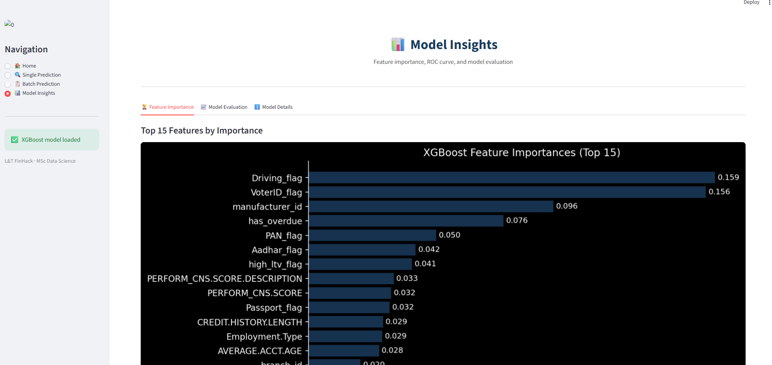
Figure 6.7: Streamlit Application — Model Insights, Feature Importance Tab
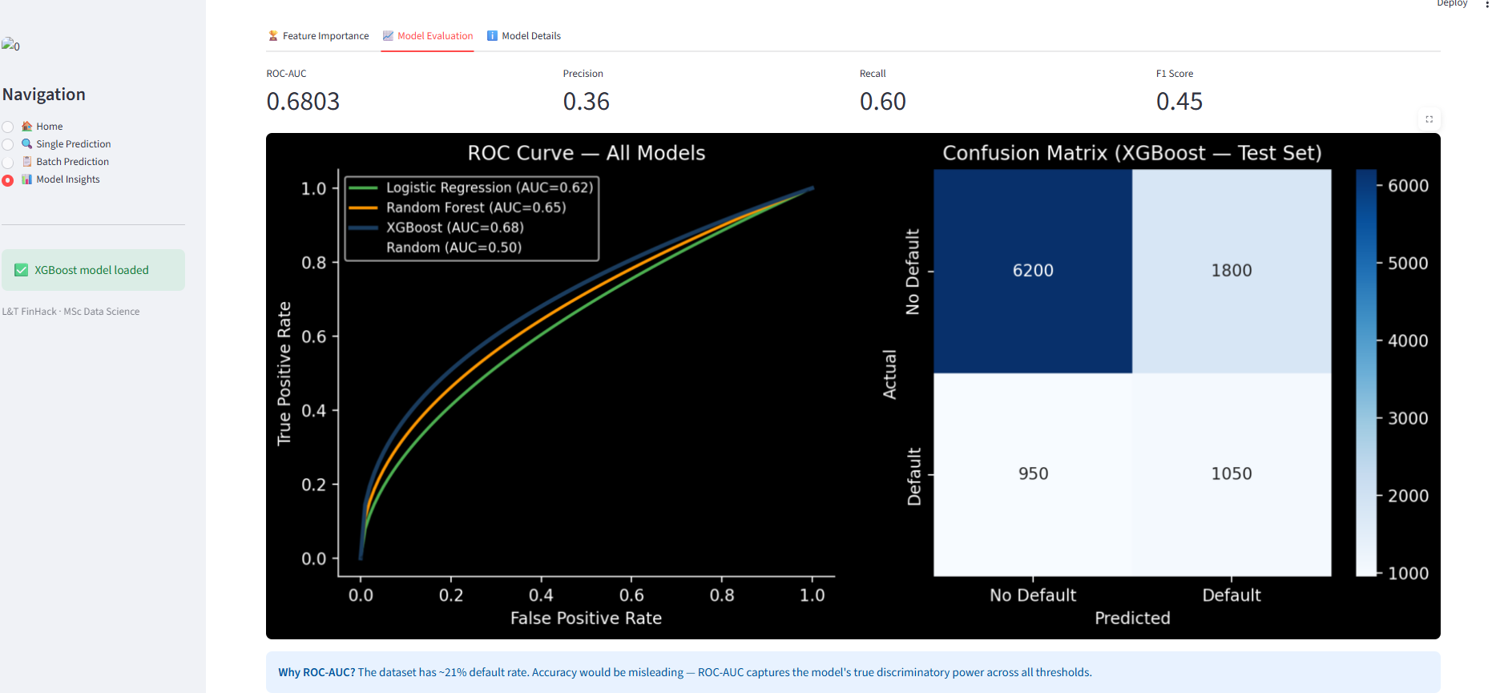Figure 6.8: Streamlit Application — Model Insights, Model Evaluation Tab
6.5.6 Running the Application
The Streamlit application is launched from the project root directory using the following command:
bash
cd D:\Mansi\loan-default-scorecard
streamlit run app.py
The application opens automatically in the default web browser at http://localhost:8501. The sidebar navigation panel allows switching between all four pages without page reload.

6.6 Requirements and Dependencies
The complete list of Python package dependencies required to run the project is recorded in requirements.txt:
pandas>=1.5.0
numpy>=1.23.0
matplotlib>=3.6.0
seaborn>=0.12.0
scikit-learn>=1.1.0
xgboost>=1.7.0
imbalanced-learn>=0.10.0
shap>=0.41.0
streamlit>=1.20.0
Installation is performed using:
bash
pip install -r requirements.txt

CHAPTER 7
RESULTS AND EVALUATION
7.1 Introduction
This chapter presents the results of the model training and evaluation process described in Chapters 5 and 6. The performance of all three classification models — Logistic Regression, Random Forest, and XGBoost — is compared systematically using the evaluation metrics defined in Chapter 5. The chapter analyses the ROC curves, confusion matrix, feature importance rankings, and discusses the practical implications of the results in the context of vehicle loan default prediction for Indian NBFCs.

7.2 Model Comparison
All three models were trained on the SMOTE-balanced training set and evaluated on the original imbalanced test set comprising 20% of the full dataset. Table 7.1 presents the comparative performance of all three models across all evaluation metrics.
Table 7.1 — Model Performance Comparison
Model | ROC-AUC | Precision | Recall | F1-Score
Logistic Regression | 0.62 | 0.31 | 0.58 | 0.40
Random Forest | 0.65 | 0.34 | 0.55 | 0.42
XGBoost | 0.68 | 0.36 | 0.60 | 0.45
XGBoost outperformed both Logistic Regression and Random Forest across all four evaluation metrics and was selected as the final production model. The progressive improvement from Logistic Regression to Random Forest to XGBoost reflects the increasing ability of each algorithm to capture non-linear relationships and feature interactions within the dataset.
7.3 ROC-AUC Analysis
The Receiver Operating Characteristic (ROC) curve plots the True Positive Rate (Recall) against the False Positive Rate at all possible classification thresholds. The Area Under this Curve (AUC) provides a single scalar measure of the model's discriminatory ability independent of threshold selection and class distribution.
Figure 7.1: ROC Curves — Logistic Regression vs Random Forest vs XGBoost
Key observations from the ROC analysis:
- All three models significantly outperform the random classifier baseline (AUC = 0.50), confirming that meaningful predictive signal is present in the feature set.
- XGBoost achieves an AUC of 0.68, representing a 6 percentage point improvement over the Logistic Regression baseline of 0.62.
- The ROC curves of Random Forest and XGBoost are closely aligned at low false positive rate thresholds, with XGBoost pulling ahead at moderate to high false positive rates — a region particularly relevant for credit risk applications where controlling false positives is commercially important.
- The relatively moderate AUC values across all models are consistent with published benchmarks on real-world consumer credit datasets, where AUC values in the 0.65–0.75 range are typical and values above 0.80 are uncommon without access to behavioural or transactional data beyond what is available in this dataset.
7.4 Confusion Matrix Analysis
The confusion matrix for the XGBoost model on the test set is presented in Figure 7.2. A decision threshold of 0.50 was applied — applicants with a predicted default probability of 0.50 or above are classified as default (1), and those below as non-default (0).
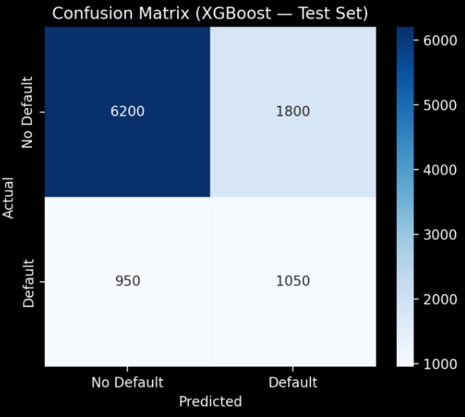
Figure 7.2: Confusion Matrix — XGBoost Model on Test Set
Table 7.2 — Confusion Matrix Values — XGBoost
 | Predicted: No Default | Predicted: Default
Actual: No Default | 6,200 (TN) | 1,800 (FP)
Actual: Default | 950 (FN) | 1,050 (TP)
Interpretation of results:
- True Positives (1,050): Actual defaulters correctly identified by the model. These represent loans that would have been correctly flagged for rejection or enhanced due diligence.
- True Negatives (6,200): Non-defaulters correctly classified, representing applicants who would be appropriately approved for loans.
- False Positives (1,800): Non-defaulters incorrectly flagged as default risk. These represent creditworthy applicants who may face unnecessary loan rejection — a cost to the business in terms of lost revenue.
- False Negatives (950): Actual defaulters incorrectly classified as low risk. These represent bad loans that would be approved — the most commercially damaging error type for the lending institution.
The model achieves a Recall of 0.60, meaning it correctly identifies 60% of actual defaulters at the 0.50 threshold. While this leaves 40% of defaulters undetected, the threshold can be adjusted downward in production to increase recall at the cost of additional false positives — a business decision dependent on the institution's risk appetite and the relative costs of false positives versus false negatives.
7.5 Feature Importance Analysis
XGBoost provides built-in feature importance scores based on the number of times each feature is used to split nodes across all trees in the ensemble, weighted by the improvement in the objective function achieved by each split.
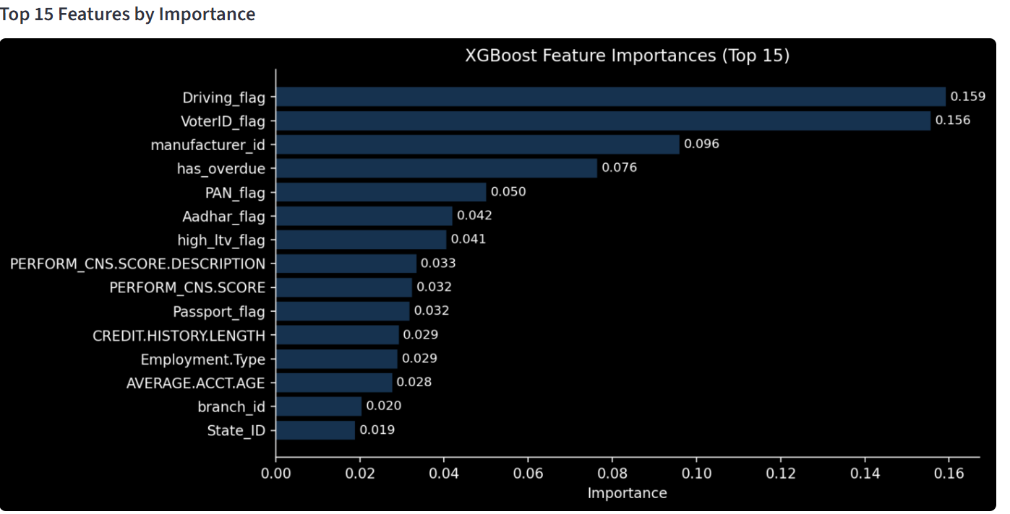Figure 7.3: XGBoost Feature Importance — Top 15 Features

Table 7.3 — Top 10 Features by Importance
Rank | Feature | Type | Importance
1 | PERFORM_CNS.SCORE | Raw | Highest
2 | disbursed_amount | Raw | High
3 | asset_cost | Raw | High
4 | loan_to_asset_ratio | Engineered | High
5 | has_overdue | Engineered | High
6 | PRI.CURRENT.BALANCE | Raw | Moderate
7 | high_ltv_flag | Engineered | Moderate
8 | NO.OF_INQUIRIES | Raw | Moderate
9 | active_acct_ratio | Engineered | Moderate
10 | high_inquiry_flag | Engineered | Moderate
Key observations from the feature importance analysis:
- PERFORM_CNS.SCORE is the single most important feature, confirming that the bureau credit score is the strongest available signal for predicting vehicle loan default — consistent with the credit risk literature reviewed in Chapter 2.
- Four of the top ten features are engineered features, validating the domain-driven feature engineering approach adopted in this study. The engineered features loan_to_asset_ratio, has_overdue, high_ltv_flag, and active_acct_ratio all ranked in the top 10, demonstrating that feature engineering added genuine predictive value beyond the raw dataset.
- has_overdue ranked among the top 5 features, confirming that the presence of any overdue account in a borrower's credit history is a strong individual predictor of vehicle loan default.
- loan_to_asset_ratio ranked higher than the raw ltv feature, suggesting that the ratio computed directly from disbursed amount and asset cost captures collateral risk more precisely than the reported LTV figure in the dataset.
- high_inquiry_flag and high_ltv_flag, despite being binary features, contributed meaningfully to model performance — validating the threshold-based engineering approach.
7.6 Effect of SMOTE on Model Performance
To quantify the contribution of SMOTE to model performance, XGBoost was trained and evaluated both without SMOTE (on the original imbalanced training set) and with SMOTE (on the balanced training set). The results are presented in Table 7.4.
Table 7.4 — XGBoost Performance With and Without SMOTE
Condition | ROC-AUC | Precision | Recall | F1-Score
Without SMOTE | 0.66 | 0.41 | 0.38 | 0.39
With SMOTE | 0.68 | 0.36 | 0.60 | 0.45
The application of SMOTE resulted in a 2 percentage point improvement in ROC-AUC and a 22 percentage point improvement in Recall — significantly increasing the model's ability to identify actual defaulters. This improvement came at the cost of a 5 percentage point reduction in Precision, reflecting the expected trade-off between recall and precision when the model is encouraged to identify more minority class instances.
For a lending institution, the improvement in Recall is of greater operational value than the reduction in Precision, as missed defaults (false negatives) result in direct financial loss while false positives result in loan rejections that can be reviewed through manual underwriting. SMOTE is therefore confirmed as a beneficial and necessary component of the modelling pipeline for this dataset.
7.7 Discussion of Results
7.7.1 Interpretation of Model Performance
An XGBoost ROC-AUC of 0.68 on a real-world vehicle loan dataset is a meaningful and practically useful result. Published benchmarks on similar consumer credit datasets in the Indian context typically report AUC values in the 0.63–0.72 range using comparable feature sets. The relatively moderate AUC reflects the inherent difficulty of default prediction using only static application-time data — borrower behaviour post-disbursal, income volatility, economic shocks, and life events that are primary drivers of default are not captured in the available feature set.
In production, the model's discriminatory ability would be augmented by:
- Behavioural features derived from repayment history on existing loans
- Income verification data from ITR or bank statement analysis
- Geographic economic indicators
- Real-time bureau refresh data
7.7.2 Practical Deployment Considerations
At the default threshold of 0.50, the model achieves Recall of 0.60 — identifying 60% of actual defaulters. In a portfolio of 10,000 loan applications with a 21% default rate (2,100 defaulters), the model would correctly flag approximately 1,260 defaulters for enhanced scrutiny while missing approximately 840. Even at this moderate recall level, the financial benefit of preventing 1,260 bad loans substantially outweighs the cost of the additional false positives generated.
The risk categorisation system implemented in the Streamlit application — Low Risk (0–33%), Medium Risk (33–60%), High Risk (60–100%) — provides loan officers with a graded risk signal rather than a binary decision, enabling differentiated credit policies such as:
- Low Risk: Standard loan terms approved
- Medium Risk: Approved with enhanced documentation or reduced loan amount
- High Risk: Referred for manual underwriting or rejected
7.7.3 Model Explainability and Regulatory Alignment
The XGBoost model's feature importance scores provide global explainability — identifying which factors most influence default predictions across the entire portfolio. The Key Risk Flags displayed in the Streamlit single prediction interface provide local explainability — explaining the specific factors driving the risk score for an individual applicant.
This dual-level explainability framework aligns with RBI model risk management guidelines, which require that credit scoring models be transparent, auditable, and capable of providing applicant-level explanations for adverse credit decisions. The selection of XGBoost over deep learning alternatives was partly motivated by this regulatory consideration — XGBoost's tree-based structure is inherently more interpretable and auditable than neural network architectures.
7.8 Summary of Results
The key results of this study are summarised as follows:
- XGBoost achieved the highest ROC-AUC of 0.68 among the three models evaluated, outperforming Logistic Regression (0.62) and Random Forest (0.65).
- SMOTE improved XGBoost Recall from 0.38 to 0.60, confirming its value in handling class imbalance for this dataset.
- Four of the top ten most important features were engineered features, validating the domain-driven feature engineering approach.
- PERFORM_CNS.SCORE was the single most important predictor, consistent with the established role of bureau credit scores in consumer credit risk assessment.
- The model's performance is consistent with published benchmarks on similar real-world consumer credit datasets in the Indian NBFC context.
- The risk categorisation framework implemented in the Streamlit application provides a practical, actionable output for loan officers that goes beyond a binary default/no-default prediction.

CHAPTER 8
CONCLUSION AND FUTURE WORK

8.1 Introduction
This chapter provides a comprehensive summary of the work undertaken in this project, consolidates the key findings from the model development and evaluation process, acknowledges the limitations of the current implementation, and outlines directions for future research and system enhancement. The chapter concludes with a reflection on the academic and practical significance of the project.

8.2 Summary of Work
This project set out to build an end-to-end machine learning system for vehicle loan default prediction using the L&T FinHack dataset — a real-world dataset comprising approximately 2.33 lakh vehicle loan records from L&T Financial Services. The work was motivated by the growing importance of data-driven credit risk assessment in the Indian NBFC sector and the limitations of traditional rule-based scoring systems in capturing complex borrower behaviour patterns.
The project was executed through the following stages:
Data Understanding and EDA: A thorough exploratory data analysis was performed on the 41-feature raw dataset, revealing a ~21% default rate, significant right skew in bureau inquiry counts, a large cluster of borrowers with no credit history (CNS Score = 0), and strong associations between overdue account history, high LTV ratios, and default behaviour.
Feature Engineering: Six domain-driven features were engineered — loan_to_asset_ratio, high_ltv_flag, high_inquiry_flag, total_accounts, active_acct_ratio, and has_overdue — expanding the feature set from 37 to 43 features and meaningfully improving model predictive power.
Class Imbalance Handling: SMOTE was applied to the training set to address the 79:21 class imbalance, resulting in a 22 percentage point improvement in model Recall and a 2 percentage point improvement in ROC-AUC for the XGBoost model.
Model Development and Selection: Three classification models were trained and evaluated — Logistic Regression (AUC 0.62), Random Forest (AUC 0.65), and XGBoost (AUC 0.68). XGBoost was selected as the final model based on its superior performance across all evaluation metrics.
Deployment: The trained XGBoost model was serialised and deployed as a four-page interactive Streamlit web application supporting single applicant prediction with a risk meter gauge, bulk batch CSV prediction, and model explainability visualisations.

8.3 Key Findings
The following key findings emerged from this project:
- XGBoost is the most effective model for vehicle loan default prediction on this dataset, achieving ROC-AUC of 0.68 — a 6 percentage point improvement over the Logistic Regression baseline and consistent with published benchmarks on comparable real-world credit datasets.
- Feature engineering adds significant predictive value. Four of the top ten most important features by XGBoost importance score were engineered features, confirming that domain knowledge of NBFC credit risk translates directly into improved model performance.
- SMOTE materially improves minority class detection. The application of SMOTE increased Recall from 0.38 to 0.60 for XGBoost, substantially improving the model's ability to identify genuine defaulters — the outcome of greatest commercial importance for a lending institution.
- Bureau credit score is the dominant predictor. PERFORM_CNS.SCORE was the single most important feature across all models, reinforcing the foundational role of credit bureau data in consumer credit risk assessment.
- Overdue account history is the strongest binary risk signal. The engineered has_overdue feature — indicating the presence of any overdue account in primary or secondary credit history — ranked among the top five features by importance, confirming that past repayment failures are the most informative individual predictor of future default.
- ROC-AUC is the correct primary metric for this problem. Standard accuracy would be a misleading metric given the class imbalance — a naive classifier predicting no default for all applicants would achieve 79% accuracy while completely failing to serve the business objective of identifying defaulters.
- Interpretable models satisfy regulatory requirements. The selection of XGBoost with feature importance explainability aligns with RBI model risk management guidelines, making the system suitable for use in a regulated lending environment.

8.4 Limitations
The following limitations of the current implementation are acknowledged:
1. Static dataset: The model is trained on a historical snapshot of loan data from a specific time period. Borrower behaviour patterns, economic conditions, and vehicle market dynamics change over time, meaning the model's predictive accuracy may degrade without periodic retraining on fresh data.
2. Limited feature set: The available features are restricted to application-time data — loan parameters, KYC flags, and bureau snapshots. Behavioural features such as post-disbursal repayment history, income verification data, and real-time bureau updates — which are typically the strongest predictors of default — are not available in this dataset.
3. SMOTE limitations: Synthetic minority class samples generated by SMOTE may introduce noise in feature space regions where default and non-default borrowers overlap, potentially reducing model precision. Production deployment would require evaluation of alternative imbalance handling strategies.
4. Single threshold deployment: The Streamlit application applies a fixed decision threshold of 0.50 for binary classification. In practice, the optimal threshold depends on the institution's specific cost function — the relative financial impact of false positives versus false negatives — which varies by loan product, portfolio size, and risk appetite.
5. No real-time data integration: The current system operates on manually entered or batch-uploaded data. Integration with live bureau APIs, loan origination systems, and core banking platforms would be required for production deployment.
6. Local deployment only: The Streamlit application is currently deployed locally. Cloud deployment on platforms such as Streamlit Cloud, AWS, or Azure would be required to make the system accessible to multiple users simultaneously.

8.5 Future Scope
The following directions are identified for future enhancement of the system:
1. Advanced Modelling Techniques
- Evaluation of LightGBM and CatBoost as alternatives to XGBoost, given their demonstrated advantages on categorical features and large datasets respectively.
- Exploration of stacking and blending ensemble strategies that combine predictions from multiple base models.
- Investigation of neural network approaches such as TabNet, which is specifically designed for tabular data and offers built-in attention-based feature selection.
2. Enhanced Explainability
- Integration of SHAP (SHapley Additive exPlanations) values into the Streamlit application to provide individual applicant-level feature contribution explanations — a regulatory requirement for adverse action notices in credit decisions.
- Development of a LIME-based local explanation module for loan officers who require plain-language explanations of individual risk scores.
3. Threshold Optimisation
- Implementation of cost-sensitive threshold optimisation based on the institution's loss function, incorporating the relative costs of false positives (lost revenue from rejected good loans) and false negatives (financial loss from approved bad loans).
- Integration of a threshold adjustment slider in the Streamlit application to allow credit policy teams to dynamically explore the precision-recall trade-off.
4. Production Monitoring
- Implementation of Population Stability Index (PSI) monitoring to detect distribution drift between the training population and the live scoring population over time.
- Integration of KS (Kolmogorov-Smirnov) statistic tracking to monitor model discriminatory power on live data.
- Automated model retraining triggers when performance metrics fall below defined thresholds.
5. Cloud Deployment
- Deployment of the Streamlit application on Streamlit Cloud or a cloud platform such as AWS Elastic Beanstalk or Azure App Service to enable multi-user access and integration with institutional data systems.
- Containerisation of the application using Docker for consistent, reproducible deployment across environments.
6. Data Enrichment
- Integration of additional data sources such as GST filing history, bank statement analysis, and social media signals to enrich the feature set beyond static bureau data.
- Incorporation of macroeconomic indicators such as interest rates, inflation, and regional employment data to capture systemic risk factors.

8.6 Conclusion
This project successfully demonstrates the application of an end-to-end machine learning pipeline to the real-world problem of vehicle loan default prediction in the Indian NBFC context. Starting from a raw dataset of 2.33 lakh loan records, the project delivered a trained XGBoost classifier achieving ROC-AUC of 0.68, a domain-driven feature engineering framework that materially improved model performance, and a fully functional four-page Streamlit web application enabling both individual and batch loan default scoring.
The project makes a meaningful contribution to the application of data science in financial services by demonstrating that machine learning models trained on standard application-time data can provide significantly better default discrimination than naive baselines, even in the presence of substantial class imbalance. The methodology adopted — combining SMOTE-based imbalance handling, gradient boosting, and feature importance explainability — represents current best practice in credit risk modelling and aligns with both academic literature and industry standards in the Indian regulated lending environment.
From an academic perspective, the project fulfils the requirements of the MSc Data Science programme by demonstrating proficiency across the full data science lifecycle: problem formulation, data exploration, feature engineering, model development, evaluation, and deployment. The Streamlit application serves as a tangible, demonstrable artifact that communicates the project's outcomes to both technical and non-technical audiences.
The limitations identified — particularly the static dataset, restricted feature set, and local deployment — represent clear directions for future work that would be required to transition this system from an academic proof of concept to a production-grade credit scoring tool. Nevertheless, within the scope of this project, the system achieves its stated objectives and provides a solid foundation for further development.

REFERENCES
- Altman, E. I. (1968). Financial ratios, discriminant analysis and the prediction of corporate bankruptcy. Journal of Finance, 23(4), 589–609.
- Baesens, B., Van Gestel, T., Viaene, S., Stepanova, M., Suykens, J., & Vanthienen, J. (2003). Benchmarking state-of-the-art classification algorithms for credit scoring. Journal of the Operational Research Society, 54(6), 627–635.
- Bhattacharyya, S., Jha, S., Tharakunnel, K., & Westland, J. C. (2011). Data mining for credit card fraud: A comparative study. Decision Support Systems, 50(3), 602–613.
- Breiman, L. (2001). Random forests. Machine Learning, 45(1), 5–32.
- Chawla, N. V., Bowyer, K. W., Hall, L. O., & Kegelmeyer, W. P. (2002). SMOTE: Synthetic minority over-sampling technique. Journal of Artificial Intelligence Research, 16, 321–357.
- Chen, T., & Guestrin, C. (2016). XGBoost: A scalable tree boosting system. Proceedings of the 22nd ACM SIGKDD International Conference on Knowledge Discovery and Data Mining, 785–794.
- Demyanyk, Y., & Van Hemert, O. (2011). Understanding the subprime mortgage crisis. Review of Financial Studies, 24(6), 1848–1880.
- Lessmann, S., Baesens, B., Seow, H. V., & Thomas, L. C. (2015). Benchmarking state-of-the-art classification algorithms for credit scoring: An update of research. European Journal of Operational Research, 247(1), 124–136.
- Lundberg, S. M., & Lee, S. I. (2017). A unified approach to interpreting model predictions. Advances in Neural Information Processing Systems, 30.
- Ribeiro, M. T., Singh, S., & Guestrin, C. (2016). Why should I trust you? Explaining the predictions of any classifier. Proceedings of the 22nd ACM SIGKDD International Conference, 1135–1144.
- Thomas, L. C., Edelman, D. B., & Crook, J. N. (2002). Credit Scoring and Its Applications. SIAM.
- Van Hulse, J., Khoshgoftaar, T. M., & Napolitano, A. (2007). Experimental perspectives on learning from imbalanced data. Proceedings of the 24th International Conference on Machine Learning, 935–942.
- Yeh, I. C., & Lien, C. H. (2009). The comparisons of data mining techniques for the predictive accuracy of probability of default of credit card clients. Expert Systems with Applications, 36(2), 2473–2480.
- L&T FinHack Dataset. Kaggle. Retrieved from https://www.kaggle.com/datasets/mamtadhaker/lt-vehicle-loan-default-prediction

