**GOOGLE ANALYTICS vs OMNITURE**

|  |  |  |  |
| --- | --- | --- | --- |
|  | GOOGLE ANALYTICS | OMNITURE | REMARK |
| 1. cost | Google Analytics is free and will process up to 10 million hits per month and is the best tool for smaller businesses and websites. Google Analytics Premium offers a number of enhanced features such as processing 1 billion hits per month, more customization, and strong technical support, but it costs a flat $150,000 annually. | Omniture’s robust application comes at a high price. Large cooperations spend over $100K per yr for SiteCatalyst.  Cost varies according to traffic volume and the service level, and depends on the needs of your company. | Google Analytics is a true winner in terms of cost effectiveness as it provides a lot of qualitative information at no cost. So no more BIG POCKETS required. |
| 1. Implementation | Implementation process is much more easier as it does not involve a lot of pre configuration at the page level | Needs technically smart people and can be handles by the ones who already know end to end process of Omniture. | Google Analytics is a true winner in terms of Implementation |
| 1. Platform | Can be used as an enterprise platform but not as apt as Omniture. It’s an amazing tool for basic tracking | It is completely an enterprise platform which is majorly used by big firms like HP, Microsoft etc. |  |
| 1. Real time data | Real time traffic reporting is possible in GA | Real time data is seen but there is a lag of around 2 hours | GA is better to track real time traffic |
| 5. Custom tracking | Only 5 custom variables can be defines in GA free service whereas paid can provide 50 variables.  Variables can be set to expire at different times, such after a page view, completion of an event, or at the visit level | Provides a limit of 75 traffic properties, 75 conversion variables and 100 events per report suite.  Variables can be set to capture whatever data you want, and can expire after a specific time (just like Google Analytics) but they can also be stacked on top of each other, giving you the chance to identify a sequence of events. | Omniture custom tracking is unbeatable. Where Google Analytics limits itself to 5 custom variables; Omniture beats up each and every boundary and offers a lot. |
| 6 Personal info | Cannot capture personal identifiable data, it is against Google Policies | Provides access to individual visitor data. Omniture has a system that will let you pull in data from 3rd party API's like salesforce and email systems. So it can associate information your sales person gathers, and intermingle it with your web data | Omniture is really powerful for pinning down individual user actions, and obviously good for getting a better feel for your conversion funnel. |
| 7. Conversion Tracking | Adwords and Analytics can be directly linked, the conversion tracking for PPC goals is free and simple to setup. Conversions tracking on Google can also group users that follow the same path on the site before a conversion. | Omniture uses the SearchCenter application to integrate PPC providers including Adwords for an additional cost. Conversion tracking can be tedious and confusing in Omniture. | Google Analytics is a true winner in terms of tracking goals; however only 4 goals maximum can be setup under a single Google Analytics account. Omniture has no such limits. |
| 8. Generation or reports | Can email daily reports in PDF, XML, CSV, and TSV. Limits each user to one default dashboard/report per site. | Can email hourly reports in Excel, PDF, HTML & Word. Larger reports can be slow during high traffic periods | Omniture is a true winner in terms of reporting as it gives reports tracking real time data. Reporting level in truly deep in Omniture as compared to Google Analytics. |
| 9. User access restriction level | Google Analytics only allows two levels of access (readonly or admin) and users must have a Google account. No contact information is stored on Analytics. | Administrators can assign access at many different levels and organize people into groups. Their contact info is also retained in SiteCatalyst | Omniture is a true winner in terms of assigning management rights at different levels. |
| 10. Site Overlay tools | Google’s site overlay feature (sometimes referred to as “heatmap”) runs through Google servers. It allows the user to look at content popularity data from any given date range over a 2 year period without any time lag. | Omniture offers ClickMap which is installed and run from the users’ computer to view content popularity of the site elements within a page. Compatibility with new browsers can also be an issue. | Google Analytics site overlay is best as compared to any other site overlay techniques in the industry. |
| 11. Application Support | No guaranteed support from Google, but their forums are regularly monitored and updated with support information. There are also Google certified consulting companies that provide support | Omniture has a 24 hour support line and a complete online resource with common questions and information about its applications. They also use Twitter to answer support questions. | Omniture application support is a true winner as customer queries are handled in no time. However Google Analytics support through forums is a slow process and consumes a lot of time. |
| 12. Segmenting setup | Very flexible – allows for custom segments and is already setup with many segments allowing for almost instantaneous analysis of correlated, retroactive data | Each segment must be manually setup and all of the data is not retroactive unless setup using another Ominture product called DataWarehouse. This can take up to 72 hours to process new reports. | Google Analytics segment setup is quite flexible and easy as compared to Omniture. |
| 13. Tracking tag performance | Response time is very consistent ensuring good page performance. | The response times varies slightly, but it doesn’t have a significant effect on page performance |  |
| 14. Tracking code configuration | The same tracking code is added to each page the user wants to track on the site. Google generates the code automatically, and setup is not very difficult to understand. | Customizable tracking code is added to each page the user wants to track on the site. The configuration can be very advanced and could require additional training, but it gives the site owner more options. | Code implementation is quite easy in Google Analytics. Not much technical skills are required to implement the code as compared to Omniture code implementation. |
| 15. Data backup | Google Analytics keeps data up to 25 months. | SiteCatalyst keeps all website data collected as long as you’re a customer. |  |

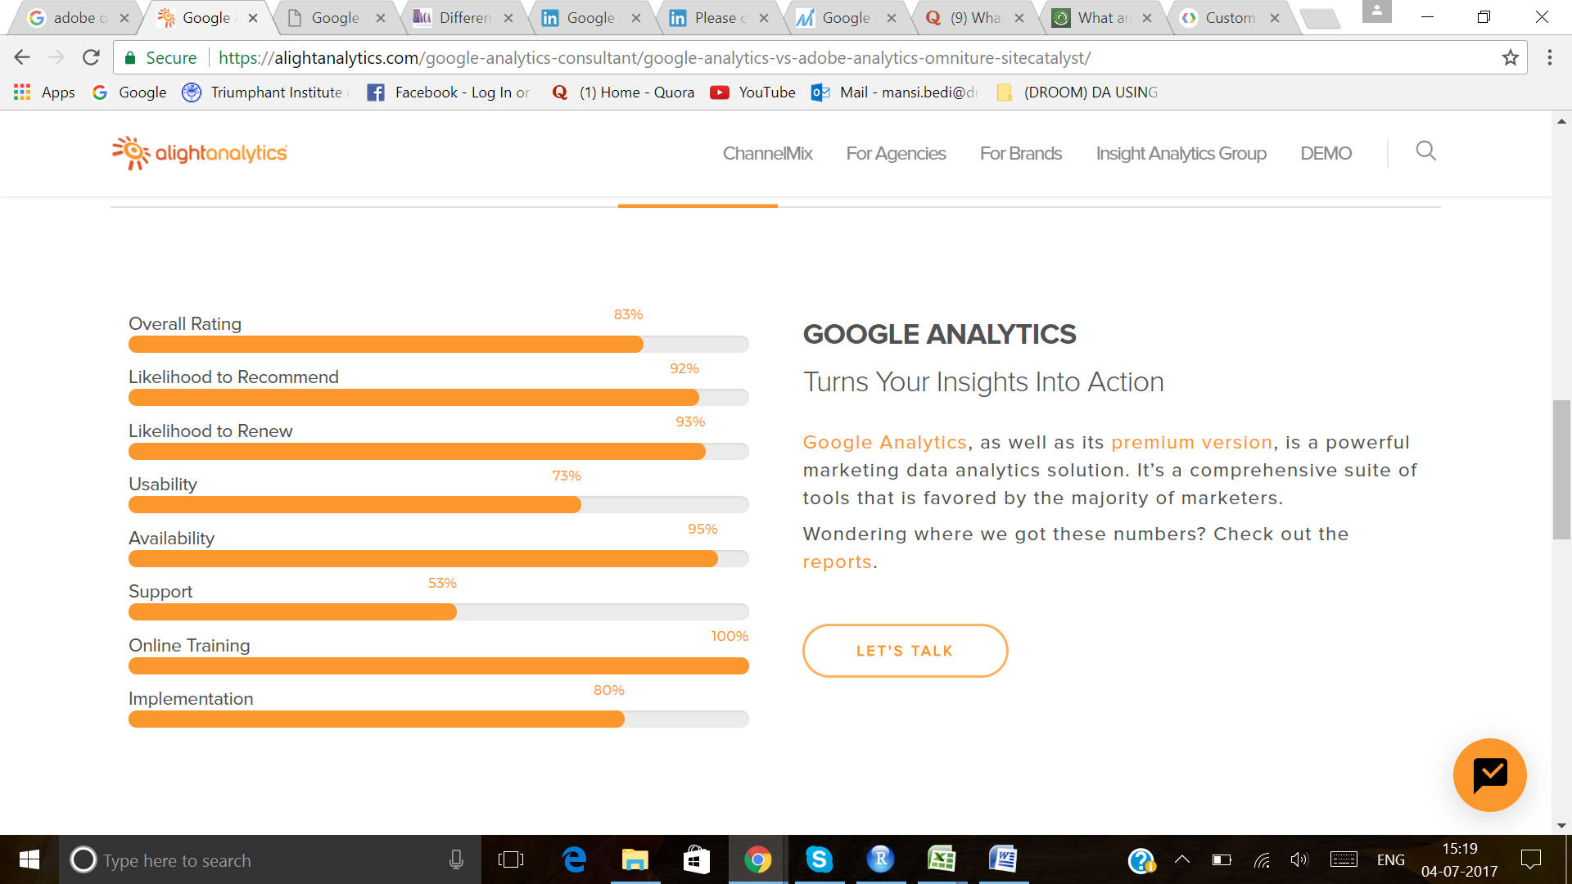

GOOGLE ANALYTICS

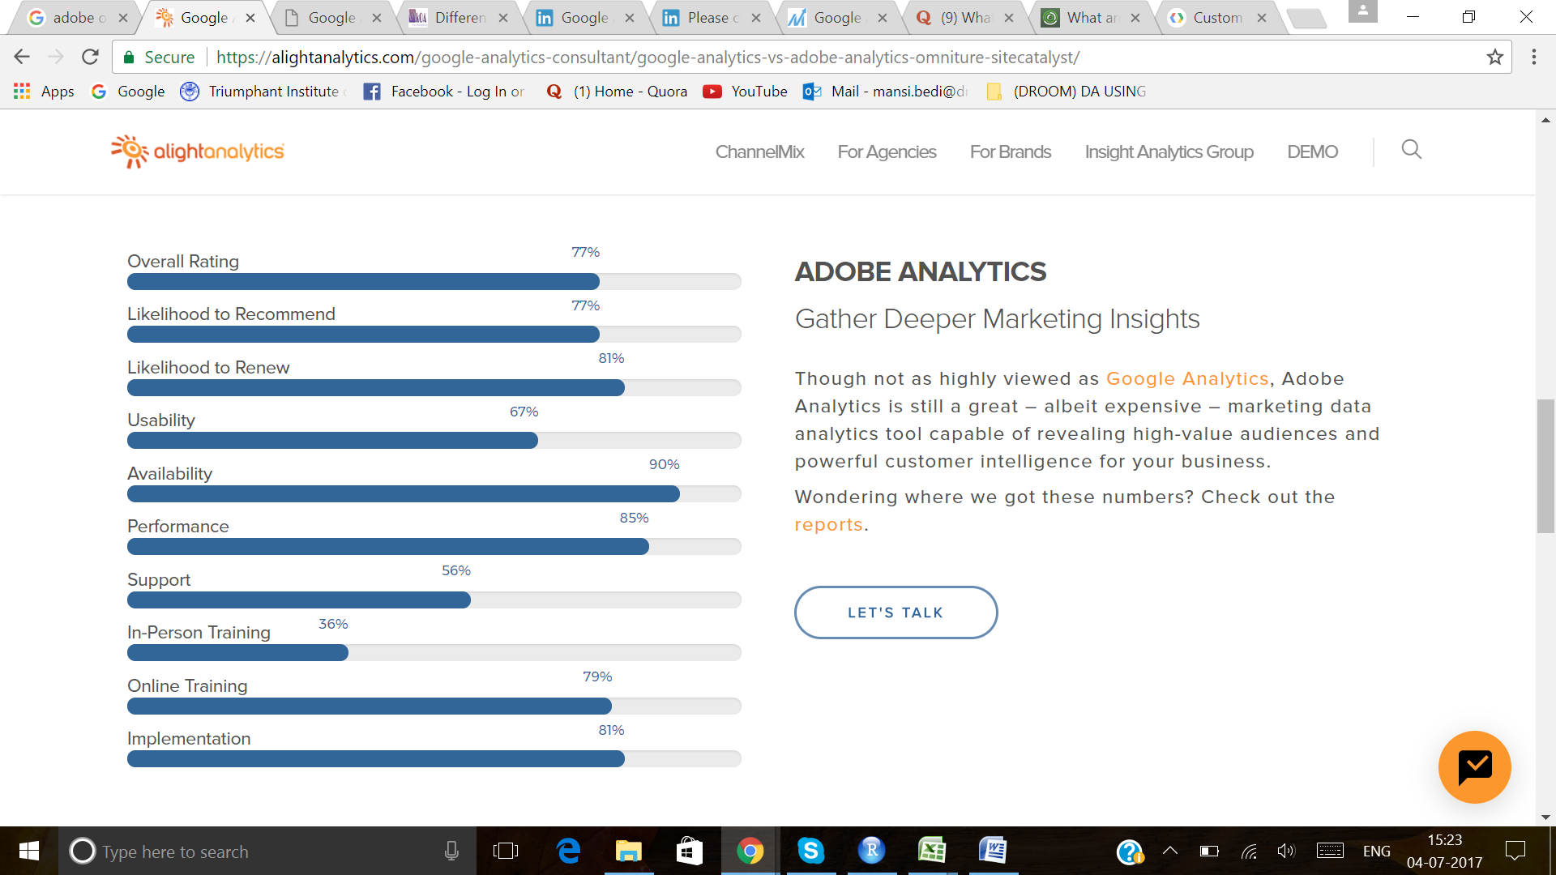

ADOBE ANALYTICS OMNITURE

CONCLUSION

If you are using only **basic level of its capability** then Google/Universal Analytics is the right choice because it is super simple to implement and your website starts showing the basic site metrics to the reporting page of your Google Analytics account instantly.

If you want to **retain your analytics data as long as you want** then Adobe Analytics is to be chosen.

If **millions of data to be tracked** then it is up to you. Google has fixed cost for premium service whereas Adobe Analytics cost varies upon your data needs.

**Complex level of data tracking** is easily done through Adobe Analytics and the reports too looks better than Google Analytics.