Blockchain's Application in
Academic Credentials Verification
A tamper-proof system for issuing and checking degree certificates,
built on the Ethereum blockchain and IPFS
MINI PROJECT REPORT
Submitted by
[ TEAM MEMBER NAMES AND ROLL NUMBERS ]
Under the guidance of
[ GUIDE'S NAME ]
[ DEPARTMENT ]
[ COLLEGE NAME ]
Academic Year 2026–27

Abstract
Fake degree certificates are easy to make and hard to catch. A printed certificate can be edited with ordinary software, and the only reliable way to check one today is to contact the university that issued it and wait for a reply. That takes days, costs staff time, and does not scale.
This project builds a working system that removes the waiting and the guesswork. When a university issues a certificate, the details are scrambled (encrypted) and the scrambled file is stored on IPFS, a shared file network. Two small pieces of information are then written to a blockchain: the address of that file, and a short fingerprint of it. Because a blockchain record cannot be changed after it is written, and because changing even one character of the file changes its fingerprint, any later tampering becomes obvious immediately.
Anyone can check a certificate in a few seconds by scanning a QR code. No account, no wallet and no permission from the university is needed. Importantly, the person checking can confirm that a certificate is genuine without being able to read what is inside it — the student holds the key that unlocks the contents and decides who sees them.
The system was built and deployed on the Polygon Amoy public test network and is fully working. We measured its real cost and speed, and we also tested the encryption method proposed in the paper this project is based on. That test found a serious weakness: the paper's encryption can be broken in under one second. We therefore replaced it with AES-256-GCM, a standard method, which our measurements show is also faster and produces far smaller files.

1. Introduction

1.1 The problem
Degree certificates decide who gets hired and who gets admitted to further study. That makes them worth forging. A convincing fake can be produced with a scanner and an image editor, and the people who need to spot it — HR staff, admissions officers — are not document experts.
The usual defence is to ask the issuing university to confirm the certificate. This works, but it is slow and manual. A single verification can take several days. For an employer screening hundreds of applicants, or a university checking every incoming transfer student, the cost adds up quickly.
There is a second, quieter problem. To verify a certificate today, the checker must normally be shown the whole document — name, marks, everything. Someone confirming that a degree is real does not necessarily need to see the student's grades.

1.2 Why blockchain helps here
A blockchain is a shared record book that many computers keep copies of. Once something is written into it, it cannot be quietly edited or deleted, because every copy would have to be changed at once and everyone would notice. There is no single company or server in charge of it.
That property is exactly what certificate verification needs. If a university publishes a permanent, unchangeable note saying "we issued this certificate, and here is its fingerprint", then anybody can check a certificate against that note later — without asking the university, and without being able to forge the note.

1.3 What this project delivers
- A smart contract deployed on a live public blockchain that records issued certificates and lets them be revoked.
- A web application with three screens: issue a certificate, verify one, and manage permissions.
- Encryption so that no personal information is ever written to the public blockchain.
- A QR code that carries the decryption key, so the student controls who can read their certificate.
- Measurements of real cost and speed on a public network, plus a security test of the original paper's encryption method.

2. Base Paper
This project implements the system described in:
S. A. Sultana, C. Rupa, R. P. Malleswari and T. R. Gadekallu, “IPFS-Blockchain Smart Contracts Based Conceptual Framework to Reduce Certificate Frauds in the Academic Field”, Information, vol. 14, no. 8, article 446, 2023.
The paper is open access, published by MDPI under a Creative Commons licence, which means it can be freely reused as long as it is credited.

2.1 What the paper proposes
The paper's design has an administrator who uploads certificate details through a web page. The details are encrypted, the encrypted data goes to IPFS, and an identifier is stored on the Ethereum blockchain. Users can then view the data. The paper defines four operations — issue, verify, revoke and view — and reports measurements of gas cost, encryption time, latency and throughput.

2.2 Where our implementation differs, and why
We followed the paper's overall design, but changed four things. Each change is deliberate and is defended below rather than hidden.

What the paper does | What we do | Why
Checks a username and password against a local database | Checks the wallet address on the blockchain itself | A password check happening on someone's private server cannot be verified by anyone else. A blockchain address cannot be faked.
Requires the viewer to hold cryptocurrency before they can check a certificate | Verification is completely free | Charging an employer to check a certificate defeats the purpose. Our verify operation is a read-only call, which costs nothing.
Uses the Ropsten test network | Uses Polygon Amoy | Ropsten and the other test networks used in older papers were shut down in 2022–23 and no longer exist.
Does not say who holds the decryption key | The student holds the key, delivered in a QR code | This makes the privacy claim real: the student decides who can read the certificate.
Uses a custom encryption method | Offers the same method plus AES-256-GCM | We tested the paper's method and broke it in under a second. See Section 7.
Table 1. Differences between the base paper and this implementation.

3. Objectives
- Build a working certificate system on a real public blockchain, not just a local simulation.
- Make sure no personal data is ever written to the public blockchain.
- Allow anyone to verify a certificate for free, without an account or a wallet.
- Let the student control who can read the contents of their certificate.
- Allow a university to withdraw a certificate it issued in error, without erasing the history.
- Measure the real cost and speed of the system, and test the security of the paper's encryption.

4. System Architecture
The diagram below shows the whole system. Reading it left to right: the university issues, the middle column stores, and the employer verifies.
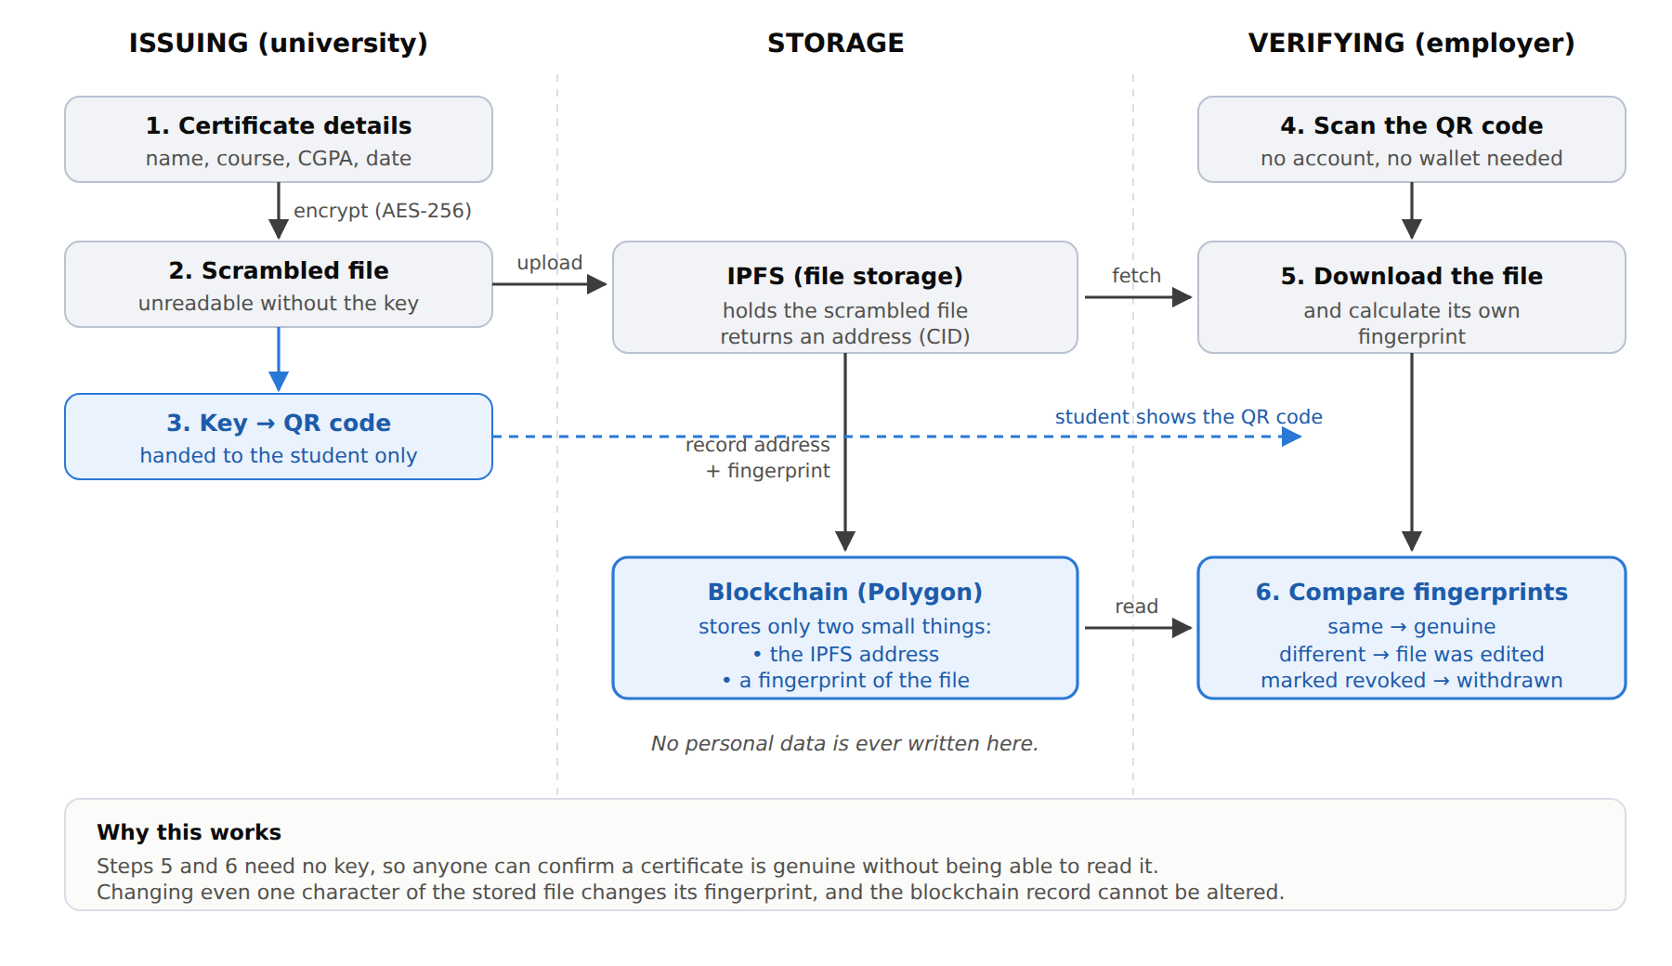
Figure 1. How a certificate is issued, stored and checked.

4.1 The three storage places, and why there are three
A common question is why the certificate is not simply stored on the blockchain. There are two reasons. Storing data on a blockchain is expensive — it would cost far more than the few paise this system costs per certificate. More importantly, everything on a public blockchain is visible to everyone forever, so putting a student's name and marks there would be a permanent privacy breach.

Where | What it holds | Who can see it
Blockchain (Polygon) | The file's address and a fingerprint of it. Nothing else. | Everyone — but it reveals nothing personal
IPFS | The encrypted certificate file | Everyone, but it is unreadable scrambled text
The student's QR code | The key that unscrambles the file | Only whoever the student shows it to
Table 2. What is stored where.

4.2 What a fingerprint is
A fingerprint — properly called a hash — is a short code calculated from a file. The same file always produces the same code, and changing anything at all in the file produces a completely different code. It cannot be reversed to recover the file.
This is what makes tampering detectable. The university calculates the fingerprint when it issues the certificate and stores it on the blockchain. Later, anyone can download the file, calculate the fingerprint themselves, and compare. If someone edited the stored file to change a grade, the two fingerprints will not match.

5. Implementation

5.1 Tools used
Tool | What it does in this project
Solidity | The language the smart contract is written in
Hardhat | Compiles the contract, runs the tests, deploys to the network
Polygon Amoy | The public test blockchain the contract runs on
IPFS with Pinata | Stores the encrypted certificate files
MetaMask | The university's wallet, used to approve transactions
React with Vite | The web application
ethers.js | Lets the web app talk to the blockchain
Web Crypto API | Performs the AES-256-GCM encryption inside the browser
Table 3. Tools and their roles.

5.2 The smart contract
The contract is the part that lives on the blockchain. It stores a record for each certificate and enforces the rules about who may do what. It provides these operations:

Operation | What it does | Who may call it
issueCertificate | Records a new certificate's address and fingerprint | Approved universities only
verifyCertificate | Checks a certificate and returns its status | Anyone, free of charge
revokeCertificate | Marks a certificate as withdrawn | Only the university that issued it
getCertificate | Reads a stored record | Anyone, free of charge
addIssuer / removeIssuer | Controls which universities may issue | The contract owner only
Table 4. Smart contract operations.
Verification returns one of four answers rather than a simple yes or no, because the difference between them matters to an employer:
- Valid — issued by an approved university, unchanged, and still in force.
- Tampered — the stored file does not match the fingerprint recorded at issue time. Someone edited it.
- Revoked — genuinely issued, but the university has since withdrawn it.
- Not found — no certificate with this identity was ever issued.
Revoked records are kept rather than deleted. An employer needs to be able to see that a certificate existed and was withdrawn; silently erasing it would hide useful information.

5.3 How a certificate is identified
Each certificate gets an identity calculated from the student's ID, the course, and the issue date. Because this is a fingerprint rather than the values themselves, the student's ID never appears on the public blockchain. It also means the same student cannot be issued two certificates for the same course on the same date, which prevents accidental duplicates.

5.4 Order of operations
The system encrypts first, then uploads to IPFS, and only writes to the blockchain last. This order is deliberate. The blockchain write is the only step that cannot be undone. If the upload fails, nothing has been lost. But if we wrote to the blockchain first and the upload then failed, we would have a permanent record pointing at a file that does not exist.

6. Testing
The project includes 47 automated tests that run in about one second: 24 covering the smart contract and 23 covering the encryption and packaging code. All of them pass.

What is tested | Examples
Permissions | An outsider cannot issue a certificate; one university cannot revoke another's certificate
Tamper detection | Editing the stored file makes verification report Tampered
Revocation | A revoked certificate reports Revoked, and its record is kept, not deleted
Free verification | Verification does not reduce the caller's balance at all
Encryption | Encrypting then decrypting returns exactly the original text, including Indian-language names
Security | The paper's encryption is brute-forced to demonstrate its weakness
Table 5. What the automated tests cover.
[ SCREENSHOT: Test results ]
Run: npm run test:all — capture the terminal showing 24 passing and 23 passing

7. Results
All measurements below were taken on the live Polygon Amoy public network, except the encryption timings, which are local because encryption happens in the browser.

7.1 Cost
Every write to a blockchain costs a small fee, measured in units called gas. Reading costs nothing. The table shows what each operation costs.

Operation | Gas used | Cost in POL | Notes
Deploy the contract | 978,715 | 0.0313 | One time only, ever
Issue a certificate | 185,095 | 0.0059 | Per certificate
Revoke a certificate | 62,448 | 0.0020 | Rarely needed
Add a university | 54,192 | 0.0017 | One time per university
Verify a certificate | 0 | Free | Costs the employer nothing
Table 6. Cost of each operation, measured on Polygon Amoy at 32 gwei.
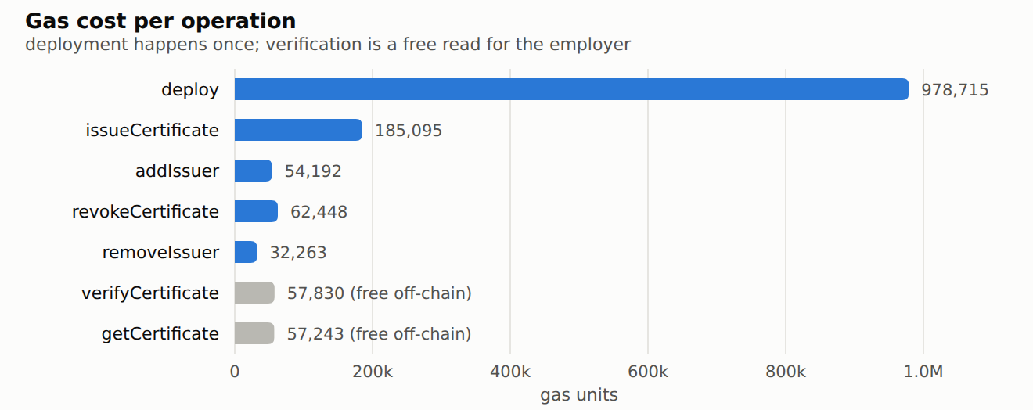
Figure 2. Gas used by each operation. Verification is shown in grey because it is free.
The headline result is that issuing a certificate costs about 0.006 POL. Issuing one hundred certificates costs roughly 0.59 POL — a few rupees in total. Verification, which is the operation that will happen most often, is completely free.
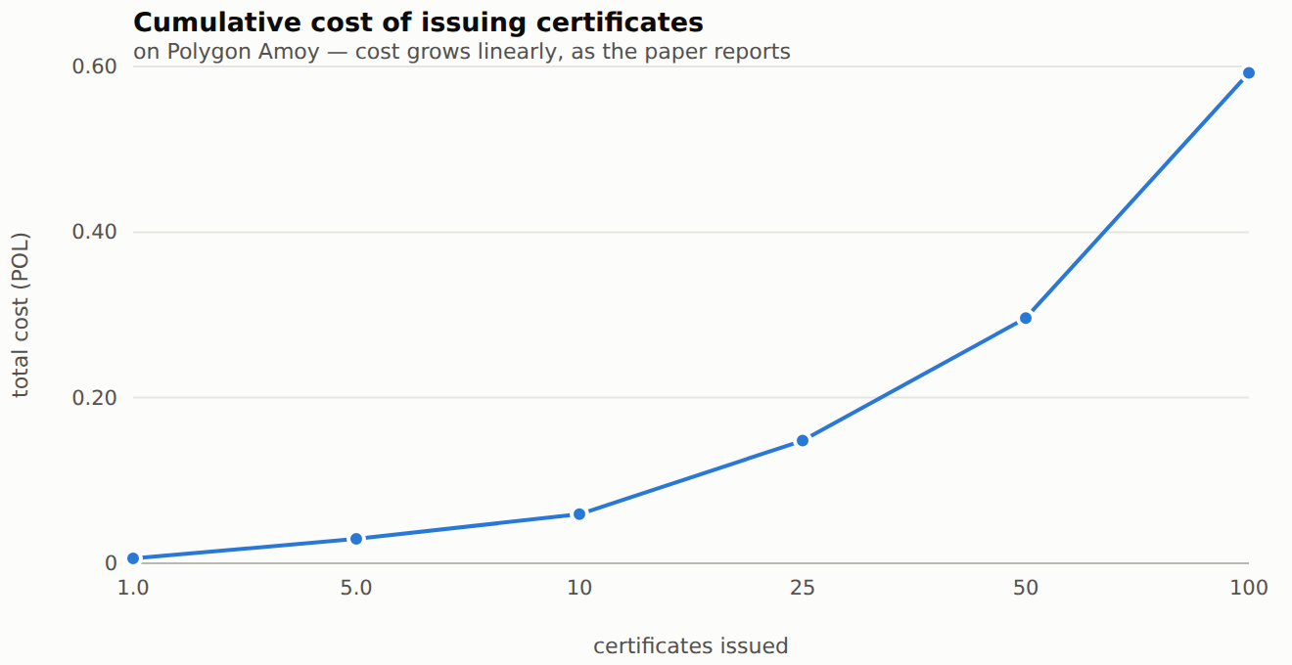
Figure 3. Total cost rises in a straight line with the number of certificates.

7.2 Speed
Each certificate took about three seconds to be confirmed on the blockchain. This is not a limitation of our system — it is simply how long the Polygon network takes to accept and confirm a transaction.

Transactions | Fastest | Average | Slowest | Per second
3 | 2.57 s | 2.93 s | 3.54 s | 0.34
6 | 2.77 s | 3.02 s | 3.58 s | 0.33
9 | 1.67 s | 3.07 s | 5.12 s | 0.33
Table 7. Time taken to confirm a certificate on Polygon Amoy.
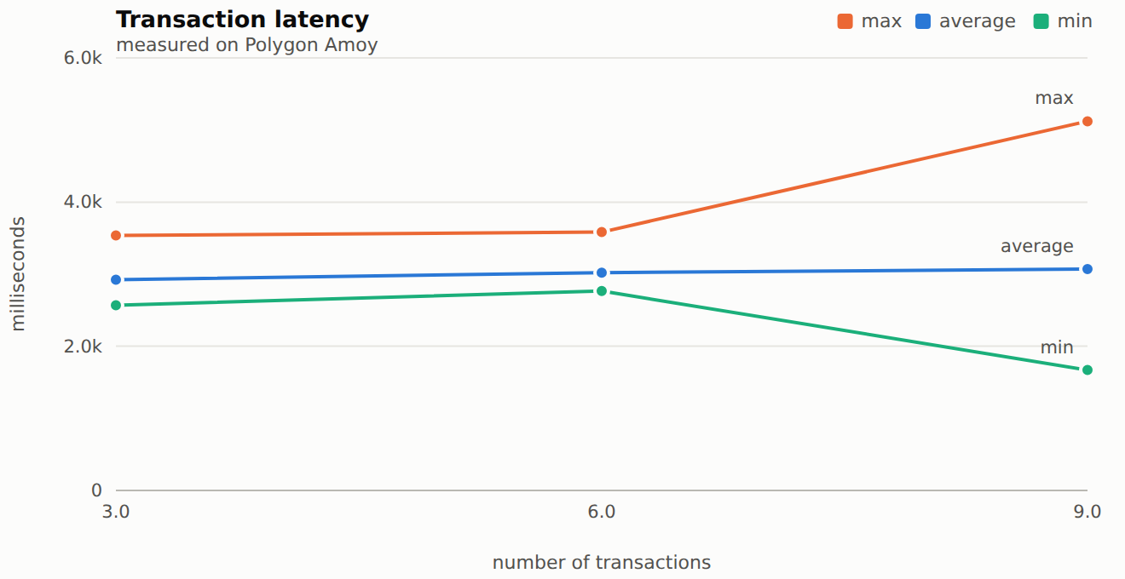
Figure 4. Confirmation time stays steady at around three seconds.
This is an important difference from the base paper. The paper reports times measured in fractions of a millisecond, which no real blockchain can achieve — those figures come from a simulated local network where transactions are accepted instantly, with no real network agreeing on them. Our figures are roughly three thousand times slower, and they are the honest ones. Three seconds is still far faster than the days a manual verification takes today.
It is worth being clear about what the speed figure means in practice. Issuing is a rare, background operation — a university issues certificates once a year. Verification, which happens constantly, does not involve a transaction at all and is effectively instant.

7.3 Encryption comparison
We implemented the encryption method described in the paper exactly as published, and compared it with AES-256-GCM, the standard method used by banks and messaging apps.
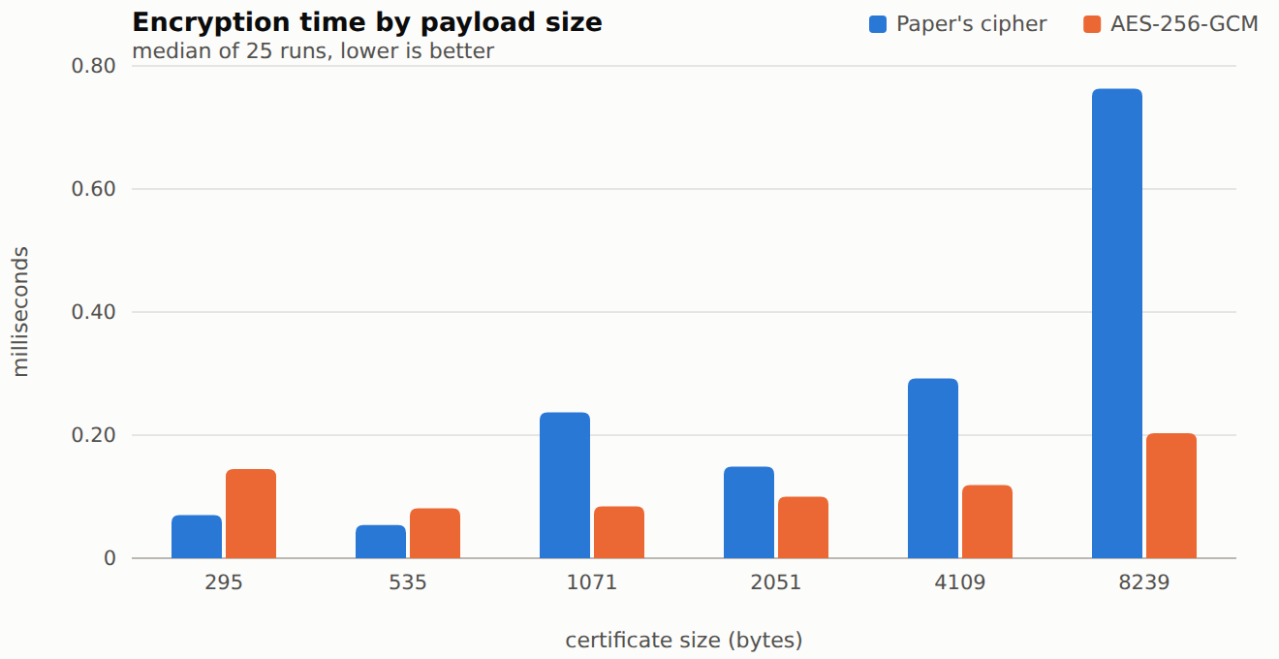
Figure 5. Time to encrypt. AES is consistently faster on realistic certificate sizes.
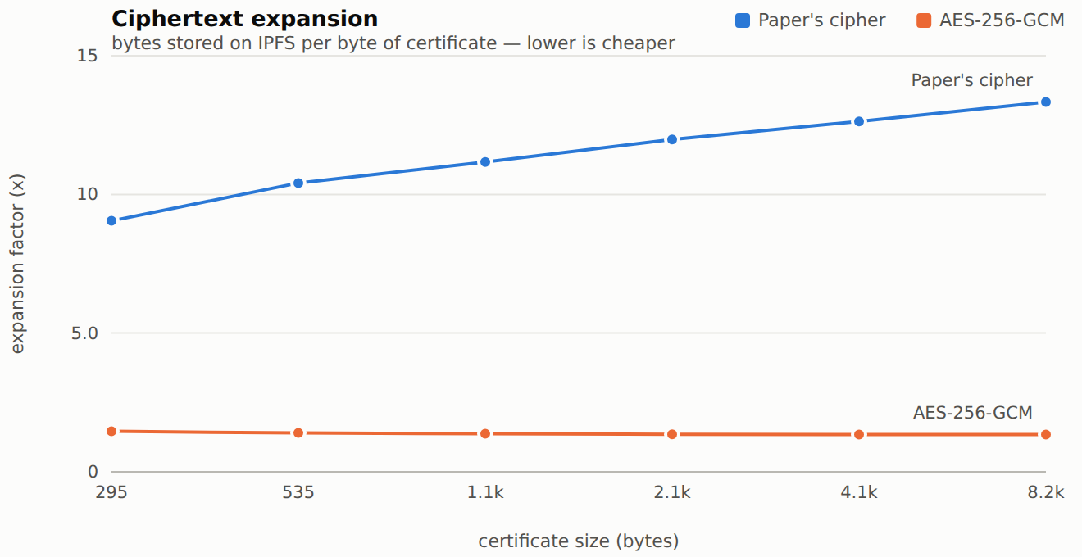
Figure 6. How much the file grows when encrypted. Lower is cheaper to store.
The paper's method makes the file roughly eleven times larger, because every character becomes two numbers with separator letters between them. AES adds only about a third. For a typical certificate this is the difference between storing 12 KB and storing 1.5 KB.

7.4 Security test of the paper's encryption
The paper claims its method resists brute-force attacks — the attack where someone simply tries every possible key until one works. We tested that claim by writing the attack.
The paper's method builds its key from tetrahedral and pentatope numbers. These are fixed mathematical sequences that anybody can look up, so the key is not really a random secret — it is just two starting positions in those sequences. That leaves only about 79,600 possible keys.

 | The paper's method | AES-256-GCM
Number of possible keys | 79,600 | About 10 followed by 76 zeros
Time to break it | 0.57 seconds | Longer than the age of the universe
Detects tampering? | No | Yes
Peer-reviewed standard? | No | Yes (NIST SP 800-38D)
Table 8. Security comparison. Our brute-force test ran on an ordinary laptop.
The attack found the correct key after 10,946 attempts in 0.57 seconds on a normal laptop. This is not a theoretical concern — it is a working break, included as an automated test in our code so it can be reproduced.
We believe the paper's security analysis over-counts the difficulty because it counts guesses of the key values rather than guesses of the two starting positions that generate them. Those are very different numbers.
One further point: the paper describes its method as homomorphic encryption. Homomorphic encryption is a specific technique that allows calculations on encrypted data without decrypting it first. The paper's method does not do this, so the name is misleading.
For these reasons our system uses AES-256-GCM by default. The paper's method remains implemented and selectable, so the comparison can be reproduced.

7.5 Working system
The system is deployed and running. A real certificate has been issued and verified on the public Polygon Amoy network.

Item | Value
Network | Polygon Amoy (public test network)
Contract address | 0x0BaEe698C3B689C74A51d9cED088B4D3C4175285
Certificates issued during testing | 20+
Automated tests passing | 47 of 47
Table 9. Deployment details.
[ SCREENSHOT: The Issue screen ]
Fill in a certificate and capture the form before submitting
[ SCREENSHOT: MetaMask confirmation ]
Capture the MetaMask popup asking to confirm the transaction
[ SCREENSHOT: QR code produced after issuing ]
Capture the success screen showing the QR code
[ SCREENSHOT: Verification showing 'Authentic' ]
Capture the green Authentic result with the details panel
[ SCREENSHOT: Verification showing 'Tampered' ]
Edit the CID slightly, or use a wrong one, to show detection
[ SCREENSHOT: Verification showing 'Revoked' ]
Revoke from the Admin screen, then verify again
[ SCREENSHOT: The encrypted file on IPFS ]
Open the Pinata gateway link to show it is unreadable
[ SCREENSHOT: The transaction on PolygonScan ]
Open the transaction link to show it is on a public blockchain

8. Limitations
Being honest about what this system does not solve is as useful as describing what it does.
- It proves a certificate was issued, not that it was deserved. If a university issues a certificate to the wrong person, the system faithfully records that mistake.
- We rely on Pinata, a commercial service, to keep the IPFS files available. If Pinata disappeared, files could become unreachable — though they could not be altered, because the blockchain fingerprint would expose any change.
- If a student loses their QR code, nobody can read the certificate contents. The certificate can still be proven genuine, but the details cannot be recovered.
- The upload key is currently stored in the web application, which is acceptable for a student project but would need a small server in real use.
- The list of approved universities is controlled by one owner account. A real deployment would want several people to approve changes together.

9. Conclusion
This project implements the framework proposed by Sultana and colleagues as a fully working system on a live public blockchain. Issuing a certificate costs about 0.006 POL and takes around three seconds. Verification costs nothing, requires no account, and completes almost instantly.
The system keeps personal data off the public blockchain entirely, and separates two things that are usually bundled together: proving a certificate is genuine, and being able to read it. An employer can do the first without the second.
Reproducing the paper's evaluation on a real network also produced two findings worth recording. The paper's reported speeds are only achievable on a simulated local network; real confirmation takes about three seconds. And the paper's encryption method can be broken in under a second, so we replaced it with a standard one that our measurements show is also faster and more compact.

9.1 Future work
- Move the upload key to a small backend server so it is not visible in the web application.
- Require several administrators to approve adding or removing a university.
- Allow a university to issue many certificates in one transaction, which would cut the cost per certificate.
- Add a way for a student to prove one fact — for example that their CGPA is above 8 — without revealing the rest of the certificate.

References
[1] S. A. Sultana, C. Rupa, R. P. Malleswari and T. R. Gadekallu, “IPFS-Blockchain Smart Contracts Based Conceptual Framework to Reduce Certificate Frauds in the Academic Field”, Information, vol. 14, no. 8, art. 446, 2023. doi:10.3390/info14080446
[2] G. Wood, “Ethereum: A Secure Decentralised Generalised Transaction Ledger”, Ethereum Yellow Paper, 2014.
[3] J. Benet, “IPFS — Content Addressed, Versioned, P2P File System”, arXiv:1407.3561, 2014.
[4] M. Dworkin, “Recommendation for Block Cipher Modes of Operation: Galois/Counter Mode (GCM) and GMAC”, NIST Special Publication 800-38D, 2007.
[5] Polygon Labs, “Polygon Amoy Testnet Documentation”, 2024.
[6] Cloudflare, “Cloudflare’s public IPFS gateways and supporting Interplanetary Shipyard”, Cloudflare Blog, 2024.

