7/15/2019 9:34 AM

The for attribute is used in labels. It refers to the id of the element this label is associated with.

For example:

<label for="username">Username</label>

<input type="text" id="username" name="username" />

Now when the user clicks with the mouse on the username text the browser will automatically put the focus in the corresponding input field. This also works with other input elements such as <textbox> and <select>.

Quote from the [specification](http://www.w3.org/TR/html401/interact/forms.html#h-17.9.1):

This attribute explicitly associates the label being defined with another control. When present, the value of this attribute must be the same as the value of the id attribute of some other control in the same document. When absent, the label being defined is associated with the element's contents.

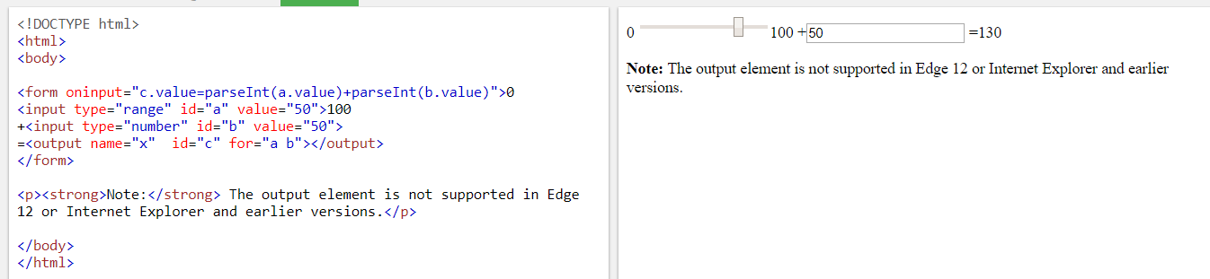

Id vs name attributes in HTML

1. The difference is that a "name" transfers from the browser to the server and can be different than the "id".
2. To put it very informally, id is what your frontend (CSS, JS) works with, while name is what your server receives and can then process.
3. It might be better to say: *The name attribute is****required*** when sending data... instead of: *The name attribute is****used****when sending data...* since any form data missing the **name** attribute will not be transmitted (or indeed will not be processed at all according to the HTML spec)
4. id is used to **identify the HTML element through the Document Object Model** (via JavaScript or styled with CSS). id is expected to be unique within the page.

name corresponds to the form element and **identifies what is posted back to the server**.