The float Property

The float property is used for positioning and formatting content e.g. let an image **float left to the text in a container**.

The float property can have one of the following values:

* left - The element floats to the left of its container
* right - The element floats to the right of its container
* none - The element does not float (will be displayed just where it occurs in the text). This is default
* inherit - The element inherits the float value of its parent

In its simplest use, the float property can be used to wrap text around images.

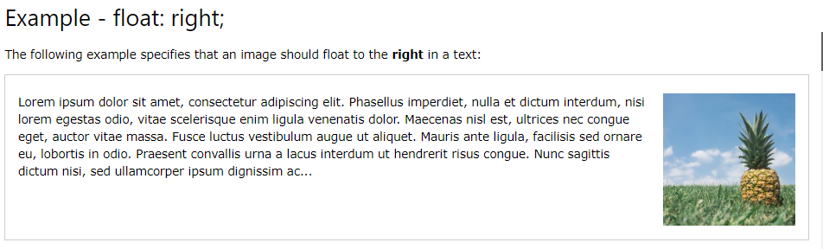

<head>

<style>

img {

float: left;

}

</style>

</head>

<body>

<img src="pineapple.jpg" alt="Pineapple" style="width:170px;height:170px;margin-left:15px;">

<p>

Lorem ipsum dolor sit amet, consectetur adipiscing elit. Phasellus imperdiet, nulla et dictum interdum, nisi lorem egestas odio, vitae scelerisque enim ligula venenatis dolor. Maecenas nisl est, ultrices nec congue eget, auctor vitae massa. Fusce luctus vestibulum augue ut aliquet. Mauris ante ligula, facilisis sed ornare eu, lobortis in odio. Praesent convallis urna a lacus interdum ut hendrerit risus congue. Nunc sagittis dictum nisi, sed ullamcorper ipsum dignissim ac. In at libero sed nunc venenatis imperdiet sed ornare turpis. Donec vitae dui eget tellus gravida venenatis. Integer fringilla congue eros non fermentum. Sed dapibus pulvinar nibh tempor porta. Cras ac leo purus. Mauris quis diam velit.</p>

</body>

The clear Property

The clear property specifies what elements can float beside the cleared element and on which side.

The clear property can have one of the following values:

* none - Allows floating elements on both sides. This is default
* left - No floating elements allowed on the left side
* right- No floating elements allowed on the right side
* both - No floating elements allowed on either the left or the right side
* inherit - The element inherits the clear value of its parent

The most common way to use the clear property is after you have used a float property on an element.

When clearing floats, you should match the clear to the float: If an element is floated to the left, then you should clear to the left. Your floated element will continue to float, but the cleared element will appear below it on the web page.

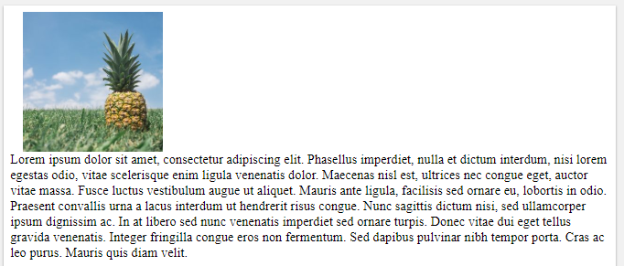

<head>

<style>

img {

float: left;

}

p{

clear:left;

}

</style>

</head>

<body>

<img src="pineapple.jpg" alt="Pineapple" style="width:170px;height:170px;margin-left:15px;">

<p>

Lorem ipsum dolor sit amet, consectetur adipiscing elit. Phasellus imperdiet, nulla et dictum interdum, nisi lorem egestas odio, vitae scelerisque enim ligula venenatis dolor. Maecenas nisl est, ultrices nec congue eget, auctor vitae massa. Fusce luctus vestibulum augue ut aliquet. Mauris ante ligula, facilisis sed ornare eu, lobortis in odio. Praesent convallis urna a lacus interdum ut hendrerit risus congue. Nunc sagittis dictum nisi, sed ullamcorper ipsum dignissim ac. In at libero sed nunc venenatis imperdiet sed ornare turpis. Donec vitae dui eget tellus gravida venenatis. Integer fringilla congue eros non fermentum. Sed dapibus pulvinar nibh tempor porta. Cras ac leo purus. Mauris quis diam velit.</p>

</body>