**console.log() vs alert() when debugging**

1. Alert() isn’t ideal as it would stop the script from running while the alert() was displayed, preventing the script from continuing its usual process.
2. Another advantage of using console.log() over alert() is that you can capture more than just string values. By passing an object to the console log, you can expand this and view all properties of the object.
3. If we call alert(obj) this will return [object Object], which isn’t very helpful.

For example if we have the following javascript variable:

var obj = {

foo: "bar",

baz: "qux"

};

alert(obj) // returns [object, object]

**Alert() dialog**

An alert just has 1 button “ok”. It is triggered with the function alert("message")

// warning  
alert("Invalid email address. Please enter again.");  
// debugging  
alert(currentCounter);

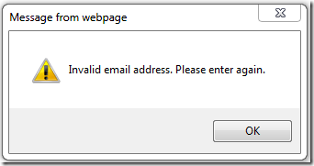

**Prompt() dialog**

This method asks user for some small input. A prompt box has a text field and two buttons (“Ok” & “Cancel”). It is called with prompt message and returns the value entered in the text field.

It takes 2 arguments:

1. Prompt message
2. Default Value

prompt("Please enter your nickname", "nickname");

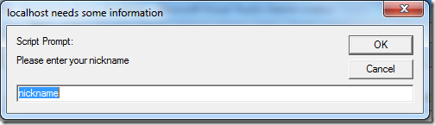

After user enters the value in prompt dialog box, its value is returned ( or null is returned in case user hits cancel).

**Confirm() dialogue**

It has two buttons (“Ok” & “Cancel”) and is called with confirmation message and returns true or false based on which button was clicked.

if (confirm("Are you sure you want to delete photo?") == true) {  
 alert("Deleting photo...");  
}  
else {  
 alert("Glad you decided against deleting the photo!");  
}