1. Each record in Mongodb is a document which is in JSON format.
   1. Table (RDBMS) = Collection (NoSQL)
   2. Record (RDBMS) = Document (NoSQL)
2. Replicaion in MongoDB enables copying data on different nodes, in case one node is down then data can be retrieved from other node.
3. JSON format is a delimited structure with key value pairs.
4. JSON key is present at Record level so we can have few documents which have extra key-value pairs.
5. Every time you want to read a value you need to provide this key.
6. Value can be primitive types (string, number, boolean etc) or array of strings, boolean, sub json documents.

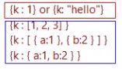

MongoDB is schema less and therefore there is no strict structure unlike RDBMS.



_id is primary key index; its value is immutable means cannot be updated with update statement. If this value is deleted then that particular document will also get deleted.

All other indexes defined by user are secondary indexes.

MongoDB uses JavaScript as the main query language. If you install MongoDB you will be able to see the JavaScript language interpreter is installed by default. In terms of query language you can choose from a variety of scripting languages for MongoDB like python, PHP or perl. But you need to install the language interpreter for these languages if you want to execute those queries against MongoDB.

Horizontal Partitioning: MongoDB supports “Horizontal” partitioning only. MongoDB partitions data at a document level. Means moving entire document to other nodes and not partial fields.

Vertical Partitioning: missing in MongoDB.

Data partioning:

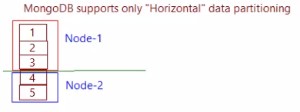

Data partioning is done for performance and scalability.

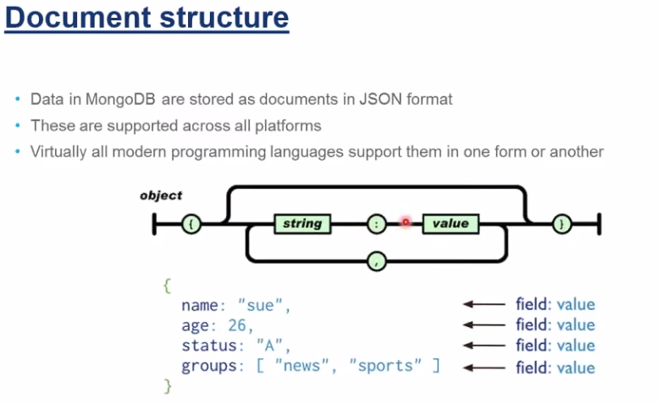

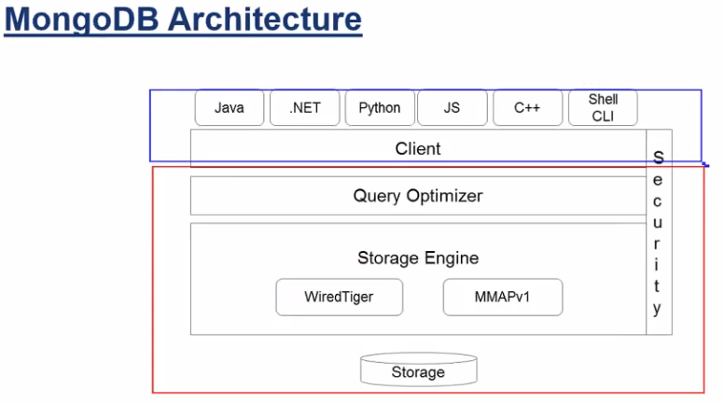

Client connects to server over TCP/IP.

Shell CLI is JS shell, through this you can perform CRUD operations.

Query Optimizer interacts with storage engine (responsible for coordinationg with memory and physical storage).

Your angular application is rendered by server.

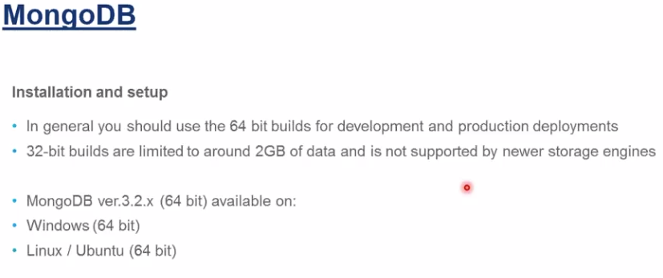

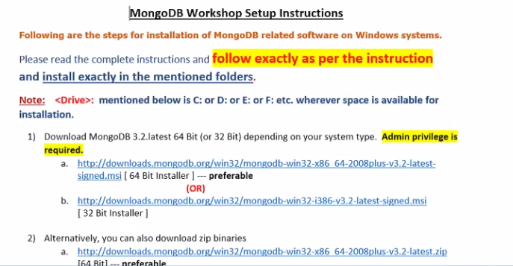

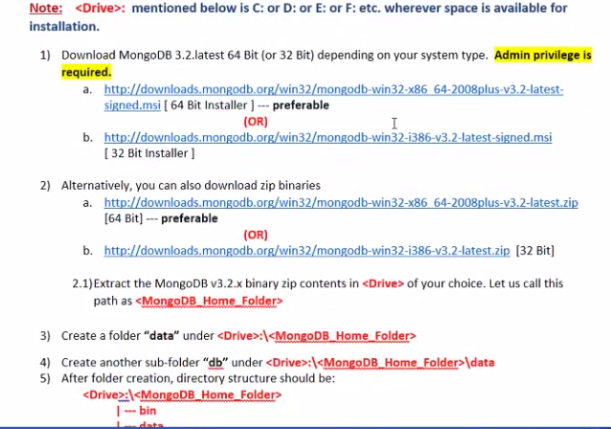

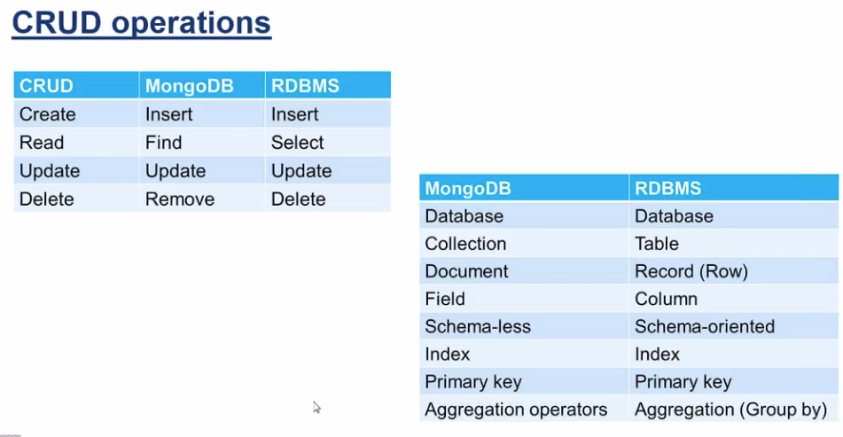

Primary Key: in MongoDB, primary key is auto selected and it is _id. You can give a value for this field otherwise it will be give its value itself.

