Rehearsal Documentation
Part 3 of 3 — Faculty Guide

Table of Contents

Faculty Overview

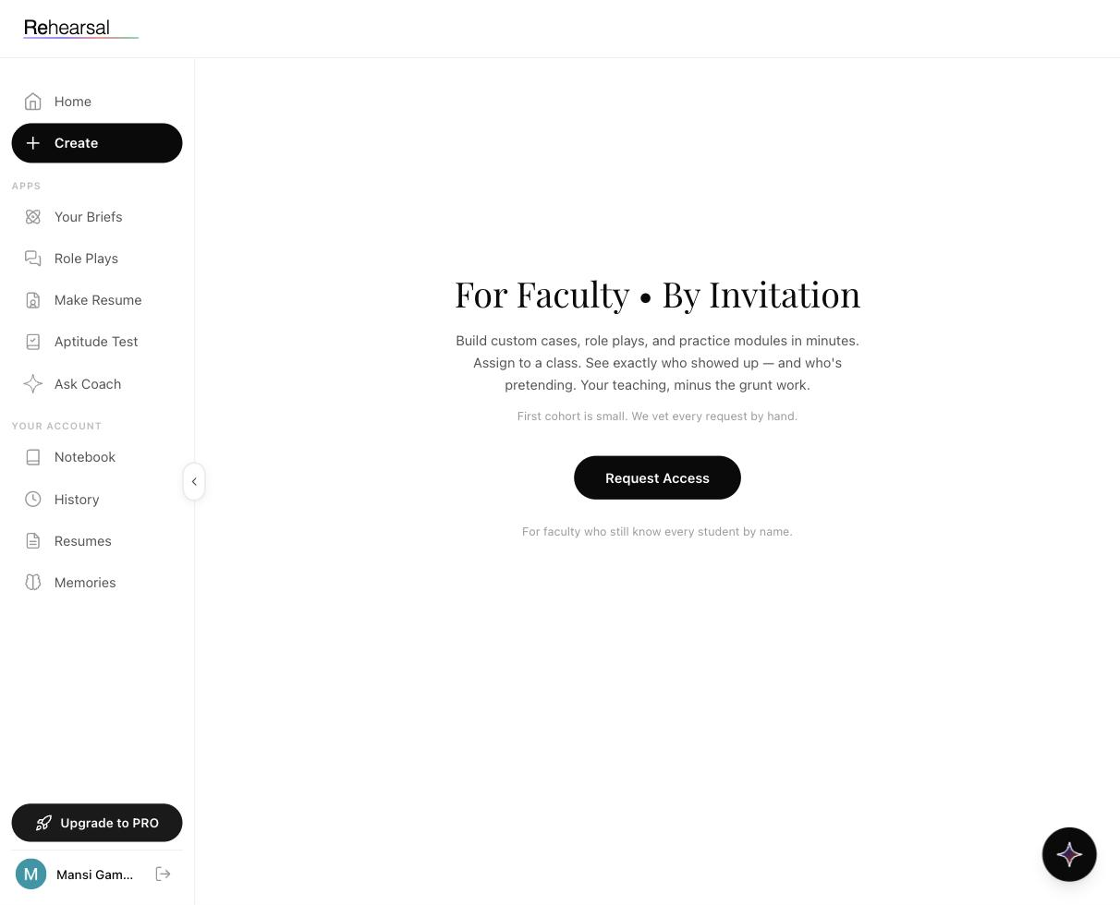

What it is
The Create module is the faculty-side of Rehearsal — a separate tool for professors, placement cells, and trainers running interview preparation for a class or cohort. It lets you:
- Build custom cases, role plays, and practice modules designed for your students, your context.
- Assign them to a specific class.
- See exactly who showed up, who engaged, and who's drifting — the attribution layer the student side doesn't show.
The positioning is deliberate: "Your teaching, minus the grunt work." This is not a bulk-upload content tool; it's an instrument for faculty who want their case materials delivered and tracked without rebuilding their pedagogy for a new platform.

Who it's for
- B-school professors running GD-PI prep as part of coursework.
- Placement cells coordinating interview readiness across the graduating batch.
- Independent trainers and coaches running cohort-based interview programs.
- Corporate L&D teams running structured interview skills programs for junior hires.

Why it exists
Three gaps that motivated the build:
- Custom cases die on their creator's hard drive. Brilliant classroom cases get built once, delivered twice, then forgotten. Create keeps them live and reusable.
- You can't tell who actually practiced. Traditional prep ends at "here's a document — go practice." Students nod. Few do. Create shows you exactly who did the work and how much.
- 1-on-1 feedback doesn't scale. You can personally coach five students. Rehearsal's AI coach extends your feedback to the other forty-five.

How access works

Create is invitation-only. The team reviews every application individually because the product is early and the quality of the first cohort matters more than volume. See Requesting Access.

What the faculty experience looks like
Once you're approved:
- Log in, tap Create in the sidebar (it becomes an active button instead of the waitlist page).
- Build a case or role play (template-assisted, not from scratch).
- Assign it to a class or cohort.
- Watch the attendance and engagement data come in live.
- Use the aggregate view to decide what to teach next session.
See Building Cases and Assign & Track for the detailed flows.

What you don't get to see
Rehearsal is careful about student privacy:
- You see attendance (did the student show up and complete) and aggregate cohort performance (average score, distribution).
- You do not see individual session transcripts by default. If a student wants to share a specific session with you for 1-on-1 feedback, they can — but the default is private.
This is a deliberate choice: students are more honest in practice when they know you're not reading every word.

How it interacts with the student modules
Students in your cohort still see the full regular product:
- Their own Briefs, Role Plays, Aptitude, CV Enhancer, Ask Coach, Notebook, History, Memories.
- Plus: cases you've assigned, flagged as coursework.
Your assignments appear as a distinct badge on the student side — "Assigned by [Your Name]" — so students know which work is cohort-mandated and which is self-directed.

Related
- Requesting Access — how to get in
- Building Cases — the case authoring flow
- Assign & Track — cohort management and attendance

Requesting Faculty Access

What it is
The Create module is invitation-only. To use it, you submit a request, and the Rehearsal team reviews each application manually. This page walks through the request flow and what to expect.



When to request access
- You're planning a placement or GD-PI prep program for an upcoming term.
- You're a corporate L&D lead running a cohort-based interview readiness program.
- You're an independent interview coach running a structured cohort of ≥ 10 students.
- You'd like to pilot Rehearsal with a small group before rolling out wider.

When not to request access
- You want a personal account — faculty Create is for teaching cohorts, not solo practice. Sign up for a regular account instead.
- You want to evaluate the student-side product — the free tier gives you full student access without needing faculty approval.

How to request access

1. Click Create in the sidebar
If you don't have faculty access yet, you'll land on the waitlist page.

2. Read the pitch
You'll see:
- Header: For Faculty • By Invitation
- Pitch paragraph: "Build custom cases, role plays, and practice modules in minutes. Assign to a class. See exactly who showed up — and who's pretending. Your teaching, minus the grunt work."
- Eligibility line: "First cohort is small. We vet every request by hand."
- A black Request Access button
- Footer line: "For faculty who still know every student by name."

3. Tap Request Access
The request form opens. You'll typically be asked about:
- Your name and institution
- Your role (professor, placement officer, trainer, L&D lead)
- The size of the cohort you plan to run
- Timing (when you'd start)
- Why Rehearsal is a fit for what you're trying to do
Exact form fields are finalised at request time — the team may ask follow-up questions over email.

4. Wait for review
The team reviews applications individually. Expect a response within a few business days — longer during peak placement seasons.

5. Onboarding
Approved faculty go through a short onboarding:
- A scoping call (15–30 min) to understand the cohort and outcomes you want.
- Help migrating any existing cases you've built elsewhere.
- A walkthrough of Building Cases and Assign & Track.

What makes an application move fast
In practice, requests get approved quickly when they clearly describe:
- A real cohort with a real timeline (not hypothetical)
- The specific kinds of interviews students will face (MBA, campus placement, consulting, etc.)
- What success looks like for you — e.g. "I want to see 80% of the batch complete at least 3 role plays before our mock panel week"

What often delays approval
- Requests that look like individual practice accounts dressed up as faculty.
- Vague timing ("sometime this year").
- Cohorts under 10 students — Create is scoped for class-level deployment; smaller groups usually don't need it.

Related
- Faculty Overview — what you'll be able to do once approved
- Building Cases — your first creation flow after onboarding

Building Custom Cases and Role Plays

What it is
Once you have faculty access, the Create module lets you build three types of content to assign to your cohort:
- Custom Cases — structured learning modules in the same format as the 22 Briefs, but with content you author.
- Custom Role Plays — mock interviews built from a JD + context you provide, specific to companies or scenarios relevant to your cohort.
- Practice Modules — short practice activities (voice prompts, frameworks to apply) that sit between cases and role plays.
All three are template-assisted — you don't build from a blank page. You provide the source material (a case, a JD, a prompt) and Create turns it into a Rehearsal-format module in minutes.

When to build what
- Custom Case — you teach a concept not covered by the 22 Briefs, or you want a version tailored to your regional/industry context.
- Custom Role Play — you want students practising interviews for a specific recruiter visiting campus, or a specific role not in the 297 library.
- Practice Module — short drills between the bigger pieces (e.g. "answer this stakeholder pushback in 60 seconds").

How to build a custom case

1. Open Create
Click Create in the sidebar (now active after onboarding).

2. Pick "New Case"
From the Create dashboard, choose New Case from the content-type options.

3. Provide your source material
The system accepts:
- A case study document (PDF, DOCX)
- A framework or model you want students to apply
- Optional supporting data (tables, exhibits, charts)

4. Set the structure
The case template walks you through filling in:
- Title and Category pill (e.g. your institution's theme or a custom category)
- Hook — one-line story or question
- Core concept — what you want students to walk away understanding
- Reading content — the main text, broken into digestible sections
- MCQs — 3–5 check questions
- Voice practice prompt — the question students speak an answer to

5. Preview as a student
Tap Preview to see the case exactly as students will experience it. Adjust until it feels right.

6. Publish and assign
Tap Publish to make the case available in your faculty library, then assign it to one or more cohorts. See Assign & Track for the assignment flow.

How to build a custom role play

1. From Create dashboard, pick New Role Play

2. Provide the interview context
- Company name / role title
- Sector (pick from the same sector list students see — Sales, Engineering, FMCG, etc., or add a custom category)
- JD (PDF upload, strongly recommended)
- Role type description — what kind of interview is this? HR screen, case round, technical deep-dive, behavioural?
- Key topics / competencies you want probed

3. Pick the difficulty
Standard, Stretch, or Senior. This calibrates how hard the AI pushes students.

4. (Optional) Add a panelist persona
You can define the personality of the interviewer — warm, adversarial, quiet, data-heavy. Useful when you're replicating a specific firm's interviewing style.

5. Preview
Run through a sample interaction yourself to see how the AI is handling the context. Iterate.

6. Publish and assign
Same flow as cases — publish to library, assign to cohort.

How to build a practice module
Shorter than either of the above. Templates include:
- Framework drills — students apply a framework to a prompt and speak their answer.
- Stakeholder pushback — students respond to a pointed challenge under time pressure.
- Data interpretation — a mini LRDI-style prompt with a spoken answer.
Same publish-and-assign flow.

Tips for good cases
- Write the hook first. If you can't state the case's question in one sentence, the case isn't ready.
- Use specific numbers. "Revenue fell 23%" beats "Revenue declined." The AI grades student answers against specifics.
- Test your MCQs with your TA. Ambiguous MCQs tank student trust in the case more than a boring case does.
- Start with 3–5 cases, not 30. First cohort's job is to validate your authoring voice. You'll iterate faster with a small, high-quality library.

Tips for good role plays
- Attach the real JD. Generic role descriptions produce generic interviews.
- Define the interviewer's style. A vague panelist persona makes every role play feel the same.
- Difficulty calibration matters. Too hard on week 1 and students disengage. Too easy on week 6 and they stop growing.

Related
- Assign & Track — how to get your content to students and see who engaged
- Faculty Overview — the wider faculty experience
- Your Briefs — reference for the 22-brief style your custom cases emulate

Assigning to a Class and Tracking Attendance

What it is
Once you've built cases, role plays, or practice modules, you assign them to a cohort and track who showed up. This is the piece the promise "See exactly who showed up — and who's pretending" is built around.

When to use it
- Beginning of term — set up your cohort and your first wave of assignments.
- Weekly — push the next assignment and review last week's engagement.
- Before a mock panel day — scan the dashboard to see who's prepared and who needs a nudge.
- End of term — pull aggregate performance to inform grading or placement recommendations.

How it works

1. Create your cohort
From the Create dashboard, create a Cohort — a named group of students (e.g. MBA PGP Batch 2026 – Section B).
Options for adding students:
- Invite by email list — paste emails, Rehearsal sends invites.
- Invite link — share one link; first N students who accept are enrolled.
- Institution SSO — if your institution is integrated, students authenticate via SSO.

2. Assign content to the cohort
From any published case, role play, or practice module:
- Tap Assign
- Pick one or more cohorts
- Set a due date (optional but recommended — students take deadlines more seriously than open-ended suggestions)
- Optionally add a note ("This is prep for the KPMG visit next Friday")
- Publish the assignment
Students in the cohort see the assignment appear on their Home feed with an Assigned by [Your Name] badge.

3. Monitor the engagement dashboard
Your faculty dashboard shows, per assignment:
- Completion rate — % of cohort who finished
- Start rate — % who even opened it
- Average Overall — aggregate score across completions
- Score distribution — histogram, so you can see if the cohort clusters high or bimodally
- Drop-off — where in the flow students stopped (opened the brief but didn't do the voice practice, etc.)
Per student, you see:
- Status — Not Started / In Progress / Completed
- Date completed
- Number of attempts (for role plays that allow retakes)
What you don't see by default:
- Individual transcripts
- Per-question answers
- Specific Ask Coach conversations
(Students can opt to share a specific session with you for 1-on-1 feedback, but the default is private.)

4. Nudge or intervene
The dashboard surfaces who's at risk — students who've opened an assignment days ago but not completed it. You can:
- Send a reminder from inside Create (Rehearsal sends the email).
- Flag the student for a 1-on-1 in class.
- Export the list for your own follow-up.

5. Cohort-level analytics over time
Beyond single assignments, you get a running cohort view:
- Engagement curve — is the cohort keeping up, fading mid-term, or cramming at deadlines?
- Performance trend — is average Overall moving up over the term?
- Practice Distribution across the cohort — which role types are being practised and which are being avoided?
Useful for reporting to programme heads and for calibrating the next term's syllabus.

Tips
- Assign a weekly rhythm, not a single dump. One brief + one role play per week, dropped on Monday, due Sunday, beats "do these 15 things by end of month."
- Use the drop-off data. If everyone opens a brief but nobody finishes the voice practice, the brief is too long or the prompt is wrong.
- Respect privacy. You can ask students to share specific sessions for feedback, but don't demand it as the default. Students are more honest when they know you're not reading every transcript.
- Celebrate the bottom quartile moving up. A student going from 40 → 55 is a bigger win than one going 75 → 80. The Learning Curve data makes this visible — use it in 1-on-1s.
- Export before the term ends. If you want data for your own records (placement reports, academic review), export early — don't assume in-product retention policies match your institution's.

Common questions
Can multiple faculty collaborate on a cohort? Yes — you can add co-instructors to a cohort with the same or limited permissions.
Can I move a student between cohorts? Yes, from the cohort management view.
What if a student leaves the programme? Remove them from the cohort. Their prior data stays in their own account; they just stop receiving new assignments.
Can I see what a student is doing outside my assignments? No. Students' self-directed practice (role plays they chose, Ask Coach conversations, memories) is private to them. You only see activity against content you assigned.

Related
- Faculty Overview — the wider context
- Building Cases — what to assign
- History — the student-side view of what you see in aggregate

