**CONCEPT**

The process of making a group of people to sit as prefixed manner is called Sitting Arrangement.

In these questions, some conditions are given, on the basis of which you are required to arrange objects, either in a row or in a circular order. It is important to note, while making arrangements, all conditions given in the questions, should follow.  
The questions may be asked in the following forms –

* Linear Arrangement
* Circular Arrangement (inward, outward or both side facing)
* Square/Rectangular Arrangement (inward, outward or both side facing)

**1. Linear Arrangement-**  
This type of question may be asked in a single row or double row arrangement. You need to take special care of the directions of the people here. Suppose 5 people are sitting in a single row.

[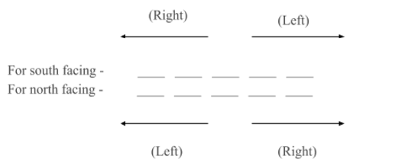](https://gs-blog-images.grdp.co/blogs/wp-content/uploads/2016/10/13104846/Capture1.png)

**2. Circular Arrangement –**  
This type of question may be asked in following forms –  
(a) All the people are facing towards the center  
(b) All the people are facing outside the center  
(c) Some people are facing inside while some are facing outside the center.

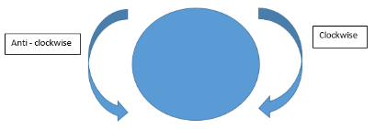

As mentioned above, you need to take special care of the directions in such problems.

**For people facing inside the center –**

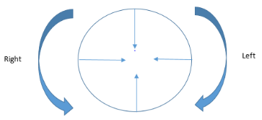

**For people facing outside the center –**

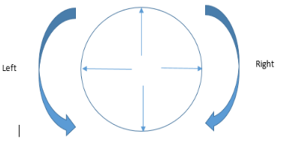

You can accordingly look for the directions of the people when some are facing inside the circle while some are facing outside the circle.

**3. Square/ Rectangular Arrangement -**In this type of arrangement as well, following arrangements are possible -  
(a) All the people are facing towards the center  
(b) All the people are facing outside the center  
(c) Some people are facing inside while some are facing outside the center.  
The directions for this arrangement are taken in the same manner as that of a circular arrangement.

**Keep following things in mind while solving seating arrangement or puzzle based questions-**

* Do not be intimidated by the size or the language of the question.
* Read the entire question carefully. Every detail required to form the arrangement is mentioned in the question, you just need to observe properly and implement all the facts logically.
* Remember, even when combined with puzzles, the approach of the question will still remain the same as that of normal seating arrangement.
* Consider all the possible scenarios which may be formed as per the given question. A lot of the possibilities will cancel out as you move forward with the question.
* Practice. That is the only way you can expect to ace this topic.

**EXAMPLE**

**Read the following information to answer the given questions.  
(i) A, B, C, D, E, F and G are playing cards sitting around a circular table  
(ii) D is not neighbour of C or E.  
(iii)A is neighbour of B and C.  
(iv) G, who is second to the left of D, is the neighbour of E and F.  
What will be the arrangement if E and D interchange their places?  
Solution:**Original arrangement in clockwise direction is DFGECABD   
Hence, after E and D interchange their places, the arrangement is EFGDCABE.