Questions 4 - 10

4) Create 10 True or False questions with solution from any topic covered in this class

1. Properties of an object are stored as rows in a table- False

2. If a table is in 1NF and does not have a composite key, then it is in 2NF- True

3. If a table is in 3NF, it is also in 2NF- True

4. The primary key does not necessarily have to be unique for a given table- False

5. The relational database model is the predominant method of storing data today. – True

6. The SQL UPDATE operation changes the table structure while leaving the data intact- False

7. SQL is not a procedural language. – TRUE

8. Indexes improve the performance for both retrieval and update queries- False

9. A relation that has a simple primary key (non-composite) must be in 2NF- True

10. Hierarchical database systems are less navigational than relational database systems- False

5) Create 10 multiple choice questions including solution covering queries, subqueries, trigger, store procedures, math functions, backup, privilege and any other topics covered in the class.

1. Select __________ from instructor where dept name= ’Comp. Sci.’;  
Which of the following should be used to find the mean of the salary?  
a) Mean(salary)  
b) Avg(salary)  
c) Sum(salary)  
d) Count(salary)

ANSWER: b) Avg(salary)

2. Which server can join the indexes when only multiple indexes combined can cover the query ?  
a) SQL  
b) DBMS  
c) RDBMS  
d) All of the mentioned

ANSWER: a) SQL

3.  Select ID, name, dept name, salary * 1.1 where instructor;  
The query given below will not give an error. Which one of the following has to be replaced to get the desired output ?  
a) Salary*1.1  
b) ID  
c) Where  
d) Instructor

ANSWER: c) Where

4. The ______ clause allows us to select only those rows in the result relation of the ____ clause that satisfy a specified predicate.  
a) Where, from  
b) From, select  
c) Select, from  
d) From, where

ANSWER: a) Where, from

5. Which statement is used to create a trigger?  
a) CREATE TRIGGER  
b) CREATE TRIGGERS  
c) PRODUCE TRIGGER  
d) PRODUCE TRIGGERS

ANSWER: a) CREATE TRIGGER

6. Select * from student join takes using (ID);  
The above query is equivalent to :  
a) Select * from student inner join takes using (ID);  
b) Select * from student outer join takes using (ID);  
c) Select * from student left outer join takes using (ID);  
d) All of the mentioned

ANSWER: Select * from student inner join takes using (ID);

7. An ________ is a set of entities of the same type that share the same properties, or attributes.  
a) Entity set  
b) Attribute set  
c) Relation set  
d) Entity model

ANSWER: a) Entity set

8. Entity is a _________  
a) Object of relation  
b) Present working model  
c) Thing in real world  
d) Model of relation

ANSWER: c) Thing in real world

9. Which of the following can be a multivalued attribute?  
a) Phone_number  
b) Name  
c) Date_of_birth  
d) All of the mentioned

ANSWER: a) Phone_number

10.  In a relation between the entities the type and condition of the relation should be specified. That is called as______attribute.  
a) Desciptive  
b) Derived  
c) Recursive  
d) Relative

ANSWER: a) Desciptive

6) Create 3 questions including solution and associated diagrams that cover normalization from 1NF, 2NF, 3NF and BCNF

**Normalization** is a process of organizing the data in database to avoid data redundancy, insertion anomaly, update anomaly & deletion anomaly. Let’s discuss about anomalies first then we will discuss normal forms with examples.

Q1.

As per the rule of first normal form, an attribute (column) of a table cannot hold multiple values. It should hold only atomic values.

**Example**: Assume a video library maintains a database of movies rented out. Without any normalization, all information is stored in one table as shown below.

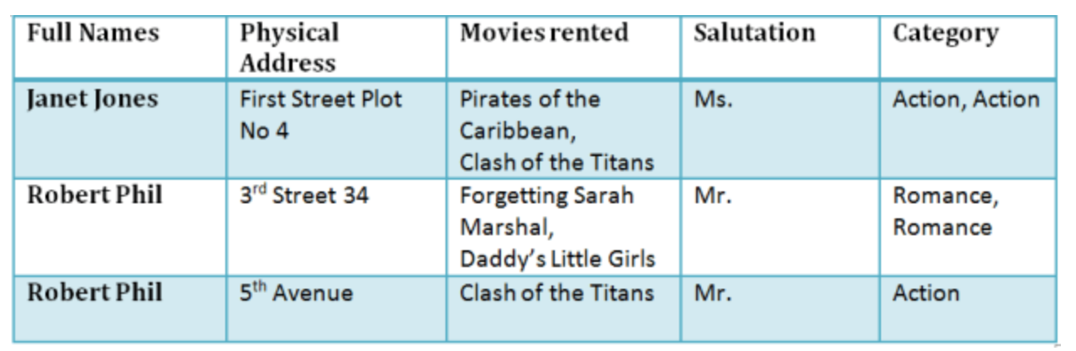

1NF

Each table cell should contain a single value.

Each record needs to be unique.

|  |  |  |  |  |
| --- | --- | --- | --- | --- |
| Full Names | Physical Address | Movies Rented | Salutation | Category |
| Janet Jones | First Street Plot No 4 | Pirates of the Caribbean | Ms. | Action |
| Janet Jones | First Street Plot No 4 | Clash of the Titans | Ms. | Action |
| Robert Phill | 3rd Street 34 | Forgetting Sarah Marshal | Mr. | Romance |
| Robert Phill | 3rd Street 34 | Daddy’s Little Girls | Mr. | Romance |
| Robert Phill | 5th Avenue | Clash of the Titans | Mr. | Action |

2NF

Be in 1NF

Single Column Primary Key

It is clear that we can't move forward to make our simple database in 2nd Normalization form unless we partition the table above.

|  |  |  |  |
| --- | --- | --- | --- |
| Membership Id | Full Names | Physical Address | Salutation |
| 1 | Janet Jones | First Street Plot No 4 | Ms. |
| 2 | Robert Phill | 3rd Street 34 | Mr. |
| 3 | Robert Phill | 5th Avenue | Mr. |

|  |  |
| --- | --- |
| Membership Id | Movies Rented |
| 1 | Pirates of the Caribbean |
| 1 | Clash of the Titans |
| 2 | Forgetting Sarah Marshal |
| 2 | Daddy’s Little Girls |
| 3 | Clash of the Titans |

3NF

* Rule 1- Be in 2NF
* Rule 2- Has no transitive functional dependencies

To move our 2NF table into 3NF, we again need to again divide our table.

|  |  |  |  |
| --- | --- | --- | --- |
| Membership Id | Full Names | Physical Address | Salutation |
| 1 | Janet Jones | First Street Plot No 4 | 2 |
| 2 | Robert Phill | 3rd Street 34 | 1 |
| 3 | Robert Phill | 5th Avenue | 1 |

|  |  |
| --- | --- |
| Membership Id | Movies Rented |
| 1 | Pirates of the Caribbean |
| 1 | Clash of the Titans |
| 2 | Forgetting Sarah Marshal |
| 2 | Daddy’s Little Girls |
| 3 | Clash of the Titans |

|  |  |
| --- | --- |
| Salutation Id | Salutation |
| 1 | Mr. |
| 2 | Ms. |
| 3 | Mrs. |
| 4 | Dr. |

Q2.

|  |  |  |
| --- | --- | --- |
| **ROLL_NO** | **NAME** | **SUBJECT_NAME** |
| 101 | Akon | OS, CN |
| 103 | Ckon | JAVA |
| 102 | Bkon | C, C++ |

**- First normal form:**

|  |  |  |
| --- | --- | --- |
| **ROLL_NO** | **NAME** | **SUBJECT_NAME** |
| 101 | Akon | OS |
| 101 | Akon | CN |
| 103 | Ckon | JAVA |
| 102 | Bkon | C |
| 102 | Bkon | C++ |

* **Second normal form:**

|  |  |  |
| --- | --- | --- |
| **SUBJECT_ID** | **SUBJECT_NAME** | **TEACHER** |
| 1 | Java | Java teacher |
| 2 | C++ | C++ teacher |
| 3 | Php | Php teacher |

|  |  |  |  |
| --- | --- | --- | --- |
| **SCORE_ID** | **STUDENT_ID** | **SUBJECT_ID** | **MARKS** |
| 1 | 10 | 1 | 70 |
| 2 | 10 | 2 | 75 |
| 3 | 11 | 1 | 80 |

* **Third normal form:**

|  |  |  |  |  |
| --- | --- | --- | --- | --- |
| **SCORE_ID** | **STUDENT_ID** | **SUBJECT_ID** | **MARKS** | **EXAM_ID** |
| 1 | 10 | 1 | 70 | 1 |
| 2 | 10 | 2 | 75 | 2 |
| 3 | 11 | 1 | 80 | 3 |

Table 5

|  |  |  |
| --- | --- | --- |
| **EXAM_ID** | **EXAM_NAME** | **TOTAL_MARKS** |
| 1 | Workshop | 200 |
| 2 | Mains | 70 |
| 3 | Practicals | 30 |

* **BCNF:**

|  |  |  |
| --- | --- | --- |
| **STUDENT_ID** | **SUBJECT** | **PROFESSOR** |
| 101 | JAVA | P.JAVA |
| 101 | C++ | P.CPP |
| 102 | JAVA | P.JAVA2 |
| 103 | C# | P.CHASH |
| 104 | JAVA | P.JAVA |

TABLE 1

|  |  |
| --- | --- |
| **STUDENT_ID** | **P_ID** |
| 101 | 1 |
| 101 | 2 |
| ANS SO ON.. |  |

Table 2

|  |  |  |
| --- | --- | --- |
| **P_ID** | **PROFESSOR** | **SUBJECT** |
| 1 | P.JAVA | JAVA |
| 2 | P.CPP | C++ |
| ANS SO ON.. |  |  |

Q3.

|  |  |  |  |  |
| --- | --- | --- | --- | --- |
| P_code | P_name | Doc_code | Dept_code | Dept_Block |
| P2101 | Tom | 1701 | DD101 | A |
| P2102 | Dona | 1701 | DD101 | A |
| P2103 | David | 1702 | DD101 | A |
| P2104 | Tina | 1703 | DD102 | B |
| P2105 | Eric | 1703 | DD102 | B |

**2 NF**

Patient:

|  |  |
| --- | --- |
| P_code | P_name |
| P2101 | Tom |
| P2102 | Dona |
| P2103 | David |
| P2104 | Tina |
| P2105 | Eric |

Doctor:

|  |  |  |
| --- | --- | --- |
| Doc_code | Dept_code | Dept_Block |
| 1701 | DD101 | A |
| 1702 | DD101 | A |
| 1703 | DD102 | B |

Primary Key Table:

|  |  |
| --- | --- |
| P_code | Doc_code |
| P2101 | 1701 |
| P2102 | 1701 |
| P2103 | 1702 |
| P2104 | 1703 |
| P2105 | 1703 |

**3 NF**

Patient details:

|  |  |
| --- | --- |
| P_code | P_name |
| P2101 | Tom |
| P2102 | Dona |
| P2103 | David |
| P2104 | Tina |
| P2105 | Eric |

Doc Details:

|  |  |  |
| --- | --- | --- |
| Doc_code | Dept_code | Dept_Block |
| 1701 | DD101 | A |
| 1702 | DD101 | A |
| 1703 | DD102 | B |

Doc Dept:

|  |  |
| --- | --- |
| Doc_code | Dept_code |
| 1701 | DD101 |
| 1702 | DD101 |
| 1703 | DD102 |

Dept Details:

|  |  |
| --- | --- |
| Dept_code | Dept_block |
| D101 | A |
| D102 | B |
| D103 | C |

7) Create 2 questions including solution and associated diagrams that cover ERD and EERD concepts

1. **ERD:**

**What is Entity Relationship Diagram (ERD)?**

Entity Relationship Diagram, also known as ERD, ER Diagram or ER model, is a type of structural diagram for use in database design. An ERD contains different symbols and connectors that visualize two important information: The major entities within the system scope, and the inter-relationships among these entities.

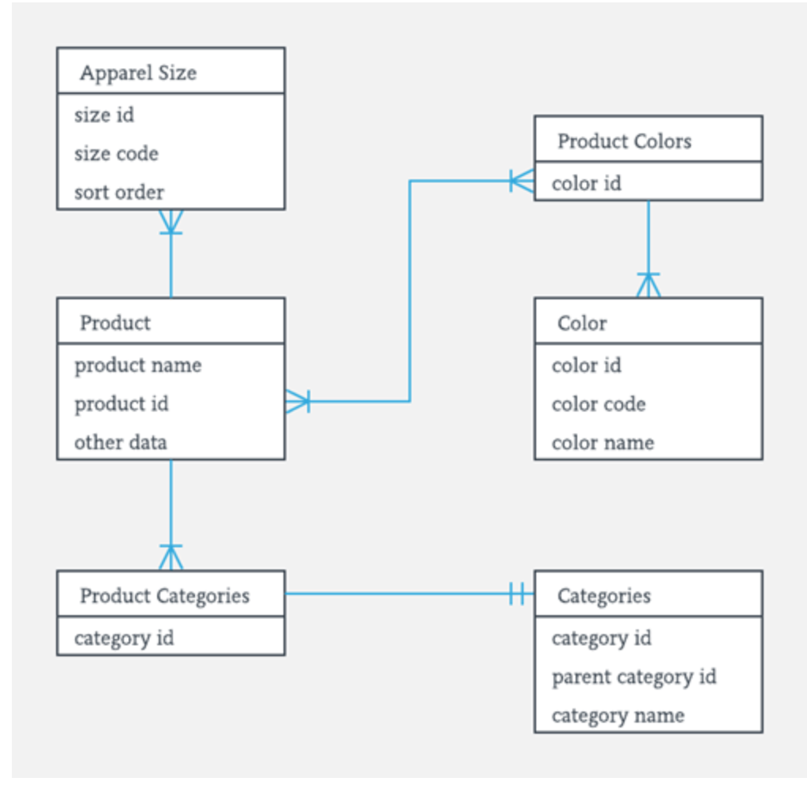

**Facts about ER Diagram Model:**

* ER model allows you to draw Database Design
* It is an easy to use graphical tool for modeling data
* Widely used in Database Design
* It is a GUI representation of the logical structure of a Database
* It helps you to identifies the entities which exist in a system and the relationships between those entities

## Components of the ER Diagram

This model is based on three basic concepts:

* Entities
* Attributes
* Relationships

## WHAT IS ENTITY?

A real-world thing either living or non-living that is easily recognizable and nonrecognizable. It is anything in the enterprise that is to be represented in our database. It may be a physical thing or simply a fact about the enterprise or an event that happens in the real world.

An entity can be place, person, object, event or a concept, which stores data in the database. The characteristics of entities are must have an attribute, and a unique key. Every entity is made up of some 'attributes' which represent that entity.

### Entity set:

An entity set is a group of similar kind of entities. It may contain entities with attribute sharing similar values. Entities are represented by their properties, which also called attributes. All attributes have their separate values. For example, a student entity may have a name, age, class, as attributes.

## Relationship

## Relationship is nothing but an association among two or more entities.

## Attributes

It is a single-valued property of either an entity-type or a relationship-type.

## Cardinality

Defines the numerical attributes of the relationship between two entities or entity sets.

Different types of cardinal relationships are:

* One-to-One Relationships
* One-to-Many Relationships
* May to One Relationships
* Many-to-Many Relationships

## ER- Diagram Notations

ER- Diagram is a visual representation of data that describe how data is related to each other.

* **Rectangles:**This symbol represent entity types
* **Ellipses :**Symbolrepresent attributes
* **Diamonds:**This symbolrepresents relationship types
* **Lines:**It links attributes to entity types and entity types with other relationship types
* **Primary key:**attributes are underlined
* **Double Ellipses:**Represent multi-valued attributes

1. **EERD**

**What is an Enhanced ER Diagram?**

Enhanced entity-relationship models, also known as extended entity-relationship models, are advanced database diagrams very similar to regular ER diagrams. Enhanced ERDs are high-level models that represent the requirements and complexities of complex databases.IN addition to the same concepts that ordinary ER diagrams encompass, EERDs include:

* Subtypes and supertypes (sometimes known as subclasses and super classes)
* Specialization and generalization
* Category or union type,
* Attribute and relationship inheritance

**Supertypes and subtypes:**

Supertype - an entity type that relates to one or more subtypes.

Subtype - a subgroup of entities with unique attributes.

Inheritance - the concept that subtype entities inherit the values of all supertype attributes.

**Generalization & Specialization**

Generalization - the process of defining a general entity type from a collection of specialized entity types.

Specialization - the opposite of generalization, since it defines subtypes of the supertype and determines the relationship between the two.

**Constraints**

Disjoints constraints - You will need to decide whether a supertype instance may simultaneously be a member of two or more subtypes. The disjoint rule forces subclasses to have disjoint sets of entities. The overlap rule forces a subclass (also known as a supertype instance) to have overlapping sets of entities.

Completeness constraints - decide whether a supertype instance must also be a member of at least one subtype. The total specialization rule demands that every entity in the superclass belong to some subclass. Just as with a regular ERD, total specialization is symbolized with a double line connection between entities. The partial specialization rule allows an entity to not belong to any of the subclasses. It is represented with a single line connection.

**Subtype Discriminators**

A subtype discriminator is an attribute of the supertype that indicates an entity's subtype. The attribute's values are what determine the target subtype.

Disjoint subtypes - simple attributes that must have alternative values to indicate any possible subtypes.

Overlapping subtypes - composite attributes whose subparts pertain to various subtypes. Each subpart has a Boolean value that indicates whether or not the instance belongs to the associated subtype.

**Creating an Effective EERD**

A well-designed EERD will help you build storage systems that are long-lasting and useful. Consider the following when evaluating your entity relationship diagram to be sure that you’re modeling a system design that will meet the requirements of your business:

* **Stability:**  Will the diagram support changing business needs?
* **Breadth:**  Can all of the data that we need to store be organized in the model?
* **Flexibility:**  Can data in this model be re-organized to support new information requirements?
* **Efficiency:**  Is this model the simplest solution possible? Is the data modeled with the appropriate symbols?
* **Accessibility:** Can both creators and end users easily understand your EERD?
* **Conformity:** Will the model integrate easily with your existing database structure?

8) Create 5 questions including solution and code covering the SQL coding skills and concept

1. Write a SQL query to fetch employee names having salary greater than or equal to 5000 and less than or equal 10000.

Answer: SELECT FullName FROM EmployeeDetails WHERE EmpId IN (SELECT EmpId FROM EmployeeSalary WHERE Salary BETWEEN 5000 AND 10000);

2. Granting All the Privilege to a User in a Table

Answer: GRANT ALL ON USERS TO ‘Yash’ @ ‘localhost’;

3. Get employee details from employee table who joined before January 1st 2013

Answer: Select * from EMPLOYEE where joining_date<’2013-01-01>

4. **List the Employees whos surname contains kar word.**

Answer: Select * from Employees where  surname like ‘%kar%’;

5. **Write a query to validate Email of Employee.**

Answer: SELECT Email FROM Employee where NOT REGEXP_LIKE(Email, ‘[A-Z0-9._%+-]+@[A-Z0-9.-]+\.[A-Z]{2,4}’, ‘i’);

9) Write a team evaluation (for each of your team members—2-3 sentences for each team member) including who do you think is the most valuable team member and why; Who did what according to your own observations? Rank everyone on your team including yourself (1 is the best, 2 is 2nd best, etc.) and why they are ranked in that order (no equal contribution will be an acceptable answer); what works best for your team and what did not? Rank all the team in class including your team.

Answer: Our team’s name is DataDiggers and we are a group of 5 members:

1. Yash Oza
2. Mansi Pandya
3. Krisha Shah
4. Pratham Patel
5. Vivel Dixit

Working with them was a great experience as everyone were good in different fields and could share knowledge on what they know and we exchanged ideas with each other. As a team we coordinated, list down solutions, which tables, functions, triggers to be created and also divided the work. And later on combined everything. Everyone in the team has worked equally hard and has given their input in the Project.

At first we had to come up with an unique topic for the PROJECT which required a lot of brain storming. And after a lot of discussions and meetings Krisha, Yash and Vivek come up with an idea of **LEVEL UP LIFE.**

According to me, 1st best would be Yash Oza as he has experience of SQL and is very good at MySQL and could solve complex queries as well. He was also like a team leader who told us how to go about the project and helped us wherever we were stuck.

I think I was the 2nd best as also I had studied database management system and has a little bit of prior experience of MySQL and knew how to go about the project. I would note down all the requirements for the project and schedule meetings for the team.

3rd best would be Krisha Shah she always coordinated with the team came up with ideas on creating functions and procedure.

4th best would be Pratham Patel has got good analytical skills could analyze what the result would be.

5th best would be Vivek Dixit he has got excellent Presentation skills and has experience in UI/UX as he has taken the web design course.

I would like to grade our team as rank 1. As our topic was something new and it is a unique topic and it has real world applications and people in their daily life help others and be kind.

Ranking the teams from 1(best)-10(least competitive)

|  |
| --- |
| **PhoeniX- 2** |
| **Tech Husky-5** |
| **F5-7** |
| **Ice Cold-6** |
| **XM-3** |
| **MIC-4** |
| **HealtcareE-1** |
| **BrownHuskies-8** |
|  |
|  |

10) If you are given an opportunity to be a paid TA or non-paid/volunteer in Fall 2019, would you be interested (Do include if you are interested in volunteer vs paid position?) If you are interested, what skillsets and quality would make you a successful TA or a part of the team?

Answer: If given an opportunity, I would definitely like to be a TA whether paid/unpaid. I would like to share the knowledge with others what I learnt in this subject. Professor Chaiyaporn Mutsalklisana is a great instructor and working under him, to be guided by him would be a great experience for me. His continuous guidance for the Project and forcing us to come up with out-of-the –box ideas and brainstorming has helped us come up with an amazing Project which could have a great impact on our resume.

I am a team player, a good listener and a person who is continuously willing to learn. I always ready to help others in any way and share my knowledge with others. I will make sure that people I support are engaged in learning and stay on task during the lesson and activity. Also I would provide them regular feedbacks on how to improve.