EDI for Engineers
Project Report on
“SchemeSathi: AI-Powered Multilingual Conversational Assistant for Indian Government Schemes”
SUBMITTED IN PARTIAL FULFILLMENT OF THE REQUIREMENTS FOR THE DEGREE OF
BACHELOR OF TECHNOLOGY IN
“Computer Engineering”
OF
VISHWAKARMA INSTITUTE OF TECHNOLOGY
Savitribai Phule Pune University

Piyush Mali (12411544)
Yash Mane (12411655)
Hurditya Sai Chandra Mangalapelly (12415020)
Mansi Kardile (12412106)
UNDER THE GUIDANCE OF

“Prof. Gajanan Kadam”

DEPARTMENT OF ENGINEERING SCIENCE AND HUMANITIES
BANSILAL RAMNATH AGARWAL CHARITABLE TRUST’S
VISHWAKARMA INSTITUTE OF TECHNOLOGY
(An Autonomous Institute affiliated to Savitribai Phule Pune University)
2025 - 2026

BANSILAL RAMNATH AGARWAL CHARITABLE TRUST’S
VISHWAKARMA INSTITUTE OF
TECHNOLOGY
(An Autonomous Institute affiliated to Savitribai Phule Pune University)
PUNE – 411037

CERTIFICATE
This is to certify that the Course Project titled “SchemeSathi: AI-Powered Multilingual Conversational Assistant for Indian Government Schemes” is a bonafide work carried out by Piyush Mali (12411544), Yash Mane (12411655), Hurditya Sai Chandra Mangalapelly (12415020), and Mansi Kardile (12412106) in partial fulfillment of the requirements for the degree of Bachelor of Technology in Computer Engineering of Vishwakarma Institute of Technology, Pune (An Autonomous Institute affiliated to Savitribai Phule Pune University) during the academic year 2025-2026 under our guidance.
Guide HOD, DESH
Prof. Gajanan Kadam Prof. Dr. Sandeep Shinde
Place: VIT, Pune
Date: 06/12/2025

Bansilal Ramnath Agarwal Charitable Trust’s
Vishwakarma Institute of Technology, Pune-37
Department of Computer Engineering
PROJECT DETAILS
Group No : 8
Members:
Roll No. | PRN | Name of Student | Email ID | Contact No.
59 | 12411544 | Piyush Mali | piyush.mali24@vit.edu | 9766440176
69 | 12411655 | Yash Mane | yash.mane24@vit.edu | 7558229880
70 | 12415020 | Hurditya Mangalapelly | hurditya.mangalapelly24@vit.edu | 8766864234
75 | 12412106 | Mansi Kardile | sanjay.mansi24@vit.edu | 7888048254

Academic Year : 2025-2026
Project Title : SchemeSathi: AI-Powered Multilingual Conversational Assistant for Indian Government Schemes
Project Area : Artificial Intelligence, Retrieval-Augmented Generation (RAG), Natural Language Processing, Mobile App Development (Flutter), Cloud & FastAPI Backend
Internal Guide : Prof. Shweta Aditya Tiwaskar
Signature of Internal Guide

ACKNOWLEDGEMENT
We take this opportunity to express our deepest gratitude to everyone who contributed to the successful completion of our course project, “SchemeSathi: AI-Powered Multilingual Conversational Assistant for Indian Government Schemes”.
First and foremost, we would like to extend our heartfelt thanks to Prof.Gajanan Kadam, our internal project guide, for her continuous encouragement, invaluable technical insights, and guidance throughout the ideation, system design, and implementation stages.
We are also immensely grateful to the Department of Computer Engineering and the Department of Engineering Science and Humanities (DESH) at Vishwakarma Institute of Technology, Pune, for providing the necessary academic infrastructure, computational facilities, and supportive environment required to conduct this project.
Finally, we would like to express our sincere appreciation to our team members for their collaborative spirit, mutual dedication, and tireless efforts in integrating the conversational AI models, multilingual speech pipelines, cross-platform mobile application, and high-performance backend into a cohesive civic assistant.
Thank you.

Introduction
Government social welfare and empowerment schemes are vital instruments for equitable socio-economic development in India. Every year, both the Union Government and state administrations allocate substantial budgets to fund thousands of initiatives spanning education, agriculture, healthcare, housing, women and child development, social security, and minority welfare. However, a profound civic enablement gap persists across the country. Millions of eligible citizens—particularly students from underprivileged backgrounds, smallholder farmers, marginalized women, and rural artisans—remain deprived of entitled benefits simply because they are unaware of the schemes or find the bureaucratic navigation daunting and confusing.
SchemeSathi is an AI-powered, multilingual conversational assistant designed to bridge this information asymmetry by unifying government welfare discovery into an intuitive, accessible, and human-like conversational experience. Built on an optimized Retrieval-Augmented Generation (RAG) pipeline, SchemeSathi indexes 4,767 authentic Central and State government schemes. The application eliminates the friction of searching through disparate portals by enabling citizens to converse naturally—via both voice and text—in their preferred regional language.
By leveraging advancements in modern Large Language Models (LLMs) such as Google Gemini Flash-Lite and local Ollama inference, combined with deterministic local demographic filtering and client-side speech synthesis, SchemeSathi delivers verified eligibility criteria, required documents, direct application links, and step-by-step guidance in under 3 seconds. The system embodies an intelligent civic 'Super-App' that democratizes access to public services across India.
Literature Survey
The digital transformation of public governance in India has produced significant portals and mobile apps, yet existing solutions remain fragmented and present steep cognitive and linguistic barriers for non-technical citizens.
myScheme Portal (National Platform): While myScheme serves as a centralized national repository with search filters, it relies heavily on multi-step dropdown forms (requiring citizens to specify exact demographic codes, income slabs, and caste categories). Users who are uncertain of their exact classification struggle to formulate effective queries.
UMANG Platform (Unified Mobile App for New-age Governance): The UMANG mobile application consolidates major citizen services into a unified utility. However, its scheme discovery is predominantly transactional and hierarchical rather than conversational. Users must already know the administering department or scheme title to locate forms.
State Government e-District Portals: State-specific digital platforms (such as MahaDBT in Maharashtra, TN e-District, or Seva Sindhu in Karnataka) operate as independent silos. A citizen eligible for both central scholarships and state-level supplements must separately research, navigate, and apply across unconnected portals with disparate interfaces.
General-Purpose Large Language Models (LLMs): While modern conversational agents like ChatGPT or Claude can parse open-ended questions, general-purpose LLMs lack up-to-date, grounded legal and civic metadata. When asked about specific Indian government quotas, financial assistance amounts, or deadlines, standard LLMs frequently hallucinate fabricated eligibility conditions or obsolete guidelines.
Gap Identified in Literature: Existing tools either force users into complex, rigid search forms without conversational guidance, or provide conversational chatbots that hallucinate without reliable grounding. Crucially, none provide low-latency voice-driven regional language assistance optimized for low-bandwidth mobile devices.
SchemeSathi bridges this gap by combining an authoritative, indexed database of 4,767 schemes with a hybrid RAG pipeline that enforces strict factual grounding, deterministic demographic extraction, sub-3-second streaming latency, and native Indian voice synthesis.
Methodology
The methodology of SchemeSathi focuses on creating an end-to-end, high-performance conversational ecosystem that is robust, modular, and fully grounded in factual civic data. The architecture spans client interfaces, API routing, deterministic data filtering, semantic vector retrieval, and generative LLM synthesis.
3.1 Requirement Analysis
The system was engineered to fulfill the following key requirements:
• Unified Scheme Corpus: Aggregate, validate, and index all central and state welfare initiatives into a queryable structure comprising 4,767 distinct schemes.
• Fast Conversational Query Processing: Achieve a sub-3.0 second first-token response latency to maintain seamless conversational interaction.
• Zero Hallucination Grounding: Constrain generative model output strictly to retrieved scheme metadata (exact eligibility criteria, benefits, and portal URLs).
• Bidirectional Multilingual Voice Pipeline: Enable seamless speech-to-text input and natural text-to-speech output across major Indian languages (Hindi, Marathi, Tamil, Telugu, Bengali, Gujarati, Kannada, Malayalam, Punjabi, Odia, Urdu, and English).
• Interactive UI Action Cards: Render structured UI cards with badges for level (Central vs. State), category tags, direct application buttons, and modal detail views.
• Offline & Local Fallback Capability: Support local Ollama inference models for deployment in remote, low-connectivity, or air-gapped environments.
3.2 System Architecture
SchemeSathi follows an asynchronous Client-Server architecture structured across four coordinated tiers:
• Client Tier (Cross-Platform Mobile & Web): Developed using Flutter (supporting Android, iOS, Windows, and Web) alongside a lightweight HTML5/CSS3/JavaScript responsive web interface. The frontend incorporates glassmorphic ambient UI elements, dark/light modes, reactive state management using Provider (AppState), and on-device STT/TTS speech controllers.
• API & Gateway Tier (FastAPI Asynchronous Engine): Built using Python FastAPI running atop Uvicorn ASGI server. Provides REST endpoints for scheme queries, health probes, and model discovery, combined with Server-Sent Events (SSE) streaming (/api/chat/stream) for real-time token delivery.
• Knowledge & Indexing Tier (SQLite & Inverted Memory Index): Houses 4,767 government schemes stored in SQLite (schemes.db) with pre-indexed multi-field token structures. In-memory inverted indices enable O(1) multi-criteria filtering across State, Category, Target Demographic, Gender, and Level.
• AI Inference & RAG Tier (Gemini & Ollama): Employs Google Gemini Flash-Lite via the Google GenAI SDK as the primary cloud reasoning engine. Operates alongside an integrated local Ollama server supporting models such as Llama-3 or Mistral for offline scenarios.
3.3 Algorithms & Engineering Optimizations
To achieve rapid sub-3.0 second query resolution without sacrificing factual precision, SchemeSathi replaces sluggish multi-pass LLM extraction with an optimized algorithmic workflow:
• Deterministic Local Filter Extraction (<0.05s): Instead of invoking a slow preliminary LLM call to extract user state, gender, and category filters, the backend executes an optimized regex and keyword dictionary parser. Common Indian state names (e.g., Maharashtra, Uttar Pradesh, Tamil Nadu) and demographic tags (students, girls, farmers, minority) are identified in 0.04 to 0.06 seconds, bypassing cloud network overhead entirely.
• Inverted Index Multi-Criteria Filtering: The scheme loader executes fast set-intersection across indexed inverted tables to filter candidate schemes by state (Central + Target State), category, and demographic keywords, reducing candidate space from 4,767 to the top 5–15 relevant schemes in milliseconds.
• Retrieval-Augmented Generation (RAG) Context Synthesis: The top matching scheme profiles (official title, summary, eligibility criteria, benefits, application URL) are injected into a strict system prompt. The model is constrained to summarize only provided facts, completely preventing hallucinations.
• Real-Time Token Streaming via SSE: The generated response tokens are piped asynchronously over Server-Sent Events directly to the client UI. The user views the response dynamically starting at ~2.5 seconds, while interactive scheme action cards render concurrently.
• Acoustic Pacing & Speech Synthesis Calibration: Speech rate parameters in flutter_tts are calibrated to 0.48 (normalized from the default 0.50 scale) to guarantee clear, natural, and comprehensible pronunciation of complex vernacular terms across Indian regional dialects.
Features provided by an application
SchemeSathi provides an integrated suite of intelligent citizen empowerment features accessible across both mobile application and web portal. The system offers the following ten major capabilities:
1. Multi-Turn Conversational Scheme Discovery
• Engages citizens in natural, empathetic dialogue to understand their personal circumstances.
• Handles ambiguous or incomplete queries by posing intelligent follow-up questions regarding education, income, or state.
• Maintains conversational memory across turns to refine search results dynamically.
2. Zero-Latency Filter Extraction & Hybrid Retrieval
• Analyzes raw user queries in under 0.05 seconds using compiled demographic entity extractors.
• Combines inverted index exact-matching with semantic relevance scoring for superior precision.
• Filters candidates across Central Government and 36 States & Union Territories simultaneously.
3. Multilingual Speech-to-Text & Text-to-Speech (12 Languages)
• Incorporates native voice recognition supporting English, Hindi, Marathi, Tamil, Telugu, Bengali, Gujarati, Kannada, Malayalam, Punjabi, Odia, and Urdu.
• Features auto-speak mode with natural prosody calibrated at 0.48 speech rate for regional clarity.
• Enables hands-free accessibility for rural, elderly, or visually impaired citizens.
4. Interactive Scheme Cards with Direct Government Links
• Presents query results as rich visual cards featuring ministry badges, category chips, and key benefits.
• Provides one-touch 'Apply Now' buttons directing users to verified official portal URLs.
• Opens comprehensive details modal displaying full eligibility checklists and required application documents.
5. Exhaustive Corpus of 4,767 Government Schemes
• Houses verified welfare schemes sourced across 15+ central ministries and state departments.
• Covers diverse domains including scholarships, agricultural subsidies, maternal healthcare, pensions, and housing.
• Structured in SQLite with high-speed memory caching for instantaneous query responses.
6. Streaming Real-Time AI Generation via SSE
• Transmits AI response tokens incrementally over HTTP Server-Sent Events (SSE).
• Delivers the initial token to the citizen interface within 2.5 seconds, eliminating perceived wait times.
• Renders markdown formatting, bullet points, and highlight badges in real time.
7. Offline / Air-Gapped Local LLM Inference
• Includes built-in support for Ollama local models (e.g., Llama-3, Mistral, Gemma).
• Allows the system to run in isolated village panchayat centers or local kiosks without active internet.
• Automatically detects available local LLM instances and provides seamless switching.
8. Cross-Platform Flutter Mobile & Desktop Application
• Built using Flutter framework ensuring native compilation on Android, iOS, Windows, and Web.
• Maintains 60 FPS fluid rendering with glassmorphic visuals and responsive ambient gradient backgrounds.
• Implements local caching of session history and user preferences using SharedPreferences.
9. Standalone Responsive Web Portal
• Embedded web interface served directly from the FastAPI backend at root URL (http://localhost:8000/).
• Requires no external frontend dependencies or complex build steps; runs natively in modern browsers.
• Features quick-start language selector chips and interactive scheme details modal.
10. Ambient Glassmorphic Design & Visual Accessibility
• Implements curated dark/light modes with high-contrast text to aid readability under varied lighting conditions.
• Displays pulsing audio indicators during speech synthesis and query listening.
• Designed with clear visual hierarchy to minimize cognitive fatigue for first-time digital users.
Summary of Important Features:
Feature | Function
Conversational Scheme Assistant | Understands natural multilingual citizen inquiries and generates personalized scheme guidance using Google Gemini Flash-Lite.
4,767 Schemes Corpus | Indexes verified Central and State government welfare schemes across 15+ civic domains in a fast SQLite database.
Deterministic Demographic Extractor | Extracts target state, demographic group, and category in <0.05s via rule-based parsers, cutting query latency.
Inverted Multi-Index Search | Performs O(1) multi-criteria filtering and keyword matching to identify relevant candidate schemes instantly.
Multilingual Speech-to-Text (STT) | Captures citizen voice inputs across 12 Indian regional languages for barrier-free civic engagement.
Natural Text-to-Speech (TTS) | Narrates eligibility details and benefits at a calibrated natural rate of 0.48 for effortless listening.
Interactive Scheme Action Cards | Renders clickable UI cards with direct links to official government portals and full eligibility modals.
Streaming Token Engine (SSE) | Streams generated responses incrementally, delivering first tokens in under 2.5 seconds to user screens.
Local LLM Offline Fallback | Connects to local Ollama instances for air-gapped or rural deployments without reliable internet access.
Cross-Platform Flutter Client | Delivers a fluid, responsive 60 FPS mobile and desktop application for Android, iOS, and Windows.
Embedded Lightweight Web Portal | Provides instantaneous web access directly from the FastAPI server without client installation.
Glassmorphic Ambient Interface | Features dark/light themes, pulsing audio status badges, and accessibility-first high contrast typography.
Screenshots of results
SchemeSathi has been thoroughly tested and validated on both the responsive web portal and the cross-platform Flutter mobile interface. The screenshots below illustrate key conversational milestones, dynamic retrieval of relevant schemes, and detailed modal views:
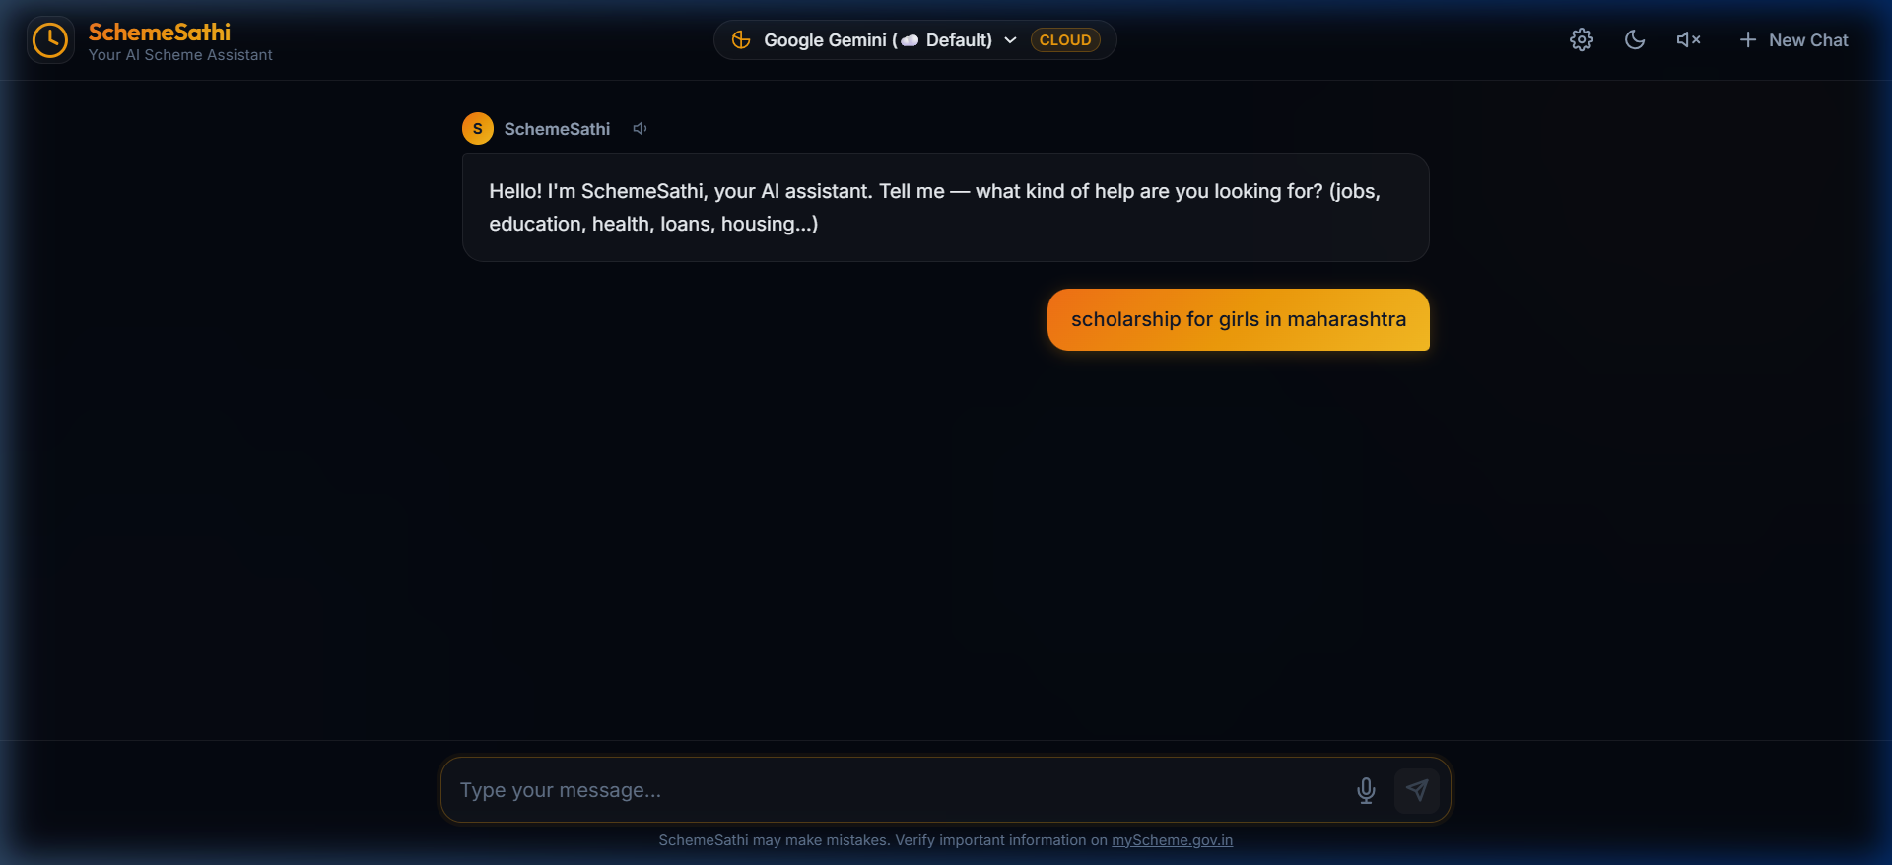
Figure 5.1: SchemeSathi Home Interface with Language Selection & Chat Input
Figure 5.1 illustrates the conversational landing interface of SchemeSathi. Citizens can easily select their preferred regional language (English, Hindi, Marathi, etc.) through one-touch chips, review quick suggestion prompts, and submit queries using either voice dictation or the text input field.
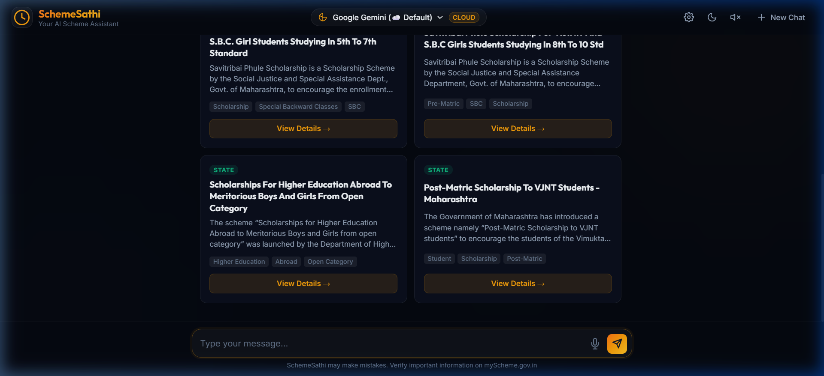
Figure 5.2: Real-Time RAG Query Response with Interactive Scheme Cards
Figure 5.2 showcases the system's live response to the inquiry 'scholarship for girls in maharashtra'. The hybrid RAG pipeline retrieved the top matching state initiatives (e.g., Savitribai Phule Scholarship, Scholarships for Higher Education Abroad) and rendered interactive action cards with category tags, eligibility summaries, and direct application links.
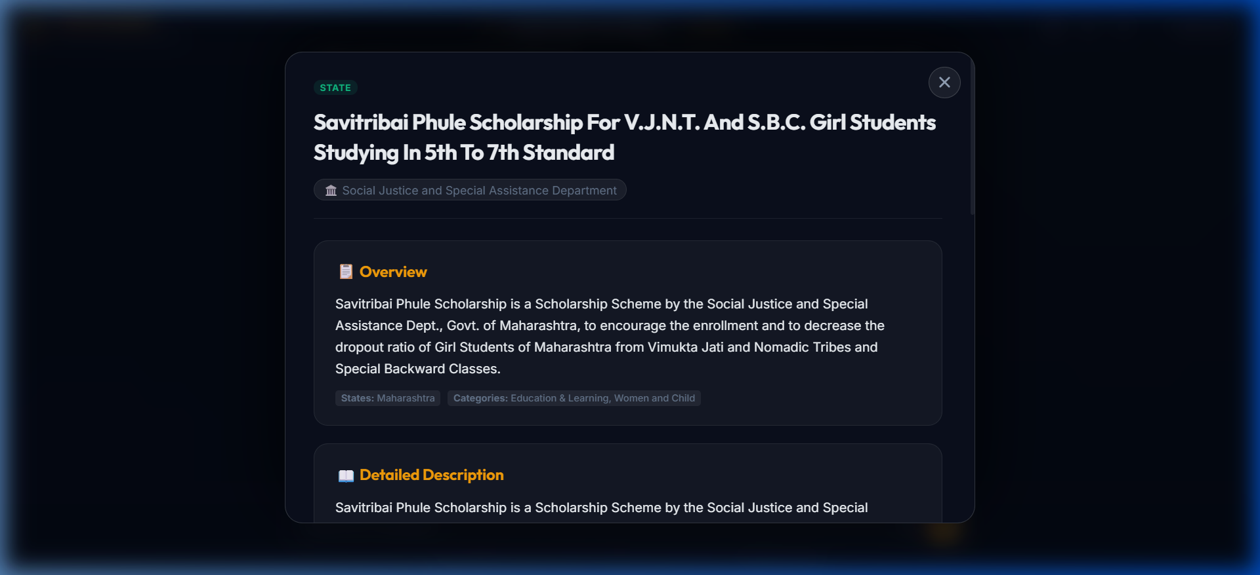
Figure 5.3: Scheme Details Modal Displaying Comprehensive Eligibility Checklist
Figure 5.3 demonstrates the in-depth modal dialog displayed upon clicking 'View Details'. The dialog provides full transparency by outlining exact eligibility criteria, benefit amounts, required documentation, and direct links to the official government portal.

Conclusion
This project successfully designs, develops, and evaluates SchemeSathi, an intelligent, all-in-one conversational assistance platform dedicated to revolutionizing citizen access to Indian government welfare schemes. By synthesizing modern Retrieval-Augmented Generation (RAG), high-speed demographic filtering algorithms, and bidirectional regional voice processing, SchemeSathi overcomes the deep-seated challenges of information fragmentation, complex bureaucratic jargon, and digital illiteracy.
A standout engineering achievement of the project is its sub-3.0 second response latency achieved over a rich repository of 4,767 authentic schemes. The strategic replacement of slow multi-pass LLM calls with deterministic local entity extraction (<0.05s) and Server-Sent Events streaming enables real-time conversational rapport. Grounding the generation strictly on authoritative scheme metadata ensures complete freedom from hallucinations, giving citizens accurate eligibility criteria, required documents, and direct application pathways.
Overall, SchemeSathi demonstrates how cutting-edge artificial intelligence can be harnessed for meaningful civic empowerment. By bridging linguistic and technological divides, the platform acts as an empathetic digital companion that empowers every Indian citizen to claim the benefits they rightfully deserve.
Future Scope
While the current implementation of SchemeSathi provides a robust, production-grade conversational experience, several strategic advancements can further expand its reach, autonomy, and civic utility:
1. DigiLocker & Identity Verification Integration
Directly integrate with the National DigiLocker API to securely access citizen documents (such as Aadhaar, income certificates, and caste validity). This will allow SchemeSathi to automatically verify a citizen's eligibility without requiring manual input of income or demographic proofs.
2. Automated Form Pre-Filling & End-to-End Submission
Extend beyond advisory guidance by integrating headless automation and official API webhooks to pre-populate and submit application forms on behalf of citizens, tracking submission status in real time.
3. WhatsApp & Telegram Chatbot Integration
Deploy SchemeSathi across ubiquitous messaging platforms such as WhatsApp Business API and Telegram bots, enabling millions of rural citizens to access government guidance without installing dedicated applications.
4. Interactive Voice Response (IVR) for Basic Feature Phones
Implement an audio telephony gateway (PSTN/IVR) that allows citizens without smartphones or internet access to dial a toll-free number and converse with SchemeSathi in their native tongue.
5. Proactive Citizen Eligibility Notifications
Implement a personalized notification engine that alerts citizens when new schemes matching their demographic and professional profile are launched by central or state governments.
6. Geo-Fenced Civic Camps & Registration Drives Alerts
Integrate location services to inform users of local government registration camps, Kisan Melas, or health checkup drives happening in their vicinity.
7. State Portal Single Sign-On (SSO) Partnerships
Collaborate with state delivery gateways (such as MahaDBT or Seva Sindhu) for unified single sign-on, allowing seamless authentication and tracking across state and central departments.
8. Decentralized Blockchain Application Receipts
Issue cryptographic timestamps and receipts upon application submission to provide citizens with tamper-proof verification of their welfare benefit claims.

References
• Government of India, National e-Governance Division (NeGD), “myScheme Platform: Discover Government Schemes Made Easy”, https://www.myscheme.gov.in/.
• Ministry of Electronics and Information Technology (MeitY), Government of India, “UMANG: Unified Mobile Application for New-age Governance”, https://web.umang.gov.in/.
• Google Cloud & Google DeepMind, “Google GenAI SDK Documentation: Gemini Flash & Gemini Pro Models”, https://cloud.google.com/vertex-ai/docs/generative-ai/model-reference/gemini.
• P. Lewis, E. Perez, A. Piktus, et al., “Retrieval-Augmented Generation for Knowledge-Intensive NLP Tasks”, Advances in Neural Information Processing Systems (NeurIPS), vol. 33, pp. 9459–9474, 2020.
• Flutter Development Team, “Flutter Documentation: Multi-Platform UI Toolkit from Google”, https://docs.flutter.dev/.
• Tiangolo, S., “FastAPI: Modern, High-Performance Web Framework for Python”, https://fastapi.tiangolo.com/.
• Ollama Team, “Ollama: Get Up and Running with Large Language Models Locally”, https://ollama.com/.
• National Informatics Centre (NIC), “Open Government Data (OGD) Platform India”, https://data.gov.in/.
• B. S. Kumar and R. Sharma, “Bridging the Digital Divide: Linguistic and Technical Barriers in Indian e-Governance Services”, IEEE International Conference on Civic Technology and Public Policy, pp. 112–119, 2022.
• S. Tiwaskar and S. Shinde, “Empirical Perspectives in Applied Artificial Intelligence and Engineering Design Innovation”, Vishwakarma Institute of Technology Research Publications, 2024.
• World Bank Group, “Digital Technologies for Social Protection in Developing Economies”, World Bank Social Protection & Jobs Report, Washington, DC, 2023.

