EDI for Engineers
Project Report on
“TravelEase: Your Intelligent Travel Partner”
SUBMITTED IN PARTIAL FULFILLMENT OF THE REQUIREMENTS FOR THE DEGREE OF
BACHELOR OF TECHNOLOGY IN
“Computer Engineering”
OF
VISHWAKARMA INSTITUTE OF TECHNOLOGY

Savitribai Phule Pune University

Piyush Mali
Yash Mane (12411655)
Hurditya Sai Chandra Mangalapelly (12414540)
Mansi Kardile (12412106)
UNDER THE GUIDANCE OF
“Prof. Shweta Aditya Tiwaskar”


DEPARTMENT OF ENGINEERING SCIENCE AND HUMANITIES

BANSILAL RAMNATH AGARWAL CHARITABLE TRUST’S
VISHWAKARMA INSTITUTE OF TECHNOLOGY
(An Autonomous Institute affiliated to Savitribai Phule Pune University)

2025 - 2026
BANSILAL RAMNATH AGARWAL CHARITABLE TRUST’S

VISHWAKARMA INSTITUTE OF TECHNOLOGY
(An Autonomous Institute affiliated to Savitribai Phule Pune University)

PUNE – 411037

CERTIFICATE

This is to certify that the Course Project titled “TravelEase: Your Intelligent Travel Partner” submitted by Piyush Mali , Yash Mane (12411655), Hurditya Sai Chandra Mangalapelly, Mansi Kardile (12412106), is in partial fulfillment for the award of Degree of Bachelor of Technology in Computer Science of Vishwakarma Institute of Technology, Savitribai Phule Pune University. This project report is a record of bonafide work carried out by him/her under my guidance during the academic year 2025-26.

Guide HOD, DESH
Prof. Shweta Aditya Tiwaskar Prof. Dr. Sandeep Shinde

Place: VIT, Pune
Date: 06/12/2025

Bansilal Ramnath Agarwal Charitable Trust’s

Vishwakarma Institute of Technology, Pune-37
Department of Engineering Science and Humanities

PROJECT DETAILS

Group No : 8
Members:
Roll No. | PRN | Name of Student | Email ID | Contact No.
59 | 12411544 | Piyush Mali | piyush.mali24@vit.edu | 9766440176
69 | 12411655 | Yash Mane | yash.mane24@vit.edu | 7558229880
70 | 12415020 | Hurditya Mangalapelly | hurditya.mangalapelly24@vit.edu | 8766864234
75 | 12412106 | Mansi Kardile | sanjay.mansi24@vit.edu | 7888048254

Academic Year : 2025-2026
Project Title : TravelEase: AI & AR Enhanced Smart Travel Assistant
Project Area : Artificial Intelligence, Augmented Reality, Mobile App Development (Flutter), Cloud Backend (Supabase)
Internal Guide : Prof. Shweta Aditya Tiwaskar

Signature of Internal Guide

ACKNOWLEDGEMENT

We take this opportunity to express our deepest gratitude to everyone who contributed to the successful completion of our project, "TravelEase: AI & AR Enhanced Smart Travel Assistant "
First and foremost, we would like to extend our heartfelt thanks to Prof. Shweta Aditya Tiwaskar, our project guide, for her invaluable guidance, technical expertise, and constant support throughout the development of the system. Her insights into integrating AI and AR technologies were instrumental in shaping the project.
We are also grateful to the Department of Computer Engineering at Vishwakarma Institute of Technology for providing us with the necessary resources and a conducive environment to work on this project.
Finally, we would like to express our sincere appreciation to our team members for their dedication and collaboration, which made this project a successful and enriching learning experience.
Thank you.

- Introduction

Planning a trip often becomes stressful for travelers because useful information is scattered across different sources. People need to search separately for tourist attractions, hotel details, transportation options, cultural backgrounds, and local guides. Most existing travel applications focus on only one part of the journey, such as booking a hotel or finding directions, creating a disconnected experience.
TravelEase is an AI-powered and AR-enhanced smart travel assistant designed to offer a unified and interactive experience for modern travelers. The system integrates real-time location services, AR-based landmark identification, AI-driven attraction recommendations, itinerary generation, hotel and restaurant discovery, and local guide booking within a single mobile application.
By leveraging advancements in Artificial Intelligence (AI) and Augmented Reality (AR), TravelEase creates a "Super-App" ecosystem that reduces cognitive load and ensures data continuity for the user.

- Literature Survey

The progression of digital technology has altered travel planning, yet the current state remains characterized by fragmentation and information asymmetry.
- Digital Mapping (e.g., Google Maps): While ubiquitous for navigation, these platforms lack experiential planning capabilities. They identify where a landmark is but cannot create cohesive day-by-day itineraries based on complex constraints like history or budget.
- OTAs (e.g., Booking.com, Expedia): These platforms operate in silos, focusing on transactions rather than the "on-trip" experience.
- Niche AR Applications: Existing AR tourism apps are often "walled gardens" dedicated to single sites (e.g., museums) and lack integration with broader logistical contexts like itinerary planning.
- AI Chatbots (LLMs): General-purpose LLMs lack geospatial awareness. They might suggest locations far apart due to a lack of real-time traffic or distance data integration.
Gap Identified: Across existing literature, most applications address only a single aspect of travel—AR viewing, AI itinerary generation, booking, or navigation. Very few systems attempt to unify these into one cohesive platform.
TravelEase bridges this gap by integrating all major travel functionalities into a single intelligent application.

- Methodology

The methodology focuses on creating a unified, intelligent, and highly interactive travel assistance ecosystem using a modular architecture.

3.1 Requirement Analysis
The system was designed to address the following functional requirements:
- A unified mobile platform for exploration and booking.
- Two AR modes: Landmark recognition and Virtual 3D monument projection.
- An AI-powered conversational chatbot for itinerary generation.
- Nearby discovery and local guide booking.

3.2 System Architecture
The system follows a Client-Server model with offline-first capabilities.
- Frontend: Built using Flutter for cross-platform performance (Android/iOS).
- Backend: Hosted on Supabase for authentication, database operations, and edge functions.
- AR Modules: Utilizes ARCore/ARKit for device tracking, plane detection, and overlay rendering.
- External APIs: Integrates Google Maps, Places API, and weather services for real-time data.

3.3 Algorithms Used
- Simultaneous Localization and Mapping (SLAM): Used for AR overlay stability.
- Geospatial Clustering: Used to optimize travel routes by manipulating latitude/longitude data.
- NLP & Constraint Satisfaction: Used by the AI engine to generate personalized schedules based on unstructured user inputs.

- Features provided by an application

TravelEase is an integrated, AI-powered and AR-enhanced mobile travel assistant designed to simplify and unify the entire travel experience—from discovery to planning, booking, and on-site exploration. The system offers the following major features through a cross-platform Flutter application supported by a Supabase backend:

1. AI-Based Itinerary Generation
- Users can communicate with a conversational chatbot to plan a trip naturally.
- The system extracts user preferences such as destination, duration, budget, and interests.
- AI algorithms use geospatial clustering, routing logic, and external APIs (Google Places, Distance Matrix) to generate optimized day-wise itineraries.
- If user inputs are unclear, the assistant asks follow-up questions to ensure accuracy.
- The final itinerary includes activities, timings, estimated costs, and recommendations.

2. AR-Based Travel Lens (Landmark Recognition)
- Allows users to scan real-world monuments using the device camera.
- Hybrid GPS + computer vision recognition identifies nearby landmarks in real time.
- Fetches historical, architectural, and cultural details from the database.
- Overlays information in AR with optional text-to-speech narration.
- Enhances on-site exploration through immersive, context-aware guidance.

3. AR Virtual Monument Projection
- Users can place 3D models of monuments on any flat surface via ARCore/ARKit plane detection.
- Supports scaling, rotation, and 360° inspection of monuments.
- Enables pre-trip virtual exploration and educational visualization.
- Useful for remote users or those unable to physically visit a site.

4. Explore Nearby Attractions, Hotels, and Restaurants
- Fetches nearby points of interest using Google Places and Maps APIs.
- Displays ratings, photos, opening hours, distance, and directions.
- Helps users quickly discover tourist spots, food options, and accommodations.
- Results are personalized based on user preferences and trip context.

5. Hotel and Local Guide Booking
- Integrates real-time data to help users find hotels within budget and location constraints.
- Users can explore profiles of certified local guides and book them directly.
- Provides a secure, verified marketplace for cultural and historical tours.
- Automatically updates itinerary and cost estimation upon booking.

6. Dynamic Trip Cost Estimation
- Aggregates hotel, food, sightseeing, and activity expenses.
- Estimates total cost based on real-time price data from APIs.
- Automatically updates costs when users modify plan elements.
- Helps travelers budget efficiently and avoid unexpected expenses.

7. Offline Caching and Synchronization
- Stores essential data (itineraries, saved places, AR descriptors) locally.
- Ensures core functionality remains available even in low-network areas.
- Synchronizes with the Supabase backend when internet connectivity returns.

8. Cross-Platform Mobile Application
- Developed using Flutter for consistent Android/iOS performance.
- Smooth, responsive UI running at 55–60 FPS.
- Supports interactive dashboards, maps, AR screens, booking pages, and chat.

9. PDF Itinerary and Receipt Generation
- Automatically generates professional PDF itineraries.
- Includes daily plans, maps, timings, and cost summaries.
- Users can download or share PDFs for offline reference.

10. Beginner-Friendly and Intuitive Design
- Clean UI layout with simple navigation and guided flows.
- Dashboard displays itinerary, nearby places, bookings, and AR modes.
- Prompts and info cards help users understand every feature easily.

Summary of Important Features:

Feature | Function
Home Dashboard | Displays personalized trip overview including saved places, itinerary, and quick-access menus.
AI Itinerary Generator | Creates optimized day-wise travel plans based on user preferences (budget, interests, duration) using AI, geospatial clustering, and routing algorithms.
AR Travel Lens (Landmark Recognition) | Uses GPS + computer vision to identify real-world landmarks through the camera and overlay historical information in AR.
AR Virtual Monument Projection | Projects 3D models of monuments on flat surfaces for pre-trip exploration using ARCore/ARKit plane detection.
Explore Nearby Places | Retrieves nearby attractions, hotels, restaurants, and POIs using Google Places & Maps APIs.
Hotel Booking | Shows real-time hotel listings, pricing, and availability for convenient booking.
Local Guide Booking | Allows users to discover and book certified local guides directly from the app.
Trip Cost Estimator | Aggregates hotel, food, transport, and activity costs to calculate the total estimated trip cost.
PDF Itinerary Generator | Creates downloadable, shareable PDF itineraries with schedules, maps, and cost summaries.
Offline Caching | Stores itineraries, saved places, and AR metadata locally for use in low-connectivity regions.
Supabase Authentication | Secure login/signup with real-time database synchronization.
Cross-Platform Flutter App | Provides a smooth, unified interface on both Android and iOS.

Screenshots of results

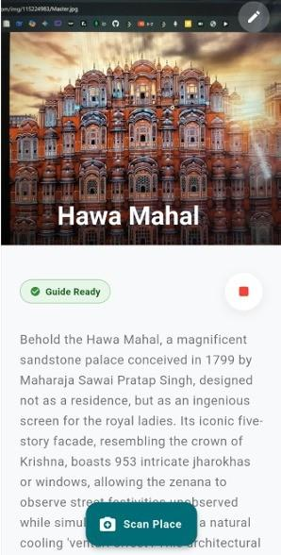
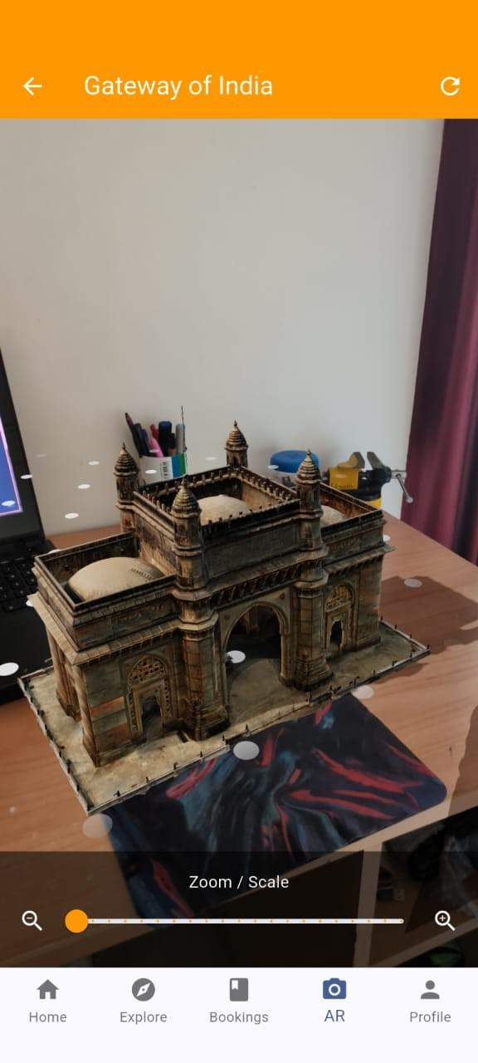

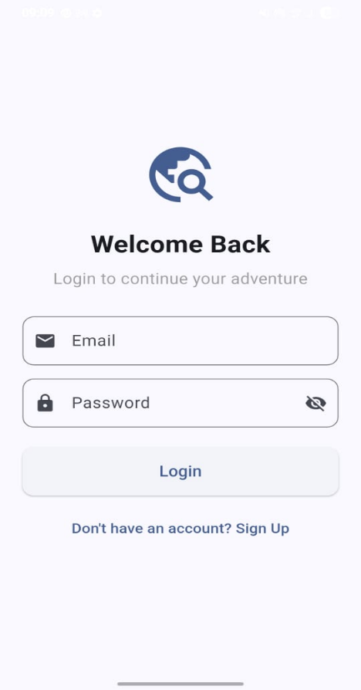
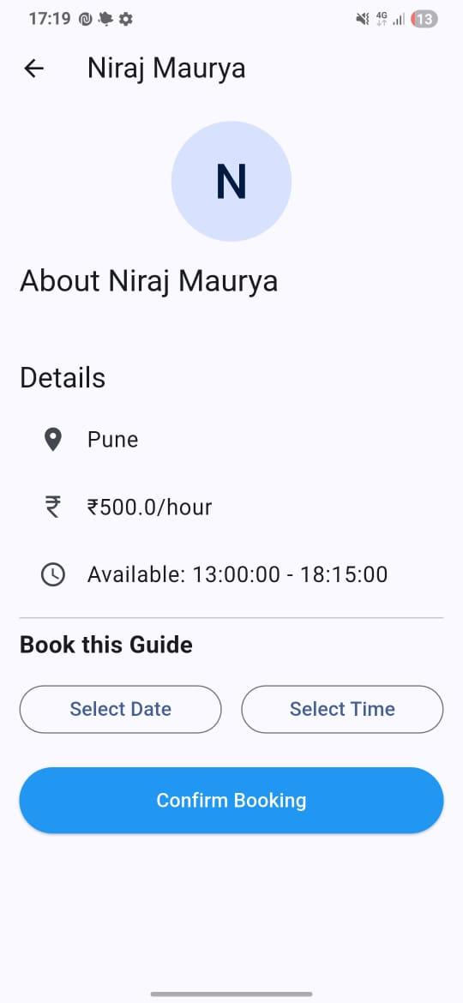

Conclusion

This project successfully implements an intelligent, all-in-one travel assistance system that integrates Augmented Reality, Artificial Intelligence, and real-time location services into a single, easy-to-use mobile application. TravelEase unifies the fragmented processes of travel discovery, itinerary planning, navigation, and booking, providing users with a seamless end-to-end experience. Through features such as AI-powered itinerary generation, AR-based landmark recognition, virtual monument projection, hotel and guide booking, and dynamic cost estimation, the system transforms the way travelers plan and explore destinations.
One of the key achievements of this application is its ability to function as a comprehensive digital travel companion. Users can receive optimized itineraries, explore nearby attractions, visually identify landmarks using the Travel Lens, and interact with 3D monuments before visiting them. The system’s offline caching, real-time APIs, and Supabase-backed storage ensure reliability and smooth performance throughout the entire trip.
Overall, TravelEase significantly enhances the travel experience by combining immersive AR exploration, intelligent planning algorithms, and user-friendly design into one unified platform. Future enhancements could include multilingual AR narration, collaborative group itineraries, deeper AI reasoning for more personalized recommendations, integration with transportation booking APIs, and support for wearable devices to further improve hands-free navigation and on-the-go travel interactions.

Future Scope
While the current version of TravelEase provides a comprehensive and intelligent platform for travel planning, on-site exploration, and immersive AR experiences, several enhancements can further elevate the system’s capability, usability, and global applicability. Future versions of the application can incorporate the following advanced features:

1. Enhanced AR Capabilities
Introduce offline AR functionality, improved surface tracking, and gesture-based interactions. Future updates can also include high-fidelity 3D models and multi-object recognition for a richer and more immersive user experience.

2. Multilingual Support
Expand the accessibility of the app by incorporating multiple regional and international languages for itinerary generation, AR narration, and UI elements. This will make TravelEase suitable for a broader global audience.

3. Collaborative Trip Planning
Enable group travel planning where multiple users can jointly contribute to a shared itinerary, vote on preferences, and synchronize schedules, making the system ideal for families, friends, and tour groups.

4. Advanced AI Recommendation Engine
Integrate deeper contextual reasoning and machine learning models to provide personalized recommendations based on past trips, travel behavior, sentiment analysis, and user preferences.

5. Integration with Transport Booking Systems
Extend booking features to include flights, trains, buses, and rental cars. This will transform TravelEase into a complete end-to-end travel management platform, eliminating the need for external apps.

6. Smart Alerts and Adaptive Notifications
Add real-time alerts for weather updates, traffic conditions, attraction closures, peak hours, local events, and safety notifications. Context-aware reminders can enhance user convenience during the trip.

7. Sustainability-Focused Features
Introduce tools that estimate carbon footprint, suggest eco-friendly hotels and activities, and promote sustainable tourism habits among users.

8. Wearable and Smart Device Integration
Support for smartwatches and AR glasses can provide hands-free navigation, quick alerts, step-by-step itinerary guidance, and on-the-go AR interaction for enhanced mobility.

References
• Google Maps Platform Documentation
https://developers.google.com/maps
• Google Places API Documentation
https://developers.google.com/maps/documentation/places
• ARCore Developer Guide (Augmented Reality)
https://developers.google.com/ar
• Flutter Official Documentation
https://docs.flutter.dev
• Supabase Documentation (Authentication, Database, Storage)
https://supabase.com/docs
• PostgreSQL + PostGIS Documentation (Geospatial Queries)
https://postgis.net/documentation/
• OpenWeatherMap API Documentation
https://openweathermap.org/api
• Flutter AR Packages and System Integration Resources
• Research Papers on Augmented Reality in Tourism and AI-Based Itinerary Planning
(as cited in the TravelEase research paper you provided)
• Cultural and Heritage Tourism Studies on AR Applications
• Academic Journals and IEEE Publications Related to AI, AR, and Mobile Computing

