Medical History Questionnaire Dr.'s Elaina M. Groo & John Kaknis
06/21
Last First Today’s
Name Name Date
Date of Birth Date of Last Eye Exam Eye Doctor Date of Last Physical Exam Physician

Medical History: Height:______Weight: LIST MEDICATIONS you are take (prescription and/or over the counter)

Do you have any allergies or allergies to any medications? Yes NO If yes, list the medications:

List all major illnesses (high blood pressure, diabetes, heart attack, glaucoma, etc.) or injuries (concussion, etc.):

List any surgeries and/or hospitalizations you have had ( ie. tonsillectomy, appendectomy, cataract) A re you pregnant and or nursing? Yes [ ] NO [ ]
Do you wear glasses? Yes [ ] NO [ ] If yes, how old is your present pair of lenses? Do you wear contact lenses? Yes [ ] NO [ ] If yes, how old is your present pair of lenses? Type of contact lenses? [ ] Rigid [ ] Soft [ ] Extended Wear [ ] Other Are they comfortable? [ ] Yes [ ] NO
What type of disinfection system do you use?
Review of Systems Do you currently have any problems in the following areas? If yes, please provide information
SYMPTOMS below require a medical visit and will be billed to your medical coverage. Evaluation and treatment are not routine and are NOT covered with your vision benefit. Additional appointments may be necessary.
YES NO
Loss of Vision
Blurred vision
Fluctuating vision
Distorted vision (halos)
Loss of side vision
Double Vision
Dryness
Mucous discharge
Redness
Sandy or gritty feeling
Itching
Burning
Foreign body sensation
Excess tearing/watering
Glare/light sensitivity
Eye pain or soreness
Infection of eye or lid (stye)
Tired eyes
Crossed eyes, lazy eye
Drooping Eyelid
Flashes/Floaters
Other

Please continue on back

Review of Systems (continued)
EARS, NOSE MOUTH, THROAT
Allergies/ Hay Fever Sinus congestion Runny Nose
Post-Nasal Dip Chronic Cough Dry Throat/ Mouth
RESPIRATORY
Asthma
Chronic Bronchitis Emphysema
VASCULAR / CARDIOVASCULAR
Diabetes Heart Pain
High Blood Pressure Vascular Disease
GASTROINTESTINAL
Diarrhea Constipation
GENITOURINARY
Genitals / Kidney / Bladder
BONES / JOINTS / MUSCLES
Rheumatoid Arthritis Muscle Pain
Joint Pain
LYMPHATIC / HEMATOLOGIC
Anemia
Bleeding Problems ALLERGIC/ IMMUNOLOGIC PSYCHIATRIC
NO YES
Explain
[ ]
[ ]
[ ]
[ ]
[ ]
[ ]
[ ]
[ ]
[ ]
[ ]
[ ]
[ ]
[ ]
[ ]
[ ]
[ ]
[ ]
[ ]
[ ]
[ ]
[ ]
[ ]
[ ]
[ ]
[ ]
[ ]
[ ]
[ ]
[ ]
[ ]
[ ]
[ ]
[ ]
[ ]
[ ]
[ ]
[ ]
[ ]
[ ]
[ ]
[ ]
[ ]
[ ]
[ ]
[ ]
[ ]
Family History (note any family history (parents, grandparents, siblings, children: living or deceased) for the following conditions:
NO YES Relationship
Blindness [ ] [ ]
Cataract [ ] [ ]
Crossed Eyes | [ | ] | [ | ]
Macular Degeneration | [ | ] | [ | ]
Retinal Detachment Disease  Arthritis Cancer Diabetes Heart Disease  High Blood Pressure Kidney Disease Lupus/Autoimmune  Thyroid Disease Other | [  [  [  [  [  [  [  [  [  [  [ | ]  ]  ]  ]  ]  ]  ]  ]  ]  ]  ] | [  [  [  [  [  [  [  [  [  [  [ | ]  ]  ]  ]  ]  ]  ]  ]  ]  ]  ]

If you answered YES to any of the above or have a condition not listed, please explain & list additional medication :

Social History This information is kept confidential. However, you may discuss this portion directly with the doctor if you prefer. [ ] Yes, I would prefer to discuss my Social History information directly with my doctor. (check box)

Do you use tobacco products? [ ] No [ ] Yes If yes, type/ amount/ how long: Do you drink alcohol? [ ] No [ ] Yes If yes, type / amount/ how long: Do you use illegal drugs? [ ] No [ ] Yes If yes, type / amount/ how long: Have you ever been exposed to or infected with: [ ] Gonorrhea [ ] Hepatitis [ ] HIV [ ] Syphilis

Current occupation / School / Grade ?______________________________________________________________

Marital Status: [ ] single, [ ] married, [ ] widowed, [ ] divorce

Living arrangements: (asked to determine if assistance is needed for the visually disabled)

Doctor Date
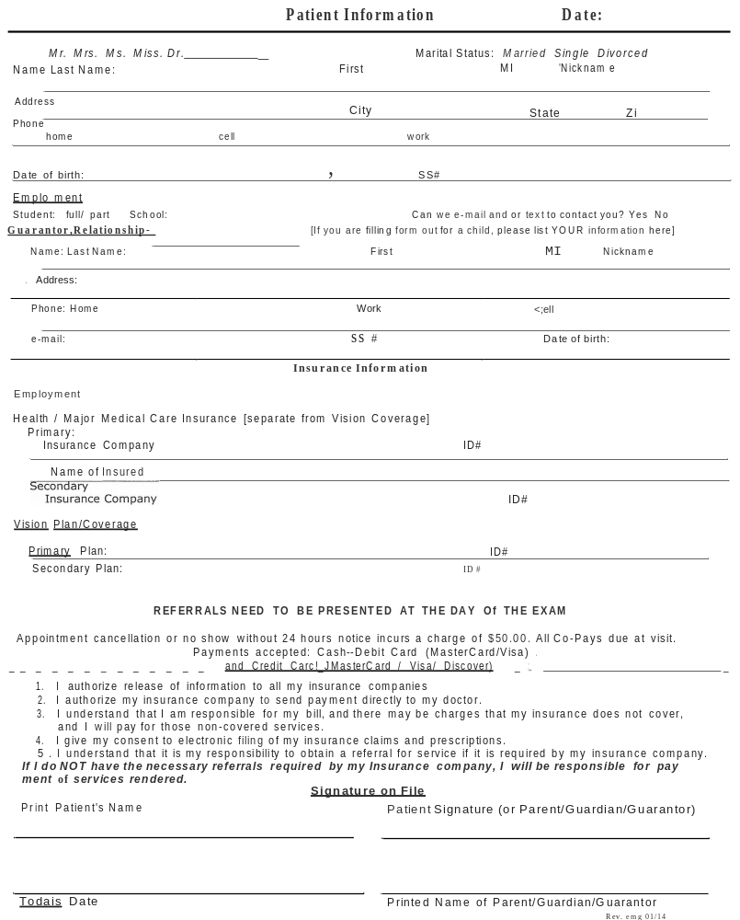
Dear Patient: This questionnaire was created to assist us in helping you choose the eyewear best suited to your particular needs and lifestyle concerns. Please take a moment to answer all the questions that apply to you.
Thank you for taking the time to complete this form.
1. What do you like about your current pair of glasses and or contact lenses?
2. What don't you like about your current pair of glasses and or contact lenses?
3. Your activities: ( circle all that apply)
cooking sewing needlepoint/knitting board games sofciering/welding painting woodworking electrical golf skiing/skating/snow boarding snorkling/suba/swim auto repair plumbing use of power tools, cyclingpainting musical instrument art scrapebook crafts cards/bingo woodworking fishing cycling boating gardening/landscaping
4. Are you bothered by glare from any of the following? ( circle all that apply)
night driving/headlights haze flourscent lights smart phone sunshine/uv exposure computer screens other tablets
5. Does your work entail unusual visual demands due to any of the following: ( cir, le all that apply)
distance viewing outdoor work natural or artifical lighting caustic environent near viewing indoor work abrupt changes in light levels clean room position driving microscope/ telescope other
6. What electronic devices do you use: smart phone, tablet, kindel, video games and how much time on each device. Do your eyes tire after viewing/reading/using these devices?
7. Do you currently use more than one pair of glasses?  bifocals distance golf  trifocals reading tennis  multifocals intermediate shooting  occupational computer hunting other hobby: sunglasses | NO | YES (circle all that apply below)  scuba specs swim goggles ski goggles driving  protective eyewear
8. Do you see clearly with the glasses for all the tasks which you need to complete? YES NO if NO ... please explain
9. Do you use a computer? NO YES What is the distance from the screen to your eyes? inches? Lap top, distance inches
Is the screen positioned to your Right Left Center?  computer a day? |  | How many hours do you spend at the | '
10. Do you currently wear contact lenses? NO YES What type of lens? (soft/disposable/gas perme- able/bifocal etc.)
What disinfection system do you use?

How many hours a day do you wear your contact lenses? Disinfection System:
Please list all the family members living at home
Name Last Eye Exam Date of Birth

NOTICE OF PRIVACY PRACTICES
HUDSON VALLEY EYE DOCTOR OF OPTOMETRY, P.C.
ELAINA M. GROO, O.D. & JOHN KAKNIS, O.D.
1 SCOBIE DRIVE
NEWBURGH, NY 12550
845-565-2020
ELAINA M. GROO,O.D., COMPLIANCE OFFICER
THIS NOTICE DESCRIBES HOW MEDICAL INFORMATION ABOUT YOU MAY BE USED AND DISCLOSED AND HOW YOU CAN GET ACCESS TO THIS INFORMATION. PLEASE REVIEW IT CAREFULLY.

We respect our legal obligation to keep health information that identifies you private. We are obligated by law to give you notice of our privacy practices. This Notice describes how we protect your health information and what rights you have regarding it.

TREATMENT, PAYMENT, AND HEALTH CARE OPERATIONS

The most common reason why we use or disclose your health information is for treatment, payment or health care operations. Examples of how we use or disclose information for treatment purposes are; setting up an appointment for you; testing or examining your eyes; prescribing glasses, contact lenses, or eye medications and faxing them to be filled; showing you low vision aids; referring you to another doctor or clinic for eye care or low vision aids or services; or getting copies of your health information from another professional that you may have seen before us. Examples of how we use or disclose your health information for payment purposes are; asking you about your health or vision care plans, or other sources of payment; preparing and sending bills or claims; and collecting unpaid amounts (either ourselves or through a collection agency or attorney). “Health care operations” mean those administrative and managerial functions that we have to do in order to run our office. Examples of how we use or disclose your health information for health care operations are; financial or billing audits; internal quality assurance; personnel decisions; participating in managed care plans; defense of legal matters; business planning; and outside storage of our records.
We routinely use your health information inside our office for these purposes without any special permission. If we need to disclose your health information outside of our office for these reasons, we will ask you for special written permission.
We will ask for special written permission in the following situations: When information is asked for by another professional or entity filling a prescription, requests for copy of prescriptions or any information regarding your health information.

USES AND DISCLOSURES FOR OTHER REASONS WITHOUT PERMISSION

In some limited situations, the law allows or requires us to use or disclose your health information without your permission. Not all of these situations will apply to us: some may never come up at our office at all. Such uses or disclosures are:
When a state or federal law mandates that certain health information be reported for a specific purpose;
for public health purposes, such as contagious disease reporting, investigation or surveillance; and notices to and from the federal Food and Drug Administration regarding drugs or medical devices;
Disclosures to governmental authorities about victims of suspected abuse, neglect or domestic violence;
uses and disclosures for health oversight activities, such as for the licensing of doctors; for audits by Medicare or Medicaid; or for investigation of possible violations of health care laws;
disclosures for judicial and administrative proceedings, such as in response to subpoenas or orders of court or administrative agencies.

disclosures for law enforcement purposes, such as to provide information about someone who is or is suspected to be a victim of a crime; to provide information about a crime at our office; or to report a crime that happened somewhere else:
disclosure to a medical examiner to identify a dead person or to determine the cause of death; or to funeral directors to aid in burial; or to organizations that handle organ or tissue donations;
Uses or disclosures for health related research;
Uses and disclosures to prevent a serious threat to health or safety;
Uses or disclosures for specialized government functions, such as for the protection of the president or high ranking government officials; for lawful national intelligence activities; for military purposes; or for the evaluation and health of members of the foreign service:
Disclosures of de-identified information;
Disclosures relating to worker’s compensation programs;
Disclosures of a “limited data set” for research, public health, or health care operations:
Incidental disclosures that are an unavoidable by-product of permitted uses or disclosures:
Disclosures to “business associates” who perform health care operations for us and who commit to respect the privacy of your health information;
[specify other uses and disclosures affected by state law].
Unless you object, we will also share relevant information about your care with your family or friends who are helping you with your eye care.

APPOINTMENT REMINDERS
We may call or write to remind you of scheduled appointments, or that it is time to make a routine appointment. We may also call or write to notify you of other treatments or services available at our office that might help you. Unless you tell us otherwise, we will mail you an appointment reminder on a post card, and or leave you a reminder message on your home answering machine or with someone who answers your phone if you are not home.

OTHER USES AND DISCLOSURES
We will not make any other uses or disclosures of your health information unless you sign a written “authorization form.” The content of an “authorization form” is determined by federal law. Sometimes, we may initiate the authorization process if the use of disclosure is our idea. Sometimes, you may initiate the process if it’s your idea for us to send our information to someone else. Typically, in this situation you will give us a properly completed authorization form, or you can use one of ours.
If we initiate the process and ask you to sign an authorization form, you do not have to sign it. If you do not sign the authorization, we cannot make the use or disclosure. If you do sign one, you may revoke it at any time unless we have already acted in reliance upon it. Revocations must be in writing. Send them to the office contact person named at the beginning of the Notice.

YOUR RIGHTS REGARDING YOUR HEALTH INFORMATION
The law gives you many rights regarding your health information. You can:
ask us to restrict our uses and disclosures for purposes of treatment (except emergency treatment), payment or health care operations. We do not have to agree to do this, but if we agree, we must honor the restrictions that you want. To ask for a restriction, send a written request to the office contact person at the address, fax or EMail shown at the beginning of this Notice.
ask us to communicate with you in a confidential way, such as by phoning you at work rather than at home, by mailing health information to a different address, or by using Email to your personal Email address. We will accommodate these requests if they are reasonable, and if you pay us for any extra cost. If you want to ask for confidential communications, send a written request to the office contact person at the address, fax or Email shown at the beginning of this Notice.
ask to see or to get photocopies of your health information. By law there are a few limited situations in which we can refuse to permit access or copying. For the most part, however, you will be able to review or have a copy of your health information within 30 days of asking us (or sixty days if the information is stored off-site). You may have to pay for photocopies in advance. If we deny your request, we will send you a written explanation and instructions about how to get an impartial review of your denial if one is legally available. By law we can have one 30 day extension of the time for us to give you access or photocopies if we send you a written notice of the extension. If you want to review or get photocopies of your health information, send a written request to the office contact person at the address, fax or Email shown at the beginning of this notice.
ask us to amend your health information if you think that it is incorrect or incomplete. If we agree, we will amend the information within 60 days from when you ask us. We will send the corrected information to persons who we know got the wrong information, and others that you specify. If we do not agree, you can write a statement of your position, and we will include it with your health information along with any rebuttal statement that we may write. Once your statement of position and / or our rebuttal is included in your health information, we will send it along whenever we make permitted disclosures of your health information. By law, we can have one 30 day extension of time to consider a request for amendment if we notify you in writing of the extension. If you want to ask us to amend your health information, send a written request, including your reasons for the amendment, to the office contact person at the address, fax or email shown at the beginning of this Notice.
get a list of the disclosures that we have made of your health information within the past six years (or shorter period if you want). By law, the list will not include: disclosures for purposes of treatment, payment or health care operations; disclosures with your authorization; incidental disclosures: disclosures required by law: and some other limited disclosures. You are entitled to one such list per year without charge. If you want more frequent lists, you will have to pay for them in advance. We will usually respond to your request within 60 days of receiving it, but by law we can have one 30 day extension of time if we notify you of the extension in writing. If you want a list, send a written request to the office contact person at the address, fax or Email shown at the beginning of this Notice.
get additional paper copies of this Notice of Privacy Practices upon request. It does not matter whether you got one electronically or in paper form already. If you want additional paper copies, send a written request to the office contact person at the address, fax or Email shown at the beginning of this Notice.

OUR NOTICE OF PRIVACY PRACTICES

By law, we must abide by the terms of this Notice of Privacy Practices until we choose to change it. We reserve the right to change this notice at any time as allowed by law. If we change this Notice, the new privacy practices will apply to your health information that we already have as well as to such information that we may generate in the future. If we change our Notice of Privacy Practices, we will post the new notice in our office, have copies available in our office, and post it on our Web site.

COMPLAINTS
If you think that we have not properly respected the privacy of your health information, you are free to complain to us or the U.S. Department of Health and Human Services, Office for Civil Rights. We will not retaliate against you if you make a complaint. If you want to complain to us, send a written complaint to the office contact person at the address, fax or Email shown at the beginning of this Notice. If you prefer, you can discuss your complaint in person or by phone.

FOR MORE INFORMATION
If you want more information about our privacy practices, call or visit the office contact person at the address or phone number shown at the beginning of this Notice.

Hudson Valley Eye Doctor
Dr. Elaina M. Groo and Dr. John Kaknis
Optometrist
1 Scobie Drive
Newburgh, New York 12550
845-565-2020
Health Insurance Privacy Practice (HIPPA)
Acknowledgement of Notification and Receipt (Please sign ONE Notice of Privacy)
[ ] I acknowledge that I have been given or downloaded a copy from DrElainaMGroo.com. to read and review a copy of this Office’s Notice of Privacy Practices.
[ ] I have elected NOT to take a copy of the Notice of Privacy Practices

Print your Name:_________________________________________________________________________________________________

Signature:_____________________________________________________________________Date:________________________

_______:_____________________________________________________________________________________________________________

[ ] I acknowledge that I have been given to read and review a copy of this
Office’s Notice of Privacy Practices and I received a copy on this date or downloaded a copy from DrElainaMGroo.com.

Print your Name:_____________________________________________________________________________________________

Signature______________________________________________________________Date:______________________

_______________________________________________________________________________________________________________________
[ ] I hereby give permission to this office the use of my cell phone number for
communication either by a phone call or text.
[ ] I hereby give this office permission to communicate by my e-mail below:

Cell Phone:___________________________________E-Mail:________________________________________

In addition to my insurance carrier, you are hereby given permission to discuss my medical and or financial records with the following person [s]s

Name Relationship Phone #
_____________________________________________________________________________________________________________________________________________________________________________________________________________________________________________________________________________________________________________________________________________________________________

