CHLOE CHAN  MSc in Marketing Candidate  Digital Marketing | Consumer Insights | Brand Strategy  Hong Kong SAR | +852 5123 4567 | chloe.chan.marketing@hku.com  linkedin.com/in/chloe-chan-marketing-demo | | 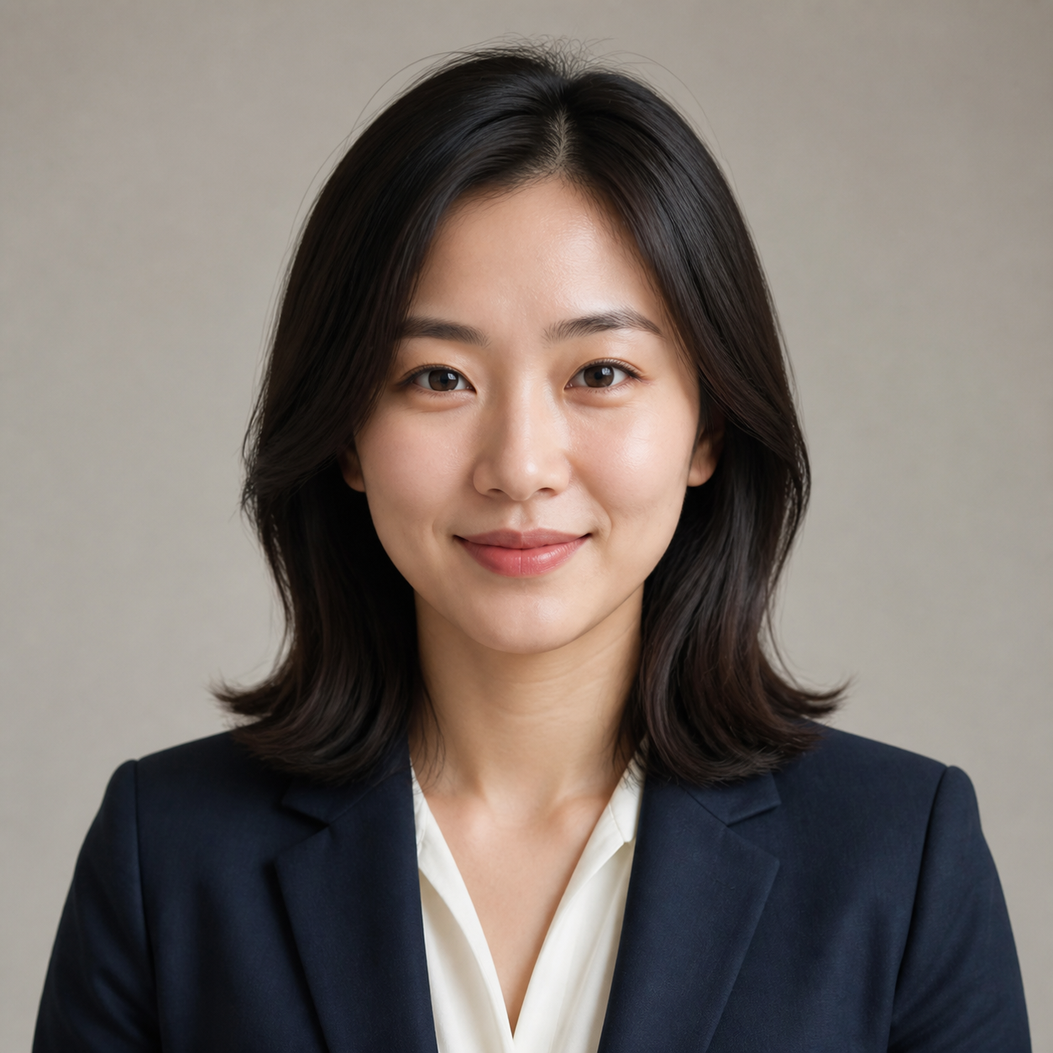
Profile
Marketing postgraduate with academic training from The University of Hong Kong and The Hong Kong University of Science and Technology. Experienced in digital campaigns, consumer research, social media strategy and marketing analytics across beauty, banking and advertising. Skilled at translating customer data into practical brand and growth recommendations. Native Cantonese speaker with professional fluency in English and Mandarin.
Education
The University of Hong Kong — HKU Business School Sep 2025 – Aug 2026 (Expected)
Master of Science in Marketing Hong Kong SAR
- Focus areas: Digital Marketing, Consumer Insights, Marketing Analytics, CRM and Brand Management.
- Recipient of the HKU Business School MSc Entrance Scholarship.
- Consulting project: segmented Gen Z customers for a sustainable fashion start-up and proposed a creator-led campaign projected to reduce acquisition cost by 18%.
The Hong Kong University of Science and Technology Sep 2021 – Jun 2025
Bachelor of Business Administration in Management; Minor in Marketing Hong Kong SAR
- CGA: 3.65/4.30; Dean’s List in 2022–23 and 2023–24.
- Final-year project: How Short-form Video Influences Purchase Intention among Gen Z Consumers in Hong Kong.
- Semester exchange at Copenhagen Business School, Jan–May 2024; studied sustainable marketing and international branding.
Professional Experience
L’Oréal Hong Kong Jun – Aug 2025
Marketing Intern — Consumer Products Division Hong Kong SAR
- Supported integrated campaigns across Instagram, YouTube, TikTok and retail channels; analysed weekly sales and media performance from more than 80 retail locations.
- Coordinated product seeding with 35 micro-influencers and tracked reach, engagement and earned content.
- Helped deliver a product launch that generated 1.2M social impressions and exceeded its engagement target by 24%.
HSBC Hong Kong Jun – Aug 2024
Digital Marketing Intern — Wealth and Personal Banking Hong Kong SAR
- Built weekly dashboards covering impressions, click-through rates, conversion rates and cost per acquisition for youth acquisition campaigns.
- Supported A/B tests on email subject lines and landing-page calls to action; the winning email increased open rate by 11% and click-through rate by 7%.
- Analysed more than 1,500 survey responses and summarised customer pain points for the digital product team.
Ogilvy Hong Kong Jun – Aug 2023
Account Management Intern Hong Kong SAR
- Prepared competitor reviews, audience profiles, creative briefs and post-campaign reports for consumer and hospitality clients.
- Monitored online conversations and translated cultural trends into weekly social-listening summaries.
- Presented a Gen Z content proposal; two recommended formats were incorporated into the final campaign plan.

Professional Experience — Continued
Harbour & Pine Coffee Sep 2022 – May 2023
Part-time Social Media and Community Assistant Hong Kong SAR
- Planned bilingual Instagram and Xiaohongshu content, growing Instagram followers from 2,800 to 4,600 in eight months.
- Launched a user-generated-content campaign that attracted more than 170 customer posts and organised two community events for 120+ participants.
Selected Projects
Hong Kong Sustainable Fashion Consumer Study 2026
Team Lead — HKU Marketing Analytics Project
- Designed a bilingual survey with 420 valid responses and used SPSS for factor analysis, cluster analysis and regression modelling.
- Identified four consumer segments and recommended differentiated messages, channels and offers.
“Hidden Hong Kong” Content Campaign 2023 – Present
Personal Creative Project
- Built a bilingual neighbourhood and street-photography account to 6,800+ organic followers; produced 90+ short videos and photo stories.
Gen Z Beauty Trends Dashboard 2025
Independent Analytics Project
- Cleaned publicly available social engagement data and built a Tableau dashboard comparing beauty topics, formats and engagement patterns.
- Translated the analysis into a sample three-month content strategy focused on high-save tutorial formats.
Leadership & Community
HKU Marketing Society 2025 – 2026
Vice President, External Relations
- Led a six-member team, developed industry partnerships and delivered four events attended by more than 300 students.
InspiringHK Sports Foundation 2024 – Present
Volunteer Communications Assistant
- Photographs community programmes and creates bilingual participant stories and social media content.
HKUST Business Students’ Union 2022 – 2023
Marketing Officer
- Managed campaign materials for student events and career workshops, helping increase registrations by 30%.
Enactus HKUST 2021 – 2022
Project Member
- Created Cantonese social media guides and introductory digital-marketing workshops for neighbourhood retailers.
Skills, Credentials & Interests
Marketing & Analytics  Campaign planning · CRM  GA4 · Excel · Power BI  Tableau · SPSS · SQL | Creative & Research  Canva · Figma · Photoshop  Qualtrics · social listening  Photography · short-form video | Languages  Cantonese — Native  English — Professional  Mandarin — Professional
CERTIFICATIONS Google Analytics Certification (2025) | Meta Certified Digital Marketing Associate (2025) | HubSpot Content Marketing (2024)
AWARDS HKU MSc Entrance Scholarship (2025) | HKUST Marketing Case Competition, First Runner-up (2024) | HKUST Dean’s List
INTERESTS Street photography · trail running · specialty coffee · sustainable fashion · travel journaling · independent bookstores

