Assignment 2 : Implement all Prompt Engineering approaches- Interview Approach, COT, TOT. Compare and contrast all and analyse their applications. Implement Zero shot and Few shot prompting and compare their results.

- Zero shot prompting

Prompt :Classify the sentiment of the following sentence as Positive, Negative, or Neutral.
Sentence: "The product quality is excellent and delivery was quick."
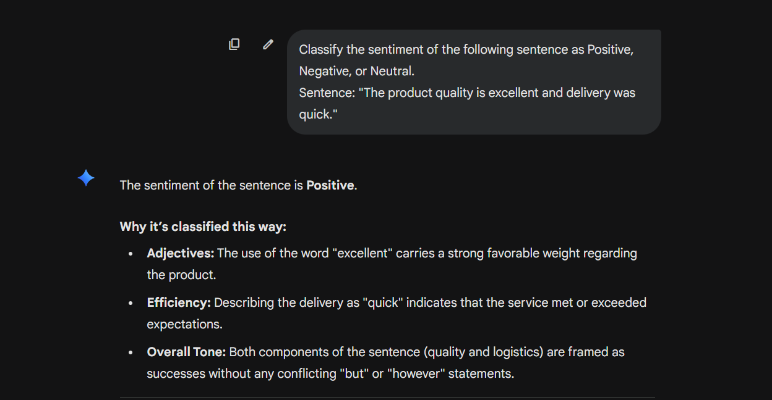

- Few shot prompting
Prompt :
Classify the sentiment of the sentence.

Sentence: "I love this product."
Sentiment: Positive

Sentence: "The service was terrible."
Sentiment: Negative

Sentence: "The movie was okay."
Sentiment: Neutral

Sentence: "The laptop works very smoothly."
Sentiment:
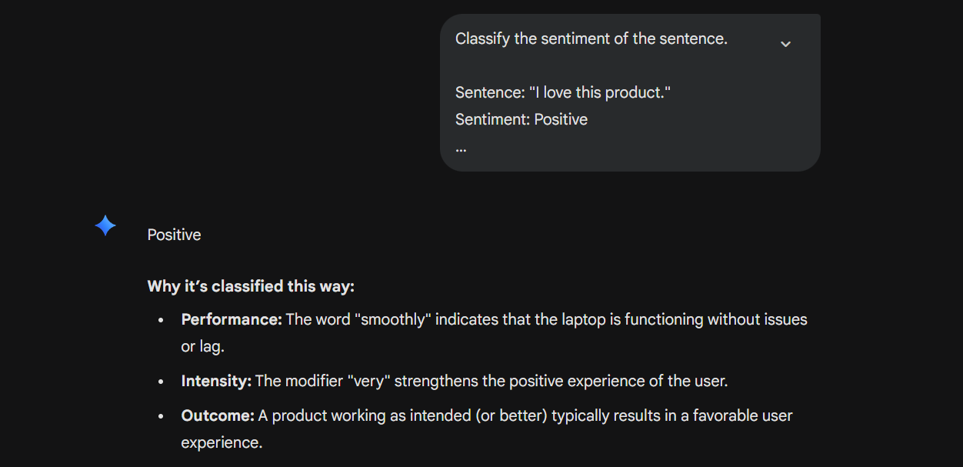
- Interview Approach
Prompt:
We will solve the problem step by step.

Question: A bank account received ₹5000 and later ₹2000.
1. What is the total amount received?
2. Show the calculation.
3. Provide the final answer.
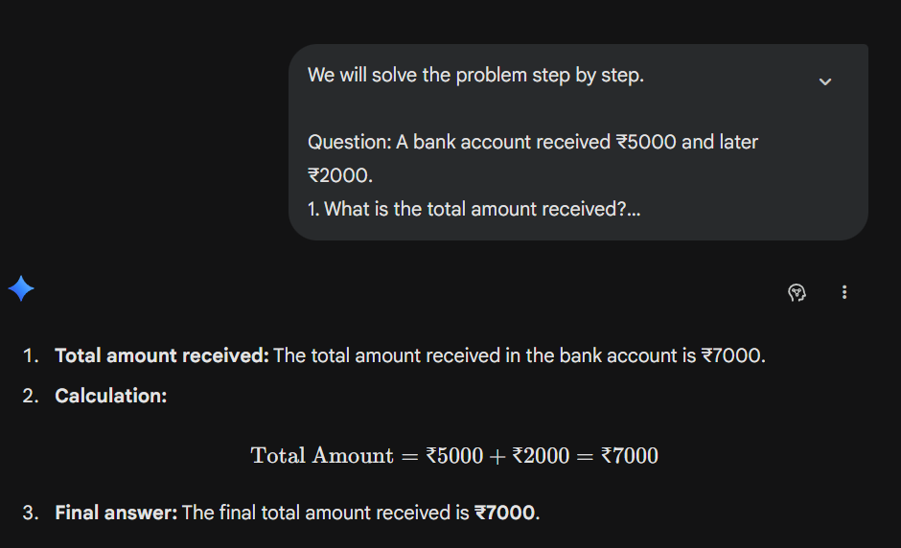
- Chain of Thought (CoT)
Prompt : Solve the following problem step by step.

A customer deposits ₹10,000 in a bank account and withdraws ₹2,500.
How much money remains?
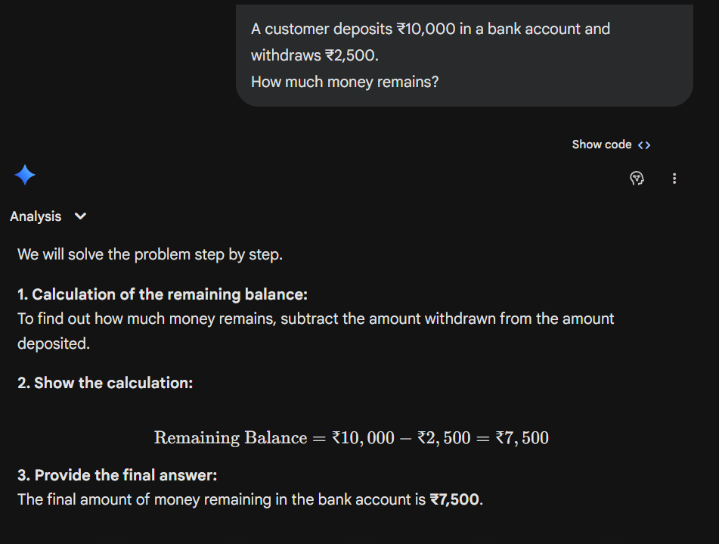
- Tree of Thought
Prompt
Solve the problem by exploring multiple approaches.

Problem: A bank detects suspicious transactions between accounts A, B, and C.

Approach 1: Analyze transaction timing
Approach 2: Analyze transaction amounts
Approach 3: Analyze account behavior

Evaluate which approach best identifies fraud.
Response Generated: To solve this problem effectively, we can break down each approach to see how it isolates suspicious activity, specifically looking for patterns like money laundering, structuring, or account takeovers.

Approach 1: Analyze Transaction Timing
This method focuses on the velocity and sequencing of transfers.
- Mechanism: It looks for "round-tripping" where money moves from $A \rightarrow B \rightarrow C \rightarrow A$ in a very short window (minutes or hours).
- Strengths: Excellent at detecting automated bot activity or "layering" phases of money laundering.
- Weakness: High-frequency trading or legitimate automated bill payments can sometimes trigger false positives.

Approach 2: Analyze Transaction Amounts
This approach monitors the value of the transfers and compares them against regulatory thresholds.
- Mechanism: It flags "structuring" (or "smurfing"), where large sums are broken into smaller amounts (e.g., ₹49,000 to stay under a ₹50,000 reporting limit). It also identifies "odd" amounts that don't fit typical consumer behavior.
- Strengths: Very effective for compliance and identifying attempts to bypass legal reporting requirements.
- Weakness: Clever fraudsters often vary amounts slightly to mimic natural spending.

Approach 3: Analyze Account Behavior
This is a holistic view that compares current activity against historical data.
- Mechanism: If Account B has historically only handled transactions of ₹1,000 but suddenly receives and transfers ₹1,00,000, it marks a "Change in Pattern."
- Strengths: Best for identifying Account Takeover (ATO), where a legitimate account is compromised and used as a "mule."

Evaluation: Which Approach is Best?
While each has merits, Approach 3 (Account Behavior) is generally considered the most robust for identifying fraud, particularly when powered by machine learning.
Rank | Approach | Why it wins/loses
1 | Account Behavior | It provides context. A "quick" or "large" transfer isn't always fraud, but a transfer that is out of character for that specific user usually is.
2 | Transaction Timing | Great for catching "mule" networks where money must move quickly before the bank freezes the account.
3 | Transaction Amounts | Useful for basic compliance, but the easiest for sophisticated fraudsters to manipulate.
Final Verdict: For the most accurate detection, a Hybrid Approach is used in the industry. However, if forced to choose one, Behavioral Analysis identifies the most sophisticated types of fraud by detecting the "human" or "bot" element that deviates from established norms.

Technique | Examples Needed | Reasoning Ability | Complexity | Best Use Cases
Zero-Shot | No | Low | Very Easy | Quick tasks
Few-Shot | Few examples | Medium | Easy | Classification
Interview Approach | Structured questions | Medium | Moderate | Learning systems
Chain of Thought | Step-by-step reasoning | High | Moderate | Math, logic
Tree of Thought | Multiple reasoning paths | Very High | Complex | Research, decision-making

