Assignment Report: Text-to-Image Generation using Transformers
Name: Mansi Mahabdi
PNR: 22420190

Objective
To explore Transformer capabilities in multimodal tasks by generating images from text prompts.

Methodology
We used a pre-trained Stable Diffusion model from Hugging Face Diffusers library. The model converts text prompts into images using Transformer-based architecture.

Implementation
The implementation involves loading the model, providing a text prompt, and generating an image output.

Results
The model successfully generated realistic images based on the provided text prompt.
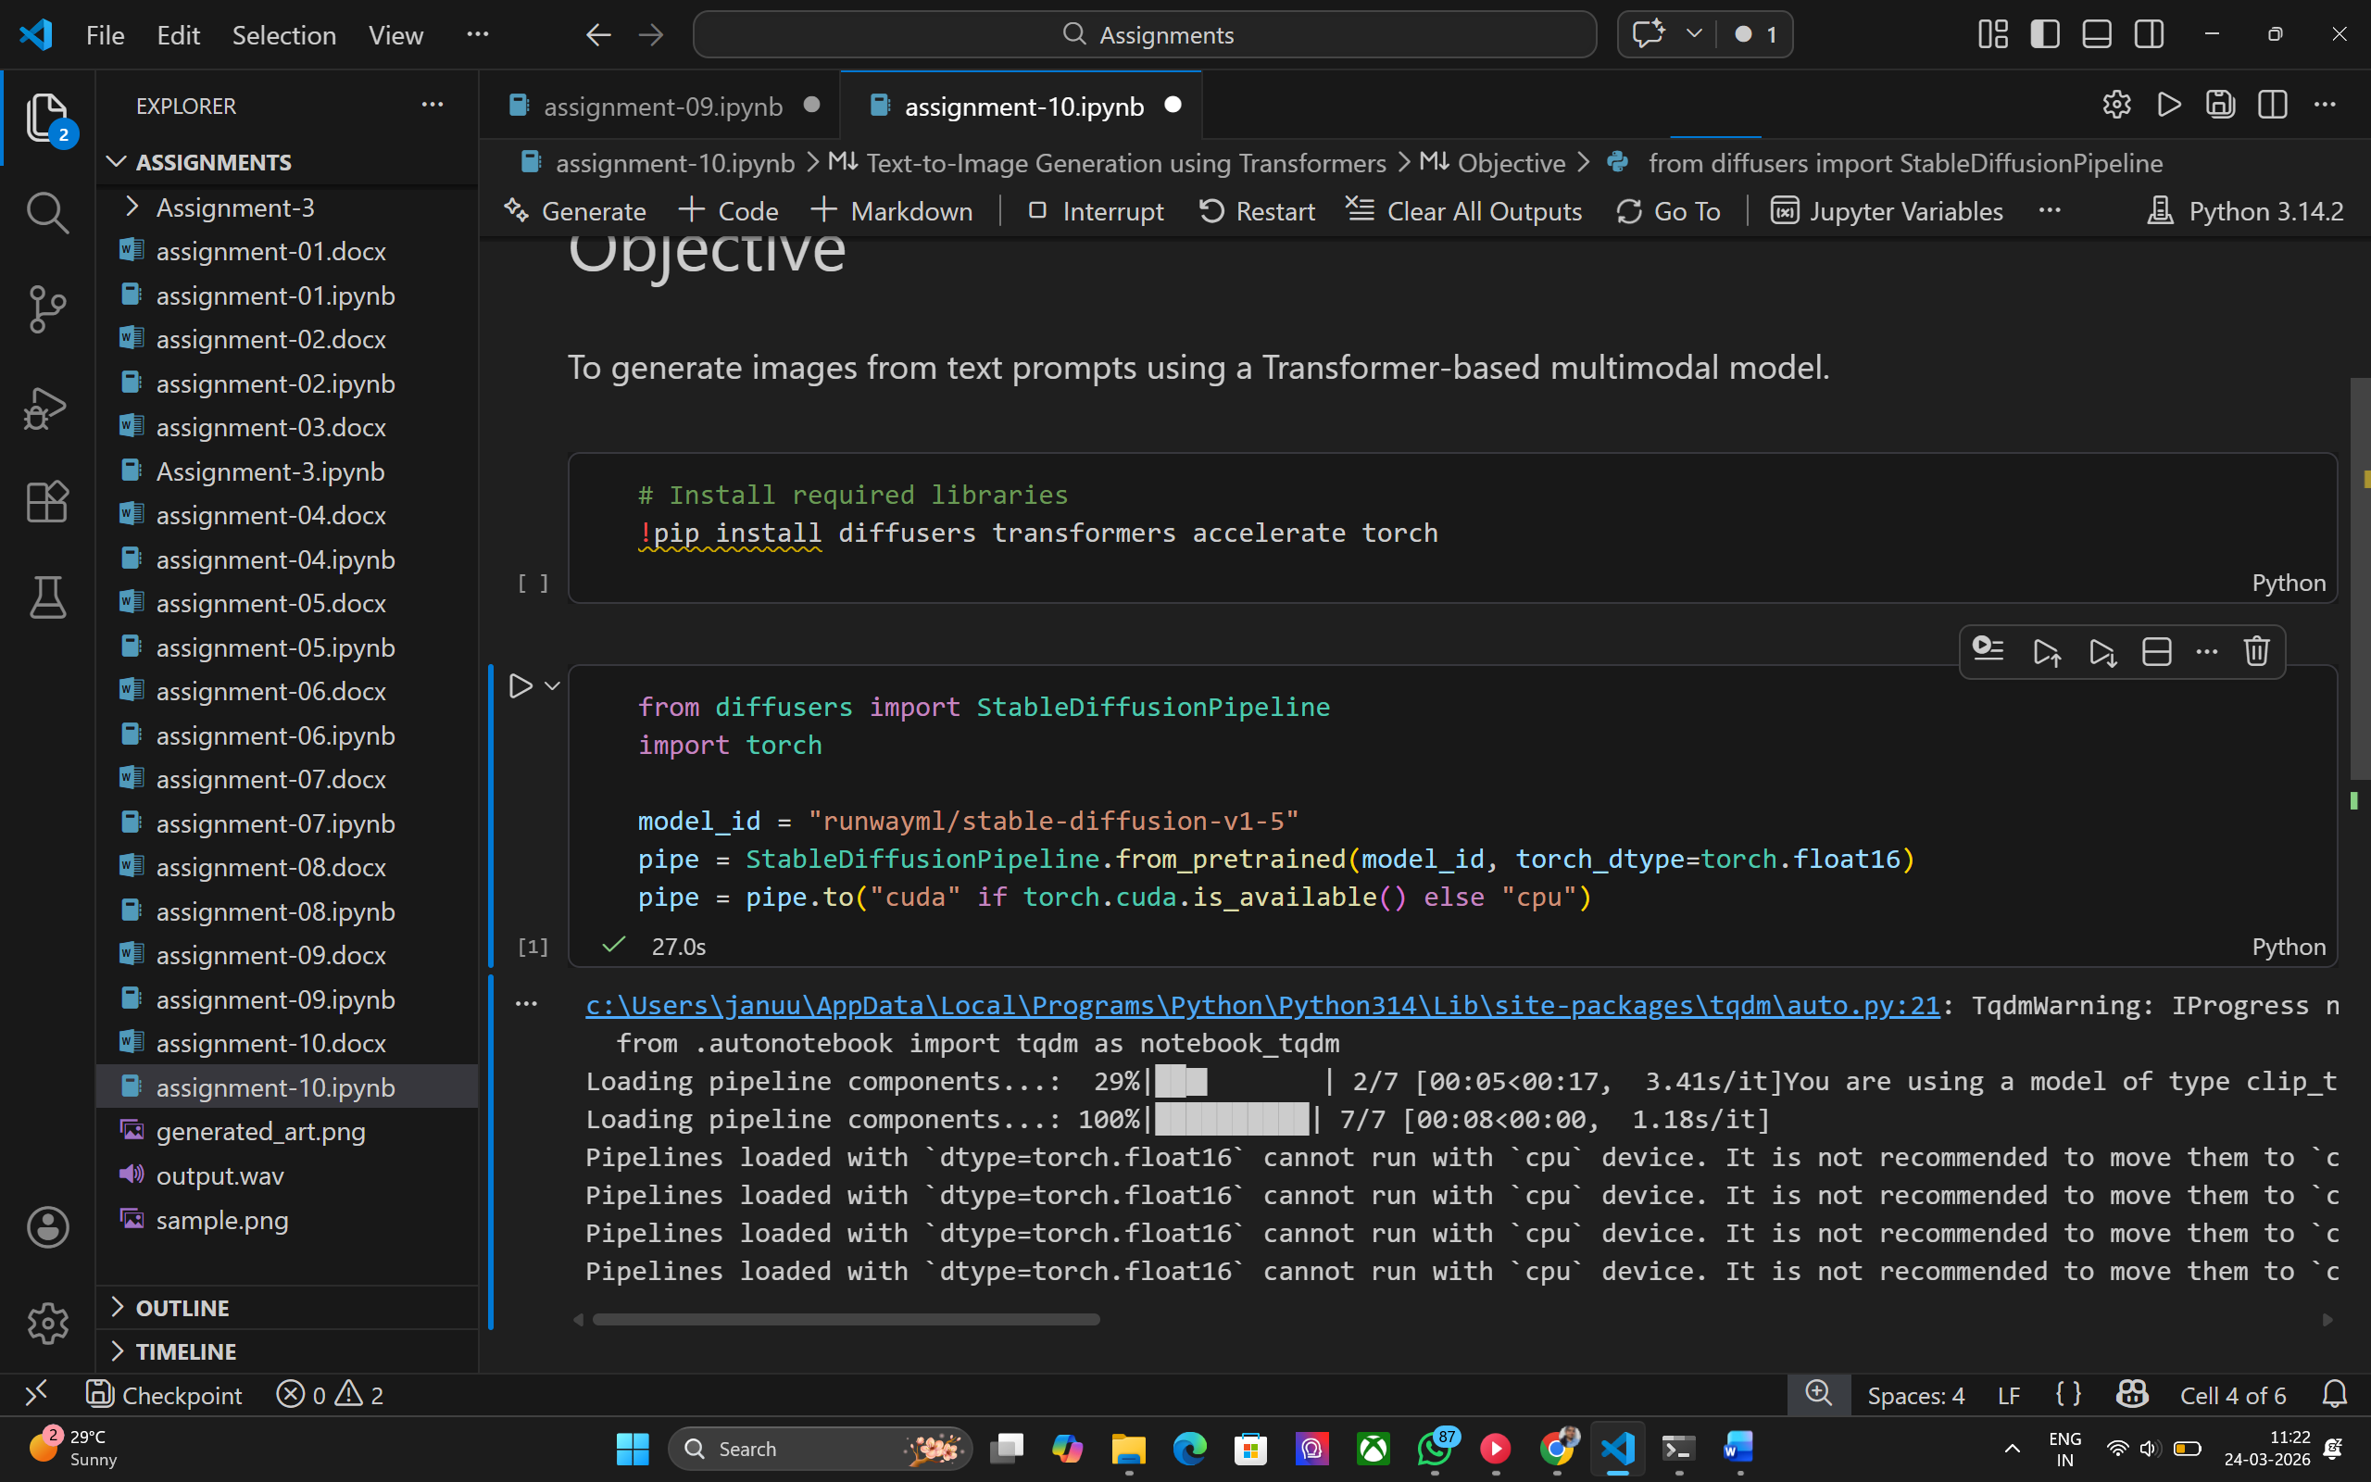
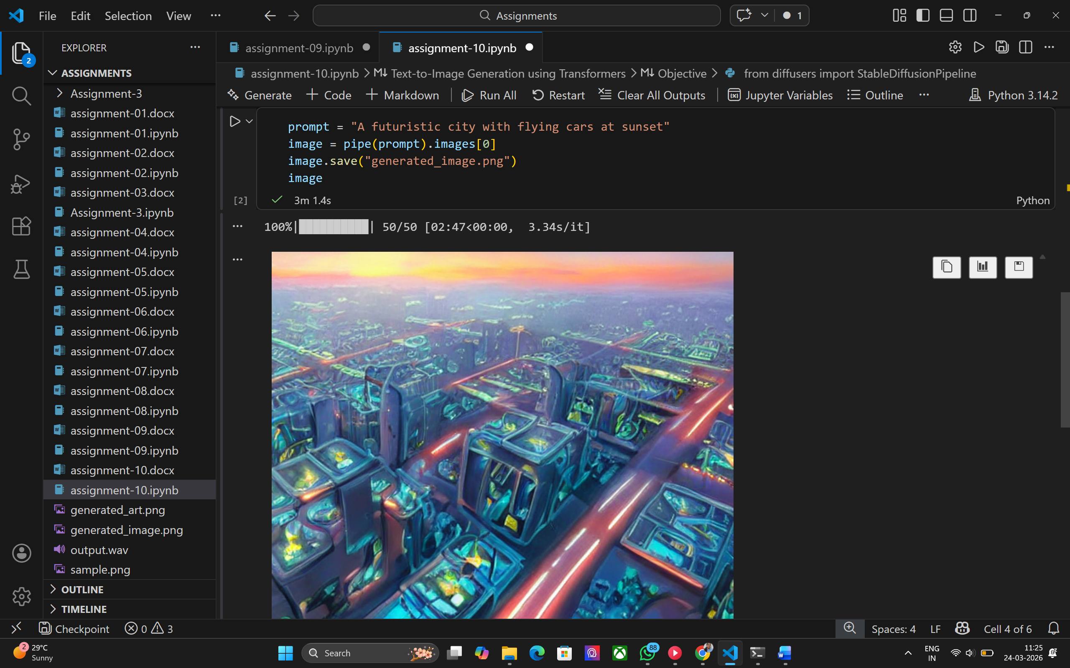

Conclusion
Transformer-based multimodal models are powerful tools for bridging text and image domains.

