Question Answering Chatbot using Pre-trained Model
Name: Mansi Mahabdi
PNR: 22420190

Objective
To build a simple chatbot that answers questions using a pre-trained language model.

Introduction
A Question Answering (QA) system is a type of chatbot that responds to user queries based on a given context using Natural Language Processing.

Methodology
We used the Hugging Face Transformers library and a pre-trained QA pipeline. The model processes the context and extracts answers for given questions.

Implementation
The chatbot is implemented using Python. It loads a pre-trained model and allows users to input questions interactively.

Results
The chatbot successfully answers questions based on the provided context with good accuracy.
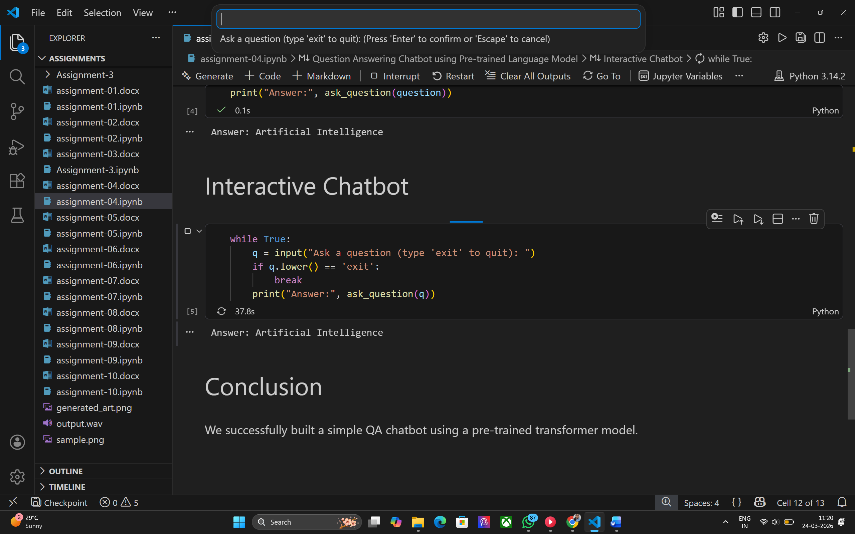

Conclusion
Pre-trained models simplify chatbot development and provide efficient results without training from scratch.

