**Project Status Report for MCA 4th Semester Mini Project**

1. Group No. : 4

2. Department/Program : MCA

3. Date of Project Report Submission : 3 July 2020

4. Supervisor’s Name : Mr. Rajesh Tripathi

5. Status of the Project : The project has been completed.

6. Project Title : MNNIT META-LIBRARY

7. Origin of the Project:

**Motivation:-**

MNNIT, being a vast organization, providing facilities to every student sometimes is not possible. We saw this particular problem in our library. The library can’t provide every book available to each and every student. Moreover, getting notes, papers can be a hectic job. We tried to solve all the problems here in this project.

MNNIT meta-library works on education domain by helping students in their studies and minimizing their time of struggle spent in search of study material and can rather devote that time in learning instead of searching.

**Technicality**:-

ER-Diagram

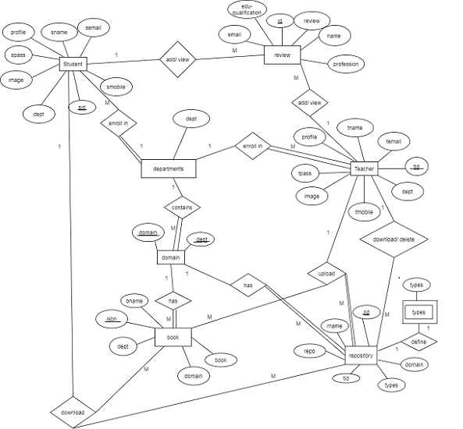 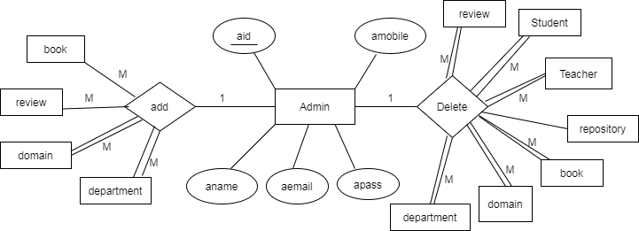

Note : We have represented admin functionality separately as the er-diagram was looking very congested.

Hardware and Software Constraints

* **Hardware Requirements ( used by us)**

Processor : Intel Pentium dual core and above

RAM : Compatible with 4 GB

Hard disk : Compatible with 1 GB

* **Software Interface**

**Server Side:**

**OS:** Independent of OS (Windows 7 or above or Linux based).

**Web Server:** Tomcat Apache 9.0 or Above.

**Application:** JDK 8.0, eclipse neon, MySQL 8.0.19.0

**Client Side:**

**OS:** Independent of OS (Windows 7 or above or Linux based).

**Browser:** Any browser (Internet Explorer 8+ , Firefox 19.0+, Chrome 25.0+, Safari 5.1+, Opera 12.1+, iOS Safari 4.0+, Opera Mini 7.0+, Browser 2.2+).

* **Platform :** Java2EE application

**Front End:** HTML, CSS, JS, JQUERY, AJAX, JSP, Bootstrap.

**Back End:** MySQL, JDBC (through Servlets).

1. Other Similar ideas available on internet :-

The websites that gave us ideas and inspiration are:-

1. <https://nalanda.bits-pilani.ac.in/>
2. <https://bookboon.com/en/textbooks>
3. Importance of the proposed project in the context of current status and its relevance to computer science and engineering :

The exiting manual system or offline system has got many **disadvantages**.

* It is a time consuming job to search for books.
* It requires much space(in terms of land) for storage of books.
* It is difficult to maintain records of books manually.
* The library system involves a lot of the employees in the library.
* Maintenance of the books.
* In availability of lecture videos, teachers personal notes.

So we go for online library system.

Before developing MNNIT Meta-Library we also analyzed e-books and online courses websites. Those websites mostly contained only books or some study material for students and many a times are paid.

So we thought that a system needs to be built where all the books and papers should be provided in a common platform which is free of cost. Also students get the lecture notes and videos of all course provided in college, which is not provided by any of the current websites of our college, creating a huge repository in years to come. There is no need to upload the material again and again for different semester or course.

10. Work Plan :

1. Methodology: The **prototyping model** is a systems development method in which a **prototype** is built, tested and then reworked as necessary until an acceptable outcome is achieved from which the complete system or product can be developed.

Requirement Analysis

Feasibility Study

Software Design

Prototyping

Customer evaluation

Customer Reviews and updation

Software Maintenance

Software Testing

Coding

1. Time Schedule of activities

|  |  |  |  |  |
| --- | --- | --- | --- | --- |
| Month | March | April | May | June |
| Task | Study of requirements, collection of resources, Project design planning | Building front-end layout, sign in and sign up pages, database connectivity. | Working on separate module of the project individually (building dynamical web pages) | Module integration through GIT, error removal. |

1. Outcome expected from the project and its relevance to computer science and engineering:-

Provide a common electronic interface for teacher and students to access different kind of study material like:- notes, videos, previous year papers and book’s.

* Provide digital study material.
* Save time (as students not have to search for books and papers in library).
* Provide interface for users to communicate with us and put their queries regarding study material.
* Collection of previous years question papers for all subject.
* Video lectures will help those students who had genuine reason for not attending the class. This can seriously help students in this pandemic time.
* Students can rereview the lectures through these pre-recorded videos.
* No limitation for the number of books that can be downloaded at a time as in case of manual library system we can issue only 3-4 books at a time per student for a week.
* Study material once downloaded will remain forever with them.
* Computerization will reduced the manual work problem.
* Easy to Use (more focus on selection rather then typing).

It is proposed to make the new system extremely user friendly with well-designed screens and limited input required to get proper outputs.

Moreover, in this pandemic time were teacher and student struggle a lot over education management. This platform can be a common ground for our university for making education non-stop to the next level.

1. Summary of roles/ responsibilities of all students : GITHUB was used for integrating and versioning.

**Student’s information/ project roles**

|  |  |  |  |
| --- | --- | --- | --- |
| **Sr. No.** | **Registration No.** | **Name** | **Roles** |
| 1 | 2018CA02 | Mansi Maheshwari | Admin profile, integration b/w modules |
| 2 | 2018CA11 | Alka Rani Tigga | Teacher profile, index page |
| 3 | 2018CA25 | Saroj Kumari | Student profile, index page |

Comments (if any): ________________________________________________________

Suggestions for improvement (if any): _________________________________________________

Signature of Supervisor

**PANEL COMMENTS**

Comments (if any): ________________________________________________________

Suggestions for improvement (if any): ________________________________________________

Signature of Panel Representative