G:\cuv\Backgrounds, logos & icons\Capture.JPGC:\Users\user\Desktop\Capture1.JPGC:\Users\user\Desktop\Capture2.JPG

***Fame - vote***

***Unlimited votes for a limited time!!***

Award’s Results

**Awards**

***Fame - vote***

FV Movie Awards

More….

FV TV Awards

Profiles

FV Music Awards

**Your text here**

....

[](http://www.youtube.com/watch?v=X2BYmmTI04I)[](http://www.youtube.com/watch?v=_L2vJEb6lVE)[](http://www.youtube.com/watch?v=tzCbCuAzgNw)[](http://www.youtube.com/watch?v=iS1g8G_njx8)[](http://www.youtube.com/watch?v=pB-5XG-DbAA)[](http://www.youtube.com/watch?v=oEm3lY3trRU)[](http://www.youtube.com/watch?v=O-zpOMYRi0w)[](http://www.youtube.com/watch?v=F90Cw4l-8NY)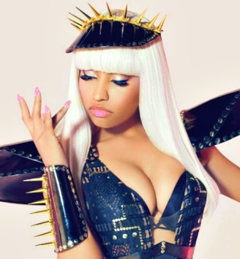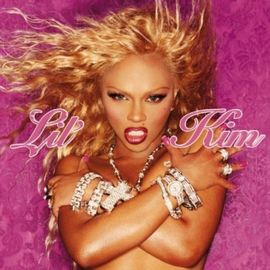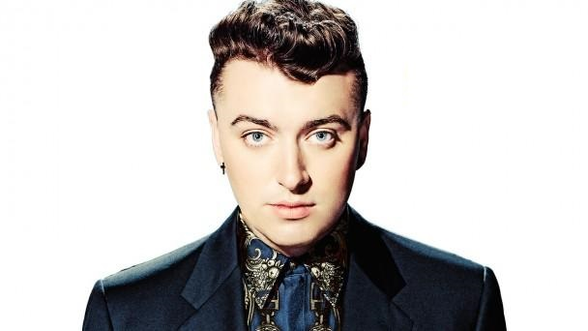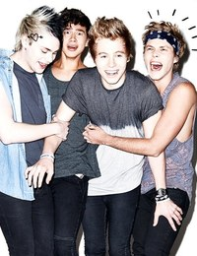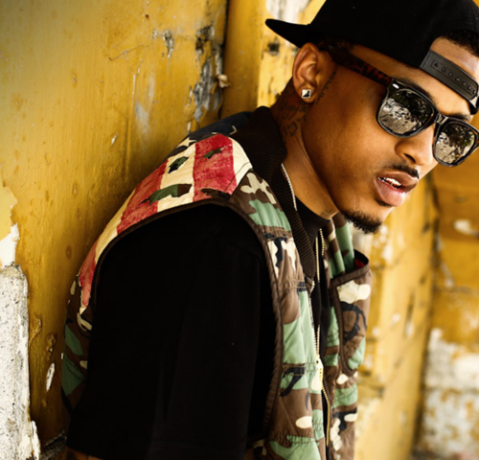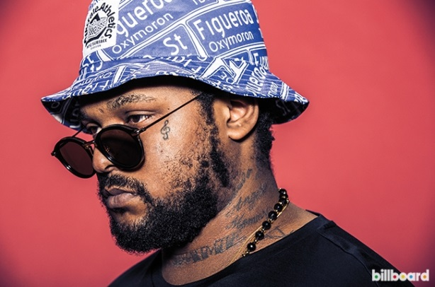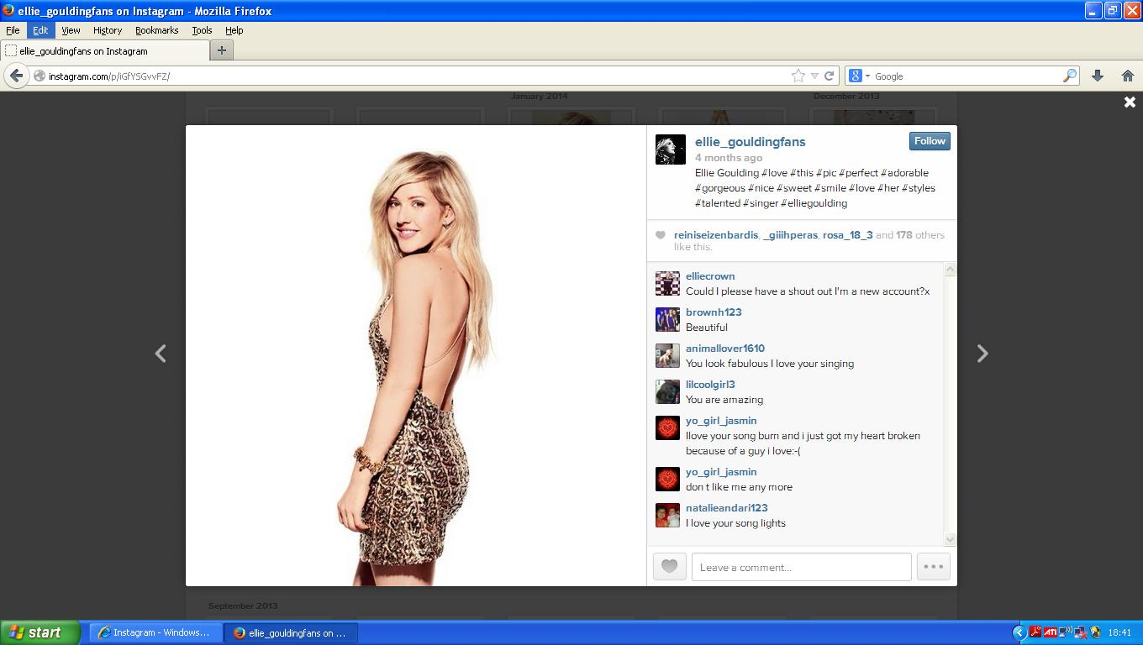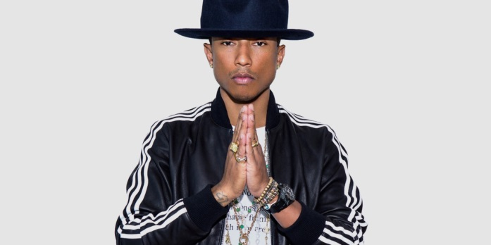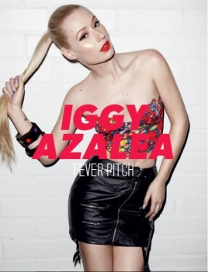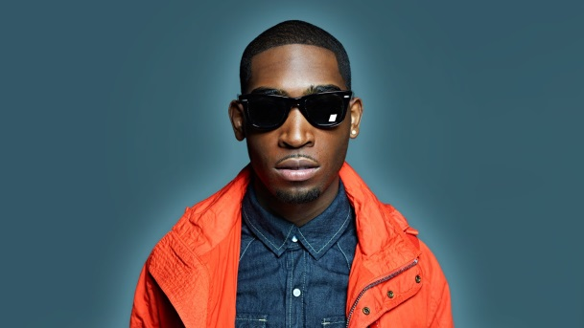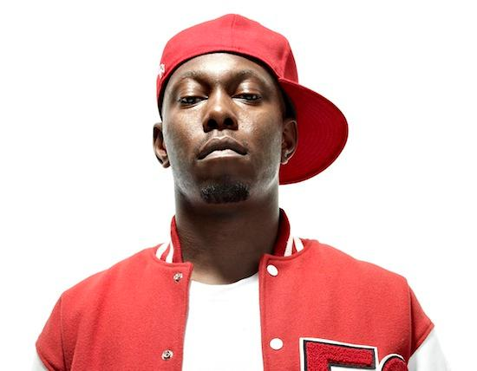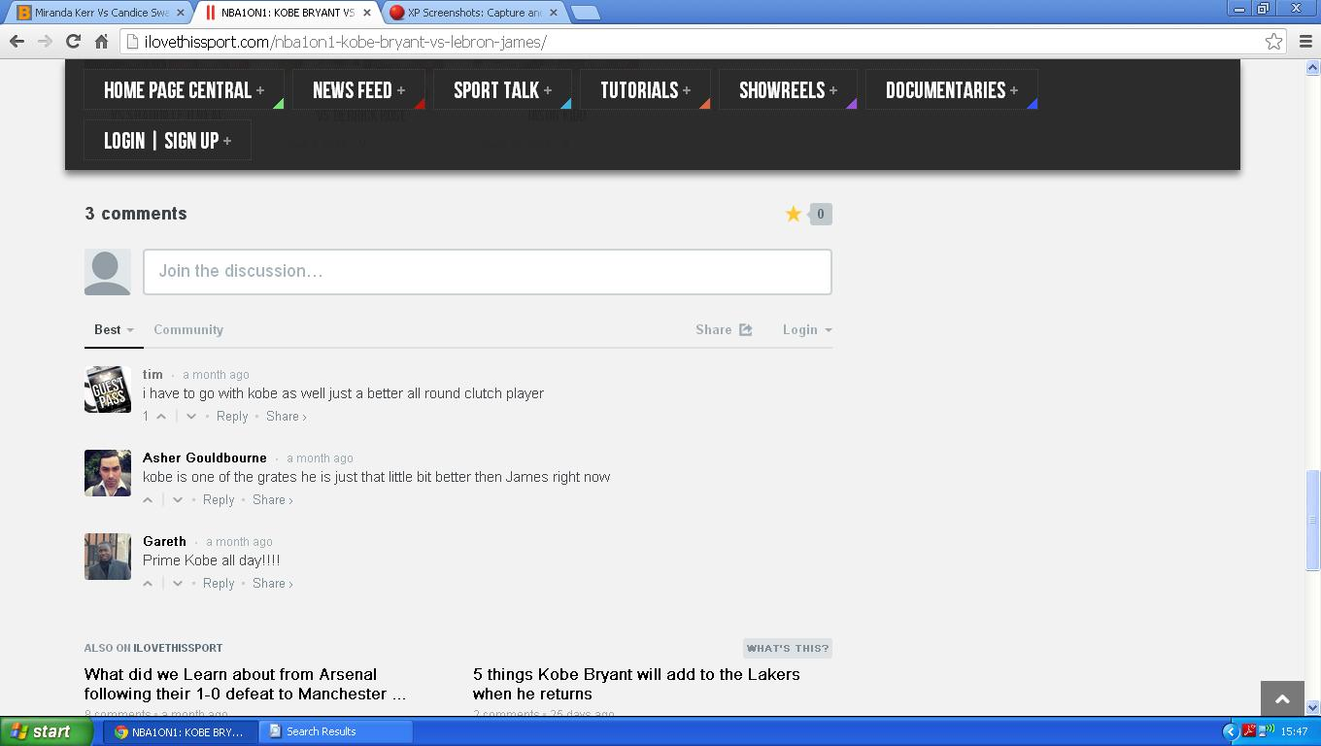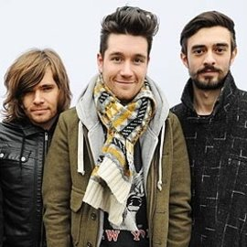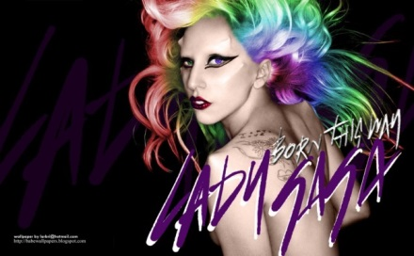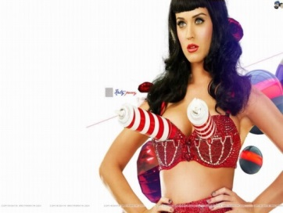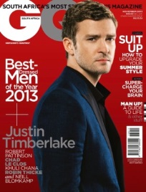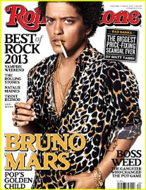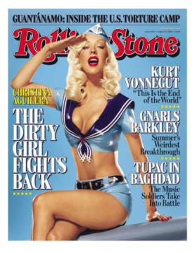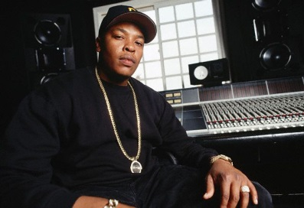

Lil’ Kim vs Nicki Minaj

Vs

Schoolboy Q

5 Seconds of Summer

Jhene Aiko

Bastille

Sam Smith

Iggy Azalea

August Alsina

Ariana Grande

Ora vs Goulding

KE$HA vs Azalea

Vs

Dizzee vs Tinnie

CREATE A POLL!!

BEST NEW ARTIST

Britney vs Aguilera

Vs

Vs

Vs

Perry vs Gaga

Timberlake vs Bruno Mars

Vs

Dr Dre vs Pharrell

Vs

Vs

New Polls

102,845

102,845

Profile

102,845

Vote

Profile

Vote

Vote

Profile

Vote

Profile

102,845

Profile

Vote

102,845

Profile

Vote

102,845

Profile

Vote

102,845

102,845

Profile

Vote

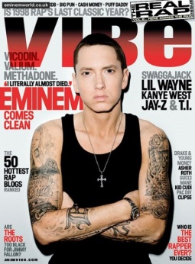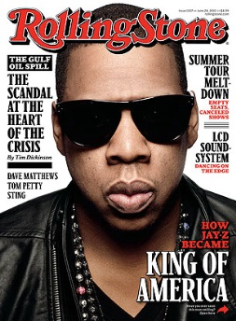

Vs

Other Music Polls

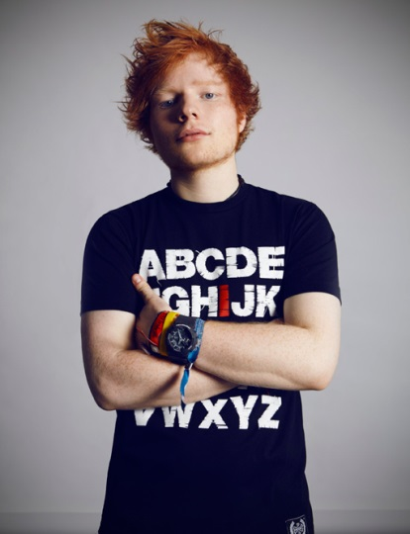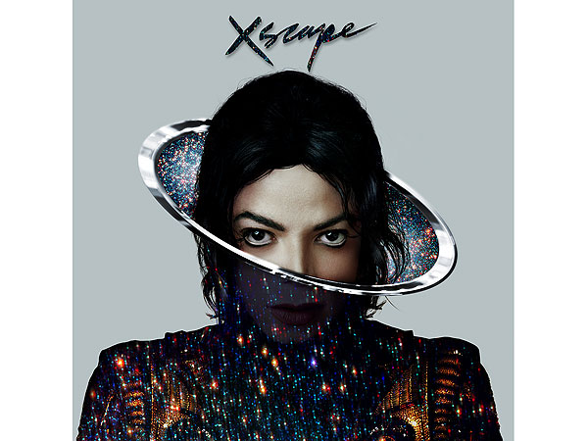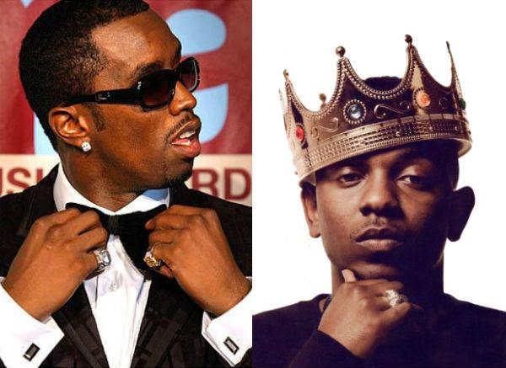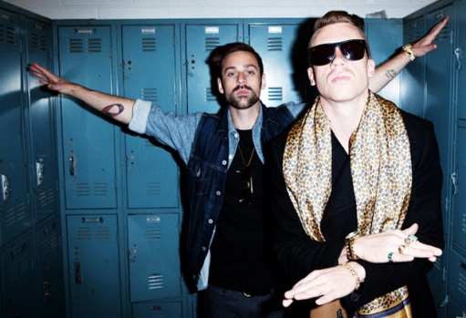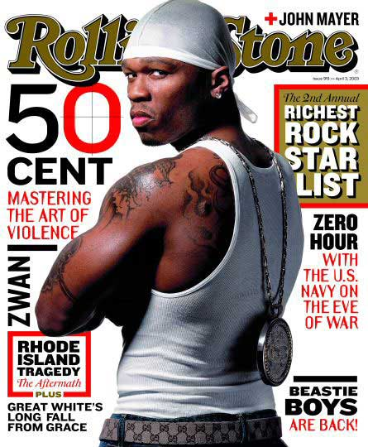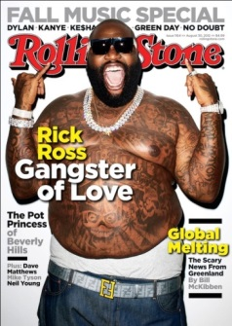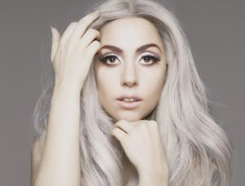

Miley Cyrus vs Miley Cyrus

***Unlimited votes for a limited time!!***

Musicians

Actors

Directors

Films

More…..

The Oscars

More….

The Grammys

The Golden Globes

The Baftas

The Oscars

More….

Award’s Results

Best Actor

Best Actress

Best TV Drama

Best Director

More….

Best Actor

Best Actress

Best Supporting Actor

Best supporting Actress

More….

Album of the year Best Rap Album

Record of the year Best Rock Album

Best New Artist Best Dance Album

Best Pop Album Best Country Album

Best R&B Album More…

**Awards**

***Fame - vote***

FV Movie Awards

More….

FV TV Awards

Profiles

FV Music Awards

Vs

Macklemore vs Kendrick Lamar

Rick Ross vs 50 Cent

Vs

CREATE A POLL !!

Vs

J.Lo vs Shakira

Lady Gaga

Rhiana vs Beyonce

Justin Timberlake

Katy Perry

Bruno Mars

Vs

Vs

Best Pop Album

Jay Z vs Eminem

Daft Punk vs Disclosure

Vs