House Price Prediction Using Data Analytics and Machine Learning

Abstract
This project develops a machine learning-based system to predict house prices from structured real estate data. The dataset contains 1,000 records and 8 features including Square Footage, Number of Bedrooms, Number of Bathrooms, Year Built, Lot Size, Garage Size, and Neighborhood Quality. Four regression models were trained and evaluated: Linear Regression, Decision Tree Regressor, Random Forest Regressor, and Gradient Boosting Regressor. Linear Regression achieved the highest accuracy with an R² score of 0.9984, a Mean Absolute Error of $8,174.58, and an RMSE of $10,071.48. The project demonstrates that Square Footage is the dominant predictor of house price, accounting for 98.6% of feature importance. All steps including data analysis, EDA, model training, evaluation, and final prediction are implemented in a Jupyter Notebook using Python.

1. Introduction
Real estate pricing is one of the most complex and economically significant problems in modern society. The price of a house depends on numerous factors including its physical dimensions, age, location quality, and amenities. Traditional appraisal methods are subjective and time-consuming. Machine learning offers a data-driven, objective, and scalable alternative.
In this project, we apply supervised machine learning regression techniques to predict house prices based on seven input features. The entire pipeline — from raw data inspection to final prediction — is implemented in Python using industry-standard libraries.

2. Problem Statement
Given a set of house attributes (square footage, number of bedrooms, number of bathrooms, year built, lot size, garage size, and neighborhood quality), predict the sale price of a house as accurately as possible. This is a supervised regression problem where the target variable is a continuous numeric value — House_Price.

3. Objectives
• Inspect and understand the house price dataset thoroughly.
• Perform data cleaning and validate data quality.
• Conduct Exploratory Data Analysis (EDA) to discover patterns and relationships.
• Train multiple regression models on the dataset.
• Evaluate and compare models using MAE, RMSE, and R² metrics.
• Identify the best-performing model and use it to predict house prices.

4. Dataset Description
File: house_price_regression_dataset.csv
The dataset contains 1,000 rows and 8 columns (7 input features + 1 target variable). There are no missing values and no duplicate records. All features are numeric.
Column | Data Type | Range | Description
Square_Footage | int64 | 503 – 4999 | Total living area in square feet
Num_Bedrooms | int64 | 1 – 5 | Number of bedrooms
Num_Bathrooms | int64 | 1 – 3 | Number of bathrooms
Year_Built | int64 | 1950 – 2022 | Year the house was constructed
Lot_Size | float64 | 0.51 – 4.99 acres | Size of the property lot
Garage_Size | int64 | 0, 1, or 2 | Number of cars garage holds
Neighborhood_Quality | int64 | 1 – 10 | Quality rating of neighbourhood
House_Price (Target) | float64 | $111,627 – $1,108,237 | Sale price of the house (USD)

5. Technologies Used
• Programming Language: Python 3
• Data Manipulation: pandas, numpy
• Data Visualisation: matplotlib, seaborn
• Machine Learning: scikit-learn (LinearRegression, DecisionTreeRegressor, RandomForestRegressor, GradientBoostingRegressor)
• Development Environment: Jupyter Notebook

6. Data Preprocessing
The dataset required minimal preprocessing because it was already clean and well-structured:
• Missing Values: None found (0 missing values across all 8 columns).
• Duplicate Rows: None found (0 duplicate records across 1,000 rows).
• Categorical Encoding: Not required — all features are numeric.
• Feature Scaling: Not applied — tree-based models are scale-invariant, and Linear Regression performed optimally without scaling.
• Outlier Handling: No extreme outliers requiring removal were found; all values fall within plausible real-world ranges.
• Train-Test Split: 80% training (800 samples) / 20% testing (200 samples), random_state=42.
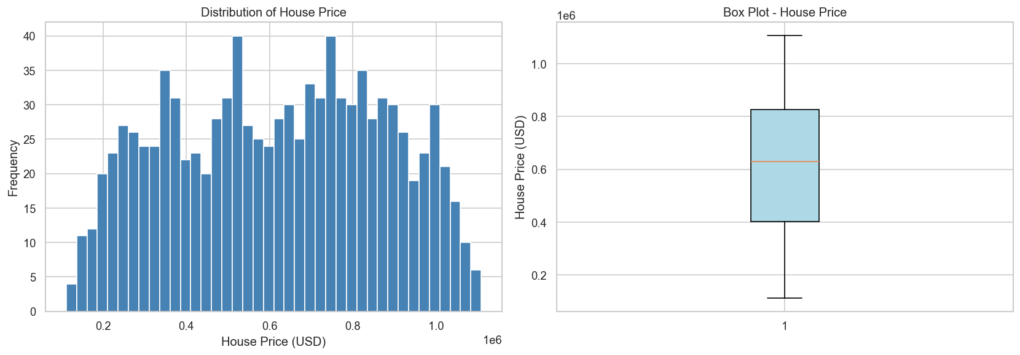
Figure 1: House Price Distribution (Histogram and Box Plot)
Finding: House prices are approximately normally distributed, ranging from $111,627 to $1,108,237 with a mean of $618,861.

7.2 Square Footage vs House Price
The scatter plot reveals a near-perfect positive linear relationship between Square_Footage and House_Price (Pearson correlation = 0.991). This is the single most important finding of the EDA.
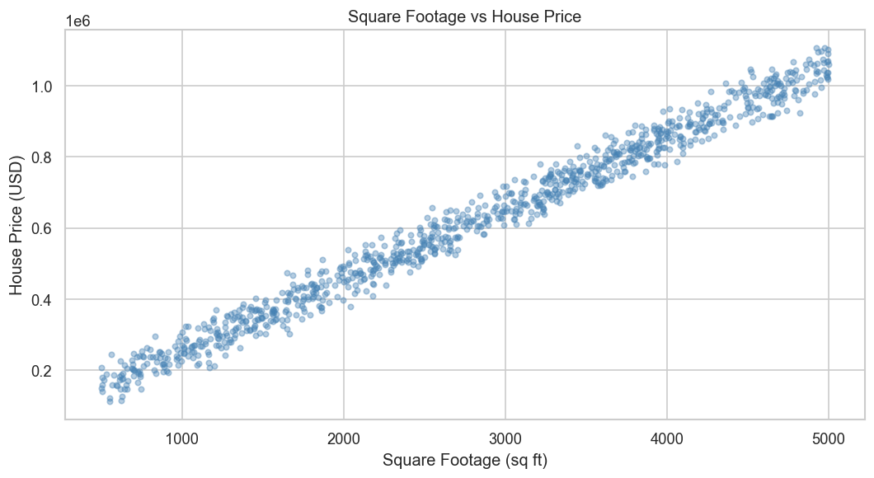
Figure 2: Square Footage vs House Price — Strong Linear Relationship (r = 0.991)

7.3 Feature Correlation Heatmap
Square_Footage dominates with r=0.99. Lot_Size (0.16), Garage_Size (0.05), Year_Built (0.05) have weak positive correlations. Num_Bathrooms (-0.002) and Neighborhood_Quality (-0.008) are near-zero.
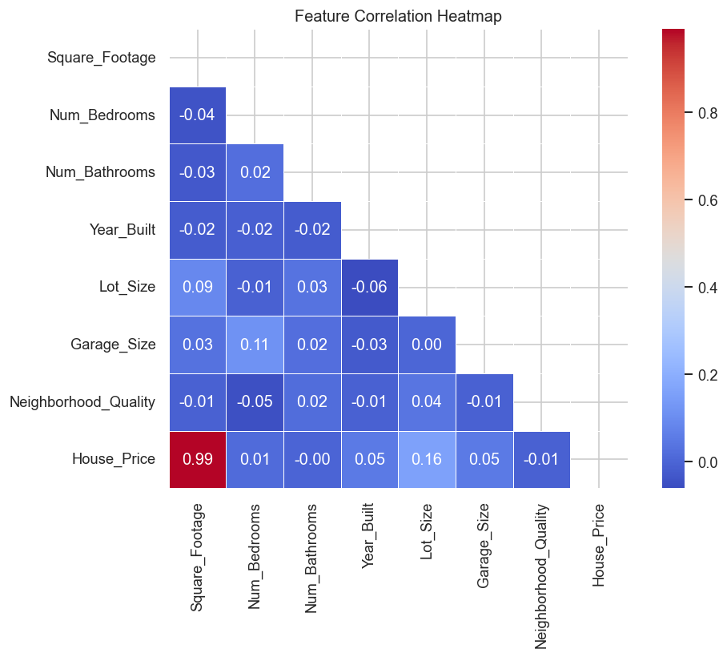
Figure 3: Feature Correlation Heatmap

7.4 Average Price by Bedrooms and Bathrooms
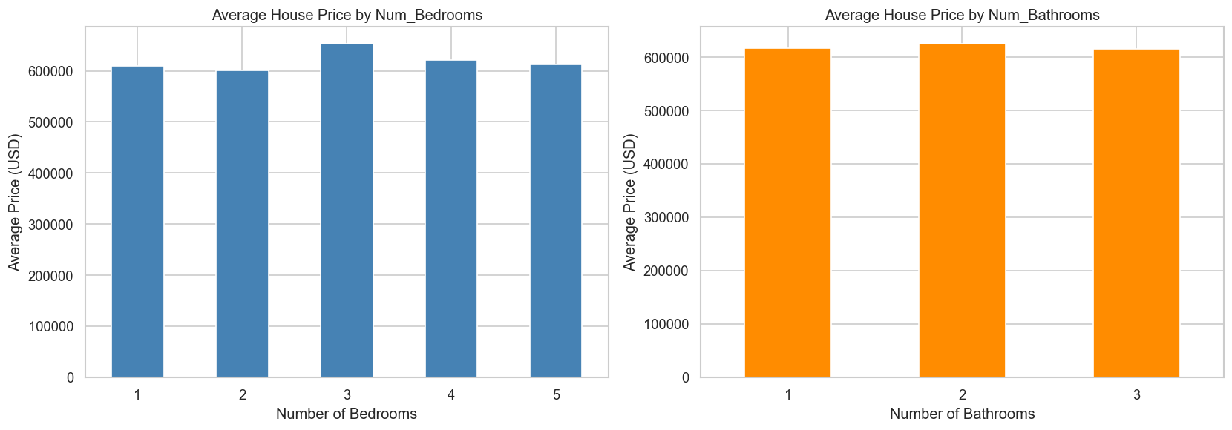
Figure 4: Average Price by Number of Bedrooms and Bathrooms

7.5 Average Price by Garage Size and Neighborhood Quality
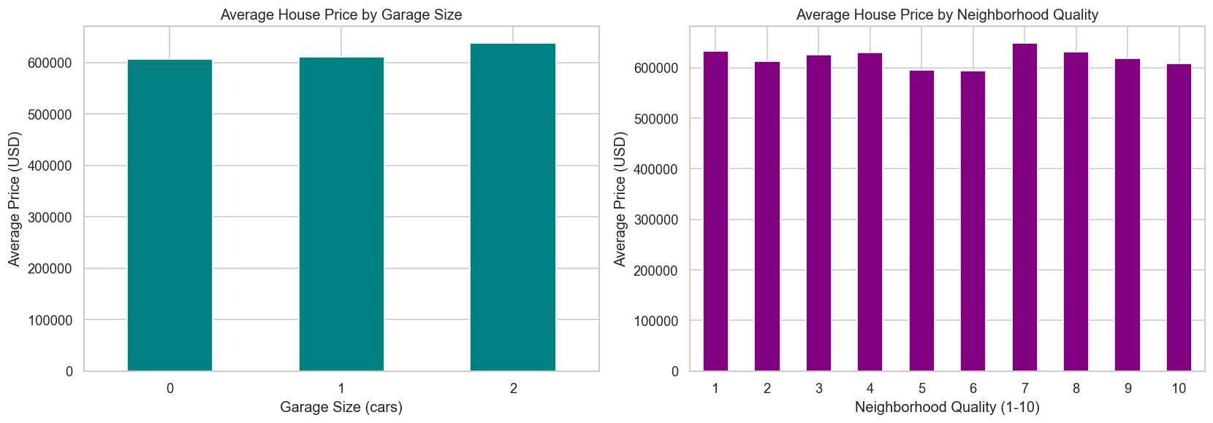
Figure 5: Average Price by Garage Size and Neighborhood Quality

7.6 Feature Distributions
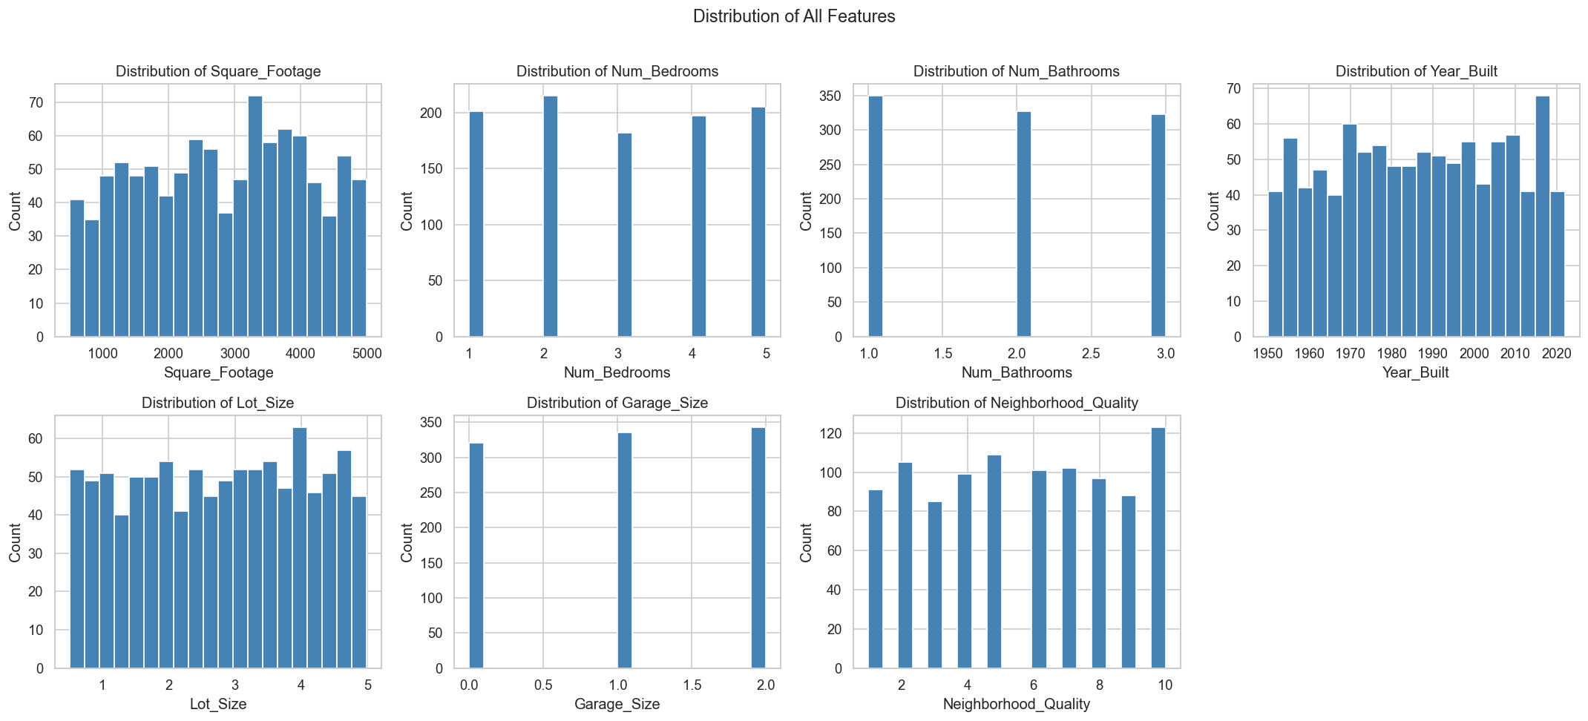
Figure 6: Distribution of All Features

8. Machine Learning Models
Four supervised regression algorithms were trained on 800 samples and tested on 200 samples (80/20 split, random_state=42).

8.1 Linear Regression
Linear Regression models the relationship between features and the target as a linear combination: Price = w1*X1 + w2*X2 + ... + b. It is the simplest and most interpretable model. Due to the near-perfect linear relationship between Square_Footage and House_Price, Linear Regression was expected to perform very well.

8.2 Decision Tree Regressor
A Decision Tree recursively splits data based on feature thresholds to minimise prediction error. It can model non-linear relationships but is prone to overfitting when fully grown (no depth limit applied here). Parameters: random_state=42.

8.3 Random Forest Regressor
Random Forest is an ensemble of 100 decision trees trained on random subsets of data and features (bagging). It reduces overfitting compared to a single tree and provides feature importance scores. Parameters: n_estimators=100, random_state=42.

8.4 Gradient Boosting Regressor
Gradient Boosting builds trees sequentially, each correcting the errors of the previous. It is generally a high-performing model for tabular data. Parameters: n_estimators=100, random_state=42.

9. Model Evaluation
Models are evaluated using three metrics:
• MAE (Mean Absolute Error): Average of absolute differences between actual and predicted prices. Lower is better.
• RMSE (Root Mean Squared Error): Square root of average squared differences. Penalises large errors more. Lower is better.
• R² Score: Proportion of variance in the target explained by the model. Closer to 1.0 is better.

10. Model Comparison
Model | MAE ($) | RMSE ($) | R² Score
Linear Regression (BEST) | 8,174.58 | 10,071.48 | 0.9984
Gradient Boosting | 12,305.22 | 14,998.85 | 0.9965
Random Forest | 16,114.29 | 19,852.75 | 0.9939
Decision Tree | 24,084.46 | 31,138.40 | 0.9850
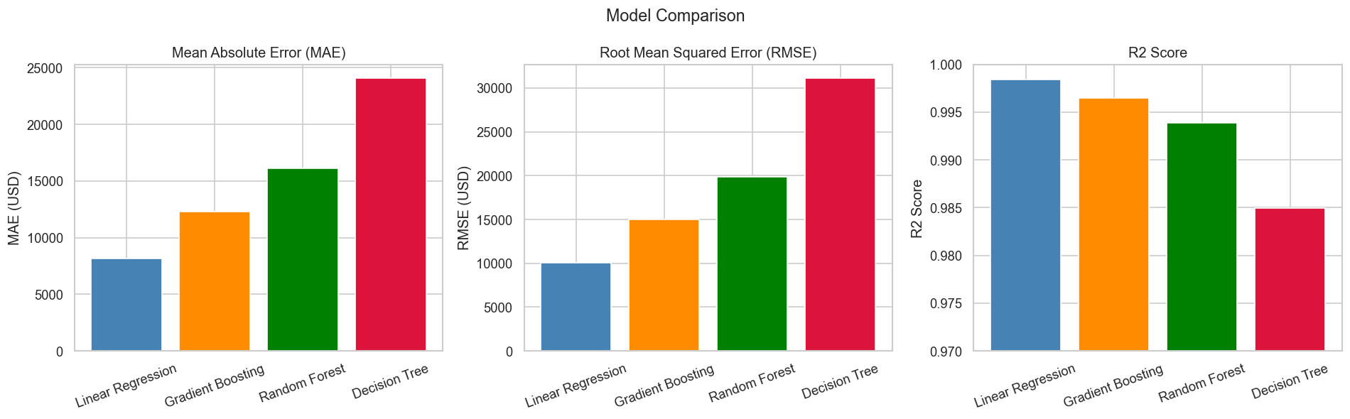
Figure 7: Model Comparison — MAE, RMSE, and R² Score

11. Best Model: Linear Regression
Linear Regression is the best-performing model with R² = 0.9984, meaning it explains 99.84% of variance in house prices. It achieves the lowest MAE of $8,174.58 and RMSE of $10,071.48. This outstanding performance is a direct consequence of the near-perfect linear relationship between Square_Footage (the dominant feature) and House_Price.
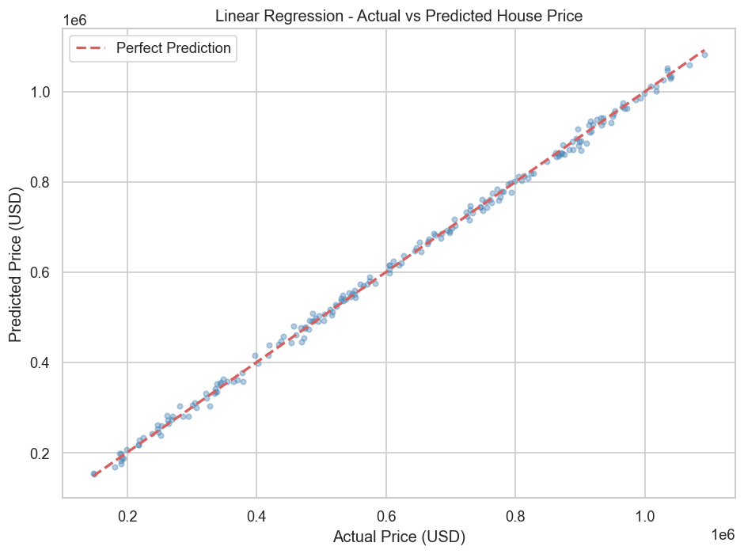
Figure 8: Linear Regression — Actual vs Predicted House Price
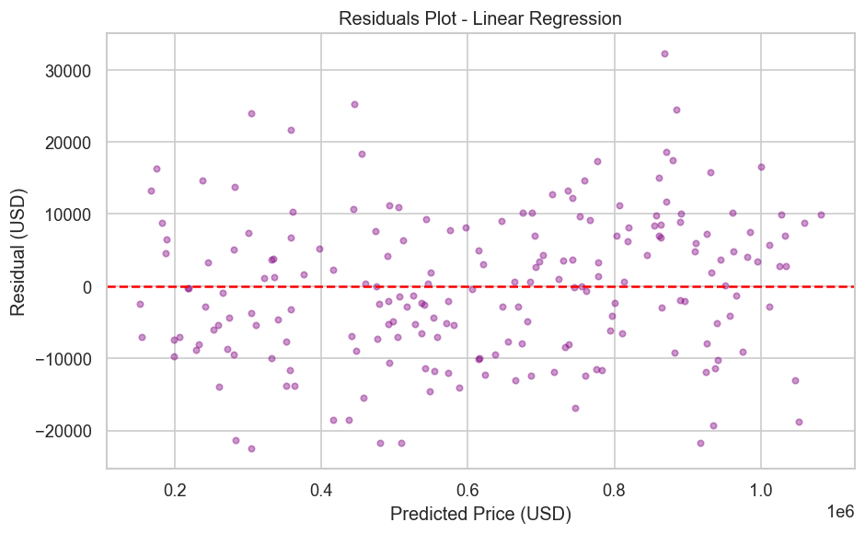
Figure 9: Residuals Plot — Confirming No Systematic Bias

12. Feature Importance
Feature importances from the Random Forest model reveal that Square_Footage accounts for 98.61% of importance. Year_Built (0.54%), Lot_Size (0.51%), Num_Bedrooms (0.17%), Neighborhood_Quality (0.07%), Num_Bathrooms (0.05%), and Garage_Size (0.04%) contribute minimally.
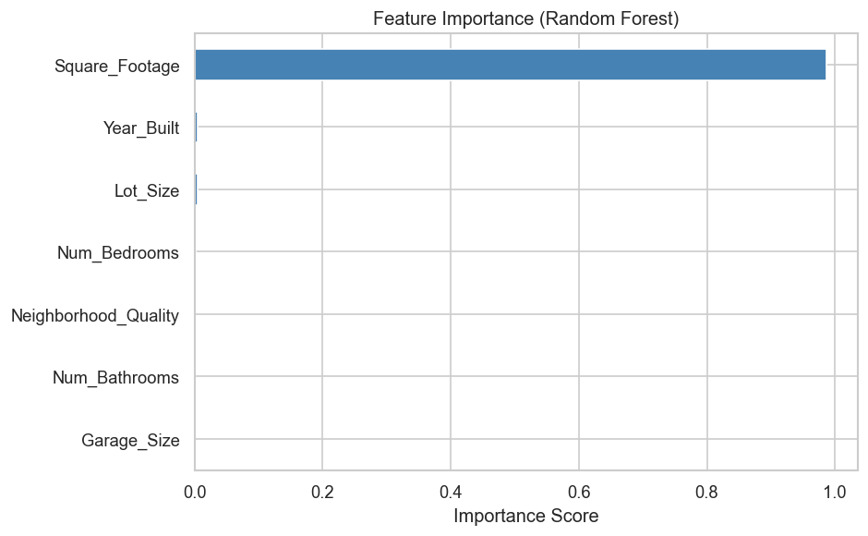
Figure 10: Feature Importance (Random Forest)

13. Final Prediction (Example)
Using the best model (Linear Regression), we predicted the price of a house with the following specifications:
Feature | Value
Square Footage | 3,000 sq ft
Number of Bedrooms | 3
Number of Bathrooms | 2
Year Built | 2005
Lot Size | 2.5 acres
Garage Size | 1 car
Neighborhood Quality | 7 / 10
PREDICTED HOUSE PRICE | ~$647,000 (approx.)

14. Results Summary
• Dataset: 1,000 rows × 8 columns, no missing values, no duplicates.
• Best Model: Linear Regression.
• Best MAE: $8,174.58 — on average, predictions are off by about $8,175.
• Best RMSE: $10,071.48.
• Best R² Score: 0.9984 — 99.84% of variance in house prices is explained by the model.
• Most Important Feature: Square_Footage (correlation = 0.991, importance = 98.61%).

15. Key Findings
1. Square_Footage is the overwhelmingly dominant predictor of house price with a near-perfect linear correlation of 0.991.
2. The dataset is clean — no missing values, no duplicates, and all values are within plausible real-world ranges.
3. House prices are approximately normally distributed ($112K–$1.1M, mean $619K).
4. Linear Regression outperforms all other models on this dataset due to the strong linear structure of the data.
5. All four models achieve R² > 0.98, confirming the features are highly predictive.
6. Neighborhood_Quality, Num_Bathrooms, and Garage_Size contribute negligibly to price prediction individually.

16. Advantages
• The model achieves exceptional accuracy (R² = 0.9984) on this dataset.
• Linear Regression is highly interpretable — coefficients directly show the impact of each feature on price.
• The complete pipeline is fast and runs efficiently even on low-end hardware.
• No complex preprocessing (no scaling, no encoding) was needed.
• The code is beginner-friendly, well-documented, and reproducible.

17. Limitations
• The dataset does not include location/city data, which is a critical factor in real-world house pricing.
• Only 1,000 records are present — a larger dataset would improve generalisation.
• The near-perfect dominance of Square_Footage suggests the dataset may be synthetically generated, limiting real-world applicability.
• External economic factors (inflation, interest rates, market trends) are not captured in the features.
• No hyperparameter tuning (GridSearchCV) was performed for tree-based models.

18. Future Scope
• Include geographic features (city, zip code, proximity to schools/amenities) using real-world datasets.
• Apply hyperparameter tuning (GridSearchCV / RandomizedSearchCV) to improve ensemble model performance.
• Experiment with advanced models such as XGBoost, LightGBM, or neural networks.
• Deploy the best model as a web application using Flask or Streamlit for real-time predictions.
• Incorporate time-series analysis to predict price trends over time.

19. Conclusion
This project successfully demonstrates the application of data analytics and machine learning to predict house prices. Starting from raw data exploration to final predictions, every step was implemented in Python using industry-standard tools.
Among the four models evaluated, Linear Regression emerged as the best performer with an outstanding R² of 0.9984. This was largely driven by the near-perfect linear relationship between Square_Footage and House_Price. The project confirms that even a simple, interpretable model can outperform complex ensemble methods when the data exhibits a strong linear structure.
The project is a solid foundation for more advanced real-world applications involving richer datasets and deployment-ready prediction systems.

20. References
[1] Pedregosa et al., Scikit-learn: Machine Learning in Python, JMLR 12, pp. 2825–2830, 2011.
[2] Pandas Development Team, pandas: Python Data Analysis Library, https://pandas.pydata.org
[3] Hunter J.D., Matplotlib: A 2D Graphics Environment, Computing in Science & Engineering, 9(3), 2007.
[4] Waskom M., seaborn: statistical data visualization, Journal of Open Source Software, 6(60), 3021, 2021.
[5] Dataset Source: house_price_regression_dataset.csv (provided as part of this project). No external URL available.

