Man Hin Kwong 31/5/2020

Bachelor of Creative Software
CS102
Portfolio Website

Contents
IDD
Purpose 2
Features 2
Sitemap 2
Wireframes 3

Report
Screen Shots 4
Header Bar 8
Portfolio Items 9
Contact Form 10
Hosting Link 12

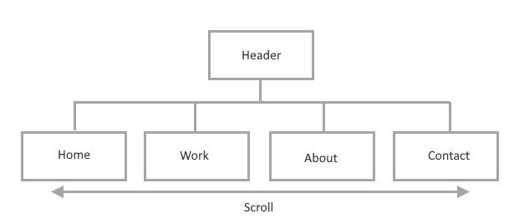
Purpose
The purpose of this site is to display my abilities and past work to the public and allow interested parties to contact me.

Features
The website should fit all screen sizes. To enable this the header will contract into a hambuger menu when the screen is small and the portfolio items will rearrange them selves into an appropriate sized grid. This will prevent the need for horizontal scrolling.
The porfolio items may be clicked on for a fullscreen view.
The site will be single page with the header links taking the user to the linked section as per requirements.
A contact form which allows the user to send a message after input validation via email as per requirement.

Sitemap

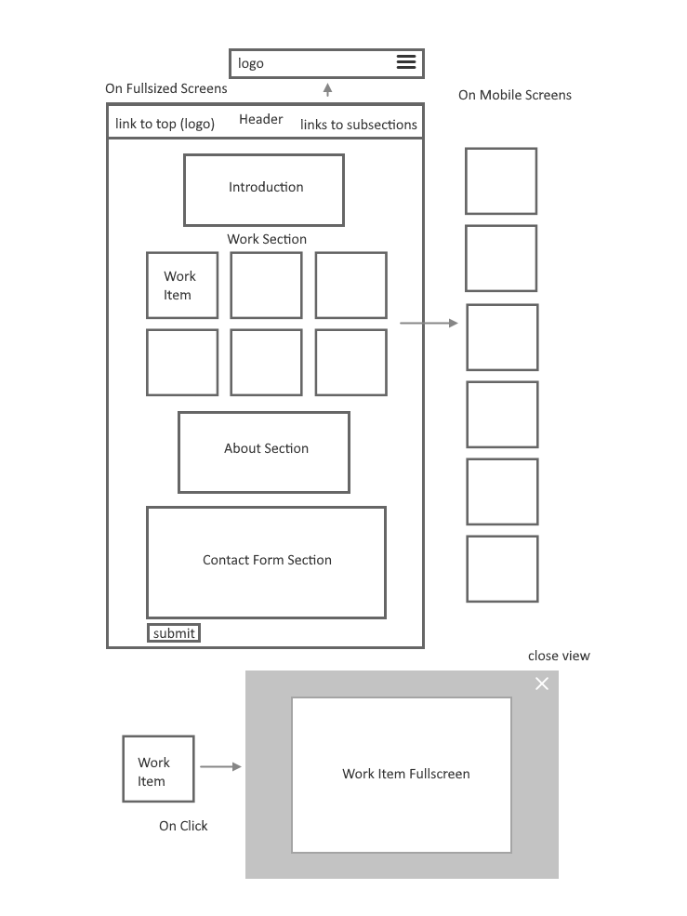
Wireframes
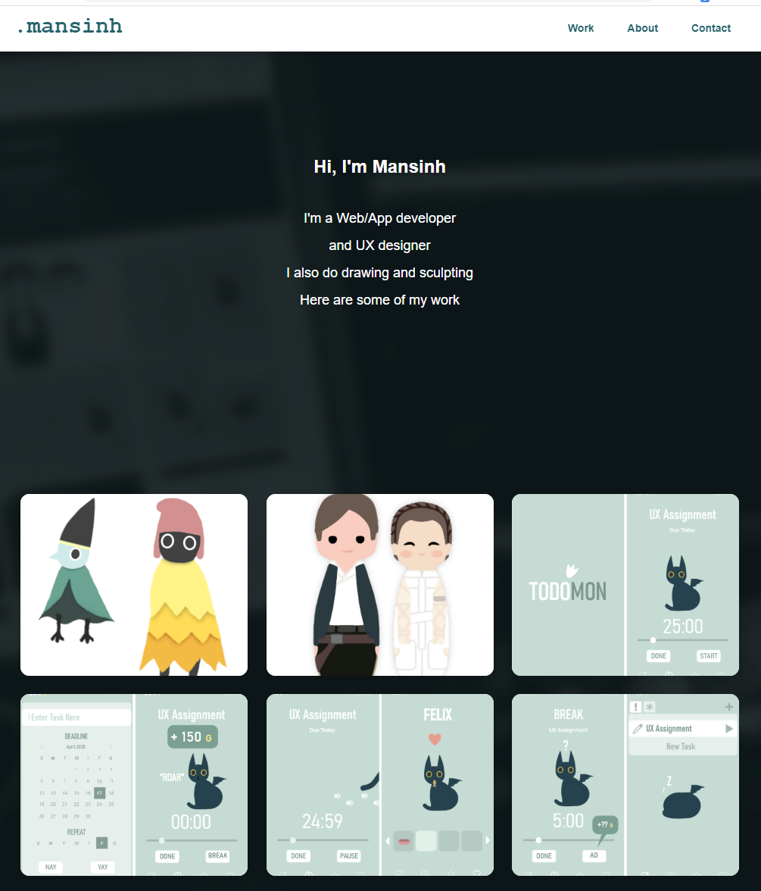
Screenshots

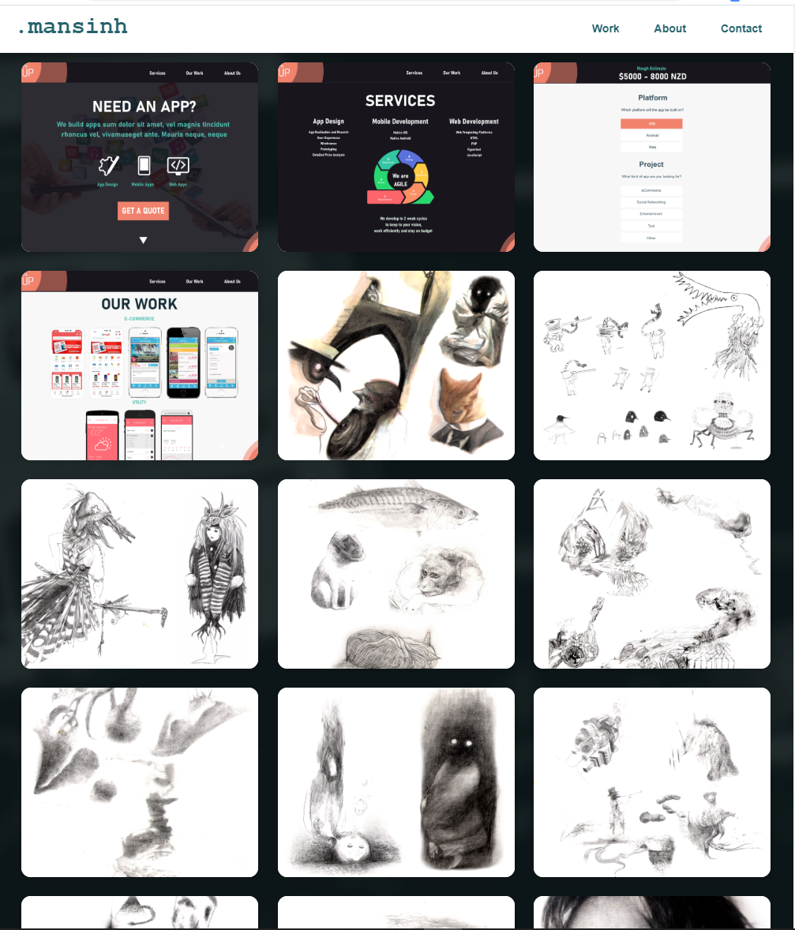

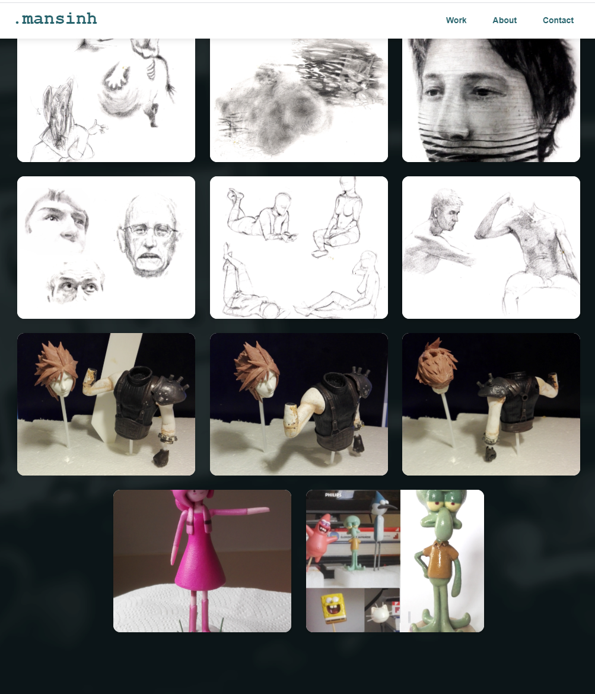

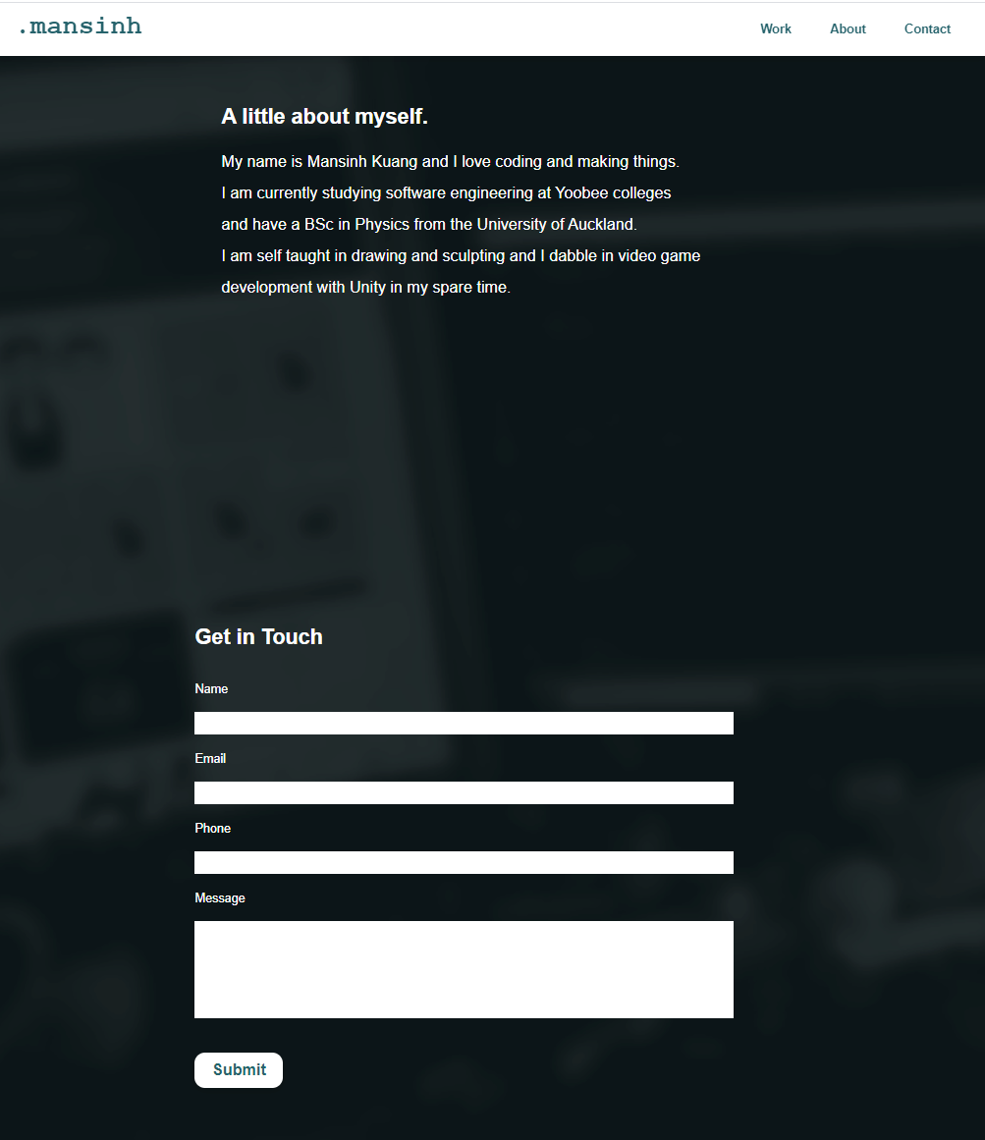


Header Bar
-If the screen is below 1000px, hide the full header and replace with hamburger menu

@media screen and (max-width: 1000px){
...display: none;

-If the window is resized above 1000, show the contracted header

window.onresize = function(){headerVisible()}
function headerVisible(){
if($(window).width() > 1000){
$("#header").show();
}
}
-On clicking the hamburger icon, show the full header

function inflateHeader(){
if($("#header").is(":visible")){
$("#header").fadeOut(300);
}
else{
$("#header").fadeIn(300);
}
}
function closeHeader(){
if($("#header").is(":visible") & $(window).width() < 800){
console.log("visible");
$("#header").fadeOut(300);
}
}

-Keep the header on the top of the page at all times

top: 0;
left: 0;
position:fixed;
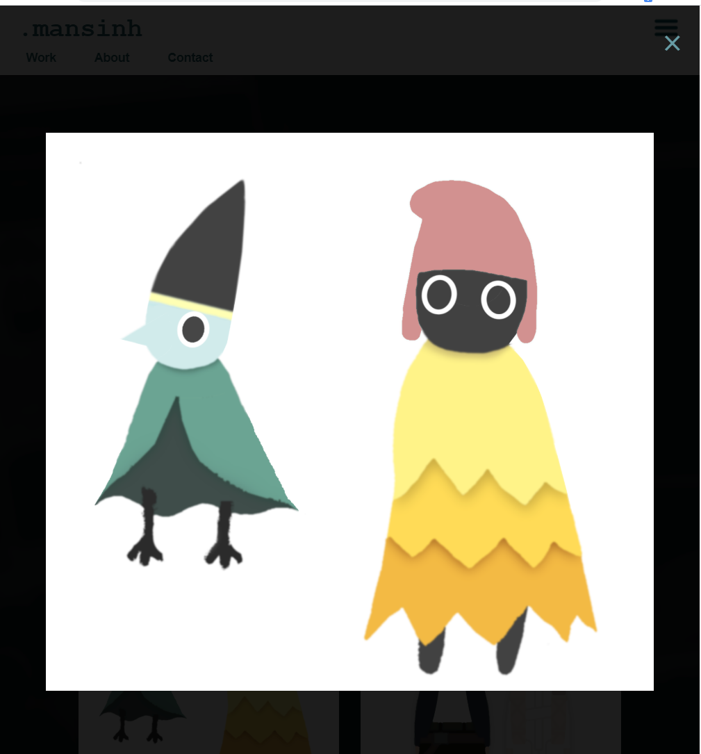
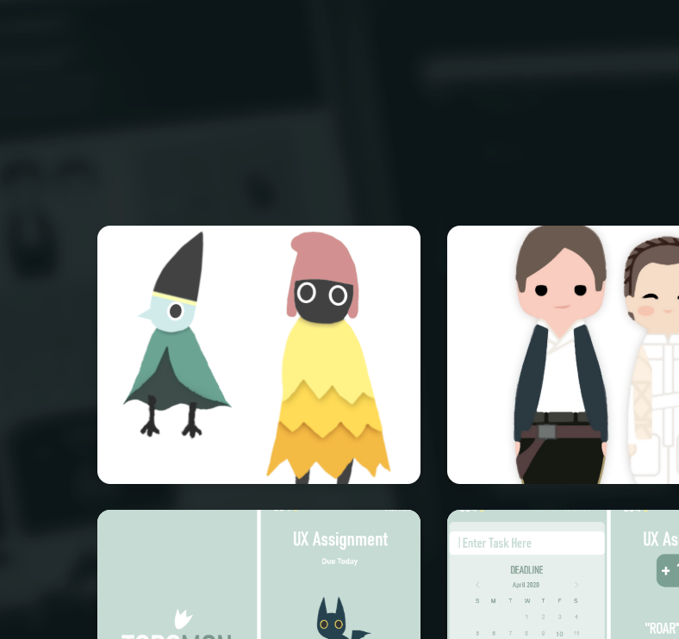
Portfolio Items

-Enlarge porfolio item to fullscreen when clicked

var enlarged = $("#enlarged");
var enlargedImg = $("#enlarged_img");

function onImgClicked(_src){
$("#enlarged").fadeIn(200);
document.getElementById("enlarged_img").src = _src;
}

-Close fullscreen view when close button clicked

function closeEnlarged(){
$("#enlarged").fadeOut(200);
}
-Show user the item is clickable with cursor

cursor:pointer;

-Arrange items into a grid fitting to the size of the screen

flex-wrap: wrap;

Contact Form

-Name validation: Non-empty, letters only. Show error message when failed.

if(name == ""){
document.getElementById('nameError').innerHTML = '*please enter your name';
valid = false;

}
else{
if(/^[A-Za-z]+$/.test(name)){
document.getElementById('nameError').innerHTML = '';

}
else{
document.getElementById('nameError').innerHTML = '*please enter letters only';
valid = false;
}
}

-Email validation: Non-empty, of structure /^([A-Za-z0-9_\-\.])+\@([A-Za-z0-9_\-\.])+\.([A-Za-z] {2,3}.Show error message when failed.

if(email == ""){
document.getElementById('emailError').innerHTML = '*please enter your email';
valid = false;
}
else{
if( /^([A-Za-z0-9_\-\.])+\@([A-Za-z0-9_\-\.])+\.([A-Za-z]{2,3})$/.test(email)){
document.getElementById('emailError').innerHTML = '';

}
else{
document.getElementById('emailError').innerHTML = '*please enter a valid email';
valid = false;
}
}

-Phone number validation: Non-empty, minimum 7 for landline, maximum 15 for international.
Show error message when failed.

if(phone == ""){
document.getElementById('phoneError').innerHTML = '*please enter your phone number';
valid = false;
}
else{

if(phone.length<=15 && phone.length>=7){
document.getElementById('phoneError').innerHTML = '';

}
else{
document.getElementById('phoneError').innerHTML = '*please enter a valid phone number';
valid = false;
}
}

-Message Validation:Non-empty. Show error message when failed.

if(message == ""){
document.getElementById('messageError').innerHTML = '*please enter a message';
valid = false;
}
else{
document.getElementById('messageError').innerHTML = '';
}

-If Valid send message to email client

if(valid){

var body = 'name: '+name+'\n'+'email: '+email+'\n'+'phone: '+phone+'\n\n'+message+'\n\n\n\n';

window.open('mailto:manhkwong@gmail.com?subject=folio message&body='+encodeURIComponent(body))
}
}
Hosting URL:
https://mansinh-d25ff.web.app

