**Vault folder creation**

Author



Dibya Ranjan Mohanty

We should ensure that at any instance, there should be at least two writable vault folders. We should create two more writable vault folders when the no. of writable vault folders becomes two.

As we can see in the below screen shot, there are exactly two writable vault folders left.

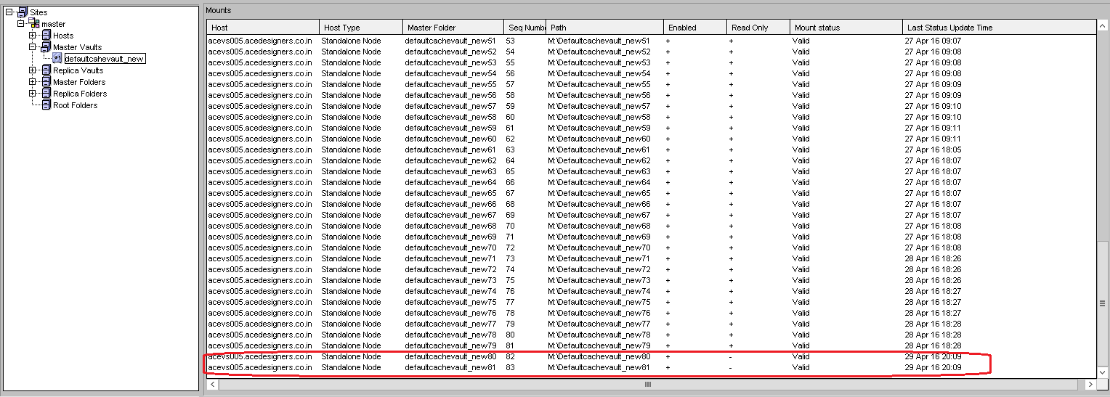

First create the folders Defaultcachevault_new82 and Defaultcachevault_new83 (the new vault folders should follow the naming sequence of the existing vault folders) in M: drive (vault folders are created in M: drive for ACE).

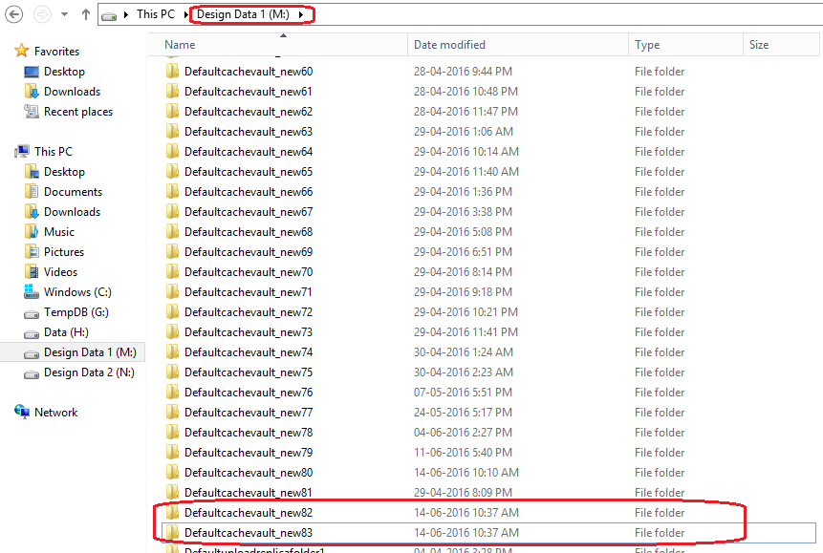

The next step is to create the vault folders in vault configuration tool.

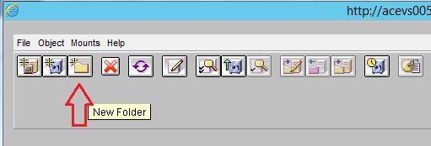

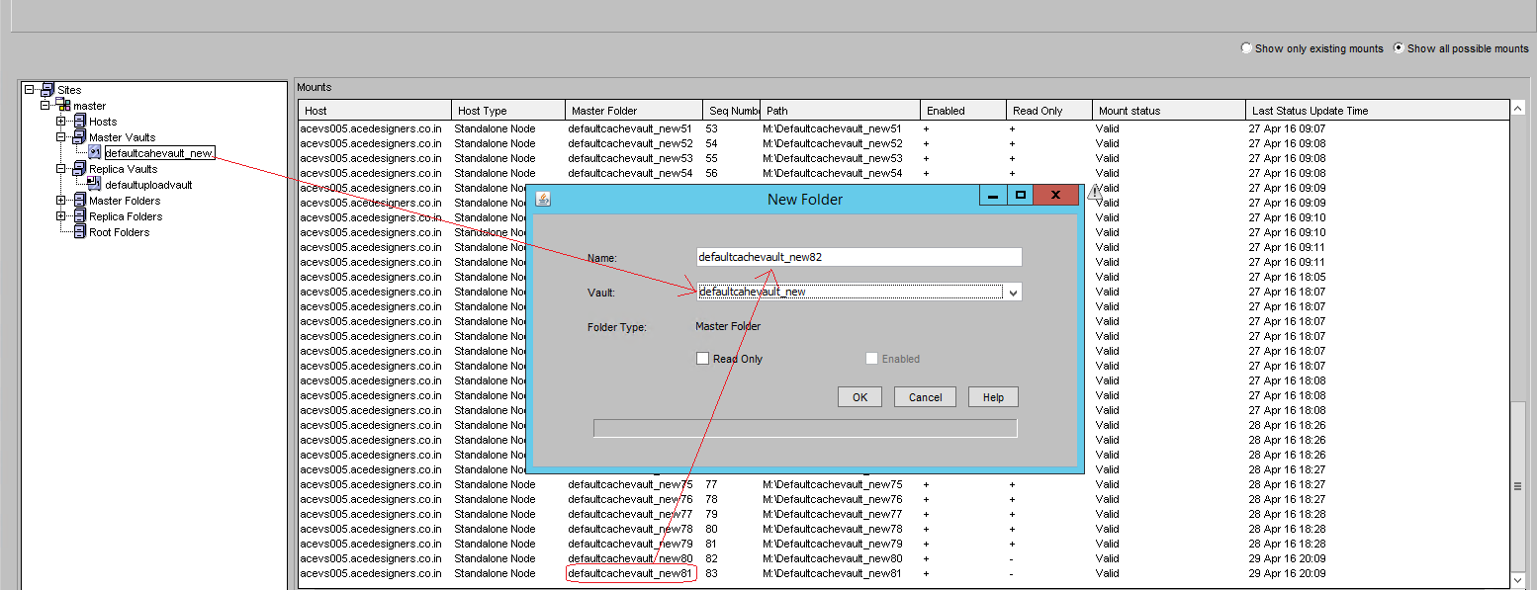

The name of the new master folder should follow the naming convention of the existing master folders. Also, please carefully select the vault (defaultcahevault_new in this case) in the drop-down menu.

In the below screen shot, two new master folders have been newly created.

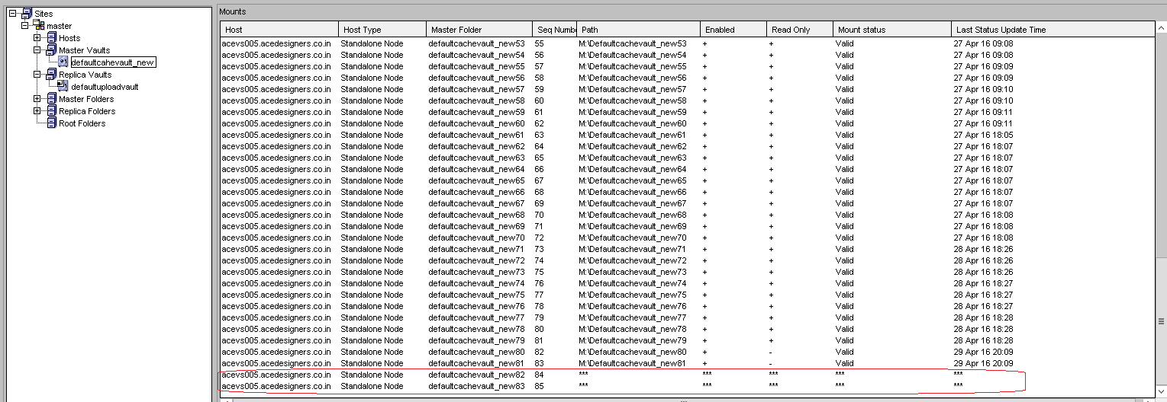

The next step is to map them to the physical folder location (previously created in M: drive), enable them and validate their mount status.

Expand the Master Folders

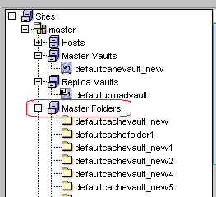

And click in the newly created folder on left side panel. Then double click on the folder on the right side panel to get the prompt to enter folder path.

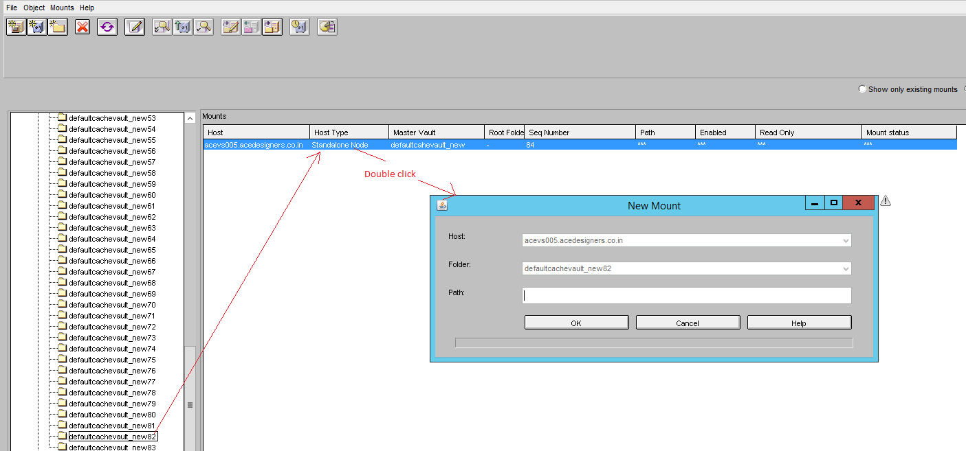

Provide the folder path as shown below and click OK.

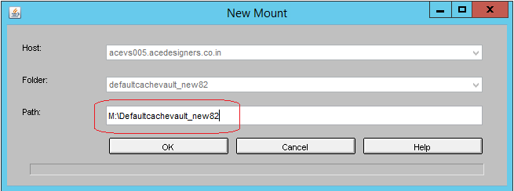

Now path will start appearing as shown below.



Now, once again click on the newly created folder to select it and then click on Object menu on top left. We need to validate the mount of the folder from this menu.

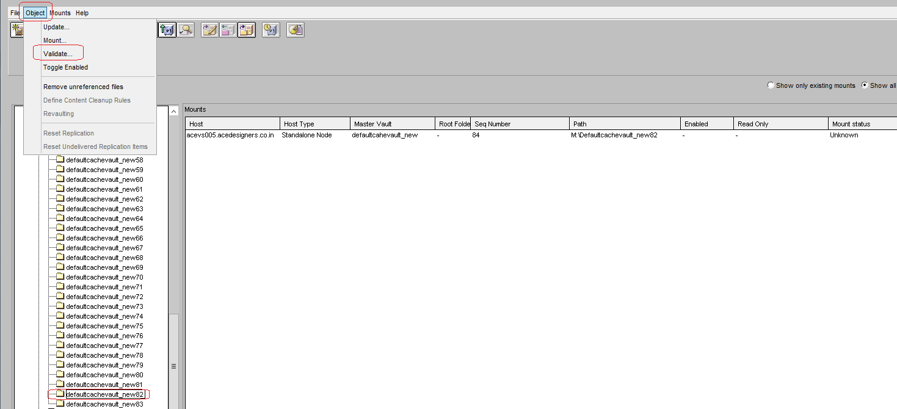

On clicking validate, a confirmation prompt should appear as shown below.

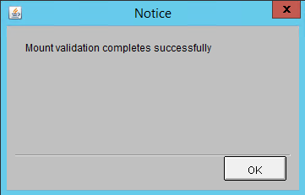

Then double click on the newly created folder to enable it as shown below. Click OK.

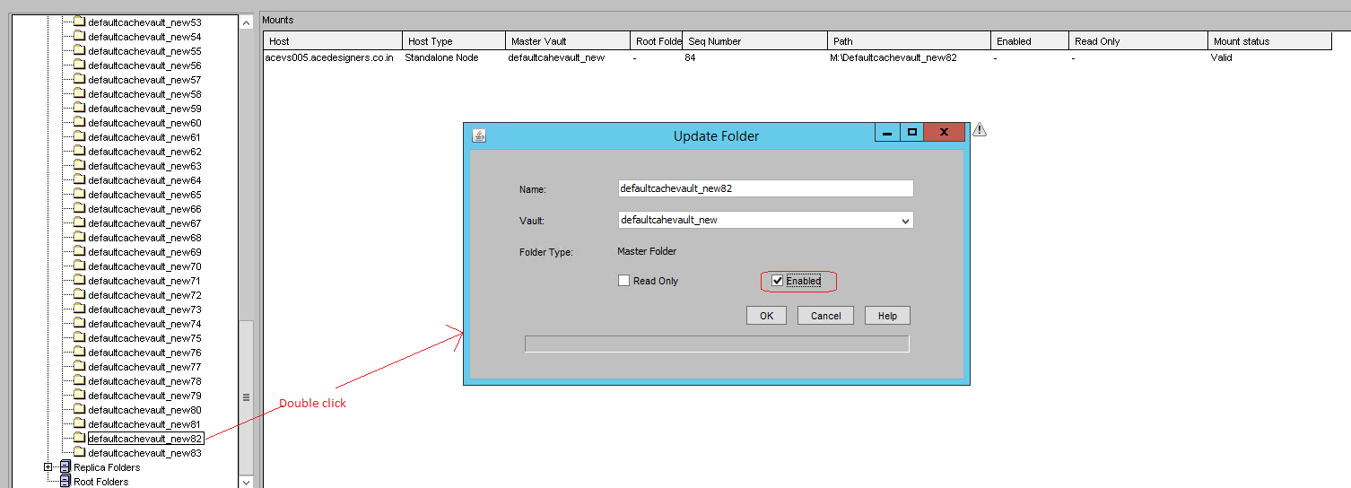

Now the newly created vault folder will be shown as both valid and enabled.



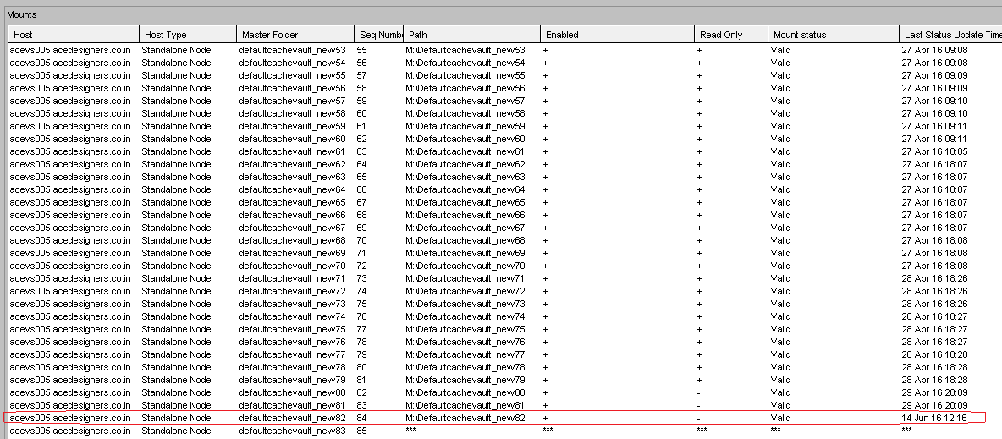

Repeat the procedure for the next new vault folder.