**MVC Table Builder**

MVC -Model–view–controller (**MVC**) is a software architectural pattern for implementing user interfaces. The Model contains Java code i.e the logic, View contains the UI i.e what is visible to the user while the controller contains the linking part where model and view are connected.

To start with:

Open Site>Utilities>Preference Management

Change a value to true of Client customization

The basic steps will be

Extend AbstractComponentBuilder

–Annotate it with @ComponentBuilder

–Provide the ComponentConfig

–Provide the Data

–Compile the class and restart the MethodServer

1.Register the package in custom.xml

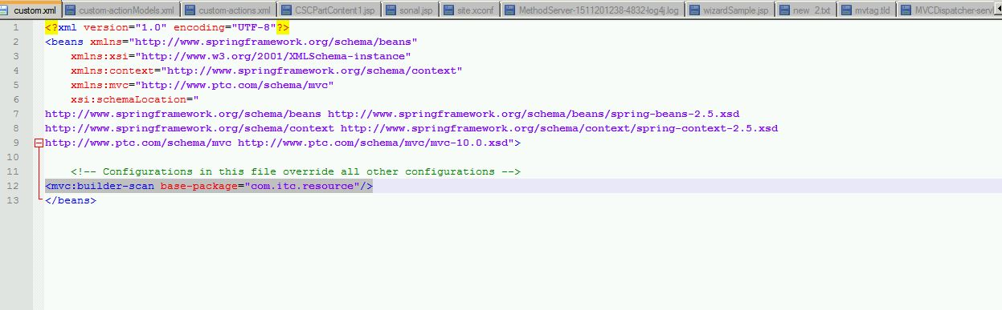

2. Add new action model and action

* 1. Create custom-actionmodels.xml

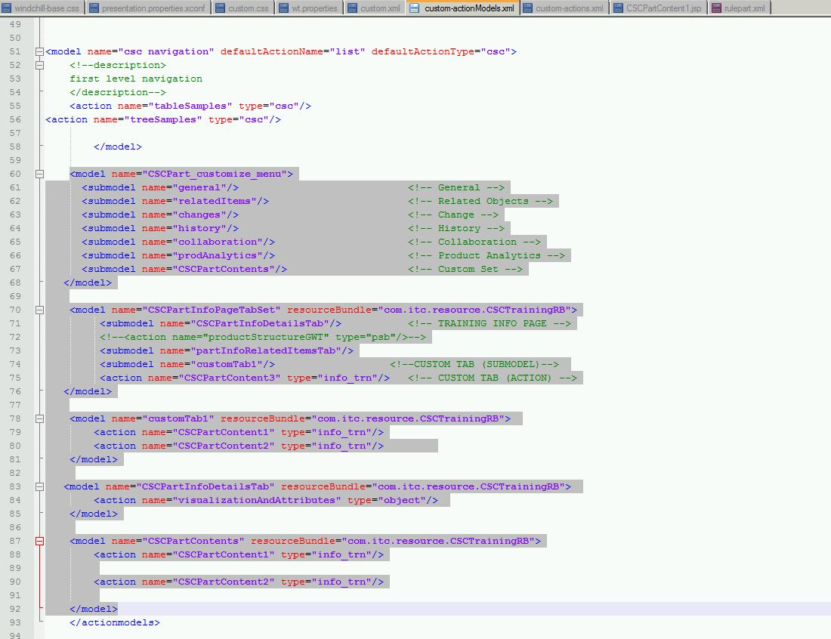

* 1. Create custom-actions.xml

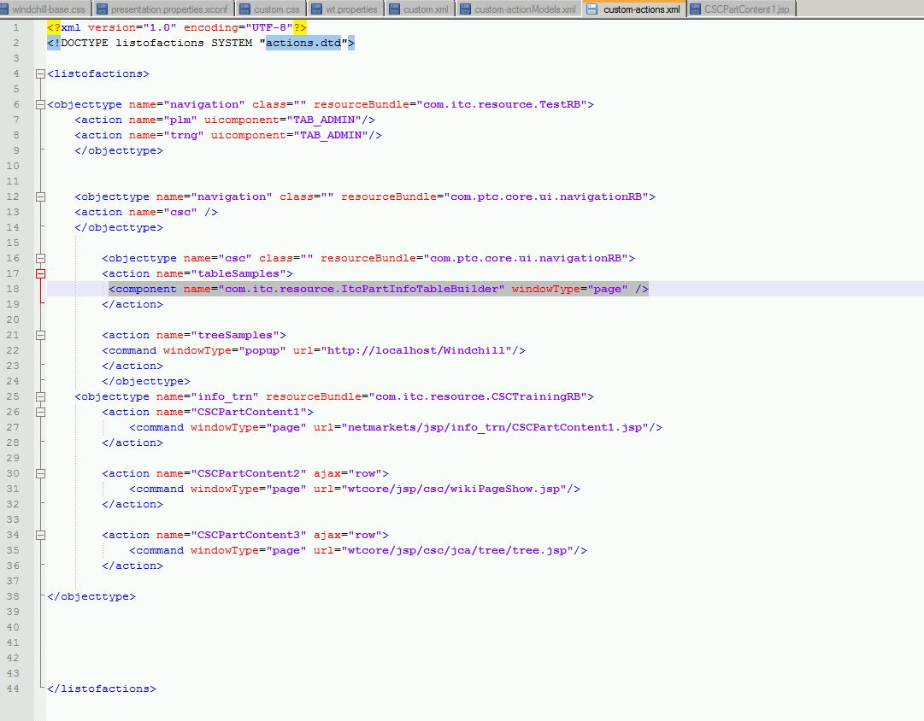

1. Create a java class ItcPartInfoTableBuilder which will fetch all the parts created and will show in the table :

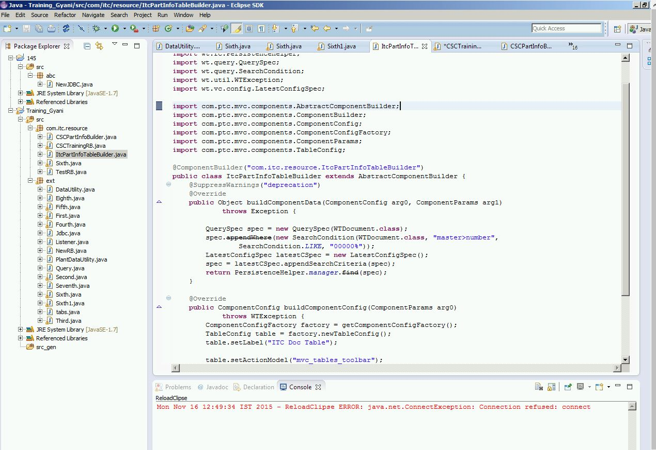

1. The output of the codes are as:

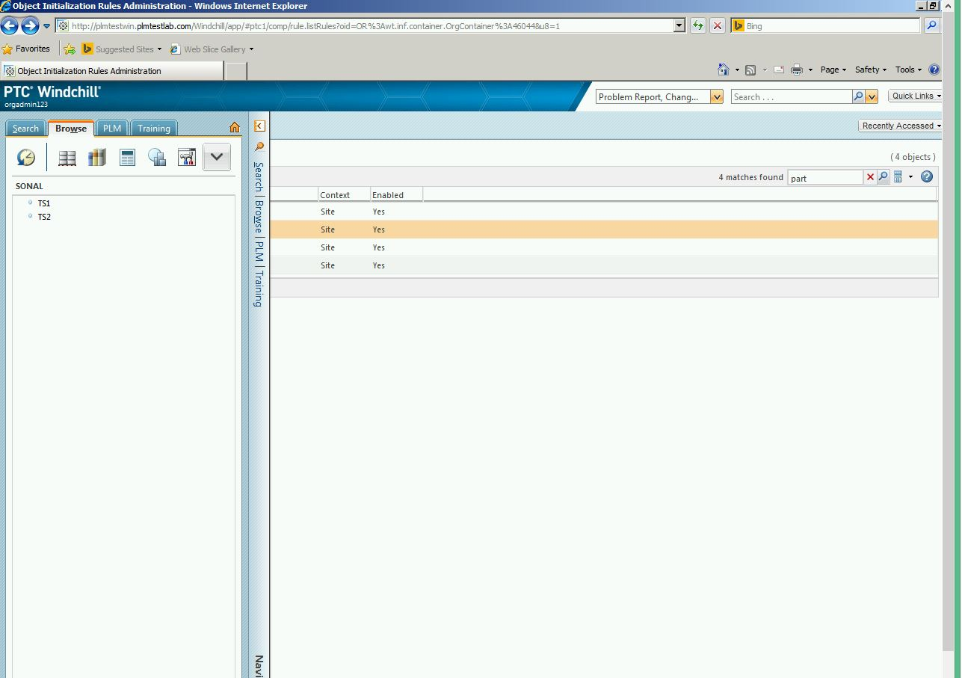

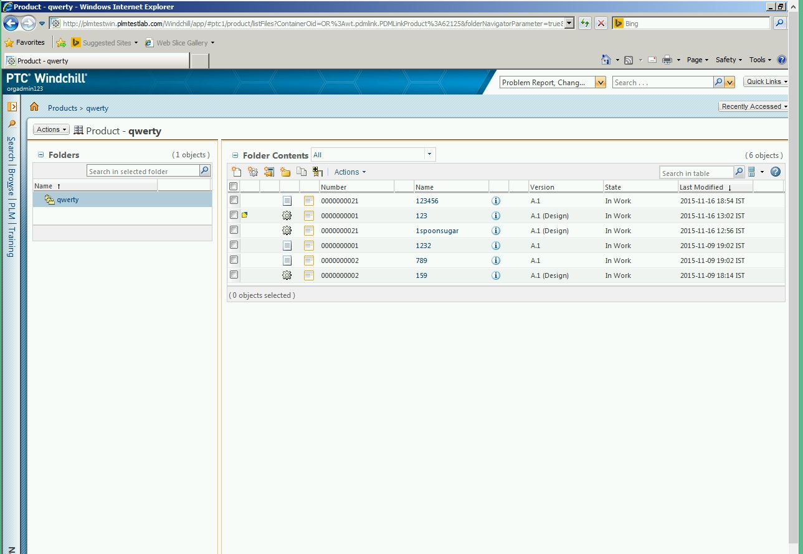

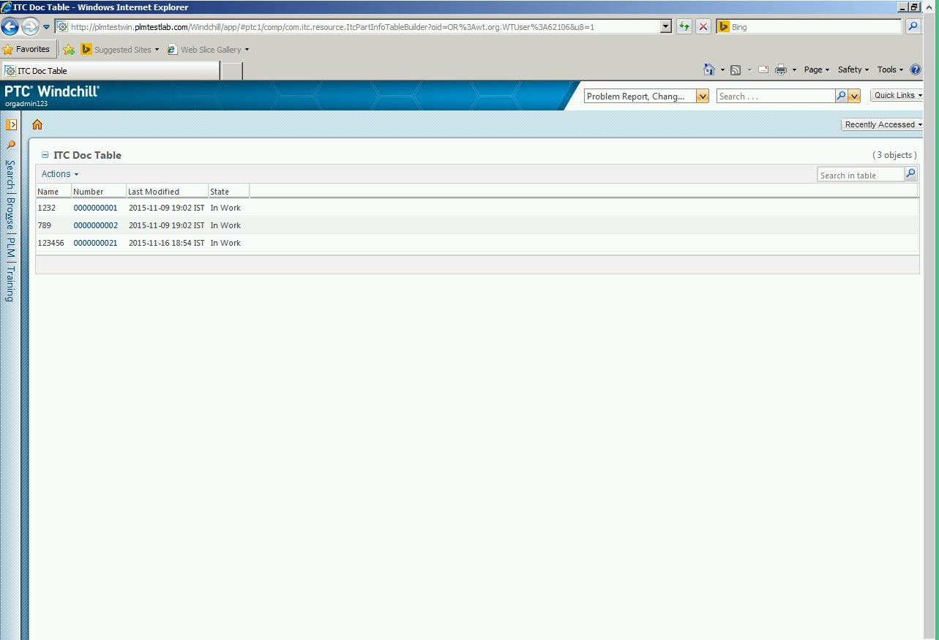

The files used are embedded as follows:

