TA Trip Tracker Groups
Dashboard should give an overview of the groups that are currently booked.
Groups are similar to the regular trips but the difference is that many people are going on the same trip. So all of the deposit date, final payment date, amount, Trip Name, etc. are all the same. The only difference is traveler names, airports and room/cabin type and the cost per trip.

Need:
- Overall, dashboard that gives a snapshot of all groups
- Group Dashboard specific to that group
- Group Input (New group)
- Add traveler to group
- Tasks & workflow are similar to trips but need ability to send emails to everyone within a group

Royal Caribbean Oasis OTS 6/1/26 – 6/8/26
Eastern Caribbean
Deposit due by 3/1/26, Deposit Amount $250 pp, Final Payment due by 4/1/26
Total Balcony Cabins – 10 @ $3000 each
Total Interior Cabins – 5 @ $2000 each
Total Revenue - $40,000

Mary Smith – Balcony, Cabin #456, ATL, $3000
John Jones – Interior, Cabin #778, NYC, $1000
Amanda Williams – Balcony, Cabin #879, DAY, $3000

Groups Dashboard – Shows ALL Groups
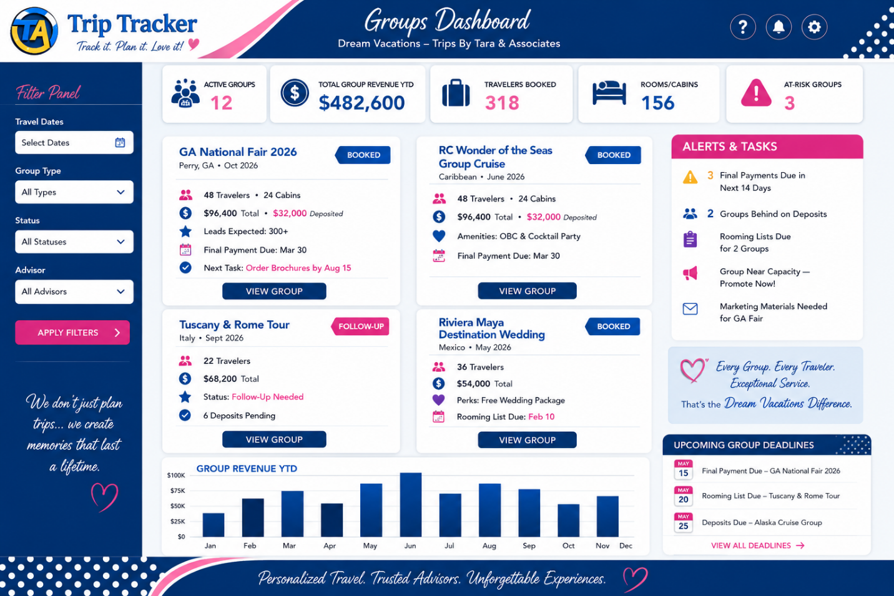

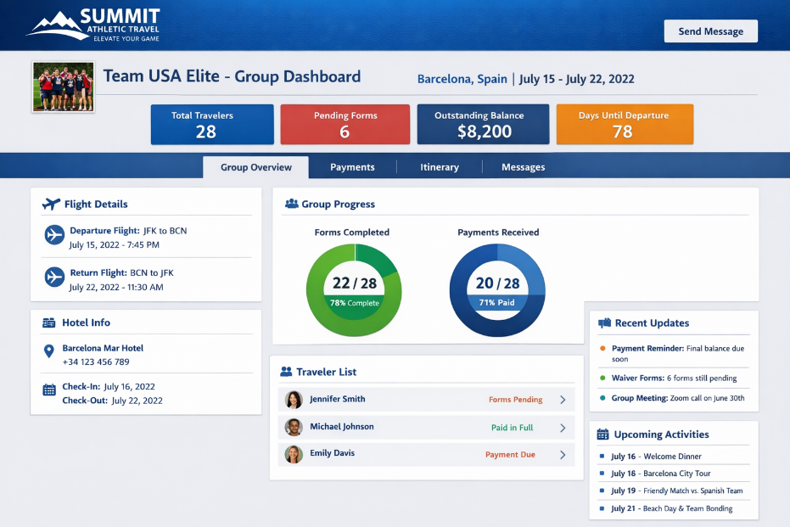
OR

Group Dashboard for XYZ Group – shows the details just for the group name.
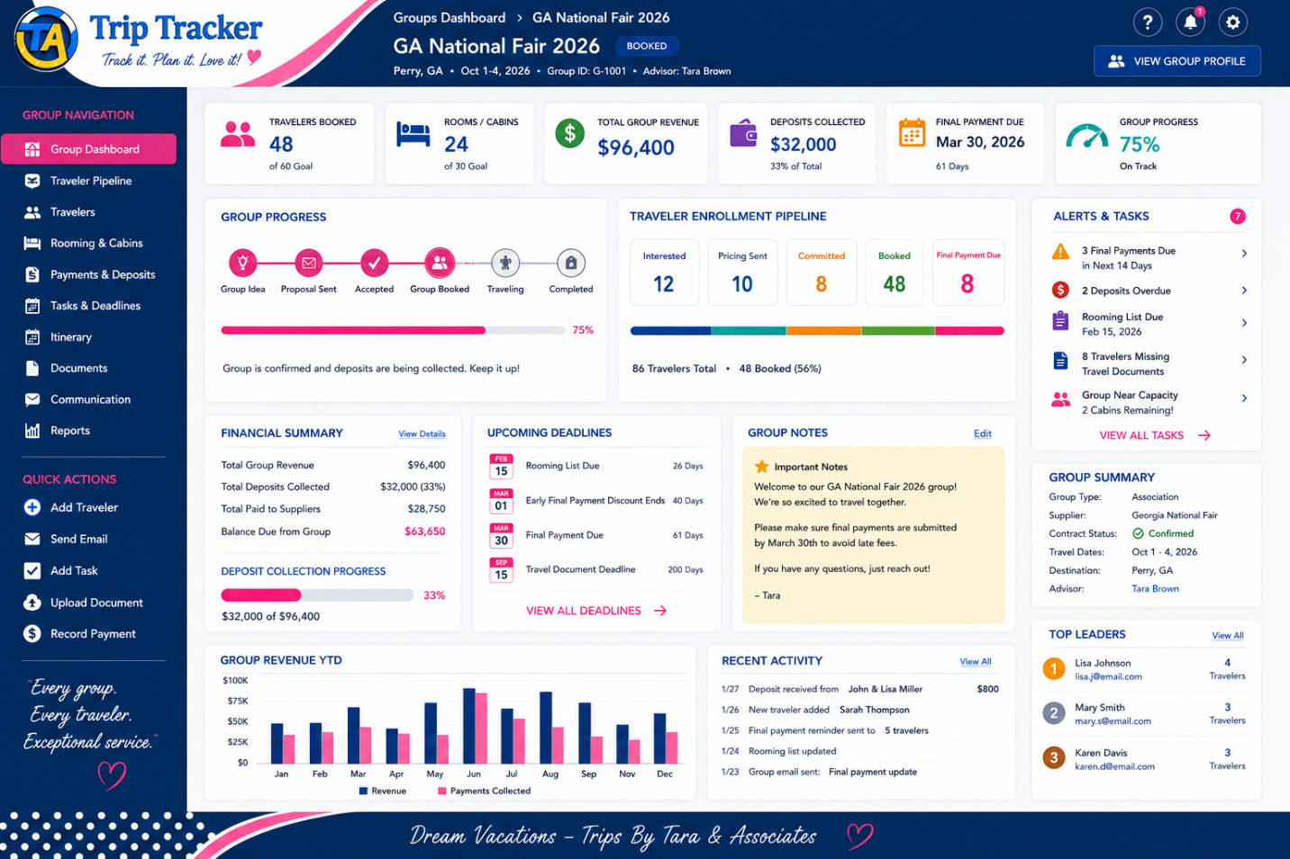
_______________________________
Groups Pipeline/Workflow – This is for the Group Itself not bookings within in the groups or travelers.
Pre-Booked Groups
1. Group Request
2. Group Proposal
3. Group Modification
4. Group Accepted
5. Group Boooked

Booked Groups
- Group Booked
- Final Payment
- Group Review
- Group Bon Voyage

Group Travel
- Group Traveling
- Group Welcome Home
- Group 6 Month Follow-Up
- Group 1 year Follow-Up

Archived Groups – Groups By year

Special Statuses
- Lost Group
- Cancelled Group
- On Hold
- Future Groups

Trips within the Group – this will be the actual bookings with traveler names
Group Bookings
- Interested (This is where a completed form should go.)
- Pricing Sent
- Committed
- Booked
- Final Payment Due

Group Traveling
- Group Review
- Group Bon Voyage
- Group Traveling
- Group Welcome home
- Group 6 Month Follow-Up
- Group 1 Year Follow-Up

If we could have 2 Progress Status’ show that would be great!
Group Progress
Shows where the group is in the Group Pipeline.
Traveler Progress
Shows how many travelers are in each trip stage.

Groups Module
Screen 1 – Groups Dashboard
(List of all groups)
Screen 2 – Group Dashboard
(Single group record)
Screen 3 – Traveler Pipeline
(Group traveler management)
Screen 4 – Group Travelers
(Traveler roster)
Screen 5 – Rooming & Cabins
Screen 6 – Payments & Deposits

Group Interest Form
Each Group should have its own Group Interest Form, similar to the existing Trip Request Form.
The purpose of this form is to collect interested travelers and move them into the Group Bookings pipeline.
Workflow
- Traveler completes the Group Interest Form.
- A new Group Traveler record is created IF there is no traveler with matching name or email address.
- The traveler is automatically added to the selected Group.
- The traveler is automatically placed in the Interested stage of the Group Bookings pipeline.
- The assigned advisor receives a notification.
Information Collected
The Group Interest Form should be a short form and should only collect:
- First Name
- Last Name
- Email Address
- Phone Number
- Number of Travelers
- Departure Airport if Airfare is needed
- Room/Cabin Preference (it would be great if this information came from the group details about the rooms, etc.)
- Comments or Questions (Notes)

Traveler Information Form – this is a form that should be available everywhere in TA Trip Tracker
Purpose: Collect information needed to identify and book the traveler.
Legal Traveler Information
- Legal First Name
- Legal Middle Name
- Legal Last Name
- Preferred Name/Nickname (optional)
- Date of Birth
- Gender
- Country of Citizenship
Contact Information
- Email Address
- Mobile Phone Number
- Home Phone Number (optional)
Address Information
Mailing Address
- Street Address
- City
- State/Province
- Postal Code
- Country
Is your Physical Address different from your Mailing Address?
- Yes
- No
If Yes:
Physical Address
- Street Address
- City
- State/Province
- Postal Code
- Country
Emergency Contact
- Emergency Contact Name
- Relationship
- Phone Number
- Email Address (optional)
Passport Information
Do you currently have a passport?
- Yes
- No
If Yes:
- Passport Expiration Date
- Passport Issuing Country
- Upload Passport
Loyalty Programs
Allow multiple entries:
- Program Name
- Membership Number
Examples:
- Airline Programs
- Cruise Line Programs
- Hotel Programs
- Tour Operator Programs
- Other Travel Loyalty Programs
Accessibility & Special Requirements
- Mobility Requirements
- Dietary Restrictions
- Accessibility Requirements
- Medical Considerations (optional)
- Additional Special Requests
Additional Notes
- Open text field
System Actions
Upon submission:
- Update Traveler Profile – search for the profile first.
- Save Passport to Documents section
- Save Loyalty Programs to Loyalty Programs tab
- Mark Traveler Information Form as Complete
- Notify Advisor

1. Group Traveler Roster
This may be the biggest one.
Inside a Group Dashboard, what does the traveler list look like?
I would want:
Traveler | Status | Room/Cabin | Amount Due | Final Payment Date | Advisor
With actions:
- View Traveler
- Move Pipeline Stage
- Send Form
- Send Email
- Add Note

2. Group Communications
You mentioned this briefly in your original document.
I would specifically define:
Send Email to:
- Entire Group
- Selected Travelers
- Travelers in a Pipeline Stage
Examples:
- Everyone in Final Payment Due
- Everyone Traveling
- Entire Group
This will become one of the most used features.

3. Group Tasks
You mentioned workflow but I'd make sure it's defined.
Group-Level Tasks
Examples:
- Send Final Payment Reminder
- Collect Rooming List
- Order Group Amenity
- Send Travel Documents
vs
Traveler-Level Tasks
Examples:
- Collect Deposit
- Passport Missing
- Final Payment Due

4. Documents
This is a big one.
Group Documents
Stored once:
- Supplier Contract
- Marketing Flyer
- Amenity Agreement
- Rooming List
- Final Documents
Traveler Documents
Stored per traveler:
- Passport
- Insurance Waiver
- Visa
- Other Documents

5. Rooming/Cabin Assignments
I think this is probably missing from what we've discussed.
For cruises:
Cabin # | Category | Occupancy
8240 | Balcony | Mary / Susan
For land groups:
Room # | Room Type | Occupancy
This will matter later.

6. Group Financial Summary
I would definitely have this on the Group Dashboard.
Group Totals
- Total Revenue
- Deposits Collected
- Outstanding Deposits
- Final Payments Outstanding
- Travelers Booked
- Rooms/Cabins Booked

7. Group Settings
A hidden section most users never see.
Examples:
- Assigned Advisor
- Supplier
- Group Type
- Travel Dates
- Deposit Date
- Final Payment Date
- Auto Reminder Settings

8. Group Status
This is the one thing I haven't heard you mention.
Do you want:
- Active
- Completed
- Cancelled
- On Hold
or will pipeline stages handle this?
Personally I'd still have a Status field separate from the pipeline.

The one feature I'd add if I could only add one
Group Capacity Tracking
For example:
Greek Isles Ladies Group
- Capacity: 40 Travelers
- Booked: 27
- Remaining: 13
or
Alaska Cruise Group
- Contracted Cabins: 20
- Booked Cabins: 16
- Remaining Cabins: 4

