**NON AI:AND NON AI:**

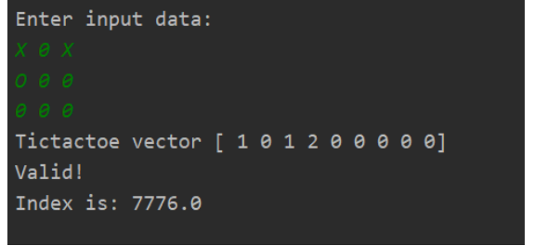

**SIMPLE HILL CLIMBING:**

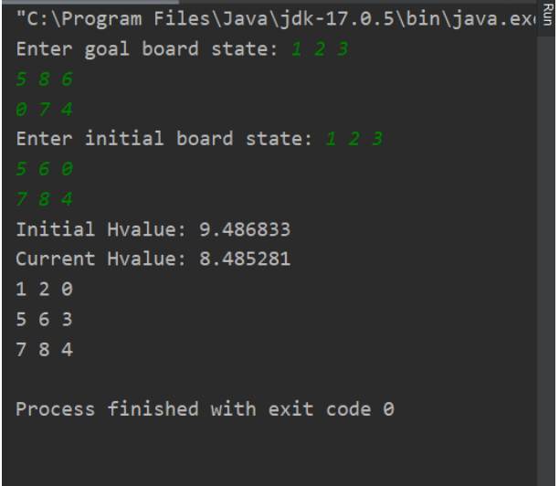

**STEEPEST HILL CLIMBING:**  
  
