AI-Generated Website Content for CodeCraft

Name: Mansi Sharma
Branch: Computer Science Engineering (CSE)
College: Government Women Engineering College, Ajmer
Subject: Prompt Engineering
Date: 5 March 2026

Introduction
This project demonstrates how Artificial Intelligence can be used to generate professional website content using effective prompts. The objective of this task was to create website content for a local software development company named CodeCraft located in Ajmer, Rajasthan.
Using AI tools, prompts were designed to generate structured website content including a Homepage, Services Page, and Call-To-Action (CTA) section. The generated content was then used to create a modern website using the Lovable platform.
This project shows how prompt engineering can help in creating professional digital content quickly and efficiently while maintaining clarity and business relevance.
Homepage Section
Prompt used :
Create homepage website content for a local software
development agency named "CodeCraft" based in Ajmer, Rajasthan.
CodeCraft helps local businesses and startups by providing:
Website development
Mobile app development
Custom software development
Include:
- Hero section headline
- About the company
- Services overview
- Why choose CodeCraft
- Client benefits
- Strong call-to-action section
Use a professional, modern, and technology-focused tone.
Keep the content simple, clear, and website-ready.
AI Generated output :
CodeCraft — Software Development Agency | Ajmer
Hero Section
Crafting Smart Digital Solutions for Growing Businesses. Websites, Mobile Apps, and Custom Software built to help your business succeed in the digital world.
Simple. Scalable. Reliable.
Start Your Project Today
About CodeCraft
CodeCraft is a software development agency based in Ajmer, Rajasthan, helping local businesses and startups build strong digital solutions.
We focus on creating modern, user-friendly, and scalable technology tailored to real business needs.
Our Services
Website Development
Professional and responsive websites that strengthen your online presence.
Mobile App Development
Custom mobile applications designed for performance and smooth user experience.
Custom Software Development
Business-focused software solutions to automate processes and improve efficiency.
Why Choose CodeCraft
✔ Customized solutions for every business
✔ Modern technology & clean development practices
✔ Affordable pricing for startups & local businesses
✔ On-time delivery with transparent communication
✔ Long-term technical support
Let’s Build Your Digital Future
Ready to grow your business with the right technology?
Partner with CodeCraft and bring your ideas to life.
Get a Free Consultation Today
Ajmer, Rajasthan | Contact Us Now
Screenshot :
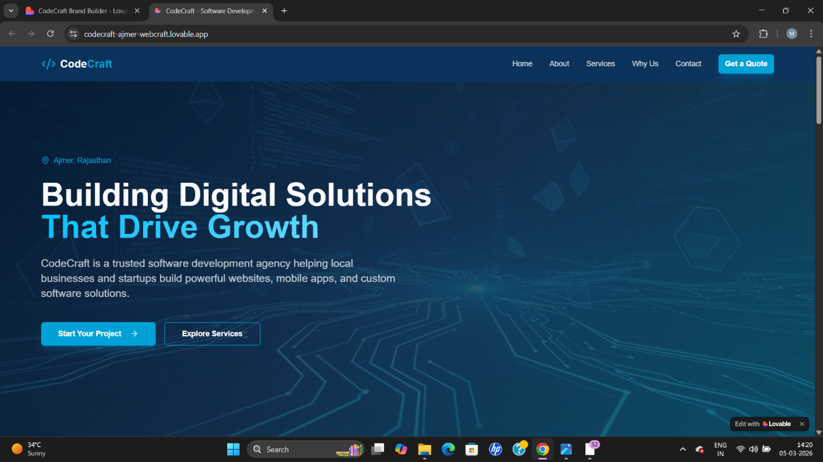
Explanation :
The homepage content was generated using structured prompts
to create professional and conversion-focused website copy
for a local software development agency named CodeCraft.
The prompt was designed to highlight the company’s services,
value proposition, and benefits for local businesses in Ajmer.
Since the initial AI output was detailed, a refinement prompt
was applied to make the content concise, readable, and suitable
for homepage layout.

Services Section
Prompt used :
Create professional and concise website content for the Services page of a software development agency named CodeCraft based in Ajmer, Rajasthan.
The tone should be clear, modern, and business-focused. Avoid repetition and keep the content easy to read.
Include the following sections:
1. Page Introduction (short overview of services)
2. Website Development
- brief description
- key offerings
- business benefits
3. Mobile App Development
- brief description
- key offerings
- business benefits
4. Custom Software Development
- brief description
- key offerings
- business benefits
5. Call-to-Action section encouraging users to contact CodeCraft.
Keep sentences short, professional, and suitable for a real company website. Avoid exaggerated marketing language.
AI Generated Output :
Our Services
CodeCraft — Software Development Agency | Ajmer, Rajasthan
Page Introduction
At CodeCraft, we provide practical and scalable software solutions designed to support business growth. Our services focus on building reliable digital products that improve efficiency, customer engagement, and operational performance.
Website Development
Overview : We design and develop modern, responsive websites that help businesses establish a strong and professional online presence.
Key Offerings
- Business & corporate websites
- E-commerce development
- Responsive UI/UX design
- Website redesign and maintenance
- SEO-ready development
How This Helps Your Business
- Improved online visibility
- Better customer engagement
- Mobile-friendly user experience
- Strong digital credibility
Mobile App Development
Overview : CodeCraft develops high-performance mobile applications tailored to business and customer needs across Android and cross-platform environments.
Key Offerings
- Custom mobile app development
- Startup MVP applications
- Business and service apps
- App testing & deployment
- Ongoing support and updates
How This Helps Your Business
- Direct customer interaction
- Enhanced service accessibility
- Increased user engagement
- Scalable digital solutions
Custom Software Development
Overview : We build customized software solutions that streamline workflows and support efficient business operations.
Key Offerings
- Business management systems
- Process automation software
- CRM and internal tools
- Custom dashboards & reporting systems
- Software integration solutions
How This Helps Your Business
- Reduced manual work
- Improved productivity
- Better data management
- Solutions tailored to business processes
Let’s Build the Right Solution for Your Business
Looking for reliable technology solutions tailored to your needs?
Partner with CodeCraft to develop software that supports your business goals.
Contact CodeCraft Today
Ajmer, Rajasthan
Request a Consultation | Get a Project Quote
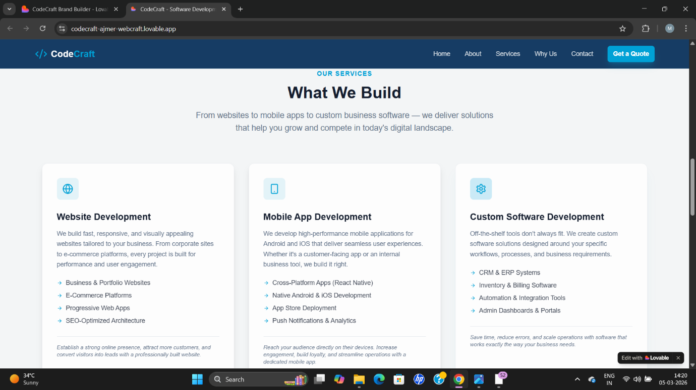
Screenshot :
Explanation :
The Services page was created to present the core offerings of CodeCraft, a local software development agency in Ajmer, Rajasthan. The goal of this page is to clearly explain the services provided by the business and help potential clients understand how these services support their digital growth.
The generated content describes three main services: Website Development, Mobile App Development, and Custom Software Development. Each section highlights the purpose of the service, the solutions offered, and the business value delivered to clients.
The structure of the page ensures that visitors can quickly identify relevant services and understand how CodeCraft can help improve their online presence, operational efficiency, and customer engagement.

Call-To-Action (CTA) Section
Prompt Used :
Create a professional and persuasive Call-To-Action (CTA) section for a local software development business named CodeCraft located in Ajmer, Rajasthan.
The CTA should encourage local businesses and startups to contact the company for Website Development, Mobile App Development, and Custom Software Development services.
Include:
- A strong and engaging headline
- A short persuasive paragraph encouraging action
- Mention of a free consultation
- Dedicated project consultant or personal guidance for clients
- Clear call-to-action lines such as contact, booking, or enquiry
- Professional, trustworthy, and business-focused tone
- Website-ready content suitable for a services website
The content should be concise, realistic, and focused on building client trust and encouraging enquiries.
AI Generated Output :
Let’s Build the Right Digital Solution for Your Business
Looking to grow your business with a professional website, mobile app, or custom software solution?
At CodeCraft, we work closely with local businesses and startups in Ajmer to understand their goals and deliver technology solutions that truly support growth.
Get started with a free consultation, where a dedicated project consultant will guide you through the best approach for your business — from idea to execution.
No technical confusion. Just clear guidance and reliable development support.
Take the next step toward digital growth.
Book Your Free Consultation
Contact CodeCraft Today
Send Your Project Enquiry
Ajmer, Rajasthan
CodeCraft — Your Technology Partner for Websites, Mobile Apps & Custom Software.
Screenshot :
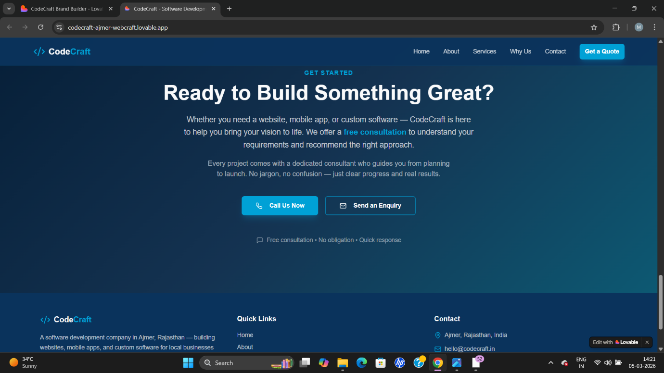
Explanation :
The CTA section was created to encourage potential clients to take action after understanding the services offered by CodeCraft, a local software development agency in Ajmer, Rajasthan. The purpose of this section is to guide website visitors toward contacting the business for project discussions or consultations.
The generated content includes a strong headline, supportive message, and clear action options such as booking a consultation or contacting the company. The CTA also highlights the availability of a dedicated project consultant to provide personalized guidance throughout the development process.
This section helps build trust and motivates visitors to initiate communication, making it an essential part of a conversion-focused business website.

Lovable Live Website Link - https://codecraft-ajmer-webcraft.lovable.app

