**REMI**

**A Mini-Project Report**

**Under**

**Project Workshop**

***Submitted by***

**MOHIT POKHARNA, N023**

**GAYATRI SACHDEVA, N026**

**SHAMINDER PAL SINGH, N034**

**AHANA SRIVASTAVA, N035**

***Under The Guidance Of***

**PROF. RATNESH CHATURVEDI**

***in partial fulfillment for the award of the degree***

***of***

**MBATECH**

**IN**

**COMPUTER ENGINEERING**

**at**



**MPSTME, NMIMS, MUMBAI**

**APRIL,2016**

**CERTIFICATE**

This is to certify that the project entitled **Remi** is the bonafide work carried out by **Mohit Pokharna, Gayatri Sachdeva, Shaminder Pal Singh & Ahana Srivastava,** MBATech (Computer Engineering), MPSTME (NMIMS), Mumbai, during the fourth semester of the academic year 2015-2016, in fulfillment of the requirements for the award of the Degree of Bachelors of Technology as per the norms prescribed by NMIMS. The project work has been assessed and found to be satisfactory.

___________________

Prof. Ratnesh Chaturvedi

Internal Mentor

_______________________ ________________________

Examiner 1 Examiner 2

________________________

Dean

Dr. Sharad Y. Mhaiskar

**DECLARATION**

We, **Mohit Pokharna, Gayatri Sachdeva, Shaminder Pal Singh & Ahana Srivastava,** MBATech (Computer Engineering), semester- IV, understand that plagiarism is defined as anyone or combination of the following:

1. Un-credited verbatim copying of individual sentences, paragraphs or illustration (such as graphs, diagrams, etc.) from any source, published or unpublished, including the internet.

2. Un-credited improper paraphrasing of pages paragraphs (changing a few words phrases, or rearranging the original sentence order)

3. Credited verbatim copying of a major portion of a paper (or thesis chapter) without clear delineation of who did wrote what.

4. We have made sure that all the ideas, expressions, graphs, diagrams, etc., that are not a result of our work, are properly credited. Long phrases or sentences that had to be used verbatim from published literature have been clearly identified using quotation marks.

5. We affirm that no portion of my work can be considered as plagiarism and we take full responsibility if such a complaint occurs. We understand fully well that the guide of the seminar/ seminar report may not be in a position to check for the possibility of such incidences of plagiarism in this body of work.

Signature of the Students:

___________ ____________ ___________ ____________

Name: ___________ ____________ ___________ ____________

Roll No. ___________ ____________ ___________ ____________

Place: Mumbai

Date: April 2016

**ACKNOWLEDGMENT**

I take this opportunity to express my sincere deference and gratitude to Prof. Krishna Samdani for his constant guidance and motivation provided during the course of this work. It was a unique privilege to work under his valuable guidance and supervision. Also my H.O.D, Dr. Dhirendra Mishra for encouraging me to perform the seminar work and Dean Dr. Sharad Y. Mhaiskar for providing such platform.

I also like to wish my immense gratitude to all the authors of the papers whose reference has made this presentation and report possible reality.

I convey my gratitude to all who’s directly or indirectly involvement and valuable suggestions helped me and hope for further inputs in the future.

I would also like to take this opportunity to thank MPSTME library, and resource for providing with all the research papers, data, archives and other reference in a timely manner.

**Table of contents**

**CHAPTER NO. TITLE PAGE NO.**

List of Figures i

List of Tables ii

Abbreviations iii

Abstract iv

1. INTRODUCTION

1.1 Project Overview

1.2 Hardware Specification

1.3 Software Specification

1.3.1 …

1.3.2 …

2. REVIEW OF LITERATURE

2.1 …

3. ANALYSIS & DESIGN

4. METHODS IMPLEMENTED

5. RESULTS & DISCUSSION

6. CONCLUSION & FUTURE SCOPE

REFERENCES

APPENDIX

***INTRODUCTION***

**Introduction to Android:**

Android is an open source and Linux-based operating system for mobile devices such as smart phones and tablet computers. Android was developed by the Open Handset Alliance, led by Google, and other companies.

Android provides a rich application framework that allows you to build innovative apps and games for mobile devices in a Java language environment.

Android Architecture:

Android operating system is a stack of software components which is roughly divided into five sections and four main layers as shown below in the architecture diagram.

Android gives you a world-class platform for creating apps and games for Android users everywhere, as well as an open marketplace for distributing to them instantly. Android operating system is a stack of software components which is roughly divided into five sections and four main layers as shown below in the architecture diagram.

You will find all the Android application at the top layer. You will write your application to be installed on this layer only. Examples of such applications are Contacts Books, Browser, Games etc. These comprise both the native applications provided with the particular Android implementation (for example web browser and email applications) and the third party applications installed by the user after purchasing the device. Applications created by third party users or developers will be installed here.

**Introduction to Application:**

***Project Overview:***

   Remi is a personal diary app which allows you to make not only text entries but voice entries as well. It comes with an in-built feature for account creation which provides the user with added security and backup and restore options.

Hardware Specification

**AP1 19**

* Processor:
  + Quad-core 1.2 GHz
  + PowerVR SGX 540 GPU.
* Memory:
  + 768 MB RAM
  + 1 GB of Flash Memory
  + Micro-SD card slot (Optional)
* Screen:
  + 3.5-inch LCD display
  + Capacitive or Resistive touch

# Review of Literature

A literature review is a text of a scholarly paper, which includes the current knowledge including substantive findings, as well as theoretical and methodological contributions to a particular topic. Most often associated with academic-oriented literature, such as a thesis, dissertation or a peer-reviewed journal article, a literature review usually precedes the methodology and results section although this is not always the case. Literature reviews are also common in a research proposal or prospectus. Its main goals are to situate the current study within the body of literature and to provide context for the particular reader. Literature reviews are a basis for research in nearly every academic field.

**Java:**

Java is a set of several computer software and specifications developed by Sun. Microsystems, later acquired by Oracle Corporation, that provides a system for developing application software and deploying it in a cross-platform computing environment. Java is used in a wide variety of computing platforms from embedded devices and mobile phones to enterprise servers and supercomputers. While less common, Java applets run in secure, sandboxed environments to provide many features of native applications and can be embedded in HTML pages.

Writing in the Java programming language is the primary way to produce code that will be deployed as byte code in a Java Virtual Machine (JVM); byte code compilers are also available for other languages, including Ada, JavaScript, Python, and Ruby. In addition, several languages have been designed to run natively on the JVM, including Scala, Clojure and Groovy. Java syntax borrows heavily from C and C++, but object-oriented features are modeled after Smalltalk and Objective-C.Java eschews certain low-level constructs such as pointers and has a very simple memory model where every object is allocated on the heap and all variables of object types are references. Memory management is handled through integrated automatic garbage collection performed by the JVM.

***ANALYSIS & DESIGN***

During the conception of the application, the requirements were mapped out first. This included analyzing the need of this application, its features and figuring out a list of functions it would perform during operation. This largely consisted of the analysis.

After performing a complete analysis, the design of the application was pursued. Abnegate was designed using material design. Material design is a comprehensive guide for visual, motion, and interaction design across platforms and devices.

## Features:

**-** Write notes about your life     
- Show all entries     
- Auto save when exit

- Delete entries

- Modify entries

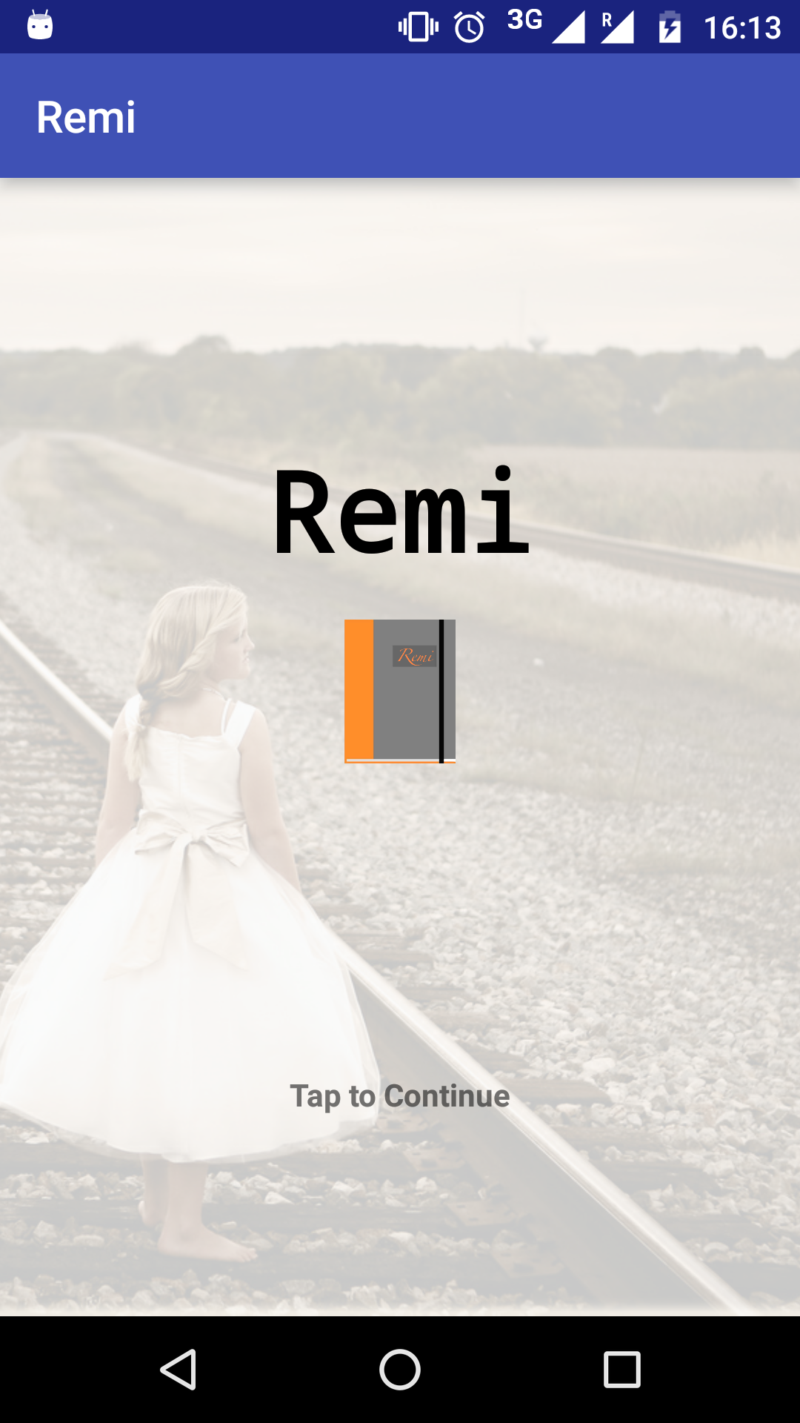

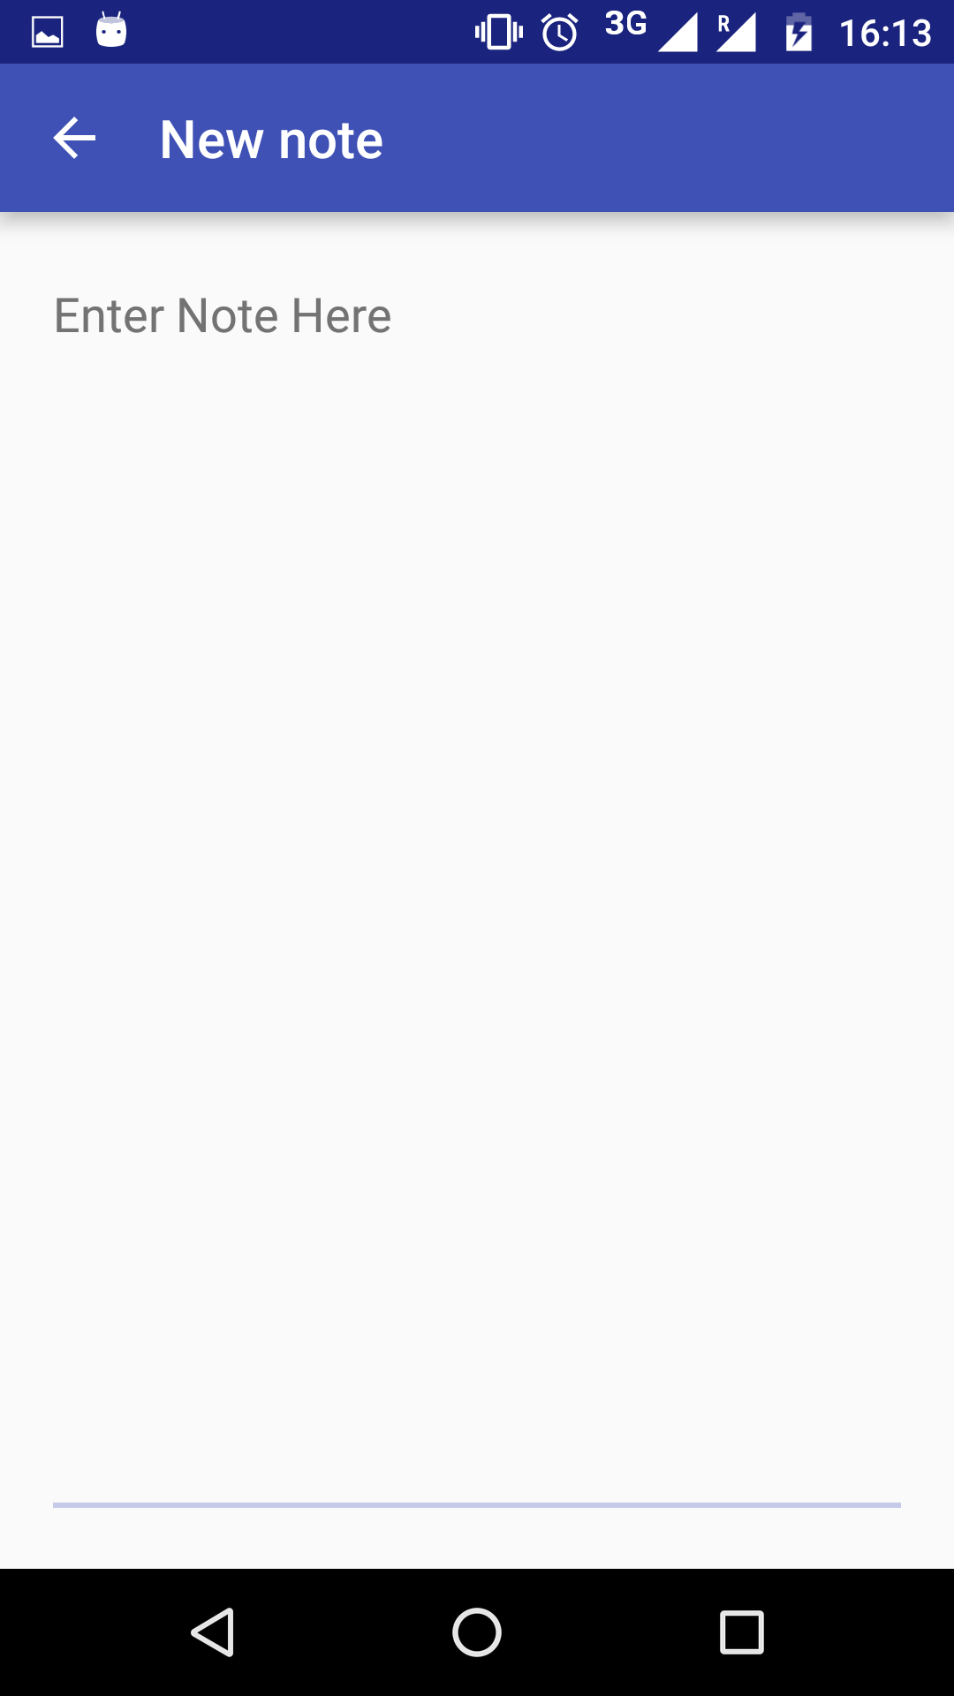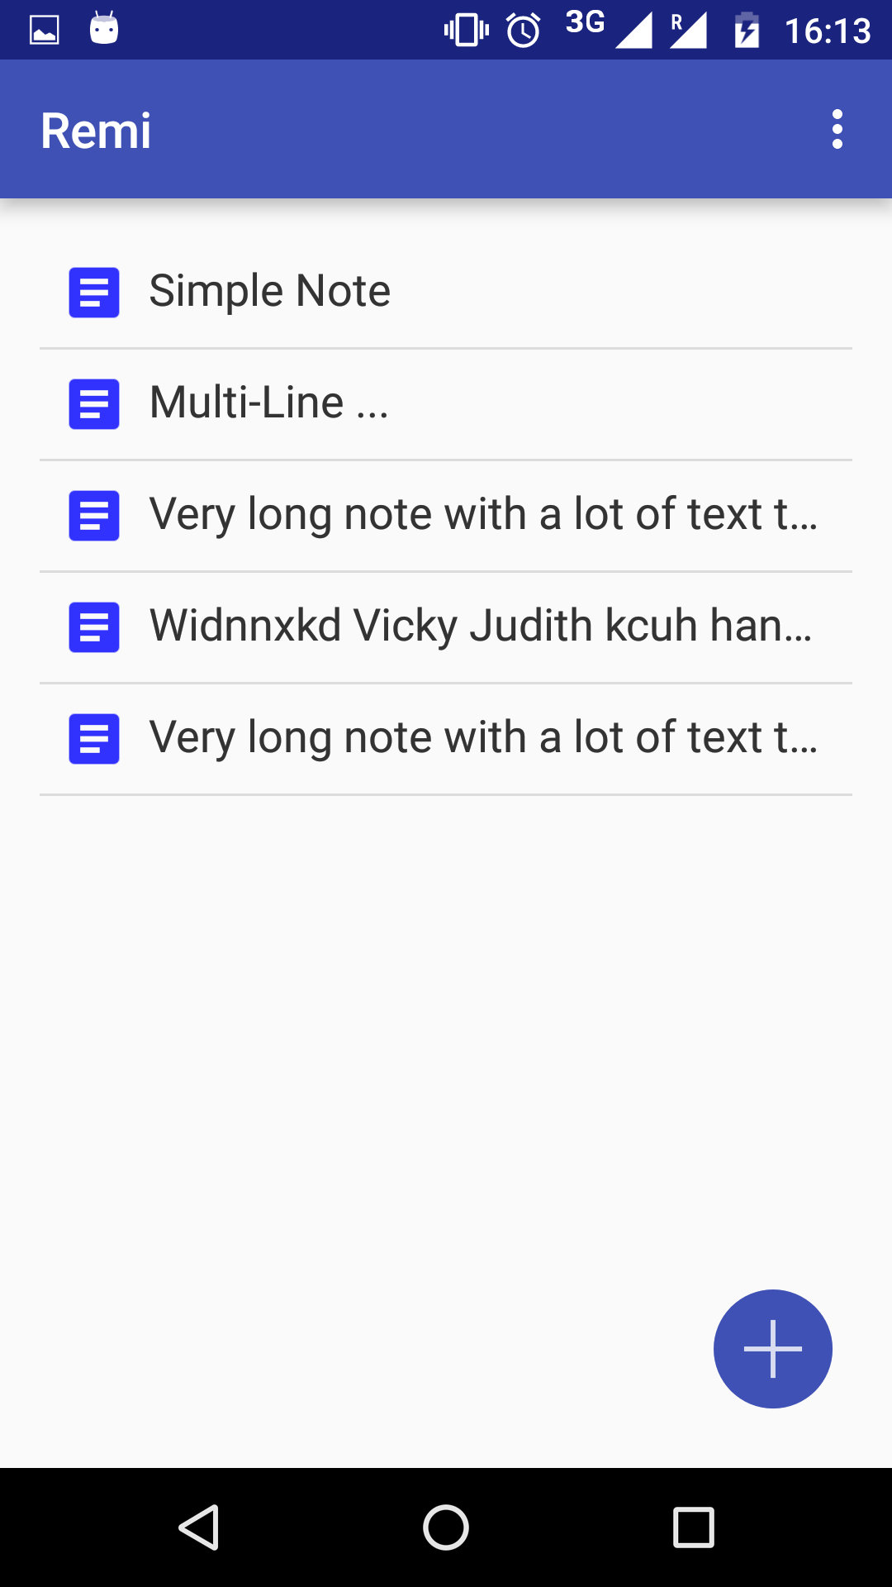

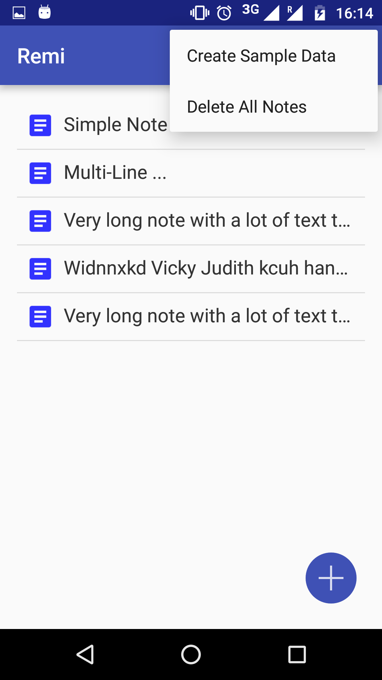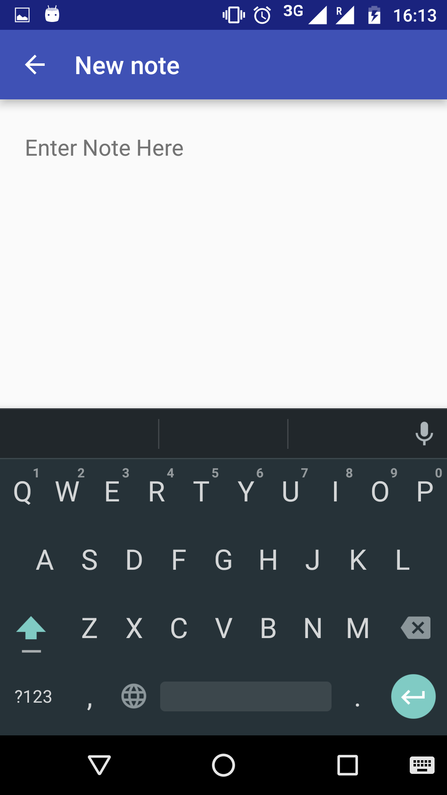

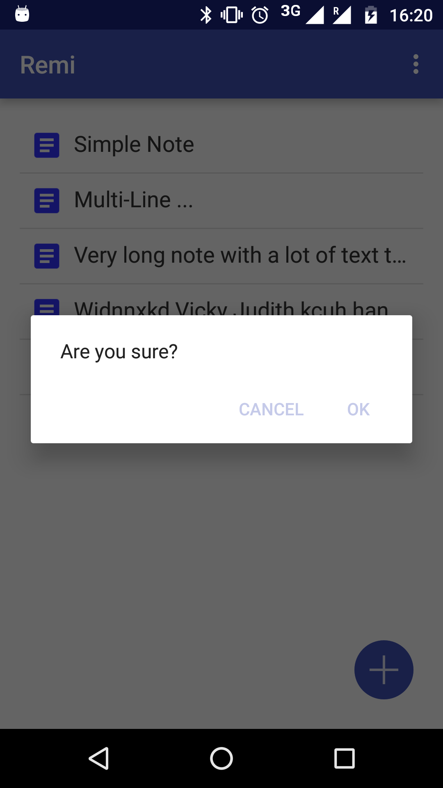

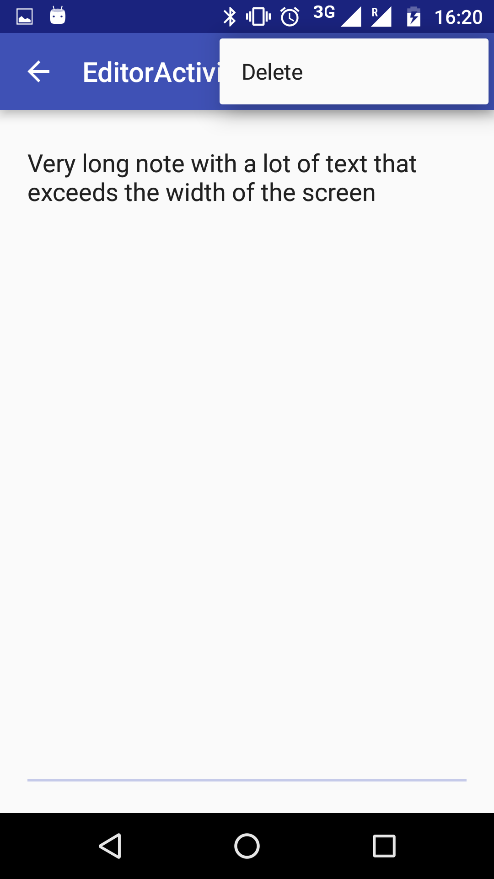

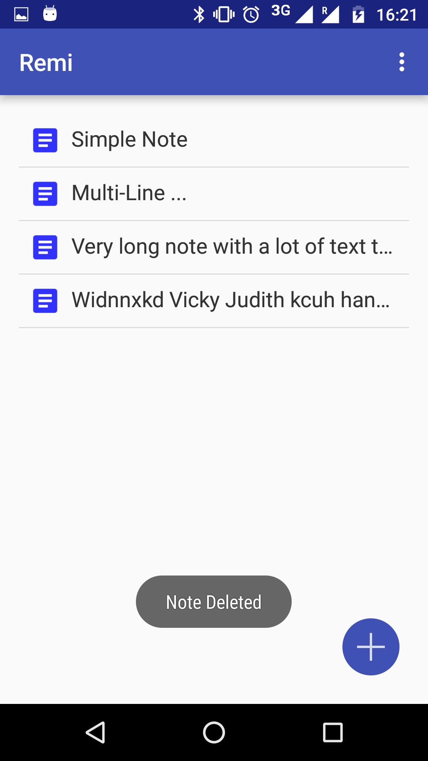

***METHODS IMPLEMENTED***

**Introduction to Android Studio:**

Android Studio is the official IDE for Android application development, based on IntelliJ IDEA. On top of the capabilities you expect from IntelliJ, Android Studio offers:

Flexible Gradle-based build system.

Build variants and multipleapk file generation.

Code templates to help you build common app features.

Rich layout editor with support for drag and drop theme editing lint tools to catch performance, usability, version compatibility, and other problems.

ProGuard and app-signing capabilities.

Built-in support for Google Cloud Platform, making it easy to integrate Google Cloud.

Messaging and App Engine.

**SQL Lite Database:**

SQLiteDatabase has methods to create, delete, execute SQL commands, and perform other common database management tasks.

See the Notepad sample application in the SDK for an example of creating and managing a database.

Database names must be unique within an application, not across all applications.

1. We have implemented SQLite database to input and modify user entries.

2.We have linked the Buttons to Activites using intent.

3. We have inserted several Text Fields and Text Views in many Activities.

4. We have created an interactive start screen.

***RESULTS AND DISCUSSION***

Our Application is still under process and we are working on it.

***CONCLUSION & FUTURE SCOPE***

Following features are to be added to the app:

- Voice input  
- Password Protection for the Diary     
- Show entries in any range of dates   
- Backup copy of your entries to Archive   
- Recovery of your entries from Archive    
- Attach photos   
- Add user categories   
- Prioritise the entries   
- Search entries   
- Send all entries as text ﬁle to e-mail    
- Location feature    
- Tags    
- Edit location   
- Draw pictures

The app is long way from being complete and we will continue to put in effort.

***REFERENCES***

1. [www.youtube.com](http://www.youtube.com)
2. developer.android.com
3. [www.google.com](http://www.google.com)