**THE WORD GAME**

**A Mini-Project Report**

**Under**

**Project Workshop**

***Submitted by***

**RAUNAK MARWAHA**

**HIMANK ARORA**

***Under The Guidance Of***

**Prof. RatneshChaturvedi**

***in partial fulfillment for the award of the degree***

***of***

**MASTER OF BUSINESS ADMINISTRATION IN TECHNOLOGY MANAGEMENT**

**IN**

**COMPUTER**

**at**



**MUKESH PATEL SCHOOL OF TECHNOLOGY MANAGEMNT AND ENGINEERING,**

**APRIL, 2016**

**CERTIFICATE**

This is to certify that the project entitled **The Word Game**is the bonafide work carried out by **Raunak Marwaha and HimankArora**MBATech (Computer Engineering), MPSTME (NMIMS), Mumbai, during the fourth semester of the academic year 2015-2016, in fulfillment of the requirements for the award of the Degree of Bechelors of Technology as per the norms prescribed by NMIMS. The project work has been assessed and found to be satisfactory.

_______________

Prof. RatneshChaturvedi

Internal Mentor

_______________________ ________________________

Examiner 1 Examiner 2

________________________

Dean

Dr. Sharad Y. Mhaiskar

**DECLARATION**

We, Raunak Marwaha and HimankAroraMBATech (Computer Engineering), semester- IV, understand that plagiarism is defined as anyone or combination of the following:

1. Un-credited verbatim copying of individual sentences, paragraphs or illustration (such as graphs, diagrams, etc.) from any source, published or unpublished, including the internet.

2. Un-credited improper paraphrasing of pages paragraphs (changing a few words phrases, or rearranging the original sentence order)

3. Credited verbatim copying of a major portion of a paper (or thesis chapter) without clear delineation of who did wrote what.

4. We have made sure that all the ideas, expressions, graphs, diagrams, etc., that are not a result of our work, are properly credited. Long phrases or sentences that had to be used verbatim from published literature have been clearly identified using quotation marks.

5. We affirm that no portion of my work can be considered as plagiarism and we take full responsibility if such a complaint occurs. We understand fully well that the guide of the seminar/ seminar report may not be in a position to check for the possibility of such incidences of plagiarism in this body of work.

Signature of the Students:

___________ ____________ ___________

Name: ___________ ____________ ___________

Roll No. ___________ ____________ ________

Place: Mumbai

Date: April 2016

**ACKNOWLEDGMENT**

I take this opportunity to express my sincere deference and gratitude to Prof.RatneshChaturvedi for his constant guidance and motivation provided during the course of this work. It was a unique privilege to work under his valuable guidance and supervision. Also my H.O.D, Dr.Dhirendra Mishra for encouraging me to perform the seminar work and Dean Dr. Sharad Y. Mhaiskar for providing such platform.

I also like to wish my immense gratitude to all the authors of the papers whose reference has made this presentation and report possible reality.

I convey my gratitude to all who’s directly or indirectly involvement and valuable suggestions helped me and hope for further inputs in the future.

I would also like to take this opportunity to thank MPSTME library, and resource for providing with all the research papers, data, archives and other reference in a timely manner.

**Table of contents**

**CHAPTER NO. TITLE PAGE NO.**

List of Figures vi

List of Tables vii

Abbreviations iii

Abstract iv

1. INTRODUCTION viii

1.1 Project Overview `ix

1.2 Hardware Specification x

1.3 Software Specification xi

2. REVIEW OF LITERATURE xii

3. ANALYSIS & DESIGN xiv

- Features xv

4. METHODS IMPLEMENTED xxi

5. CONCLUSION AND RESULTS

REFERENCES

APPENDIX

**List of Figures**

**CHAPTER NO. TITLE PAGE NO.**

1. INTRODUCTION

Fig1.1 Introduction Screen – Levels xvi

Fig1.2 Age distribution difficulties xvii

Fig1.3 Score Board xviii

Fig1.4 Gameplay xix

Fig1.5 Example Game xx

*************

***NOTE:***

* *Figures must be properly explained in the text*
* *Figure No. and caption of the figure must be below the figure in all the chapters.*

**List of Tables**

**CHAPTER NO. TITLE PAGE NO.**

1. INTRODUCTION

2. REVIEW OF LITERATURE

*************

***NOTE:***

* *Tables must be properly explained in the text.*
* *Table No. and caption of the table must be above the table in all the chapters.*

**INTRODUCTION**

**Word game** is a paper and pencil guessing gamefor two or more players. One player thinks of a word, phrase or sentence and the other tries to guess it by suggesting letters or numbers, within a certain number of guesses.

In the English language, the twelve most commonly occurring letters are, in descending order: e-t-a-o-i-n-s-h-r- d-l-u. This and other letter frequency lists are used by the guessing player to increase the odds when it is their turn to guess.

On the other hand, the same lists can be used by the puzzle setter to stump their opponent by choosing a word which deliberately avoids common letters (e.g. rhythm or zephyr) or one that contains rare letters (e.g. jazz).

According to a 2010 study conducted by Jon McLoone for Wolfram Research, the most difficult words to guess include jazz, buzz, hajj, faff, fizz, fuzz and variations of these.

**PROJECT OVERVIEW**

The word to guess is represented by a row of dashes, representing each letter of the word. Words you cannot use include proper nouns such as names, places, and brands.

At the start a set of vowels will be provided and will be cancelled subsequently if the user fails to guess the right letter. If the guessing player suggests a letter which occurs in the word, the other player writes it in all its correct positions. If the suggested letter or number does not occur in the word, the other player/the application displays one element of a hanged man stick figure as a tally mark.

Upon guessing the word correctly, the app shows the user the meaning of the word with thesaurus. Points are added subsequently to the users profile.

**HARDWARE SPECIFICATIONS**

Word Game is not a hardware intensive application, thus requires very basic level of hardware, as its application ranges across all devices, low end to high end, phones to tablets. Thus, the following are the minimum hardware specifications required to run the application:

* Processor:
  + Quad-core 1.2 GHz
  + PowerVR SGX 540 GPU.
* Memory:
  + 768 MB RAM
  + 1 GB of Flash Memory
  + Micro-SD card slot (Optional)
* Screen:
  + 3.5-inch LCD display
  + Capacitive or Resistive touch

During Development of the application, an LG Nexus smartphone was used to develop and test the application.

**SOFTWARE SPECIFICATIONS**

Word Game is designed to work on Android 4.0, Ice Cream Sandwich and above.

Apart from Android 4.0 and above, the application, like most android applications can run on the following Operating Systems:

* Blackberry OS 11
* Sailfish OS
* Chrome OS
* Color OS
* INUI OS
* YUN OS
* Nokia X mobile Platform

Some of these are based on android, while some (Bbos 11, Sailfish OS) are made compatible to run android applications. Following is the list of Android versions on which Word Game has been tested:

* Android 4.0 (Ice Cream Sandwich)
* Android 4.2 (Jellybean)
* Android 4.3 (Jellybean)
* Android 4.4 (KitKat)
* Android 5.0 (Lollipop)
* Android 5.0.2 (Lollipop)
* Android 5.1 (Lollipop)

This gives the application a broad platform, as these operating systems are in majority of smart phones being used by prospective users.

**REVIEW OF LITERATURE**

A literature review is a text of a scholarly paper, which includes the current knowledge including substantive findings, as well as theoretical and methodological contributions to a particular topic.

Most often associated with academic-oriented literature, such as a thesis, dissertation or a peer-reviewed journal article, a literature review usually precedes the methodology and results section although this is not always the case.

Literature reviews are also common in a research proposal or prospectus. Its main goals are to situate the current study within the body of literature and to provide context for the particular reader. Literature reviews are a basis for research in nearly every academic field.

**INTRODUCTION TO ANDROID**

Android is an open source and Linux-based operating system for mobile devices such as smart phones and tablet computers. Android was developed by the Open Handset Alliance, led by Google, and other companies.

Android provides a rich application framework that allows you to build innovative apps and games for mobile devices in a Java language environment.

Android gives you a world-class platform for creating apps and games for Android users everywhere, as well as an open marketplace for distributing to them instantly. Android operating system is a stack of software components which is roughly divided into five sections and four main layers as shown below in the architecture diagram.

You will find all the Android application at the top layer. You will write your application to be installed on this layer only. Examples of such applications are Contacts Books, Browser, Games etc. These comprise both the native applications provided with the particular Android implementation (for example web browser and email applications) and the third party

applications installed by the user after purchasing the device. Applications created by third party users or developers will be installed here.

**JAVA**

Java is a set of several computer software and specifications developed by Sun. Microsystems, later acquired by Oracle Corporation, that provides a system for developing application software and deploying it in a cross-platform computing environment.

Java is used in a wide variety of computing platforms from embedded devices and mobile phones to enterprise servers and supercomputers. While less common, Java applets run in secure, sandboxed environments to provide many features of native applications and can be embedded in HTML pages.

Writing in the Java programming language is the primary way to produce code that will be deployed as byte code in a Java Virtual Machine (JVM); byte code compilers are also available for other languages, including Ada, JavaScript, Python, and Ruby.

In addition, several languages have been designed to run natively on the JVM, including Scala, Clojure and Groovy.

Java syntax borrows heavily from C and C++, but object-oriented features are modeled after Smalltalk and Objective-C.Java eschews certain low-level constructs such as pointers and has a very simple memory model where every object is allocated on the heap and all variables of object types are references. Memory management is handled through integrated automatic garbage collection performed by the JVM.

**ANALYSIS AND DESIGN**

During the conception of the application, the requirements were mapped out first. This included analyzing the need of this application, its features and figuring out a list of functions it would perform during operation. This largely consisted of the analysis.

After performing a complete analysis, the design of the application was pursued. Abnegate was designed using material design. Material design is a comprehensive guide for visual, motion, and interaction design across platforms and devices.

At the start a set of vowels will be provided and will be cancelled subsequently if the user fails to guess the right letter. If the guessing player suggests a letter which occurs in the word, the other player writes it in all its correct positions. If the suggested letter or number does not occur in the word, the other player/the application displays one element of a hanged man stick figure as a tally mark.

**FEATURES**

**1. Dictionary**

After guessing the correct word, the application displays the meaning of the word and also shows its usage in the form of a complete sentence.

Upon guessing the word correctly, the app shows the user the meaning of the word with thesaurus. Points are added subsequently to the users profile.

**2. Auto-Save and Exit**

**3. Sync your game with different social media platforms**

**4. Experience different levels**

Default mode - Present at the start of the game when the user has no points at all. As and when the user completes one session successfully, the points as well as the difficulty level gets increased.

The user has an option of choosing amongst the default and the age group distribution mode.

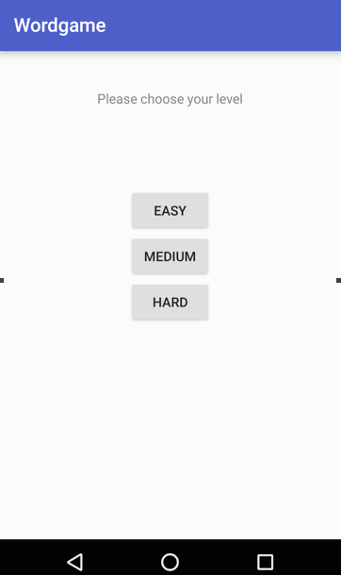

**5. Age group distribution**

The second mode of the game which pops up on the home screen right at the start. The user is asked his/her age group and depending upon that, the application selects a set of words which will be asked.

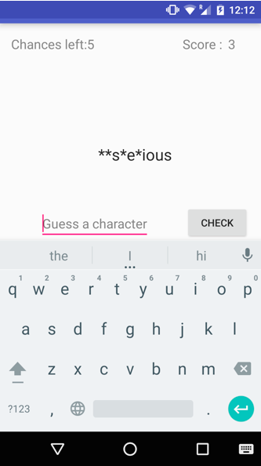

**6. Share your score with friends**

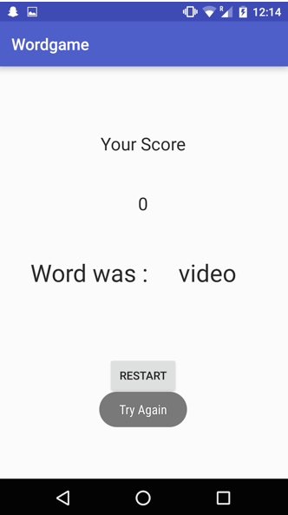

**7. Game Play**

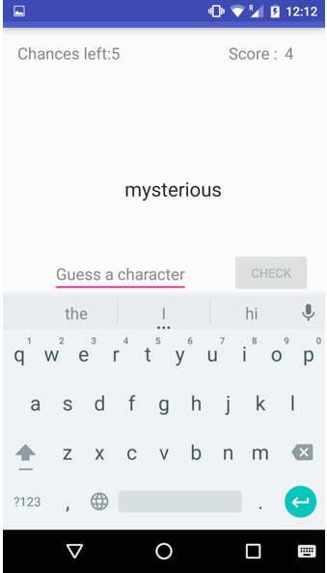

**EXAMPLE GAME**

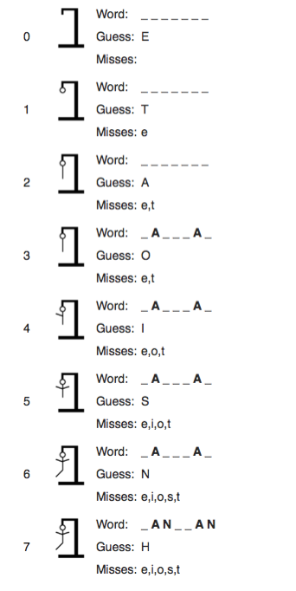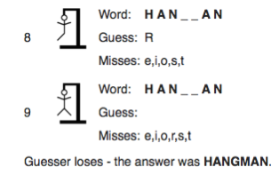

**METHODS IMPLEMENTED**

**Introduction to Android Studio**

Android Studio is the official IDE for Android application development, based on IntelliJ IDEA. On top of the capabilities you expect from IntelliJ, Android Studio offers :

Flexible Gradle-based build system.

Build variants and multipleapk file generation.

Code templates to help you build common app features.

Rich layout editor with support for drag and drop theme editing lint tools to catch performance, usability, version compatibility, and other problems.

ProGuard and app-signing capabilities.

Built-in support for Google Cloud Platform, making it easy to integrate Google Cloud.

Messaging and App Engine.

**SQL Lite Database**

SQLiteDatabase has methods to create, delete, execute SQL commands, and perform other common database management tasks.

See the Notepad sample application in the SDK for an example of creating and managing a database.

Database names must be unique within an application, not across all applications

1.We have implemented the Sqlite Database on the Login and Register Activities.

2.We have linked the Buttons to Activites using intent.

3.We have inserted several Text Fields and Text Views in many Activities.

4.We have linked the SQLite Database to the Login and Register Activities in our application.

**ABBREVIATIONS**

|  |  |
| --- | --- |
| **Abbreviation** | **Description** |
| ADB | Android Debugging Bridge |
| ADT | Android Development Tools |
| Android SDK | Android Software Development Kit |
| ART | Android Runtime |
| CPU | Central Processing Unit |
| CR | Class Representative |
| GPU | Graphic Processing Unit |
| HoD | Head of Department |
| IPS | In-Plane Switching |
| LCD | Liquid Crystal Display |
| RAM | Random Access Memory |
| SQL | Structured Query Language |
| SR | Student Representative |
| XML | Extensible Markup Language |

**ABSTRACT**

Modern hand held devices such as smart phones and PDAs have become increasingly powerful in recent years. Dramatic breakthroughs in processing power along with the number of extra features included in these devices have opened the doors to a wide range of commercial possibilities. In particular, most cell phones regularly include cameras, processors comparable to PCs from only a few years ago, and internet access. However, even with all these added abilities, there are few applications that allow much passing of the environmental information and location based services.

As mobile devices become more like PCs they will come to replace objects we tend to carry around such as checkbooks, credit cards, cameras, planners, mp3 players, etc. In s hort, we will be using them to accomplish our daily tasks. One application that falls into this category is the **Word Game**developed for Android Phones.

**Word game** is a paper and pencil guessing gamefor two or more players. One player

thinks of a word, phrase or sentence and the other tries to guess it by suggesting

letters or numbers, within a certain number of guesses.

The users can login into the app by registering or using ‘Sign in with Google’ option. The user can find all the premium brands he chooses to have. The user has the facility to make a call directly to our company and can also obtain the detailed info of the product he chooses.

The Project is developed in Java Programming Language by using the Android Studio Integrated Development Environment (IDE). We used the Android Software Development Kit (SDK) which includes a variety of custom tools that help us develop mobile applications on the Android platform. The most important of these are the Android Emulator, HXAM Accelerator and the Android Development Tools (ADT) packages for Android Studio.

**CONCLUSION AND RESULTS**

The Word Game application has been succesfully designed and is nearing completion. Android Studio along with innovatie ideas have been put into the formation of this project which has the scope of giving new dimensions to playing games related to guessing and improvising on user grammar skills.

The end product will be a user friendly application which fulfills it’s purpose of providing an enriched user experience.

**REFERENCES**

* 1  Foreign English Teacher Under Attack For Playing Hangman Game, *Japan Probe*, July 23, 2010
* **2  Jump up   ^** McLoone, John (13 August 2010). "Jon McLoone 25 Best Hangman Words". Wolfram Research. Archived from the original on 15 August 2010. Retrieved 14 March 2015.

**3.** developer.android.com