**Machine Learning Prediction of Death in Critically Ill Patients with COVID-19**

Matthew M Churpek, MD, MPH, PhD,1* Shruti Gupta, MD, MPH,2* Alexandra B. Spicer, MS,1 Salim S. Hayek, MD,3 Anand Srivastava, MD, MPH,4 Lili Chan, MD, MSCR,5 Michal L. Melamed, MD, MHS,6 Samantha K. Brenner, MD, MPH,7 Jared Radbel, MD,8 Farah Madhani-Lovely, MD,9 Pavan K. Bhatraju, MD, MSc,10 Anip Bansal, MD,11 Adam Green, MD, MBA,12 Nitender Goyal, MD,13 Shahzad Shaefi, MD, MPH,14 Chirag R. Parikh, MD, PhD,15 Matthew W. Semler, MD,16 David E. Leaf, MD, MMSc,2 for the STOP-COVID Investigators

*These authors contributed equally.

**Online Data Supplement**

**STOP-COVID INVESTIGATORS**

**Baylor College of Medicine:** Carl P. Walther*, Samaya J. Anumudu

**Baylor University Medical Center:** Justin Arunthamakun*, Kathleen F. Kopecky, Gregory P. Milligan, Peter A. McCullough, Thuy-Duyen Nguyen

**Beth Israel Deaconess Medical Center:** Shahzad Shaefi*, Megan L. Krajewski, Sidharth Shankar, Ameeka Pannu, Juan D. Valencia

**Boston Medical Center:** Sushrut S. Waikar*, Zoe A. Kibbelaar

**Cook County Health:** Ambarish M. Athavale*, Peter Hart, Oyintayo Ajiboye, Matthew Itteera

**Cooper University Health Care:** Adam Green*, Jean-Sebastien Rachoin, Christa A. Schorr, Lisa Shea

**Duke University Medical Center:** Daniel L. Edmonston*, Christopher L. Mosher

**Hackensack Meridian Health Mountainside Medical Center:** Alexandre M. Shehata*, Zaza Cohen, Valerie Allusson, Gabriela Bambrick-Santoyo, Noor ul aain Bhatti, Bijal Metha, Aquino Williams

**Hackensack University Medical Center:** Samantha K. Brenner*, Patricia Walters, Ronaldo C. Go, Keith M. Rose

**Harvard T.H. Chan School of Public Health:** Miguel A. Hernán

**Harvard University:** Amy M. Zhou, Ethan C. Kim, Rebecca Lisk

**Icahn School of Medicine at Mount Sinai:** Lili Chan*, Kusum S. Mathews*, Steven G. Coca, Deena R. Altman, Aparna Saha, Howard Soh, Huei Hsun Wen, Sonali Bose, Emily Leven, Jing G. Wang, Gohar Mosoyan, Girish N. Nadkarni

**Indiana University School of Medicine/Indiana University Health:** Allon N. Friedman*, John Guirguis, Rajat Kapoor, Christopher Meshberger

**Johns Hopkins Hospital:** Chirag R. Parikh*, Brian T. Garibaldi, Celia P. Corona-Villalobos, Yumeng Wen, Steven Menez, Rubab F. Malik, Carmen Elena Cervantes, Samir C. Gautam, Crystal Chang

**Loma Linda University:** H. Bryant Nguyen*, Afshin Ahoubim

**Mayo Clinical, Arizona:** Leslie F. Thomas*

**Mayo Clinic, Florida:** Pramod K. Guru*

**Medical College of Wisconsin:** Paul A. Bergl*, Yan Zhou, Jesus Rodriguez, Jatan A. Shah, Mrigank S. Gupta

**MedStar Georgetown University Hospital:** Princy N. Kumar*, Deepa G. Lazarous, Seble G. Kassaye

**Montefiore Medical Center/Albert Einstein College of Medicine**: Michal L. Melamed*, Tanya S. Johns. Ryan Mocerino, Kalyan Prudhvi, Denzel Zhu, Rebecca V. Levy, Yorg Azzi, Molly Fisher, Milagros Yunes, Kaltrina Sedaliu, Ladan Golestaneh, Maureen Brogan, Jyotsana Thakkar, Neelja Kumar, Michael J. Ross, Michael Chang

**New York-Presbyterian Queens Hospital**: Ritesh Raichoudhury*

**New York-Presbyterian/Weill Cornell Medical Center:** Edward J. Schenck*, Soo Jung Cho, Maria Plataki, Sergio L. Alvarez-Mulett, Luis G. Gomez-Escobar, Di Pan, Stefi Lee, Jamuna Krishnan, William Whalen

**New York University Langone Hospital:** David Charytan*, Ashley Macina

**Northwell Health:** Daniel W. Ross

**Northwestern Memorial Hospital:** Northwestern University Feinberg School of Medicine - Anand Srivastava*, Alexander S. Leidner, Carlos Martinez, Jacqueline M. Kruser, Richard G. Wunderink, Alexander J. Hodakowski

**Ochsner Medical Center:** Juan Carlos Q. Velez*, Eboni G. Price-Haywood, Luis A. Matute-Trochez, Anna E. Hasty, Muner MB. Mohamed

**Oregon Health and Science University Hospital:** Rupali S. Avasare*, David Zonies*

**Partners Healthcare:** Brigham and Women’s Hospital, Brigham and Women’s Faulkner Hospital, Massachusetts General Hospital, and Newton Wellesley Hospital - David E. Leaf*, Shruti Gupta*, Rebecca M. Baron, Meghan E. Sise, Erik T. Newman, Samah Abu Omar, Kapil K. Pokharel, Shreyak Sharma, Harkarandeep Singh, Simon Correa Gaviria, Tanveer Shaukat, Omer Kamal, Wei Wang, Heather Yang, Jeffery O. Boateng, Meghan Lee, Ian A. Strohbehn, Jiahua Li, Saif A. Muhsin, Ernest I. Mandel, Ariel L. Mueller

**ProMedica Health System**: Promedical Toledo Hospital – Nicholas S. Cairl

**Renown Health:** Farah Madhani-Lovely,Chris Rowan*, Farah Madhai-Lovely*

**Rush University Medical Center:** Vasil Peev*, Jochen Reiser,John J. Byun, Andrew Vissing, Esha M. Kapania, Zoe Post, Nilam P. Patel, Joy-Marie Hermes

**Rutgers/New Jersey Medical School:** Anne K. Sutherland*, Amee Patrawalla, Diana G. Finkel, Barbara A. Danek, Sowminya Arikapudi, Jeffrey M. Paer

**Rutgers/Robert Wood Johnson Medical School:** Jared Radbel*, Sonika Puri, Jag Sunderram, Matthew T. Scharf, Ayesha Ahmed, Ilya Berim, Jayanth Vatson

**Stanford Healthcare:** Stanford University School of Medicine –Shuchi Anand*, Joseph E. Levitt, Pablo Garcia

**Temple University Hospital:** Suzanne M. Boyle*, Rui Song

**Thomas Jefferson University Hospital**: Jingjing Zhang*

**Tulane Medical Center:** Moh’d A. Sharshir*, Vadym V. Rusnak

**University of Colorado Anschutz Medical Campus:** Anip Bansal*, Amber S. Podoll, Michel Chonchol, Sunita Sharma, Ellen L. Burnham

**University Hospitals Cleveland Medical Center:** Arash Rashidi*, Rana Hejal

**University of Alabama-Birmingham Hospital:** Eric Judd*, Laura Latta, Ashita Tolwani

**University of California-Davis Medical Center:** Timothy E. Albertson*, Jason Y. Adams

**University of California-Los Angeles Medical Center:** Ronald Reagan-UCLA Medical Center - Steven Y. Chang*, Rebecca M. Beutler; UCLA Medical Center, Santa Monica – Carl E. Schulze

**University of California-San Diego Medical Center:** Etienne Macedo*, Harin Rhee

**University of California-San Francisco Medical Center:** Kathleen D. Liu*, Vasantha K. Jotwani

**University of Chicago Medical Center:** Jay L. Koyner*

**University of Florida Health-Gainesville:** Chintan V. Shah*

**University of Florida-Health-Jacksonville:** Vishal Jaikaransingh*

**University of Illinois Hospital and Health Sciences System:** Stephanie M. Toth-Manikowski*, Min J. Joo*, James P. Lash

**University of Kentucky Medical Center:** Javier A. Neyra*, Nourhan Chaaban

**University Medical Center of Southern Nevada:** Alfredo Iardino, Elizabeth H. Au, Jill H. Sharma

**University of Miami Health System:** Marie Anne Sosa*, Sabrina Taldone, Gabriel Contreras, David De La Zerda, Hayley B. Gershengorn

**University of Michigan:** Salim S. Hayek*, Pennelope Blakely, Hanna Berlin, Tariq U. Azam, Husam Shadid, Michael Pan, Patrick O’ Hayer, Chelsea Meloche, Rafey Feroze, Kishan J. Padalia, Jeff Leya, John P. Donnelly, Andrew J. Admon

**University of North Carolina Hospitals:** Jennifer E. Flythe*, Matthew J. Tugman

**University of Oklahoma Health Sciences Center:** Brent R. Brown*

**University of Pennsylvania Health System:** Amanda K. Leonberg-Yoo*, Ryan C. Spiardi, Todd A. Miano, Meaghan S. Roche, Charles R. Vasquez

**University of Pittsburgh Medical Center:** Amar D. Bansal*, Natalie C. Ernecoff

**University of Tennessee Health Science Center and Memphis VA Medical Center/Methodist University Hospital** – Csaba P. Kovesdy*, Miklos Z. Molnar*

**University of Texas Southwestern Medical Center and Parkland Health and Hospital System:** S. Susan Hedayati*, Mridula V. Nadamuni, Sadaf S. Khan, Duwayne L. Willett

**University of Vermont Larner College of Medicine:** Samuel A.P. Short

**University of Virginia Health System:** Amanda D. Renaghan*

**University of Washington Medical Center:** Pavan Bhatraju*, A. Bilal Malik

**Vanderbilt University Medical Center:** Matthew W. Semler

**Washington University in St. Louis/Barnes Jewish Hospital**: Anitha Vijayan*, Christina Mariyam Joy, Tingting Li, Seth Goldberg, Patricia F. Kao

**Wellforce Health System:** Lowell General Hospital **-** Greg L. Schumaker*, Tufts Medical Center - Nitender Goyal*, Anthony J. Faugno, Greg L. Schumaker, Caroline M. Hsu, Asma Tariq, Leah Meyer

**Westchester Medical Center:** Marta Christov*

**Yale School of Medicine:** Francis P. Wilson*, Tanima Arora, Ugochukwu Ugwuowo

*Site Principal Investigator

**eMethods**

**Definition of an intensive care unit (ICU) patient**

Intensive care unit (ICU) admission was defined as admission to a usual ICU room or to a non-ICU room that was functioning as an ICU room due to surge capacity. Non-ICU rooms were considered to be functioning as an ICU room if: 1) the patient was being treated by an ICU team; 2) the patient was receiving extracorporeal membrane oxygenation or invasive mechanical ventilation; 3) the patient was receiving continuous renal replacement therapy; or 4) the patient was receiving vasopressors, inotropes, or mechanical cardiac support (e.g., a ventricular assist device) in a room where this usually would not be allowed.

**Data collection and validation**

REDCap, a secure web-based platform for building and managing databases and surveys, was used for data collection. The data were quality checked, with queries provided to each site enabling sites to double check questionable values and correct any input errors. The directions requested that PEEP and PaO2/FiO2 ratio should only be entered if a patient was on a mechanical ventilator. Thus, when this was not the case this variable was set to missing. PEEP was set to 0 if not a on a mechanical ventilator and missing if on BiPaP/CPAP/High flow Nasal Cannula.

**Machine learning methods**

Several machine learning methods were compared in this study. Each model type has its own set of hyperparameters that control model building. These hyperparameters can be thought of as a series of dials that can be optimized. All hyperparameters were selected in the training data using ten-fold cross validation to maximize the area under the receiver operating characteristic curve (AUC) from the out-of-sample folds (i.e., the training data was separated into ten parts to perform ten-fold cross-validation). Missing values were imputed using bagged trees, and the imputation models were developed in the training data, and then applied to the test datasets to impute missing values.

***Elastic net logistic regression:*** This approach combines multivariable logistic regression with lasso and ridge regression penalty terms. These penalty terms shrink the model coefficients to decrease overfitting and consequently improve performance while also providing variable selection. Ten-fold cross-validation in the training data was used to determine the values of the penalty terms that maximized the area under the receiver operating characteristic curve (AUC). To account for potential non-linearity of the continuous predictor variables, restricted cubic splines were used. This allows the risk of mortality to vary for both low and high values of a variable in non-linear fashion, which can improve model accuracy.

***eXtreme Gradient Boosting (XGBoost):*** Gradient boosted machines (GBM) is based on simple decision trees that separate patients with and without the outcome of interest using simple yes-no splits, which can be visualized in the form of a tree. GBM builds many trees sequentially such that each tree attempts to improve the model fit by weighing the difficult-to-predict cases to a greater degree, which results in a tree ensemble model that is more accurate than any one individual tree. An improved version of GBM, called eXtreme Gradient Boosting (XGBoost), was used in this work which increases the speed of the algorithm and includes penalty terms to avoid model overfitting. The number of trees, depth of trees, learning rate as new trees were added, and the minimum size of the terminal leaves were determined using ten-fold cross-validation in the training data.

***Random forests:*** The random forests algorithm is similar to XGBoost in that it builds an ensemble of decision trees, but instead of building them sequentially it builds each tree separately based on a random sample of the training data. Within each tree, only a random number of predictor variables are available for each yes-no split, which results in trees that are different from each other. The final random forest model is therefore a tree ensemble containing hundreds and sometimes thousands of individual decision trees, with each of them combining to make predictions on new patients. The number of trees and the number of predictor variables available at each split were determined using ten-fold cross-validation in the training data.

***Neural networks:*** Neural networks are flexible, non-linear models that were initially inspired by how the brain works. These models are composed of a combination of individual neuron-like units that take the predictor variables as inputs, combine them in hidden layers, transform them through activation functions, and then output predictions. They can be shallow, with few hidden layers, or deep, with multiple hidden layers. Neural networks have revolutionized the private sector and have demonstrated high accuracy in large datasets in clinical medicine. In this study, a feed-forward multi-layer perceptron neural network was used. The number of hidden layers, size of each hidden layer, learning rate, and decay were determined using ten-fold cross-validation in the training data.

***Support vector machines (SVMs):*** SVMs project the patient data onto a higher dimensional space and create a linear decision boundary in that space that attempts to maximize the margin between the patients categorized by outcome. This decision boundary maps to a nonlinear decision boundary in the original space of patient data. In this study, we utilized the radial basis kernel, which allows the decision boundary to be non-linear in the input space, potentially improving accuracy. The optimal value of the cost penalty, which penalizes the model for misclassified points, was determined using ten-fold cross-validation in the training data.

***K-nearest neighbors (KNN):*** KNN is an approach that also projects the data into multidimensional space, but assigns the outcome of a new patient based on the majority outcome of the K closest training points (i.e., its neighbors). In this study, the number of nearest neighbors and the distance metric used were determined using ten-fold cross-validation in the training data.

**Sensitivity analysis of 28-day mortality in patients discharged from the hospital prior to 28 days**

In a subset of patients admitted to six hospitals in Boston, MA who had been discharged from the hospital prior to 28 days, we called them or reviewed their charts to ascertain their 28-day survival status. All of the 50 discharged patients reviewed remained alive at 28 days.

**eFigure 1. Distribution of the number of patients included in the study by site.** Histogram displaying the number of patients enrolled in the study at each site.

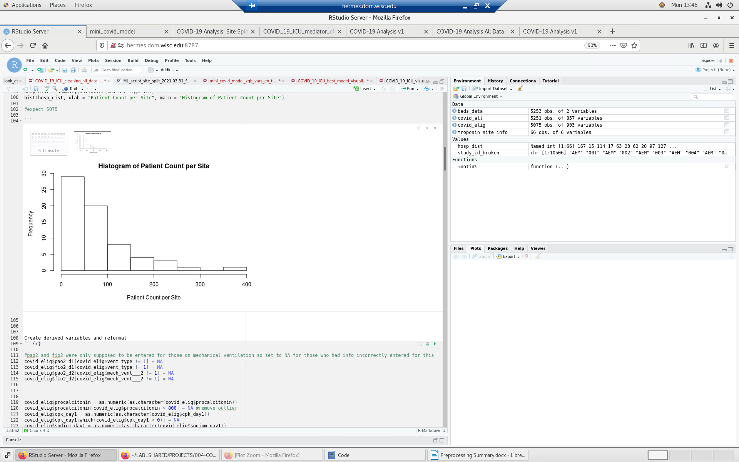

**eFigure 2. Comparison of model discrimination between the different models for in-hospital mortality.**

Abbreviations: AUC: area under the receiver operating characteristic curve; XGBoost = eXtreme Gradient Boosting; SVM = support vector machine; SCMI = STOP-COVID Mortality Index; SOFA = sequential organ failure assessment; KNN = K-nearest neighbors; NEWS = national early warning score

**eFigure 3. Calibration plots and statistics for the different machine learning models for the external (top) and temporal (bottom) validations.** Perfect calibration is shown by the shaded gray line, where actual (y-axis) and predicted (x-axis) probabilities are the same, p-values are from the unreliability index, and the vertical bars are histograms of predicted probabilities. XGBoost, Elastic Net, and SVM were well-calibrated (unreliability p>0.05), with a calibration intercept of 0 and slope of 1 and the plot showing that the actual probability of mortality is similar to the predicted probability of death from the model (as illustrated by the dark line falling within the shaded gray line). All other models demonstrated poor calibration (unreliability p<0.01).

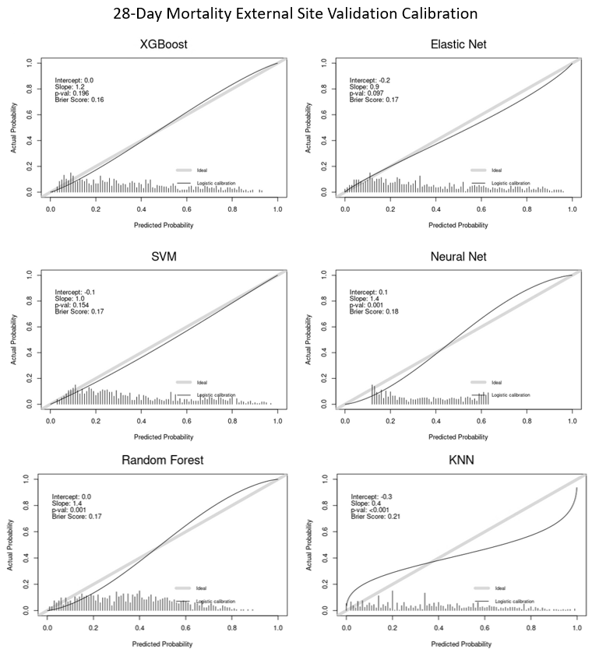

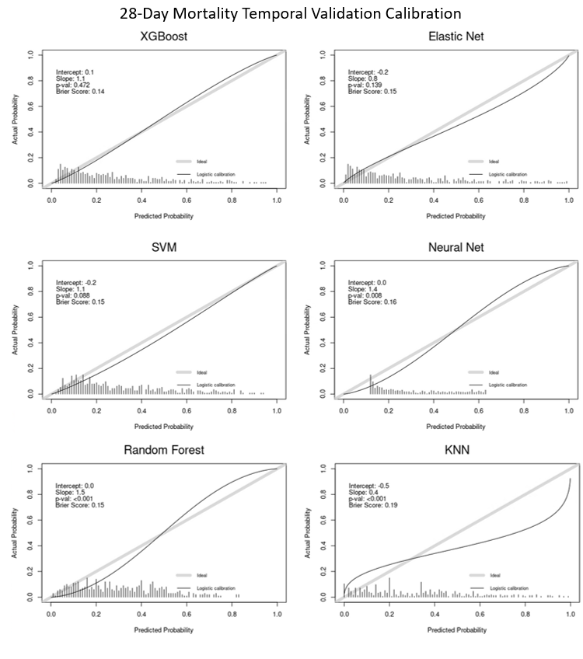

Abbreviations: XGBoost = eXtreme Gradient Boosting; SVM = support vector machine; KNN = K-nearest neighbors

**eFigure 4. Relationship between the modified SOFA Score and 28-day mortality in the external validation.**

Abbreviations: SOFA = sequential organ failure assessment

**eFigure 5. Relationship between the modified NEWS score and 28-day mortality in the external validation.**

Abbreviations: NEWS = National Early Warning Score

**eFigure 6. Relationship between the modified CURB-65 score and 28-day mortality in the external validation.**

**eFigure 7. Variable importance heat map illustrating the ten most important variables across the different models.** Variables are shown from most important (1 = dark blue) to less important (10 = light blue) to unimportant (white).

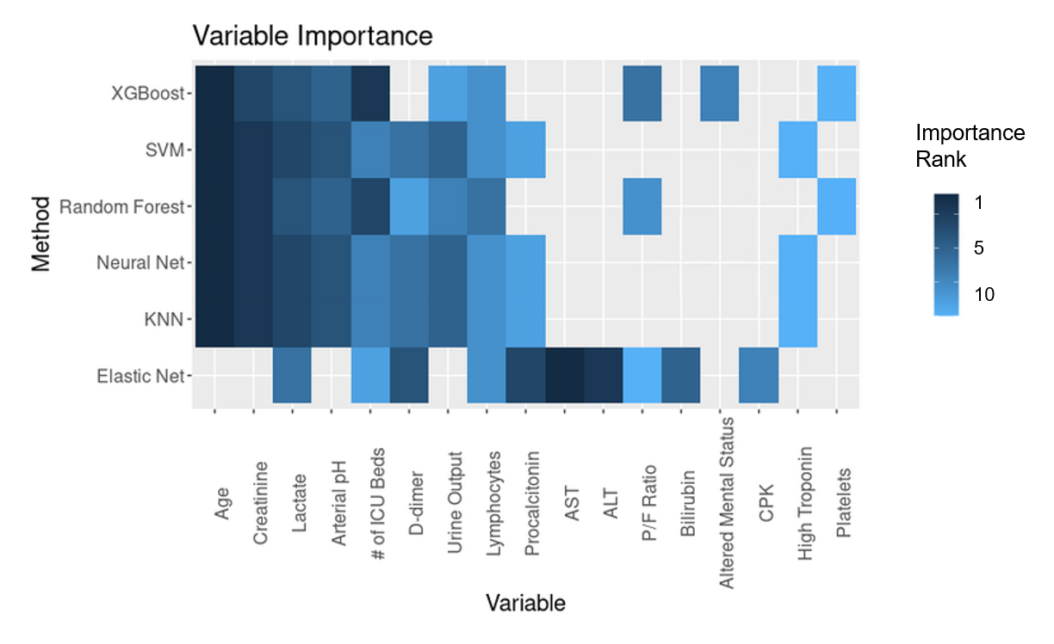

Abbreviations: SVM = support vector machine; KNN = K-nearest neighbors; ICU = intensive care unit; P/F ratio = PaO2/FiO2 ratio; PEEP = positive end-expiratory pressure; ALT = alanine aminotransferase

**eTable 1. Participating sites**

|  |
| --- |
| **Northeast** |
| Beth Israel Deaconess Medical Center |
| Brigham and Women’s Faulkner Hospital |
| Brigham and Women's Hospital |
| Cooper University Health Care |
| Hackensack Meridian Health Hackensack University Medical Center |
| Hackensack Mountainside Hospital |
| Johns Hopkins Hospital |
| Kings County Hospital Center |
| Lowell General Hospital |
| Massachusetts General Hospital |
| MedStar Georgetown University Hospital |
| Montefiore Medical Center |
| Mount Sinai |
| Newton Wellesley Hospital |
| New York-Presbyterian Queens Hospital |
| New York-Presbyterian/Weill Cornell Medical Center |
| New York University Langone Hospital |
| Rutgers/New Jersey Medical School |
| Rutgers/Robert Wood Johnson Medical School |
| Temple University Hospital |
| Thomas Jefferson University Hospital |
| Tufts Medical Center |
| United Health Services Hospitals |
| University of Pennsylvania Health System |
| University of Pittsburgh Medical Center |
| Westchester Medical Center |
| Yale University Medical Center |
| **South** |
| Baylor College of Medicine, Houston |
| Baylor University Medical Center/Baylor Scott White and Health |
| Duke University Medical Center |
| Mayo Clinic, Florida |
| Memphis VA Medical Center |
| Methodist University Hospital |
| Ochsner Medical Center |
| Tulane Medical Center |
| University of Alabama-Birmingham Hospital |
| University of Florida Health-Gainesville |
| University of Florida Health-Jacksonville |
| University of Miami Health System |
| University of North Carolina Hospitals |
| University of Texas Southwestern Medical Center |
| University of Virginia Health System |
| **Midwest** |
| Barnes-Jewish Hospital |
| Cook County Health |
| Froedtert Hospital |
| Indiana University Health Methodist Hospital |
| Mayo Clinic, Rochester Minnesota |
| Northwestern Memorial Hospital |
| Promedica Health System |
| Rush University Medical Center |
| University Hospitals Cleveland Medical Center |
| University of Chicago Medical Center |
| University of Illinois Hospital and Health Sciences System |
| University of Kentucky Hospital |
| University of Michigan Hospital |
| University of Oklahoma Health Sciences Center |
| **West** |
| Loma Linda University Medical Center |
| Mayo Clinic, Arizona |
| Oregon Health and Science University Hospital |
| Renown Health |
| Stanford Healthcare |
| University of California-Davis Medical Center |
| University of California-Los Angeles Medical Center |
| University of California-San Diego Medical Center |
| University of California-San Francisco Medical Center |
| UCHealth University of Colorado |
| University Medical Center of Southern Nevada |
| University of Washington Medical Center |

**eTable 2. Definitions of key variables and outcomes**

|  |  |
| --- | --- |
| **Baseline Characteristics** |  |
| Baseline serum creatinine | Lowest value (mg/dl) within 365 to 7 days prior to hospital admission. If not available, serum creatinine on hospital admission |
| Healthcare worker | Physician, nurse, technician, or other medical professional who provides direct care to patients (does not include ancillary staff such as clerks, pharmacists, or kitchen/cleaning staff) |
| Home medications | Medications that the patient was taking at home within 1 week prior to admission. Does not include those started at an outside hospital if the patient was transferred. |
| Anticoagulation | Therapeutic anticoagulants, not including anti-platelet agents such as aspirin or clopidogrel |
| Immunosuppressant drugs | Chemotherapy (in the 30 days prior to admission), corticosteroids >10 mg prednisone/day (or equivalent), calcineurin inhibitors (systemic, not topical), mycophenolate mofetil, azathioprine, rituximab, other |
| **Coexisting Conditions** |  |
| Asthma | Per chart review |
| Atrial fibrillation/flutter | Per chart review |
| Bone marrow transplant | Per chart review |
| Cancer | Per chart review; active malignancy (other than non-melanoma skin cancer) treated in the past year. Defined as cancer of the lung, breast, colorectal, prostate, gastric, pancreatic, melanoma, ovarian, brain, or other |
| Chronic kidney disease | Baseline eGFR< 60 on at least two consecutive values at least 12 weeks apart prior to hospital admission. If not available, defined as per chart review |
| Chronic liver disease | Cirrhosis, alcohol-related liver disease, nonalcoholic fatty liver disease, autoimmune hepatitis, hepatitis B or hepatitis C, primary biliary cirrhosis, or other |
| Chronic obstructive pulmonary disease | Per chart review |
| Congestive heart failure | Per chart review; heart failure with preserved versus reduced ejection fraction |
| Coronary artery disease | Per chart review; any history of angina, myocardial infarction, or coronary artery bypass graft surgery |
| Diabetes mellitus | Per chart review; insulin versus non-insulin dependent |
| End stage renal disease | Per chart review; on hemodialysis or peritoneal dialysis |
| History of alcohol abuse | Per chart review |
| HIV/AIDS | Per chart review |
| Homelessness | Per chart review |
| Hypertension | Per chart review |
| Solid organ transplant | Per chart review (kidney, liver, heart, lung, other) |
| Smoking | Per chart review; does not include vaping or smoking of non-tobacco products. Non-smoker, former smoker, current smoker |
| **Longitudinal Parameters and Treatmentsa** |  |
| Extracorporeal membrane oxygenation | Veno-venous, veno-arterial, or veno-arterial-venous |
| Mechanical cardiac support | Impella, intra-aortic balloon pump, LVAD, RVAD, other |
| Mechanical ventilation | Invasive mechanical ventilation |
| Renal replacement therapy | CRRT, intermittent hemodialysis, peritoneal dialysis, other |
| PaO2b | Lowest PaO2 available during each 24 hour day (midnight to midnight) |
| FiO2b | FiO2 corresponding to the lowest PaO2 |
| PEEPb | Highest PEEP available during each 24 hour day (midnight to midnight) |
| Vasopressors | Maximum number of vasopressors required each day |
| **Outcomesa** |  |
| Acute kidney injuryc | Doubling of serum creatinine from baseline or need for renal replacement therapy (RRT), corresponding with stages 2 and 3 of the Kidney Disease: Improving Global Outcomes Criteria.1 Baseline serum creatinine was defined as the lowest value from within 365 to 7 days prior to hospital admission. If unavailable, the hospital admission value was used as the baseline. |
| Acute liver injury | Modified version of the CTCAE criteria2: bilirubin >3.0 mg/dl *and* either AST>100 units per liter or ALT>100 units per liter |
| Acute cardiac injury | Troponin T or I > the 99th percentile upper reference limit of normal for that lab |
| Acute respiratory distress syndrome | Modified Berlin criteria3 (all three of the following were required): PaO2:FiO2 ratio<300 mm Hg and mechanically ventilated and a diagnosis of ARDS per chart review |
| Arrhythmia (new onset) | Per chart review; includes atrial fibrillation/flutter, ventricular tachycardia (sustained versus non-sustained), and ventricular fibrillation |
| Cardiac arrest | Per chart review |
| Coagulopathy | INR>2 or PTT>40 seconds in the absence of therapeutic anticoagulation |
| Congestive heart failure (new onset) | Per chart review; includes both heart failure with preserved and reduced ejection fraction |
| Disseminated intravascular Coagulation | Per chart review |
| Major bleed | Per chart review; bleeding in a critical area or organ (e.g., intracranial, retroperitoneal, pericardial, or intramuscular bleeding with compartment syndrome) or bleeding requiring a procedural intervention (e.g., EGD or IR embolization) |
| Myocarditis | Per chart review |
| Pericarditis | Per chart review |
| Respiratory failure | Requirement for invasive mechanical ventilation |
| Secondary Infection | Per chart review; suspected or confirmed new infection other than COVID-19 that developed after admission to the ICU. Pneumonia (including ventilator-associated), urosepsis, biliary sepsis, bacteremia, other |
| Shock | Requirement for 2 or more vasopressors |
| Thromboembolic event | Per chart review; deep venous thrombosis, pulmonary embolism, stroke, heparin-induced thrombocytopenia, other |
| **Cause of Death** | Per chart review; ARDS/respiratory failure, congestive heart failure, septic shock, kidney failure, liver failure, other |

Abbreviations: ALT = alanine transaminase; AST = aspartate transaminase; COVID-19 = coronavirus-19; CRRT = continuous renal replacement therapy, CTCAE = Common Terminology Criteria for Adverse Events; DVT = deep vein thrombosis; EGD = esophagogastroduodenoscopy; eGFR = estimated glomerular filtration rate; FiO2 = fraction of inspired oxygen; HIV/AIDs = human immunodeficiency syndrome/acquired immunodeficiency virus; IR = interventional radiology; LVAD = left ventricular assist device; PaO2 = partial pressure of oxygen; PE = pulmonary embolism; PEEP = positive end-expiratory pressure; RVAD = right ventricular assist device.

aLongitudinal treatments and outcomes were recorded daily for the first 14 days following admission to the ICU. If multiple values were present, the lowest PaO2 available, along with the corresponding FiO2 at the time, was recorded, while the highest PEEP on each day was recorded. If the patient had an outcome, the date of the outcome was recorded.

bOnly applies to patients on mechanical ventilation with an arterial blood gas available.

cExcludes patients with end stage renal disease.

References:

1Kidney Disease; Improving Global Outcomes (KDIGO) Acute Kidney Injury Work Group. KDIGO clinical practice guideline for acute kidney injury. *Kidney Int Suppl 2*, 2012: 1-138.

2US Department of Health and Human Services. Common Terminology Criteria for Adverse Events (CTCAE). Bethesda, MD: National Institute of Health, National Cancer Institute, 2017.

3The ARDS Definition Task Force. Acute Respiratory Distress Syndrome. The Berlin Definition. *JAMA*, 2012; 307(23): 2526-2533.

**eTable 3. Final variables used in the machine learning models.** The direction of high risk clarifies which value would be taken if more than one value is collected on day 1 and day 2 of the study and only applies to variables collected on both days (e.g., if two P/F ratios are available, we used the lower of the two values in the models).

|  |  |  |  |  |  |
| --- | --- | --- | --- | --- | --- |
| **Category** | **Variable** | **Direction of high risk\*** | **% Missing in Training Data** | **% Missing in Internal Test Data** | **% Missing in External Test Data** |
| **Demographics** |  |  |  |  |  |
|  | Age |  | 0.0 | 0.0 | 0.0 |
|  | Body Mass Index |  | 3.9 | 5.3 | 1.1 |
|  | Sex |  | 0.0 | 0.0 | 0.0 |
| **Vital signs (collected on day 1 only)** |  |  |  |  |  |
|  | Highest Heart Rate |  | 0.0 | 0.0 | 0.0 |
|  | Highest Respiratory Rate |  | 0.0 | 0.0 | 0.2 |
|  | Lowest Systolic Blood Pressure |  | 0.1 | 0.0 | 0.0 |
|  | Max Temperature |  | 0.1 | 0.0 | 0.2 |
|  | P/F Ratio | lower | 35.1 | 31.6 | 65.2 |
| **Coexisting Conditions** |  |  |  |  |  |
|  | Asthma |  | 0.0 | 0.0 | 0.0 |
|  | Atrial fibrillation |  | 0.0 | 0.0 | 0.0 |
|  | Bacterial Pneumonia |  | 0.0 | 0.0 | 0.0 |
|  | CKD |  | 0.0 | 0.0 | 0.0 |
|  | Congestive Heart Failure |  | 0.0 | 0.0 | 0.0 |
|  | COPD |  | 0.0 | 0.0 | 0.0 |
|  | Coronary Artery Disease |  | 0.0 | 0.0 | 0.0 |
|  | Hypertension |  | 0.0 | 0.0 | 0.0 |
|  | Insulin-dependent Diabetes |  | 0.0 | 0.0 | 0.0 |
|  | No Cardiovascular Comorbidities |  | 0.0 | 0.0 | 0.0 |
|  | No Infection |  | 0.0 | 0.0 | 0.0 |
|  | No Other Comorbidities |  | 0.0 | 0.0 | 0.0 |
|  | Non-Insulin-dependent Diabetes |  | 0.0 | 0.0 | 0.0 |
|  | Other Lung Diseases |  | 0.0 | 0.0 | 0.0 |
|  | Smoking |  | 14.5 | 13.4 | 9.1 |
|  |  |  |  |  |  |
| **Symptoms** | Altered Mental Status |  | 8.1 | 5.1 | 5.7 |
|  | Chills |  | 0.0 | 0.0 | 0.0 |
|  | Confusion |  | 0.0 | 0.0 | 0.0 |
|  | Cough |  | 0.0 | 0.0 | 0.0 |
|  | Diarrhea |  | 0.0 | 0.0 | 0.0 |
|  | Fatigue |  | 0.0 | 0.0 | 0.0 |
|  | Fever |  | 0.0 | 0.0 | 0.0 |
|  | Headache |  | 0.0 | 0.0 | 0.0 |
|  | Myalgia Arthralgia |  | 0.0 | 0.0 | 0.0 |
|  | Nasal Congestion |  | 0.0 | 0.0 | 0.0 |
|  | Nausea/Vomiting |  | 0.0 | 0.0 | 0.0 |
|  | Prior Symptom Days |  | 0.6 | 0.3 | 0.9 |
|  | Short of breath |  | 0.0 | 0.0 | 0.0 |
|  | Sore Throat |  | 0.0 | 0.0 | 0.0 |
|  | Sputum Production |  | 0.0 | 0.0 | 0.0 |
| **Labs** |  |  |  |  |  |
|  | Albumin | lower | 9.6 | 9.8 | 8.4 |
|  | ALT | higher | 7.9 | 10.6 | 10.0 |
|  | Arterial pH | lower | 20.6 | 19.1 | 34.1 |
|  | AST | higher | 8.1 | 10.6 | 10.0 |
|  | Bilirubin | higher | 8.6 | 10.6 | 10.0 |
|  | CPK (recorded day 1 only) |  | 48.5 | 59.5 | 48.1 |
|  | Creatinine | higher | 2.2 | 0.6 | 4.1 |
|  | CRP | higher | 23.3 | 27.6 | 18.8 |
|  | D-dimer | higher | 30.5 | 37.7 | 16.8 |
|  | Ferritin | higher | 25.8 | 30.8 | 25.2 |
|  | Hemoglobin | lower | 2.3 | 0.7 | 3.9 |
|  | Indicator for High Troponin | higher | 36.4 | 41.2 | 36.6 |
|  | Lactate | higher | 27.4 | 34.8 | 30.5 |
|  | Lymphocyte Count | lower | 11.3 | 9.5 | 15.4 |
|  | Platelets | lower | 2.6 | 0.7 | 4.3 |
|  | Procalcitonin |  | 38.2 | 34.6 | 30.5 |
|  | Sodium |  | 0.5 | 0.3 | 0.9 |
|  | Urine Output | lower | 27.7 | 26.8 | 49.5 |
|  | White Blood Cell Count | higher | 2.3 | 0.7 | 3.9 |
| **Treatments** |  |  |  |  |  |
|  | Mechanically Ventilated |  | 0.1 | 0.0 | 0.2 |
|  | Number of Vasopressors | higher | 0.0 | 0.0 | 0.0 |
|  | PEEP if on a Ventilator (day1 and day2) |  | Day 1: 34.6  Day 2: 4.7 | Day 1: 29.2  Day 2: 4.5 | Day 1: 52.5  Day2: 2.3 |
|  | Renal Replacement Therapy |  | 0.0 | 0.0 | 0.0 |
| **Other** |  |  |  |  |  |
|  | Hospital Type |  | 0.0 | 0.0 | 0.0 |
|  | Number of ICU beds |  | 0.0 | 0.0 | 0.0 |
|  | Source Admit |  | 0.0 | 0.0 | 0.0 |

*If two or more values were available, then the worst value was chosen based on the direction of high risk.

Abbreviations: ICU = intensive care unit; CKD = chronic kidney disease; COPD = chronic obstructive pulmonary disease; P/F ratio = PaO2/FiO2 ratio; PEEP = positive end-expiratory pressure; ALT = alanine aminotransferase; AST = aspartate aminotransferase

**eTable 4. Modified SOFA score.** The SOFA score was modified from the original published version because of missing Glasgow coma scale, mean arterial pressure, and vasopressor doses in the database.

|  |  |  |  |  |  |
| --- | --- | --- | --- | --- | --- |
|  | **0** | **1** | **2** | **3** | **4** |
| **SOFA Renal (Cr [mg/dl], UOP [ml/day], and acute RRT)** | Cr<1.2 and UOP≥500 | Cr 1.2-1.9 and UOP≥500 | Cr 2-3.4 and UOP≥500 | Cr 3.5-4.9 or UOP 200-499 | Cr ≥5 or UOP<200 or acute RRT or ESRD |
| **SOFA Liver (Bilirubin, mg/dl)** | <1.2 | 1.2-1.9 | 2.0-5.9 | 6.0-11.9 | ≥12 |
| **SOFA Coagulation (Platelets, K/mm3)** | ≥150 | 100-149 | 50-99 | 20-49 | <20 |
| **SOFA Respiratory (PaO2:FiO2)** | ≥400 or not intubated | 300-399 | 200-299 | 100-199 | <100 |
| **SOFA Cardiovascular (#vasopressors/inotropes)** | 0 | 1 | 2 | 3 | ≥4 |
| **SOFA CNS** | No AMS |  | AMS |  |  |

Abbreviations: CNS = central nervous system; Cr = creatinine; ESRD = end stage renal disease; RRT = renal replacement therapy; SBP = systolic blood pressure; SOFA = sequential organ failure assessment; UOP = urine output; AMS = altered mental status

**eTable 5. Modified NEWS.** The NEWS was modified from its original version due to missing oxygen saturation and because nearly all patients were on some form of supplemental oxygen.

|  |  |  |  |  |
| --- | --- | --- | --- | --- |
|  | **0** | **1** | **2** | **3** |
| **Respiratory Rate (per minute)** | 12-20 | 9-11 | 21-24 | ≤8 or ≥25 |
| **Systolic Blood Pressure (mmHg)** | 111-219 | 101-110 | 91-100 | ≤90 or ≥ 220 |
| **Pulse (per minute)** | 51-90 | 41-50 or 91-110 | 111-130 | ≤40 or ≥ 131 |
| **Temperature (°C)** | 36.1-38.0 | 35.1-36.0 or 38.1-39.0 | ≥39.1 | ≤35 |
| **Air or Oxygen** | Not Ventilated Day 1 |  | Ventilated Day 1 |  |
| **Consciousness** | No AMS |  |  | AMS |

Abbreviations: NEWS = National Early Warning Score; AMS = altered mental status

**eTable 6. Comparison of patient characteristics for those who survived vs. died at 28 days after ICU admission.**

|  |  |  |  |  |
| --- | --- | --- | --- | --- |
| **Variable** | **Summary Measure** | **All Patients**  **(n = 5075)** | **Survivors**  **(n = 3229)** | **Non-Survivors**  **(n = 1846)** |
| **Demographics** |  |  |  |  |
| Age (years) | Median (P25-P75) | 62 (52-71)* | 59 (49-68) | 67 (58-76) |
| Body Mass Index (kg/m2) | Median (P25-P75) | 30.3 (26.4-35.9)* | 30.7 (26.6-36.0) | 29.8 (25.8-35.3) |
| Male | n (%) | 3198 (63.0)* | 1981 (61.4) | 1217 (65.9) |
| **Symptoms** |  |  |  |  |
| Cough | n (%) | 3661 (72.1)* | 2430 (75.3) | 1231 (66.7) |
| Diarrhea | n (%) | 1039 (20.5)* | 720 (22.3) | 319 (17.3) |
| Fatigue or malaise | n (%) | 1606 (31.6) | 1034 (32.0) | 572 (31.0) |
| Fever | n (%) | 3353 (66.1)* | 2218 (68.7) | 1135 (61.5) |
| Nausea/Vomiting | n (%) | 793 (15.6)* | 583 (18.1) | 210 (11.4) |
| Prior Symptom Days | Median (P25-P75) | 7 (4-10)* | 7 (4-11) | 7(3-10) |
| Dyspnea | n (%) | 3793 (74.7) | 2417 (74.9) | 1376 (74.5) |
| Sputum Production | n (%) | 532 (10.5)* | 368 (11.4) | 164 (8.9) |
| **Coexisting Conditions** |  |  |  |  |
| Asthma | n (%) | 544 (10.7)* | 378 (11.7) | 166 (9.0) |
| Chronic Kidney Disease | n (%) | 665 (13.1)* | 343 (10.6) | 322 (17.4) |
| Congestive Heart Failure | n (%) | 516 (10.2)* | 284 (8.8) | 232 (12.6) |
| Chronic Obstructive Pulmonary Disease | n (%) | 439 (8.7)* | 230 (7.1) | 209 (11.3) |
| Coronary Artery Disease | n (%) | 685 (13.5)* | 347 (10.7) | 338 (18.3) |
| Hypertension | n (%) | 3113 (61.3)* | 1809 (56.0) | 1304 (70.6) |
| Insulin Dependent Diabetes | n (%) | 843 (16.6)* | 471 (14.6) | 372 (20.2) |
| Non-Insulin Dependent Diabetes | n (%) | 1295 (25.5)* | 780 (24.2) | 515 (27.9) |
| Other Pulmonary Disease | n (%) | 334 (6.6) | 203 (6.3) | 131 (7.1) |
| Smoking |  |  |  |  |
| Former | n (%) | 1229 (28.1)* | 723 (25.5) | 506 (32.9) |
| Current | n (%) | 259 (5.9) | 164 (5.8) | 95 (6.2) |
| **Vital signs on ICU Day 1** |  |  |  |  |
| Highest Heart Rate (beats/min) | Median (P25-P75) | 104 (90-120)* | 103 (90-117) | 108 (93-124) |
| Lowest Systolic Blood Pressure (mm Hg) | Median (P25-P75) | 97 (85-111)* | 99 (87-111) | 94 (82-109) |
| Max Temperature (°C) | Median (P25-P75) | 37.9 (37.2-38.8)* | 37.9 (37.2-38.8) | 37.8 (37.1-38.7) |
| **Labs on ICU Days 1-2** |  |  |  |  |
| Creatinine (mg/dl) | Median (P25-P75) | 1.2 (0.9-2.1)* | 1.1 (0.8-1.6) | 1.6 (1.0-2.9) |
| C-reactive protein (mg/L) | Median (P25-P75) | 167 (90-256)* | 162 (87-246) | 181 (100-273) |
| D-dimer (ng/mL) | Median (P25-P75) | 1590 (751-4340)* | 1260 (660-3180) | 2390 (1078-7955) |
| Lactate (mmol/L) | Median (P25-P75) | 1.6 (1.2-2.4)* | 1.5 (1.1-2.0) | 2.0 (1.3-3.0) |
| Lymphocytes (%) | Median (P25-P75) | 8.5 (5.0-13.4)* | 9.6 (6.0-14.4) | 7.0 (4.0-11.0) |
| Platelets (K/mm3) | Median (P25-P75) | 203 (154-263)* | 208 (162-267.0) | 192.0 (139.0-254.0) |
| Total Bilirubin (mg/dl) | Median (P25-P75) | 0.6 (0.4-0.9)* | 0.6 (0.4-0.9) | 0.6 (0.4-1.0) |
| White Blood Cell Count (per mm3) | Median (P25-P75) | 9.6 (6.8-13.6)* | 9.1 (6.6-12.5) | 10.8 (7.6-15.4) |
| **Severity of Illness on ICU Days 1-2** |  |  |  |  |
| PEEP Day 1 | Median (P25-P75) | 10 (5-15)* | 10 (0-14) | 12 (8-15) |
| P/F Ratio (mm Hg) | Median (P25-P75) | 116 (80-171)* | 122 (84-178) | 106 (76-159) |
| Ventilation |  |  |  |  |
| Invasive Mechanical Ventilation | n (%) | 3029 (59.7)* | 1712 (53.1) | 1317 (71.3) |
| BiPaP/CPAP/High flow Nasal Cannula | n (%) | 1372 (27.1)* | 962 (29.8) | 410 (22.2) |
| Renal Replacement Therapy | n (%) | 381 (7.5) | 200 (6.2)* | 181 (9.8) |
| Vasopressors |  |  |  |  |
| 1 | n (%) | 1788 (35.2)* | 1102 (34.1) | 686 (37.2) |
| 2 or more | n (%) | 829 (16.3)* | 374 (11.6) | 455 (24.6) |
| **Other** |  |  |  |  |
| Number of pre-COVID ICU beds | Median (P25-P75) | 87 (48-115)* | 98 (55-120) | 58 (47-100) |

*P-value <0.05 for difference between survivors and non-survivors (Wilcoxon rank-sum test for continuous variables and chi-squared for categorical variables). Abbreviations: PEEP = positive end-expiratory pressure; P/F = PaO2/FiO2; ICU = intensive care unit.

**eTable 7. Other baseline and first 48-hour characteristics among patients who died vs. survived by day 28**

|  |  |  |  |  |
| --- | --- | --- | --- | --- |
| **Variable** | **Summary Measure** | **All Patients**  **(n = 5075)** | **Survivors**  **(n = 3229)** | **Non-Survivors**  **(n = 1846)** |
| **Symptoms** |  |  |  |  |
| Altered Mental Status | n (%) | 1183 (25.2)* | 524 (17.4) | 659 (39.2) |
| Chills | n (%) | 984 (19.4)* | 679 (21.0) | 305 (16.5) |
| Confusion | n (%) | 649 (12.8)* | 317 (9.8) | 332 (18.0) |
| Headache | n (%) | 447 (8.8)* | 352 (10.9) | 95 (5.1) |
| Myalgia Arthralgia | n (%) | 1104 (21.8)* | 831 (25.7) | 273 (14.8) |
| Nasal Congestion | n (%) | 299 (5.9)* | 219 (6.8) | 80 (4.3) |
| Sore Throat | n (%) | 391 (7.7)* | 272 (8.4) | 119 (6.4) |
| **Coexisting Conditions** |  |  |  |  |
| No Cardiovascular/Pulmonary Comorbiditie | n (%) | 1139 (22.4)* | 872 (27.0) | 267 (14.5) |
| No Secondary Infectio | n (%) | 3942 (77.7)* | 2565 (79.4) | 1377 (74.6) |
| No Other Comorbiditie | n (%) | 3740 (73.7)* | 2532 (78.4) | 1208 (65.4) |
| **Vital signs¹** |  |  |  |  |
| Highest Respiratory Rate (beats/min) | Median (P25-P75) | 31 (26-38) | 32 (26-38) | 31 (26-38) |
| **Laboratory values** |  |  |  |  |
| Albumin (g/dl) | Median (P25-P75) | 2.9 (2.5-3.3)* | 3.0 (2.6-3.3) | 2.8 (2.4-3.1) |
| Alanine aminotransferase - ALT (U/L) | Median (P25-P75) | 38 (23-65)* | 37 (23-63) | 38 (24-67) |
| Arterial pH | Median (P25-P75) | 7.3 (7.3-7.4)* | 7.4 (7.3-7.4) | 7.3 (7.2-7.4) |
| Aspartate aminotransferase - AST (U/L) | Median (P25-P75) | 56 (37-89)* | 52 (36-82) | 64 (41-107) |
| Creatinine Phosphokinase¹ - CPK (U/L) | Median (P25-P75) | 192 (87-518)* | 179 (83-467) | 230 (100-663) |
| Ferritin (ng/ml) | Median (P25-P75) | 1052 (522-2000)* | 951(483-1795) | 1268 (597-2667) |
| Hemoglobin (g/dl) | Median (P25-P75) | 11.8 (10.3-13.1)* | 11.9 (10.5-13.2) | 11.5 (9.9-13.0) |
| High Troponin Indicator | n (%) | 1578 (49.5)* | 836 (41.1) | 742 (64.3) |
| Procalcitonin¹ (ng/ml) | Median (P25-P75) | 0.4 (0.2-1.4)* | 0.3 (0.1-0.9) | 0.7 (0.2-2.6) |
| Sodium¹ | Median (P25-P75) | 137 (134-140)* | 137 (134-140) | 137 (134-141) |
| Urine Output (mL) | Median (P25-P75) | 700 (315-1135)* | 800 (410-1250) | 525 (210-950) |
| **Severity of Illness** |  |  |  |  |
| PEEP Day 2 | Median (P25-P75) | 10 (0-14)* | 8 (0-14) | 10 (0-14) |
| Mechanical Ventilator Day 2 | n (%) | 3317 (65.4)* | 1938 (60.0) | 1379 (74.7) |
| **Other** |  |  |  |  |
| Hospital Type: main vs affiliate | n (%) | 4389 (86.5) | 2813 (87.1) | 1576 (85.4) |
| Source of Admit |  |  |  |  |
| Emergency Department | n (%) | 2787 (54.9) | 1755 (54.4) | 1032 (55.9) |
| Hospital Ward | n (%) | 1522 (30.0)* | 926 (28.7) | 596 (32.3) |

*P-value <0.05 for difference between survivors and non-survivors (Wilcoxon rank sum test for continuous variables and chi-squared for categorical)

1Available day 1 only; peep and ventilation value included for both day 1 and day 2 due to differences in granularity of ventilator type

2Indicator for lack of any of the following cardiovascular and pulmonary comorbidities: diabetes mellitus, hypertension, coronary artery disease, congestive heart failure, atrial fibrillation/flutter, COPD, Asthma, other lung disease

3Indicator for lack of any of the following infections: bacterial pneumonia, viral respiratory infection, urosepsis, biliary sepsis, cellulitis, bacteremia/endocarditis, other

4Indicator for lack of any of the following other comorbidities: chronic kidney disease, ESRD, chronic liver disease, HIV/AIDS, active malignancy, solid organ transplant, bone marrow transplant, other immunodeficiency

Abbreviations: PEEP = positive end-expiratory pressure

**eTable 8. Model details.** Details of R packages and tuning grids utilized. Bold indicates chosen hyperparameter in final model.

|  |  |  |  |
| --- | --- | --- | --- |
| **Model** | **Model within caret package** | **Hyperparameters Tested** | **Method to obtain probabilities\*** |
| **Elastic Net** | glmnet with rcs and 3 knots for continuous variables | alpha = c(0,0.1,0.2,0.4,0.6,0.8,**1**), lambda = sequence from **0** to .1 20 digits long | elastic net logistic regression |
| **XGBoost** | xgbtree | nrounds=c(500, 1000, **1500**), max_depth=c(**2**, 5, 10) , eta=c(0.001, **0.01**,0.1), gamma = c(**0**),, colsample_bytree = c(**1**), min_child_weight = c(**1**,2, 5), subsample = c(**0.5**) | sum of leaf’s weights |
| **Random Forest** | rf | mtry = c(2,4,5,**20**) | proportion of trees voting for a given class |
| **KNN** | kknn | kmax = c(5,7,**9**,12,15), kernel =  c("**optimal**"), distance = c(1,**2**) | proportion of neighbors voting for a given class |
| **Neural Net** | mlpKerasDropout | random search length 100 chose  size = 8, dropout = 0.6242863, batch_size = 869, lr = 0.07409052, rho = 0.6956519, decay = 0.2133154 and activation = sigmoid | sigmoid |
| **SVM** | svmRadial | sigma = c(**.01**), C = seq(0.25, 2, length = 20) **0.639** | rescaled version of the original classifiers scored through a logistic transformation |

*The default method for calculating probabilities for each model’s package was used, with a brief description in this column.

Abbreviations: KNN = K-nearest neightbors, SVM = support vector machine