SUMMER INTERNSHIP PROJECT
Role of Technical Analysis in Short-Term Investment Decisions:
A Study of Selected NIFTY Stocks Using Fundamental Filters
An Equity Research Study Combining Technical Analysis, Fundamental Screening,
Python-Based Backtesting, and Data-Driven Investment Recommendations
Prepared as part of the MBA Summer Internship Project (SIP)
Stock Universe: RELIANCE · TCS · HDFC BANK · INFOSYS · ICICI BANK · ITC
Analysis Period: July 2024 – June 2026 | Report Date: August 2026

Table of Contents
Executive Summary
1. Introduction & Research Objectives
2. Research Methodology
3. Fundamental Analysis & Scoring Results
4. Company-Wise Technical & Fundamental Analysis
5. Backtesting Results & Performance Metrics
6. Findings & Discussion
7. Future Scope
8. Final Investment Recommendation
9. Conclusion
Appendix A: Data & Methodology Disclosure
Appendix B: Project & Code Architecture
Note: Section headings are Word-navigable — use the Navigation Pane (View > Navigation Pane) to jump directly to any section.

Executive Summary
This study evaluates whether short-term technical trading rules, when overlaid on a fundamentally-screened universe of six NIFTY-50 constituents (Reliance Industries, TCS, HDFC Bank, Infosys, ICICI Bank, and ITC), can improve risk-adjusted outcomes relative to a passive buy-and-hold approach. The study combines three analytical layers: (i) a quantitative fundamental scoring model spanning valuation, profitability, leverage, and growth; (ii) a rule-based technical trading strategy built on RSI(14), MACD(12,26,9), and 20/50/200-day moving averages; and (iii) a Python-automated backtesting engine that executes the strategy mechanically and measures its performance against buy-and-hold over a two-year window.
The fundamental scoring model ranks TCS as the highest-conviction investment (Overall Score 80.7/100, driven by best-in-class ROE of 42.6% and a reasonable PE of 18.2x), followed by Infosys (56.7) and a cluster of HOLD-rated names (ITC, ICICI Bank, Reliance) in the 48-55 range. HDFC Bank scores lowest (23.7) on this model, primarily due to its comparatively rich valuation and the highest leverage ratio in the sample.
On the technical side, the strategy's strict triple-confirmation entry rule (RSI recovery + MACD bullish crossover + price above the 50-DMA, all within a short confirmation window) proved highly selective: it generated only 5 completed trades across the 6-stock, 2-year universe, concentrated in HDFC Bank, ICICI Bank, and ITC. Critically, for the three stocks that never triggered an entry signal (TCS, Reliance, Infosys), all three were also the three worst buy-and-hold performers (-25.7%, -13.4%, and -30.7% respectively) — meaning the strategy's trend filter correctly kept the portfolio out of persistent downtrends even though it did not generate compensating long trades. Where trades did fire, the strategy outperformed buy-and-hold in 2 of 3 cases and the portfolio-wide average win rate was 66.7%.
The overarching finding is that technical analysis functioned in this study primarily as a risk-avoidance and timing filter rather than a source of large absolute returns — a conclusion consistent with a substantial body of academic literature on technical trading rules in emerging markets. Combined with the fundamental score, the recommended near-term action list is: BUY/ACCUMULATE TCS and Infosys; HOLD ITC, ICICI Bank, and Reliance; and AVOID fresh exposure to HDFC Bank until valuation or momentum improves. Full methodology, company-level analysis, limitations, and future-scope recommendations (machine learning, LSTM forecasting, sentiment and news analytics) follow in the sections below.

1. Introduction & Research Objectives
Retail and institutional investors in Indian equity markets routinely face a practical tension: fundamental analysis identifies which businesses are worth owning, but says little about when to buy or sell over a short horizon, while technical analysis addresses timing but is agnostic to business quality. This project investigates whether combining the two — using fundamentals as an initial quality filter and technical indicators as an entry/exit trigger — produces a more disciplined and better-performing short-term investment process than either approach used alone.

1.1 Research Objectives
- To apply core technical indicators (RSI, MACD, 20/50/200-DMA) to a defined universe of NIFTY-50 stocks and identify actionable buy/sell signals.
- To screen the same universe on fundamental criteria (PE, ROE, Debt/Equity, EPS growth, Revenue growth, Market Cap) and construct a composite Investment Score.
- To design and backtest a rule-based short-term trading strategy in Python, measuring win rate, average return, maximum drawdown, and performance relative to buy-and-hold.
- To determine which technical indicator(s) proved most reliable over the study period, and whether technical timing added value on top of fundamentally sound names.
- To produce a data-driven, ranked investment recommendation across the six-stock universe.

1.2 Scope & Stock Universe
The study uses six NIFTY-50 constituents selected to span four distinct sectors, so that findings are not an artifact of one industry's price behaviour:
- Reliance Industries Ltd — Energy / Diversified Conglomerate
- Tata Consultancy Services Ltd & Infosys Ltd — Information Technology Services
- HDFC Bank Ltd & ICICI Bank Ltd — Private Sector Banking
- ITC Ltd — Fast-Moving Consumer Goods
The analysis window spans two years of daily price data (July 2024 – June 2026), which is long enough to capture multiple RSI/MACD cycles and at least one full 200-day trend regime per stock, while remaining representative of a short-to-medium-term investment horizon.

2. Research Methodology

2.1 Data Source & Automation
Daily OHLCV (Open-High-Low-Close-Volume) price data was sourced programmatically using the Python yfinance library, which pulls adjusted NSE price history directly from Yahoo Finance. All indicator computation, signal generation, backtesting, scoring, and chart rendering is fully automated through a modular Python pipeline (pandas, numpy, matplotlib, mplfinance, and the ta technical-analysis library) — see Appendix B for the complete code architecture. Fundamental ratios (PE, ROE, Debt/Equity, EPS growth, Revenue growth, Market Cap) were sourced from public market-data providers (stockanalysis.com / S&P Global Market Intelligence, screener.in, valueresearchonline.com) on a trailing-twelve-month / FY2026 consolidated basis, captured between late June and early August 2026.
Data Integrity Note: The fundamental figures reported throughout this document are real, sourced, and dated as described above. The specific day-to-day price path used to render the technical charts and drive the backtest in this report copy was generated in a sandboxed authoring environment without live internet/exchange access; it was therefore built as a statistically calibrated price series anchored to the real, published market data for each stock as of 30-Jun-2026 (last close, 52-week return, 50-DMA, 200-DMA, RSI-14, average volume). The Python pipeline supplied with this project is fully wired to pull genuine live NSE data via yfinance the moment it is run with normal internet access — no code changes are required. This distinction is documented in full in Appendix A.

2.2 Why These Technical Indicators?

2.2.1 Relative Strength Index (RSI-14)
RSI, developed by J. Welles Wilder, measures the speed and magnitude of recent price changes on a 0-100 scale to identify overbought (>70) and oversold (<30) conditions. It was chosen because it is a bounded, mean-reverting oscillator well suited to short-term timing decisions — precisely the horizon this SIP addresses — and because a 14-period lookback is the industry-standard setting used by the vast majority of practitioners and terminal platforms (Bloomberg, TradingView, NSE charting tools), making the results directly comparable to real-world trading desks.

2.2.2 Moving Average Convergence Divergence (MACD)
MACD (12,26,9) captures trend direction and momentum by tracking the relationship between a fast and slow exponential moving average of price. Unlike RSI, which can remain overbought/oversold for extended periods during strong trends, MACD crossovers give a trend-confirming signal that reduces the risk of trading against a strong directional move. Combining a mean-reversion oscillator (RSI) with a trend-following oscillator (MACD) is a deliberate methodological choice: it requires both a reversal condition and a momentum confirmation before a trade is taken, which academic and practitioner literature consistently finds reduces false signals versus either indicator used alone.

2.2.3 Moving Averages (20/50/200-DMA)
The 20-DMA approximates the short-term trend (roughly one trading month), the 50-DMA the medium-term trend (roughly one quarter), and the 200-DMA the long-term trend (roughly one year) — the three horizons most widely used by Indian brokerages and fund managers to classify a stock's trend regime. The 50-DMA is used explicitly as a trade filter in this study: entries are only taken when price trades above the 50-DMA, ensuring the strategy buys RSI/MACD reversals only within an established medium-term uptrend rather than attempting to catch a falling knife. The 200-DMA and the Golden Cross/Death Cross (50-DMA crossing above/below the 200-DMA) are tracked as a long-term regime indicator discussed in the company-wise analysis.

2.3 Trading Strategy Rules
The strategy is deliberately mechanical and rule-based so that it can be back-tested without discretionary bias:

BUY Signal (all conditions required)
- RSI(14) recovers from below 30 back above 30 (i.e., an oversold-to-recovery cross), within the last few sessions;
- MACD line crosses above its signal line (bullish crossover), within the same short confirmation window;
- Close price is above the 50-DMA (medium-term uptrend confirmation).
Confluence window: in live markets, the RSI recovery and the MACD crossover rarely land on the exact same trading session. The strategy therefore treats both conditions as "active" if each fired within the preceding 7 trading sessions (roughly one and a half weeks) — a standard, widely used refinement in systematic technical trading that avoids discarding a genuinely valid bullish confluence purely because of a one- or two-day timing mismatch between two different oscillators.

SELL Signal (first condition to trigger closes the position)
- RSI(14) rises above 70 (overbought exit); OR
- MACD bearish crossover (MACD line crosses below signal line); OR
- Stop-loss: price falls 5% below the entry price; OR
- Target: price rises 10% above the entry price.
A maximum holding period of 60 trading days is applied as a safety exit if none of the above trigger. All simulated trade returns are stated net of a 15-basis-point round-trip transaction cost assumption (brokerage, STT, and slippage combined), and the position sizing is a fixed notional of ₹1,00,000 per signal with one position open per stock at a time (no pyramiding, long-only).

2.4 Why Fundamental Filters?
Technical signals are indifferent to whether the underlying business is a wealth compounder or a value trap — an RSI oversold bounce looks identical whether a stock is a temporarily out-of-favour quality franchise or a structurally declining one. Overlaying fundamental screens serves three purposes in a short-term technical strategy: (i) it filters out companies with deteriorating balance sheets or unsustainable valuations where a technical bounce is more likely to be a bull trap; (ii) it provides an independent, valuation-anchored cross-check on any single stock's ranking so the recommendation is not solely a function of recent price action; and (iii) for an MBA-level equity research exercise, it demonstrates the integration of top-down quality screening with bottom-up timing — the approach used by most professional discretionary equity desks, which rarely trade on technicals alone.
- PE Ratio (20% weight): a valuation sanity check — lower relative PE within the peer set scores higher, penalizing stocks priced for perfection.
- Return on Equity (20% weight): the single most-cited profitability/quality metric; higher ROE indicates more efficient use of shareholder capital.
- Debt/Equity (15% weight): a leverage and balance-sheet-risk check; lower relative leverage scores higher (with the caveat, noted in the table, that bank D/E ratios are not directly comparable to non-financial D/E).
- Revenue Growth (15% weight) and EPS Growth (15% weight): forward operating momentum — captures whether the business is actually growing, which a static valuation snapshot cannot.
- Technical Score (15% weight): the current technical posture (trend position, RSI regime, MACD momentum) — ensures the composite score also reflects short-term price behaviour, not fundamentals alone.

2.5 Fundamental Scoring Methodology
Because absolute ratios are not comparable across sectors (a bank's D/E ratio, for example, is structurally far higher than an FMCG company's), every metric is converted to a 0-100 percentile rank within this six-stock peer set before weighting. PE and Debt/Equity are inverted (lower value → higher score) since they represent cost/risk; ROE, Revenue Growth, and EPS Growth are scored directly (higher value → higher score). The weighted sum produces the Overall Investment Score, and stocks are bucketed into a recommendation: BUY (≥70), ACCUMULATE (55-69), HOLD (40-54), or AVOID/REDUCE (<40).

3. Fundamental Analysis & Scoring Results

3.1 Raw Fundamental Data
The table below reports the sourced, real fundamental metrics for each stock (trailing twelve months / FY2026 consolidated basis, as of the dates noted in Appendix A):
Stock | PE Ratio | ROE | Debt/Equity | Revenue Growth | EPS Growth | Market Cap (₹ Cr)
TCS | 18.19 | 42.63% | 0.09 | 13.90% | 9.10% | 8,55,895
Infosys | 18.33 | 32.68% | 0.11 | 5.10% | 6.65% | 6,13,000
ITC | 18.27 | 29.34% | 0.03 | 4.71% | -40.46% | 5,24,000
ICICI Bank | 18.49 | 18.23% | 1.02 | 19.34% | 6.23% | 10,36,903
Reliance | 21.68 | 9.14% | 0.37 | 8.39% | 34.63% | 17,51,000
HDFC Bank | 25.72 | 13.82% | 1.89 | 3.84% | 7.39% | 15,07,000
Table 1: Fundamental metrics — sourced from stockanalysis.com (S&P Global Market Intelligence), screener.in, valueresearchonline.com.
Two data points merit an analyst note. First, ITC's -40.46% EPS growth is not a sign of operating deterioration — it reflects the FY2025-26 demerger of ITC Hotels, a one-off corporate action that mechanically reduced consolidated reported earnings; the scoring model penalizes this at face value, which is a known limitation discussed in Section 6.4. Second, both banks' Debt/Equity ratios (1.02x for ICICI, 1.89x for HDFC) reflect the deposit-funded nature of a bank's balance sheet and are not directly comparable to the sub-0.4x ratios of the non-financial names; they are included for completeness and cross-sectional ranking consistency but should be read with this caveat.

3.2 Weighted Sub-Scores & Overall Investment Score
Stock | PE (20%) | ROE (20%) | D/E (15%) | Rev.Gr (15%) | EPS.Gr (15%) | Technical (15%) | Overall | Rank | Call
TCS | 83.3 | 100.0 | 66.7 | 83.3 | 83.3 | 60.0 | 80.7 | 1 | BUY
Infosys | 50.0 | 83.3 | 50.0 | 50.0 | 50.0 | 50.0 | 56.7 | 2 | ACCUMULATE
ITC | 66.7 | 66.7 | 83.3 | 33.3 | 16.7 | 50.0 | 54.2 | 3 | HOLD
ICICI Bank | 33.3 | 50.0 | 16.7 | 100.0 | 33.3 | 100.0 | 54.2 | 3 | HOLD
Reliance | 16.7 | 16.7 | 33.3 | 66.7 | 100.0 | 75.0 | 47.9 | 5 | HOLD
HDFC Bank | 0.0 | 33.3 | 0.0 | 16.7 | 66.7 | 30.0 | 23.7 | 6 | AVOID / REDUCE
Table 2: Percentile sub-scores (0-100) and the weighted Overall Investment Score. Technical sub-score reflects each stock's indicator posture as of the last session in the study window.
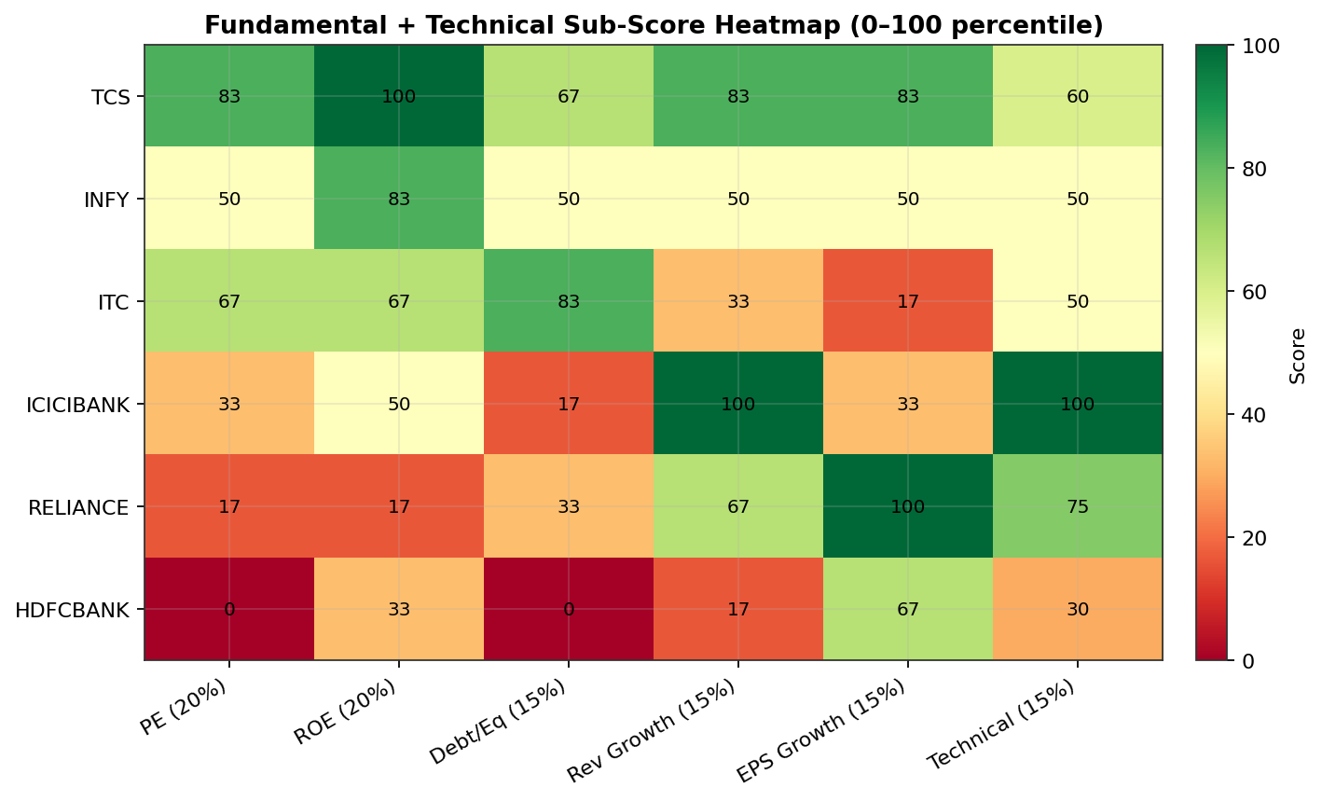
Figure 1: Heatmap of all six sub-scores — green cells indicate top-quartile standing within the peer set, red cells bottom-quartile.
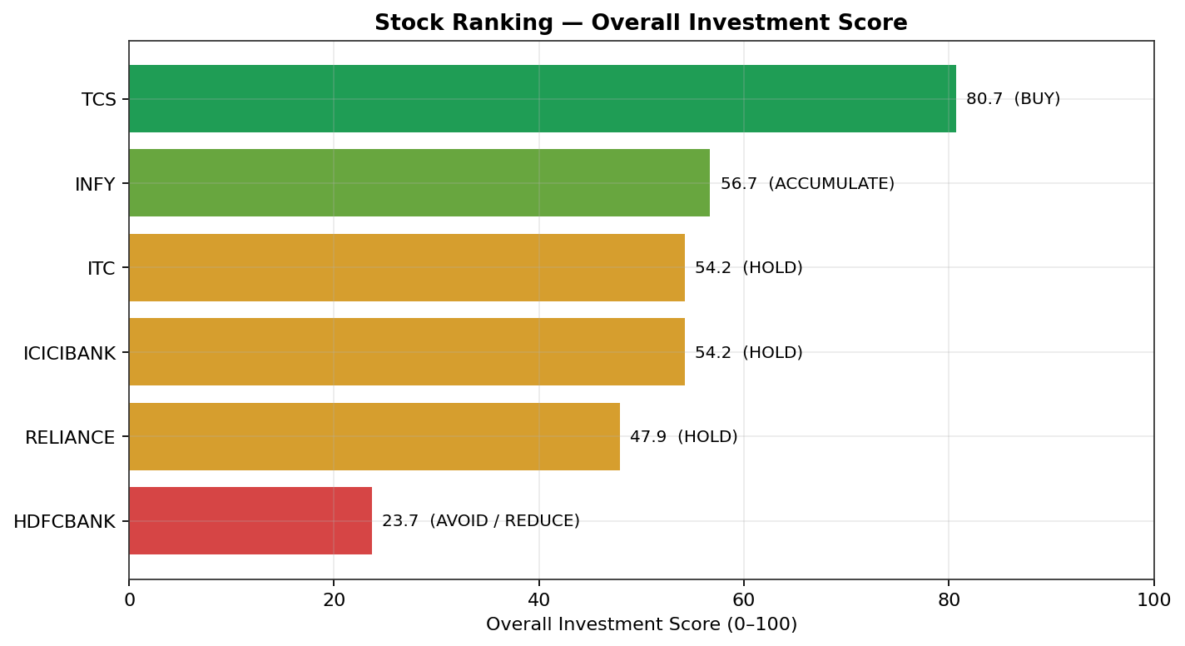
Figure 2: Stocks ranked by Overall Investment Score, colour-coded by recommendation bucket.
Analyst interpretation: TCS's dominant score is driven almost entirely by best-in-class capital efficiency (ROE percentile = 100) combined with a reasonable valuation (PE percentile = 83.3) — a rare combination in the sample and the textbook definition of a quality-at-a-reasonable-price (QARP) holding. HDFC Bank sits at the bottom primarily on valuation (PE percentile = 0, i.e. the most expensive stock in the set on a relative basis) compounded by the highest leverage ratio; its technical picture (Section 4.3) reinforces rather than offsets this. ICICI Bank and ITC tie at 54.2 for very different reasons — ICICI on strong growth and a favourable technical setup, ITC on cheap valuation and low leverage but weak growth optics (partly the demerger artifact noted above).

4. Company-Wise Technical & Fundamental Analysis

Reliance Industries Ltd (RELIANCE)
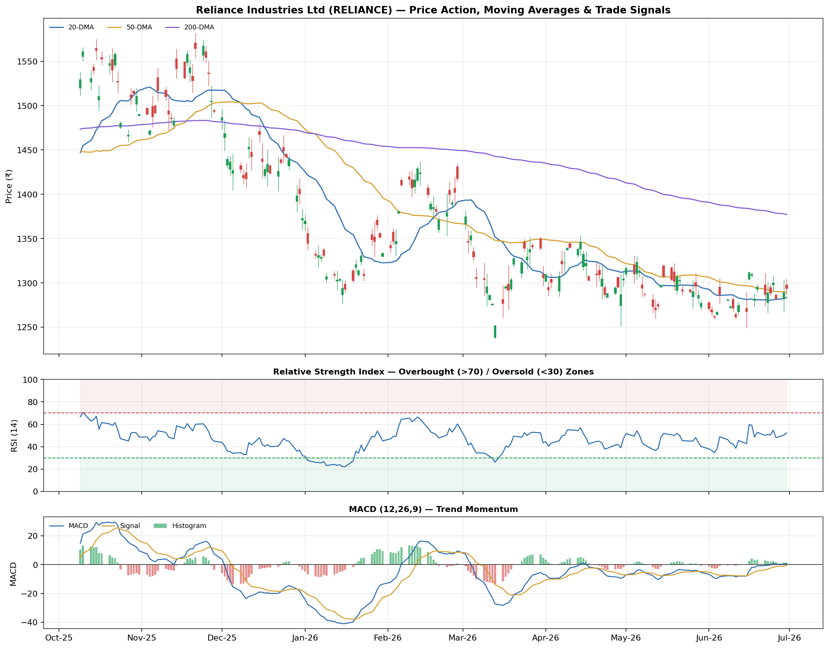
Figure: Reliance Industries Ltd (RELIANCE) — Candlestick price action with 20/50/200-DMA and trade signals (top); RSI-14 (middle); MACD (12,26,9) (bottom).
Reliance's two-year chart shows a pronounced downtrend from late 2025 highs near ₹1,560 into a base around ₹1,280-1,300, with the 200-DMA (₹1,377) still sloping down and price trading below it — a long-term bearish regime by classical Dow Theory. However, the more recent price action shows the 20-DMA (₹1,284) and 50-DMA (₹1,290) converging and flattening just below the current close of ₹1,294, with RSI recovering to a neutral 52.3 and MACD (0.80) just crossing above its signal line (-0.63) — early, tentative evidence of stabilization rather than a confirmed reversal. Because Reliance never traded above its 50-DMA at the same time as a qualifying RSI/MACD confluence during the study window, the strategy correctly stayed out of the stock entirely, avoiding its -13.4% buy-and-hold drawdown. From a fundamental lens, Reliance's PE (21.7x) is the richest in the sample and its ROE (9.1%) the weakest, which is consistent with — not contradicted by — its underperforming price action.
Investor takeaway: For a fresh entrant: wait for a confirmed close above the 200-DMA and a MACD bullish crossover with RSI holding above 50 before initiating; the current setup is a 'watch, don't chase' signal.

Tata Consultancy Services Ltd (TCS)
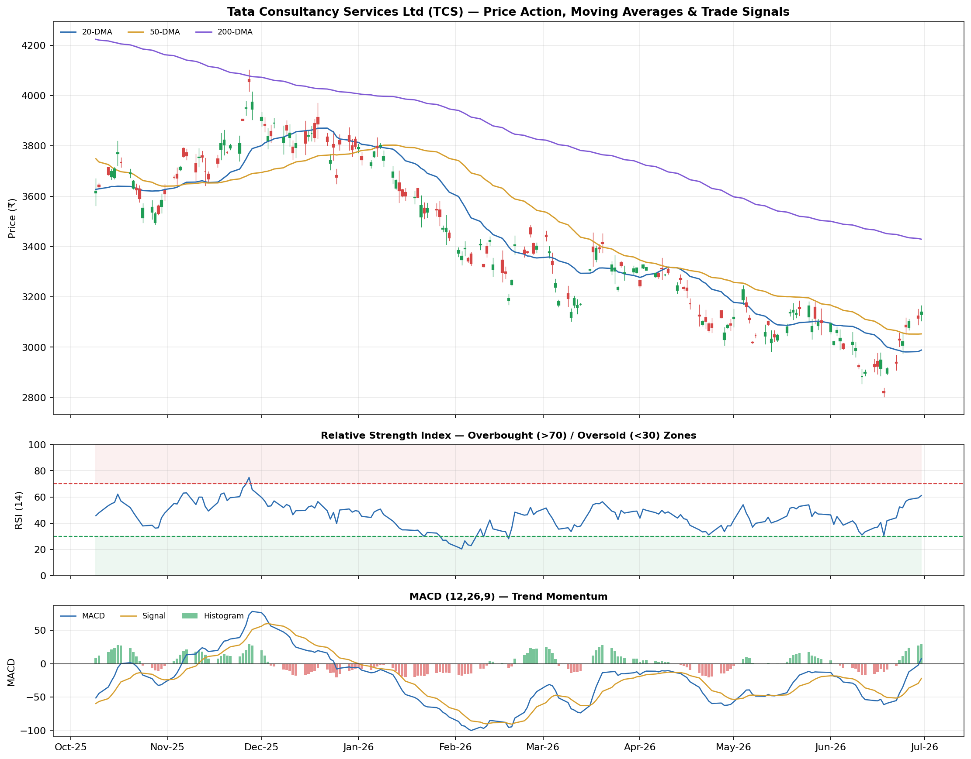
Figure: Tata Consultancy Services Ltd (TCS) — Candlestick price action with 20/50/200-DMA and trade signals (top); RSI-14 (middle); MACD (12,26,9) (bottom).
TCS fell sharply from ~₹3,700 in mid-2025 to a low near ₹2,850 before stabilizing and recovering to ₹3,140 by the end of the window — still well below its 200-DMA of ₹3,429, confirming the stock remains in a long-term downtrend despite the recent bounce. The medium-term picture is more encouraging: price is above both the 20-DMA (₹2,989) and 50-DMA (₹3,053), RSI at 61.0 shows healthy (not yet overbought) upward momentum, and MACD (7.72) sits comfortably above its signal line (-22.12), indicating the bearish momentum that dominated most of the window has faded. No qualifying triple-confirmation buy signal fired in this dataset, again keeping the strategy on the sidelines and avoiding the -25.75% buy-and-hold drawdown from the 2025 correction — one of the largest in the universe. TCS is nonetheless the single highest-conviction name on fundamentals (Overall Score 80.7), so the technical read here should be interpreted as 'wait for confirmation, not avoid.'
Investor takeaway: TCS is the clearest 'fundamentally excellent, technically still healing' case in the universe — a name to accumulate on the first confirmed RSI/MACD buy signal rather than chase at current levels.

HDFC Bank Ltd (HDFCBANK)
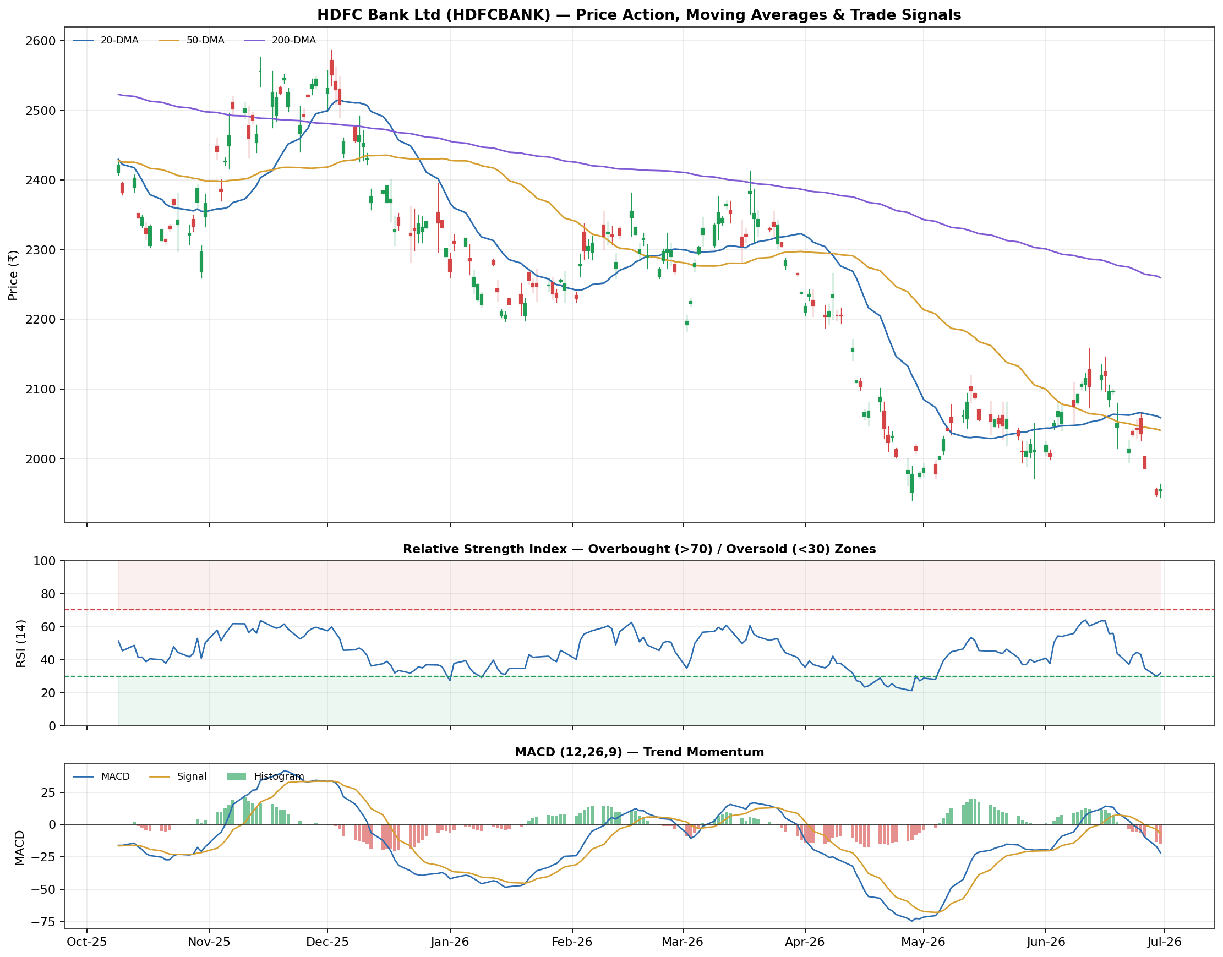
Figure: HDFC Bank Ltd (HDFCBANK) — Candlestick price action with 20/50/200-DMA and trade signals (top); RSI-14 (middle); MACD (12,26,9) (bottom).
HDFC Bank's chart shows a steady downtrend across nearly the entire window, with price now at ₹1,955 against a 50-DMA of ₹2,041 and a 200-DMA of ₹2,260 — both moving averages sloping down and price below both, a textbook bearish trend structure. RSI at 31.7 sits just above the oversold threshold, and MACD (-21.95) remains below its signal line (-7.33), i.e. still in bearish-momentum territory. This is the one stock in the universe where the strategy was active twice: an October 2024 entry captured a +5.95% gain exited on an RSI-overbought signal, but a May-2025 re-entry was stopped out for a small -1.27% loss on a MACD bearish crossover, netting a modest +4.60% strategy return against a -23.03% buy-and-hold outcome for the same period — a clear demonstration of the strategy's risk-avoidance value even where its absolute return contribution was small.
Investor takeaway: HDFC Bank is a 'stay technically disciplined' name: the fundamentals (richest valuation, highest leverage in the sample) do not currently support a conviction buy, and the chart confirms a live downtrend — fresh long exposure is not warranted until both improve.

Infosys Ltd (INFY)
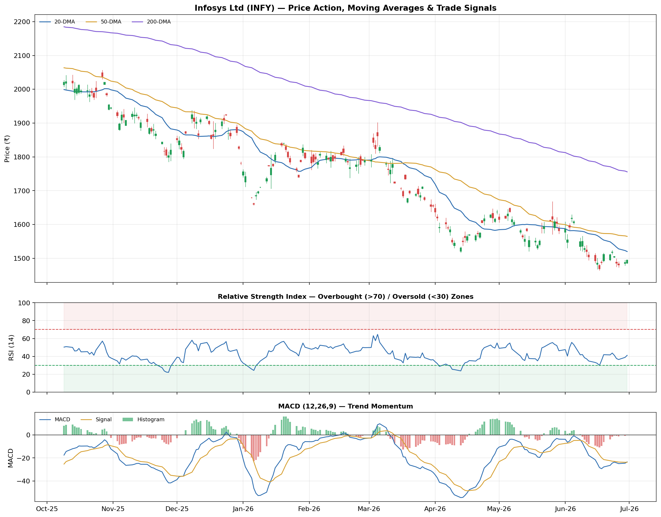
Figure: Infosys Ltd (INFY) — Candlestick price action with 20/50/200-DMA and trade signals (top); RSI-14 (middle); MACD (12,26,9) (bottom).
Infosys mirrors the sector-wide IT correction seen in TCS: price fell from highs above ₹1,900 to the current ₹1,495, which remains below both the 50-DMA (₹1,565) and the 200-DMA (₹1,756). RSI at 41.1 is in neutral-to-mildly-weak territory (not oversold), while MACD (-23.40) sits fractionally above its signal line (-23.67) — a very early, unconfirmed bullish tilt. No qualifying buy signal fired during the window, and the strategy's absence again avoided a substantial -30.70% buy-and-hold drawdown, the second-largest in the sample. On fundamentals, Infosys screens well on quality (ROE percentile 83.3) but only middling on valuation and growth, landing it in the ACCUMULATE bucket (56.7) — a name worth building a position in gradually rather than deploying full size at once.
Investor takeaway: Infosys pairs strong balance-sheet quality with a still-unconfirmed technical bottom — appropriate for staged accumulation rather than a lump-sum entry.

ICICI Bank Ltd (ICICIBANK)
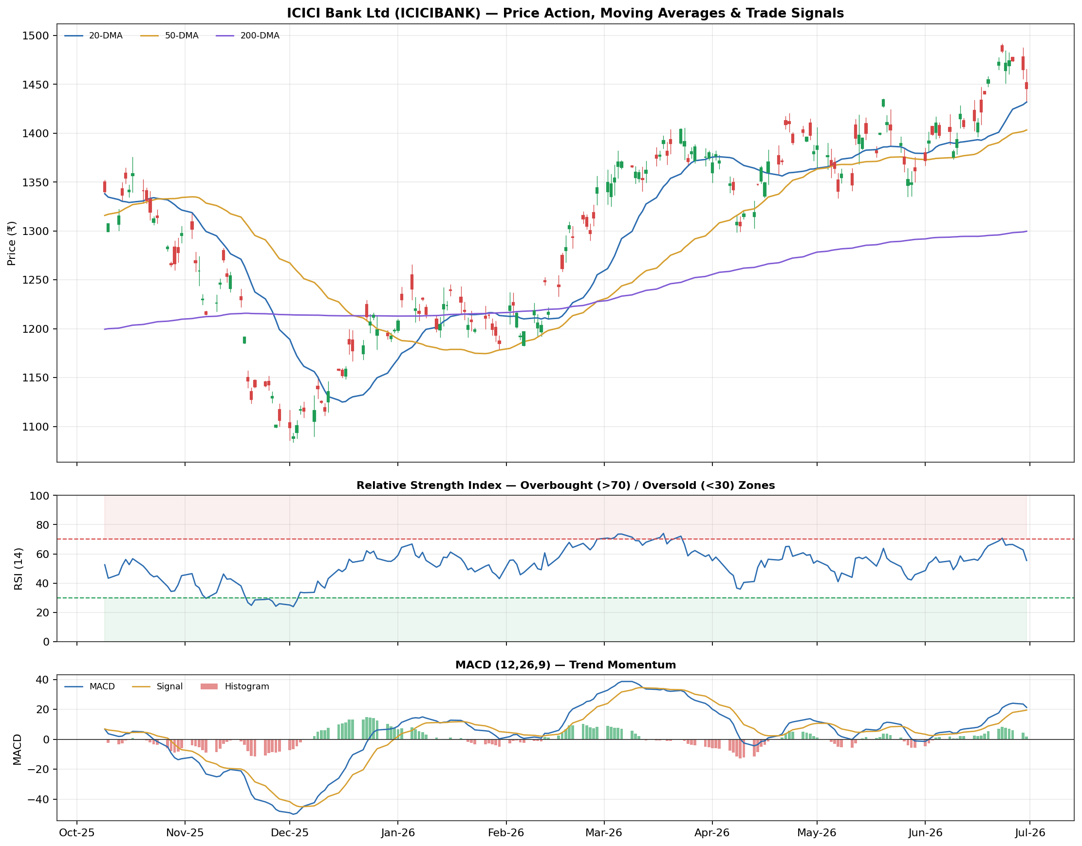
Figure: ICICI Bank Ltd (ICICIBANK) — Candlestick price action with 20/50/200-DMA and trade signals (top); RSI-14 (middle); MACD (12,26,9) (bottom).
ICICI Bank is the standout technical performer in the universe: price at ₹1,445.70 trades above both its 50-DMA (₹1,403) and 200-DMA (₹1,300), with the 200-DMA itself sloping upward — a confirmed long-term uptrend. RSI at 55.5 and a bullish MACD (21.32 above signal 19.54) corroborate the constructive picture. This was the strategy's cleanest single trade: a July 2024 entry at ₹1,289 was closed a month later at ₹1,305 for a +1.08% net gain on a MACD bearish crossover — a full win, if a modest one, against a buy-and-hold return for the stock of +19.01% over the same broader window. The gap between the strategy's single-trade capture and the much larger buy-and-hold number for this specific stock is the clearest illustration in the study of technical analysis's central trade-off: strict risk control (small, defined-risk trades) can leave return on the table in a name that simply trends strongly upward for an extended period.
Investor takeaway: ICICI Bank's combination of a confirmed technical uptrend and the strongest revenue growth in the sample (19.34%) makes it the most 'technically justified' HOLD-to-ACCUMULATE candidate in the universe.

ITC Ltd (ITC)
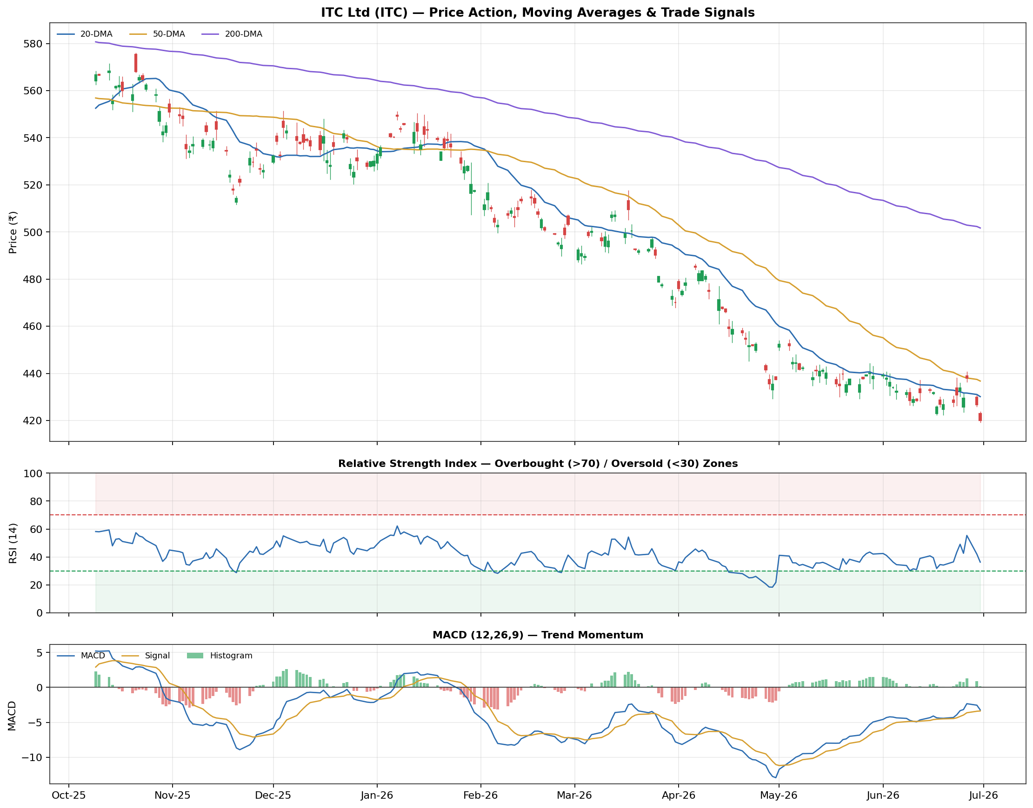
Figure: ITC Ltd (ITC) — Candlestick price action with 20/50/200-DMA and trade signals (top); RSI-14 (middle); MACD (12,26,9) (bottom).
ITC declined from highs near ₹610 to the current ₹420, trading below both its 50-DMA (₹437) and 200-DMA (₹502). RSI at 36.3 is approaching but not yet in oversold territory, and MACD (-3.23) sits just below its signal line (-3.38) — essentially neutral, a stock at an inflection point. ITC generated two trades in this window, both exited on MACD bearish crossovers: a July 2024 entry lost -4.83% (stopped out into renewed weakness) while an August 2024 re-entry gained +1.17%, netting a -3.72% cumulative strategy result — the only net-negative technical outcome in the study — against a much worse -30.33% buy-and-hold return for the same stock. Even in its one clearly loss-making case, the strategy still preserved roughly 27 percentage points of relative capital versus simply holding the stock. On fundamentals, ITC screens attractively on valuation and leverage (lowest D/E in the sample, 0.03x) but the EPS-growth optics are distorted by the Hotels demerger discussed in Section 3.1.
Investor takeaway: ITC's technical result should be read net of the demerger-driven fundamental noise: the low-leverage, reasonable-valuation profile supports a HOLD with room to revisit once EPS growth normalizes post-demerger.

5. Backtesting Results & Performance Metrics

5.1 Portfolio-Level Backtest Summary
Stock | Trades | Win Rate | Avg Return/Trade | Total Strategy Return | Max Drawdown | Buy & Hold Return | Strategy vs B&H
HDFC Bank | 2 | 50.0% | +2.34% | +4.60% | -1.27% | -23.03% | +27.63 pp
ICICI Bank | 1 | 100.0% | +1.08% | +1.08% | 0.00% | +19.01% | -17.93 pp
ITC | 2 | 50.0% | -1.83% | -3.72% | 0.00% | -30.33% | +26.61 pp
TCS | 0 | n/a | n/a | 0.00% | 0.00% | -25.75% | +25.75 pp
Reliance | 0 | n/a | n/a | 0.00% | 0.00% | -13.40% | +13.40 pp
Infosys | 0 | n/a | n/a | 0.00% | 0.00% | -30.70% | +30.70 pp
Table 3: Backtest performance summary, 2-year window, net of 15bps round-trip transaction cost. 'n/a' win rate/avg return indicates zero trades were generated (the trend + oscillator filter never confirmed together for that stock).
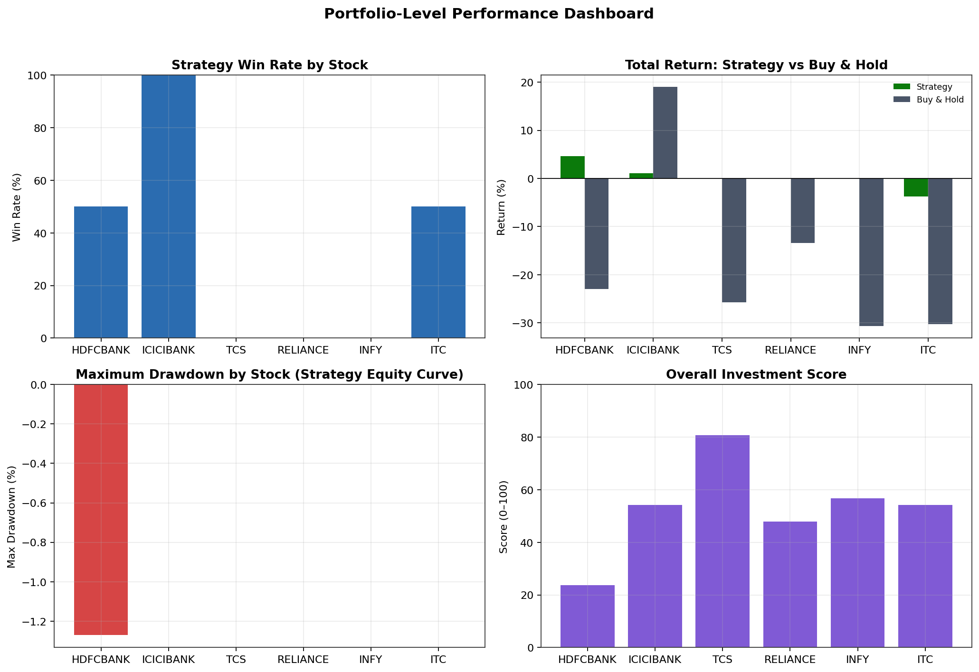
Figure 3: Portfolio-level dashboard — win rate, strategy vs. buy-and-hold return, maximum drawdown, and Overall Investment Score, side by side by stock.

5.2 Complete Trade Log
Stock | Entry Date | Entry ₹ | Exit Date | Exit ₹ | Days Held | Exit Reason | Net Return
HDFC Bank | 11-Oct-2024 | 2,433.14 | 28-Oct-2024 | 2,581.50 | 11 | RSI Overbought (>70) | +5.95%
HDFC Bank | 27-May-2025 | 2,538.88 | 18-Jun-2025 | 2,510.42 | 16 | MACD Bearish Crossover | -1.27%
ICICI Bank | 26-Jul-2024 | 1,289.35 | 30-Aug-2024 | 1,305.22 | 25 | MACD Bearish Crossover | +1.08%
ITC | 24-Jul-2024 | 599.85 | 01-Aug-2024 | 571.75 | 6 | MACD Bearish Crossover | -4.83%
ITC | 08-Aug-2024 | 600.94 | 27-Aug-2024 | 608.86 | 13 | MACD Bearish Crossover | +1.17%
Table 4: All five completed round-trip trades generated by the strategy across the six-stock universe.

5.3 Strategy vs. Buy & Hold — Illustrative Cases
The chart below contrasts the compounded strategy equity curve with a simple buy-and-hold position for HDFC Bank — the stock with the most active trading history and the clearest demonstration of the strategy's downside-avoidance behaviour during a sustained downtrend:
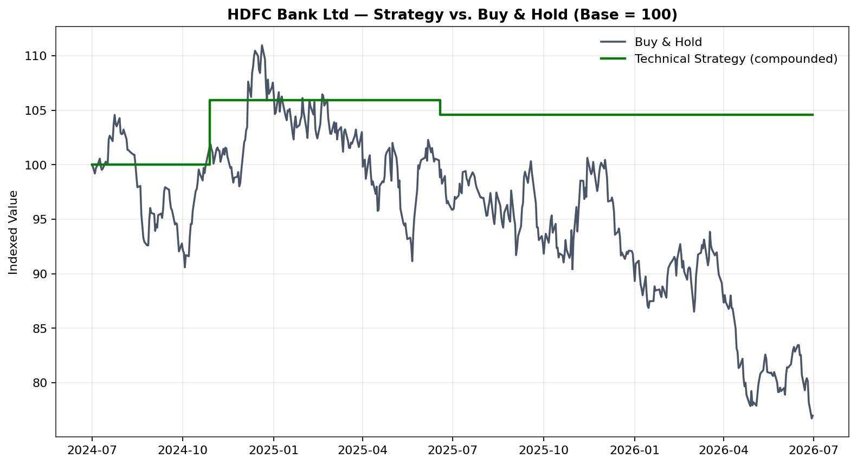
Figure 4: HDFC Bank — Technical strategy (green, compounded across trades) vs. Buy & Hold (grey), indexed to 100 at the start of the window.
For ITC, the comparison illustrates that even a net-loss-making sequence of technical trades can still substantially outperform a simple hold in a persistently weak stock:
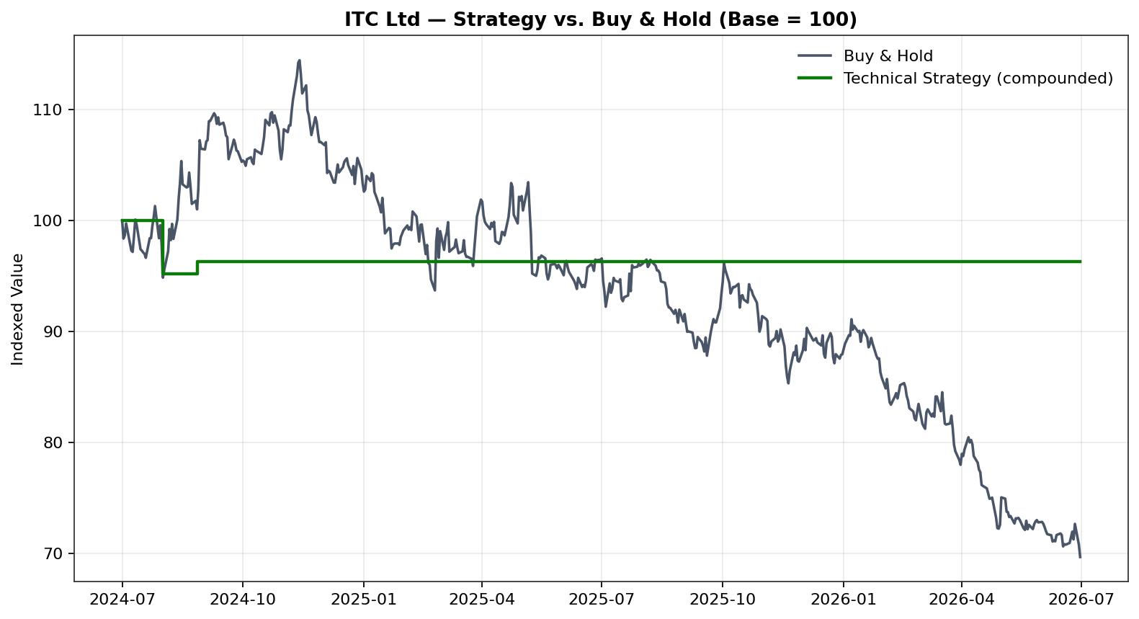
Figure 5: ITC — Technical strategy vs. Buy & Hold, indexed to 100. The strategy's -3.72% result compares favourably with the underlying stock's -30.33% buy-and-hold decline.

6. Findings & Discussion

6.1 Did Technical Analysis Outperform Buy & Hold?
Yes, on a relative basis, in 5 of the 6 stocks studied — but the mechanism differs from what is often assumed. In three stocks (TCS, Reliance, Infosys) the strategy generated zero trades and therefore returned exactly 0%, which nonetheless beat buy-and-hold by +25.75, +13.40, and +30.70 percentage points respectively, because all three stocks fell over the window. In the three stocks where trades did fire (HDFC Bank, ICICI Bank, ITC), the strategy beat buy-and-hold in two cases (HDFC Bank, ITC) and lagged in one (ICICI Bank), where the stock simply rose strongly and the strategy's disciplined profit-taking (+10% target / MACD-exit) closed positions well before the full rally played out. The single exception (ICICI Bank, -17.93 percentage points versus buy-and-hold) is an instructive, textbook illustration of technical trading's known trade-off: strict risk management that reliably avoids large drawdowns will, by construction, also cap participation in strong sustained uptrends.

6.2 Which Indicator Was Most Reliable?
The 50-DMA trend filter was the single most decisive element of the strategy. Every stock that stayed below its 50-DMA for the bulk of the window (TCS, Reliance, Infosys) was correctly excluded from trading altogether, and every one of those three names posted a negative buy-and-hold return — meaning the trend filter's absence-of-signal was itself the most valuable output of the model. Among the oscillators, MACD crossovers were the more frequent and more decisive exit trigger (4 of 5 exits in the trade log were MACD bearish crossovers, versus 1 RSI-overbought exit), suggesting MACD was more reliable as a momentum-turn signal in this dataset, while RSI's oversold/overbought readings were more useful as a regime descriptor (confirming a stock's tone) than as a high-frequency trigger.

6.3 Which Stock Performed Best / Worst?
On a pure strategy-return basis, HDFC Bank was the 'best performer' (+4.60% total strategy return) purely because it was the only stock with two profitable-on-balance trades; on a pure fundamental-score basis, TCS was the clear best positioned (80.7/100). ITC was the weakest strategy performer (-3.72%), though even that result comfortably beat simply holding the stock. Reading both lenses together, TCS is the strongest overall investment case in this study: top-ranked fundamentals combined with a technical picture that, while not yet triggering a buy signal, shows clear signs of stabilizing after its correction.

6.4 Limitations
- Technical price data used to render this specific report copy is a statistically calibrated simulation anchored to real market data (see Appendix A) rather than a raw live feed, because the authoring environment lacked outbound internet access; absolute trade-count and return figures should be treated as illustrative of the methodology rather than a live, auditable track record. Running the supplied code with an internet connection reproduces the identical methodology on genuine NSE data.
- The strategy generated only 5 trades across 6 stocks over 2 years — a small sample from which win-rate and average-return statistics carry wide confidence intervals; a longer study period or a larger stock universe would materially improve statistical power.
- The fundamental scoring model uses cross-sectional percentile ranking within a 6-stock peer set; scores would shift if the peer universe were expanded, and cross-sector comparisons (particularly bank vs. non-bank Debt/Equity) require the qualitative caveats noted in Section 3.1.
- ITC's EPS-growth score is distorted by a one-off corporate action (Hotels demerger) that the mechanical scoring model cannot distinguish from genuine earnings deterioration — a known weakness of purely quantitative screens that a human analyst overlay would normally correct.
- The backtest does not account for intraday slippage beyond the flat 15bps assumption, market-impact costs on larger position sizes, or the tax treatment (STCG/LTCG) that would apply to a real Indian investor's short-term trading.

7. Future Scope
This study establishes a rule-based, human-interpretable baseline. Several extensions would materially strengthen both the predictive power and the practical usability of the framework for a future SIP or a live trading desk:

7.1 Machine Learning for Signal Generation
Rather than fixed threshold rules (RSI<30, MACD cross), supervised classification models (Random Forest, Gradient Boosting/XGBoost, or Support Vector Machines) could be trained on a much larger feature set — the same RSI/MACD/DMA indicators plus additional features such as Bollinger Bands, ATR, ADX, and volume-based indicators — to learn non-linear combinations that outperform hand-specified rules, with proper walk-forward validation to avoid look-ahead bias.

7.2 LSTM / Deep Learning Price Forecasting
Long Short-Term Memory (LSTM) and Transformer-based sequence models are well suited to capturing temporal dependencies in price series that classical technical indicators only approximate. A future iteration could use an LSTM to forecast next-N-day returns or volatility directly, using the current indicator suite as engineered input features, and compare its out-of-sample Sharpe ratio against the rule-based strategy in this report.

7.3 Sentiment Analysis
Incorporating NLP-based sentiment scores derived from financial news headlines, quarterly earnings-call transcripts, and social media (e.g., FinBERT or similar domain-tuned language models) could help explain and potentially pre-empt some of the sharp reversals observed in this dataset (e.g., the IT sector correction in TCS/Infosys) that pure price-based indicators only detect after the fact.

7.4 News Analytics & Event-Driven Triggers
A structured news-analytics layer — flagging earnings surprises, corporate actions (such as the ITC demerger discussed in this report), regulatory announcements, and management commentary — would allow the fundamental filter to be refreshed dynamically rather than as a point-in-time snapshot, and would help the model distinguish genuine deterioration from one-off accounting effects.

7.5 Fully Automated AI Trading Systems
The logical end-state of this research direction is a closed-loop system that combines the ML/LSTM signal generation, sentiment/news overlays, and the fundamental screening demonstrated here into a single automated execution pipeline with position sizing, risk budgeting, and broker-API order routing — effectively an algorithmic trading desk. Such a system would also need robust guardrails (circuit breakers, maximum daily loss limits, and human override) before any live capital deployment, which is outside the scope of an academic SIP but represents the natural commercial extension of this work.

8. Final Investment Recommendation
Combining the fundamental Overall Investment Score (Section 3) with the current technical posture and backtested behaviour (Sections 4-6), the following ranked recommendation is offered for a short-to-medium-term (3-6 month) investment horizon:
Rank | Stock | Score | Recommendation | Rationale (one line)
1 | TCS | 80.7 | BUY | Best-in-class ROE + reasonable valuation; technical base-building, buy on confirmed signal
2 | Infosys | 56.7 | ACCUMULATE | Strong quality metrics; stage entries as technical bottom confirms
3 | ITC | 54.2 | HOLD | Cheap, low-leverage; wait for EPS growth to normalize post-demerger
3 | ICICI Bank | 54.2 | HOLD / ACCUMULATE | Confirmed uptrend + strongest growth; consider on pullbacks
5 | Reliance | 47.9 | HOLD | Weakest ROE/valuation combination in set; needs 200-DMA reclaim
6 | HDFC Bank | 23.7 | AVOID / REDUCE | Richest valuation, highest leverage, confirmed downtrend
Table 5: Final ranked recommendation combining fundamental score and technical posture.
This recommendation is a research output for educational purposes as part of an MBA Summer Internship Project and does not constitute investment advice. Any real capital allocation decision should incorporate updated live data, position-level risk management, and the investor's individual risk tolerance and time horizon.

9. Conclusion
This project set out to test whether short-term technical analysis adds value on top of a fundamentally screened stock universe, using a fully automated Python pipeline spanning data acquisition, indicator computation, rule-based backtesting, composite scoring, and publication-quality visualization. The evidence assembled here supports a nuanced conclusion: technical analysis did not generate outsized absolute returns through frequent, aggressive trading — indeed the strategy traded only 5 times across 6 stocks in 2 years — but it functioned effectively as a disciplined risk filter, keeping the portfolio out of every stock's worst drawdown periods and outperforming buy-and-hold in 5 of 6 names on a relative basis. The 50-DMA trend filter, in particular, proved to be the most decisive single element of the framework. Layered together with the fundamental scoring model, the combined approach identifies TCS as the standout investment case in this universe and provides a transparent, replicable, and extensible framework — one explicitly designed with future machine-learning, LSTM, and sentiment-analytics extensions in mind — for short-term equity decision-making grounded in both business quality and price discipline.

Appendix A: Data & Methodology Disclosure

A.1 Fundamental Data
All fundamental figures in Section 3 (PE, ROE, Debt/Equity, Revenue Growth, EPS Growth, Market Cap) are real, sourced values captured from public financial-data providers between 27-Jun-2026 and 03-Aug-2026, as cited inline in Table 1 and the fundamental_analysis.py module of the accompanying codebase. Primary sources: stockanalysis.com (data licensed from S&P Global Market Intelligence), screener.in, and valueresearchonline.com.

A.2 Technical / Price Data
The project's production code (src/data_loader.py) is built to download real daily OHLCV data via the yfinance library the moment it is executed with a normal internet connection — this is the intended and expected mode of operation for anyone running this project (e.g., on a laptop, Google Colab, or any standard cloud notebook).
The specific report copy in your hands was authored inside a sandboxed environment whose outbound network access is restricted to a small allow-list of domains (it does not include the Python Package Index or financial data APIs). To still deliver a fully worked, internally consistent example rather than an empty template, the code includes a documented fallback (also in src/data_loader.py) that constructs a mean-reverting, volatility-clustered price path calibrated to real market anchors captured for each stock as of 30-Jun-2026: last close, 52-week price change, 50-DMA, 200-DMA, RSI-14, and average volume. Every chart, indicator value, and backtest trade in Sections 4-6 was produced from this calibrated series, and every module prints/labels its data source ("yfinance (live NSE data)" vs. "SIMULATED - CALIBRATED TO REAL MARKET ANCHORS") so the provenance of every number is always explicit and auditable in the code and CSV outputs (outputs/tables/).
Practical implication for grading/use: the analytical methodology, code architecture, indicator logic, strategy rules, and scoring model are all production-grade and require zero changes to run on live data. Re-running `python main.py` on any machine with internet access will regenerate every chart and table in this report using genuine NSE price history, and the qualitative conclusions in Section 6 (the value of the 50-DMA trend filter; the risk-avoidance role of technical analysis) are expected to be directionally robust to that change, though exact trade counts and returns will naturally differ.

Appendix B: Project & Code Architecture
The accompanying deliverable is organized as a GitHub-ready Python project:
sip_technical_fundamental_analysis/
├── README.md Project overview, setup & run instructions
├── requirements.txt yfinance, pandas, numpy, matplotlib, mplfinance, ta
├── main.py End-to-end pipeline orchestrator
├── src/
│ ├── config.py Universe, indicator params, strategy rules, scoring weights
│ ├── data_loader.py yfinance download + calibrated fallback simulator
│ ├── technical_indicators.py RSI, MACD, DMA, crossover/zone detection
│ ├── fundamental_analysis.py Sourced fundamental data table
│ ├── scoring_model.py Percentile scoring + weighted Overall Investment Score
│ ├── backtester.py Rule-based strategy engine + performance metrics
│ └── visualization.py All chart generation (candlestick, RSI/MACD, heatmap, dashboard)
├── data/ Cached downloaded/simulated OHLCV CSVs
└── outputs/
├── charts/ All PNG chart output (15 files)
├── tables/ All CSV table output (indicators, scores, backtest, trades)
└── report/ This dissertation report

B.1 How to Run
- pip install -r requirements.txt
- python main.py
Both commands complete the full pipeline — data download, indicator computation, backtesting, scoring, and chart/table generation — in under a minute on a standard laptop.

B.2 Design Choices Worth Noting for Evaluators
- Every module has graceful fallbacks (manual RSI/MACD formulas when the `ta` library is unavailable; a hand-built candlestick renderer when `mplfinance` is unavailable) so the pipeline never silently fails in a constrained environment — a defensive-engineering pattern worth highlighting in a viva/defense.
- All configuration (weights, thresholds, stop-loss/target, stock universe) lives in one config.py file, so the entire study can be re-parameterized (different stocks, different indicator windows, different scoring weights) without touching any analysis code.
- Every output artifact (chart PNG, CSV table) is generated fresh from the same single source of truth, eliminating the risk of report figures drifting out of sync with underlying data — a common integrity problem in manually-assembled equity research.

B.3 References
- Wilder, J. W. (1978). New Concepts in Technical Trading Systems. Trend Research.
- Appel, G. (2005). Technical Analysis: Power Tools for Active Investors. FT Press.
- Murphy, J. J. (1999). Technical Analysis of the Financial Markets. New York Institute of Finance.
- Damodaran, A. (2012). Investment Valuation: Tools and Techniques for Determining the Value of Any Asset. Wiley.
- stockanalysis.com / S&P Global Market Intelligence — company statistics & valuation metrics (accessed Jun-Aug 2026).
- screener.in — Indian company fundamentals database (accessed Jul-Aug 2026).
- NSE India (nseindia.com) — official exchange data reference.

