MAS8404 Practical Report 2

Mansoor Hamid

11/9/2019

### Question 1:

#### Part(a)

genexpr_data=read.csv("C:/Users/User/Documents/RWorkSpace/data/Ch10Ex11.csv",header=TRUE)  
#Check dimesion of the loaded data  
dim(genexpr_data)

## [1] 999 40

#transpose once to correct the data  
genexpr_data = t(genexpr_data)

##### Creating correlation distance matrix

#Transpose the matrix in order to use cor function  
genexpr_data_transposed = t(genexpr_data)  
  
#Compute the inter-observation correlations  
r_obs = cor(genexpr_data_transposed)  
#Create the distance matrix  
d_cor = 1-r_obs  
  
#convert the distance matrix to dis object  
d_cor = as.dist(d_cor)

##### Perform hierarchical clustering using hclust with metod specified as “single” to indicate single-linkage

hc_c = hclust(d_cor, method = "single")

##### Plot the dendrogram

plot(hc_c, cex=0.5,main="",sub="",xlab="")

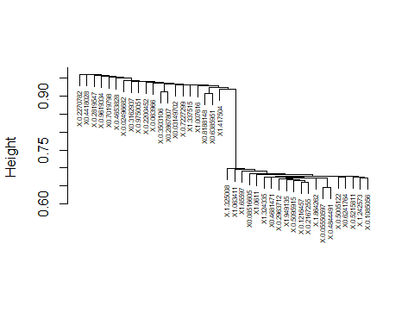

#### Part(b)

##### Perform hierarchical clustering using hclust with metod specified as “complete” and “average”

hc_c_complete = hclust(d_cor, method = "complete")  
hc_c_average = hclust(d_cor, method = "average")

##### Plot the dendrograms

plot(hc_c_complete, cex=0.5,main="",sub="",xlab="")

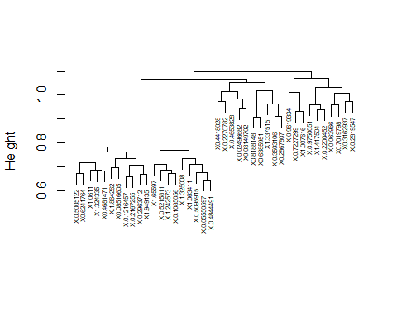

plot(hc_c_average, cex=0.5,main="",sub="",xlab="")

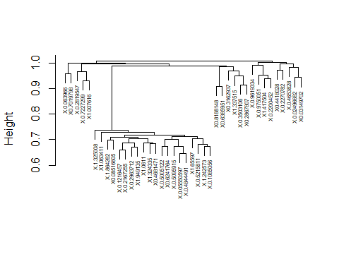

#### Part(c)

###### Determine Euclidean distance and perform hierarchical clustering with single-linkage

genexpr_data_euc = dist(genexpr_data)  
hc_c_euc_single = hclust(genexpr_data_euc, method = "single")

##### Plot the dendrogram

plot(hc_c_euc_single, cex=0.5,main="",sub="",xlab="")

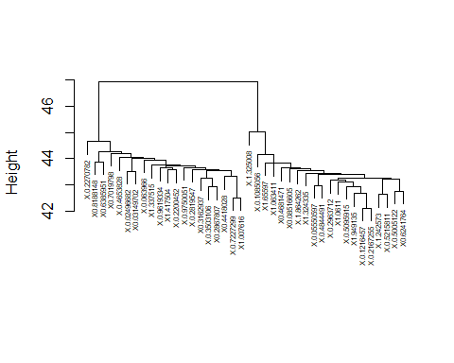

### Question 2:

#### Part(a)

#Scale the data  
Kmax = 10  
genexpr_data_scaled = scale(genexpr_data)