Name : Mansoor Kashif

Data Source link : <https://www.kaggle.com/datasets/hendratno/covid19-indonesia/data>

Github repository link :

**Visualisation 1: Number of New Cases and New Deaths in Indonesia**

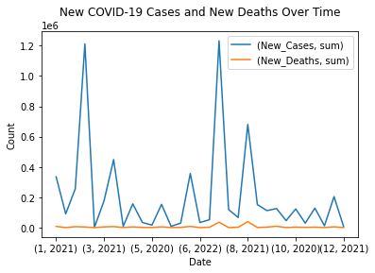

**Description:**

**Visualisation 2: Top five Cities with the Highest New COVID-19 cases**

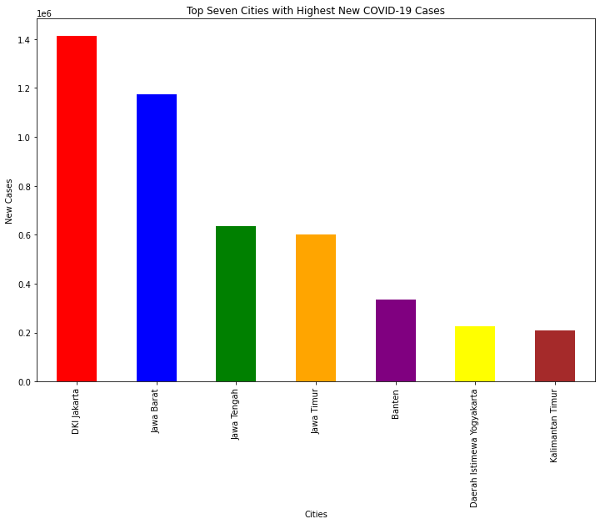

**Description:**

**Visualisation 3: Total Cases, Deaths and Recovered Cases from 2020 to 2023**

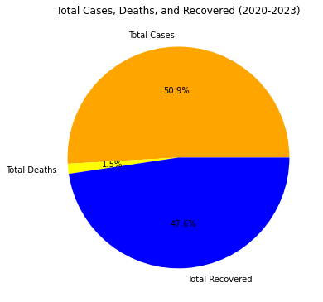

**Description:**