**Teacher Computer Retrieval:**

**Project Type:**

.NetCore 3.1 Console App

**Project Structure:**

Project Consists of a Tests and a Console Project with the following directory structure:

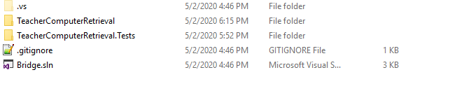

**Input and Output Format:**

Being a console app and to support different Inputs before making a choice on what action to perform the user first needs to provide sample data (Test academies and distance between them) to run the module with in the following format:

ABC where (A -> start/source academy, B-> end/destination academy, C -> distance between start and end academy)

**Note**: As distance between two academies can’t be negative it is assumed that C will never be negative.

**Building and Running App:**

To run the console app, navigate to “TeacherComputerRetrieval” folder and run the following command in command prompt to build and run the project:

**C:\Users\mansoor\Bridge\TeacherComputerRetrieval> dotnet run**

**Running Test Project:**

To run the console app, navigate to “TeacherComputerRetrieval.Tests” folder and run the following command in command prompt to build and run the tests:

**C:\Users\mansoor\Bridge\TeacherComputerRetrieval> dotnet tests**

**Sample Output:**

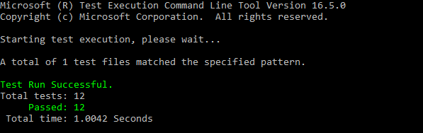

**Observations:**

While I initially thought that I could have different filters for second module(getting different routes between academies, I eventually figured out that we can’t support having “MinStops” and “MinDistance” filters.

Reason being: It would run into and infinite loops wherein we have a loop inside graph/routes in academies)

**NextSteps**:

1. I am currently not handling any input validations on user input provided, I could probably add a few input validations to make the app user friendly and provide the user a better context of what went wrong.
2. I could probably work on building up an UI windows forms for an example where in it would be intuitive and a user friendly interaction.
3. Handling more edge cases in Unit Tests Input.
4. Having Better Names (While I have tried to name variables and files as much relative as I can I feel that I can still have better names on few of them).
5. I am currently using “int” to return the result but as the distance could really be huge we could probably use “long” depending on the input constraints.

**Additional Notes:**

* I am using a AdjacentAcademiesDictMap to store the adjacent academies for a given academy
* In case if you want to change the AdjacentAcademiesDictMap please refer to “TestHelper” class in “TeacherComputerRetrieval.Tests\TestUtils\”. As this is something which is used to build the AdjacentAcademiesDictMap before running the tests.
* “TestDataClass” can be used to provide different inputs to tests in case if required.