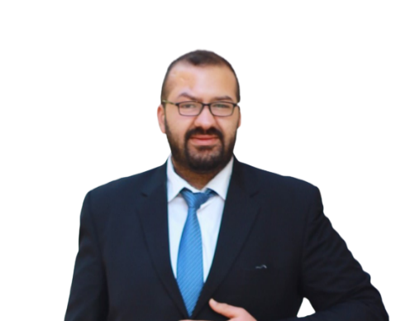

**Mansoor Moqbel**

Full Stack Developer

**Contact:**

* **Phone:**

+962788865214

* **Email:**

[mansoormoqbel124@outlook.com](mailto:mansoormoqbel124@outlook.com)

* **LinkedIn:**

<https://www.linkedin.com/in/mansoormoqbel>

* **GitHub:**

<https://github.com/mansoormoqbel>

**Personal details:**

* **Nationality:**

Jordanian.

* **Marital status:**

single.

* **Age:**

twenty-seven.

* **Address:**

Amman-Jordan

* **License:**

Driving License.

**About:**

I am Full Stack developer. Looking for new opportunity so I can use my knowledge and skills and also learn and improve new skills.

**Technical skills**

* HTML/CSS
* JavaScript-OOP
* Bootstrap
* AJAX-JSON
* Problem-solving Basics
* PHP (Native OR Laravel)
* Basic Python
* SQL -PL/SQL

**Languages:**

* **English (**good**)**
* **Arabic** (Native language)

**Experiences:**

* **Graduation Project:** B2B page web | 9/2021 to 1/2022

It is a site that takes products from companies (factories) and displays them to stores. Using PHP native, SQL, HTML, CSS, JavaScript, Bootstrap, and jQuery.

* **Computer teacher: |**9/2022 to 1/2023

Writing exams and teaching 11th class students at Salah Al-Din School.