Infosys Springboard Virtual Internship

NewsPulse-- Global News Analysis System

Milestone-1 :Data Collection & System foundation

Mansooralikhan Pattan
date:16-02-2026
1. Introduction
NewsPulse is an AI-driven system designed to automatically collect, organize, and analyze global news articles. With thousands of articles published daily across multiple platforms, manual reading becomes impractical and inefficient. NewsPulse addresses this challenge by leveraging automation and Natural Language Processing (NLP) to identify trending topics, popular keywords, and sentiment patterns.
Milestone 1 lays the groundwork for this system by focusing on data collection and preparation. The goal is to ensure that reliable, structured, and clean datasets are available for advanced NLP tasks in later phases, such as trend detection, topic modeling, and sentiment analysis.

2. Objectives of Milestone 1
The key objectives of this milestone are:
- Understand the NewsPulse system and its real-world applications.
- Learn how global news data can be collected automatically.
- Fetch real-time news using APIs.
- Store collected articles in a structured format (CSV).
- Perform basic data cleaning to remove inconsistencies.
- Display and verify the dataset.
- Extract simple insights such as article counts and source diversity.
- Prepare the dataset for future NLP-based analysis.

3. System Architecture & Workflow
The NewsPulse system follows a clear step-by-step workflow:
High-Level Workflow
News Websites → Data Collection → Data Storage → Cleaning → Basic Analysis → Future NLP Processing
Components
- News Sources
  - Global providers such as BBC, CNN, Reuters, The Hindu, Times of India, Al Jazeera.
  - These serve as the raw input for the system.
- Data Collection Module
  - Uses News APIs (e.g., NewsAPI, GNews) to fetch articles automatically.
  - Eliminates the need for manual browsing and copy-pasting.
- Data Storage
  - Articles are stored in CSV format.
  - Structured storage ensures reusability and consistency.
- Data Cleaning
  - Removes missing values, duplicate entries, and unwanted symbols.
  - Produces a clean dataset suitable for analysis.
- Basic Analysis
  - Extracts simple insights such as total number of articles and unique sources.
  - Validates dataset usability before advanced NLP tasks.
- Future NLP Processing (Next Milestones)
  - Trend detection, keyword extraction, sentiment analysis, and topic modeling.

4.Code Implementation
pip install requests
{
"title": "AI changing healthcare",
"source": { "name": "BBC" },
"publishedAt": "2026-02-07"
}
import requests

api_key = "bc77c71eccd74ae9845635f73a9c3bdc "

url = f"https://newsapi.org/v2/top-headlines?country=us&apiKey={api_key}"

response = requests.get(url)
data = response.json()

articles = data["articles"]

for i in range(5):
print(f"{i+1}. {articles[i]['title']}")
import requests

api_key = "bc77c71eccd74ae9845635f73a9c3bdc "

url = f"https://newsapi.org/v2/top-headlines?country=us&apiKey={api_key}"

response = requests.get(url)
data = response.json()

articles = data["articles"]

for i in range(5):
title = articles[i]["title"]
source = articles[i]["source"]["name"]
date = articles[i]["publishedAt"]

print("Title:", title)
print("Source:", source)
print("Published Date:", date)
print("-" * 50)
pip install requests
import requests

api_key = "bc77c71eccd74ae9845635f73a9c3bdc"

url = f"https://newsapi.org/v2/top-headlines?country=us&apiKey={api_key}"

response = requests.get(url)

if response.status_code == 200:
data = response.json()
articles = data["articles"]

if len(articles) == 0:
print("No news available at the moment.")
else:
for i in range(min(5, len(articles))):
print(f"{i+1}. {articles[i]['title']}")
else:
print("Error:", response.status_code)
pip install requests
import requests
import csv

api_key = "bc77c71eccd74ae9845635f73a9c3bdc "

url = f"https://newsapi.org/v2/top-headlines?country=us&apiKey={api_key}"

response = requests.get(url)

if response.status_code == 200:
data = response.json()
articles = data["articles"]

with open("news_data.csv", "w", newline="", encoding="utf-8") as file:
writer = csv.writer(file)

# Write column headers
writer.writerow(["Title", "Source", "Published Date"])

# Write rows
for article in articles:
title = article["title"]
source = article["source"]["name"]
date = article["publishedAt"]

writer.writerow([title, source, date])

print("News successfully saved to news_data.csv")

else:
print("Error:", response.status_code)
csv_data = """
Title,Source,Published Date
AI startups grow,Reuters,2026-02-07
Markets rise globally,CNN,2026-02-07
Tech summit begins,BBC,2026-02-07
"""
import csv

with open("news_data.csv", "r", encoding="utf-8") as file:
reader = csv.reader(file)

for row in reader:
print(row)
import pandas as pd

df = pd.read_csv("news_data.csv")

print(df.head())
import pandas as pd

df = pd.read_csv("news_data.csv")
df = df.dropna()
df = df.drop_duplicates(subset=["Title"])
df["Title"] = df["Title"].str.replace(r"[^\w\s]", "", regex=True)
df.to_csv("news_data_cleaned.csv", index=False)

print("Cleaned data saved successfully.")
import pandas as pd

df = pd.read_csv("news_data.csv")

# Remove empty rows
df = df.dropna()

# Remove duplicates
df = df.drop_duplicates(subset=["Title"])

# Clean special characters
df["Title"] = df["Title"].str.replace(r"[^\w\s]", "", regex=True)

# Save cleaned file
df.to_csv("news_data_cleaned.csv", index=False)

print("Cleaned data saved successfully.")
import pandas as pd

df = pd.read_csv("news_data_cleaned.csv")
from google.colab import drive
drive.mount('/content/drive')
total_articles = len(df)
print("Total News Articles:", total_articles)
unique_sources = df["Source"].nunique()
print("Unique News Sources:", unique_sources)
import pandas as pd

df = pd.read_csv("news_data_cleaned.csv")

total_articles = len(df)
unique_sources = df["Source"].nunique()

print("Total News Articles:", total_articles)
print("Unique News Sources:", unique_sources)

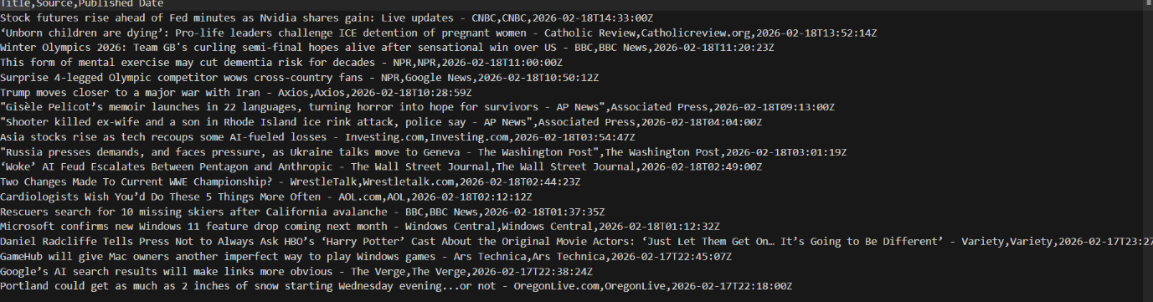
5.Output Screenshots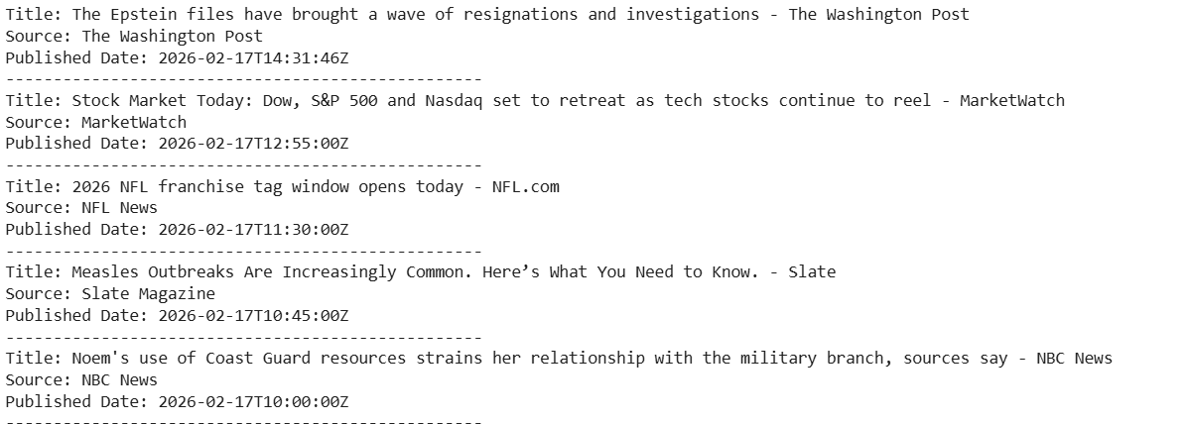

6. Outcomes of Milestone 1
By the end of Milestone 1, the following outcomes were achieved:
- A clear understanding of NewsPulse’s purpose and architecture.
- Successful collection of real-time news articles via APIs.
- Storage of articles in a structured CSV format.
- Application of basic cleaning techniques to improve dataset quality.
- Extraction of preliminary insights (e.g., article count, source diversity).
Establishment of a strong foundation for text preprocessing and NLP tasks in Milestone 2

7. Conclusion
Milestone 1 successfully established the data foundation for NewsPulse. Real-time Basic insights validated the dataset’s usability, confirming readiness for advanced text analysis.
This milestone ensures that NewsPulse can move forward with confidence into Milestone 2, where the focus will shift to text preprocessing and NLP techniques such as tokenization, stopword removal, and sentiment analysis.

