Infosys Springboard Virtual Internship

NewsPulse-- Global News Analysis System

Milestone-2 :Data PreProcessing &NLP pipeline
Mansooralikhan Pattan
X

1. Introduction
This documentation covers Milestone 2 of the NewsPulse project, which focuses entirely on Data Preprocessing and building a Natural Language Processing (NLP) pipeline. NLP is a branch of artificial intelligence that enables computers to understand, process, and analyze human language. When collecting raw news data from APIs or web scraping, the text inherently contains noise such as special characters, HTML tags, duplicate text, and punctuation . If this raw data is not cleaned, machine learning models will misinterpret the text, decreasing accuracy and making sentiment and topic modeling unreliable . Implementing a robust preprocessing pipeline ensures clean data, which directly leads to better model performance and more accurate trend detection.
2. Objective
The primary goal of this milestone is to build a basic, fully functioning NLP pipeline. By
the end of this phase, the system should be able to:
- Clean raw news data by removing noise.
- Perform tokenization and remove meaningless stop-words.
- Apply TF-IDF (Term Frequency – Inverse Document Frequency) for feature extraction.
- Generate initial topic and trend results using topic modeling.
- Apply sentiment analysis to understand public mood and detect global trends.
- Combine all these components into a single, organized Python script .
3. Workflow
The pipeline follows a systematic flow: Raw Data → Clean → Tokenize → TF-IDF → Topic Model. Here is the detailed breakdown:
- Step 1: Text Preprocessing: The raw CSV dataset is loaded, and the text is converted to lowercase . Regular expressions are used to remove HTML tags, punctuation, and special characters .
- Step 2: Tokenization & Stopword Removal: Using the NLTK library, the cleaned text is split into smaller units called tokens (words) . Common words that do not add important meaning (stopwords like "is", "the", "and") and very short words are filtered out .
- Step 3: Feature Extraction: Because computers cannot understand raw text, the processed words are converted into a numerical matrix using TF-IDF . This method is excellent for trend detection because it gives a high weight to important, rare words and a low weight to common words.
- Step 4: Topic Modeling: The pipeline uses Latent Dirichlet Allocation (LDA) to automatically discover hidden themes and group similar news articles together . The model is trained to generate 3 to 5 distinct topics and extract the top keywords for each .
- Step 5: Sentiment Analysis: The TextBlob library is implemented to determine the emotional tone of the text . Articles are classified as Positive, Neutral, or Negative, which is crucial for identifying crisis situations or positive developments .

4.Code Implementation
import re

def clean_text(text):
# Convert text to lowercase
text = text.lower()
# Remove punctuation and special characters, keeping only alphanumeric and whitespace
text = re.sub(r'[^a-zA-Z0-9\s]', '', text)
return text

print("The 'clean_text' function has been defined.")

"""## Load data

### Subtask:
Load the `news_data_cleaned.csv` file into a pandas DataFrame, as this file contains the data we need to clean.

**Reasoning**:
The subtask requires loading the 'news_data_cleaned.csv' file into a pandas DataFrame named `df`.
"""

import pandas as pd
df = pd.read_csv('news_data_cleaned.csv')
print("Data loaded successfully into DataFrame 'df'.")

"""**Reasoning**:
The next step is to apply the defined `clean_text` function to the 'Title' column of the loaded DataFrame (`df`).

"""

df['Title'] = df['Title'].apply(clean_text)
print("The 'clean_text' function has been applied to the 'Title' column.")

"""**Reasoning**:
The next step is to save the modified DataFrame, with the cleaned 'Title' column, to a new CSV file named 'news_data_cleaned_titles.csv', as specified in the main task.

"""

df.to_csv('news_data_cleaned_titles.csv', index=False)
print("Cleaned DataFrame saved to 'news_data_cleaned_titles.csv'.")

"""**Reasoning**:
To confirm that the 'Title' column has been successfully cleaned and saved, I will load the 'news_data_cleaned_titles.csv' file and display the head of the DataFrame to inspect the changes.

"""

import pandas as pd

df_cleaned = pd.read_csv('news_data_cleaned_titles.csv')
print("First 5 rows of the cleaned DataFrame:")
print(df_cleaned.head())

"""## Summary:

### Data Analysis Key Findings

* A `clean_text` function was successfully defined to preprocess text by converting it to lowercase and removing punctuation and special characters using the regular expression `r'[^a-zA-Z0-9\s]'`.
* The `news_data_cleaned.csv` file was loaded into a pandas DataFrame.
* The `clean_text` function was applied to the 'Title' column of the DataFrame, ensuring all titles were converted to lowercase and free of punctuation or special characters.
* The modified DataFrame, containing the cleaned 'Title' column, was saved to a new CSV file named `news_data_cleaned_titles.csv`.
* Verification confirmed that the 'Title' column in the `news_data_cleaned_titles.csv` file was successfully cleaned, as evidenced by sample outputs like "the epstein files have brought a wave of resig..." and "stock market today dow sp 500 and nasdaq set t...".

### Insights or Next Steps

* The cleaned 'Title' column is now prepared for subsequent natural language processing tasks, such as feature extraction, sentiment analysis, or machine learning model training.
* The `clean_text` function can be adapted or expanded to incorporate additional text preprocessing steps like stop word removal or stemming/lemmatization, depending on further analytical requirements.

# Task
Perform word frequency analysis on the 'Title' column of the `news_data_cleaned_titles.csv` file by tokenizing the titles, counting word occurrences, and excluding common stop words to identify the most frequent terms.

## Perform Word Frequency Analysis

### Subtask:
Analyze the 'Title' column in `news_data_cleaned_titles.csv` to identify the most frequent words by tokenizing the titles and counting word occurrences, excluding common stop words.

**Reasoning**:
The first step is to import the necessary libraries for data manipulation (pandas), natural language processing (nltk), and word counting (collections.Counter). Additionally, it's crucial to download the 'punkt' tokenizer and 'stopwords' corpus from NLTK, as these are required for tokenization and stop word removal in subsequent steps. I will check if they are already downloaded to avoid re-downloading.
"""

import pandas as pd
import nltk
from collections import Counter

# Download NLTK data if not already present
try:
nltk.data.find('tokenizers/punkt')
except LookupError:
nltk.download('punkt')
try:
nltk.data.find('corpora/stopwords')
except LookupError:
nltk.download('stopwords')

print("Libraries imported and NLTK data checked/downloaded.")

"""**Reasoning**:
The next step is to load the `news_data_cleaned_titles.csv` file into a pandas DataFrame, as specified in the instructions.

"""

df_titles = pd.read_csv('news_data_cleaned_titles.csv')
print("Data loaded successfully into DataFrame 'df_titles'.")

"""**Reasoning**:
I need to define a Python function named `tokenize_and_clean` that tokenizes the input text, converts words to lowercase, and removes NLTK English stop words, as per the instructions.

"""

from nltk.corpus import stopwords
from nltk.tokenize import word_tokenize

# Get English stop words from NLTK
stop_words = set(stopwords.words('english'))

def tokenize_and_clean(text):
# Tokenize the text
tokens = word_tokenize(text)
# Convert to lowercase and remove stop words
cleaned_tokens = [word.lower() for word in tokens if word.isalpha() and word.lower() not in stop_words]
return cleaned_tokens

print("The 'tokenize_and_clean' function has been defined.")

"""**Reasoning**:
Now that the `tokenize_and_clean` function is defined, I will apply it to the 'Title' column of the `df_titles` DataFrame to tokenize and clean each title, storing the list of cleaned words in a new column.

"""

import nltk

# Ensure 'punkt_tab' is downloaded before proceeding
try:
nltk.data.find('tokenizers/punkt_tab')
except LookupError:
nltk.download('punkt_tab')

df_titles['cleaned_tokens'] = df_titles['Title'].apply(tokenize_and_clean)
print("The 'tokenize_and_clean' function has been applied to the 'Title' column and results stored in 'cleaned_tokens'.")

import nltk

# Force download 'punkt', 'stopwords', and 'punkt_tab' to ensure they are present
nltk.download('punkt')
nltk.download('stopwords')
nltk.download('punkt_tab')

print("NLTK 'punkt', 'stopwords', and 'punkt_tab' resources downloaded/checked.")

df_titles['cleaned_tokens'] = df_titles['Title'].apply(tokenize_and_clean)
print("The 'tokenize_and_clean' function has been applied to the 'Title' column and results stored in 'cleaned_tokens'.")

"""**Reasoning**:
The previous step failed because the `punkt_tab` resource was not found by NLTK. Although `punkt` was downloaded, `punkt_tab` is a separate resource often needed for `word_tokenize`. I need to ensure that `punkt_tab` is explicitly downloaded in the NLTK data download step to resolve this `LookupError`.

"""

import pandas as pd
import nltk
from collections import Counter

# Download NLTK data if not already present
try:
nltk.data.find('tokenizers/punkt')
except nltk.downloader.DownloadError:
nltk.download('punkt')
try:
nltk.data.find('corpora/stopwords')
except nltk.downloader.DownloadError:
nltk.download('stopwords')
# Explicitly download punkt_tab if not found, as suggested by the error message
try:
nltk.data.find('tokenizers/punkt_tab')
except nltk.downloader.DownloadError:
nltk.download('punkt_tab')

print("Libraries imported and NLTK data checked/downloaded.")

"""**Reasoning**:
The previous error indicated an `AttributeError` because `nltk.downloader.DownloadError` is not the correct exception type to catch when `nltk.data.find` raises an error. `nltk.data.find` raises a `LookupError` if the resource is not found. I will correct the exception type in the `try-except` blocks to `LookupError` to properly handle missing NLTK data downloads.

"""

import pandas as pd
import nltk
from collections import Counter

# Download NLTK data if not already present
try:
nltk.data.find('tokenizers/punkt')
except LookupError:
nltk.download('punkt')
try:
nltk.data.find('corpora/stopwords')
except LookupError:
nltk.download('stopwords')
# Explicitly download punkt_tab if not found, as suggested by the error message
try:
nltk.data.find('tokenizers/punkt_tab')
except LookupError:
nltk.download('punkt_tab')

print("Libraries imported and NLTK data checked/downloaded.")

"""**Reasoning**:
The previous NLTK download step has successfully ensured that all necessary resources, including 'punkt_tab', are available. Now, I will re-attempt to apply the `tokenize_and_clean` function to the 'Title' column of the `df_titles` DataFrame, as this was the step that failed previously due to missing NLTK data.

"""

df_titles['cleaned_tokens'] = df_titles['Title'].apply(tokenize_and_clean)
print("The 'tokenize_and_clean' function has been applied to the 'Title' column and results stored in 'cleaned_tokens'.")

"""**Reasoning**:
Now that the titles have been tokenized and cleaned, I need to aggregate all the words from the `cleaned_tokens` column into a single list so that word frequencies can be counted across the entire dataset.

"""

all_words = [word for tokens_list in df_titles['cleaned_tokens'] for word in tokens_list]
print("All cleaned words aggregated into a single list.")

"""**Reasoning**:
Now that all cleaned words are in a single list, I will use `collections.Counter` to count the occurrences of each word and then print the 20 most frequent words, as specified in the instructions.

"""

word_counts = Counter(all_words)
print("Most common 20 words:")
for word, count in word_counts.most_common(20):
print(f"{word}: {count}")

"""## Generate Word Cloud Visualization

### Subtask:
Create a word cloud visualization of the most frequent words identified in the previous step.

**Reasoning**:
I need to import the necessary libraries (`WordCloud` and `matplotlib.pyplot`), create a WordCloud object, generate the word cloud from the `word_counts` dictionary, and then display it with a title.
"""

from wordcloud import WordCloud
import matplotlib.pyplot as plt

# Create a WordCloud object
wordcloud = WordCloud(width=800, height=400, background_color='white', colormap='viridis').generate_from_frequencies(word_counts)

# Display the generated image:
plt.figure(figsize=(10, 5))
plt.imshow(wordcloud, interpolation='bilinear')
plt.axis('off')
plt.title('Word Cloud of News Titles')
plt.show()

print("Word cloud visualization generated successfully.")

"""## Conduct Basic Sentiment Analysis

### Subtask:
Apply a simple sentiment analysis technique to determine the sentiment (e.g., positive, negative, neutral) of each news title.

**Reasoning**:
The first step for sentiment analysis is to import the necessary `SentimentIntensityAnalyzer` from `nltk.sentiment.vader` and ensure the `vader_lexicon` is downloaded, as it is required by the analyzer to perform sentiment scoring. I will handle potential `LookupError` during download, similar to previous NLTK downloads.
"""

from nltk.sentiment.vader import SentimentIntensityAnalyzer
import nltk

# Download vader_lexicon if not already present
try:
nltk.data.find('sentiment/vader_lexicon')
except LookupError:
nltk.download('vader_lexicon')

# Initialize the SentimentIntensityAnalyzer
sia = SentimentIntensityAnalyzer()

print("SentimentIntensityAnalyzer imported and initialized. vader_lexicon checked/downloaded.")

"""**Reasoning**:
Now that the `SentimentIntensityAnalyzer` is initialized, I will define a function to categorize sentiment based on compound scores, apply it to the 'Title' column of the `df_titles` DataFrame, and store the results in a new 'sentiment' column, then display the head of the DataFrame to verify.

"""

def get_sentiment(text):
scores = sia.polarity_scores(text)
compound_score = scores['compound']

if compound_score >= 0.05:
return 'positive'
elif compound_score <= -0.05:
return 'negative'
else:
return 'neutral'

df_titles['sentiment'] = df_titles['Title'].apply(get_sentiment)

print("Sentiment analysis applied and new 'sentiment' column added.")
print("First 5 rows of the DataFrame with sentiment:")
print(df_titles.head())

"""## Visualize Sentiment Distribution

### Subtask:
Create a bar chart or pie chart to visualize the distribution of sentiments across all news articles, ensuring the visualization includes appropriate labels and a legend for clarity.

**Reasoning**:
The first step is to calculate the value counts for the 'sentiment' column to understand the distribution of positive, negative, and neutral sentiments, which will then be used for visualization.
"""

sentiment_counts = df_titles['sentiment'].value_counts()
print("Sentiment Distribution:")
print(sentiment_counts)

"""**Reasoning**:
Now that the sentiment counts have been calculated, I will use `matplotlib.pyplot` and `seaborn` to create a bar chart visualizing the distribution of sentiments, ensuring it has appropriate labels and a title as per the instructions.

"""

import matplotlib.pyplot as plt
import seaborn as sns

# Create a bar chart for sentiment distribution
plt.figure(figsize=(8, 6))
sns.barplot(x=sentiment_counts.index, y=sentiment_counts.values, palette='viridis')
plt.title('Sentiment Distribution of News Titles')
plt.xlabel('Sentiment')
plt.ylabel('Number of Articles')
plt.show()

print("Bar chart of sentiment distribution generated successfully.")

"""**Reasoning**:
The previous code generated a `FutureWarning` because `palette` was used without assigning `hue`. To fix this, I will explicitly set `hue` to `sentiment_counts.index` and `legend` to `False` in the `sns.barplot` function, as recommended by the warning, to ensure correct color mapping and suppress the warning.

"""

import matplotlib.pyplot as plt
import seaborn as sns

# Create a bar chart for sentiment distribution
plt.figure(figsize=(8, 6))
sns.barplot(x=sentiment_counts.index, y=sentiment_counts.values, hue=sentiment_counts.index, palette='viridis', legend=False)
plt.title('Sentiment Distribution of News Titles')
plt.xlabel('Sentiment')
plt.ylabel('Number of Articles')
plt.show()

print("Bar chart of sentiment distribution generated successfully.")

5.Output Screenshots
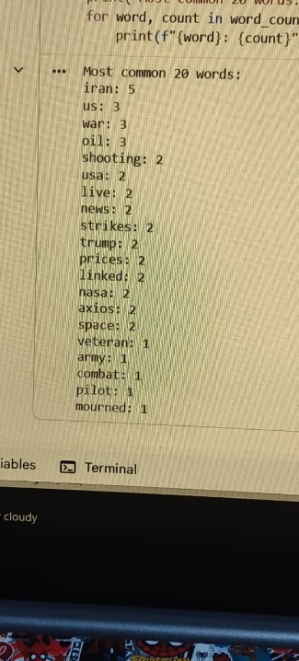
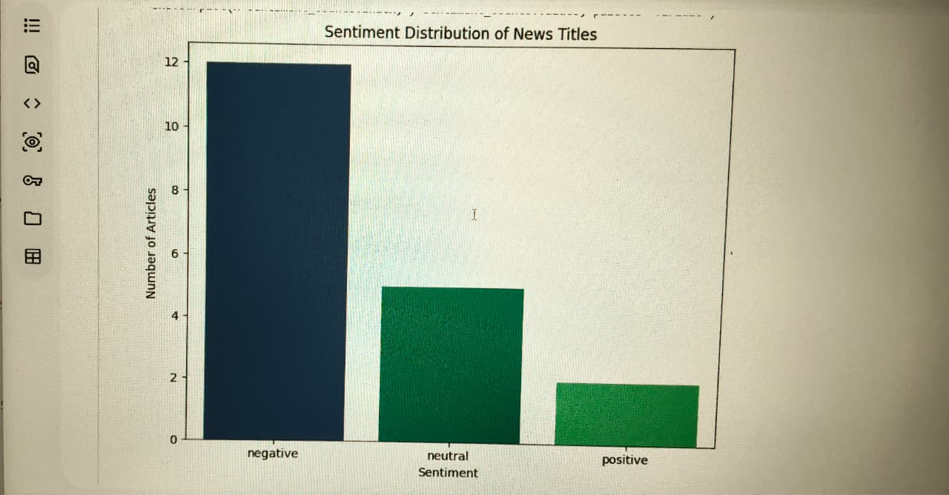
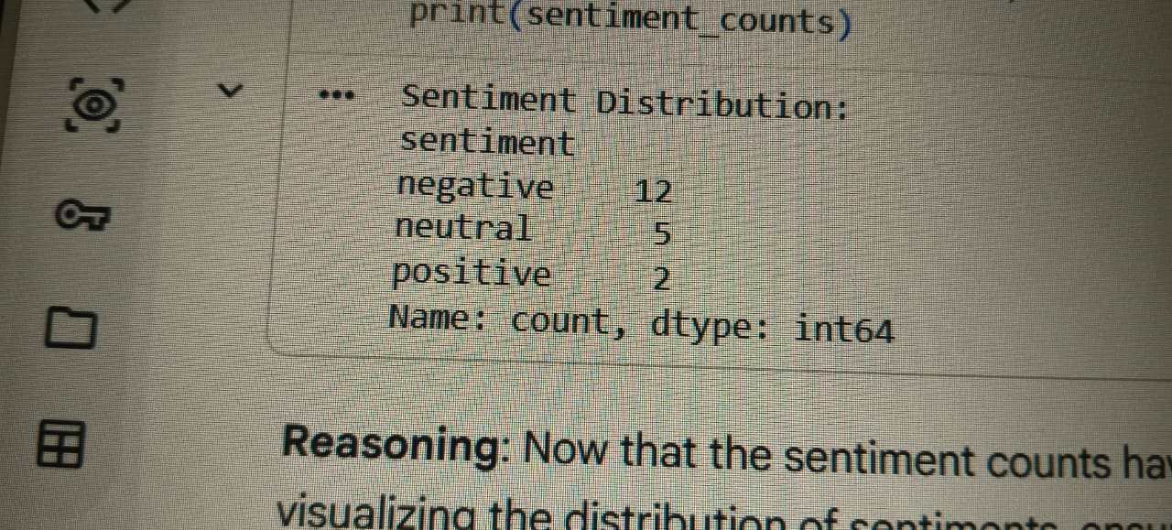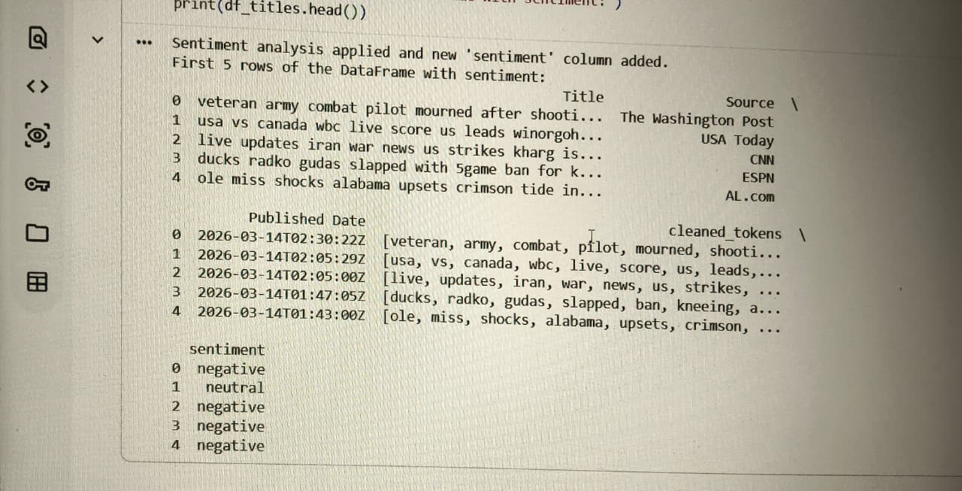
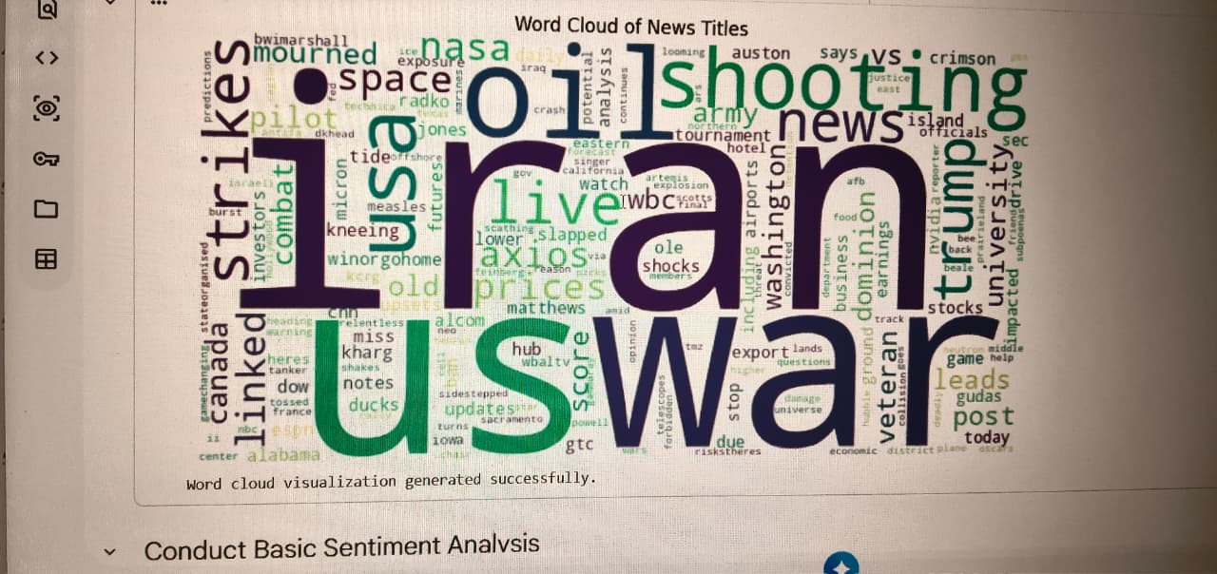

6. Conclusion
The successful completion of Milestone 2 results in a fully working preprocessing and topic modeling system. The final deliverables include a cleaned and tokenized dataset, a TF-IDF feature matrix, 3 to 5 generated topics, and organized code structure . By establishing this complete NLP pipeline, the NewsPulse project can now successfully extract meaningful insights, identify trending keywords, and support data-driven analysis from raw news articles .

