Laboratory Activity: Database Design and Implementation in the Digital Firm (Chapter 6)
Scenario: The Evergreen Boutique
Evergreen Boutique is an online clothing retailer currently managing its sales data through a manual spreadsheet system. As the business grows, this "flat-file" approach has become unsustainable. Data is often duplicated, customer records are inconsistent, and tracking orders with multiple items requires repetitive manual entry.
Your objective is to apply the principles of database management to modernize their operations. You will analyze their existing data, design a logical schema, and implement a relational database using MySQL.
The Legacy Sales Log
Carefully review the current sales records below. Identify patterns of redundancy and potential data integrity issues, such as the entry for "Alice S." in Order 1004.
OrderID | Date | CustomerName | CustomerEmail | Product | Category | UnitPrice | Qty
1001 | 01/03/2026 | Alice Smith | alice@email.com | Silk Scarf | Accessories | 45 | 1
1001 | 01/03/2026 | Alice Smith | alice@email.com | Cotton Tee | Tops | 25 | 2
1002 | 01/03/2026 | Bob Jones | bob.j@web.com | Denim Jacket | Outerwear | 89 | 1
1003 | 02/03/2026 | Charlie Day | c.day@mail.com | Silk Scarf | Accessories | 45 | 1
1003 | 02/03/2026 | Charlie Day | c.day@mail.com | Knit Hat | Accessories | 20 | 1
1003 | 02/03/2026 | Charlie Day | c.day@mail.com | Cotton Tee | Tops | 25 | 1
1004 | 03/03/2026 | Alice S. | alice@email.com | Denim Jacket | Outerwear | 89 | 1
1005 | 04/03/2026 | Bob Jones | bob.j@web.com | Silk Scarf | Accessories | 55 | 1

Instructions
Database Design. Analyze the legacy log to determine how the data should be partitioned into separate tables. Your design must eliminate redundancy while ensuring that one order can contain multiple different products. Use Microsoft Word or any preferred diagramming tool to create a schema diagram. This diagram must display all table names, their respective columns, and lines indicating the relationships between Primary and Foreign Keys.
Implementation via MySQL. Open your MySQL command-line interface. You are required to build the database structure and populate it using only SQL queries. Do not use any graphical wizards for table creation.

- Create a database named EvergreenBoutique.
- Write and execute the CREATE TABLE commands for your identified tables. Ensure you define proper data types, Primary Keys, and Foreign Key constraints.
- Use INSERT INTO statements to migrate the data from the legacy log into your new tables.
- Execute a SELECT query for each table to verify that the data has been correctly stored.

Deliverables
Submit a single Microsoft Word file organized as follows:
- Diagram Include the diagram you created showing your tables and their relationships.

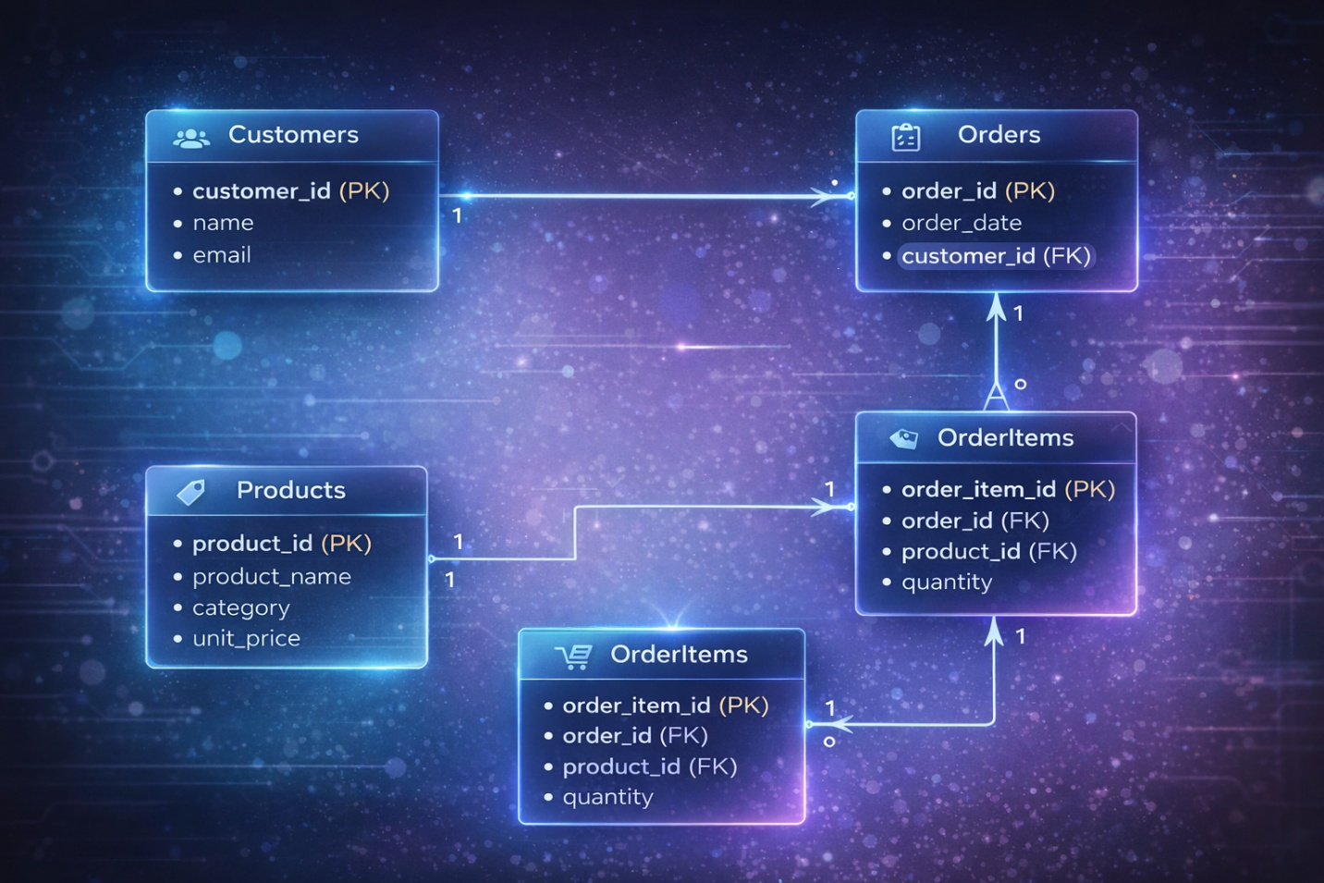

2. Provide screenshots of your MySQL command prompt. These screenshots must clearly show:
- The CREATE TABLE queries and their successful execution.
- The INSERT INTO queries used to populate the tables.
- The results of your SELECT * FROM [TableName] queries to confirm the data is present.
3. Answer the following in a dedicated section of your report:
- Explain your reasoning for the specific number of tables you chose to create.
  - I created 4 tables to eliminate data redundancy and organize information in a logical, manageable way. The Customers table stores unique customer details like name and email just once instead of repeating them for every order or item a customer purchases. The Orders table captures one row per order, recording the order date and linking to the relevant customer to track order headers clearly. Finally, the Order Items table connects orders to specific products, enabling each order to include multiple items without unnecessary repetition.
- Detail how this new relational structure specifically solves the "Alice S." inconsistency and the price update issue found in the original log.
  - This relational structure directly solves key issues from the original log. For the "Alice S." inconsistency, since both "Alice Smith" and "Alice S." shared the same email address, we stored only one standardized entry ("Alice Smith") in the Customers table, with all her orders (including Order 1004) linked to this single record to ensure consistent customer data

RESULT
