
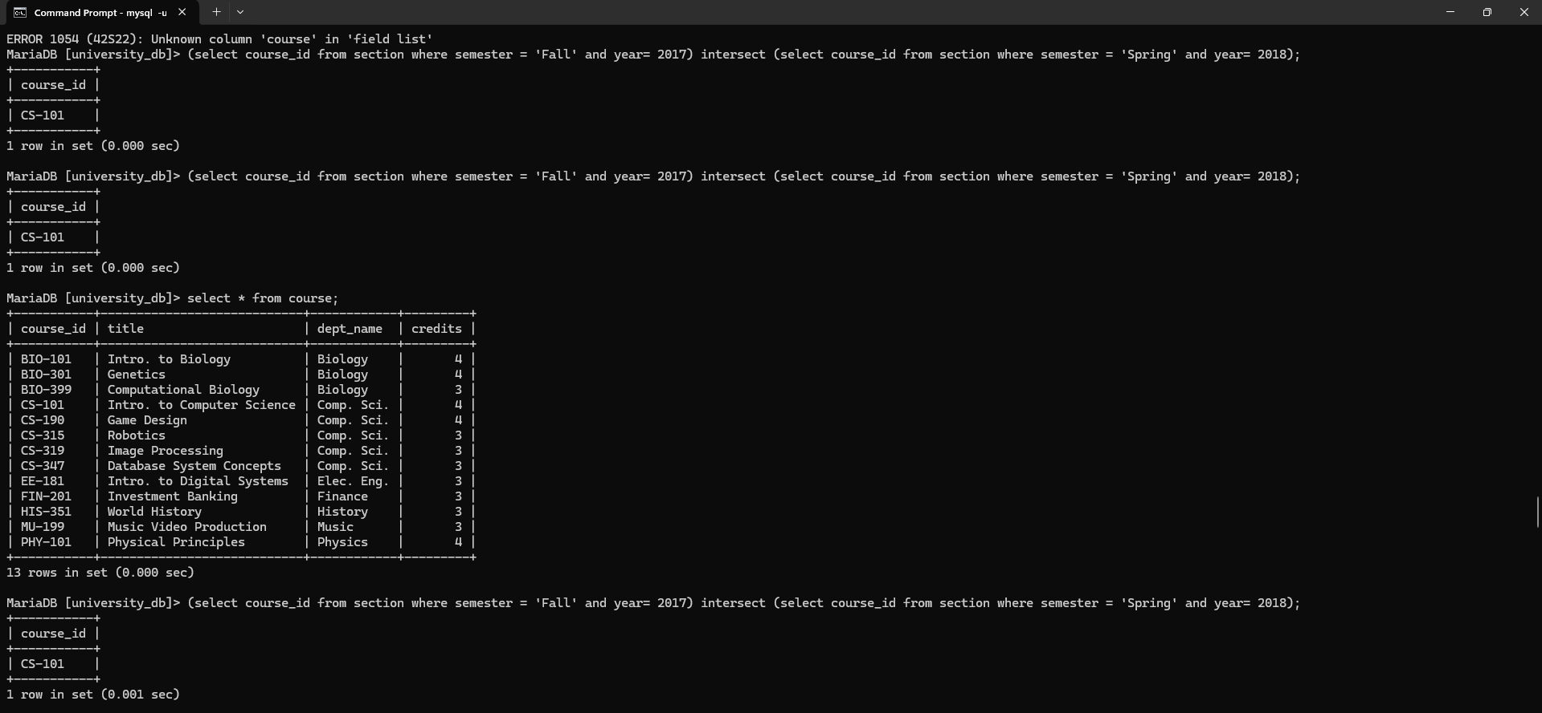
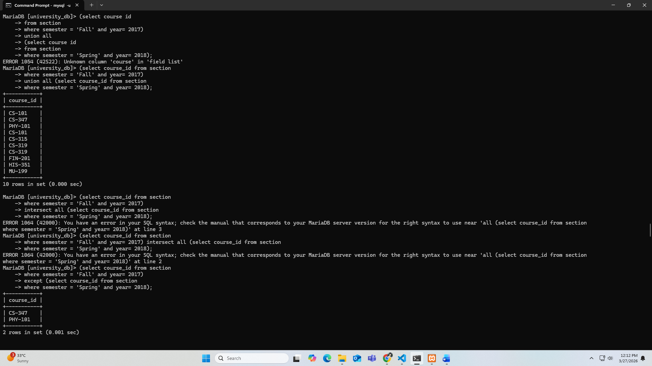
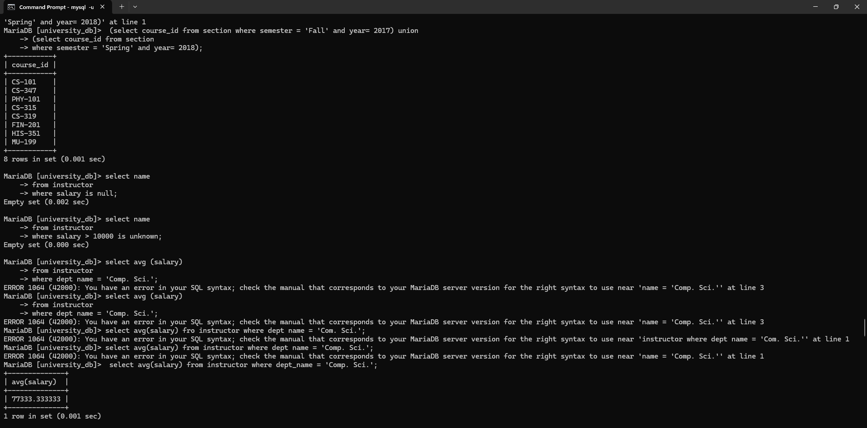
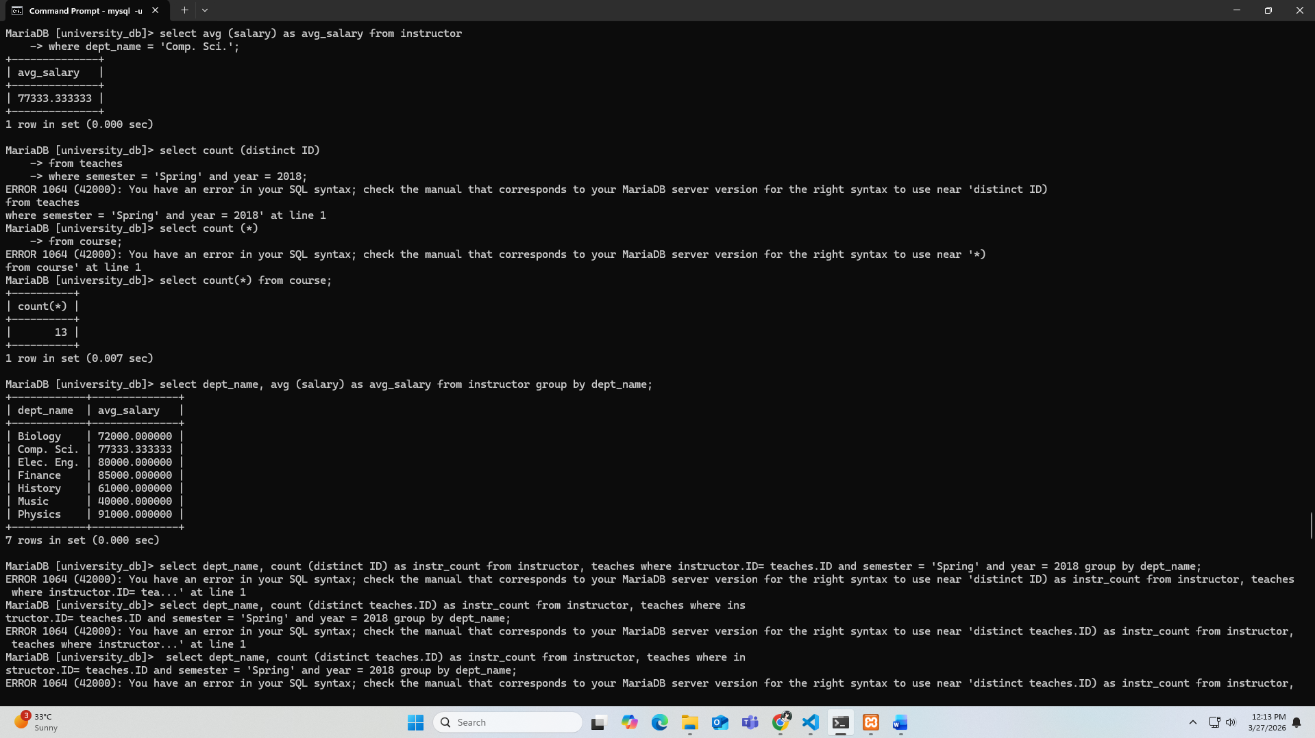
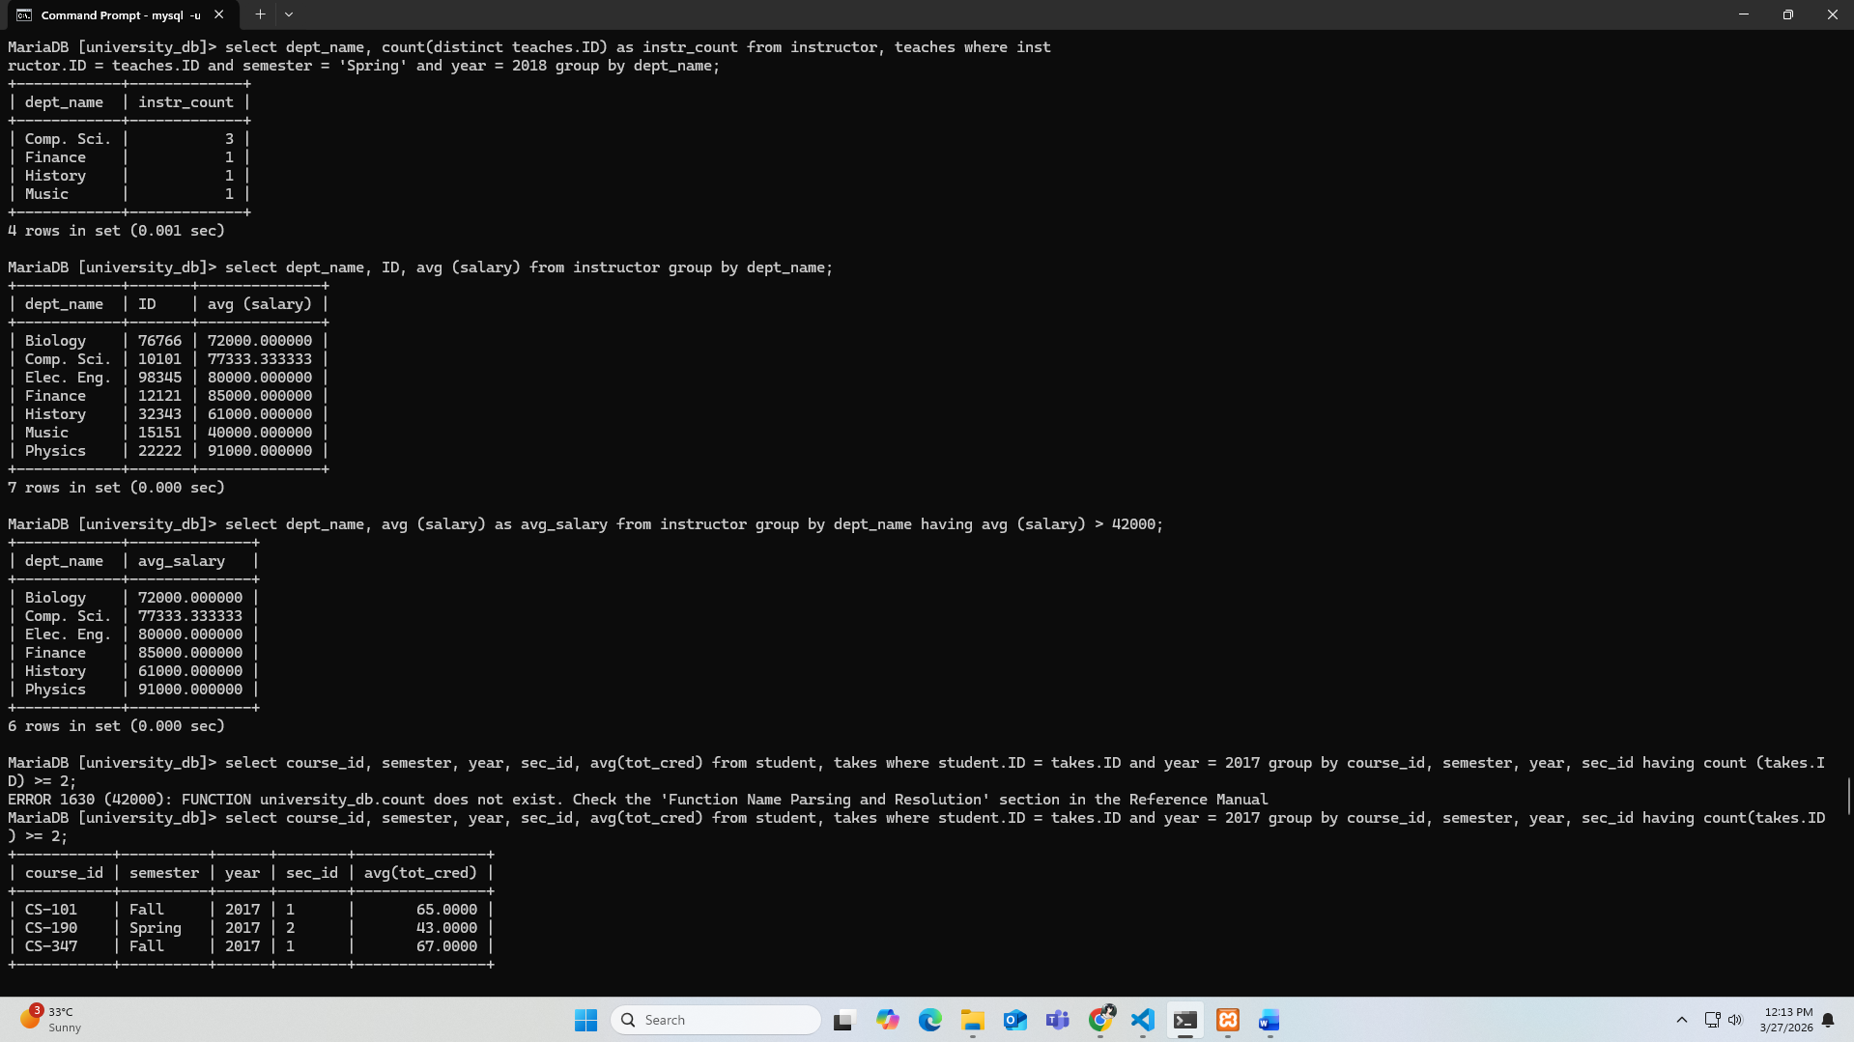
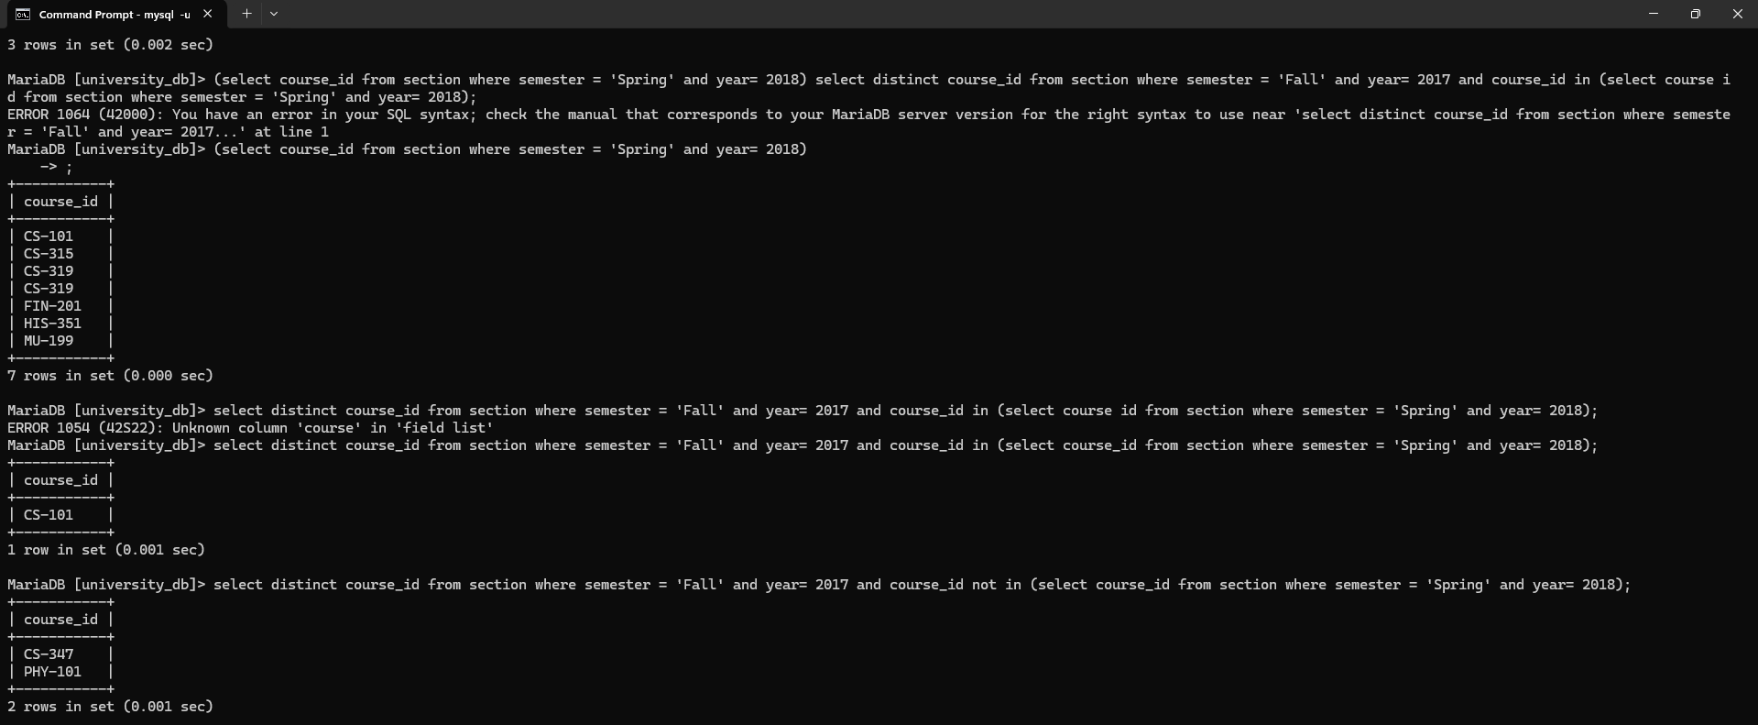
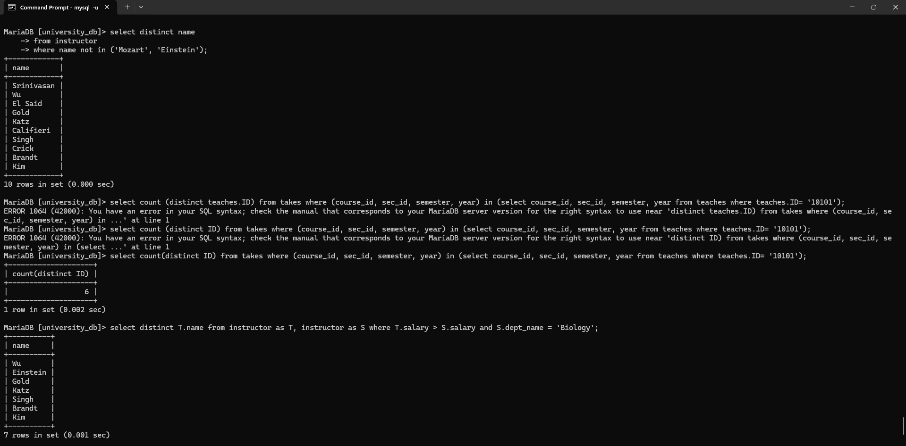
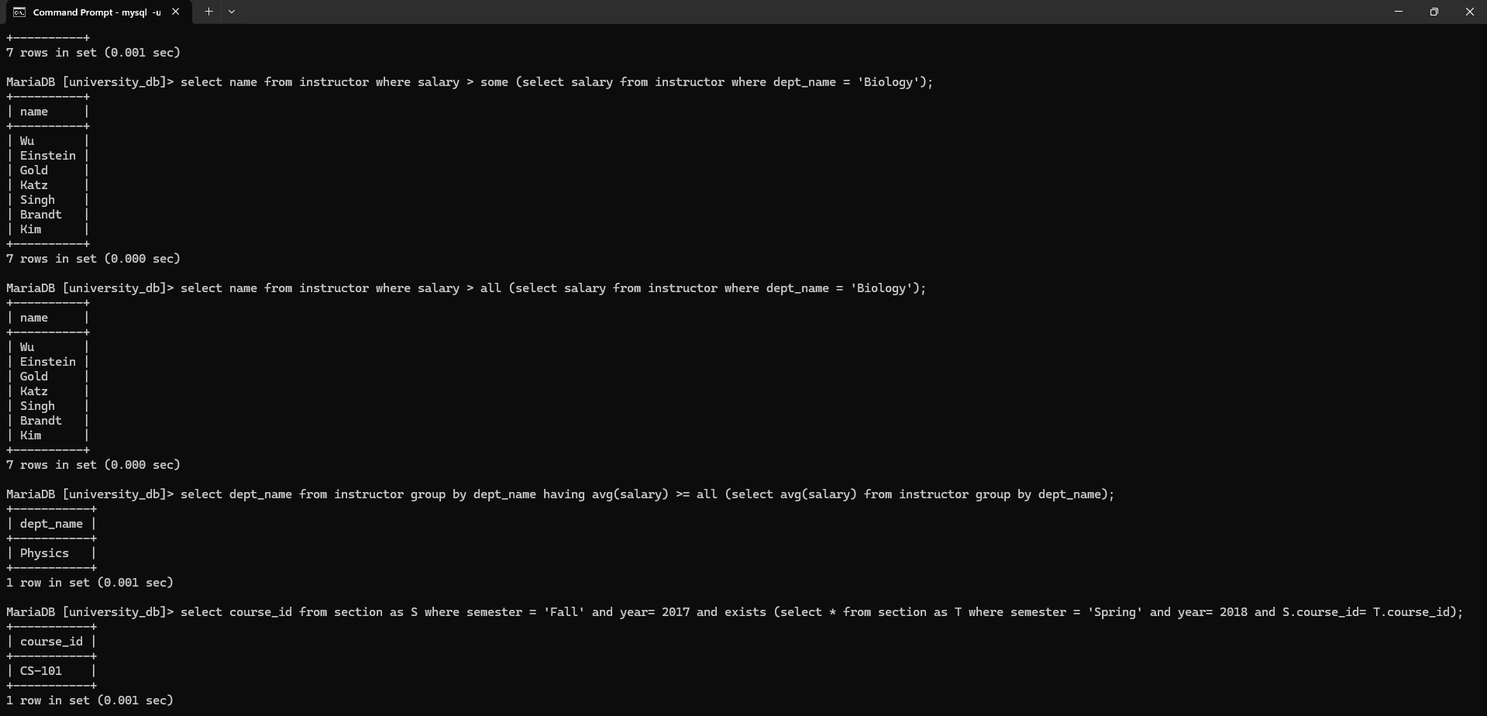
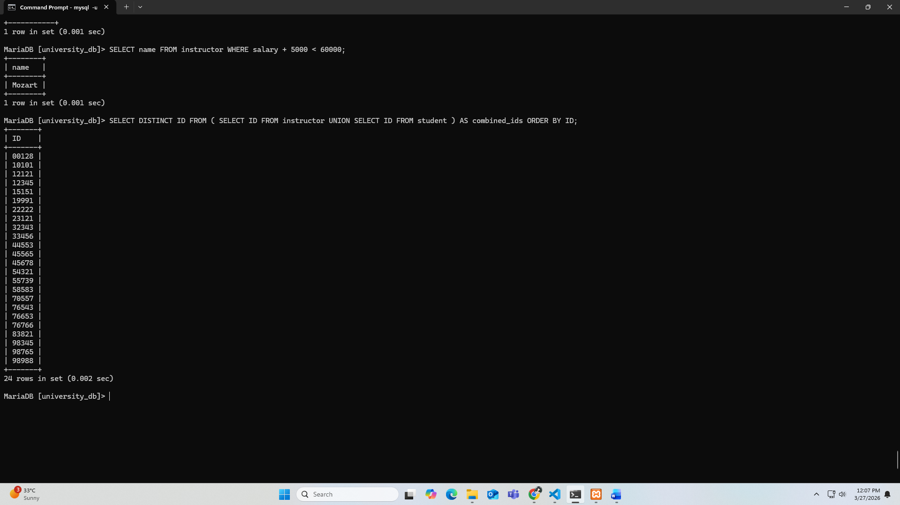
- Find the names of instructor whose annual salary, after a flat 5,000 bonus is added, still totals less than 60,000.
SELECT name FROM instructor WHERE salary + 5000 < 60000;
- The university administration needs a master list of all unique identification numbers currently in the system. Generate a single list of all IDs that appear in either the instructor table or the student table.
SELECT DISTINCT ID FROM ( SELECT ID FROM instructor UNION SELECT ID FROM student ) AS combined_ids ORDER BY ID;

