PRIVATE PRODUCT ARCHITECTURE MEMO
AGI OS Super App
Reference Structure, Architecture, and Product Scope
Prepared for: Mansur Abdurahimov
Purpose: Give the AI assistant a strict operating blueprint so the product stops behaving like a generic chat app and starts acting like a personal operating system.
Core thesis  One brain, three surfaces, shared system language, and a small number of trusted domain hubs. | Non-negotiable  Every action must show intent, plan, source, result, confidence, approval state, and undo.

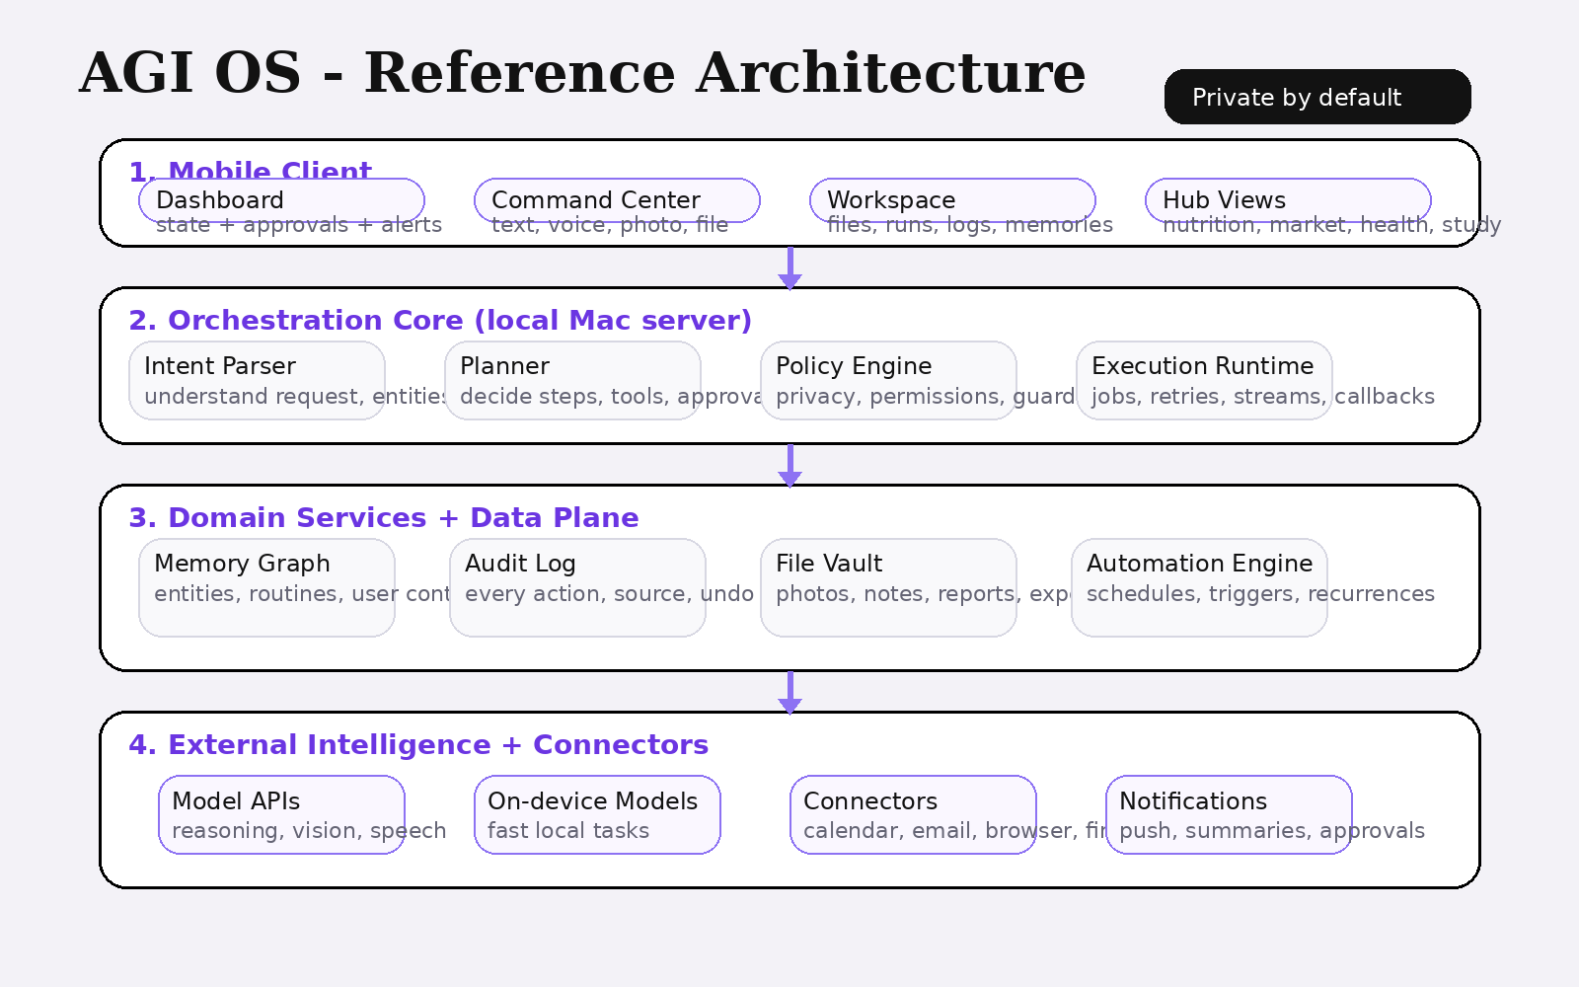

VERSION 1.0 | STRICT INTERNAL DRAFT

1. Executive Summary
AGI OS should be built as a private personal operating system, not as a loose collection of mini apps. The product exists to turn a user intent into a visible execution result, then preserve the outcome as durable state inside a local trusted system.
The right product shape is: one home-server intelligence core, one mobile control surface, a universal command layer, and a small set of domain hubs with a shared shell. This keeps the system strict, understandable, and extensible.
The current design direction is strong visually, but the missing piece is operational architecture. This memo defines the fixed system layers, product boundaries, object model, approval rules, module taxonomy, and delivery roadmap required to make the app serious.
2. Product Definition
AGI OS is a private super app for one person or a small trusted group. It uses cloud models for reasoning, but the real source of truth lives in the local server running on the user’s Mac. That local core owns memory, files, logs, automations, connectors, and policies.
The mobile app is the control panel. It is not the brain. Its job is to capture inputs, stream actions, display state, request approvals, and present outputs in a clear way.
The product goal is not “chat better.” The goal is to help a person operate life and work with one assistant that can observe, reason, act, remember, and report.
3. Product Principles
Private by default. Sensitive user context such as health, plans, finances, and personal files must persist locally first, with cloud usage limited to the minimum required for intelligence tasks.
Action over conversation. The assistant should not stop at answering. It should be able to parse intent, choose tools, run workflows, and return concrete state changes.
Shared system language. Every hub, tool, agent, and automation should feel like the same product. The app must avoid looking like unrelated mini apps glued together.
Trust through visibility. Every AI action must show what was understood, what is happening now, what changed, and how to reverse it.
Strict scope. V1 must prove the architecture with a few excellent hubs, not fifty shallow ones.
4. Information Architecture
The app should keep only three primary navigation surfaces: Dashboard, Command Center, and Workspace. All domain functionality should open inside these surfaces instead of becoming first-class tabs.
Dashboard is for state. It shows daily briefings, hub summaries, approvals, active agents, warnings, and system status.
Command Center is for intent. It accepts text, voice, images, and files. It displays planning, execution, streaming tool use, and result summaries.
Workspace is for evidence. It stores files, runs, notes, memories, exports, and audit history. Anything the AI creates or changes should be visible here.
Hubs are domain spaces such as Nutrition, Market, Health, Study, Travel, and Plans. Users should access them from search, command results, dashboard cards, or a module catalog - not from a crowded bottom bar.
5. Fixed Module Taxonomy
A scalable AGI OS should use exactly four module types. Hubs are long-lived domain spaces with their own state. Tools are single-purpose capabilities such as camera capture or browser extraction. Agents are named workers with identity and role. Automations are scheduled or triggered routines that run with approval policy.
This taxonomy prevents chaos. Without it, every new feature becomes “another app,” which makes the system impossible to understand and impossible to brand consistently.
Module type | Purpose | Examples
Hub | Persistent domain state | Nutrition, Health, Study, Market Pulse
Tool | Single action or capability | Camera capture, browser, parser, transcription
Agent | Named worker with role | Web Scout, Memory Weaver, Health Sentinel
Automation | Scheduled or triggered routine | Morning brief, meal log, weekly review

6. Interaction Contract for Every AI Action
For every action the assistant takes, the UI must expose six fields: understood intent, execution plan, source or tool used, resulting changes, confidence level, and undo or reversal path.
Example: after a meal photo is submitted, the assistant can say: “Detected salmon rice bowl; estimated 632 kcal; logged to Nutrition Hub; updated daily total; confidence 84 percent; undo available.” This is the core trust pattern.
7. Technical Architecture
Layer 1 - Mobile Client: authentication, push notifications, camera and microphone capture, file input, streaming responses, and rich UI rendering. No durable personal truth should be authored exclusively here.
Layer 2 - Orchestration Core on the user’s Mac: intent parser, planner, job runtime, policy engine, connector manager, memory writer, event bus, and audit logger. This is the operational heart of the system.
Layer 3 - Domain Services and Data Plane: memory graph, file vault, task store, insights store, automation engine, embeddings or retrieval indices, and structured hub databases.
Layer 4 - External Intelligence and Integrations: large-model APIs, speech services, vision models, and external connectors such as calendar, email, browser, health data, finance feeds, and document stores.
Design rule: cloud models can reason, but local infrastructure owns state, permissions, and truth.
8. Canonical Data Objects
The assistant should only create or update a small set of canonical objects: File, Run, Memory, Task, Insight, Automation, and LogEntry.
A photo-based meal example shows why this matters. The uploaded image becomes a File. The inference becomes a Run. The nutrition estimate becomes an Insight. The updated habit or preference can become a Memory. The audit trail becomes a LogEntry. This structure makes Workspace coherent.
Object | What it stores | Why it matters
File | Binary or text artifact | Makes every source tangible in Workspace
Run | One execution instance | Tracks tool use, timing, and outputs
Memory | Persistent learned context | Lets the system get better over time
Task | Actionable planned work | Separates intention from evidence
Insight | Interpreted result | Stores AI conclusions with confidence
Automation | Scheduled rule | Enables recurring service
LogEntry | Immutable audit event | Creates trust and reversibility

9. Hub Shell Design Standard
Every hub should inherit the same shell: status header, quick actions row, timeline or feed, AI insight card, and source/confidence/history footer. The shell changes only in content, not in interaction pattern.
Nutrition Hub can use actions like Take Photo, Add Meal, Ask Coach. Market Pulse can use Scan Receipt, Review Spend, Ask Budget Agent. Study Hub can use Capture Notes, Quiz Me, Summarize Lecture. The exact actions differ, but the shell remains stable.
10. V1 Scope
V1 should include the mobile shell, secure local-server connection, universal input bar, dashboard, command center, workspace, audit log, approval system, and no more than four production hubs: Nutrition, Market Pulse, Health, and Study.
V1 should not include a public marketplace, social network features, dozens of domain packs, or fully autonomous money movement. The architecture should mature before the system expands.
Include in V1 | Do not include in V1
Dashboard, Command Center, Workspace  • Nutrition, Market, Health, Study hubs  • Text, voice, image, file input  • Audit log and approvals  • Daily brief and basic automations | Open public marketplace  • Fifty hubs at launch  • Unbounded autonomous spending  • Random UI patterns per module  • Anything without auditability

11. Delivery Roadmap
Phase 1: foundations - identity, local sync, data objects, permissions, encryption, design system, event logging.
Phase 2: core flows - dashboard, command center, workspace, universal command bar, nutrition flow, spending flow.
Phase 3: high-trust operations - health workflows, study workflows, approvals, automations, daily brief, better retrieval and memory.
Phase 4: extension layer - internal module catalog, installation framework, module search, configurable hub registry.
12. Final Recommendation
Position the product as a private personal operating system with domain hubs. Avoid describing it as “many mini apps.” That framing weakens the architecture and turns the product into a collection instead of a system.
The winning outcome is a disciplined stack where the user can say anything once, the assistant routes the work correctly, the result appears visibly, and the state remains trustworthy forever.

Appendix A. Screen Direction
The concept visuals already establish a strong premium direction: editorial headings, quiet backgrounds, rounded white cards, and restrained accent usage. The design priority now is a stricter shell and clearer system feedback.
Blueprint board
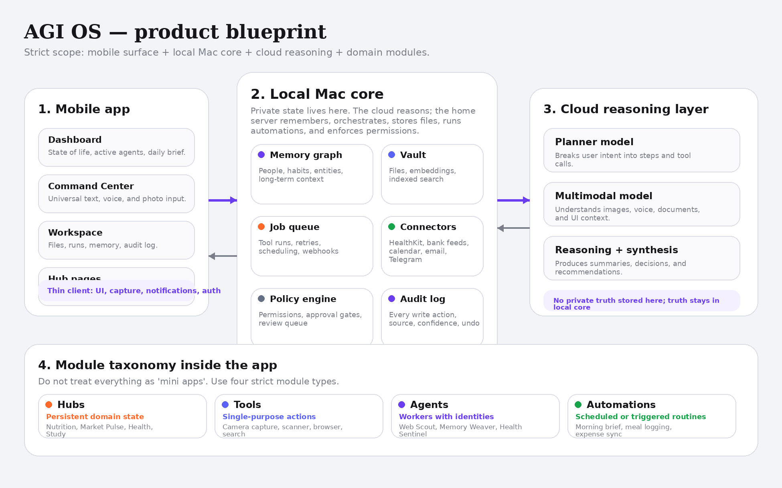
Dashboard direction
