Problem statement:

Suppose you are writing a Adventure game. The following are the characters

i) King

ii) Queen

iii) Knight

All these characters can fight. They can fight with any of the following weapons

i) Sword

ii) Knife

iii) BowAndArrow

iv) Axe

Write a simple app which has all these characters and assign one weapon to them and call fight method which display.
Each character has display() method which when called will display e.g “I am a king” or “I am a queen”.
Each Character has fight() method which when called will display “I am fighting with sword” or “I am fighting
with BowAndArrow” based on what weapon the character has

Design pattern(s) used:
I used Stratagy design pattern.

Design Justification :

I used the Strategy design pattern because as per given problem we need to create a character which will have a weapon initialized. A character can change weapon at run time. So Strategy design pattern provides a way to define different strategy and run time we can change the behaviour of a character based on selected weapon type.

Design Representation :
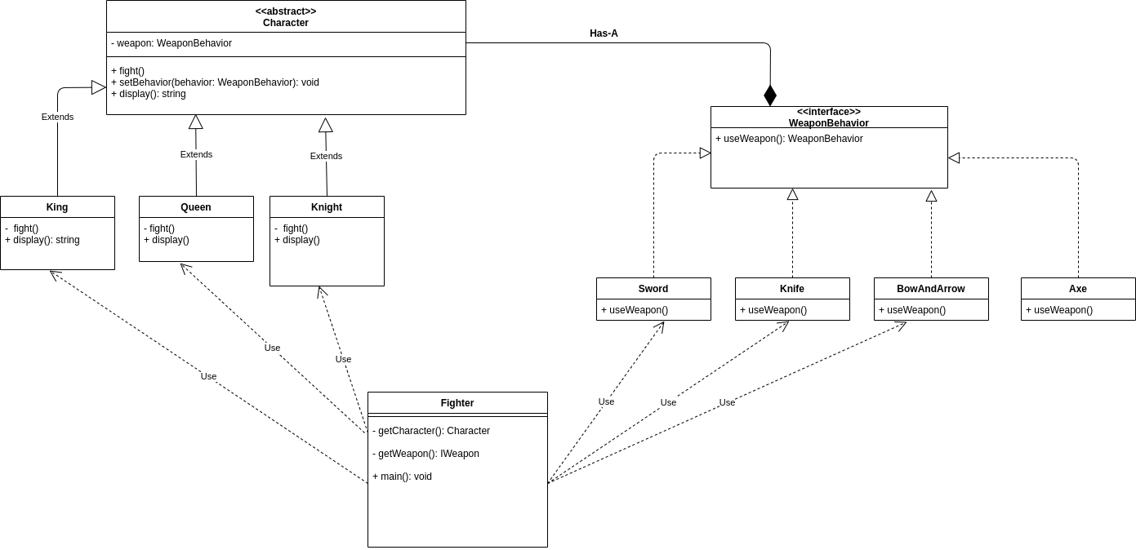

PseudoCode : classes and interface
IWeaponBehavior:{ useWeapon() }
abstract Character class { display(), fight(), setWeapon()}
classe Sword, Knife, BowAndArrow, Axe implemanets IWeaponBehavior { //implements method of interface}
King extends Character: {//override extended Character class methods}

Queen extends Character: {//override extended Character class methods}

Knight extends Character: {//override extended Character class methods}

Client classe:

Fighter: { //has few methods to create a character and set the wepon behavior for that character }

